APPLICATION FOR A CERTIFICATE OF LAWFULNESS FOR PROPOSED USE OR DEVELOPMENT

APPLICATION REFERENCE: | PL/2026/00780
APPLICATION TYPE: | Lawful development: Proposed use
SITE ADDRESS: | Down View, Great Wishford, Salisbury, SP2 0NX
DEVELOPMENT DESCRIPTION: | Certificate of Lawfulness (Proposed Use) for a Caravan at Downview, Station Road, Great Wishford
RECOMMENDATION: | APPROVE

PROPOSAL
The applicants seek a Lawful Development Certificate pursuant to Section 192 (1) of the 1990 Act to formally confirm the proposed use of the land for the siting of a caravan to provide ancillary domestic accommodation within the garden of a dwelling house.

The proposed site plan, as shown below outlines where the proposed caravan (log cabin) would be sited, in the rear garden of the dwelling, 8m from the rear of the dwelling, 1m from the site boundary.

Location plan and proposed site plan

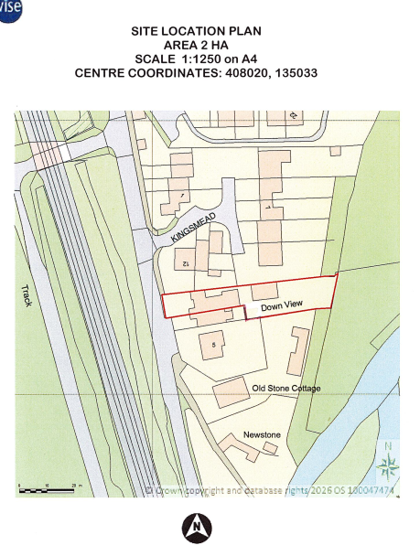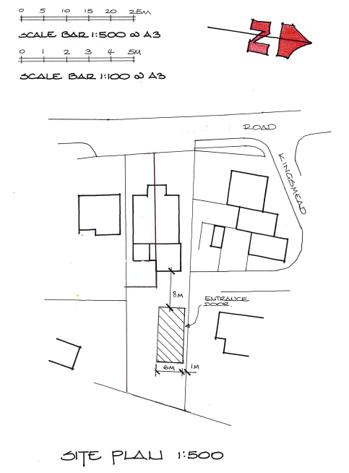

SITE DESCRIPTION
The application relates to Down View, semi-detached dwelling, set back and down from the road with a small area of off road parking to the front. The property has a large rear garden (to the east) which slopes downwards and backs onto open fields and the River Wylye. There is vehicle access to the rear garden from ‘Kingsmead’ cul-de-sac.

The application site is within the settlement boundary of the Large Village of Great Wishford as defined by Wiltshire Core Strategy (WCS) core policies 1 (Settlement Strategy), 2 (Delivery Strategy) and 4 (Spatial Strategy for the Amesbury Community Area).

There are residential neighbours to the north and south, a railway line to the west and the River Wylye to the east.

The application site is subject to the following planning policy constraints:
- Hampshire River Avon Catchment
- Salisbury Plain and West Wiltshire Downs Countryside Character Area
- Flood zone 1 (eastern edge of site within zones 2 & 3)

THE EVIDENCE SUBMITTED IN SUPPORT OF THE APPLICATION
• Application form (received 11/02/2026)
• Location plan (received 11/02/2026)
• Proposed site plan, Floor Plan and Elevations (received 04/03/2026)
• Structural Analysis (received 12/02/2026)
• Supporting Statement rev A (received 03/04/2026)
• General Method of Moving a Keops Mobile Home (received 04/03/2026)

RELEVANT LEGISLATION AND POLICY
The Town and Country Planning Act 1990, (as amended)
Section 55 (1)
Sections 191-193

Also of relevance - Caravan Sites & Control of Development Act 1960, Caravan Sites Act 1968 (Definition of Caravan) (Amendment) (England) Order 2006)

LEGISLATION / PLANNING PRACTICE GUIDANCE
Section 55 (1) Subject to the following provisions of this section, in this Act, except where the context otherwise requires, “development,” means the carrying out of building, engineering, mining or other operations in, on, over or under land, or the making of any material change in the use of any buildings or other land.

Section 192(1) of the Act outlines that “if any person wishes to ascertain whether—
(a) any proposed use of buildings or other land; or
(b) any operations proposed to be carried out in, on, over or under land, would be lawful, he may make an application for the purpose to the local planning authority specifying the land and describing the use or operations in question.

Section 192(2) of the Act outlines that “if, on an application under this section, the local planning authority are provided with information satisfying them that the use or operations described in the application would be lawful if instituted or begun at the time of the application, they shall issue a certificate to that effect; and in any other case they shall refuse the application.

REPRESENTATIONS
There is no legal obligation to consult third parties, including Town/Parish Councils or neighbouring properties, for this type of application.

RELEVANT SITE HISTORY
The site has the following relevant planning history:

Proposal / Summary
S/1996/0213 - Full planning permission Decision - Approve with Conditions Date: 9/4/1996 – Enlargement of existing porch on front of house
S/1989/0444 - Full planning permission Decision - Approve with Conditions Date: 30/6/1989 – ALTERATIONS AND EXTENSIONS TO DWELLING
S/2008/1263 - Full planning permission Decision - Refused Date: 11/9/2008 – FIRST FLOOR EXTENSION TO FORM BEDROOM
S/2008/2091 - Full planning permission Decision - Approve with Conditions Date: 10/2/2009 – FIRST FLOOR EXTENSION TO FORM BEDROOM
16/00140/FUL - Full planning permission Decision - Approve with Conditions Date: 4/3/2016 – Proposed single storey rear extension
S/2006/0895 Construction of dwelling with new access from ‘Kingsmead’ – Refused Date: 07/06/2006
S/2006/1744 Outline application for construction of single dwelling with new access from Kingsmead – Refused Date: 13/10/2006

PRINCIPLE OF DEVELOPMENT
The Local Planning Authority needs to consider whether, on the facts of the case and relevant planning law, the specific matter is or would be lawful. Planning merits are not relevant at any stage in this particular type of application or appeal process. Views expressed by third parties on the planning merits of the case, or on whether the applicant has any private rights to carry out the operation, use, or activity in question, are therefore irrelevant when determining the application.

This Lawful Development Certificate for Proposed Use relates to the proposed siting of a caravan (in this instance a log cabin) within the curtilage of an existing dwelling (Down View, Great Wishford, Salisbury, SP2 0NX) to operate as ancillary to the use of the main dwelling.

The proposed caravan would be sited within the garden of the host dwelling and would measure 12m in length and 6m in width and 2.99m internal height, as stated within the accompanying drawings. The proposal does not include the provision of any separate curtilage, access or parking for the caravan.

ASSESSMENT
The applicant seeks a Lawful Development Certificate to use the private residential curtilage of their home to site a caravan for use as residential accommodation ancillary to the main dwelling for the family of the existing residents of Down View.

In order for a Lawful Development Certificate to be granted under Section 192 of the 1990 Act, the onus is on the applicant to demonstrate that the development would be lawful.

The Supporting Statement sets out that the caravan unit is to be used as ancillary accommodation. The log cabin will be used exclusively by a family member to allow them to remain within the curtilage of the family home. The occupier will make use of shared facilities within the main dwelling, including laundry and main cooking. The land will continue to be used as a single planning unit for residential purposes, with no change of use proposed at any point. The unit will not have a separate address, and all access, utilities and services will be connected to the main house, such that the dwelling and the caravan unit will be occupied as a single planning unit in a single-family occupation.

The basis for the claim is that the proposed use of land, ancillary to the main dwelling, is excluded from Class E Part 1 of Schedule 2 of the GPDO 2015 (as amended) and therefore it comes under the schedule of the Caravan Site and Control of Development Act 1960 (as amended).

The definition of a caravan was modified by Section 13 (1) of the Caravan Sites Act 1968 to include 'twin-unit caravans'. As such it is claimed that the caravan falls within the definition of a caravan and there would be no material change of use or operational development.

Details of the structure, including its size, composition, mobility and method of delivery have been submitted along with the confirmation of use. Within the Planning Act, the term caravan has the same meaning as for the purposes of the Caravan Site and Control of Development Act 1968. Essentially it is any structure designed or adapted for human habitation which is capable of being moved from one place to another, whether it is towed, or transported on a motor vehicle.

The are two issues to be determined, whether the caravan falls within the description of a caravan and whether there would be a change of use of the land within the curtilage of a dwellinghouse for the siting of a mobile home and thus whether that amounts to development within the meaning of the 1990 Planning Act.

The caravan would be a designed as a single unit and would be brought to the site by a lorry. The application is supported by ‘General Method of Moving Log Cabin Mobile Home, Keops’ and ‘Structural Analysis of Lifting and Trailering a Typical Log Cabin Mobile Home’, that confirms how the unit would be transported and lifted.

The supporting statement confirms that “the cabin will not be permanently fixed to the ground”.

In this instance, it is deemed that the unit meets the required construction and mobility tests and would fall within the relevant size parameters in order to meet the tests of a caravan or mobile home and not an outbuilding. The Local Planning Authority therefore concur that the type and size of the caravan unit falls within the definition of a caravan.

The Local Planning Authority are satisfied that the site comprises a residential property with domestic curtilage and that the red line on the submitted location plan defines the extent of that planning unit. On the basis of the use of the caravan, as set out in the planning statement, the Local Planning Authority concur that the stationing of a caravan within the curtilage of the dwelling for use in connection with the occupation of the dwelling would not amount to a change of use and would not constitute development, for which planning permission would be required if used in the manner stated.

An application such as this can only be assessed on the basis of the stated purpose and if some other use of the caravan were to take place such that it is not used in association with the dwelling, then it would not benefit from the Lawful Development Certificate.

GROUND WORKS
A site visit was undertaken by the Case Officer to Down View and it appears that groundworks to re-profile the land or extend the area for the siting of the caravan have taken place. The images below show recent signs of soil removal and mechanical disruption of the land:

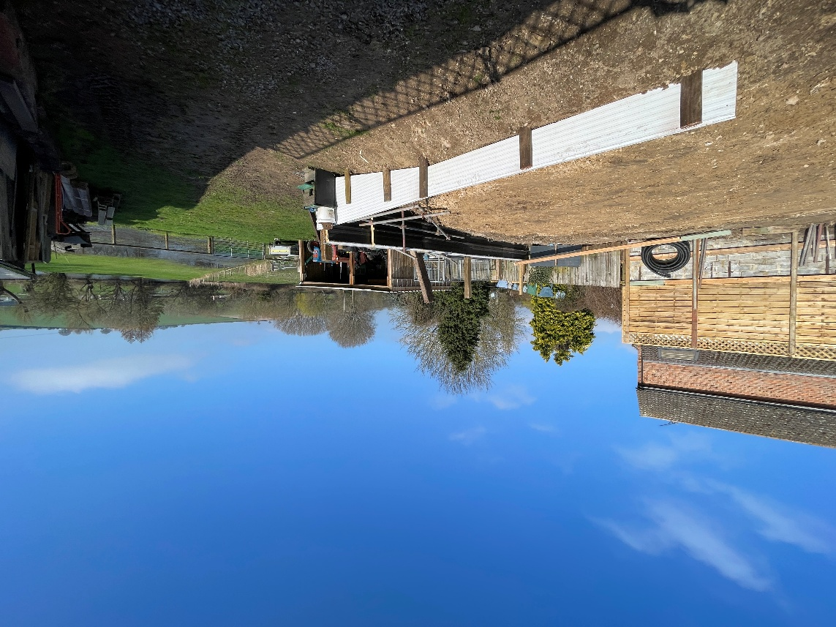
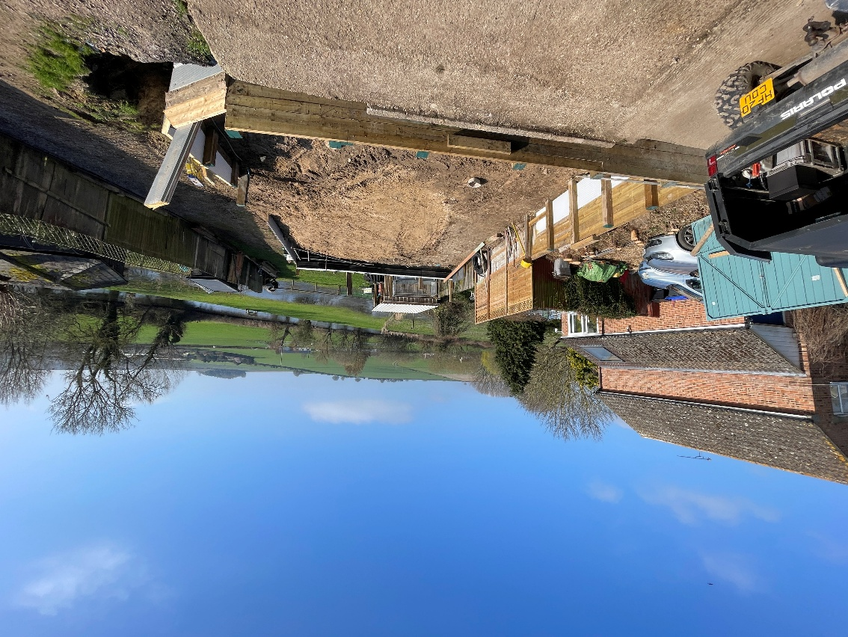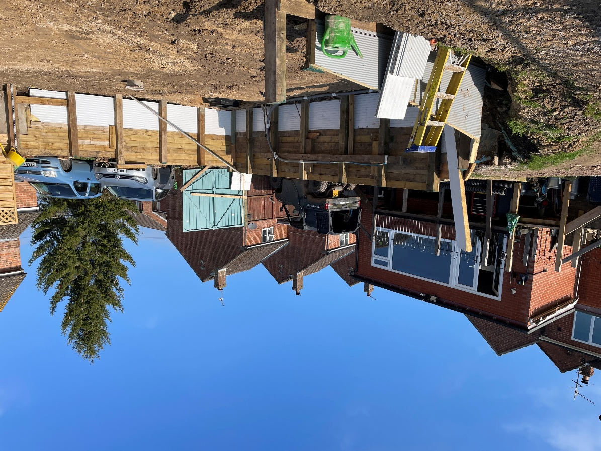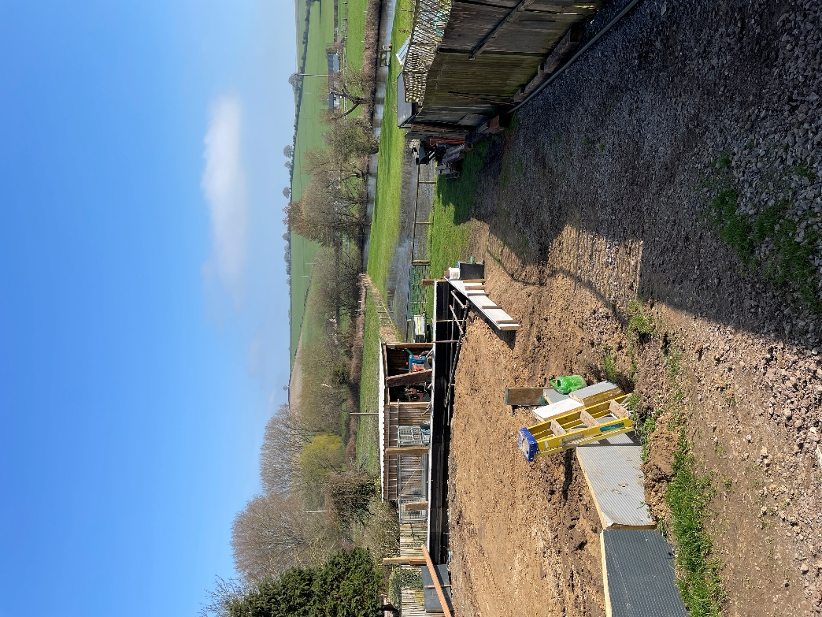

Planning history for the site and photographs provided by the applicant show that historically there has been an outbuilding sited within the rear garden of Down View and that some amount of levelling would have taken place to accommodate that.

Photo from applicant of cabin put up in May 2011
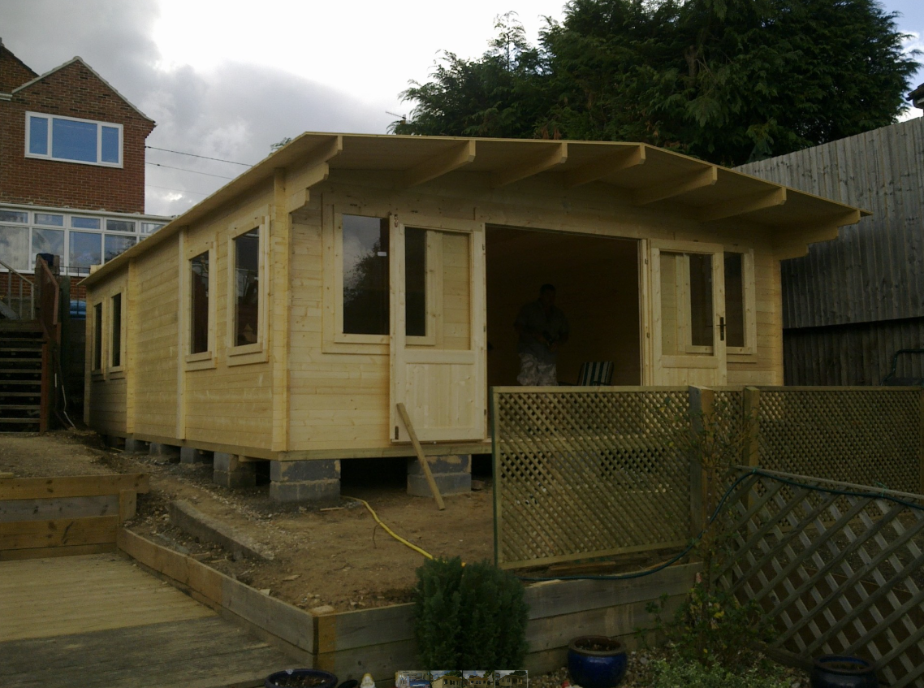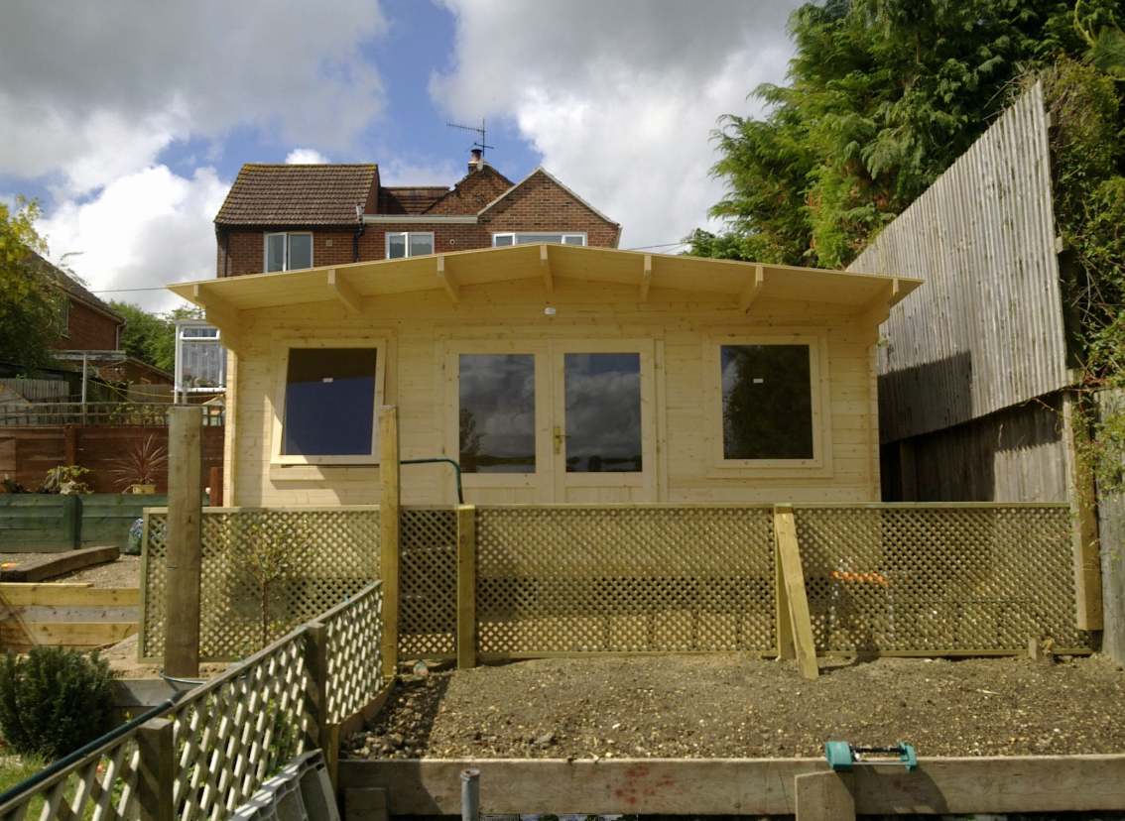

Drawings and photographs from planning application 16/00140/FUL show this log cabin and terracing to the garden:
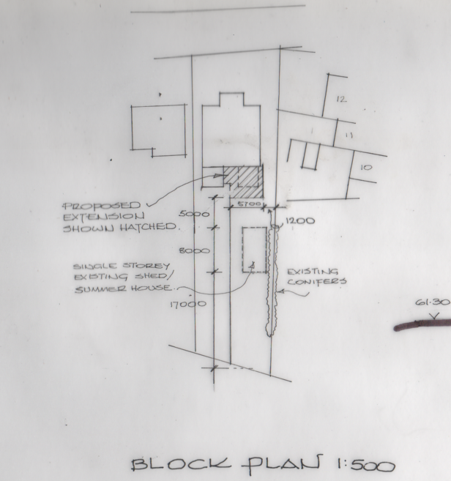

Site photos from 16/00140/FUL
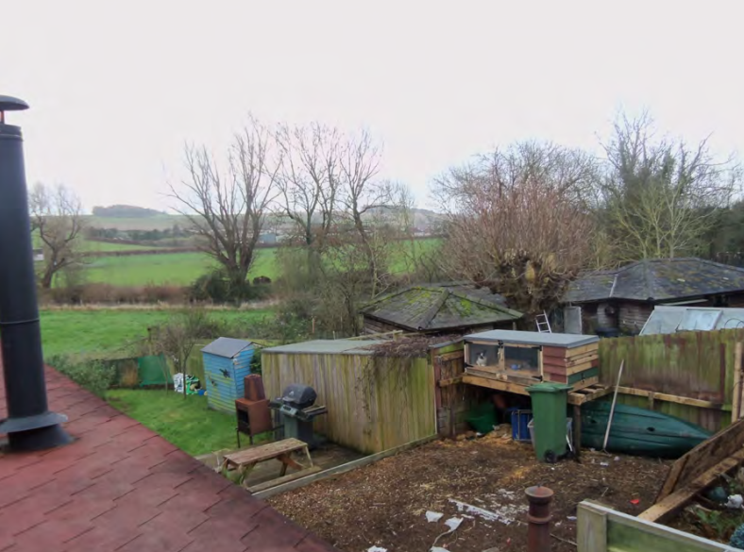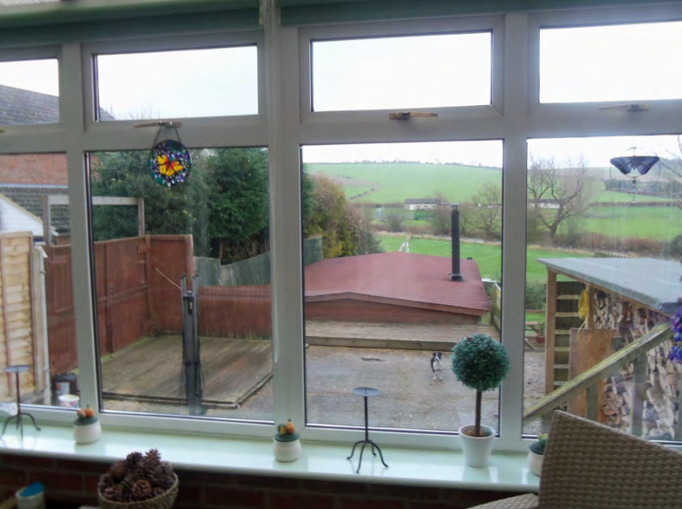
Aerial photography from 2020
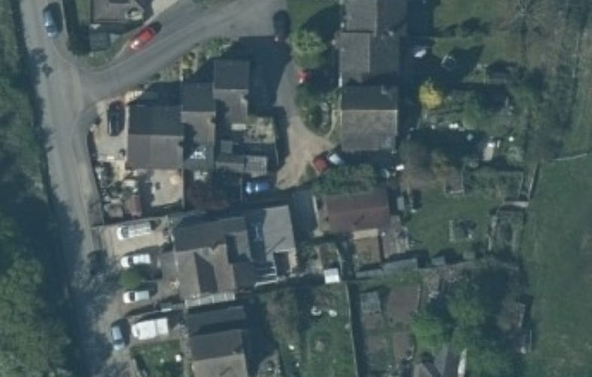

Aerial photography from 2002 shows a swimming pool
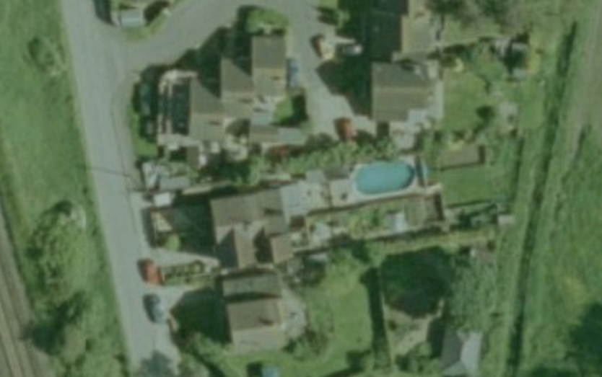

However, given that the documentation for the 2016 application shows a shed/summer house of 8m in length and the historical photographs available show a previous terraced rear garden, it is the opinion of the case officer, that groundworks considered to be engineering works have taken place to extend the base for the proposed caravan and provide a sloped access to the side of the proposed site, which constitutes development under Section 55 Town and Country Planning Act. Therefore, these groundworks do not benefit from permitted development rights under Class E of the GPDO and as such, would require planning permission

Whilst the groundworks undertaken require planning permission, the submission of this certificate only seeks the Local Planning Authority’s confirmation that the siting of a caravan in the curtilage of Down View does not comprise ‘development’ as defined by the Town and Country Planning Act 1990 (as amended).

It is important to confirm that the groundworks undertaken are not being considered under the scope of this certificate application and require regularisation through the submission of a separate planning application to be submitted to the Local Planning Authority for consideration. Therefore, the groundworks undertaken do not prevent the approval of this Certificate of Lawfulness and an informative can be added to the decision advising of the need to address the groundworks via a separate planning application.

CONCLUSION

S192 of the Town and Country Planning Act 1990 (as amended) allows a Local Planning Authority to issue a certificate for the proposed operations as described in an application if they are considered lawful or unless it can be proved conclusively that there is a material change in matters relevant to the determining of such lawfulness.

In determining lawfulness, the only issue to be considered is whether or not the proposal can be implemented without the need for planning permission from the local planning authority. It therefore needs to be established whether the proposal involves either ‘permitted development’ or is not characterised as development at all.

For the reasons above and in the light of the legislation, it is considered that the use of land within part of the domestic curtilage of the dwellinghouse for the stationing of a caravan, to be used as an integral part of the main use as a single dwellinghouse and/or to be used for activities incidental to the dwellinghouse within the same Use Class (namely, Class C3) of the Town and Country Planning (Use Classes) Order 1987 (as amended) as the dwellinghouse, will not result in the formation of a separate planning unit and does not comprise ‘development’ as defined by the Town and Country Planning Act 1990 (as amended).

Consequently a Certificate of Lawfulness can be issued for the stationing of the caravan only. The groundworks undertaken are not being considered under the scope of this certificate application and require regularisation through the submission of a separate planning application.

RECOMMENDATION:
Approve issue of the certificate

Wiltshire Council hereby certify that on 19/03/2026 the operations described in the First Schedule to this Certificate in respect of the land specified in the Second Schedule to this Certificate and edged red on the plan attached to this certificate are lawful within the meaning of section 192 of the Town and Country Planning Act 1990 (as amended) for the following reason(s):

The use of land within part of the domestic curtilage of the dwellinghouse for the stationing of a caravan (excluding any engineering works to the land), to be used as an integral part of the main use as a single dwellinghouse and/or to be used for activities incidental to the dwellinghouse within the same Use Class (namely, Class C3) of the Town and Country Planning (Use Classes) Order 1987 (as amended) as the dwellinghouse, will not result in the formation of a separate planning unit and does not comprise ‘development’ as defined by the Town and Country Planning Act 1990 (as amended).

FIRST SCHEDULE: Certificate of Lawfulness Application (Proposed Use) for a Caravan

SECOND SCHEDULE: Down View, Great Wishford, Salisbury, SP2 0NX

INFORMATIVE TO APPLICANT(S)
This permission relates solely to stationing of the caravan, and not to any engineering works to the land. The groundworks undertaken within the red line boundary of the site constitute engineering operations require planning permission and therefore do not fall within the scope of the certificate granted by the Local Planning Authority. Consequently, these works fall within the scope of ‘development’ as defined under Section 55(1) of the Town and Country Planning Act and therefore, the applicant is advised to submit a separate planning application for the regularisation of the earthworks undertaken upon the land before any caravan is sited upon it.

