APPLICATION FOR HOUSEHOLDER PLANNING PERMISSION
DELEGATED REPORT

APPLICATION REFERENCE: | PL/2026/00325
APPLICATION TYPE: | Householder Planning Permission
SITE ADDRESS: | 18 Rickfield, Bradford on Avon, BA15 1PP
DEVELOPMENT DESCRIPTION: | A split-level single-story side extension, including a roof terrace and raised decking; landscaping to create levelled usable garden areas, and a rear-facing 1st floor balcony. The existing property will also be refurbished to improve its layout and energy performance, including added external insulation and over-cladding / rendering.
RECOMMENDATION: | That Planning Permission be GRANTED

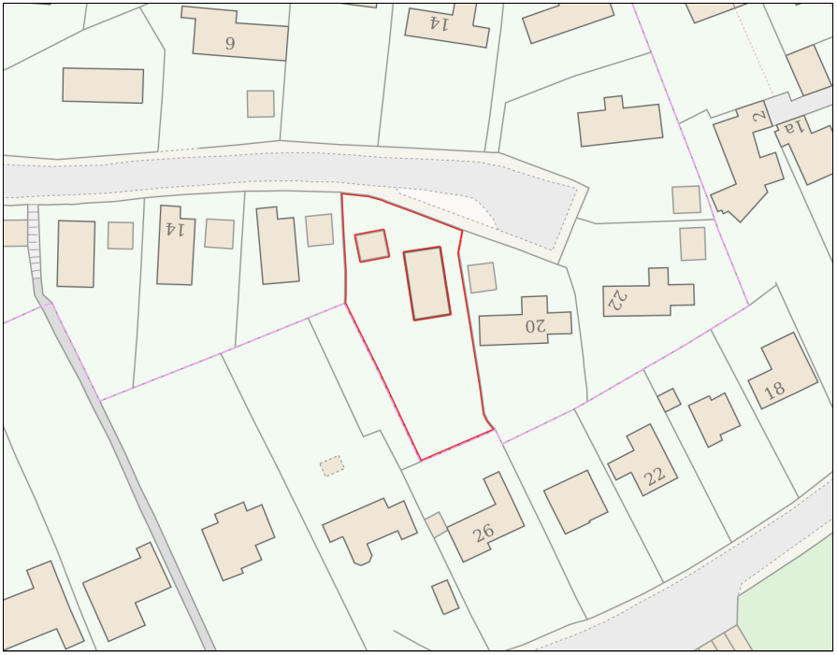

PROPOSAL

The proposal seeks planning permission for a side extension and internal reconfiguration of the dwelling at 18 Rickfield. It includes a split-level, single-storey extension to the west, rationalisation of the layout to group living areas at the upper level and bedrooms below, and the introduction of a new entrance porch and utility spaces. A roof-terrace and small balcony would provide direct access from the main living areas to the rear garden. Landscaping works, including terracing and planting, are proposed to improve the steep garden, and the refurbishment incorporates new windows, and photovoltaic panels. The number of bedrooms would remain unchanged.

SITE DESCRIPTION / CONTEXT

The application site comprises a 1970s detached dwelling located toward the end of a cul-de-sac, set on a steeply sloping plot that results in a low and discreet presence within the street scene. Due to this topography, the property sits significantly below road level, with the majority of the building screened from public viewpoints. The dwelling currently has an unconventional “upside-down” layout, with living accommodation at the upper level and most bedrooms below. Mature planting, level changes, and fencing form the boundaries with neighbouring properties to the South, East and West. The site is outside the Bradford-on-Avon Conservation Area and contains no designated heritage assets.

The application site is subject to the following planning policy constraints:

- GHS 4km Core Roost Buffer.
- GHS 4km SAC Parcel Buffer.
- LHS 2km Core Roost Buffer.
- Strategic Flood Risk Assessment (sFRA) negligible risk from ground and surface water flooding.
- Flood Zone 1.
- Within Bradford on Avon Settlement Boundary (Market Town).

PLANNING HISTORY

No relevant planning history has been identified for the site subject of this application.

RELEVANT LEGILSATION, POLICIES AND GUIDANCE

Wiltshire Core Strategy:

Core Policy 1 Settlement Strategy;
Core Policy 2 Delivery Strategy;
Core Policy 7 Bradford on Avon Community Area;
Core Policy 50 Biodiversity and Geodiversity;
Core Policy 51 Landscape
Core Policy 57 Ensuring High Quality Design and Place Shaping;
Core Policy 60 Sustainable Transport;
Core Policy 61 Transport & Development;
Core Policy 62 Development Impacts on the Transport Network;
Core Policy 64 Demand Management
Core Policy 67 Flood Risk;

Bradford on Avon Neighbourhood Plan 2013-2026

The National Planning Policy Framework (NPPF)

The Planning Practice Guidance (PPG)

Wiltshire Design Guide - Appendix D – Design Guidance for Householder extensions

The Wiltshire Local Transport Plan 2011 – 2026: Car Parking Strategy (March 2015).

The Wiltshire Local Transport Plan 4 (LTP4) (March 2025)

Emerging Policy – Wiltshire Local Plan Review

The Council’s emerging Local Plan has reached Regulation 24 stage, and is progressing through examination but the emerging plan carries limited weight at this stage with the hearing sessions currently being paused.

- Policy 1 Settlement Strategy
- Policy 85 Sustainable construction and low carbon energy
- Policy 88 Biodiversity and Geodiversity
- Policy 89 Biodiversity Net Gain
- Policy 95 Flood Risk
- Policy 98 High Quality Design and Place Shaping

CONSULTATION RESPONSES

Bradford on Avon Town Council – No Objection

REPRESENTATIONS

Three representations were received objecting to the proposal, raising concerns primarily relating to loss of privacy, overlooking and noise associated with the proposed raised terrace, balcony and access steps. The comments received consider that the elevated position of these elements would introduce new and direct views into gardens and rear‑facing windows, resulting in a harmful perception of being overlooked. Objectors also questioned the effectiveness of the proposed side privacy screens and planting, noting that vegetation cannot provide guaranteed or permanent mitigation. Additional concerns were raised regarding the increased scale and massing of the extension, its proximity to shared boundaries, and the potential for the structure to appear overbearing or cause loss of light when viewed from neighbouring gardens and habitable rooms, particularly those at a lower topographical level.

Further objections related to the proposed use of materials, including metal roofing, extensive vertical timber cladding, render and aluminium fenestration. Neighbours consider that the combination of multiple contemporary finishes would be visually incongruous and not reflective of the more traditional and cohesive character of Rickfield. Some representations also asserted that the Design and Access Statement did not sufficiently address impacts on properties to the south, and expressed concern that existing boundary planting affected by honey fungus may decline, increasing future exposure to overlooking. Overall, objectors consider the scale, design approach and elevated outdoor areas to be out of keeping with the surrounding area and detrimental to their privacy and residential amenity.

ASSESSMENT

Section 38(6) of the Planning and Compulsory Purchase Act 2004 states:

"If regard is to be had to the development plan for the purposes of any determination to be made under the planning Acts, the determination must be made in accordance with the plan unless material considerations indicate otherwise."

In accordance with this statutory requirement, this application has been assessed against the relevant policies of the Development Plan, including the adopted Wiltshire Core Strategy (2015) and, where applicable, any made Neighbourhood Plans.

Design and Impact upon the upon the character and context of the area
Core Policy 57 of the Wiltshire Core Strategy and Policy 98 of the emerging Wiltshire Local Plan require development to achieve high‑quality design that responds positively to local context, reinforces local distinctiveness, and takes account of factors such as scale, massing, materials, building line and landscape setting. In this case, the site sits within a varied but coherent streetscene at Rickfield, where Bath stone remains the dominant material but where several properties incorporate contemporary timber elements that contribute to an evolving local palette.

The proposal includes a modest ground‑floor link extension between the main dwelling and the detached garage, positioned below street level and largely screened from public views. Its form responds well to the steep topography, with the external terrace above reflecting the terraced garden arrangements found in parts of the locality. The glazed link and single‑pitch roof create a subtle butterfly roof effect that integrates comfortably with the host dwelling. Overall, the extension and terrace read as a contemporary yet sensitive intervention that aligns with the aims of Core Policy 57.

The scheme also involves alterations to the existing dwelling, including extensive use of vertical timber cladding. While this material differs from the predominant Bath stone, nearby examples at 12, 5 and 22 Rickfield demonstrate that timber is an established and contextually appropriate feature. Although the proposed use is more extensive than typical, it remains compatible with the area’s character, particularly as sections of Bath stone are retained to reinforce local distinctiveness. The proposed replacement windows in dark‑grey powder‑coated aluminium and timber frames are modest in scope and would sit comfortably within the proposed material palette.

Additional elements include a 1.8‑metre slatted timber privacy screen along the western boundary and further screening around the southern balcony. These features are modest in scale, reflect materials used elsewhere within the design, and do not result in visual harm. The extensions all sit below the main roofline, aside from one section of the link which aligns with the ridge. This ensures that the development reads predominantly as single‑storey, with only a small two‑storey component of approximately 18sqm connecting the house and garage. The resultant stepped composition unifies the previously disjointed relationship between the buildings and responds positively to the sloping site.

The proposal also includes replacing the existing concrete roof tiles with a dark‑grey matte standing‑seam metal roof. Although this represents a departure from the traditional roofscape, the low‑gloss finish would appear recessive, and national policy confirms that development should be sympathetic to local character while not discouraging innovation. Core Policy 57 and the Wiltshire Design Guide similarly support high‑quality contemporary materials where they are well detailed and contextually appropriate. Subject to a condition securing the precise specification—materials schedule, samples, and confirmation of seam dimensions—the metal roof is considered a visually acceptable modern enhancement.

Having regard to the above, the proposal is considered to comply with the design principles set out in Core Policy 57 of the Wiltshire Core Strategy and Appendix D of the Wiltshire Design Guide.

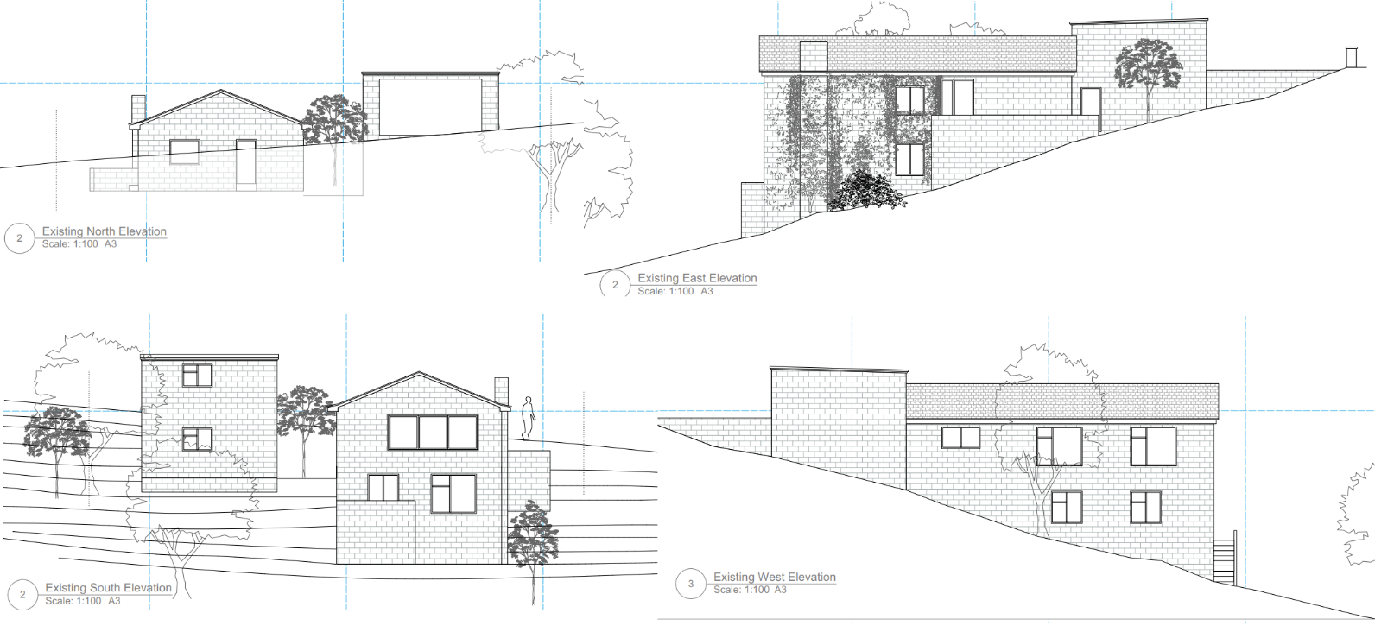
Existing Elevations

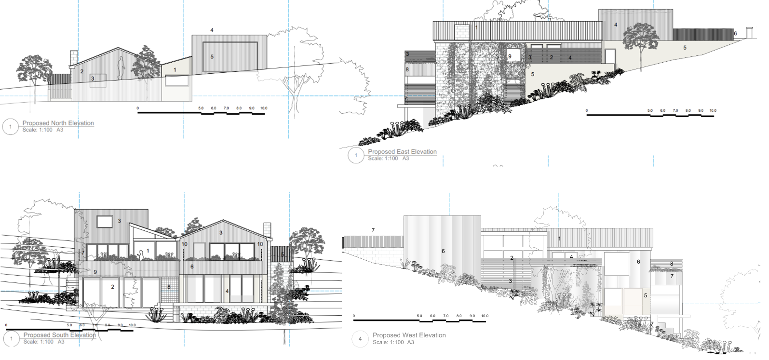
Proposed Elevations

Amenity
Core Policy 57 (criterion vii) and Paragraph 135 of the NPPF require development to safeguard the living conditions of existing occupiers. The proposal has been assessed in terms of privacy, noise, light, and overbearing impact. The most notable element is the first‑floor balcony on the southern elevation, positioned approximately 22.9 metres from the southern boundary. This is a substantial separation distance and, combined with dense boundary vegetation, is sufficient to prevent harmful overlooking of properties to the south. Privacy screens to the east and west further restrict oblique views, ensuring that potential overlooking towards neighbouring gardens at distances of 9.8m and 6.8m is effectively mitigated. Given the dwelling’s existing upper‑floor living accommodation and associated views, the balcony would not materially increase the perception of overlooking relative to the current arrangement. Proposed integrated planting would further soften and filter outward views.

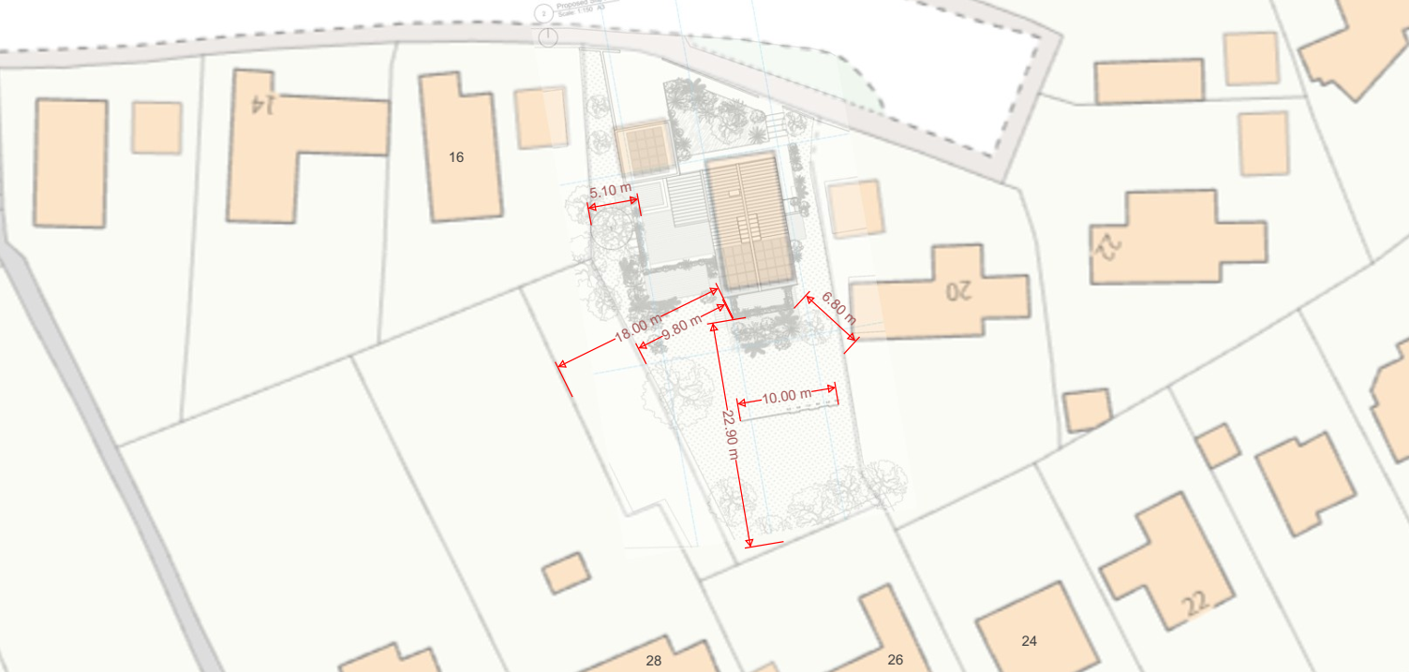
Site Plan Overlay and Distances

The raised ground‑level terrace above the single‑storey extension would sit around 5.1 metres from the western boundary; however, this boundary is considerably vegetated and already accommodates a small seating area. The proposal introduces a 1.8‑metre privacy screen along this edge, which would improve the existing level of protection and is consistent with similar raised terraces within the estate, such as that observed at 14 Rickfield. Concerns regarding noise have been considered, but domestic outdoor activity is an established part of residential occupation. The existing garden already contains areas capable of supporting seating without acoustic screening, and the proposed privacy screens would provide greater containment of sound than the current open arrangement. There is no evidence that the terrace would generate noise beyond what is ordinarily expected within a residential context.

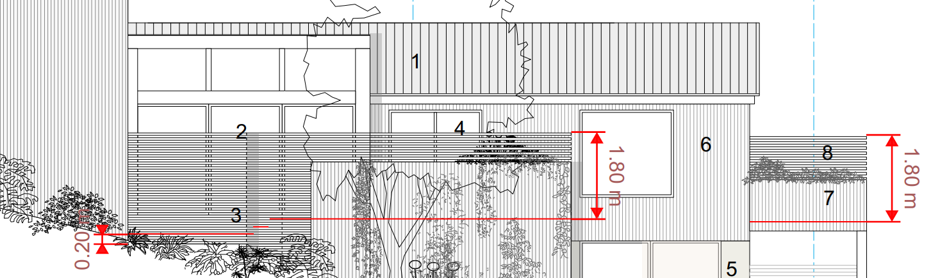
Proposed West Elevation and indicated privacy screening

In terms of light and overbearing impact, the site’s orientation means the development would not impede sunlight to neighbouring properties. The proposal does not increase the main roof height and remains significantly below street level to the north. To the south, the extensions do not project beyond the existing building line, and the link extension is recessed by approximately 3.7 metres. The stepped design reduces perceived bulk, and the highest part of the ground‑floor structure sits below 4 metres—comparable to a form that could reasonably be constructed under permitted development rights. As such, the development is not considered to give rise to an overbearing relationship or loss of light.

To ensure that the amenity mitigation relied upon in this assessment is secured for the lifetime of the development, a condition will require the privacy screens to be installed prior to first use of the balcony and terrace and retained thereafter. Subject to this condition, the proposal is considered to accord with Core Policy 57 and Appendix D of the Wiltshire Design Guide in respect of residential amenity.

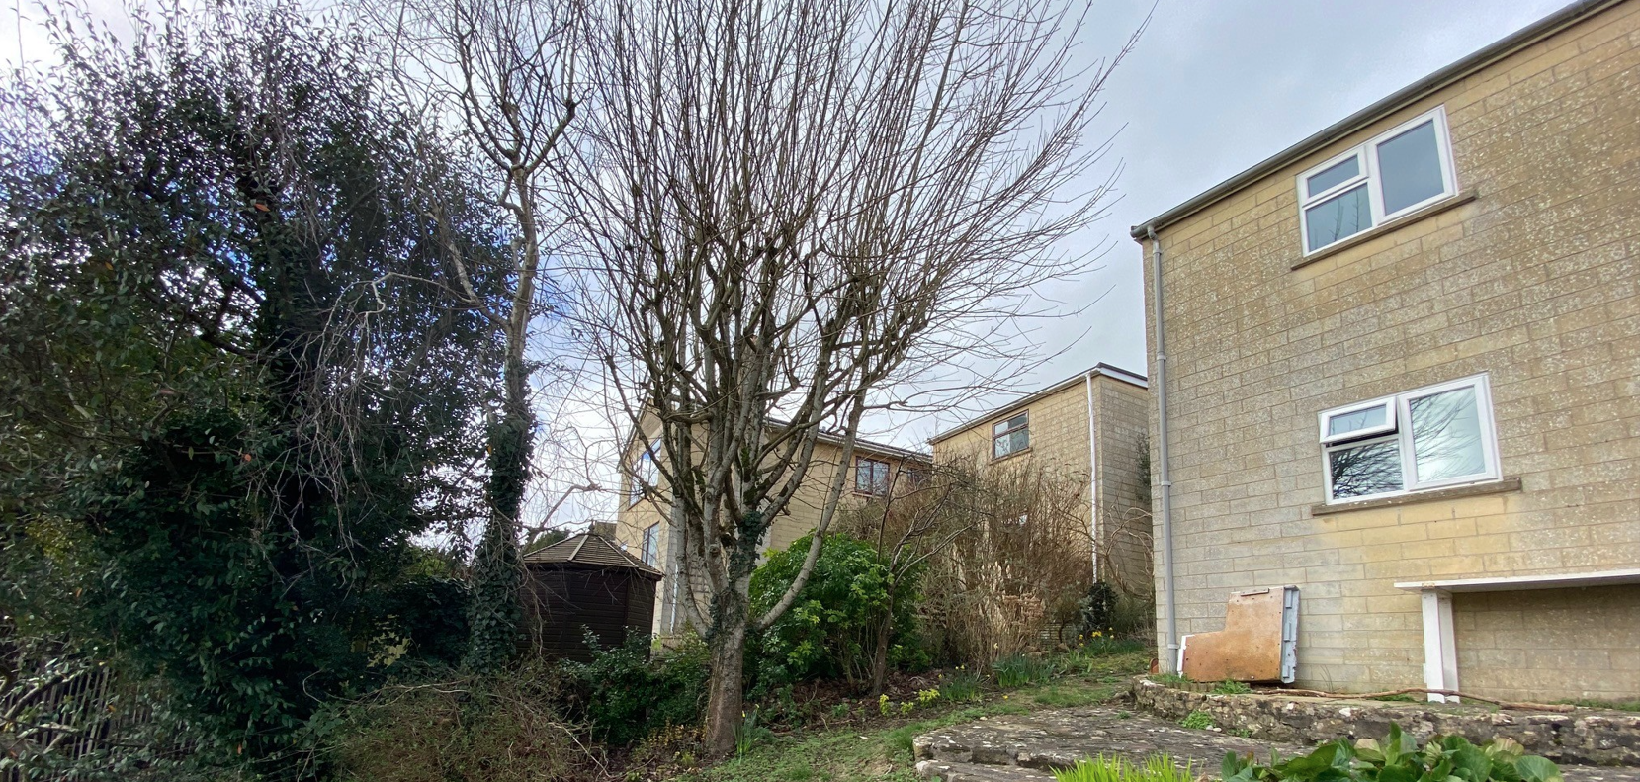
Image of boundary shared with 16 Rickfield

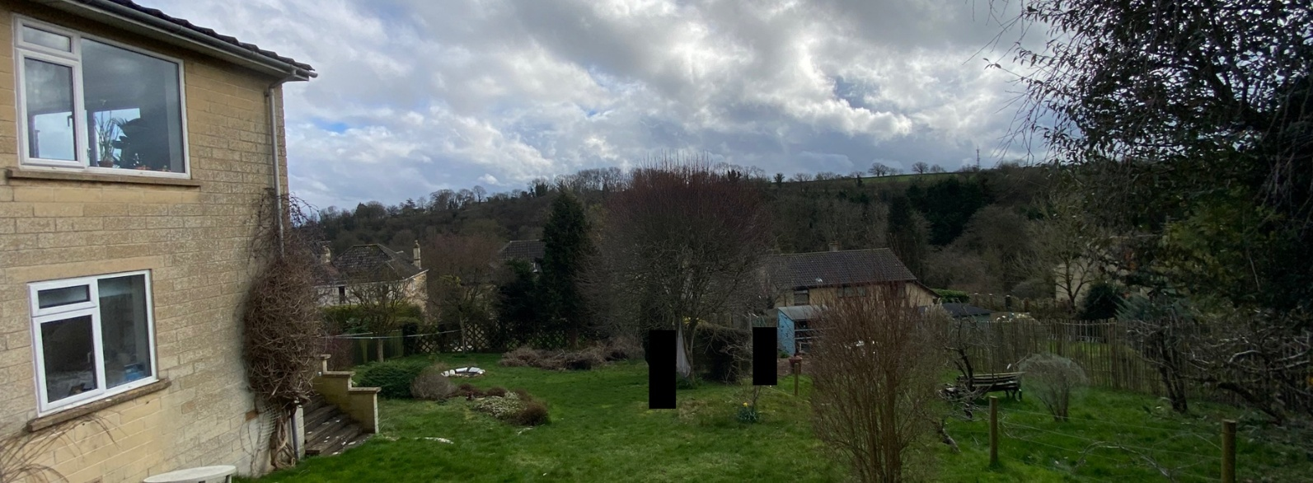
Image facing South from proposed raised external space

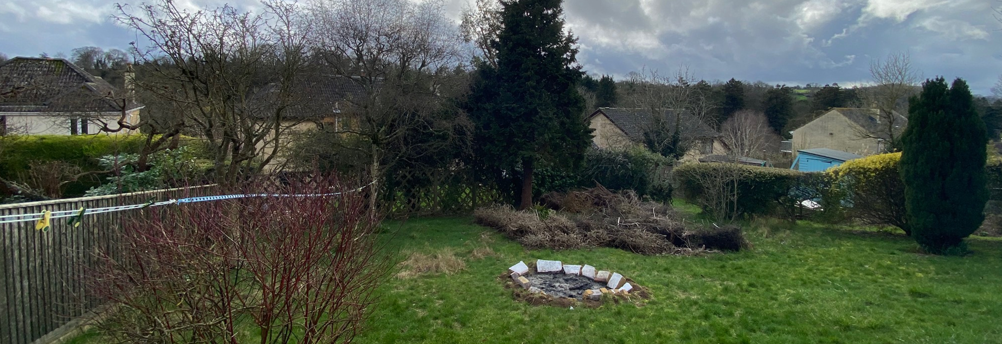
Image from ground below proposed balcony

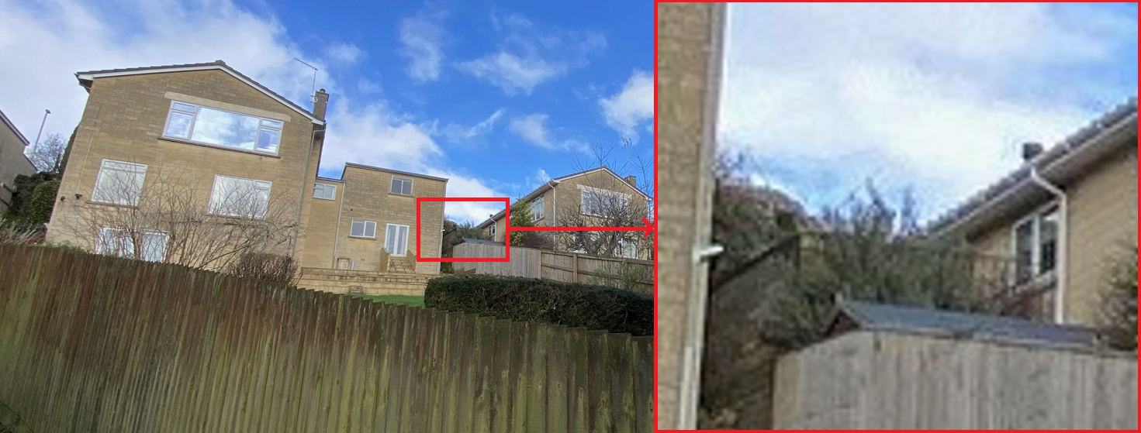
Raised external space associated with number 14 Rickfield

Transport and Highways
Core Policy 60 of the WCS states that Council will support and encourage safe and efficient movement of people and, where necessary, mitigate the impact of development on transport users and local communities. Core Policy 61 specifies that development should demonstrate that consideration has been given to a hierarchy of transport users and that proposals must, where relevant, serve as a safe access to the highway network. Paragraph 116 of the NPPF states that “Development should only be prevented or refused on highways grounds if there would be an unacceptable impact on highway safety, or the residual cumulative impacts on the road network, following mitigation, would be severe, taking into account all reasonable future scenarios”.

The proposal does not involve any changes to the existing access arrangements or parking provision, nor does it increase the number of bedrooms within the dwelling. As such, the development is not expected to generate additional vehicle movements or intensify the use of the existing access, and no highway safety concerns are identified.

Ecology
Core Policy 50 of the Wiltshire Core Strategy requires development to avoid and reduce impacts on sensitive species and habitats. While Biodiversity Net Gain is now a statutory requirement under Schedule 7A of the Town and Country Planning Act 1990 (as amended), householder applications are exempt under Section 4(2)(a). Policy 88 of the emerging Wiltshire Local Plan also requires decision‑makers to consider the mitigation hierarchy and ensure development does not harm features of nature conservation value.

The site lies within both the 2km Core Bat Roost Buffer and the 4km SAC Parcel Buffer; however, the proposal involves alterations to an existing modern dwelling and its managed residential curtilage, with works confined to existing built form, hardstanding and domestic garden. These areas have a low likelihood of supporting sensitive habitats or roost features, and the building itself does not exhibit characteristics associated with high bat‑roosting potential. No trees, hedgerows or semi‑natural habitat would be affected, and no evidence suggests the presence of protected species or priority habitats that could be harmed. The development is therefore considered to present very low ecological risk. An advisory note will remind the applicant of their legal duties under the Wildlife and Countryside Act 1981 and the Conservation of Habitats and Species Regulations 2017, including the requirement to stop work and seek ecological advice if protected species are encountered. Subject to this informative, the proposal is judged to comply with Core Policy 50 and Policy 88 of the emerging Local Plan, and no further ecological assessment is required.

Flooding and Drainage
Core Policy 67 of the WCS provides detail on the management of flooding in association with new development. Policy 95 of the emerging Wiltshire Local Plan directs new development to the requirement for a sequential test, as outlined by the NPPF. The policy states that new development will include measures to reduce rainwater run-off, and the incorporation of sustainable drainage systems. The NPPF sets out the application of a sequential, risk-based approach to the location of new development in paragraph 172.

Given that the application site falls within Flood Zone 1 and the Strategic Flood Risk Assessment identifies no risk of groundwater or surface water flooding for this location, the proposal is considered acceptable in principle in flood-risk terms. The development would result in an increase in impermeable surface area of approximately 133sqm; however, this increase would occur within an area already characterised by hard landscaping, including existing garden patios, steps and rock surfaces. As such, the change is not expected to materially alter local drainage characteristics. In line with Core Policy 67 and Policy 95 of the emerging Wiltshire Local Plan, the scheme can incorporate appropriate sustainable drainage measures as part of the wider redevelopment, ensuring that surface-water run-off is appropriately managed and does not increase flood risk elsewhere.

CONCLUSION

The proposal is considered to be acceptable and in accordance with the relevant policies and guidance outlined above.

RECOMMENDATION: That Planning Permission be GRANTED subject to the following conditions:

1.
The development hereby permitted shall be begun before the expiration of three years from the date of this permission.
REASON: To comply with the provisions of Section 91 of the Town and Country Planning Act 1990 as amended by the Planning and Compulsory Purchase Act 2004.

2.
The development hereby permitted shall be carried out in accordance with the following approved plans and documents:

Proposed Site Plan A1.04 Rev 2 (3 March 2026)
Proposed First Floor Plan A1.06 Rev 2 (3 March 2026)
Existing and Proposed West Elevations A1.17 Rev 3 (19 March 2026)
Existing and Proposed South Elevations A1.13 Rev 2 (3 March 2026)
Existing and Proposed East Elevations A1.11 Rev 2 (3 March 2026)
Existing and Proposed North Elevations A1.14 (19 January 2026)
Proposed Ground Floor Plan A1.08 (19 January 2026)
Proposed Roof Plan A1.10 (19 January 2026)
Design and Access Statement (19 January 2026)
Proposed Location Plan A1.02 (19 January 2026)

REASON: For the avoidance of doubt and in the interests of proper planning.

3.
No development above slab level shall commence until full details of the proposed standing‑seam metal roofing system have been submitted to and approved in writing by the Local Planning Authority. These details shall include:

- The manufacturer, product name and material type (e.g. zinc, coated steel or aluminium);
- The final colour and finish, to include confirmation of matte or low‑gloss reflectivity;
- Large‑format material samples or sample panels showing the proposed finish, colour and texture;
- Technical details of the seam profile, including:
pan width (seam module),
rib height, and
seam spacing;
- Manufacturer’s technical datasheet confirming:
surface reflectance values,
durability, and
that the material is suitable for use in a residential setting adjacent to neighbouring properties.

The development shall thereafter be carried out in full accordance with the approved details, and the roofing materials shall be retained as approved for the lifetime of the development.

Reason: To ensure a high quality and visually appropriate finish that responds positively to local character and complies with Core Policy 57 of the Wiltshire Core Strategy, the Wiltshire Design Guide (SPD), and Section 12 of the National Planning Policy Framework.

4.
Prior to the first use of the balcony and seating area hereby approved, the privacy screens shown on the approved plans shall be fully installed in accordance with the submitted details. The privacy screens shall be retained and maintained in their approved form for the lifetime of the development. They shall not be removed, reduced in height, or altered in any way without the prior written approval of the Local Planning Authority.

Reason: To safeguard the privacy and amenity of neighbouring occupiers in accordance with Core Policy 57 of the Wiltshire Core Strategy and Paragraph 130(f) of the National Planning Policy Framework.

