APPLICATION FOR HOUSEHOLDER PLANNING PERMISSION
DELEGATED REPORT

APPLICATION REFERENCE: | PL/2026/00365 & PL/2026/00480
APPLICATION TYPE: | Householder planning permission & Listed Building Consent
SITE ADDRESS: | Kiln Cottage, Teffont Evias, Salisbury, SP3 5RQ
DEVELOPMENT DESCRIPTION: | Take down and rebuild chimney to 1.8m above ridge.
RECOMMENDATION: | That Planning Permission and Listed Building Consent be GRANTED

This report covers both the householder planning permission (PL/2026/00365) and listed building consent (PL/2026/00480) applications.

PROPOSAL

The proposal seeks planning permission and listed building consent to repair and extend the height of an existing chimney on the west end of the cottage, from 0.7m to 1.8m above the ridge of the thatch roof to comply with current Building Regulations and meet insurance requirements.

Revised elevations were received 02.02.2026 following comments from the Conservation Officer.

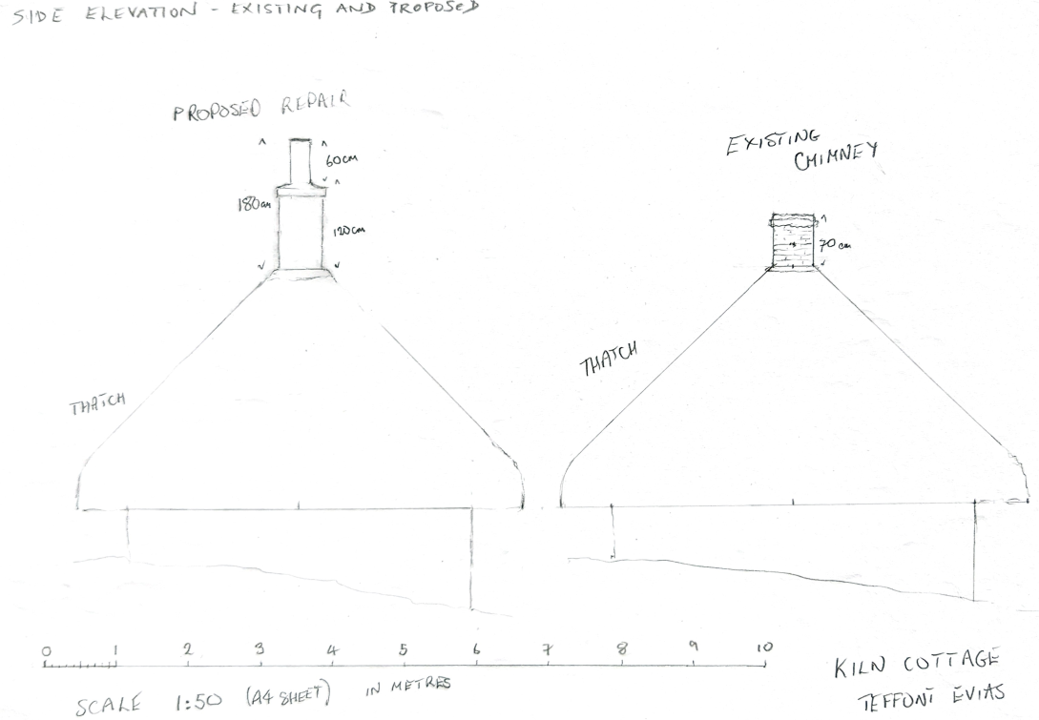

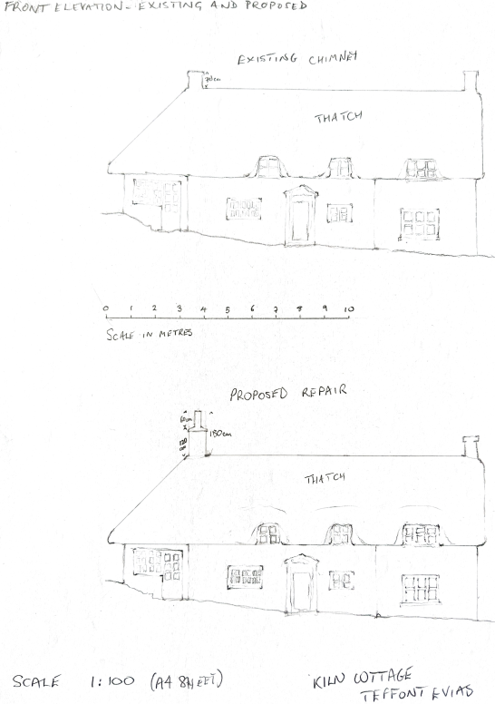

SITE DESCRIPTION/CONTEXT
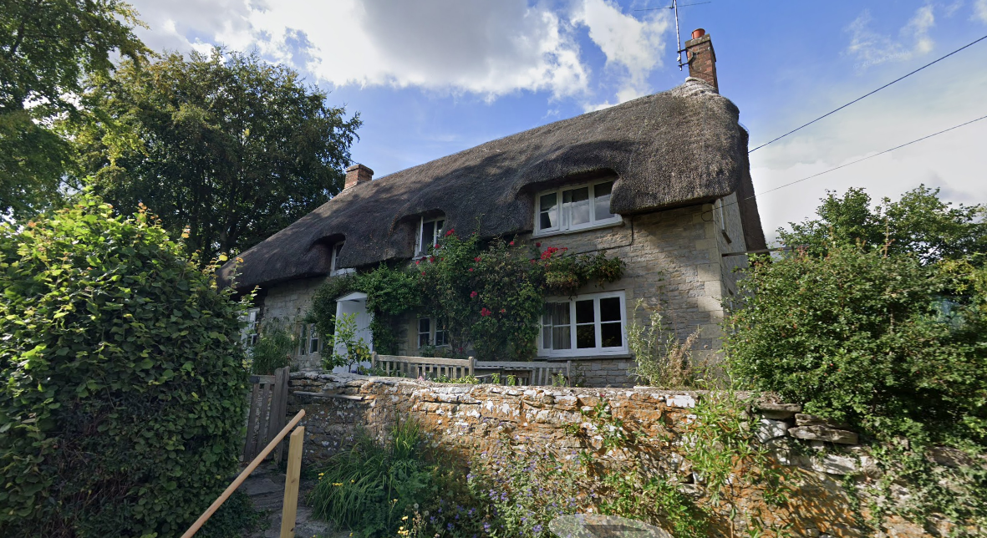

The application relates to Kiln Cottage, a Grade II listed, detached, natural stone and thatched dwelling within the small village of Teffont Evias, as defined by Wiltshire Core Strategy (WCS) core policies 1 (Settlement Strategy), 2 (Delivery Strategy) and CP33 (Spatial Strategy for the Wilton Community Area).

The listing is as follows:

ST 93 SE TEFFONT CARTERS LANE (north side)
1/146 Kiln Cottage
GV II
Detached cottage. Late C17. Rubble stone, thatched roof, gable end brick stacks. Single-storey and attic, 3 windows. Planked door in gabled C20 porch to left of centre, 2-light recessed chamfered mullioned window and 3-light casement to right, 3-light mullioned window to left. Attic dormers have two 2-light and one 3-light casement. Right return has 1-light casement to attic. To left is attached weatherboarded extension under hipped thatched roof with C20 door and casement. Rear has C20 extension with thatched roof. Interior not accessible at time of survey (April 1985).
Listing NGR: ST9901831390

The Cottage is set higher from the road, to the eastern side of it plot.

The application site is within the Conservation Area and there are several listed buildings in the site vicinity, including Grade II Listed ‘Home Farm Cottage’ to the east and ‘Acacia Cottages’ to the south east.

Location plan

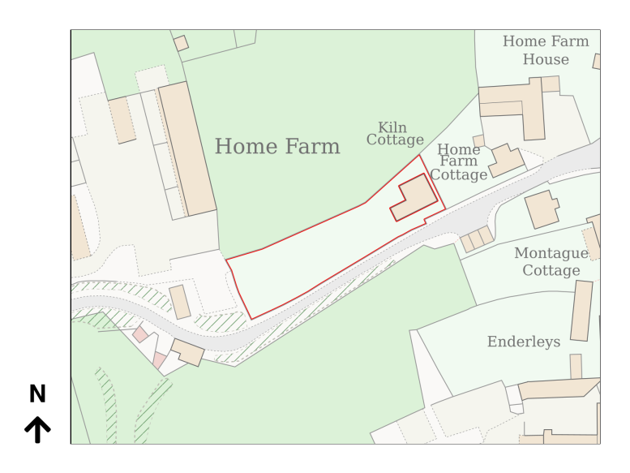

Snip showing conservation area and listed buildings within site vicinity

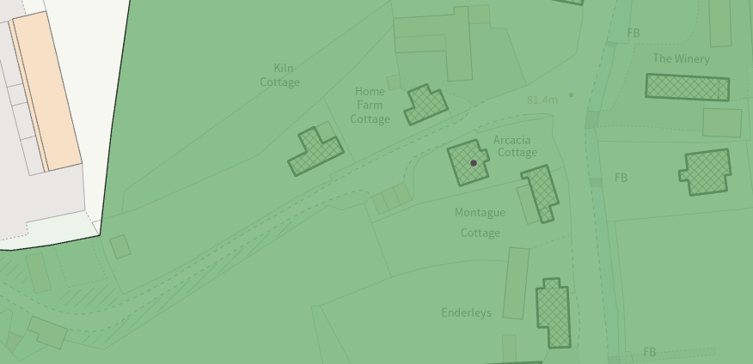

The site is within the Blackmore Vale and Vale of Wardour Countryside Character Area, the Cranbourne Chase & West Wiltshire Downs National Landscape, the Chilmark Quarries Barbastelle SAC,

PLANNING HISTORY

Proposal / Summary
S/2012/1111 - Full planning permission Decision - Approve with Conditions Date: 21/9/2012 – The creation of an access and the construction of a double garage.

RELEVANT POLICIES AND GUIDANCE

Wiltshire Core Strategy:
- Core Policy 1: Settlement Strategy
- Core Policy 2: Delivery Strategy
- Core Policy 33: Spatial Strategy for the Wilton Community Area
- Core Policy 57 Ensuring High Quality Design and Place Shaping
- Core Policy 51: Landscape
- Core Policy 58: Ensuring the Conservation of the Historic Environment

Wiltshire Design Guide: Appendix D – Design Guidance for Householder extensions

Section 66 of the Planning (Listed Buildings and Conservation Areas) Act 1990 requires ‘special regard’ to be given to the desirability of preserving a listed building or its setting.
Section 72 of the Planning (Listed Buildings and Conservation Areas) Act 1990
The National Planning Policy Framework (NPPF)

The Planning Practice Guidance

National Design Guide

CONSULTATION RESPONSES

Teffont Parish Council: No objection

Conservation Officer: Comments received as follows:
The building is grade II listed, adjacent to another listed building (Home Farm Cottage), and within the Teffont Conservation Area (which covers both Evias and Magna). The LPA is required to pay special regard to the desirability of preserving the character, setting and features of special interest of listed buildings by sections 16(2) and 66(1) of the PLBACA Act 1990, and similar for CAs by section 72. The NPPF, NPPG, Wiltshire Core Strategy CP58 and Historic England guidance all apply.
I met the owners on site this morning to consider the proposal, rebuilding the chimney above the ridge to a greater height for fire safety reasons/insurance demand. Currently the stack is unused (and has been disused for many years, having been altered to a cupboard in the mid-C20) but the proposal is to install a woodburner. HETAS installers and insurance companies are very keen that stacks should match the height in the building regs (albeit that only actually applies to new build), and research has confirmed that it can help to reduce fire risk. The vast majority of fires in thatched properties are related to woodburners, these generate significantly hotter flue gases than open fires and can, if not adequately clear of debris, eject burning material out of the pot, especially when lighting or refuelling; a flue liner must be used in order to reduce the risk of hot gases squirting through loose joints into ultra-dry thatch. The liner increases the draught and surely contributes to the ejection risk, so a bird-guard of some kind is essential.
Accepting that the applicants are very keen to have a woodburner in the dining room fireplace, it follows that the stack would be safer if raised from its current height (circa 700-750mm) to 1800mm. The building's position in the landscape is on ground rising to the west, set slightly back from a narrow rural lane (leading to the lime kilns, hence the name), so the front cannot be viewed head-on: there is some symmetry to the roof and chimneys, but one of those is on a 1930s extension and both have had their exposed brickwork rebuilt in the C20. I am satisfied that a mismatch of stack heights would not be unduly harmful. I would however, request (as discussed on site) that the design be revised so that there is 1200mm brickwork and a 600mm pot, to reduce the bulk of the structure. It should be cheaper too. A lead tray was mentioned - these are not traditional but for a stack like this I do not consider its inclusion to be of concern. The bricks, pot and mortar will need to be carefully chosen and approved by condition.
I would be happy to be consulted informally on the revised drawing.
I note that the application description needs revising to a compliant format - something more like 'Take down and rebuild chimney to 1.8m above ridge' and no more. The work is not repair, involves no instability and is nothing to do with building regs compliance.

Revised comments received following receipt of revised drawings:
Subject to the conditions referred to before, I am pleased to confirm that the revisions perfectly reflect what I'd suggested.

REPRESENTATIONS

No comments were received.

ASSESSMENT

Section 38(6) of the Planning and Compulsory Purchase Act 2004 states:

"If regard is to be had to the development plan for the purposes of any determination to be made under the planning Acts, the determination must be made in accordance with the plan unless material considerations indicate otherwise."

In accordance with this statutory requirement, this application has been assessed against the relevant policies of the Development Plan, including the adopted Wiltshire Core Strategy (2015) and, where applicable, any made Neighbourhood Plans.

Design, scale & materials

Core Policy 57 - Ensuring High Quality Design and Place Shaping of the Wiltshire Core Strategy seeks to ensure that all new development is of high design quality, reflecting local context, character, and distinctiveness.

The proposal is to raise the height of the existing chimney on the west end of the dwelling to allow for the installation of a log burner that would comply with building regulations and insurance requirements. The existing brick chimney would be extended from 0.7m above the ridge to 1.8m above the ridge. Following comments from the Conservation Officer, a chimney pot was introduced to reduce the bulk of the structure. A condition to approve the materials for the bricks, mortar and pot will be included to maintain the appearance of the Conservation Area.

The dwelling sits above the street level, accessed from a narrow lane and as such, the change in height of the chimney stack will not be easily visible from public view points.

Having regard to the above, the proposal complies with the design principles set out in Core Policy 57 of the Wiltshire Core Strategy and Appendix D of the Wiltshire Design Guide.

Heritage and Conservation Area Impact
From the point of view of the historic environment the main statutory tests are set out within the Planning (Listed Building and Conservation Areas) Act 1990.

Section 66 requires that special regard be given to the desirability of preserving listed buildings, their settings or any features of special architectural or historic interest which they possess.

Section 72(1) of the Act requires the Council to pay special attention to the desirability of preserving or enhancing the character or appearance of designated Conservation Areas.

The Council’s Core Strategy Policy CP58 ‘Ensuring the conservation of the historic environment’ requires that designated and non-designated heritage assets and their settings will be conserved, and where appropriate enhanced, in a manner appropriate to their significance and encourages proposals which improve the condition of heritage assets at risk.

The Council’s Core Strategy CP 57: Ensuring high quality design requires a high quality of design in all new developments. The policy requires applicants to “demonstrate how the proposal will make a positive contribution to the character of Wiltshire through (amongst other things) responding to the value of the natural and historic environment and being sympathetic to and conserving historic buildings and landscapes. Development is required to respond positively to the existing in terms of building layouts, built form, height, mass, scale, building line, plot size, elevational design, materials, streetscape and rooflines to effectively integrate the building into its setting.

The NPPF outlines government policy for planning. Chapter 16 of the NPPF 'Conserving and enhancing the historic environment' sets out the Government's high-level policies concerning heritage and sustainable development.

The application site is within the Terront Magna and Evias Conservation Area and a Grade II Listed Building. The Conservation Officer made a site visit, met with the applicants and commented:
The building's position in the landscape is on ground rising to the west, set slightly back from a narrow rural lane (leading to the lime kilns, hence the name), so the front cannot be viewed head-on: there is some symmetry to the roof and chimneys, but one of those is on a 1930s extension and both have had their exposed brickwork rebuilt in the C20. I am satisfied that a mismatch of stack heights would not be unduly harmful. I would however, request (as discussed on site) that the design be revised so that there is 1200mm brickwork and a 600mm pot, to reduce the bulk of the structure. It should be cheaper too. A lead tray was mentioned - these are not traditional but for a stack like this I do not consider its inclusion to be of concern. The bricks, pot and mortar will need to be carefully chosen and approved by condition.
Revised proposals were submitted, showing a chimney pot as suggested by the Conservation Officer. The proposal, by virtue of its scale, design, and use of materials, is considered to preserve the character and appearance of the conservation area and setting of the listed building, subject to a condition relating to the approval of materials. It would not result in harm to the setting of any heritage assets, and no objections have been raised by the Conservation Officer.

The development is therefore considered to comply with Core Policy 58 of the Wiltshire Core Strategy and Sections 66 and 72 of the Planning (Listed Buildings and Conservation Areas) Act 1990, as well as the relevant provisions of the NPPF.

Amenity

Point vii of Core Policy 57 - Ensuring High Quality Design and Place Shaping of the Wiltshire Core Strategy seeks to ensure that developments do not adversely affect neighbouring properties.

The National Planning Policy Framework (NPPF), particularly Paragraph 135(f), stresses that planning decisions should ensure developments provide a high standard of amenity for existing and future users.

Due to the nature of the development the proposals are not considered to impact upon neighbouring properties.

National Landscape
Core Policy 51 of the Wiltshire Core Strategy requires all development to protect, conserve, and where possible enhance the character and quality of Wiltshire’s landscapes, giving particular weight to designated areas such as National Landscapes.

The National Planning Policy Framework (NPPF), in Paragraph 176, states that “great weight” should be given to conserving and enhancing landscape and scenic beauty in National Landscapes (formerly Areas of Outstanding Natural Beauty). Development within or affecting the setting of a National Landscape must demonstrate that it will not result in unacceptable harm to the special qualities of that area.

The proposals involve minor alterations to an existing dwelling. Whilst the proposed development would not necessarily ‘seek to further’ the purposes of the protected landscape, which in this case is the Cranbourne Chase & West Wiltshire Downs National Landscape, the proposed development is modest in nature and as there would be no encroachment into the open countryside, it is considered that the proposed development would have a neutral impact upon the special qualities of the National Landscape.

The development therefore complies with Core Policy 51 of the Wiltshire Core Strategy and Paragraph 176 of the NPPF in conserving and enhancing the National Landscape.

Ecology Impact
Core Policy 50 of the Wiltshire Core Strategy seeks to protect and enhance biodiversity and geodiversity, including through ensuring that development avoids harm to protected species and habitats.

The National Planning Policy Framework (NPPF), in Paragraphs 193, requires that development minimises impacts on and provides net gains for biodiversity, including ensuring mitigation is secured where harm cannot be avoided.

The Conservation of Habitats and Species Regulations 2017 (as amended): Requires that the Local Planning Authority considers the likelihood of protected species being affected by development.

The application site lies within the Chilmark Quarries Barbastelle Bat Special Area of Conservation. The proposed works are to an existing chimney and as such there is no reasonable likelihood of protected species being affected. The development complies with Core Policy 50 and the relevant provisions of the NPPF. An informative will be added highlighting the Conservation of Habitats and Species Regulations 2017 (as amended).

Biodiversity Net Gain

Householder planning applications are exempt from the requirement to deliver Biodiversity Net Gain under Schedule 7A, Section 4(2)(a) of the Town and Country Planning Act 1990, as inserted by the Environment Act 2021.

Pre-commencement Condition Agreement

This recommendation includes a pre-commencement planning condition relating to materials. In accordance with Section 100ZA of the Town and Country Planning Act 1990 and the Town and Country Planning (Pre-commencement Conditions) Regulations 2018, the Local Planning Authority formally notified the applicant/agent of the proposed condition and sought their agreement. Written confirmation of agreement was received from the applicant on 10.03.2026.

CONCLUSION

The proposed development is considered to be acceptable in terms of its design, scale, and relationship with the surrounding area. It would not result in any unacceptable harm to the character of the locality, the amenities of neighbouring occupiers, or the interests of heritage, or ecology.

The proposal is therefore considered to comply with the relevant policies of the Wiltshire Core Strategy, the Wiltshire Local Plan, and the National Planning Policy Framework. As such, the application is recommended for approval, subject to the conditions set out below.

RECOMMENDATION: Approve with conditions

For Planning Permission ref: PL/2026/00365

- The development hereby permitted shall be begun before the expiration of three
years from the date of this permission.
REASON: To comply with the provisions of Section 91 of the Town and Country
Planning Act 1990 as amended by the Planning and Compulsory Purchase Act
2004.

- The development hereby permitted shall be carried out in accordance with the
following approved plans and documents:
Location Plan PP-14626097v1, received 20.01.2026
Front Elevation – Existing and Proposed, received 02.02.2026
Side Elevation – Existing and Proposed, received 02.02.2026
Roof Plan, received 26.01.2026

REASON: For the avoidance of doubt and in the interests of proper planning.

- No development shall commence on site until details of the brick, mortar colour and chimney pot to be used on the development have been submitted to and approved in writing by the Local Planning Authority. Development shall be carried out in accordance with the approved details.

REASON: The application contained insufficient information to enable this matter to be considered prior to granting planning permission and the matter is required to be agreed with the Local Planning Authority before development commences in order that the development is undertaken in an acceptable manner, in the interests of visual amenity and preserving the character and appearance of the listed building and its setting.

Informatives
There is a low risk that bats may occur at the development site. Many species of bat depend on buildings for roosting, with each having its own preferred type of roost. Most species roost in crevices such as under ridge tiles, behind roofing felt or in cavity walls and are therefore not often seen in the roof space. Bat roosts are protected all times by the Conservation of Habitats and Species 2017 (as amended) even when bats are temporarily absent because, being creatures of habit, they usually return to the same roost site every year. Planning permission for development does not provide a defence against prosecution under this legislation or substitute for the need to obtain a bat licence if an offence is likely. If bats or evidence of bats is found during the works, the applicant is advised to stop work and follow advice from an independent ecologist or the applicant is advised to follow the advice of a professional ecologist or to contact Natural England.

For listed building consent ref: PL/2026/00480

- The works for which Listed Building Consent is hereby granted shall be begun before the expiration of three years from the date of this consent.

REASON: To comply with the provisions of Section 18 of the Planning (Listed Buildings and Conservation Areas) Act 1990 as amended by the Planning and Compulsory Purchase Act 2004.

- The development hereby permitted shall be carried out in accordance with the
following approved plans and documents:

Location Plan PP-14626097v1, received 20.01.2026
Front Elevation – Existing and Proposed, received 02.02.2026
Side Elevation – Existing and Proposed, received 02.02.2026
Roof Plan, received 26.01.2026

REASON: For the avoidance of doubt and in the interests of proper planning.

- No development shall commence on site until details of the brick, mortar colour and chimney pot to be used on the development have been submitted to and approved in writing by the Local Planning Authority. Development shall be carried out in accordance with the approved details.

REASON: The application contained insufficient information to enable this matter to be considered prior to granting planning permission and the matter is required to be agreed with the Local Planning Authority before development commences in order that the development is undertaken in an acceptable manner, in the interests of visual amenity and preserving the character and appearance of the listed building and its setting.

