APPLICATION FOR FULL PLANNING PERMISSION
CASE OFFICER REPORT

APPLICATION REFERENCE: | PL/2025/08288
APPLICATION TYPE: | Full Planning Application
SITE ADDRESS: | The Willows, 72 Boreham Road, Warminster, BA12 9JN.
DEVELOPMENT DESCRIPTION: | Replace the existing single-glazed timber-framed windows with double-glazed uPVC units. The proposed windows will closely replicate the original design in terms of appearance, including frame shape, colour, and the division of glazing panes.
RECOMMENDATION: | Approve with Conditions

PROPOSAL
The proposal seeks planning permission for the proposed replacement of aged timber framed windows, with new heat efficient uPVC double glazed units.
SITE DESCRIPTION/CONTEXT
The site is a three-storey substantial building, known as The Willows, at No.72 Boreham Road, Warminster. The building is not listed and is located within the Warminster Conservation Area, the area or location is characterised by established large sized residential properties. The building is used as a residential care home for adults with learning disabilities and complex needs, including behaviours that may include autism and other associated conditions. The property functions as a full-time residence for the individuals and includes essential facilities to meet their daily living and care requirements.

RELEVANT PLANNING HISTORY
Proposal / Summary
W/95/00740/FUL Demolition of old extension to rebuild larger sized internal alterations to main house. Approved.
W/04/02130/FUL Demolition of existing side extension and construction of new two storey extension and formation of new vehicular access. Approved.

RELEVANT POLICIES AND GUIDANCE
Wiltshire Core Strategy:

- Core Policy 57 Ensuring High Quality Design and Place Shaping
- Core Policy 50: Biodiversity and Geodiversity
- Core Policy 51: Landscape
- Core Policy 58: Ensuring the Conservation of the Historic Environment
- Core Policy 61: Transport and New Development
- Core Policy 64: Demand Management
- Core Policy 67: Flood Risk

Check for saved policies from former district plans where relevant

Warminster ‘Made’ Neighbourhood Plan

Wiltshire Design Guide: Appendix D – Design Guidance for Householder extensions

The National Planning Policy Framework (NPPF)

The Planning Practice Guidance

National Design Guide

Emerging Wiltshire Local Plan:
The examination of the emerging Wiltshire Local Plan has been paused and the weight to be afforded to any part of the emerging plan can be no more than very limited. A decision on how to proceed will be made by the Council in May 2026.

CONSULTATION RESPONSES
Warminster Town Council: No objections.

Conservation Officer: No objections and offers comments as discussed throughout this report.

REPRESENTATIONS
No comments were received.

PRINCIPLE OF THE PROPOSAL.
The principle of the proposed scheme is considered to be acceptable for all the reasons as discussed below.

ASSESSMENT
Section 38(6) of the Planning and Compulsory Purchase Act 2004 states:

"If regard is to be had to the development plan for the purposes of any determination to be made under the planning Acts, the determination must be made in accordance with the plan unless material considerations indicate otherwise."

In accordance with this statutory requirement, this application has been assessed against the relevant policies of the Development Plan, including the adopted Wiltshire Core Strategy (2015) and the Warminster ‘Made’ Neighbourhood Plan for Warminster.

Design and Impact upon the upon the character and context of the area
Core Policy 57 - Ensuring High Quality Design and Place Shaping of the Wiltshire Core Strategy seeks to ensure that all new development is of high design quality, reflecting local context, character, and distinctiveness. The proposals can be viewed within the plan snippets taken from the submitted plans:

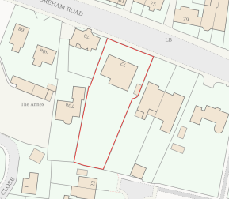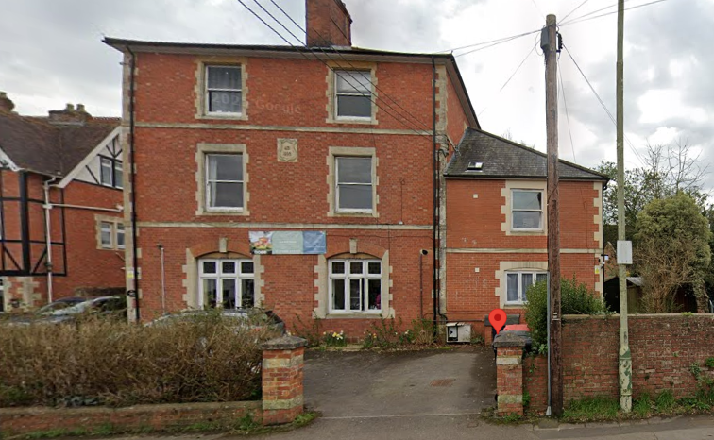
Location Plan Site photograph from Street View.
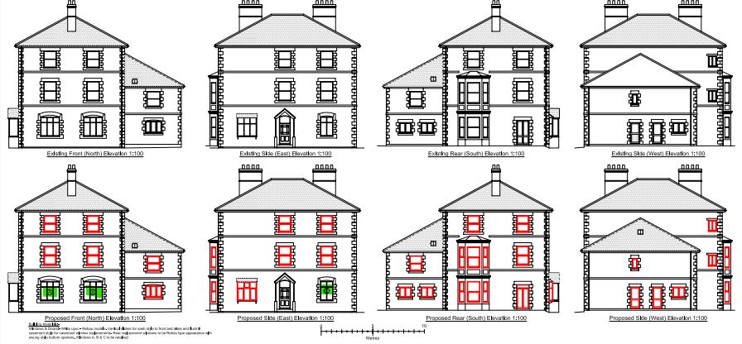

Existing & Proposed Fenestration (All Elevations).

The proposal would see the removal and replacement of all the windows, except for the three windows highlighted in green, as above. These three windows labelled as A, B, and C on the front north and east side elevations are decorative with coloured glass, and which have been agreed to be retained by the council’s Conservation Officer.

The replacement fenestration would be manufactured and supplied by a firm called Rehau, with the windows being from their ‘Heritage Range’, this manufacturer is fully supported by the Conservation Officer, who has dealt with this company before and is familiar with their heritage range of windows.

The Conservation Officer has been consulted on this application, who is supportive in principle and has asked for the above three windows as identified, A, B and C be retained and not replaced. The agent has agreed to this and the three windows are specifically excluded from the proposed plans, with supporting text included within the plans. The windows (apart from fenestration A, B and C) will be replaced on a like for like basis, therefore sash windows will be replaced by uPVC sash and casement windows replaced by uPVC casement windows. A Rehau product brochure has been supplied and the heritage range specialise for older style of buildings, where the frames are slimmer than in conventional uPVC windows. The following photographic example is an extract from their brochure and shows this to be the case:

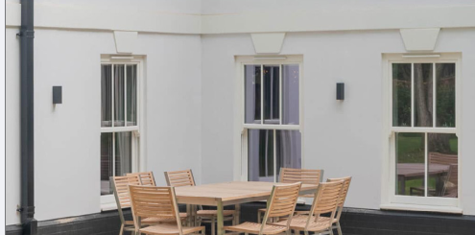

The Conservation Officer is in support concludes with the following comments:

“I have no objection to the REHAU heritage range to replace the Victorian box sash windows. Any new casement windows should be flush-framed casement windows. All trickle vents should be concealed i.e. not obvious”.

Such details are to be covered by planning condition and the proposal complies with the design principles set out in Core Policy 57 of the Wiltshire Core Strategy and Appendix D of the Wiltshire Design Guide.

Amenity
Point vii of Core Policy 57 - Ensuring High Quality Design and Place Shaping of the Wiltshire Core Strategy seeks to ensure that developments do not adversely affect neighbouring properties. The National Planning Policy Framework (NPPF), particularly Paragraph 135(f), stresses that planning decisions should ensure developments provide a high standard of amenity for existing and future users.
The impact on amenity in this instance relates to the visual impact of the windows on the host building and the surrounding public realm, albeit the building is not of listed status but is within the Warminster Conservation Area. The use of a quality window manufacturer such as Rehau are appropriate for the provision of sensitive and appropriate fenestration, which is appraised as being wholly acceptable within the surrounding heritage context of the area.

The proposal therefore accords with Core Policy 57 point vii. in respect of safeguarding residential amenity and Appendix D of the Wiltshire Design Guide.

Heritage Impact
From the point of view of the historic environment the main statutory tests are set out within the Planning (Listed Building and Conservation Areas) Act 1990.

Section 66 requires that special regard be given to the desirability of preserving listed buildings, their settings or any features of special architectural or historic interest which they possess.

Section 72(1) of the Act requires the Council to pay special attention to the desirability of preserving or enhancing the character or appearance of designated Conservation Areas.

The Council’s Core Strategy Policy CP58 ‘Ensuring the conservation of the historic environment’ requires that designated and non-designated heritage assets and their settings will be conserved, and where appropriate enhanced, in a manner appropriate to their significance and encourages proposals which improve the condition of heritage assets at risk.

There are two listed buildings close to the site and the area is within the Warminster Conservation Area, however, due to the appropriate and slimline window frame design, the character of the building and in turn its impact on the character of the surrounding Conservation Area will be preserved and not harmed. Therefore, due to these factors it is appraised that there would be no damaging impact on the setting, character or significance of these heritage assets from the proposed change in fenestration.

Ecology Impact CP50 requires no net loss of biodiversity on site. The site is not located within any bat zone and so would not have any impact on biodiversity matters.

CONCLUSION
The proposed replacement window works are acceptable in terms of design, scale, and relationship with the surrounding area. It would not result in any unacceptable harm to the heritage character of the locality, the amenities of neighbouring occupiers, or ecology.

The proposal is therefore considered to comply with the relevant policies of the Wiltshire Core Strategy, the Wiltshire Local Plan, and the National Planning Policy Framework. As such, the application is recommended for approval, subject to the conditions set out below.

RECOMMENDATION: Planning Permission be GRANTED subject to conditions.

