

Planning Statement (Inclusive of Heritage Statement)

Proposal: Change of use of outbuilding to short-term holiday let studio.
c
Retention of artistic installation to chimney pot. Site: 45 High Street, Pewsey, Wilts, SN9 5AF

On Behalf Of : Mr & Mrs Baier Date: March 2026

RS Hughes Planning

Contents
- Introduction

- Site Context and Background

- Planning History

- Policy Considerations

- Proposed Development
- Planning Assessment
- Conclusions

Introduction
  - This Planning Statement has been prepared by RS Hughes Planning on behalf of Mr and Mrs Baier ‘the applicants’, in support of their submission of a Full Planning Application for the ‘Change of use of outbuilding to short term holiday let studio. Retention of artistic installation to chimney pot’ at 45 High Street, Pewsey, Wilts, SN9 5AF (‘the application site’).
  - As this application does not relate to major development nor the provision of one or more dwellinghouses or building(s) where the floorspace exceeds 100 sqm within a designated area, a Design and Access Statement is not required in support of this proposal¹. Nevertheless, for completeness, this statement will provide an overview of the proposal and justification for the development having regard to the planning policy context against which it falls to be considered. It is inclusive of a Heritage Statement, as required by paragraph 207 of the National Planning Policy Framework (NPPF).

Site Context and Background
  - The application site occupies a broadly central location within the defined settlement boundary of Pewsey, identified as a local service centre within the Wiltshire Core Strategy (WCS). It falls just inside the designated Pewsey Conservation Area which covers the historic core of the settlement. The settlement of Pewsey is located within the North Wessex Downs (NWD) National Landscape.
  - 45 High Street Pewsey is an established detached residential dwelling set within a generous, verdant plot. Vehicular access to the property is taken from a gated driveway joining Whatley Drive to the south. The applicants have owned the property since 1989 and are both accomplished artists (please refer to application supporting information which provides further details in this regard). The property was extended in 1993 with the addition of two connected outbuildings, attached to the north/north east of the dwelling to provide an artist’s studio and workshop for Lucy Baier to work from home. In 2016, the north eastern most outbuilding was converted for use as ancillary guest accommodation in connection with the main residential dwelling. Later that year the outbuilding was let as a studio providing short term holiday accommodation on platforms such as Air BNB. In 2022 a decorative artistic installation was added to an existing chimney pot on the south west facing roof slope of the property, which has also made a dramatic improvement to the draw of their sitting room fire as well.
  - This application is submitted following communication from the Council’s Enforcement Team, the Council confirming that the artistic installation to the chimney pot requires planning consent and considering that a material change of use of the outbuilding has taken place; inviting the submission of an application to regularise the developments.
  - With regard to site designations, aside those referred at 2.1 above (Pewsey Conservation Area and NWD National Landscape), within the residential curtilage of the property and lining a footway link toward the High Street to the south are mature trees which the Council’s online mapping systems record as being covered by a Tree Preservation Order (TPO).

¹ Article 9 (Town and Country Planning (Development Management Procedure) (Order) (England) 2015 as amended

  - The Environment Agency flood zone maps recording the development site within Flood Zone 1 (lowest risk). There are no public Rights of Way (RoW) or listed buildings within the application site or its immediate vicinity.
  - The site falls within the Hampshire River Avon Catchment and Salisbury Plain SPA mitigation zone. The application does not propose any additional new building floorspace, the outbuilding in question and site were already served by existing utilities and used for overnight accommodation, therefore the proposal does not have any associated additional demands on the Hampshire River Avon to trigger requirement for nutrient neutrality mitigation.
  - The location of the application site and the immediate site context is identified on the aerial photograph below.
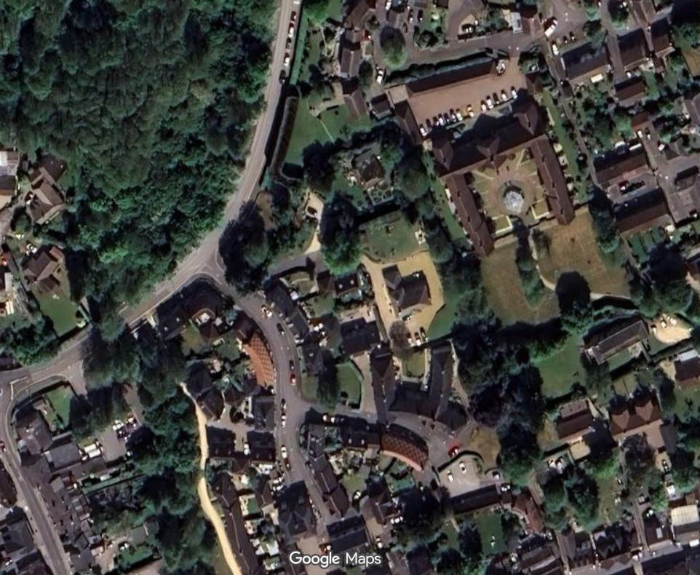
Application Site
Figure 1: Aerial Illustration of Application Site and Immediate Context (not to scale) (source: google maps)

Planning History
  - No relevant or recent planning history pertaining to the application site is recorded on Wiltshire
Council’s online mapping system.

Policy Considerations
  - Relevant planning policy framework, against which this application for development falls to be assessed will now be summarised. This is in accordance with Section 38(6) of the Planning and Compulsory Purchase Act 2004, which requires planning applications to be determined in accordance with the provisions of the development plan, unless material considerations indicate otherwise.
  - The government’s policies are set out within the National Planning Policy Framework (NPPF), supported by the National Planning Practice Guidance (NPPG). The revised and updated framework published in December 2024 describes how the planning system should achieve sustainable development and when the presumption of sustainable development is engaged. In particular, policy within the following paragraphs of the NPPF are considered of relevance to this proposal:
  - Paragraph 2 sets out that applications must be determined in accordance with the development plan, unless material considerations indicate otherwise.
  - Paragraphs 7 cites that the purpose of the planning system is to contribute to the achievement of sustainable development and paragraph 8 sets out that in order to achieve this goal the planning system has 3 overarching objectives, economic, social and environmental which are independent and need to be pursued in mutually supportive ways.
  - Paragraph 11 highlights that plans and decisions should apply a presumption in favour of sustainable development and that for decision taking, this means approving development which accords with an up-to-date development plan without delay.
  - Paragraph 88 requires planning policies and decisions to enable sustainable rural tourism and leisure developments which respect the character of the countryside.
  - Paragraph 109 requires planning authorities to pursue opportunities to promote walking, cycling and public transport use in order to promote sustainable transport.
  - Paragraph 116 records that development should only be prevented or refused on highway grounds if there would be an unacceptable impact on highway safety, or the residual cumulative impacts on the road network, following mitigation, would be severe.
  - Paragraph 131 explains that good design is a key aspect of sustainable development and that the creation of high quality, beautiful and sustainable buildings and places is fundamental to what the planning and development process should achieve.
  - Paragraph 135 requires planning policies and decisions to ensure that developments will add to the overall quality of their area, are visually attractive as a result of good architecture, layout and appropriate and effective landscaping and are sympathetic to local character and history,

including the surrounding built environment and landscaped setting without preventing or discouraging appropriate innovation or change.
  - Paragraph 189 states that great weight should be given to conserving and enhancing landscape and scenic beauty in National Landscapes (amongst other examples).
  - Paragraph 207 requires applicants to describe the significance of any heritage asset affected by the proposal including any contribution made by their setting. The level of detail should be proportionate to the assets significance and no more than is sufficient to understand the potential impact of a proposal on their significance.
  - Paragraph 212 sets out that when considering the impact of a proposed development on the
significance of a heritage asset, great weight should be given to the asset’s conservation.
  - Paragraph 213 requires that any harm to, or loss of significance of a designated heritage asset should require clear and convincing justification.
  - At local level, the policies for Wiltshire are set out within the Wiltshire Core Strategy (WCS) (2011-2026) adopted January 2015, supplemented by a small number of retained policies of the Kennet Local Plan (KLP) 2011.
  - The applicable policies of the WCS, along with their salient points of relevance to the development proposal are recorded below:
  - Core Policy 1 Settlement Strategy – CP1 identifies settlements where sustainable development will take place in order to improve the lives of all those who live and work in Wiltshire. It identifies a four-tier settlement hierarchy, namely Principal Settlements, Market Towns, Local Service Centres and Large and Small Villages (in descending order).
  - Core Policy 2 Delivery Strategy – CP2 seeks to deliver development within the county in a sustainable manner. CP2 records that other than in circumstances as set out within the exception policies elsewhere within the plan, development will not be permitted outside the limits of development as defined on the policies maps.
  - Core Policy 18 Pewsey Community Area – CP18 identifies settlements within the Pewsey Area according to the settlement hierarchy set out at CP1. Pewsey is designated as a Local Service Centre within CP18. CP18 sets out at paragraph 5.95 specific circumstances which applications for development within the area should address where relevant.
  - Core Policy 39 Tourism Development – Supports tourist and visitor facilities in sustainable settlements including in or close to Local Service Centres. Allows for tourism uses within principal settlements, market towns, and local service centres/small and large villages, located in existing or replacement buildings where practicable.
  - Core Policy 40 Hotels, Bed and Breakfasts, Guest Houses and Conference Facilities – These facilities are supported by CP40 within Local Service Centres where they are of an appropriate scale and character within the context of the immediate surroundings and settlement as a whole. Proposals must demonstrate that they do not have an unacceptable impact on vitality of the town centre and avoid unacceptable traffic generation.
  - Core Policy 51 Landscape – Requires development to protect, preserve and where possible enhance landscape character and must not have a harmful impact on landscape character, any

negative impacts must be mitigated as far as possible through sensitive design, landscape mitigation and enhancement measures.
  - Core Policy 57 Ensuring High Quality Design and Place Shaping – Seeks high quality design and place shaping, concerning not only the design of any new buildings themselves, but the layout and landscaping, in order to create attractive environments which respond positively to the locality. The policy also covers the issue of residential amenity.
  - Core Policy 58 Ensuring the Conservation of the Historic Environment – States that development should protect, conserve and where possible enhance the historic environment. Records that designated heritage assets and their settings will be conserved, and where appropriate enhanced in a manner appropriate to their significance.
  - Core Policy 60 Sustainable Transport, 61 Transport and Development and 64 Demand Management – Focus on the desire to reduce the need to travel, particularly by private car and encourage the use of sustainable transport alternatives. They aim to ensure developments adequately address matters of access, road safety and parking provision in order to ensure the continued safety of the local highway network.
  - Core Policy 67 Flood Risk – Requires development to be focussed toward land within Flood Zone
1 (lowest risk) and supports a sustainable approach to surface water drainage within new development, advocating the use of sustainable drainage systems (SuDs).
  - The following adopted documents are also applicable to the application; Wiltshire Local Transport Plan (LTP3) 2011-2026, Car Parking Strategy March 2011, Pewsey Conservation Area Character Appraisal and Management Proposals 2007 and Pewsey Village Design Statement 2007.
  - Section 72 (1) of the Planning (Listed Building and Conservation Area) Act 1990 provides that in the exercise of planning functions in conservation areas; local planning authorities pay ‘special attention to the desirability of preserving or enhancing the character and appearance of that area’. Historic England publications ‘Conservation Principles’ and ‘The Setting of Heritage Assets’ are relevant good practice guides concerning heritage environments.
  - With regard to neighbourhood planning, the site falls under the area encompassed by the Pewsey Neighbourhood Development Plan (NDP) 2006-2026. A review plan (Pewsey NDP 2025-2038) is currently at pre-submission Reg 14 stage. Under the listed main objectives of the Pewsey NDP 2006-2026, point 7 lists a number of measures intended to enhance the economic sustainability of the village which includes ‘appropriate type and scale of employment, in particular tourism related is encouraged’ (our emphasis added).

Proposed Development
  - This application comprises two elements, the retention of an artistic installation to an existing chimney pot on the south west facing hipped roof slope of the main dwelling (pictured overleaf) and secondly, seeks to regularise the change of use of an attached outbuilding as a holiday let studio providing short term tourist accommodation. No external changes to the fabric of the building or the site are proposed in connection with change of use.

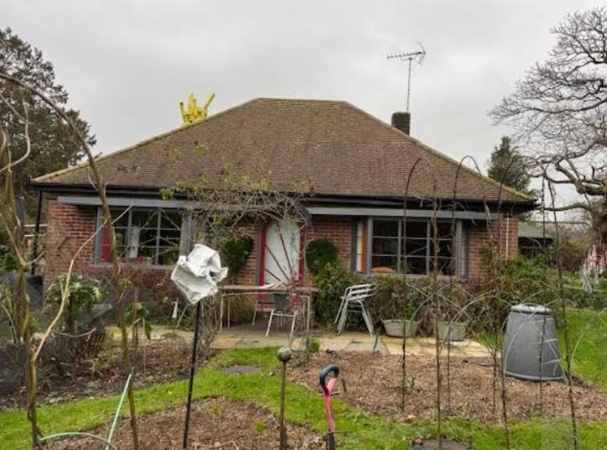
Figure 2: Photograph of south facing elevation of 45 High Street Pewsey showing artistic installation to chimney pot

Planning Assessment
  - The key planning issues for consideration in connection with this proposal are:
    - The Principle of Development
    - The Impact on the Character and Appearance of the Locality (including Heritage Assessment);
    - Residential Amenity; and
    - Access and Parking.

The Principle of Development
  - 45 High Street Pewsey is an established residential dwelling, situated within the settlement boundary of the village of Pewsey, itself defined as a local service centre within the WCS, reflecting the role of the village in providing for a significant rural hinterland. Hence in planning policy terms, the site is considered a sustainable location for development of this scale.

  - Encouraging growth in the tourism sector is cited within policy set out within the WCS and Pewsey NDP, with a recognition that tourism has the potential to aid economic growth and

acknowledgement that there is unmet demand for overnight tourism accommodation, particularly in the south of the county. For example, Strategic Objective 1 of the WCS ‘Delivering a thriving economy’ lists tourism as one target sector for growth to promote a higher value economy, stating:
‘The potential of tourism should be realised as a major growth sector through capitalising on the quality of the environment and location Wiltshire benefits from’.
  - Theme 2 Policy 4 Tourism Development of the Pewsey NDP states:

‘Proposals for sustainable tourism development will be supported, providing there is no conflict with other policies of the Development Plan’. ‘The village and surrounding area are not able to provide sufficient overnight accommodation for visitors and this reduces their per capita spend. Subject to planning considerations regarding local impact, expansion of tourist accommodation would be supported. There is a need to promote the area as a sustainable tourist attraction, this is currently being actively addressed by the Community Partnership and the Chamber of Commerce. The plan aims to support the provision of overnight tourist accommodation and to support initiatives which promote tourism and related employment, using the surrounding area.’ Extracts from paragraphs 7.27 and 7.28 Pewsey NDP (our emphasis added).

  - The use of the attached outbuilding at 45 High Street Pewsey as a short-term holiday let studio accords with the aspirations of the above local planning policies as will add to the availability of overnight tourist accommodation within the village, with visitors likely to support local services, businesses and attractions with resulting positive uplift to the local economy. The application site is located within a local service centre and the holiday let studio has been created within an existing attached outbuilding (itself constructed in excess of 30 years ago), hence the change of use fully accords with the provisions of CP39 of the WCS, which allows for tourism and visitor facilities in local service centres and where practicable, located within existing or replacement buildings. The development would also be compliant with the provisions of CP40, which at point
ii) allows for new tourist accommodation facilities within local service centres where they ‘are of an appropriate scale and character within the context of the immediate surroundings and the settlement as a whole’. In this case, the proposal relates to a modest amount of holiday let accommodation, comprising a studio unit set within an established residential curtilage which is considered compatible in scale, nature and character with the site context. CP40 also requires that the proposal would ‘not harm the vitality of the town centre’ and would ‘avoid unacceptable traffic generation’. The change of use would not harm the vitality of the centre of Pewsey, conversely, as already set out within this section, the development is considered to add to the vitality of the settlement through attracting visitors to support the local facilities, businesses and local economy. Turning to associated traffic generation, the application proposes a single unit of studio tourist accommodation, which due to its size is limited in terms of traffic generation. Moreover, the application site represents a sustainable location within a local service centre, with facilities, services and visitor attractions available within walking distance and regular bus services to nearby settlements and tourist attractions. Whilst off-street parking and turning space is available for visitors within the site, Pewsey train station is within easy walking distance (400m as the crow flies) and the applicants have found this a popular mode of travel for visitors, further illustrating the sustainable location of the site for a development of this nature. For the above reasons the proposed regularisation of the use of an attached outbuilding at 45 High Street Pewsey as studio accommodation for short term holiday let use is supported in principle by relevant WCS and Pewsey NP policies.
  - The ‘in principle’ acceptability of minor additions to dwellings within residential curtilages such as that represented by the artistic installation to the chimney pot, would fall to be assessed

against CP57 and any other site-specific considerations. CP57 requires a high standard of design in all developments and encourages the introduction of art and design (within the public realm). The artistic installation has been designed by the applicants, both highly revered artists and reflects a personalisation of their home. Policy concerning design within the NPPF does not seek to prevent or discourage appropriate innovation or change (paragraph 135c NPPF). The addition is minor in nature and is largely invisible from outside the site. As such the installation is considered to accord with policy contained within CP57 of the WCS. Other issues of acknowledged importance are covered below:

The Impact on the Character and Appearance of the Locality (including Heritage Assessment)

  - In accordance with paragraph 207 of the NPPF this statement now considers the significance of any heritage assets which stand to be affected by the scheme at a level that is proportionate to their importance.
  - The application site is located within Pewsey Conservation Area, a designated heritage asset. There are no listed buildings within the site proximity that stand to be affected by the proposal.
  - A review of the Pewsey Conservation Area Appraisal and Management Plan has been undertaken. Notably, the document makes reference to the site as follows:
‘The well wooded gardens of No.45 High Street, the TPO tree belt connecting it with the High Street, and the tree belt bordering Broomcroft Road provide an important sense of enclosure for the historic centre and soften the impact of recent development served by Broomcroft Road’.
As illustrated by the above reference, the contribution made by the site to the character of the surrounding Conservation Area can be linked to its verdant wooded character, which is unaffected by this application. The sense of enclosure at the site is highlighted within the CA Appraisal and Management Plan, with the dwelling itself largely obscured from public view due to existing vegetation. Indeed, neither the artistic installation to the chimney pot nor the outbuilding subject to the COU are visible from public view. Nevertheless, the artistic addition to the chimney pot is considered to align with design policy advice, which requires a high standard of design and construction and importantly does not preclude contemporary design or look to stifle appropriate innovation or change (paragraph 135c of the NPPF). The holiday let studio is considered compatible in this central village location, the character of use appropriate within the local service centre setting. As such it is not considered that the application would have any adverse impacts on the character and appearance of the surrounding conservation area, and in this regard the proposal is in accordance with policy CP58 of the WCS and policy within chapter 16 of the NPPF.

Residential Amenity
  - The application site occupies a central village location, surrounded by a mix of uses, with those closest to the site predominately residential in nature. 45 High Street is a detached dwelling set within a generous curtilage. The limited intervisibility between the application site and neighbouring residential dwellings would limit material impacts from the proposal on neighbouring properties. Notwithstanding this, the artistic installation to the chimney pot is a minor addition which would not adversely affect residential amenity to any material degree and the holiday let use is also modest in nature, relating to a studio unit accommodating a maximum of 2 guests at a time, situated within an existing outbuilding and which is considered compatible in nature and scale with surrounding residential uses. For these reasons the proposed

development would preserve amenities of surrounding residential properties and is in full accordance with policy CP57 of the WCS.

Access/Parking Arrangements
  - Access to the application site would be unchanged as a result of this proposal. Visitors to the holiday let studio can utilise the existing established vehicular access point onto Whatley Drive to the south and the pedestrian footway south toward the High Street. The vehicular access point can safely and suitably accommodate the very modest additional traffic movements associated with the holiday let use. The application site benefits from off street parking and turning facilities with sufficient space on site to comfortably accommodate any additional vehicle associated with the holiday let studio.
  - It is important to consider that the site is located within the built envelope of a local service centre, where options are available for sustainable travel modes, with Pewsey mainline train station found approximately 400 metres from the site as the crow flies and the village being well served by several local bus routes. Local services and facilities in the settlement are accessible to visitors on foot and there would not be a reliance on travel to and from the site via private motor vehicle. As mentioned earlier within this statement, the applicants have found the proximity of the train station has led to train being a popular mode of travel to for visitors. As such the site location is considered suitable and sustainable for the short term holiday let use.
  - Paragraph 116 of the NPPF states that ‘Development should only be prevented or refused on highway grounds if there would be an unacceptable impact on highway safety or the residual cumulative impacts on the road network, following mitigation would be severe’. In view of the above, it is considered that the scheme will ensure road safety within the site vicinity and local highway network is preserved, complying with requirements of CP60, 61 and 64 of the WCS and Chapter 9 of the NPPF.

Other Issues
  - The application site falls within flood zone 1 (lowest risk). The outbuilding was previously used for guest accommodation incidental to the main dwelling and was already connected to the existing utilities at the site in regards to water (including foul water) and electricity.
  - The change of use of the outbuilding does not propose any external changes to the building/application site. The artistic installation to the chimney pot is a minor addition confined to the exterior of the chimney of the main building, the dwelling currently in active use. As such there would be no impacts on green infrastructure, biodiversity or wildlife associated with this application.

Conclusions

  - Full planning permission is sought for the ‘Change of use of outbuilding to short term holiday let studio. Retention of artistic installation to chimney pot’ at 45 High Street Pewsey. This statement has demonstrated that the proposals accord with relevant policies contained within the Development Plan and the NPPF, the principle of the change of use acceptable in this sustainable location and aligned with policy which seeks to support tourist accommodation with associated benefits for the local economy. Relevant detailed planning considerations have been

outlined within this statement against which it has been demonstrated that the proposal complies, to include; heritage and amenity impacts, flooding and highway safety.
  - We trust the LPA will agree with the merits of this proposal and will be able to approve the application.

