DESIGN/ACCESS AND HERITAGE STATEMENT for ENCLOSURE OF EXISTING CAR PORT TO PROVIDE ANCILLARY ROOM at PENNYFARTHING COTTAGE, HIGH STREET, ANSTY, WILTSHIRE

Pennyfarthing Cottage has been acquired by new owners whose requirements for additional secure ancillary space has prompted review of the recently constructed car port at the site. The proposal has been the subject of pre-application enquiry (ENQ/2025/01900) where it was noted that the proposal is acceptable in both principle and in terms of enclosure of the existing car port. Concerns were however raised with regard to the potential for cars to park more closely to the south gable of Pennyfarthing Cottage which is a Grade II Listed Building. These comments have been addressed in this submission by the proposal for a planter bed with raised oak sleeper surround to ensure distance is maintained.

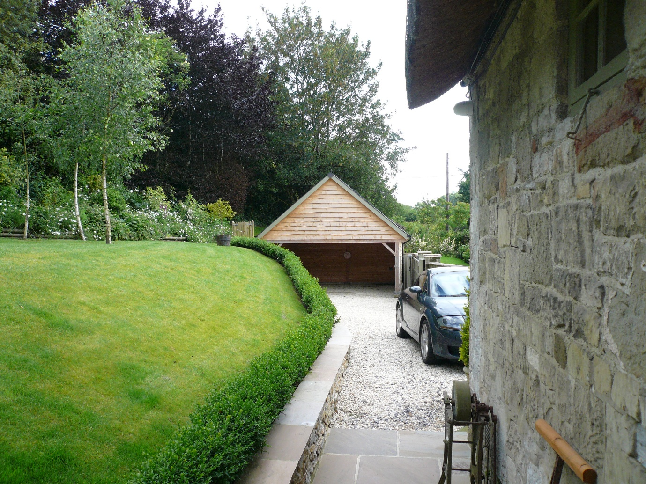
View of the car port as existing looking east from Pennyfarthing Cottage over drive.

To make best use of the available space rather than enclosing the car port with boarded doors it is proposed to install a glazed screen/doors to allow the most flexibility in terms of use. Drawing 224028/02A accompanying this submission shows the situation as existing and proposed. The car port comprises boarded elevations below a pitched slated roof. The structure adopts simple vernacular form with open frontage to the ground floor/drive level. The lower part of the existing building is generally screened from public view by the sliding gate and natural stone walls to the west boundary/High Steet. The proposed enclosure will not affect the scale, form or indeed detailing of the car port the legibility of which will be retained by setting the new screen well back within the existing opening. Accordingly the proposed works will have no impact upon the immediate and wider setting of the site and the Listed Building. The proposal will also not affect the provision for off street car parking.

HERITAGE STATEMENT

Pennyfarthing Cottage is a Grade II Listed Building. The property occupies a linear plot on the east side of High Street (at the northern end of the village). The cottage is set immediately adjacent to the highway with private garden to the rear. The site is located within the designated Conservation Area of Ansty, forming part of the wider Cranborne Chase and West Wiltshire Downs Area of Outstanding Natural Beauty.
The listing schedule for the property notes the following:

Date Listed: 27th July 1985 Grade: II English Heritage Building ID: 320246
Detached cottage. C18. Uncoursed dressed limestone, thatched roof, limestone and brick stacks to right. 2-storey, 2-window. Planked door to left, 2-light casement to right and two 2-light casements to first floor. Left return is brick with light timber framing to gable, half-hipped roof, attached to left is weatherboarded extension with planked door. Right return is windowless, coped verge to roof. Interior has open fireplace with timber lintel.

Accommodation in the existing cottage is arranged across two storeys with Kitchen/Dining and Sitting Room at ground floor with two bedrooms and a bathroom to the upper storey. The form of the existing building references the evolution of the structure as existing, with a principle two storey element (of stone/thatch) and secondary lower element with boarded elevations under slate roof.
The property was the subject of a single storey extension to the rear c.2018 and at the same time the car port the subject of this application was constructed.
As previously noted the works proposed to enclose the car port have been the subject of pre-application dialogue where the principle and detail proposed was considered acceptable. The car port building itself is discrete in terms of the setting of the Listed Building and the changes proposed will not cause any adverse impact.
The proposal to add a planting bed with raised sleeper surround follows comments arising from preapplication submission and has been introduced in order to maintain distance between car parking and the cottage. The bed will not affect the Listed Building as it is separated by an existing drainage channel and will not be visible to the public realm due to the frontage boundary wall.

 224028.March 2026

