APPLICATION FOR HOUSEHOLDER PLANNING PERMISSION
DELEGATED REPORT

APPLICATION REFERENCE: | PL/2025/10004
APPLICATION TYPE: | Householder planning permission
SITE ADDRESS: | 34 MAUNDERS DRIVE, STAVERTON, TROWBRIDGE, BA14 8UL
DEVELOPMENT DESCRIPTION: | Conservatory to Rear of Property
RECOMMENDATION: | That Planning Permission be GRANTED

PROPOSAL

The proposal seeks planning permission for construction of a conservatory on the rear elevation of the host dwelling.

SITE DESCRIPTION/CONTEXT
This application relates to a two-storey detached dwelling, 34 Maunders Drive, located within an established residential area in Trowbridge. The host dwelling benefits from an off-road parking area to the south side elevation and a detached garage.

The application site sits within the Bath and Bradford on Avon Special Area of Conservation for bats and Trowbridge and red zone of the Westbury Bat Mitigation Strategy (TWBMS)

PLANNING HISTORY
N/a

RELEVANT POLICIES AND GUIDANCE

The Wiltshire Core Strategy (WCS) 2015
Core Policy 2 Delivery Strategy
Core Policy 29 – Spatial Strategy for the Trowbridge Community Area
Core Policy 50 – Biodiversity and Geodiversity
Core Policy 51 – Landscape
Core Policy 57 - Ensuring High Quality Design and Place Shaping
Core Policy 67 – Flood Risk

Trowbridge Bat Mitigation Strategy SPD, adopted February 2020
Wiltshire Design Guide: Appendix D – Design Guidance for Householder extensions

The National Planning Policy Framework (NPPF)

The Planning Practice Guidance

National Design Guide

CONSULTATION RESPONSES
Staverton Parish Council: No objection

REPRESENTATIONS
No comments were received.

ASSESSMENT
Section 38(6) of the Planning and Compulsory Purchase Act 2004 states:

"If regard is to be had to the development plan for the purposes of any determination to be made under the planning Acts, the determination must be made in accordance with the plan unless material considerations indicate otherwise."

In accordance with this statutory requirement, this application has been assessed against the relevant policies of the Development Plan, including the adopted Wiltshire Core Strategy (2015) and, where applicable, any made Neighbourhood Plans.

Design and Impact upon the character and context of the area
Core Policy 57 - Ensuring High Quality Design and Place Shaping of the Wiltshire Core Strategy seeks to ensure that all new development is of high design quality, reflecting local context, character, and distinctiveness.

The conservatory would be positioned on the east elevation, extending to the rear of the host dwelling by a distance of 5.2m sitting adjacent to the built form of the existing garage. The ridge height of the conservatory would sit at a height of 3m.

The conservatory would be constructed on a brick dwarf wall with glazing on the rear elevation with windows and patio doors on the north side elevation accessing the applicant’s private residential rear curtilage.

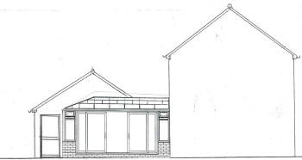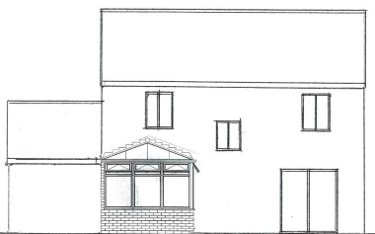
North (side) elevation and east (rear) elevation of the proposed conservatory

The use of matching materials (red brick elevations with glazing, under grey ‘metro’ roof tiles) with matching white UPVC fenestration would ensure the proposal would integrate into the built form of the host dwelling and surrounding setting.

It is considered that the extension would by virtue of its height, scale and design constitute a complementary addition to the host dwelling that would appear commensurate to the size of the property and plot.

Having regard to the above, the proposal complies with the design principles set out in Core Policy 57 of the Wiltshire Core Strategy and Appendix D of the Wiltshire Design Guide.

Amenity
Point vii of Core Policy 57 - Ensuring High Quality Design and Place Shaping of the Wiltshire Core Strategy seeks to ensure that developments do not adversely affect neighbouring properties.

The National Planning Policy Framework (NPPF), particularly Paragraph 135(f), stresses that planning decisions should ensure developments provide a high standard of amenity for existing and future users.

The proposed development has been assessed in terms of its potential impact on the residential amenity of neighbouring properties, with particular regard to loss of light, overshadowing, loss of privacy, and overbearing effects.

The proposal relates to a single storey extension to the rear of the host dwelling that would sit adjacent to the existing form of the detached garage to the rear. All windows would overlook the applicants private residential rear garden therefore no overlooking concerns are raised.

The conservatory would be of limited height and mass and due to the detached nature of the host dwelling with extended separation distances to any neighbouring occupiers no overshadowing, overbearing or loss of light impacts are raised.

The proposal therefore accords with Core Policy 57 point vii in respect of safeguarding residential amenity and Appendix D of the Wiltshire Design Guide.

Ecology Impact
Core Policy 50 of the Wiltshire Core Strategy seeks to protect and enhance biodiversity and geodiversity, including through ensuring that development avoids harm to protected species and habitats.

The National Planning Policy Framework (NPPF), in Paragraphs 193, requires that development minimises impacts on and provides net gains for biodiversity, including ensuring mitigation is secured where harm cannot be avoided.

The application site is located within one of the ‘consultation zones’ for the Bath and Bradford-on-Avon Bat Special Area of Conservation (SAC), as well as the grey, hatched zone of the Trowbridge and Westbury Bat Mitigation Strategy (TWBMS).

The proposed development comprises an extension to existing residential development consisting of limited built form close to the existing dwelling. Given the established high density urban residential nature of the location and the absence of any works affecting the roof of the existing dwelling or resultant loss of vegetation, it is considered highly unlikely that any bats would be affected in the construction of the conservation and significant effects relating to the disturbance to bats can therefore be ruled out.

As a precautionary measure an informative would be added to any decision that in event any evidence of bat activity is detected that the applicant should follow the advice of a professional ecologist or contact Natural England.
As such, the development complies with Core Policy 50 of the Wiltshire Core Strategy and the relevant provisions of the NPPF.

Drainage and Flood Risk
Core Policy 67 of the Wiltshire Core Strategy and paragraph 181 of the NPPF requires that all new development avoids increasing flood risk on-site or elsewhere and, where appropriate, incorporates sustainable drainage measures. Development must also comply with national policy on flood risk management and drainage design. Paragraph 176 (via footnote 62) of the NPPF states that householder development should not be subject to the sequential test, nor the exception test.

Paragraph 051 of the Planning Practice Guidance (Reference ID: ID: 7-051-20220825) states that minor developments “are unlikely to raise significant flood risk issues unless; they would have an adverse effect on a watercourse, floodplain or its flood defences; they would impede access to flood defence and management facilities, or; where the cumulative impact of such developments would have a significant effect on local flood storage capacity or flood flows”.

The site of the development is located within flood zone 1 however the Council’s Strategic Flood Risk Assessment indicates that the site is at risk of surface water flooding, as illustrated in the map insert below.

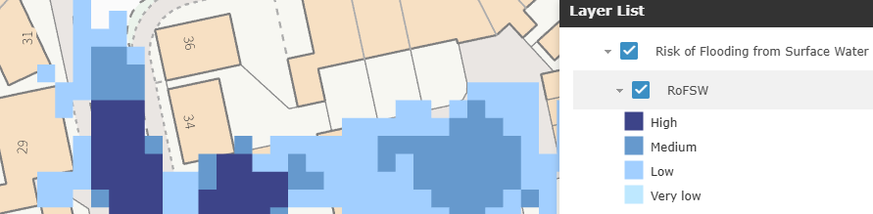

A plan illustrating how surface water will be dealt with when the development is implemented has been submitted and is considered to adequately address any surface water drainage issues, that no increase of flooding would arise on the site and that the site can be adequately drained. Therefore, the proposed development is considered acceptable.

The proposal therefore complies with Core Policy 67 of the Wiltshire Core Strategy and the policy in the NPPF, ensuring that flood risk is not increased and that surface water drainage is appropriately managed.

Biodiversity Net Gain
Householder planning applications are exempt from the requirement to deliver Biodiversity Net Gain under Schedule 7A, Section 4(2)(a) of the Town and Country Planning Act 1990, as inserted by the Environment Act 2021.

CONCLUSION
The proposed development is considered to be acceptable in terms of its design, scale, and relationship with the surrounding area. It would not result in any unacceptable harm to the character of the locality, the amenities of neighbouring occupiers, or the interests of ecology or flood risk.

The proposal is therefore considered to comply with the relevant policies of the Wiltshire Core Strategy, the Wiltshire Local Plan, and the National Planning Policy Framework. As such, the application is recommended for approval, subject to the conditions set out below.

RECOMMENDATION: That Planning Permission be GRANTED subject to conditions.

Conditions
- The development hereby permitted shall be begun before the expiration of three years from the date of this permission.
REASON: To comply with the provisions of Section 91 of the Town and Country Planning Act 1990 as amended by the Planning and Compulsory Purchase Act 2004.

2. The development hereby permitted shall be carried out in accordance with the following approved plans and documents:
Site Plan
Location Plan
Existing North and South Elevations
Existing & Proposed Rear Elevation
Existing Ground Floor Plan
Proposed North and South Elevations
Proposed Ground Floor Plan
All Plans Received 18.12.2025
Proposed Ground Floor Plan with Drainage - Received 16.03.2026

REASON: For the avoidance of doubt and in the interests of proper planning.

Informative
If bats or evidence of bats are found during the works, the applicant is advised to stop work and follow advice from an independent ecologist or to contact Natural England’s Bat Line through the internet.

