APPLICATION FOR HOUSEHOLDER PLANNING PERMISSION
DELEGATED REPORT

APPLICATION REFERENCE: | PL/2026/00541
APPLICATION TYPE: | Householder planning permission
SITE ADDRESS: | 58 Bouverie Avenue, Salisbury, SP2 8DX
DEVELOPMENT DESCRIPTION: | Single storey rear extension & associated internal alterations.
RECOMMENDATION: | That Planning Permission be GRANTED

PROPOSAL

The proposal seeks planning permission for the demolition of an existing single storey rear extension and replacement with larger single storey rear and side, wraparound extension.

Existing Plans Proposed Plans

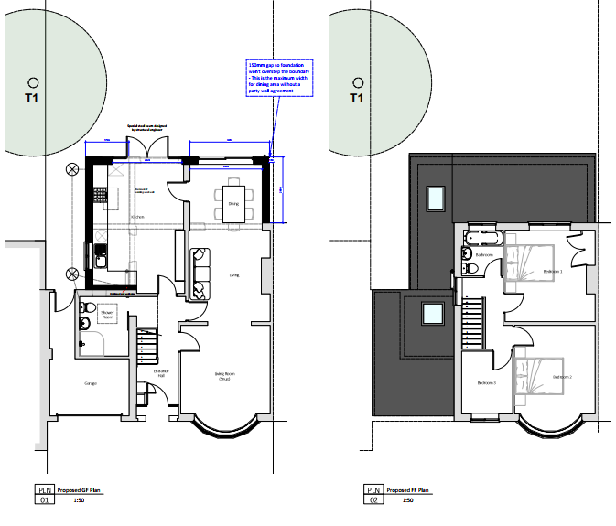
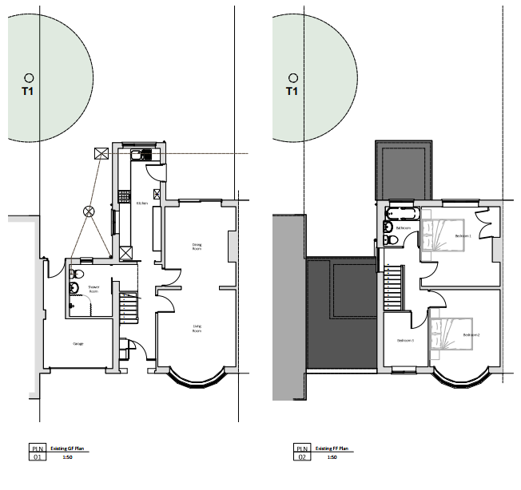

Existing Elevations

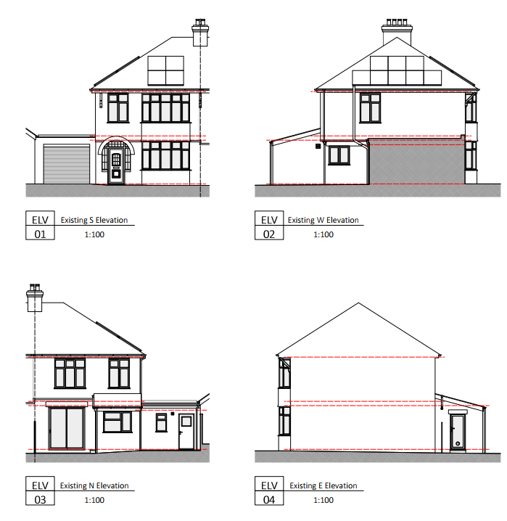

Proposed Elevations

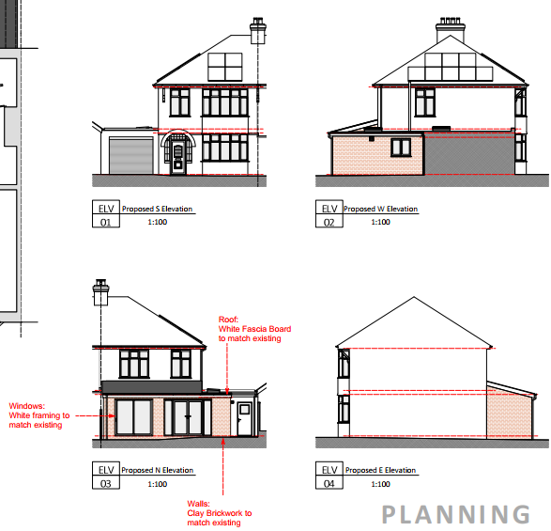

SITE DESCRIPTION/CONTEXT
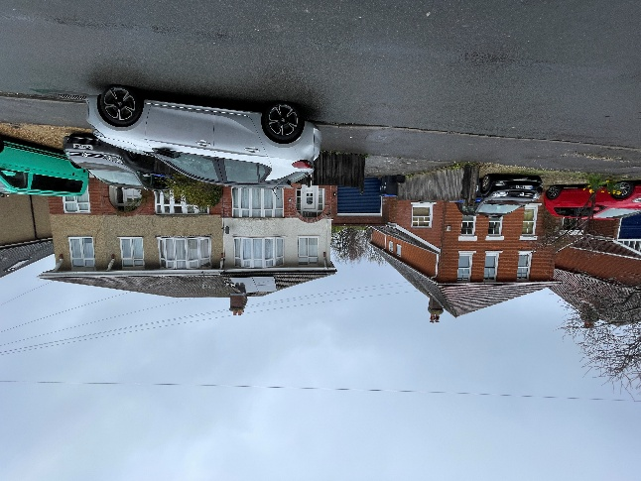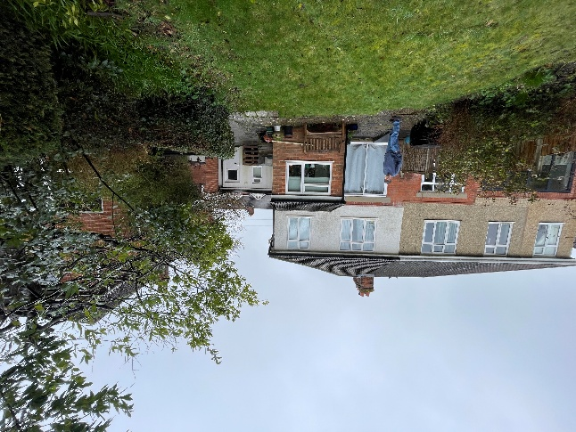

The application relates to 58 Bouverie Avenue, a semi-detached, two storey dwelling on the northern side of Bouverie Avenue, within the south of the principal settlement of Salisbury as defined by Wiltshire Core Strategy (WCS) core policies 1 (Settlement Strategy), 2 (Delivery Strategy) and 20 (Spatial Strategy for the Salisbury Community Area).

The site is surrounded to the east, south and west by residential properties, and is bound to the north by an area of woodland. The property is part of a semi-detached pair with no 56 Bouverie Avenue and is also attached via single storey garage to no 60 Bouverie Avenue. The property benefits from off-road parking to the front and a rear garden.

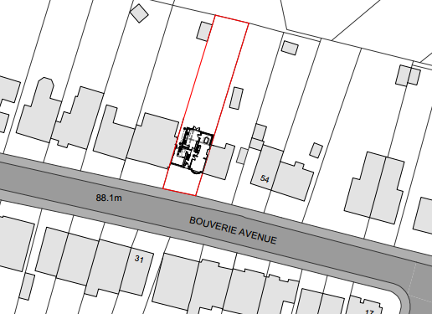

Whilst the site is situated in Flood Zone 1 and is some distance from any rivers; it is situated within the catchment of the River Avon Special Area for Conservation (SAC). It is also within the 15 kilometres recreational zone of influence for the New Forest SAC, Special Protection Area (SPA) and Ramsar site.

PLANNING HISTORY

None

RELEVANT POLICIES AND GUIDANCE

Wiltshire Core Strategy:
- Core Policy 1: Settlement Strategy
- Core Policy 2: Delivery Strategy
- Core Policy: 20 Spatial Strategy for the Salisbury Community Area
- Core Policy 50: Biodiversity and Geodiversity
- Core Policy 51: Landscape
- Core Policy 57: Ensuring High Quality Design and Place Shaping

Salisbury Neighbourhood Development Plan 2020 to 2038. Made March 2025

Wiltshire Design Guide: Appendix D – Design Guidance for Householder extensions

The National Planning Policy Framework (NPPF)

The Planning Practice Guidance

National Design Guide

CONSULTATION RESPONSES

Salisbury City Council: No comment

REPRESENTATIONS

No comments were received.

ASSESSMENT

Section 38(6) of the Planning and Compulsory Purchase Act 2004 states:

"If regard is to be had to the development plan for the purposes of any determination to be made under the planning Acts, the determination must be made in accordance with the plan unless material considerations indicate otherwise."

In accordance with this statutory requirement, this application has been assessed against the relevant policies of the Development Plan, including the adopted Wiltshire Core Strategy (2015) and, where applicable, any made Neighbourhood Plans.

Design and Impact upon the character and context of the area

Core Policy 57 - Ensuring High Quality Design and Place Shaping of the Wiltshire Core Strategy seeks to ensure that all new development is of high design quality, reflecting local context, character, and distinctiveness.

The proposed single storey extensions are to the side and rear of the property, projecting from the side by 1.77m and the rear by 2.69m, across the full width of the building.

The roof is proposed to be a lean-to roof for the part of the extension extending from the rear wall and a flat roof for the side extension. The proposed eaves height is 2.72m.

The proposed materials are facing brick, to match the existing, interlocking concrete tiles on the pitched section of the roof and EPDM rubber on the flat roof.

The proposed north elevation, with a combination of both lean-to roof and flat roof does not appear entirely cohesive, this elevation is not visible from public vantage points, and does not impact on visual amenity within the streetscape. The difference in rooflines is only visible when viewed from the west, and within the residential setting this is not considered of measurable detrimental impact

The proposed single storey extensions are subservient to the existing dwelling and located at the rear of the property, would not be visible from public vantage points. The design, form and materials are traditional and preserve the character and appearance of the area.

Having regard to the above, the proposal complies with the design principles set out in Core Policy 57 of the Wiltshire Core Strategy and Appendix D of the Wiltshire Design Guide.

Amenity

Point vii of Core Policy 57 - Ensuring High Quality Design and Place Shaping of the Wiltshire Core Strategy seeks to ensure that developments do not adversely affect neighbouring properties.

The National Planning Policy Framework (NPPF), particularly Paragraph 135(f), stresses that planning decisions should ensure developments provide a high standard of amenity for existing and future users.

The proposed development has been assessed in terms of its potential impact on the residential amenity of neighbouring properties, with particular regard to loss of light, overshadowing, loss of privacy, and overbearing effects.

The proposed side extension has one window from the kitchen facing towards the shared boundary with no 60 Bouverie Avenue. There is an existing kitchen window on this elevation, but the extension would bring it 1.7m closer to the boundary. This area of shared boundary has a brick wall and no windows on the neighbouring property facing towards the site. It is therefore considered that the increased proximity of this kitchen window to the boundary will not affect the amenity of 60 Bouverie Avenue through loss of privacy and the window is acceptable.

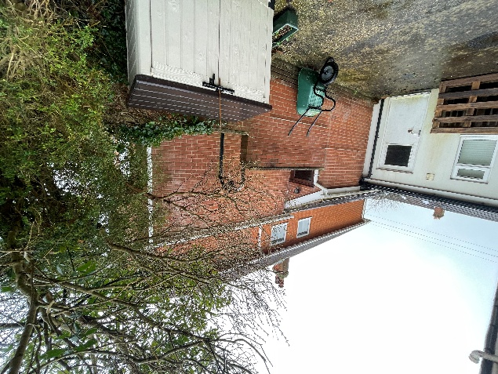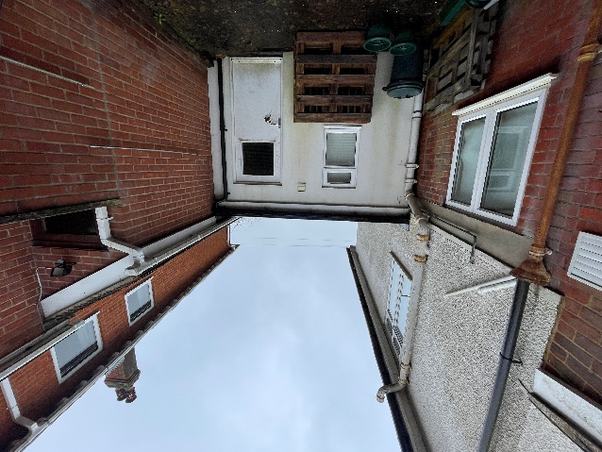

Two glazed doors are proposed on the north elevation, in view of the rear garden, and woodland further to the north, and are not considered of impact on any residential dwellings. Therefore, the proposed doors will not overlook or cause harm to privacy.

The proposed extension would introduce a solid wall close to the shared boundary with no 56. This will affect the amount of light reaching the neighbour’s ground floor rooms. Given that the proposed extension is single-storey, modest in scale relative to the host property and plot, and located on the north elevation, it is considered that any potential impact in terms of loss of light or dominance is unlikely to be significant and it is noted that the property has permitted development rights and the applicant could construct a single storey rear extension of up to three meters in length, which therefore represents a fallback position for the assessment of this current scheme. No windows are proposed in the east elevation and a condition preventing the additional of windows in this elevation will be included to maintain the privacy of no 56.

Subject to conditions, the proposal accords with Core Policy 57 point vii in respect of safeguarding residential amenity and Appendix D of the Wiltshire Design Guide.

Trees
The submitted site plans show a tree close to the development, within the boundary of 60 Bouverie Avenue:
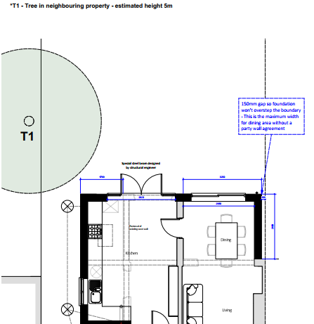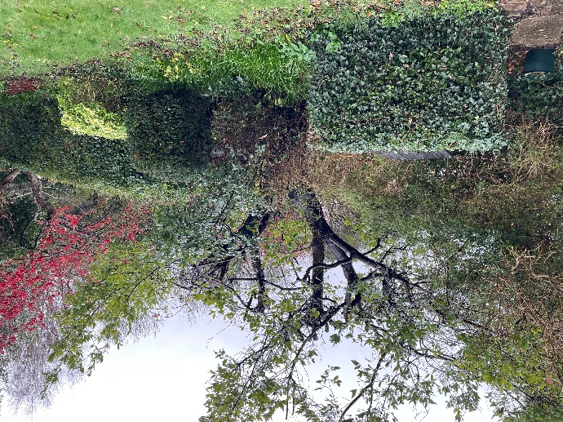

A site visit was made by the Case Officer and it is considered that the tree is modest in scale, has no TPO or Conservation Area protection and is a sufficient distance away from the proposed development that the proposals are considered acceptable with regard to this tree.

Ecology Impact
Core Policy 50 of the Wiltshire Core Strategy seeks to protect and enhance biodiversity and geodiversity, including through ensuring that development avoids harm to protected species and habitats.

The National Planning Policy Framework (NPPF), in Paragraphs 193, requires that development minimises impacts on and provides net gains for biodiversity, including ensuring mitigation is secured where harm cannot be avoided.

The proposal relates to a single-storey extension to a dwelling with no trees or roof voids affected. The application site is within the New Forest Protection Sites 13.8km Recreation zone of influence and Hampshire River Avon Catchment but due to the nature of the development, ecological impact is not an issue for this application. There is no reasonable likelihood of protected species being present or affected. The development complies with Core Policy 50 and the relevant provisions of the NPPF.

Biodiversity Net Gain

Householder planning applications are exempt from the requirement to deliver Biodiversity Net Gain under Schedule 7A, Section 4(2)(a) of the Town and Country Planning Act 1990, as inserted by the Environment Act 2021.

CONCLUSION

The proposed development is considered to be acceptable in terms of its design, scale, and relationship with the surrounding area. It would not result in any unacceptable harm to the character of the locality or the amenities of neighbouring occupiers.

The proposal is therefore considered to comply with the relevant policies of the Wiltshire Core Strategy, the Wiltshire Local Plan, and the National Planning Policy Framework. As such, the application is recommended for approval, subject to the conditions set out below.

RECOMMENDATION: That Planning Permission be GRANTED subject to conditions.

- The development hereby permitted shall be begun before the expiration of three years from the date of this permission.
REASON: To comply with the provisions of Section 91 of the Town and Country Planning Act 1990 as amended by the Planning and Compulsory Purchase Act 2004.

- The development hereby permitted shall be carried out in accordance with the following approved plans and documents:

Location Plan 1165/08, received 27.01.2026
Proposed Plans & Elevations, 1165/05 Rev C, received 16.03.2026
REASON: For the avoidance of doubt and in the interests of proper planning.
- The materials to be used in the construction of the external surfaces of the development hereby permitted shall match in material, colour and texture those used in the existing building and detailed on the application form.
REASON: In the interests of visual amenity and the character and appearance of the area.

- Notwithstanding the provisions of the Town and Country Planning (General Permitted Development) (England) Order 2015 (or any Order revoking or reenacting or amending that Order with or without modification), no windows, doors or other form of openings other than those shown on the approved plans, shall be inserted in the east elevation (shared boundary wall) of the development hereby permitted.

REASON: In the interests of residential amenity and privacy

