APPLICATION FOR FULL PLANNING PERMISSION DELEGATED REPORT

APPLICATION REFERENCE: | PL/2025/09520
APPLICATION TYPE: | Full planning permission
SITE ADDRESS: | Salisbury and South Wiltshire Golf Club, Netherhampton Road, Netherhampton, Salisbury, SP2 8PR
DEVELOPMENT DESCRIPTION: | Replacement Balcony
RECOMMENDATION: | That Planning Permission be GRANTED

PROPOSAL

The proposal seeks planning permission for the replacement of a balcony to the rear of the club house at Salisbury and South Wiltshire Golf Club

Existing and proposed rear elevation of the club house showing the existing and proposed balcony included below.

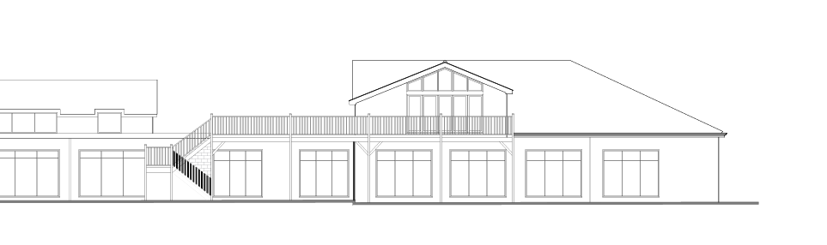

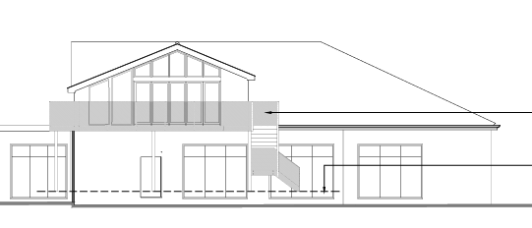

Existing and proposed second floor plan below showing the location and scale of the balcony.

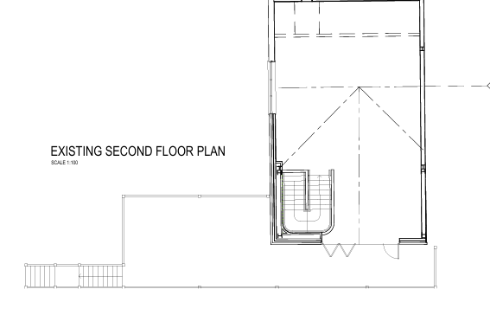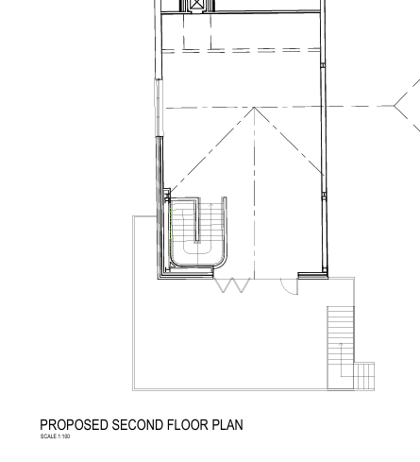

SITE DESCRIPTION/CONTEXT

The application site relates to the existing, established Salisbury and South Wiltshire Golf Club located on the south side of Netherhampton Road on the outskirts of the City of Salisbury. The Salisbury and South Wiltshire Golf Club comprises the golf course, parking club house and associated ancillary buildings. This application specifically relates to the club house which is set back from Netherhampton Road by approx. 200m on land rising gently from Netherhampton Road towards the south. The surrounding landscape is rural and open in nature with agricultural fields forming the adjacent use. The site is screened from the east by a tree lined public right of way (footpath NHAM2) which itself is topographically lower than the golf course.

PLANNING HISTORY

The application site has an extensive site history but only the planning application below is relevant to the current proposed replacement balcony.

S/2010/1845 - Full planning permission Decision - Approve with Conditions Date: 2/2/2011 – First floor extension to create members dining room, external terrace seating and associated works

RELEVANT POLICIES AND GUIDANCE

The National Planning Policy Framework (NPPF)
The Planning Practice Guidance
National Design Guide

Wiltshire Core Strategy:

Core Policy 50: Biodiversity and Geodiversity
Core Policy 51: Landscape
Core Policy 57 Ensuring High Quality Design and Place Shaping

Salisbury District Local Plan policies (Saved by Wiltshire Core Strategy):

R1A - Expansion of existing sporting facilities
R5 - Protection of existing outdoor facilities
C6 – Special Landscape Area
R15 – Golf Course

Wiltshire Design Guide
Creating Places Design Guide

CONSULTATION RESPONSES

Parish Council: None received

REPRESENTATIONS

No comments were received.

ASSESSMENT

Section 38(6) of the Planning and Compulsory Purchase Act 2004 states:

"If regard is to be had to the development plan for the purposes of any determination to be made under the planning Acts, the determination must be made in accordance with the plan unless material considerations indicate otherwise."

In accordance with this statutory requirement, this application has been assessed against the relevant policies of the Development Plan, including the adopted Wiltshire Core Strategy (2015) and, where applicable, any made Neighbourhood Plans.

Principle

The principle of a replacement balcony to the existing club house is acceptable in principle subject to compliance with other relevant planning policy, guidance and material considerations.

Design and Impact upon the character and context of the area

Core Policy 57 - Ensuring High Quality Design and Place Shaping of the Wiltshire Core Strategy seeks to ensure that all new development is of high design quality, reflecting local context, character, and distinctiveness.

The proposal relates to a replacement balcony on the rear/south elevation of the existing club house at Salisbury and South Wiltshire Golf Club. The case officer noted during a site visit that the existing balcony had recently been removed, when asked, the applicant confirmed that this was for safety reasons due to the poor condition of the balcony. The image below taken from the website for Salisbury and South Wiltshire Golf Club shows the previous balcony in situ.

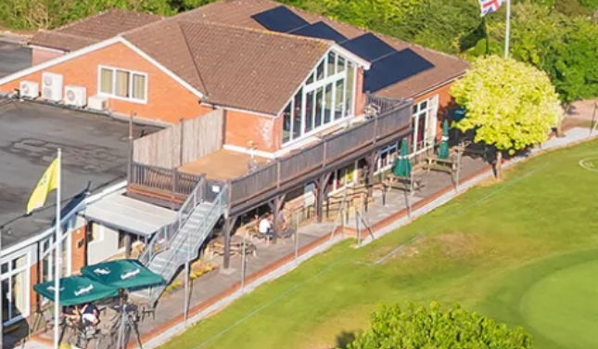

The proposed new/replacement balcony will be constructed in a similar position to the original as above but will project out further to the rear whilst also being pulled in from the side to create a narrower but deeper balcony area. The external access stairs will be installed to the east of the balcony. The balustrade will be glass with steel posts.

Given the location of the club house and proposed balcony and the overall context within the golf course complex, it is not considered that the proposed balcony will have a significant impact on the character of the area and special landscape area. The overall design is considered to be an improvement to the previous balcony in terms of design and appearance.

Having regard to the above, the proposal complies with the design principles set out in Core Policy 57 of the Wiltshire Core Strategy and the provisions within the NPPF.

Amenity

Point vii of Core Policy 57 - Ensuring High Quality Design and Place Shaping of the Wiltshire Core Strategy seeks to ensure that developments do not adversely affect neighbouring properties.

The National Planning Policy Framework (NPPF), particularly Paragraph 135(f), stresses that planning decisions should ensure developments provide a high standard of amenity for existing and future users.

The proposed development has been assessed in terms of its potential impact on the residential amenity of neighbouring properties, with particular regard to loss of light, overshadowing, loss of privacy, and overbearing effects.

There are no immediately adjacent neighbours or other buildings or dwellings in close proximity to the site. It is not considered that the proposal would have any demonstrable impact on the amenities of existing residential properties.

The proposal therefore accords with Core Policy 57 point vii in respect of safeguarding residential amenity, the Wiltshire Design Guide and relevant provisions within the NPPF.

Highways Impact

Core Policy 57 (xiv) of the Wiltshire Core Strategy seeks to ensure that development must meet the requirements of Core Policy 61. This policy requires proposals to be capable of being served by safe access to the highway network. Core Policy 64 seeks to ensure compliance with parking standards set out in the Local Transport Plan.

The National Planning Policy Framework (NPPF), particularly Paragraph 115 and 116, requires that development proposals do not have an unacceptable impact on highway safety and that safe and suitable access to the site can be achieved for all users.

There are no changes to the means of access or traffic generation as a result of the development other than during the construction phase and the scale of the proposed development is unlikely to have any impact on the highway in terms of the movement of construction vehicles.

The proposal is therefore considered to comply with Core Policies 57 (xiv), 61 and 64 of the Wiltshire Core Strategy, the NPPF, and the Wiltshire Local Transport Plan.

Ecology Impact

Core Policy 50 of the Wiltshire Core Strategy seeks to protect and enhance biodiversity and geodiversity, including through ensuring that development avoids harm to protected species and habitats.

The National Planning Policy Framework (NPPF), in Paragraphs 193, requires that development minimises impacts on and provides net gains for biodiversity, including ensuring mitigation is secured where harm cannot be avoided.

Biodiversity Net Gain - As of 2nd April 2024, the requirement for Biodiversity Net Gain (BNG) on all new sites came into force. Any small scale (non-major)/major scheme will need to demonstrate no net loss and a minimum of 10% net gain in biodiversity on the site, in line with the requirements of the NPPF, WCS policy CP50 (Biodiversity and Geodiversity) and the Environment Act.

However based on the information available the biodiversity gain planning condition is not considered to apply to this application as the development meets the following exemption criteria and is therefore below the de minimis threshold, meaning the development: − does not impact an onsite priority habitat (a habitat specified in a list published under section 41 of the Natural Environment and Rural Communities Act 2006); and − impacts less than 25 square metres of onsite habitat that has biodiversity value greater than zero and less than 5 metres in length of onsite linear habitat (as defined in the statutory metric).

As such, the development complies with Core Policy 50 of the Wiltshire Core Strategy and the relevant provisions of the NPPF.

CONCLUSION

The proposed development is considered to be acceptable in terms of its design, scale, and relationship with the surrounding area. It would not result in any unacceptable harm to the character of the locality, the amenities of neighbouring occupiers, or the interests of highway safety or ecology.

The proposal is therefore considered to comply with the relevant policies of the Wiltshire Core Strategy, the Wiltshire Local Plan, and the National Planning Policy Framework. As such, the application is recommended for approval, subject to the conditions set out below.

RECOMMENDATION: That Planning Permission be GRANTED subject to conditions.

1. The development hereby approved shall be begun before the expiration of three years from
the date of this permission.

REASON: To comply with the provisions of Section 91 of the Town and Country Planning Act 1990 as amended by the Planning and Compulsory Purchase Act 2004.

2. The development hereby permitted shall be carried out in accordance with the following approved plans

Application form received 03/12/2025
Location plan/proposed site plan received 16/03/2026
Proposed section/elevations drg no 10131.101 x 2 received 16/03/2026
Proposed plans drg no 10131.103 received 12/02/2026

REASON: For the avoidance of doubt and in the interests of proper planning

Informative

1. BNG not required

The effect of paragraph 13 of Schedule 7A to the Town and Country Planning Act 1990 is that planning permission granted for development of land in England is deemed to have been granted subject to the condition (biodiversity gain condition) that development may not begin unless:

(a) a Biodiversity Gain Plan has been submitted to the planning authority, and
(b) the planning authority has approved the plan.

The planning authority, for the purposes of determining whether to approve a Biodiversity Gain Plan, if one is required in respect of this permission would be Wiltshire Council.
There are statutory exemptions and transitional arrangements which mean that the biodiversity gain condition does not always apply. For further information on exempt developments please refer to:
https://www.gov.uk/guidance/biodiversity-net-gain-exempt-developments
Based on the information available this permission is considered to be one which will not require the approval of a biodiversity gain plan before development is begun because one or more of the statutory exemptions or transitional arrangements is considered to apply.

