APPLICATION FOR LISTED BUILDING CONSENT
DELEGATED REPORT

APPLICATION REFERENCE: | PL/2026/00519
APPLICATION TYPE: | Listed Building Consent
SITE ADDRESS: | Down House, High Street, Wylye, Warminster, BA12 0QN
DEVELOPMENT DESCRIPTION: | Removal of existing garage and erection of new garage and home office
RECOMMENDATION: | That listed building consent be GRANTED

PROPOSAL

The proposal seeks listed building consent for:

Removal of existing garage and erection of new garage and home office at Down House, High Street, Wylye, Warminster.

This application has been submitted alongside PL/2026/00331 which will deal with all related planning matters. Down House is a grade II listed building. The replacement garage would have a single garage area and introduce a home office and shower.

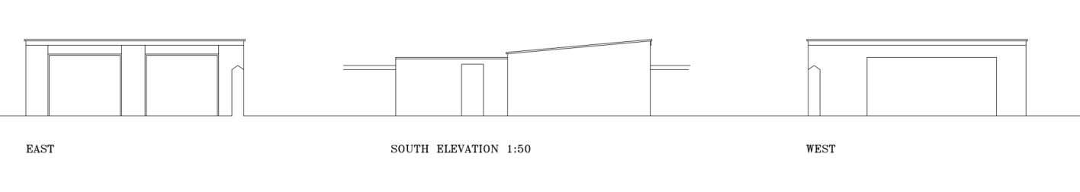

Existing Elevations

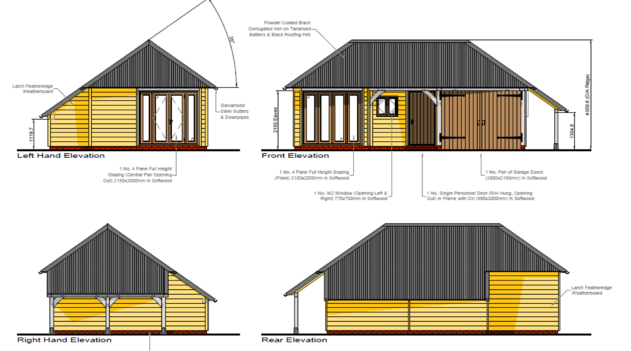

Proposed Elevations

SITE DESCRIPTION/CONTEXT

Down House is a grade II listed building where the listed building description reads;

“WYLYE HIGH STREET SU 03 NW (west side) 2/136 Down House GV II Detached house. Late C17, rear wing mid C18, some alterations late C20. Dressed limestone, tiled roof with gable end brick stacks and coped verges. L-plan. Two-storey, 3-windowed; casements. Central door with 6 fielded panels in beaded case with C20 flat wooden hood, C20 three-light mullioned casement either side. First floor retains three 3-light recessed chamfered mullioned casements. Left return has one blocked chamfered light to attic, C18 rear wing has 2-light casement. Rear of main build has 12-pane sash and attached C20 flat-roofed extension and conservatory, first floor has 3-light and 2-light leaded casement and 3-light steel casement. Rear wing to right has two 2-light recessed chamfered mullioned casements, 2-light and 3-light steel casements, original 3-light leaded casement to first floor, roof hipped to gable end. Interior has good late C17 closed string stairs with turned balusters and wide moulded handrail, chamfered beams and 4 and 6- panelled doors.”

The garage subject to this application is detached (although built into the boundary wall, which historically has been considered to be curtilage listed) and appears to be a simple brick and concrete render structure with a corrugated metal roof. The garage is approximately 40m away from Down House itself.

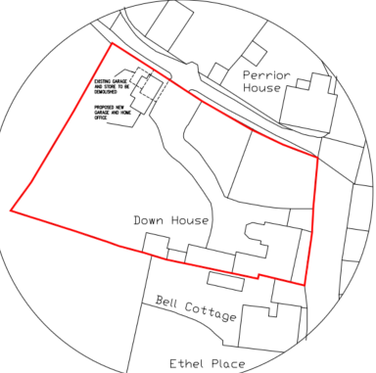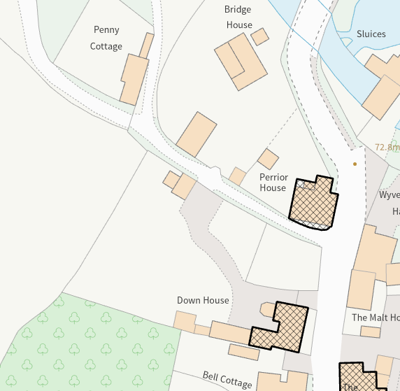

Block Plan and Council Mapping Image of the Site

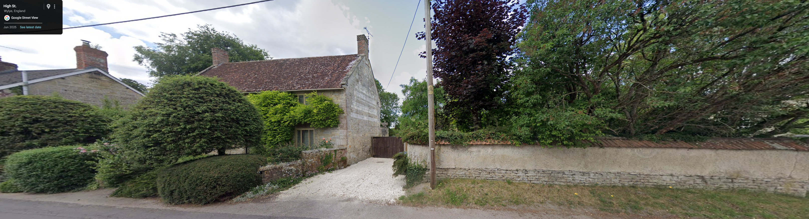

June 2025 Google Street View Image of Down House as view from High Street

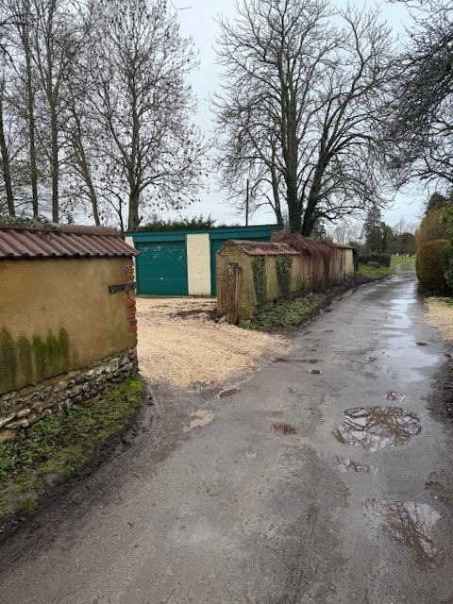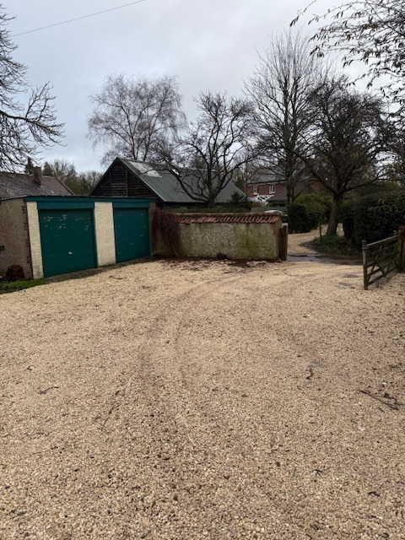

Applicant images of the existing garage

The application site is subject to the following planning policy constraints:

- Grade II listed building (as is Perrior House and Wylye opposite)

PLANNING HISTORY

Proposal / Summary
S/1998/1606 - Listed building consent Decision - Approve with Conditions Date: 16/11/1998 – REFURBISH OUTHOUSE, LOG STORE AND GARDEN STORE TO FORM BEDROOM AND PLAYROOM
S/1997/1645 - Listed building consent Decision - Approved Date: 1/12/1997 – INSTALL SERVICES, CONSTUCT STUD PARTITIONS AND FORM HALL, DINING ROOM AND BOXROOM
21/02204/FUL - Full planning permission Decision - Approve with Conditions Date: 13/8/2021 – Replacement conservatory and stone paving.
21/00632/LBC - Listed building consent Decision - Approve with Conditions Date: 13/8/2021 – Replacement conservatory and stone paving.
PL/2025/09075 - Listed building consent (Alt/Ext) – Internal alterations to remove modern partitions, kitchen and other works
16/06739/FUL - Full planning permission Decision - Approve with Conditions Date: 6/9/2016 – Proposed single storey extension to rear of property.
S/2003/0397 - Full planning permission Decision - Approve with Conditions Date: 24/4/2003 – ALTERATIONS AND TWO STOREY EXTENSION AND REPLACEMENT CONSERVATORY
S/2006/1104 - Full planning permission Decision - Approve with Conditions Date: 17/7/2006 – SINGLE-STOREY REAR EXTENSION

RELEVANT POLICIES AND GUIDANCE

Statutory Legislation:

From the point of view of the historic environment the main statutory tests are set out within the Planning (Listed Building and Conservation Areas) Act 1990.

Section 16 requires that special regard be given to the desirability of preserving listed buildings, their settings or any features of special architectural or historic interest which they possess.

National Context:

The NPPF outlines government policy for planning. Chapter 16 of the NPPF 'Conserving and enhancing the historic environment' sets out the Government's high-level policies concerning heritage and sustainable development.

The Planning Practice Guidance

Local Context:

Wiltshire Core Strategy:

- Core Policy 57 Ensuring High Quality Design and Place Shaping
- Core Policy 58: Ensuring the Conservation of the Historic Environment

The Council’s Core Strategy Policy CP58 ‘Ensuring the conservation of the historic environment’ requires that designated and non-designated heritage assets and their settings will be conserved, and where appropriate enhanced, in a manner appropriate to their significance and encourages proposals which improve the condition of heritage assets at risk.

The Council’s Core Strategy CP 57: Ensuring high quality design requires a high quality of design in all new developments. The policy requires applicants to “demonstrate how the proposal will make a positive contribution to the character of Wiltshire through (amongst other things) responding to the value of the natural and historic environment and being sympathetic to and conserving historic buildings and landscapes. Development is required to respond positively to the existing in terms of building layouts, built form, height, mass, scale, building line, plot size, elevational design, materials, streetscape and rooflines to effectively integrate the building into its setting.

Wylye does not have a Neighbourhood Plan or Area Designation
CONSULTATION RESPONSES

Wylye Parish Council: Support

Wiltshire Council Conservation Officer:

The application for LBC is only required if works are being carried out to a pre-1948 structure. It does appear from the way the N elevation is drawn that the historic boundary wall has been overbuilt by a modern garage, but the application tells us nothing of the existing structures nor of the manner of removing the existing while leaving the wall in a sound condition, nor any works required to make it so. The location of the garage is distant from its host listed building and is unlikely to have any impact on its setting, but consideration does need to be given to the setting of Wylye House, also listed, to whose drive it would be immediately adjacent.

Following receipt of the site photos – no objection

REPRESENTATIONS

No comments were received.

ASSESSMENT

Section 38(6) of the Planning and Compulsory Purchase Act 2004 states:

"If regard is to be had to the development plan for the purposes of any determination to be made under the planning Acts, the determination must be made in accordance with the plan unless material considerations indicate otherwise."

In accordance with this statutory requirement, this application has been assessed against the relevant policies of the Development Plan, including the adopted Wiltshire Core Strategy (2015) and, where applicable, any made Neighbourhood Plans.

Heritage Impact

As confirmed by the Council’s Conservation Officer, the proposal, by virtue of its scale, design, and use of materials, is considered to preserve the setting of the listed building and the other adjacent listed buildings.

The garage is being set back from the historic wall and would not be of a size or height to have any adverse impact on the setting of Wylye House. The hipped roof would also help mitigate the increased bulk and mass of the proposed building.

The existing garage appears to have been built into the historic wall, which itself is understood to be circa 600-700mm thick. Therefore, works to the wall to make it good when demolishing the garage will be required.

No harm would be caused to the historic significance of Down House or the two adjacent listed buildings, Wylye House and Perrior House.
The development is therefore considered to comply with Core Policy 58 of the Wiltshire Core Strategy and Section 16 of the Planning (Listed Buildings and Conservation Areas) Act 1990, as well as the relevant provisions of the NPPF.

CONCLUSION

The proposed development is considered to be acceptable in terms of its design, scale, and relationship with the surrounding area. It would not result in any unacceptable harm to the character and historic fabric of the historic wall and would also preserve the setting of the listed building.

The proposal is therefore considered to comply with the relevant policies of the Wiltshire Core Strategy, the Wiltshire Local Plan, and the National Planning Policy Framework. As such, the application is recommended for approval, subject to conditions.

RECOMMENDATION: That Listed Building Consent be GRANTED subject to conditions.

