APPLICATION FOR HOUSEHOLDER PLANNING PERMISSION
DELEGATED REPORT

APPLICATION REFERENCE: | PL/2026/00331
APPLICATION TYPE: | Householder planning permission
SITE ADDRESS: | Down House, High Street, Wylye, Warminster, BA12 0QN
DEVELOPMENT DESCRIPTION: | Removal of existing garage and erection of new garage and home office
RECOMMENDATION: | That Planning Permission be GRANTED

PROPOSAL

The proposal seeks planning permission for:

Removal of existing garage and erection of new garage and home office at Down House, High Street, Wylye, Warminster.

This application has been submitted alongside PL/2026/00519 as Down House is a grade II listed building and will solely deal with listed building elements of the application. The garage would have a single garage area and introduce a home office and shower.

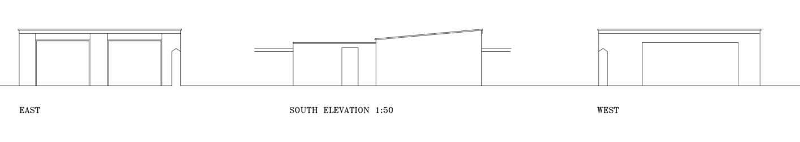

Existing Elevations

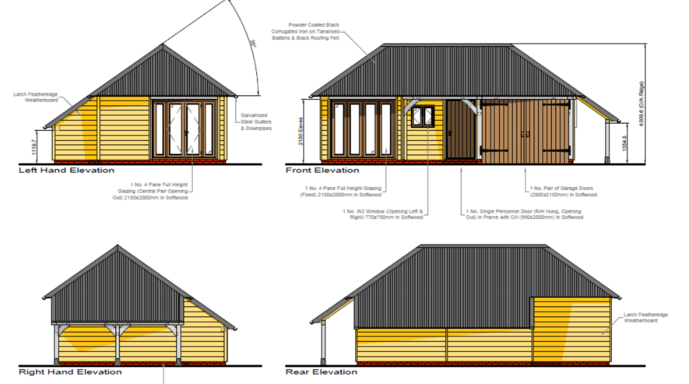

Proposed Elevations

SITE DESCRIPTION/CONTEXT

Down House is a grade II listed building where the listed building description reads;

“WYLYE HIGH STREET SU 03 NW (west side) 2/136 Down House GV II Detached house. Late C17, rear wing mid C18, some alterations late C20. Dressed limestone, tiled roof with gable end brick stacks and coped verges. L-plan. Two-storey, 3-windowed; casements. Central door with 6 fielded panels in beaded case with C20 flat wooden hood, C20 three-light mullioned casement either side. First floor retains three 3-light recessed chamfered mullioned casements. Left return has one blocked chamfered light to attic, C18 rear wing has 2-light casement. Rear of main build has 12-pane sash and attached C20 flat-roofed extension and conservatory, first floor has 3-light and 2-light leaded casement and 3-light steel casement. Rear wing to right has two 2-light recessed chamfered mullioned casements, 2-light and 3-light steel casements, original 3-light leaded casement to first floor, roof hipped to gable end. Interior has good late C17 closed string stairs with turned balusters and wide moulded handrail, chamfered beams and 4 and 6- panelled doors.”

The garage subject to this application is detached (although built into the boundary wall, which historically has been considered to be curtilage listed) and appears to be a simple brick and concrete render structure with a corrugated metal roof. The garage is approximately 40m away from Down House itself.

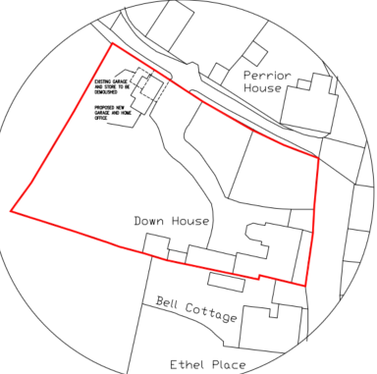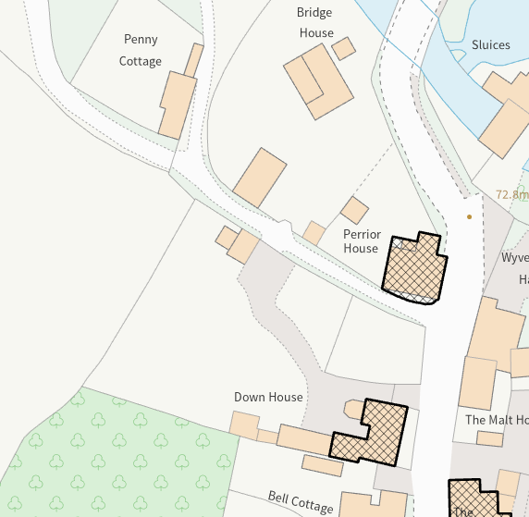

Block Plan and Council Mapping Image of the Site

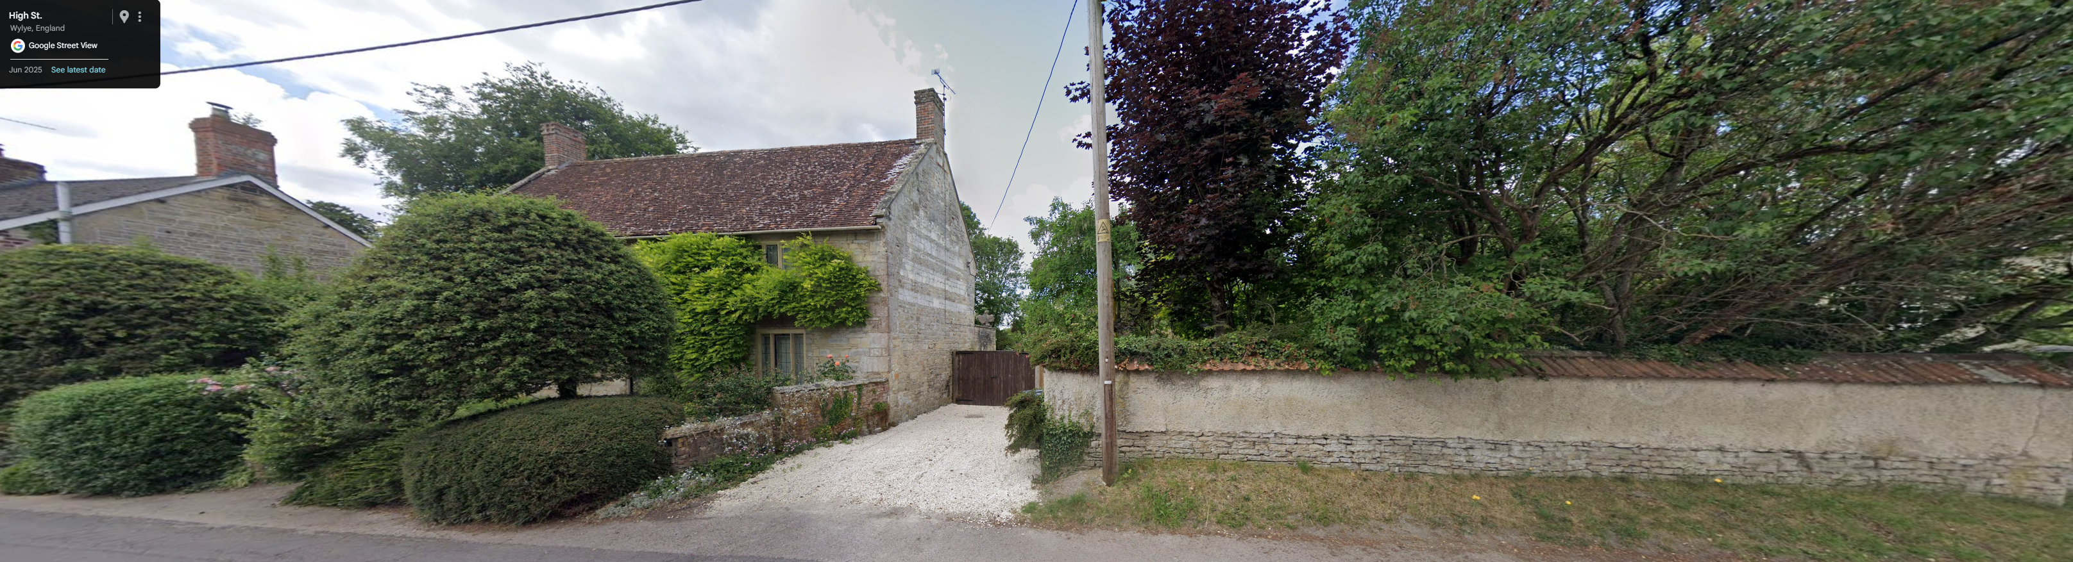

June 2025 Google Street View Image of Down House as view from High Street

The site is not subject to any surface or ground water issues. The application site is also not within a conservation area.

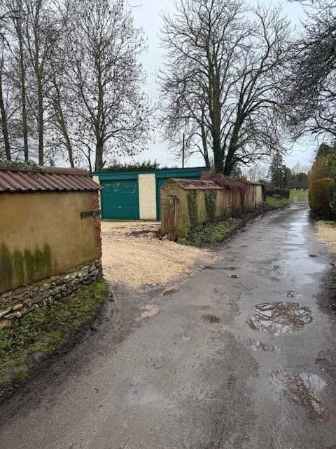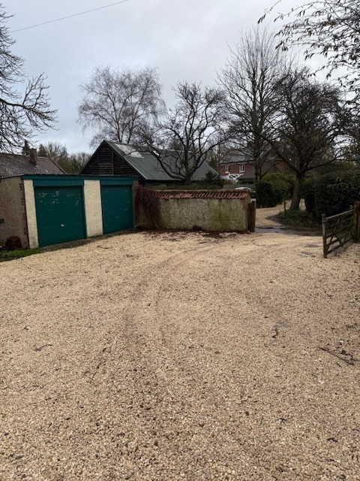

Applicant images of the existing garage

The application site is subject to the following planning policy constraints:

- Grade II listed building (as is Perrior House and Wylye opposite)
- Cranborne Chase and West Wiltshire Downs National Landscape
- Sailsbury SPA 6.4km buffer
- Hampshire and River Avon Catchment
- Phosphorous Small Discharge Risk Zones

PLANNING HISTORY

Proposal / Summary
S/1998/1606 - Listed building consent Decision - Approve with Conditions Date: 16/11/1998 – REFURBISH OUTHOUSE, LOG STORE AND GARDEN STORE TO FORM BEDROOM AND PLAYROOM
S/1997/1645 - Listed building consent Decision - Approved Date: 1/12/1997 – INSTALL SERVICES, CONSTUCT STUD PARTITIONS AND FORM HALL, DINING ROOM AND BOXROOM
21/02204/FUL - Full planning permission Decision - Approve with Conditions Date: 13/8/2021 – Replacement conservatory and stone paving.
21/00632/LBC - Listed building consent Decision - Approve with Conditions Date: 13/8/2021 – Replacement conservatory and stone paving.
PL/2025/09075 - Listed building consent (Alt/Ext) – Internal alterations to remove modern partitions, kitchen and other works
16/06739/FUL - Full planning permission Decision - Approve with Conditions Date: 6/9/2016 – Proposed single storey extension to rear of property.
S/2003/0397 - Full planning permission Decision - Approve with Conditions Date: 24/4/2003 – ALTERATIONS AND TWO STOREY EXTENSION AND REPLACEMENT CONSERVATORY
S/2006/1104 - Full planning permission Decision - Approve with Conditions Date: 17/7/2006 – SINGLE-STOREY REAR EXTENSION

RELEVANT POLICIES AND GUIDANCE

Statutory Legislation:

From the point of view of the historic environment the main statutory tests are set out within the Planning (Listed Building and Conservation Areas) Act 1990.

Section 66 requires that special regard be given to the desirability of preserving listed buildings, their settings or any features of special architectural or historic interest which they possess.

Section 72 requires special attention to be paid to the desirability of preserving or enhancing the character or appearance of a conservation area.

National Context:

The NPPF outlines government policy for planning. Chapter 16 of the NPPF 'Conserving and enhancing the historic environment' sets out the Government's high-level policies concerning heritage and sustainable development.

The Planning Practice Guidance

Local Context:

Wiltshire Core Strategy:

- Core Policy 50: Biodiversity and Geodiversity
- Core Policy 51: Landscape
- Core Policy 57 Ensuring High Quality Design and Place Shaping
- Core Policy 58: Ensuring the Conservation of the Historic Environment

The Council’s Core Strategy Policy CP58 ‘Ensuring the conservation of the historic environment’ requires that designated and non-designated heritage assets and their settings will be conserved, and where appropriate enhanced, in a manner appropriate to their significance and encourages proposals which improve the condition of heritage assets at risk.

The Council’s Core Strategy CP 57: Ensuring high quality design requires a high quality of design in all new developments. The policy requires applicants to “demonstrate how the proposal will make a positive contribution to the character of Wiltshire through (amongst other things) responding to the value of the natural and historic environment and being sympathetic to and conserving historic buildings and landscapes. Development is required to respond positively to the existing in terms of building layouts, built form, height, mass, scale, building line, plot size, elevational design, materials, streetscape and rooflines to effectively integrate the building into its setting.

Wylye does not have a Neighbourhood Plan or Area Designation

Wiltshire Design Guide: Appendix D – Design Guidance for Householder extensions

CONSULTATION RESPONSES

Wylye Parish Council: Support

Wiltshire Council Highways Officer – No objection

The proposal will reduce the garage spaces from 2 to 1 however the site benefits from adequate space to accommodate further vehicles.

Wiltshire Council Conservation Officer:

The application for LBC is only required if works are being carried out to a pre-1948 structure. It does appear from the way the N elevation is drawn that the historic boundary wall has been overbuilt by a modern garage, but the application tells us nothing of the existing structures nor of the manner of removing the existing while leaving the wall in a sound condition, nor any works required to make it so. The location of the garage is distant from its host listed building, and is unlikely to have any impact on its setting, but consideration does need to be given to the setting of Wylye House, also listed, to whose drive it would be immediately adjacent.

Following receipt of the site photos – no objection

REPRESENTATIONS

No comments were received.

ASSESSMENT

Section 38(6) of the Planning and Compulsory Purchase Act 2004 states:

"If regard is to be had to the development plan for the purposes of any determination to be made under the planning Acts, the determination must be made in accordance with the plan unless material considerations indicate otherwise."

In accordance with this statutory requirement, this application has been assessed against the relevant policies of the Development Plan, including the adopted Wiltshire Core Strategy (2015) and, where applicable, any made Neighbourhood Plans.

For the avoidance of doubt the home office and shower room would be ancillary accommodation to Down House, meaning the principle of development is supported.

Design and Impact upon the character and context of the area
Core Policy 57 - Ensuring High Quality Design and Place Shaping of the Wiltshire Core Strategy seeks to ensure that all new development is of high design quality, reflecting local context, character, and distinctiveness.

The existing garage is of no architectural or design merit and would not be fit for purpose for the garaging of modern cars due to its height and depth. It stands on a footprint of approximately 7m wide, 5m deep and 2.6m tall sloping to 2.4m at eaves.

Its replacement would be set in from the historic wall by 1.5m and increase the footprint to 8.4m wide, 5.7m deep, 4.2m tall sloping to 2.3m at eaves. It would have a hipped roof under a black corrugated iron clad roof. The walls would be built with larch feather board cladding. It is considered that the replacement building, whilst larger than the existing garage would still be a relatively small structure as compared to surrounding buildings and would be of an appropriate design.

Having regard to the above, the proposal complies with the design principles set out in Core Policy 57 of the Wiltshire Core Strategy and Appendix D of the Wiltshire Design Guide.

Amenity

Point vii of Core Policy 57 - Ensuring High Quality Design and Place Shaping of the Wiltshire Core Strategy seeks to ensure that developments do not adversely affect neighbouring properties.

The National Planning Policy Framework (NPPF), particularly Paragraph 135(f), stresses that planning decisions should ensure developments provide a high standard of amenity for existing and future users.

The proposed development has been assessed in terms of its potential impact on the residential amenity of neighbouring properties, with particular regard to loss of light, overshadowing, loss of privacy, and overbearing effects.

The replacement building would not be of a size or close enough to any neighbour as to cause any demonstrable harm by overbearing or overlooking impacts.

The proposal therefore accords with Core Policy 57 point vii in respect of safeguarding residential amenity and Appendix D of the Wiltshire Design Guide.

Heritage Impact

As confirmed by the Council’s Conservation Officer, the proposal, by virtue of its scale, design, and use of materials, is considered to preserve the setting of the listed building, the other adjacent listed buildings and the character and appearance of the conservation area.

The garage is being set back from the historic wall and would not be of a size or height to have any adverse impact on Wylye House. The hipped roof would also help mitigate the increased bulk and mass of the proposed building.

The existing garage appears to have been built into the historic wall, which itself is understood to be circa 600-700mm thick. Therefore, works to the wall to make it good when demolishing the garage will be required (included in the listed building consent application).

The development is therefore considered to comply with Core Policy 58 of the Wiltshire Core Strategy and Sections 66 and 72 of the Planning (Listed Buildings and Conservation Areas) Act 1990, as well as the relevant provisions of the NPPF.

Ecology Impact

Core Policy 50 of the Wiltshire Core Strategy seeks to protect and enhance biodiversity and geodiversity, including through ensuring that development avoids harm to protected species and habitats.

The National Planning Policy Framework (NPPF), in Paragraphs 193, requires that development minimises impacts on and provides net gains for biodiversity, including ensuring mitigation is secured where harm cannot be avoided.

The Council’s Ecology Officer has not been consulted on this application, but the application site is within the 6.4km zone of influence of the Salisbury Plain SPA and in light of the HRA for the Wiltshire Core Strategy and the HRA for the Wiltshire Housing Site Allocations Plan it is screened into Appropriate Assessment due to the potential impact of recreational pressure on stone curlew in combination with other plans and projects.

A strategic Appropriate Assessment (AA) has been prepared pertaining to development within the 6.4 km zone of influence that could result in a likely significant effect on the SPA as a result of an increase in recreational / visitor pressure. The AA reached a conclusion of no adverse effects on the integrity of the SPA or its qualifying features provided that the council’s mitigation strategy continues to be implemented. Annual stone curlew monitoring and protection measures continue to be secured by the Council.

In January 2026 Natural England (NE) confirmed that the 2025 strategic AA for Salisbury Plain SPA continues to be supported by NE.

As such, the development complies with Core Policy 50 of the Wiltshire Core Strategy and the relevant provisions of the NPPF.

National Landscape

Core Policy 51 of the Wiltshire Core Strategy requires all development to protect, conserve, and where possible enhance the character and quality of Wiltshire’s landscapes, giving particular weight to designated areas such as National Landscapes.

The National Planning Policy Framework (NPPF), in Paragraph 176, states that “great weight” should be given to conserving and enhancing landscape and scenic beauty in National Landscapes (formerly Areas of Outstanding Natural Beauty). Development within or affecting the setting of a National Landscape must demonstrate that it will not result in unacceptable harm to the special qualities of that area.

The proposal, by virtue of its scale, siting, and design, would not harm the special qualities or scenic character of the North Wessex Downs National Landscape.

The development therefore complies with Core Policy 51 of the Wiltshire Core Strategy and Paragraph 176 of the NPPF in conserving and enhancing the National Landscape.

Biodiversity Net Gain

Householder planning applications are exempt from the requirement to deliver Biodiversity Net Gain under Schedule 7A, Section 4(2)(a) of the Town and Country Planning Act 1990, as inserted by the Environment Act 2021.

CONCLUSION

The proposed development is considered to be acceptable in terms of its design, scale, and relationship with the surrounding area. It would not result in any unacceptable harm to the character of the locality, the amenities of neighbouring occupiers, heritage, or ecology.

The proposal is therefore considered to comply with the relevant policies of the Wiltshire Core Strategy, the Wiltshire Local Plan, and the National Planning Policy Framework. As such, the application is recommended for approval, subject the conditions.

RECOMMENDATION: That Planning Permission be GRANTED subject to conditions.

