APPLICATION FOR FULL-PLANNING PERMISSION CASE OFFICER REPORT

APPLICATION REFERENCE: | PL/2026/00478
APPLICATION TYPE: | Full planning permission
SITE ADDRESS: | 55-57 Winterslow Road, Porton, Salisbury, SP4 0LF
DEVELOPMENT DESCRIPTION: | Change of use from a Hairdressing Salon (Use Class E(a)) to residential (Use Class C3) and creation of Utility/Boot room.
RECOMMENDATION: | Approve with Conditions

SITE DESCRIPTION/CONTEXT

The application site relates to an existing two storey detached property located on a corner plot on a crossroads with Winterslow Road to the south, Idmiston Road to the east and Gomeldon Road opposite heading south. The site is located within the settlement boundary (thick black line on map extract below) of the large village of Porton as defined by Wiltshire Core Strategy (WCS) policies CP1 (Settlement Strategy), CP2 (Delivery Strategy) and CP4 (Amesbury Community Area). The site is located within the Porton conservation area (shaded dark green on the map extract below) and adjacent to Grade 2 listed Church of St Nicholas (black hatching on the map extract below). To the north, east and south, the site is surrounded by other residential properties.

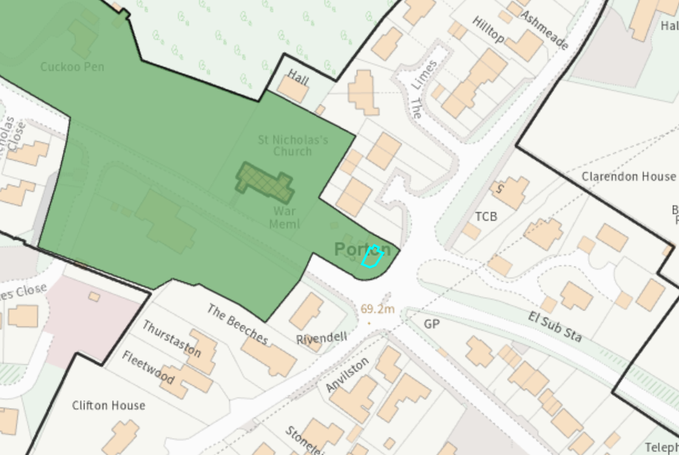

The building itself comprises a four bed dwelling and associated garage with a ground floor retail shop last used as a hair dresser at the eastern end of the property. This application relates to the ground floor retail unit and incorporating this into the adjoining dwelling. Access to the retail unit is via a separate entrance to the main dwelling, the door to the dwelling is on the south elevation, the door to the retail unit on the south east corner as seen on the image below.

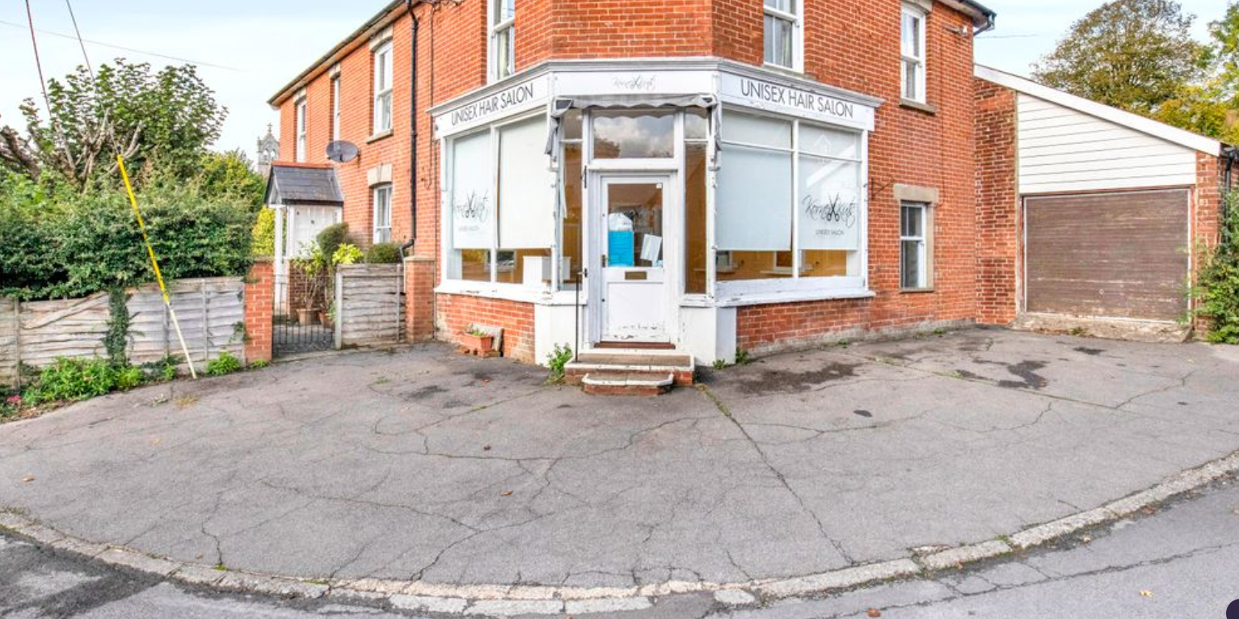

Whilst the site is not situated in the immediate vicinity of any rivers and is in Flood Zone 1; it is situated within the catchment of the River Avon Special Area for Conservation (SAC). It is also within the 6.4 kilometre recreational buffer of the Salisbury Plain Special Protection Area (SPA); and within 15 kilometres of the New Forest SAC, SPA and Ramsar site.

PROPOSAL

The application is seeking permission for “the change of use from a Hairdressing Salon (Use Class E(a)) to residential (Use Class C3) and creation of Utility/Boot room”.

The proposed C3 use of the existing retail unit will see the space incorporated into the associated dwelling and will form a kitchen/dining area with a new doorway created to link the two properties. The proposed change of use will not create a whole new separate unit of residential accommodation. The works also include the creation of a utility/boot room within the existing garage. Existing and proposed floor plans included below.

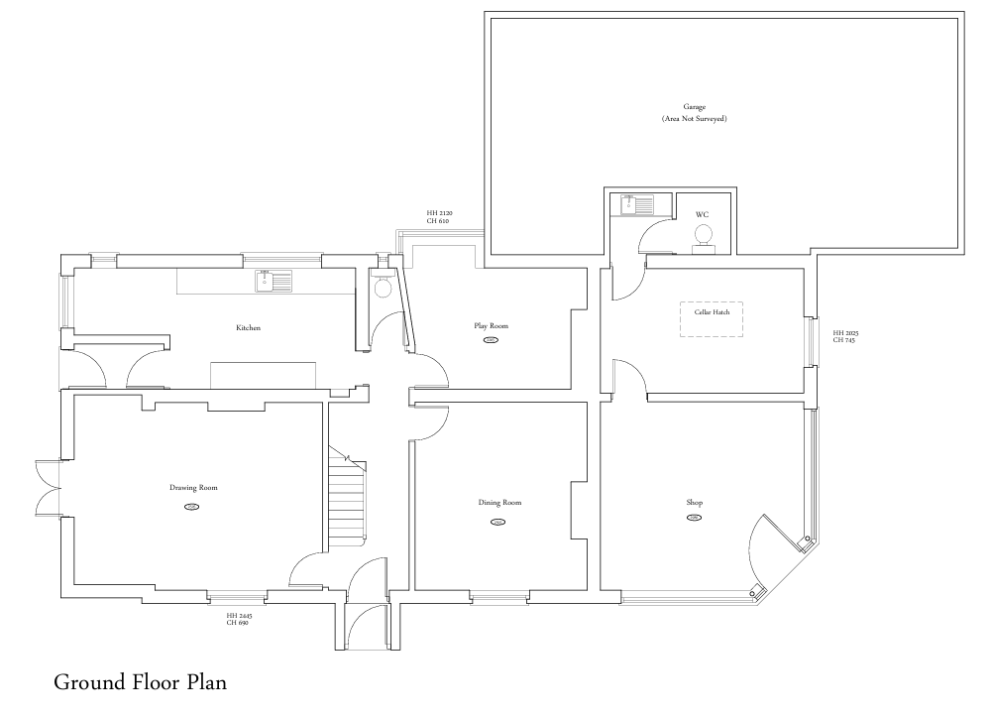

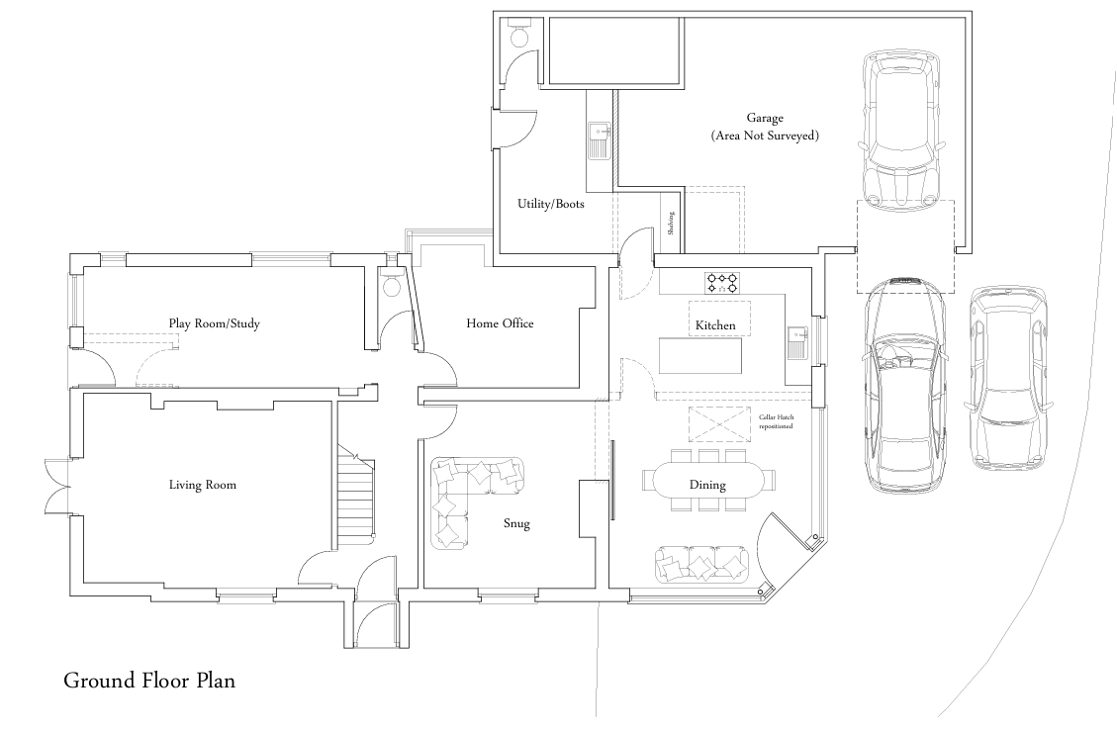

PLANNING HISTORY

PL/2025/05821 Change of use from a Hairdressing Salon (Use Class E(a)) to residential (Use Class C3). Withdrawn

This application was withdrawn due to a lack of any marketing or other evidence to demonstrate that the building was not viable or still required for use as a village shop, as required by WCS policy CP49 (Protection of Rural Services & Community Facilities).

PL/2025/07851 To convert a vacant use Class E Hairdressing Salon to residential use under Class MA. Approved.

This application for Prior Approval was however granted for the conversion of the existing hair dressers (retail use class E (a) into a one bedroom dwelling within the provisions of Class MA of Part 3 of Schedule 2 of the Town & Country Planning (General Permitted Development) (England) Order 2015 (as amended) (GPDO). This prior approval process is less onerous than a planning application and the development plan policies are not relevant to its consideration. There was therefore no need to justify the loss of a retail use as part of this previous application. The Class MA consent has not yet been implemented, but it does remain extant and therefore the decision represents a legitimate fallback position for the consideration of this current scheme.

RELEVANT LEGISLATION, POLICIES AND GUIDANCE

Planning (Listed Building and Conservation Areas) Act 1990 - S72 and 66

National Planning Policy Framework (NPPF)
National Planning Practice Guidance (NPPG)
National Design Guide (NDG)

Salisbury District Local Plan policies (Saved by Wiltshire Core Strategy) (SDLP):
C6 – special landscape area

Wiltshire Core Strategy (WCS):
CP1 (Settlement Strategy)
CP2 (Delivery Strategy)
CP3 (Infrastructure Requirements)
CP4 (Amesbury Community Area)
CP38 (Retail and Leisure)
CP49 (Protection of rural services and community facilities)
CP50 (Biodiversity and Geodiversity)
CP57 (Ensuring High Quality Design & Space Shaping)
CP58 (Ensuring the Conservation of the Historic Environment)
CP60 (Sustainable Transport)
CP61 (Transport & Development)
CP62 (Development Impacts on the Transport Network)
CP64 (Demand Management)
CP69 (Protection of the River Avon SAC)

Wiltshire Housing Site Allocations Plan (February 2020) (WHSAP)

Supplementary Planning Documents:

Wiltshire Design Guide (March 2024)
Creating Places Design Guide SPG (April 2006)
Achieving Sustainable Development SPG (April 2005)
Wiltshire Local Transport Plan – Car Parking Strategy
The Idmiston, Porton and Gomeldon Village Design Statement
Idmiston Neighbourhood Plan
ISSUES

Principle
Heritage, Character & Design
Neighbouring Amenities
Highway Safety
Ecology

CONSULTATION RESPONSES

Parish Council: No objection

Highways: No confirmation has been given of the number of bedrooms in the existing dwelling, however 3 parking spaces are shown on the submitted plan. This meets Wiltshire’s current parking standards and although the layout is not ideal, it is how vehicles current park on the site.
For confirmation none of the tarmacked area around the corner of the property that faces either Winterslow Road or Idmiston Road is public highway.
I therefore raise no highway objection to the proposal.

Conservation: The proposal involves no changes to the appearance or use of the building not already approved under the Prior Approval scheme. There would be no impact on the setting of the nearby church and conservation area, with regard to sections 66 and 72 of the PLBCA Act 1990. As a dwelling it would of course gain permitted development rights that would allow changes that could be harmful - primarily the removal of the shopfront or an oddly placed porch, for instance - if considered acceptable, PD rights should be withdrawn with regard to these or similar.

REPRESENTATIONS

In accordance with the requirements of the Town and Country Planning (Development Management Procedure) (England) Order 2015 (as amended), the application was publicised by way of:

- Neighbour notification letters sent to adjoining and nearby properties;
- A site notice displayed near the site;
- An advertisement placed in the local press

These methods were used to inform interested parties and provide a period of 21 days for comments to be submitted.

Below is a summary of the representations received during the consultation period. Only material planning considerations have been taken into account in the assessment of this application. Non-material issues, such as property values or private legal disputes, cannot be considered in the determination process.

One letter of strong support has been received.

ASSESSMENT

Section 38(6) of the Planning and Compulsory Purchase Act 2004 states:

"If regard is to be had to the development plan for the purposes of any determination to be made under the planning Acts, the determination must be made in accordance with the plan unless material considerations indicate otherwise."

In accordance with this statutory requirement, this application has been assessed against the relevant policies of the Development Plan, including the Wiltshire Core Strategy (2015) and, where applicable, any made Neighbourhood Plans. Consideration has also been given to the policies of the National Planning Policy Framework (NPPF) as a material consideration in the assessment.

Principle of Development

At the heart of the NPPF is a presumption in favour of sustainable development and the adopted Wiltshire Core Strategy seeks to build resilient communities and to support rural areas; but this must not be at the expense of sustainable development principles. The Settlement and Delivery Strategies of the WCS are designed to ensure new development fulfils the fundamental principles of sustainability. This means focusing growth around those settlements with a range of facilities; where local housing, service and employment needs can be met in a sustainable manner. A settlement hierarchy has therefore been identified in the WCS based on the size and function of each settlement within the County, which is the basis for setting out how the Spatial Strategy will deliver the levels of growth required.

As is identified above, the site is situated within the settlement boundary of the large Village of Porton, as defined by WCS polies CP1 (Settlement Strategy), CP2 (Delivery Strategy) and CP4 (Amesbury Community Area). WCS policy CP1 (Settlement Strategy) sets out the 'Settlement Strategy' for the County, and identifies four tiers of settlement - Principal Settlements, Market Towns, Local Service Centres, and Large and Small Villages. Only the Principal Settlements, Market Towns, Local Service Centres and Large Villages have defined limits of development/settlement boundaries within which residential development will be accepted.

The site is located within Porton Parish and the WCS delivery strategy locates the site within the Amesbury Community Area and Core Policy 4 (Amesbury Community Area) confirms that ‘Development in the Amesbury Community Area should be in accordance with the Settlement Strategy set out in Core Policy 1.’

The principle of new residential accommodation on this site and in this sustainable Large Village location could therefore be accepted within this policy context. However, in this instance, the existing building on the site is a retail unit with a lawful Class E use. Whilst the former use has ceased trading, and the unit has remained vacant for some time; no evidence has been provided to suggest that the unit could not be made viable and/or that there is no demand for such a use to sustain the local community. WCS policy CP49 (Protection of Rural Services & Community Facilities) therefore usually requires a 6 month marketing exercise to be undertaken in order establish if there is any need or demand for such a facility before an alternative use would be accepted. The previous planning application for change of use was withdrawn on this basis.

However, no evidence of such a marketing exercise has been submitted with this application. Instead, the supporting documentation relies on the fallback position of the Class MA Prior Approval consent, which is still extant and could still be implemented. As the implementation of such a consent would result in the loss of the retail unit anyway, the application submission details that there is no need to demonstrate if there is any market or demand for a retail unit in this village. The Local Planning Authority agrees that the fallback position is a material consideration and would result in the loss of the shop in any event. It is not therefore considered to be necessary in this instance for evidence to be provided to satisfy WCS policy CP49 (Protection of Rural Services & Community Facilities), and the principle of the site’s redevelopment for alternative residential purposes is accepted.

This in principle acceptability is however, subject to the detail. The implications of the development for the character of the area/heritage assets; neighbouring amenities; highway safety; and ecology will all therefore need to be addressed in more detail below.

Heritage, character and design

From the point of view of the historic environment, the main statutory tests are set out within the Planning (Listed Building and Conservation Areas) Act 1990.

Section 66 (Planning Permission) requires that special regard be given to the desirability of preserving listed buildings, their settings or any features of special architectural or historic interest which they possess.

The Council’s Core Strategy Policy CP58 ‘Ensuring the conservation of the historic environment’ requires that designated and non-designated heritage assets and their settings will be conserved, and where appropriate enhanced, in a manner appropriate to their significance and encourages proposals which improve the condition of heritage assets at risk.

The Council’s Core Strategy CP 57: Ensuring high quality design requires a high quality of design in all new developments. The policy requires applicants to “demonstrate how the proposal will make a positive contribution to the character of Wiltshire through (amongst other things) responding to the value of the natural and historic environment and being sympathetic to and conserving historic buildings and landscapes. Development is required to respond positively to the existing in terms of building layouts, built form, height, mass, scale, building line, plot size, elevational design, materials, streetscape and rooflines to effectively integrate the building into its setting.

The proposals relate to a material change of use and internal alterations only, there are no external alterations proposed as confirmed at para 4.31 of the submitted planning statement. The existing shop is a small sized unit, to incorporate it into the existing attached dwelling in this instance is not considered to have adverse impacts on the character of the area. The Council’s Conservation Officer has confirmed that there are no adverse impacts on the heritage assets which include the conservation area and setting of nearby listed buildings. However, it is suggested that a condition should be added to any approval to remove permitted development rights for additions, alterations, and extensions to the property in relation to the shopfront to protect the character and appearance of the property and conservation area/streetscene.

There are no concerns raised regarding the creation of the utility/boot room.

Amenity

Core Policy 57 (Point vii) of the Wiltshire Core Strategy requires development to respect the amenity of existing occupants and ensure appropriate amenity levels for future residents.

The National Planning Policy Framework (NPPF), particularly Paragraph 135, reinforces the need for development to provide a high standard of amenity for both existing and future users.

The conversion of the existing retail unit to provide additional residential space incorporated into the adjoining dwelling is not considered to conflict with residential amenity either for occupiers of the application site or neighbouring properties.

The proposal therefore accords with Core Policy 57 point vii in respect of safeguarding residential amenity, para 135 of the NPPF and the Wiltshire Design Guide.

Highways Impacts and Parking

Core Policy 57 (xiv) of the Wiltshire Core Strategy seeks to ensure that development must meet the requirements of Core Policy 61. This policy requires proposals to be capable of being served by safe access to the highway network. Core Policy 64 seeks to ensure compliance with parking standards set out in the Local Transport Plan.

The National Planning Policy Framework (NPPF), particularly Paragraph 115 and 116, requires that development proposals do not have an unacceptable impact on highway safety and that safe and suitable access to the site can be achieved for all users.

The application site currently provides for at least three off road parking spaces including the garage, it is considered prudent to condition that the remaining garage space is not converted to residential accommodation to ensure adequate parking is retained on site.

There are no changes proposed to the access or parking provision, the highway authority as raised no objections accordingly.

Ecology and Biodiversity

Core Policy 50 of the Wiltshire Core Strategy seeks to protect and enhance biodiversity and geodiversity, including through ensuring that development avoids harm to protected species and habitats.

The National Planning Policy Framework (NPPF), in Paragraphs 193, requires that development minimises impacts on and provides net gains for biodiversity, including ensuring mitigation is secured where harm cannot be avoided.

River Avon SAC - This development falls within the catchment of the River Avon SAC and has potential to cause adverse effects alone or in combination with other developments through discharge of phosphorus in wastewater. A test of likely significance has been carried out by the relevant Competent Authority (Wiltshire Council) as required by Regulation 63 of the Conservation of Habitats and Species Regulations 2017 (as amended). Given that technically there will be no net increase in overnight accommodation (the proposed works are not to add a new dwelling, but the change of use of a retail to provide an extension to the residential living space for an existing dwelling), it can be considered that there would be no overall mechanism for adverse effect. The HRA has concluded that the application is not likely to have significant impacts on the SAC and subsequently the pre-application is screened out of Appropriate Assessment.

New Forest SPA, New Forest SAC and New Forest Ramsar site -The site is located within the 15km zone of influence for the New Forest internationally protected sites, which comprises the New Forest SPA, New Forest SAC and New Forest Ramsar site. Any applications within this area are screened into appropriate assessment under the Conservation of Habitats and Species Regulations 2017 (as amended) on account of its potential to cause adverse effects on the New Forest protected sites through increased recreational pressure which may occur alone and in-combination with other plans and projects. Many of the special features of the New Forest protected sites afforded protection are vulnerable to adverse effects associated with an increase in recreation as demonstrated in Natural England’s supplementary advice issued for the SPA on 19 March 2019 and for the SAC on 18 March 2019. Following a Cabinet decision on 7 May 2024, Wiltshire Council’s “Interim recreation mitigation strategy for the New Forest internationally protected sites” (Version 1.1, 21 March 2023) is being revised. However, as the proposals relate to the change of use of a retail to provide an extension to the living space for an existing dwelling and does not involve new overnight accommodation, nor will it be bringing additional people to the locality which will impact on the New Forest protected sites, and subsequently the pre-application is screened out of Appropriate Assessment.

Biodiversity Net Gain - As of 2nd April 2024, the requirement for Biodiversity Net Gain (BNG) on all new sites came into force. Any small scale (non-major)/major scheme will need to demonstrate no net loss and a minimum of 10% net gain in biodiversity on the site, in line with the requirements of the NPPF, WCS policy CP50 (Biodiversity and Geodiversity) and the Environment Act.

However based on the information available the biodiversity gain planning condition is not considered to apply to this application as the development meets the following exemption criteria and is therefore below the de minimis threshold, meaning the development: − does not impact an onsite priority habitat (a habitat specified in a list published under section 41 of the Natural Environment and Rural Communities Act 2006); and − impacts less than 25 square metres of onsite habitat that has biodiversity value greater than zero and less than 5 metres in length of onsite linear habitat (as defined in the statutory metric).

As such, the development complies with Core Policy 50 and 69 of the Wiltshire Core Strategy and the relevant provisions of the NPPF.

PLANNING BALANCE AND CONCLUSION

Given that a Class MA permission exists on this site to convert the existing shop into a dwelling (PL/2025/07851), the proposed conversion of the retail until residential accommodation to be additional to the adjoining dwelling is considered to be acceptable in principle. There are no proposed external changes, therefore there are no objections raised regarding character, design or heritage impacts. The proposals are also unlikely to result in any implications for highway safety; neighbouring amenities; or protected species. The proposed development is therefore considered to comply with the above listed policies and guidance and there are no materials considerations which would lead officers to object to the development as proposed.

RECOMMENDATION:
That Planning Permission be GRANTED, subject to conditions

1. The development hereby approved shall be begun before the expiration of three years from
the date of this permission.

REASON: To comply with the provisions of Section 91 of the Town and Country Planning Act 1990 as amended by the Planning and Compulsory Purchase Act 2004.

2. The development hereby permitted shall be carried out in accordance with the following approved plans

Application form received 23/01/2026
Existing Location & Site Plan Drg no 0955/Ex/02 received 05/02/2026
Proposed Plan & Elevations Drg no 0955/Pr/01 Rev C received 05/02/2026

REASON: For the avoidance of doubt and in the interests of proper planning

3. Notwithstanding the provisions of the Town and Country Planning (General Permitted Development) (England) Order 2015 (as amended by the Town and Country Planning (General Permitted Development) (Amendment) (No.3) (England) Order 2020 (or any Order revoking or re-enacting or amending those Orders with or without modification), no alterations or additions or extensions shall take place on the south and east elevations including the removal or alterations to the existing shopfront of the development hereby permitted

REASON: In the interests of the character and amenity of the area including the conservation area and to enable the Local Planning Authority to consider individually whether planning permission should be granted for additions, extensions or enlargements.

4. Notwithstanding the provisions of the Town and Country Planning (General Permitted Development) (England) Order 2015 (or any Order revoking or re- enacting or amending that
Order with or without modification), the garage provision as shown on approved plan drg no 0955/Pr/01 Rev C shall not be converted into habitable accommodation.

REASON: To secure the retention of adequate parking provision, in the interests of highway safety.

Informatives

1. BNG not required

The effect of paragraph 13 of Schedule 7A to the Town and Country Planning Act 1990 is that planning permission granted for development of land in England is deemed to have been granted subject to the condition (biodiversity gain condition) that development may not begin unless:

(a) a Biodiversity Gain Plan has been submitted to the planning authority, and
(b) the planning authority has approved the plan.

The planning authority, for the purposes of determining whether to approve a Biodiversity Gain Plan, if one is required in respect of this permission would be Wiltshire Council.

There are statutory exemptions and transitional arrangements which mean that the biodiversity gain condition does not always apply. For further information on exempt developments please refer to:
https://www.gov.uk/guidance/biodiversity-net-gain-exempt-developments
Based on the information available this permission is considered to be one which will not require the approval of a biodiversity gain plan before development is begun because one or more of the statutory exemptions or transitional arrangements is considered to apply.

2. Building regs

Any alterations to the approved plans, brought about by compliance with Building Regulations or any other reason must first be agreed in writing with the Local Planning Authority before commencement of work.

3. CIL

The applicant is advised that the development hereby approved may represent chargeable development under the Community Infrastructure Levy Regulations 2010 (as amended) and Wiltshire Council's CIL Charging Schedule. If the development is determined to be liable for CIL, a Liability Notice will be issued notifying you of the amount of CIL payment due. If an Additional Information Form has not already been submitted, please submit it now so that we can determine the CIL liability. In addition, you may be able to claim exemption or relief, in which case, please submit the relevant form so that we can determine your eligibility. The CIL Commencement Notice and Assumption of Liability must be submitted to Wiltshire Council prior to commencement of development. Should development commence prior to the CIL Liability Notice being issued by the local planning authority, any CIL exemption or relief will not apply, and full payment will be required in full and with immediate effect. Should you require further information or to download the CIL forms please refer to the Council's Website https://www.wiltshire.gov.uk/dmcommunityinfrastructurelevy

