Development Management,
Wiltshire Council,
Bythesea Road
Trowbridge
Wiltshire
BA14 8JN

13 March 2026

Dear Sir/Madam,

RE: PROPOSED REORGANIZATION OF EXISTING TRAVELLER SITE
LANSDOWNE, LITTLETON, SEMINGTON, WILTSHIRE, BA14 6JJ

Please find attached completed planning application forms, plans and supporting information in respect of the above-mentioned proposal.

PLANNING STATEMENT

Site Description

The existing caravan site is sub-divided into 3 parts: The eastern part of the site (Plot 1) comprises 2 pitches; the central area (Plot 2) comprises 3 pitches; and the western part Plot 3) comprises 2 pitches. The current application site comprises Plot 3, at the western end of the larger caravan site: pitches 6 and 7, and a vehicle parking area, as shown on Figure 1 below:

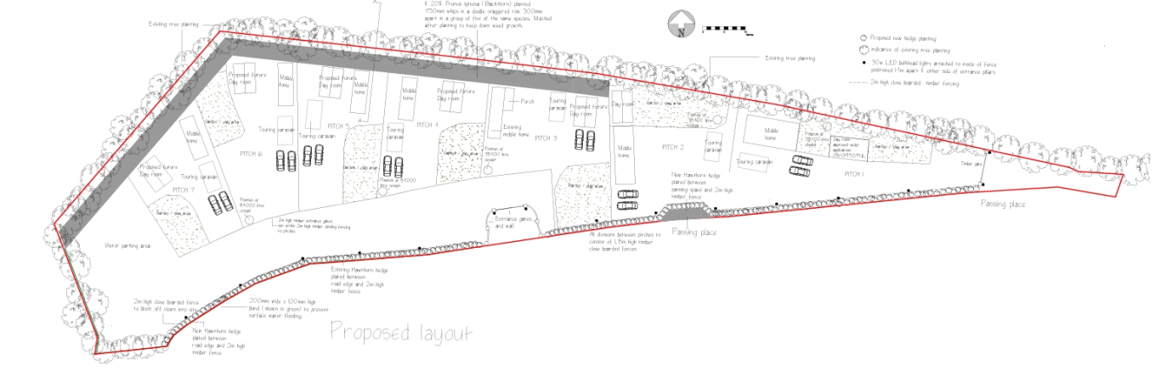

Figure 1: Site Layout approved under Application No. 15/08789/FUL

Site History

Planning permission was originally granted on 19 December 2002, under application No. 02/01145/FUL, for a single traveller pitch, accommodating 2 mobile homes (Pitch 1 on Figure 1).

Planning permission granted on 12 September 2008, under application No. 08/01952/FUL, for erection of a dwelling on Pitch 1.

Planning permission was granted on appeal, under application No. 13/016123/FUL, for retention of existing Gypsy and Traveller site to create an additional 4 pitches, i.e. making 5 in total

Planning permission granted on 11 February 2015, under application No. 15/08789/FUL, for alterations to the site layout to form a total of 7 pitches. Each pitch is authorised to accommodate 2 caravans, including no more than one static caravan/mobile home.

Figure 2 below shows how the site was actually laid out in August 2016, with almost the whole site laid to hardstanding. Access to the current application site was available via an access formed within Pitch 3.

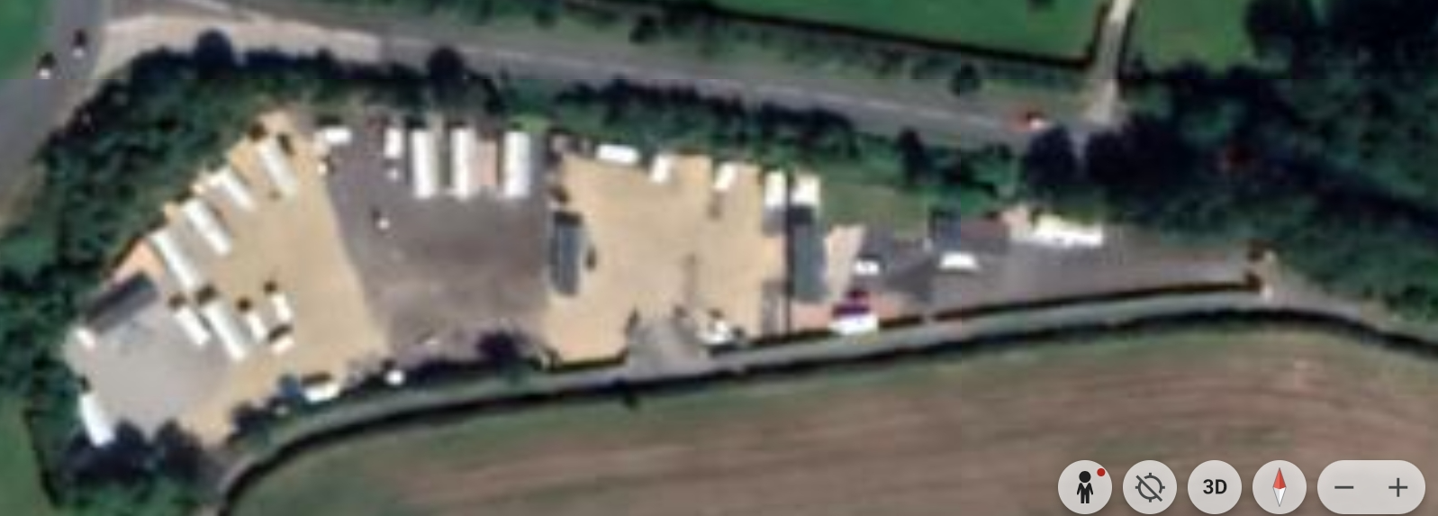
Figure 2 – August 2016
Figure 3 below shows how the site has developed since 2016, with access to the current application site being unavailable via Pitch 3 and, a new access having been formed to serve Plot 3. This has resulted from Plot 2 being in

separate ownership from the remainder of the site. The applicant now has no control over the approved access.

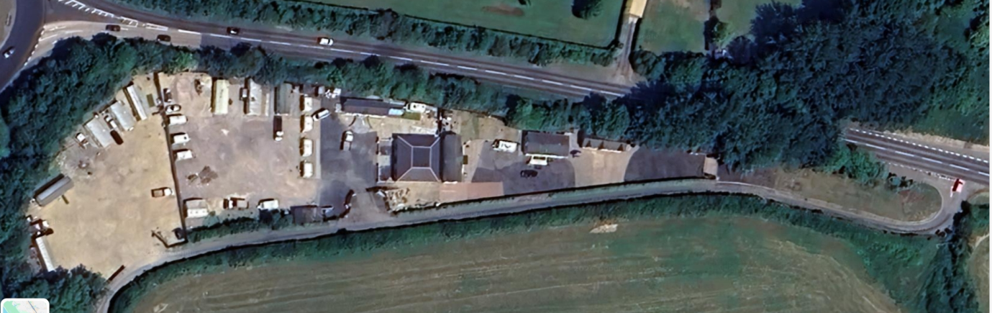
Figure 3 – June 2023
Proposed Development
It is proposed to station 9 mobile homes within the application site for residential purposes and, erect a communal day room for use by site residents who do not wish to rely, for cultural reasons, on the facilities within their mobile homes. It is also proposed to slightly re-locate the existing access in order to improve visibility along the access lane.
The proposed pitches are intended for occupation by Gypsies and Travellers falling within the definition set out in Annex 1 of Planning policy for traveller sites (PPTS - December 2024).
The site is bounded on two sides by trees and hedgerows, and on a third side by the fenced boundary with Plot 2. The shortest boundary is with a lightly-used access road where it is proposed to set a gateway back from the lane, and provide screen fencing and hedgerows either side.
National Planning Policy
The National Planning Policy Framework (NPPF) puts the presumption in favour of sustainable development at the heart of plan-making and decision-taking. For decision-taking this means approving development proposals that accord with an up-to-date development plan without delay; or where there are no

relevant development plan policies, or the policies which are most important for determining the application are out of date, granting planning permission unless, inter alia, any adverse impacts of doing so would significantly and demonstrably outweigh the benefits when assessed against the policies in the Framework taken as a whole; or the application of policies in the Framework that protect areas or assets of particular importance provides a clear reason for refusing the development proposed.
In the latter regard, the application site is not located within the Green Belt, or within a SPA, SSSI, Conservation Area, Local Green Space, National Landscape or National Park. Furthermore, the proposed caravan site is not located within an area shown on the Environment Agency’s flood maps as being at high risk from fluvial flooding.
Footnote ⁸ explains that development plan policies are out-of-date for applications involving the provision of housing, in situations where: the local planning authority cannot demonstrate a five year supply of deliverable housing land. Paragraph 28 of PPTS makes clear that if a local planning authority cannot demonstrate an up-to-date 5 year supply of deliverable sites for Gypsies and Travellers, the provisions in paragraph 11(d) of the National Planning Policy Framework apply.
As such, the LPA should grant permission unless:
...any adverse impacts of doing so would significantly and demonstrably outweigh the benefits, when assessed against the policies in this Framework taken as a whole, having particular regard to key policies for directing development to sustainable locations, making effective use of land, securing well-designed places and providing affordable homes, individually or in combination.

Need and Supply
The Wiltshire Gypsy and Traveller Accommodation Assessment (GTAA), published in June 2024, provides the most up to date evidence for gypsy and

traveller site needs in Wiltshire LPA’s area. It estimates that there is a net need for the provision of an additional 188 permanent gypsy and traveller pitches in Wiltshire, during the period 2024 – 2038 for gypsies and travellers found by the report’s authors to comply with the definition of “gypsy” in the 2023 version of PPTS. In addition, up to 38 pitches are required for families whose gypsy status is currently unknown (because their families were not interviewed) and, 73 pitches for gypsies who do not meet the 2023 definition.

The PPTS change to the definition of “gypsies and travellers” in December 2024, which is more of a cultural definition, is likely to encompass those travellers whose status was unknown and those who did not meet the 2023 definition. The total need is, therefore, in the region of 299 permanent pitches. It is axiomatic that, in the absence of any allocated sites in the Development Plan, the Council cannot demonstrate an up-to-date 5 year supply of deliverable sites for Gypsies and Travellers, and the ‘tilted balance’ of NPPF para. 11d is engaged.

Sustainability
PPTS sets out that new traveller site development in open countryside that is ‘away from’ existing settlements or outside areas allocated in the development plan should be very strictly limited. Here, the site is an existing traveller site, less than one mile by road from Semington which contains a primary school, village hall/post office, church and public house. The closest shops are in Melksham, within about 2 miles, by road, of the application site. There are hospitals and GP surgeries available in Melksham and Trowbridge
Paragraph 110 of the NPPF recognises that different policies and measures will be required in different communities and, opportunities to maximise sustainable transport solutions will vary from urban to rural areas. Paragraph 110 generally seeks to direct developments that generate significant movement to locations where the need to travel will be minimised and the use of sustainable transport modes can be maximised. PPTS recognises that gypsy sites can be appropriately located in rural or semi-rural areas and a

development of 7 additional caravan pitches would not generate significant movement, i.e. requiring submission of a Transport Statement or Transport
Assessment (para. 118 of the NPPF). As such, the proposed development should only be prevented or refused on transport grounds where the residual cumulative impacts of development are severe (para. 116). In this case, the site residents would be in a similar position to the many other families living in this rural area and, even if primarily reliant on the private car, car trips would relatively short in both length and duration. The application site is, in my opinion, a reasonably sustainable location for a traveller site.
Notwithstanding the above, the NPPF and PPTS require a consideration of the effects of development on a broader basis than simply in relation to transport. That is true of all developments – but particularly sites for gypsies because they have a travelling way of life by definition and this must be factored into the planning assessment. Footnote 57 to the NPPF makes clear that, when assessing the sustainability of traveller sites, particular regard should be had to paragraph 13 of PPTS.
Paragraph 13 of PPTS makes no mention of distances to services or modes of travel when assessing the sustainability of gypsy sites. PPTS expects local planning authorities to ensure that gypsy sites are sustainable economically, socially and environmentally – by promoting access to appropriate health services and ensuring that children may attend school regularly. “Access” in this sense is related to the fact that gypsies may only have the right to register with a GP or obtain education if they have a settled base. In this case, the site residents will be able to register with local doctors and, will be able to register children in local schools.
Considered in the round and taking into account the provisions of the NPPF and PPTS, the site would be in a suitable location having regard to its countryside location and accessibility to services and facilities for the proposed development.

Development Plan
Core Strategy Policy 2: Delivery Strategy states that, other than in circumstances as permitted by other policies within the plan, development will not be permitted outside the limits of development as defined on the policies map. Core Policy 47 is one such policy which permits development outside the settlement development boundaries. If the proposed development complies with Core Policy 47, it will also comply with Core Policy 2.

Core Policy 47 states that: “where proposals satisfy the following general
criteria they [proposals for new gypsy sites] will be considered favourably”:

- No significant barriers to development exist in terms of flooding, poor drainage, poor ground stability or proximity to other hazardous land or installation where conventional housing would not be suitable.

The Government’s long-term flood map for planning indicates that there is a very low risk from fluvial and pluvial flooding, even in the longer term

- It is served by a safe and convenient vehicular and pedestrian access. The proposal should not result in significant hazard to other road users.

I examine this issue, separately, below.

- The site can be properly serviced and is supplied with essential services, such as water, power, sewerage and drainage, and waste disposal.

The site is already connected to mains electric and water. Sewerage is by means of cess pits and, domestic waste is disposed of by means of the local authority waste collection service.

- The site must also be large enough to provide adequate vehicle parking, including circulation space, along with residential amenity and play areas.

The site would accommodate on-site turning facilities and, each mobile home would be provided with 2 car parking spaces. A community

building would be provided, together with a small area of amenity open space.
- It is located in or near to existing settlements within reasonable distance of a range of local services and community facilities, in particular schools and essential health services.

I have already examined the sustainability credentials of the application site and, found the site to be in a reasonably sustainable location having regard to the provisions of the Framework and PPTS.

- It will not have an unacceptable impact on the character and appearance of the landscape and the amenity of neighbouring properties, and is sensitively designed to mitigate any impact on its surroundings.

The development site forms part of an existing traveller site. It is well screened from public vantage points and, would only be visible at very close range, in the context of the existing caravan site. The proposed development would not have an unacceptable impact on either the character or appearance of this rural location.

- Adequate levels of privacy should be provided for occupiers.

The proposed layout would comply with the requirements of the model
caravan site licensing conditions for the spacing of caravans, which are
considered to provide an adequate standard of privacy for residents.

- Development of the site should be appropriate to the scale and character of its surroundings and existing nearby settlements.

The proposed development would not over-dominate the closest settled community of Semington in any physical or visual sense, and would not place undue pressure on local atmosphere.

- The site should not compromise a nationally or internationally recognised designation nor have the potential for adverse effects on river quality, biodiversity or archaeology.

The proposed development is not located in an area subject to a national or international designation and, because the site has been hardsurfaced for at least 10 years, would have no effect on biodiversity.

Highway Safety

The only matter that has previously counted against development of the application site has been the safety of the existing access. The Inspector in a previous appeal (APP/Y3940/C/18/3217780) found the existing access to be unsafe, with substandard visibility, but could not consider any alternative as part of an enforcement notice appeal. The appellant had said that he could submit a new planning application to formalise the matter. The Inspector considered that this would be the best way to see if the highway safety concerns could be addressed.

This application proposes relocation of the access further west, on the outside of the right-angled bend, where it would provide views in both directions along the lane. The lane is a narrow, lightly-used, cul-de-sac where traffic speeds are constrained both by the width of the carriageway and the right-angled bend. It is unlikely that vehicles approaching the bend would exceed 30 mph (and, probably less than 20 mph). Manual for Streets 2 (MfS2) advises that for a speed of 30 mph, visibility splays of 2.4 metres (“x” distance) x 43 metres (“y” distance) are required. The Site Layout Plan demonstrates that these splays can be achieved within the highway boundary.

Planning Balance

Due to the lack of a five years supply, paragraph 11 d)ii) of the National Planning Policy Framework is engaged. This requires planning permission to be granted unless the adverse impacts of doing so would significantly and demonstrably outweigh the benefits when assessed against the policies in the Framework as a whole. It adds that particular regard should be had to policies relating to design, affordable housing, the effective use of land and development in sustainable locations. Matters of detailed design and affordable housing are of little relevance to the proposal.

With regard to sustainable locations, the site provides reasonable access to services and facilities and would not be away from a settlement. It would hence be supported by paragraph 110 of the Framework. Furthermore,

substantial weight should be given to the benefit of four pitches at a time where there is a shortfall of supply, to the current unmet need with no alternative sites currently available, and to the fact the pitches would allow reasonable access to services and facilities. As such I consider that having addressed concerns in terms of highway safety, any harm associated with the proposed development would not significantly and demonstrably outweigh the benefits when considered against the Framework as a whole.

I trust that you will feel able to support my client’s proposals but, should you require any further information in support of this application please do not hesitate to contact me.

Kind regards,

PHILIP BROWN BA (Hons) Urban and Regional Planning

