APPLICATION FOR VARIATION/REMOVAL OF CONDITION
CASE OFFICER REPORT

APPLICATION REFERENCE: | PL/2026/00137
APPLICATION TYPE: | Removal/variation of conditions
SITE ADDRESS: | Tulip Tree Lodge, 8 Cliffe Drive, Limpley Stoke, Bath, BA2 7FY
DEVELOPMENT DESCRIPTION: | Variation of Condition 2 (Approved Plans) and 4 (Ecological Enhancements) of PL/2025/06410 - Re-roofing, re-cladding, garage conversion and extension
RECOMMENDATION: | Approve with Conditions

PROPOSAL
The proposal seeks variation to a planning permission for householder application that was granted permission on 14 October 2025, for a series of alterations to the existing dwellinghouse, which included the re-roofing, recladding, garage conversion and small single storey extension of the property.

The main operative part of this permission remains unchanged, whereby a number of minor material amendments are sought, namely minor alterations to the window design and position; cladding extent and change to the roof profile of the small ground floor side extension to a flat roof.

The application also seeks to amend the wording of condition 4 of permission ref: 2025//0641 from a pre-commencement to a compliance condition in accordance with the submitted updated Ecological Enhancement Plan. This relates to the number, design and locations of bat boxes and also boxes for nesting birds.

SITE DESCRIPTION/CONTEXT
The application site is located within the Small Village of Limpley Stoke some 3km to the West of Bradford on Avon and south of the River Avon and Kennet and Avon Canal. It is located within the Green Belt, the Cotswolds National Landscape and within the southern fringes of the Cotswolds Special Landscape Area. It is also within the Bath and Bradford on Avon Bat Special Area of Conservation and within an area designated as priority habitat. To the west is Stoke Lodge a Grade II listed Building. Access is served off Cliffe Drive.

The application site is subject to the following planning policy constraints:

National Context:
National Planning Policy Framework December 2024 (NPPF)
Planning Practice Guidance (PPG)
Planning (Listed Buildings and Conservation Areas) Act 1990

Local Context:
Wiltshire Core Strategy (WCS) adopted 2015:
WCS - CP1 Settlement strategy
WCS - CP2 Delivery strategy
WCS - CP7 Spatial Strategy Bradford on Avon Community Area
WCS - CP50 Biodiversity and geodiversity
WCS - CP51 Landscape
WCS - CP57 Ensuring high quality design and place shaping
WCS - CP58 Conservation of the Historic Environment
WCS - CP60 Sustainable transport
WCS - CP61 Transport and development
WCS - CP64 Demand management Wiltshire Car Parking Strategy
Wiltshire Local Transport Plan 2011- 2026 Car Parking Strategy
Wiltshire Local Transport Plan 2011- 2026: Cycling Strategy

Saved Policies for the West Wiltshire District Local Plan (1st Alteration)
H20: Replacement Dwellings
C3 Special Landscape Area

Freshford and Limpley Stoke ‘Made’ Neighbourhood Plan
The Cotswolds AONB Management Plan 2018-2023

Wiltshire Design Guide: Appendix D – Design Guidance for Householder extensions
The National Planning Policy Framework (NPPF)
The Planning Practice Guidance
National Design Guide

RELEVANT PLANNING HISTORY
Proposal / Summary
PL/2024/03212 Demolition of existing dwelling and erection of a replacement 4 bedroom dwelling. Approved.
PL/2025/06410 Re-roofing, re-cladding, garage conversion & extension. Approved.

Emerging Wiltshire Local Plan:
The emerging Wiltshire Local Plan has reached Regulation 24 stage. The examination is programmed to have more hearing sessions through 2026 and as such, the weight to be attributed to the emerging local plan is very limited at this stage.

CONSULTATION RESPONSES
LImpley Stoke Parish Council: No objections and support the application.

Ecology: No objections.

Highways: No objections.

REPRESENTATIONS
One email of support received stating that the proposed works would be an improvement to the building and request consideration to neighbours with regard to builders’ radio noise.

PRINCIPLE OF THE PROPOSAL.
The principle of the proposed scheme and amendments is considered to be acceptable for the reasons as discussed below.

ASSESSMENT
Section 38(6) of the Planning and Compulsory Purchase Act 2004 states:

"If regard is to be had to the development plan for the purposes of any determination to be made under the planning Acts, the determination must be made in accordance with the plan unless material considerations indicate otherwise."

In accordance with this statutory requirement, this application has been assessed against the relevant policies of the Development Plan, including the adopted Wiltshire Core Strategy (2015) and the Freshford & Limpley Stoke ‘Made’ Neighbourhood Plan.

Design and Impact upon the upon the character and context of the area

Core Policy 57 - Ensuring High Quality Design and Place Shaping of the Wiltshire Core Strategy seeks to ensure that all new development is of high design quality, reflecting local context, character, and distinctiveness.

The proposals can be viewed within the plan snippets taken from the submitted plans:

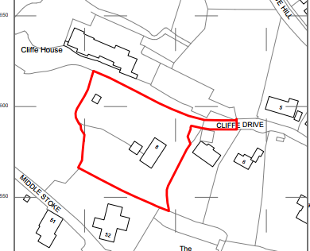
Location Plan

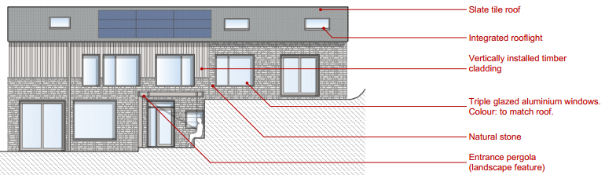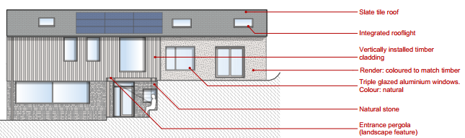
As previously approved and as proposed West elevations.

As shown, the proposals would extend the vertical timber cladding, change the fenestration, and introduce the use of coloured render, which would match the colour of the timber cladding.

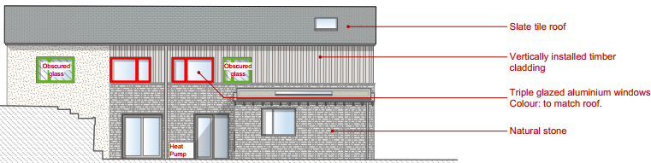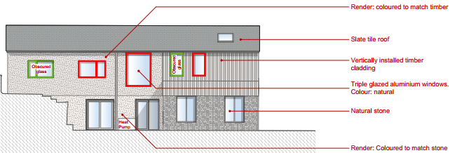
As previously approved and as proposed East Elevation.

The proposals would reduce and extend the vertical timber cladding, change and alter the fenestration and introduce the use of coloured render, which would match the colour of the building’s stone.

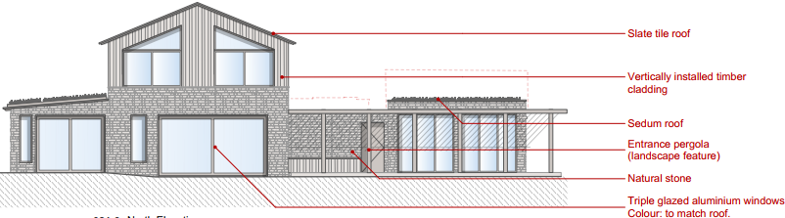

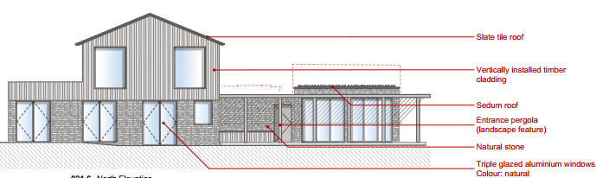
As previously approved and as proposed North elevations.

The proposals would introduce smaller sized fenestration at both first floor and ground floor level, a small sized flat roof would also be introduced in place of the shallow pitched on the small single storey side extension. The natural timber cladding would also be slightly extended.

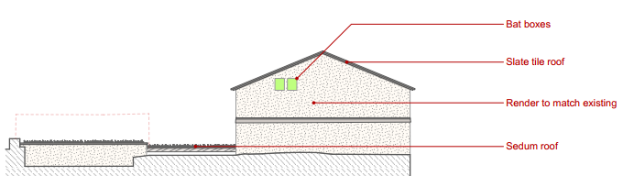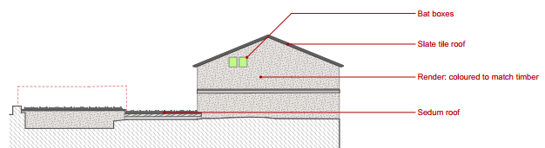
As previously approved and as proposed South Elevations

As shown in the above two snippets for the south elevation, the only changes would be the change in colour of the side elevation render, to match that of the natural timber.

The revised changes for each of the elevations as shown above have been highlighted and discussed, they are all considered to be acceptable and not cause harm. Therefore, in summary, having regard to the above, the proposal complies with the design principles set out in Core Policy 57 of the Wiltshire Core Strategy and Appendix D of the Wiltshire Design Guide.

Amenity
Point vii of Core Policy 57 - Ensuring High Quality Design and Place Shaping of the Wiltshire Core Strategy seeks to ensure that developments do not adversely affect neighbouring properties. The National Planning Policy Framework (NPPF), particularly Paragraph 135(f), stresses that planning decisions should ensure developments provide a high standard of amenity for existing and future users.
The amenity aspects of the proposed changes have been fully explored and discussed within the accompanying report to the previous application ref: 2025/06410 and it is appraised that the current proposals would not harmfully impact on amenity. The large sized picture windows within the end North elevation which were previously appraised as being acceptable due large neighbour distances, have been reduced in size and so are equally acceptable.

As there are no immediate neighbours there would not be any overshadowing or loss of light impacts on neighbouring amenity, due to sufficient separation distances.
The proposals therefore accord with Core Policy 57 point vii. in respect of safeguarding residential amenity and Appendix D of the Wiltshire Design Guide.

Highway Matters.
Core Policy 57 (xiv) of the Wiltshire Core Strategy seeks to ensure that development must meet the requirements of Core Policy 61. This policy requires proposals to be capable of being served by safe access to the highway network. Core Policy 64 seeks to ensure compliance with parking standards set out in the Local Transport Plan.

The National Planning Policy Framework (NPPF), particularly Paragraph 115 and 116, requires that development proposals do not have an unacceptable impact on highway safety and that safe and suitable access to the site can be achieved for all users.

The proposed development would not result in any adverse impact on highway safety. As previously appraised, adequate parking and turning provision is already provided on site in accordance with Wiltshire’s adopted parking standards, and the Highways Officer has not raised any objections.

The proposal is therefore considered to comply with Core Policies 57 (xiv), 61 and 64 of the Wiltshire Core Strategy, the NPPF, and the Wiltshire Local Transport Plan.

Green Belt.
The site lies within Green Belt land and there is no relevant WCS development plan policies relating to the Green Belt, therefore the NPPF provides the policy direction. The recently revised NPPF (December 2024) sets out within paragraph 142 that “The Government attaches great importance to Green Belts. The fundamental aim of Green Belt policy is to prevent urban sprawl by keeping land permanently open; the essential characteristics of Green Belts are their openness and their permanence”. Openness is the absence of development and Paragraph 143 the NPPF sets out five key purposes of the Green Belt with one being to safeguard the open countryside from encroachment. The NPPF explains how to treat proposals within the Green Belt.

Paragraph 153 of the NPPF states inappropriate development is, by definition, harmful to the Green Belt and should not be approved except in very special circumstances. The two key characteristics of the Green Belt are its openness and its permanence.

Paragraph 154 sets out the categories of development which may be regarded as being ‘appropriate’ or exceptions in the Green Belt, such that in this instance sub-paragraph C allows for extensions as an exception. In this instance the extension consists of a small area of development within the main build of the rear of the dwelling and is no different from that as previously appraised with the previous application ref: 2025/06410. Therefore, in accordance with the policy, the works would not result in a disproportionate addition. Officers have concluded that the development is an acceptable exception in the meaning of the NPPF at paragraph 154(c).

The development is therefore not ‘inappropriate’ and there is no requirement for very special circumstances to be demonstrated.

Design & Landscape Impacts: The site is located within the Cotswolds National Landscape and also within a Special Landscape Area.

Policy CP51 of the adopted WCS States that “proposals for development within or affecting an AONB shall demonstrate that they have taken account of the objectives, policies and actions set out in the relevant Management Plans for these areas". As such careful consideration must be given to the nature and scale of the proposed works.

The NPPF states in paragraph 189 that great weight should be given to conserving and enhancing landscape and scenic beauty in National Landscapes, which have the highest status of protection in relation to landscape and scenic beauty, and the extent of development within National Landscapes should be limited.

Core Policy 51 of the adopted Wiltshire Core Strategy states “great weight will be afforded to conserving and enhancing landscapes and scenic beauty”.

Saved Policy C3 requires the landscape character of this area to be “conserved and enhanced and development will not be permitted which is considered to be detrimental to the high quality of these landscapes”.

Core Policy 57 requires ‘a high standard of design in all new developments. of particular relevance is paragraph (iii) which requires development to respond positively to the existing townscape and landscape features in terms of building layouts, built form, height, mass, scale, building line, plot size, elevational design, materials, streetscape and rooflines to effectively integrate the building into its setting’.

The NPPF also states at paragraph 131 that the creation of high quality, beautiful and sustainable buildings and places is fundamental to what the planning and development process should achieve. Good design is a key aspect of sustainable development, creates better places in which to live and work and helps make development acceptable to communities.

The proposed works and reported amendments in this instance relate to the specific refurbishment of the main house including the construction of a small sized single storey extension, all of which serve to upgrade the main principal dwelling, such works are comparatively small and due to appropriate design and use of quality materials is appraised as being acceptable and not having a significant impact on the land designations and the openness of their character.

Heritage Impact
As previously reported, it is noted that there is a there is a Grade II listed building to the west of the site known as Stoke Lodge listed building. As such, Section 16(2) of the Planning (Listed building and Conservation area) Act 1990 applies and which states that the Local Planning Authority has a duty to pay special attention to preserving the desirability of the building or its setting or any features of special architectural or historic interest which it possesses.

Furthermore, Core Policy 58 of the Wiltshire Core Strategy aims to ensure that Wiltshire’s important monuments, sites and landscapes and areas of historic and built heritage significance are protected and enhanced in order that they continue to make an important contribution to Wiltshire’s environment and quality of life. The current proposals are still minor in their nature and are such that they would substantially improve the character and amenities of the immediate locality, therefore, for the reasons as discussed throughout, it is appraised that there would not be any harm to the setting or character of this listed building.

Ecology Impact CP50 requires no net loss of biodiversity on site. The site lies within a core sustenance zone for Greater Horseshoe bats, Lesser Horseshoe bats and Bechstein’s bats associated with the Bath and Bradford-on-Avon Bats SAC. The current application seeks to change condition 04 of permission reference PL/2025/06410 from that of a pre-commencement to compliance condition, by submitting the necessary information at this stage.

The council’s ecology section were consulted for this application who were able to examine and assess the revised information, with the officer being in support and not raising any objections, the officer commented:

“Concurrently, an Ecological Enhancement Plan and updated Bat Mitigation Plan have been submitted in effort to alter Condition 4 to a compliance condition rather than pre-commencement.
As previously proposed, an integrated crevice feature will be built into the south elevation of the renovated property that will lead into a sheltered cavity in the wall of the new building. This is to accommodate for the loss of an occasionally used serotine day roost. The Bat Mitigation Plan has been updated to refer to the recent planning permission.

The Ecological Enhancement Plan outlines further enhancements for bats, including 2 bat boxes on mature trees within the application site – the location and specifications are provided in the enhancement document. Five bird nest boxes, including a tawny owl nest box, are proposed along the southern boundary.

Overall, I have no objections to the proposed amendments, and the ecological enhancements condition should be updated to a compliance condition”.

A suitably worded compliance condition has been submitted, which is wholly adequate and which because of its nature means that the previously imposed pre-commencement is not required. It is further noted that the same said condition has now been officially discharged by the applicant. The compliance condition is still considered to be necessary and relevant to ensure ecology compliance for the lifetime of the development. Accordingly, the proposals are acceptable and the development complies with Core Policy 50 of the Wiltshire Core Strategy and the relevant provisions of the NPPF.

Biodiversity Net Gain. This application is exempt from the requirement to deliver Biodiversity Net Gain under Schedule 7A, Section 4(2)(a) of the Town and Country Planning Act 1990, as inserted by the Environment Act 2021, because the proposal is a householder extension.

CONCLUSION
The proposed alterations as discussed throughout are acceptable in terms of their design, scale, and relationship with the surrounding area and would not result in any unacceptable harm to the character of the locality. Neither would there be any harm to the amenities of neighbouring occupiers, or the interests of highway safety, heritage, or ecology.

The proposed alterations are therefore considered to comply with the relevant policies of the Wiltshire Core Strategy, the Wiltshire Local Plan, and the National Planning Policy Framework. As such, the application is recommended for approval, subject to the conditions set out below.

RECOMMENDATION: Planning Permission be GRANTED subject to conditions.

