APPLICATION FOR FULL PLANNING PERMISSION
DELEGATED REPORT

APPLICATION REFERENCE: | PL/2025/08732
APPLICATION TYPE: | FULL planning permission
SITE ADDRESS: | The Grange, 4a Clearwood, Dilton Marsh, Westbury, BA13 4BD.
DEVELOPMENT DESCRIPTION: | Erection of equestrian barn on existing outdoor menage.
RECOMMENDATION: | That Planning Permission be APPROVED.

PROPOSAL
The proposal seeks planning permission for the construction and siting of an equestrian stables/barn on land at The Grange, 4a Clearwood, Dilton Marsh. It would be sited at the eastern end of an existing outdoor manège, to the south west of the host dwelling.

SITE DESCRIPTION/CONTEXT
The site is located within the large village of Dilton Marsh, to the south of Stormore, it is within a rural location and accessed by a private track, which serves two other properties, with the site being at the end location. The access track, which lies to the north of the site, is also a public right of way (footpath DMAR31) and continues into a non-vehicular path to the north of the site. The site is surrounded by open land, with The Grange having a substantial holding of 12 acres as laid to grass and in the main utilised for the recreational keeping of horses. The accompanying statement sets out that the existing equestrian facilities comprise a 60 x 30m outdoor manège, masonry built stables, a storage barn and a range of different sized paddocks. The site is located within the Special Landscape Area, as designated by the saved policy of the West Wiltshire Local Plan.

RELEVANT PLANNING HISTORY
Proposal / Summary
W/11/00652/Ful Extension of existing menage and new storage barn. Approved.
W/03/02026/FUL Change of use of part of paddock to manège with associated works. Approved

RELEVANT POLICIES AND GUIDANCE

Wiltshire Core Strategy:

- Core Policy 57 Ensuring High Quality Design and Place Shaping
- Core Policy 50: Biodiversity and Geodiversity
- Core Policy 51: Landscape
- Core Policy 58: Ensuring the Conservation of the Historic Environment
- Core Policy 61: Transport and New Development
- Core Policy 64: Demand Management

Saved policy from West Wiltshire Local Plan
C3 Special Landscape Area

Dilton Marsh ‘Made’ Neighbourhood Plan.

Wiltshire Design Guide: Appendix D – Design Guidance for Householder extensions

The National Planning Policy Framework (NPPF)

The Planning Practice Guidance

National Design Guide

Emerging Wiltshire Local Plan:
The emerging Wiltshire Local Plan has reached Regulation 24 stage. The examination is programmed to have more hearing sessions through 2026 and as such, the weight to be attributed to the emerging local plan is very limited at this stage.

CONSULTATION RESPONSES
Dilton Marsh Parish Council: No objections.

Highways: No objections.

Rights of Way: No response.

Ecology: No objections subject to condition/s.

REPRESENTATIONS
No comments were received.

ASSESSMENT
Section 38(6) of the Planning and Compulsory Purchase Act 2004 states:

"If regard is to be had to the development plan for the purposes of any determination to be made under the planning Acts, the determination must be made in accordance with the plan unless material considerations indicate otherwise."

In accordance with this statutory requirement, this application has been assessed against the relevant policies of the Development Plan, including the adopted Wiltshire Core Strategy (2015) and the Neighbourhood Plan for Dilton Marsh.

Principle of Development
The site lies within the open countryside where there is general presumption against the principle of new development unless justified. In this case, the use of the site and surrounding land has been established by the grant of previous permissions for equestrian related facilities. The principle of development is appraised as being acceptable in this case as the equine use of the site is established and the re-use of an area of the manège for the siting of the stables is appropriate as this area of land is already developed and the siting relates to the existing facilities. However, the equine use of the site is recreational and non-commercial and therefore as the proposal would represent a significant increase in the number of stables in addition to the existing stables, it is considered both relevant and necessary to include a condition controlling the future use of the stables to this effect in order that the impact of any future commercial use would be subject to consideration through an application to vary the condition.

Design and Impact upon the upon the character and context of the area

Core Policy 57 - Ensuring High Quality Design and Place Shaping of the Wiltshire Core Strategy seeks to ensure that all new development is of high design quality, reflecting local context, character, and distinctiveness.

The proposals can be viewed within the plan snippets taken from the submitted plans:

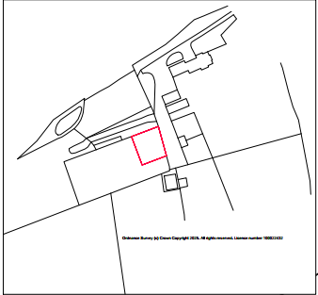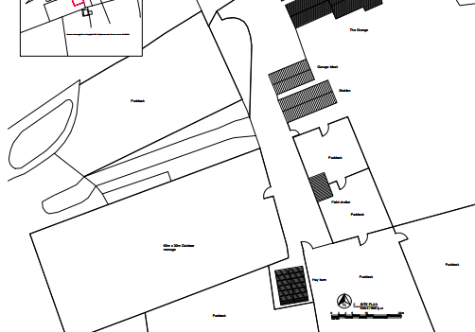
Location Plan Existing Site Plan (In Part).

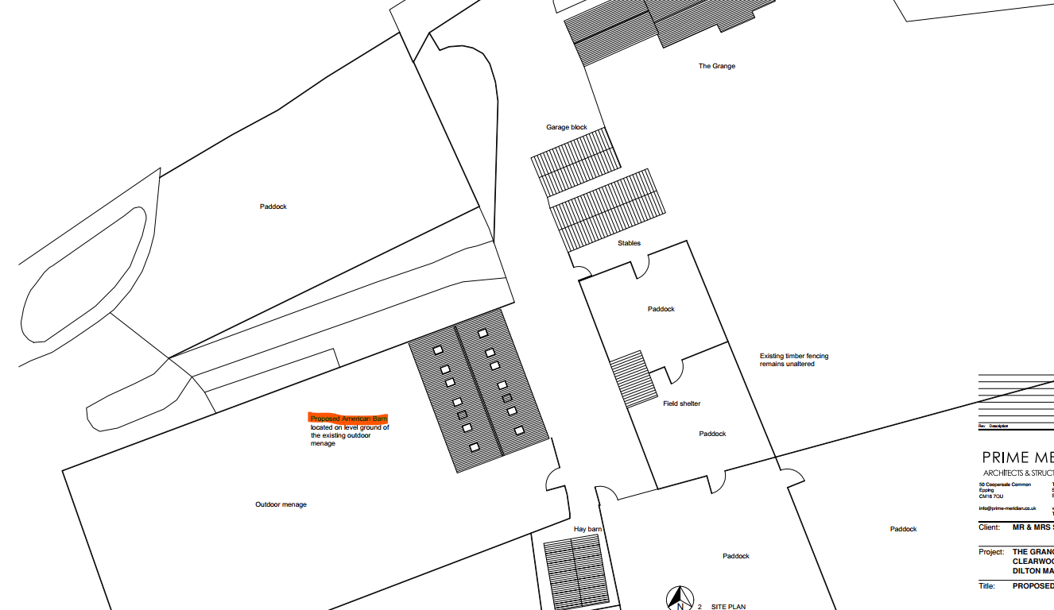
Proposed site plan with proposed stables building highlighted in orange.

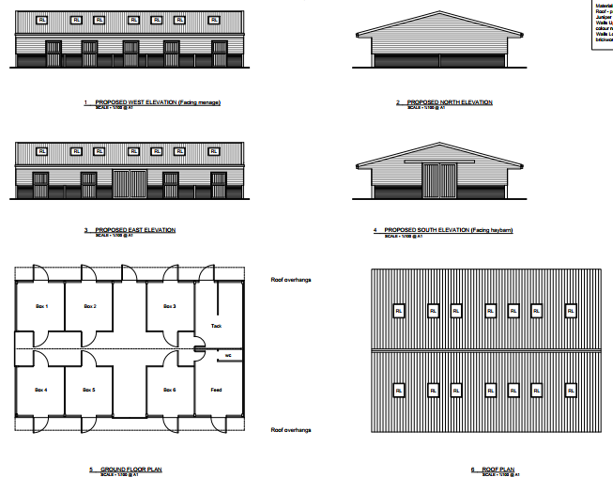
Proposed elevations with floor and roof plans

The proposal would see the construction of a large sized stable barn within the existing manège area, as shown in the above proposed site plan. The manège is already in place having received permission some years ago and measures 60m by 30m. The proposal would open onto it and so would have direct access to its use from the stables. The proposed stable block would be of a standard design with a low-pitched roof, whose upper walls would be constructed from natural timber, with its lower walls being made from red brick, matching the existing house. The roof would be covered with rolled aluminium sheeting coloured juniper green.

The large size of the manège and the contained surrounding area allows for the siting of the stables at this location without looking out of context. The supplied aerial photograph shows this to be the case:

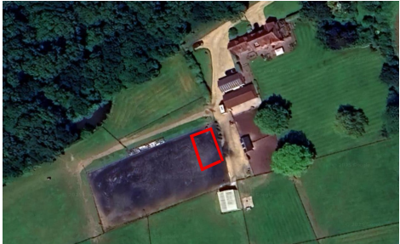

The stables building would have six individual horse box cubicles within it, together with two additional rooms for the storage of feed and tack. There would also be entrance doors to each stable box and storage area, as shown in the above snippets.

The use of a part of the menage for the siting of the barn prevents developing other undeveloped areas of the site for its provision and which in turn helps to maintain the rural appearance of the site.

Therefore, in summary, having regard to the above, the proposal complies with the design principles set out in Core Policy 57 of the Wiltshire Core Strategy and Appendix D of the Wiltshire Design Guide.

Amenity
Point vii of Core Policy 57 - Ensuring High Quality Design and Place Shaping of the Wiltshire Core Strategy seeks to ensure that developments do not adversely affect neighbouring properties. The National Planning Policy Framework (NPPF), particularly Paragraph 135(f), stresses that planning decisions should ensure developments provide a high standard of amenity for existing and future users.
The proposed stable building would be single storey and would look out onto and face its own private land area. The site for the proposals is shielded from views from the north by dense woodland and from the south by the rising ground. There are no immediate nearby neighbours who may be affected by the proposals, and the following photograph further shows the contained and private nature of the site:

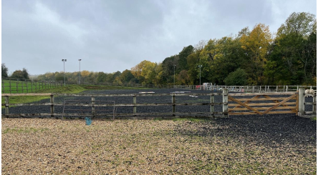

The proposal therefore accords with Core Policy 57 point vii. in respect of safeguarding residential amenity and Appendix D of the Wiltshire Design Guide.

Highway Matters.
Core Policy 57 (xiv) of the Wiltshire Core Strategy seeks to ensure that development must meet the requirements of Core Policy 61. This policy requires proposals to be capable of being served by safe access to the highway network. Core Policy 64 seeks to ensure compliance with parking standards set out in the Local Transport Plan. The National Planning Policy Framework (NPPF), particularly Paragraph 115 and 116, requires that development proposals do not have an unacceptable impact on highway safety and that safe and suitable access to the site can be achieved for all users.

The proposed development would continue to use the established site access which would not be altered and would not have any adverse impact on highway safety. The Council’s highways officer has been consulted who has not raised any objections. As set out earlier in the report, the use of the stables would be limited to non-commercial purposes to ensure that there would be no material increase in vehicular traffic.

The proposal is therefore considered to comply with Core Policies 57 (xiv), 61 and 64 of the Wiltshire Core Strategy, the NPPF, and the Wiltshire Local Transport Plan.

Public Right of Way.
There is a public right of way to the north boundary of the site (ref.DMAR31) over which access to the site is gained. The right of way continues into a non-vehicular footway, to the north of the site, as shown by the mapping extract below showing the definitive route. However, the proposed stables would be lower than the existing haybarn and The Grange and will appear within the context of the existing built form. The backdrop to the barn will be the large mature trees in the grounds of The Grange and separated by the distance and so consequently will not create a harmful visual impact. The following photograph provided by the application shows that the proposed barn (in red outline) would not be visually harmful:

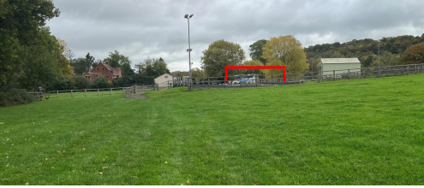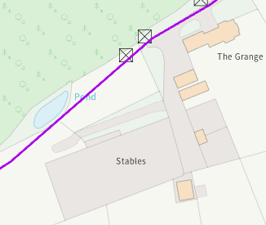
Site photograph Plan showing public footpath

Ecology Impact
CP50 requires no net loss of biodiversity on site. The council’s ecologist has been consulted who notes that the proposed development would not cause any loss of functional habitat for bats, as none exists within the development boundary because it is an artificial surface, with the site being located within an existing equestrian facility. The ecologist commented that based on the function of the site there is already a baseline level of disturbance, as there is artificial lighting onsite including six fixed floodlights surrounding the manège.

The ecologist comments that any light spill from the facility onto the surrounding habitat, particularly the woodland edge, must not be increased above baseline levels because of this development. No new lighting is proposed in the submitted plans, and the agent has confirmed that the development will not include any additional operational lighting that would cause degradation. The ecologist concludes that given the small scale and temporary nature of the works, the baseline disturbance, and existing lighting associated with the facility, any impacts arising during the construction phase are unlikely to result in significant effects on bats.

The site is within consultation zones for bats associated with the Bath & Bradford on Avon Bats Special Area of Conservation SAC, and also the yellow medium risk zone of the Trowbridge & Westbury Bat Mitigation Strategy (TWBMS). The yellow medium risk zone represents the areas where habitat has been shown to be of importance, or is highly likely to be of importance for bats associated with the Bath and Bradford-on-Avon Bat SAC, the application has therefore been considered under the Habitats Regulations.

The application site lies within the 6.4km zone of influence of the Salisbury Plain SPA and considering the HRA for the Wiltshire Core Strategy and the HRA for the Wiltshire Housing Site Allocations Plan, it is screened out of Appropriate Assessment due to the low potential impact of recreational pressure on stone curlew.

A test of likely significance was carried out by the relevant Competent Authority (Wiltshire Council) as required by Regulation 63 of the Conservation of Habitats and Species Regulations 2017 (as amended). This concluded that given the scale and nature of the development and temporary construction impacts and operational impacts would be de-minimus. The HRA concluded that the application is not likely to have significant impacts on the Bath & Bradford on Avon bat SAC and Salisbury Plain SPA, subsequently the application is screened out of Appropriate Assessment.

The ecologist concludes that no objections are raised subject to two planning conditions being inserted relating to compliance with submitted documentation and the control of exterior lighting.

Biodiversity Net Gain.
The application is exempt from the requirement to deliver Biodiversity Net Gain under Schedule 7A, Section 4(2)(a) of the Town and Country Planning Act 1990, as inserted by the Environment Act 2021, because the proposed development is unlikely to result in any net loss of biodiversity due to its location on the existing surfaced area of the manège.

CONCLUSION
The principle of development is acceptable subject to the use of the building remaining for non-commercial purposes as set out in the accompanying statement since it maintains the existing use of the land. The proposed development is considered acceptable in terms of its design, scale, and relationship with the surrounding area and would not result in any unacceptable harm to the character of the locality, the amenities of neighbouring occupiers, nor the interests of highway or ecology.

The proposal is therefore considered to comply with the relevant policies of the Wiltshire Core Strategy, the Wiltshire Local Plan, and the National Planning Policy Framework. As such, the application is recommended for approval, subject to the conditions set out below.

RECOMMENDATION: Planning Permission be GRANTED subject to conditions.

