APPLICATION FOR HOUSEHOLDER PLANNING PERMISSION
DELEGATED REPORT

APPLICATION REFERENCE: | PL/2025/09478
APPLICATION TYPE: | Householder planning permission
SITE ADDRESS: | 2 Hillview Close, Amesbury, Salisbury, SP4 7AB
DEVELOPMENT DESCRIPTION: | Erection of side and rear extensions
RECOMMENDATION: | That Planning Permission be GRANTED

PROPOSAL

The proposal seeks planning permission for the single storey rear and side flat roofed extensions and internal alterations to an existing single storey dwelling. The extensions would create a kitchen/dining/ living space and a third bedroom. An existing detached garage would be demolished.

Revised elevations were received 6th February 2026 clarifying the proposed materials. Further revised plans were received 10th March 2026, removing the parapet roof, adjacent to the northwest boundary to reduce the eaves height and showing onsite parking.

Existing and proposed plans

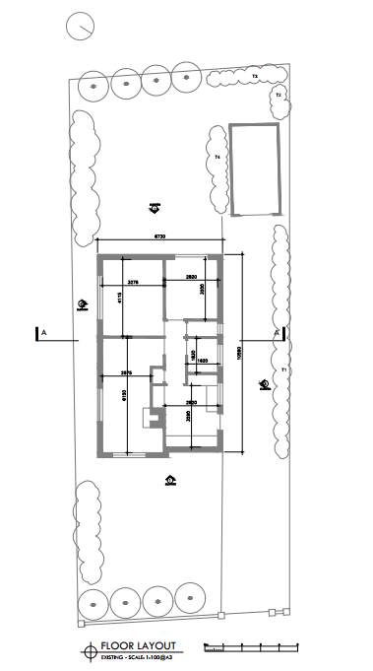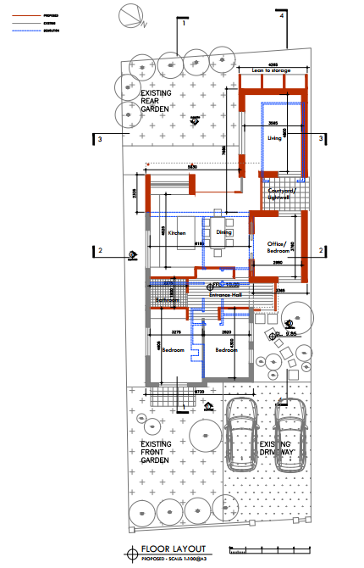

Proposed elevations

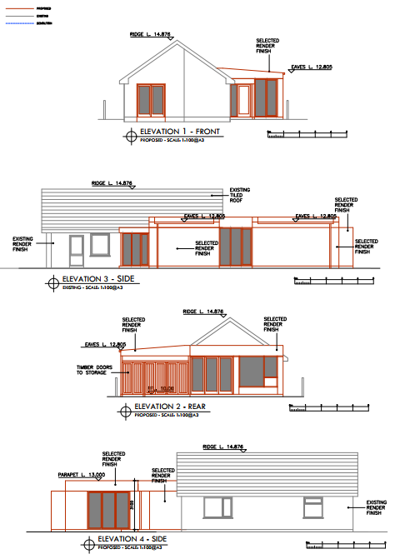

SITE DESCRIPTION/CONTEXT
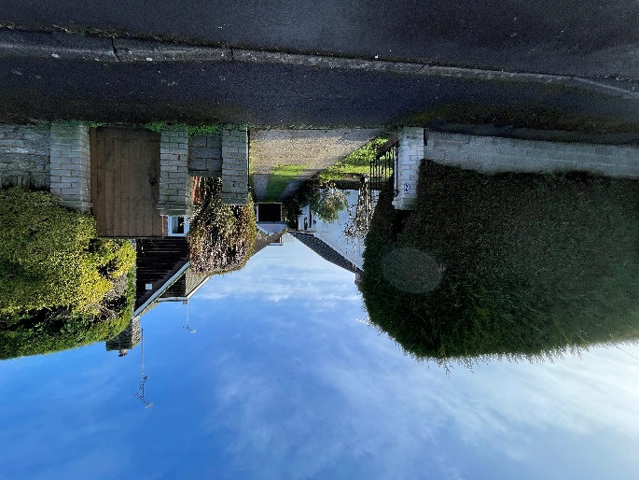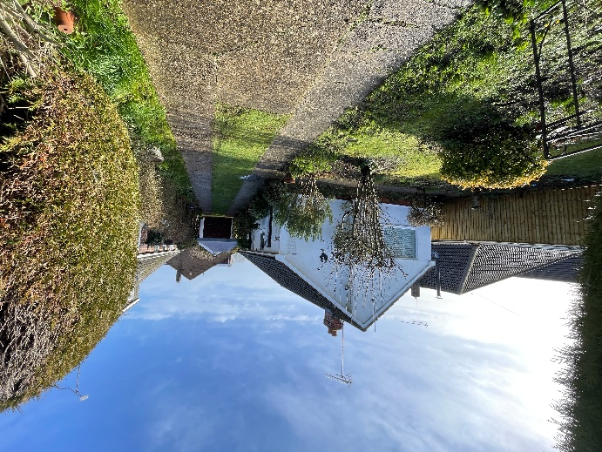

The application relates to 2 Hillview Close, a detached single storey dwelling on the northern edge of the Market Town of Amesbury, as defined by Wiltshire Core Strategy (WCS) core policies 1 (Settlement Strategy), 2 (Delivery Strategy) and CP 4 (Spatial Strategy for the Amesbury Community Area). The property has painted render walls, with a pantile roof.

The property sits centrally to the plot; a large mature hedge screens it from the road. There is off-road parking on a driveway that extends along the north west boundary to a detached garage at the rear of the site. There are residential neighbours on all sides, these are typically detached bungalows, situated close to the shared boundaries.

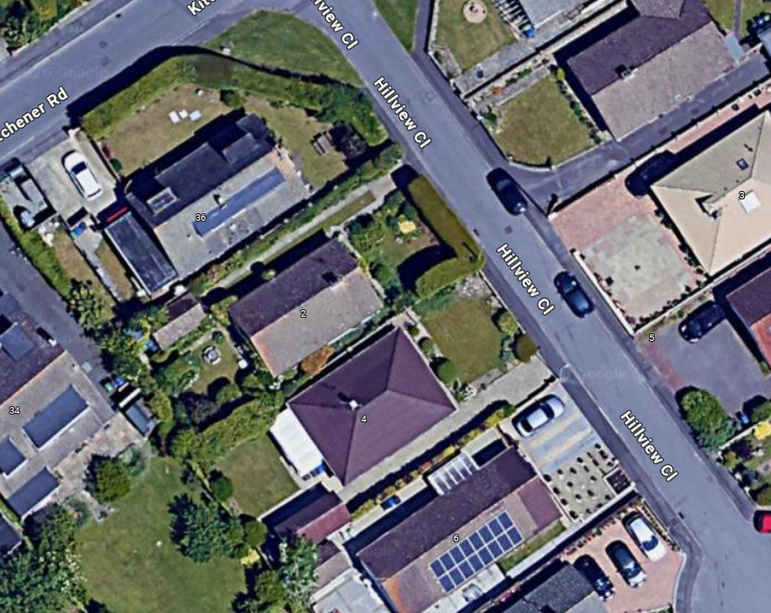
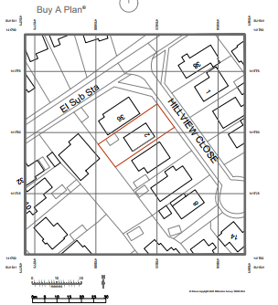

PLANNING HISTORY

None

RELEVANT POLICIES AND GUIDANCE

Wiltshire Core Strategy:
- Core Policy 1: Settlement Strategy
- Core Policy 2: Delivery Strategy
- Core Policy 4: Amesbury Community Area
- Core Policy 57: Ensuring High Quality Design and Place Shaping
- Core Policy 61: Transport and New Development

The Wiltshire Local Transport Plan 2011 – 2016: Car Parking Strategy (March 2011)
Wiltshire Design Guide: Appendix D – Design Guidance for Householder extensions

The National Planning Policy Framework (NPPF)

The Planning Practice Guidance

National Design Guide

CONSULTATION RESPONSES

Amesbury Town Council: No comment

REPRESENTATIONS

No comments were received.

ASSESSMENT

Section 38(6) of the Planning and Compulsory Purchase Act 2004 states:

"If regard is to be had to the development plan for the purposes of any determination to be made under the planning Acts, the determination must be made in accordance with the plan unless material considerations indicate otherwise."

In accordance with this statutory requirement, this application has been assessed against the relevant policies of the Development Plan, including the adopted Wiltshire Core Strategy (2015) and, where applicable, any made Neighbourhood Plans.

Design and Impact upon the character and context of the area

Core Policy 57 - Ensuring High Quality Design and Place Shaping of the Wiltshire Core Strategy seeks to ensure that all new development is of high design quality, reflecting local context, character, and distinctiveness.

The proposals are for a single storey extension to the north and east of the existing dwelling. The existing detached garage would be demolished. There is proposed to be a 3.365 x 4.4m side extension on the north elevation to create an office/bedroom 3. There is then proposed a 2.3m rear extension across the full width of the west elevation and then a further 4.265m x 5.54m extension to the north west corner of the site to create a living room with lean-to storage. An enclosed porch is proposed on the north elevation. The proposed extensions would have flat roofs, behind a small parapet upstand, materials are proposed to be render. Amended plans were received during the application process, omitting the parapet wall to the roofs along the northwest boundary, replacing with a flat roof eaves detail to reduce the height of the extensions adjacent to neighbour 36 Kitchener Road.

The arrangement of the extensions avoids any windows to habitable rooms facing towards the northwest boundary and creates a small courtyard/lightwell between the living room and bedroom extensions to provide daylighting.

The proposals are a contrasting aesthetic to the existing dwelling, with parapet roofs and larger areas of glazing, this is considered appropriate in the context of the dwelling and surroundings where there is no distinct architectural style and a mix of property types. The proposed extensions are in three parts and utilise the footprint of the existing garage, this breaks up the massing and ensures that the proposals are subservient and not unduly obtrusive. The proposed flat roofs with small parapets or eaves is considered appropriate.

Having regard to the above, the proposal complies with the design principles set out in Core Policy 57 of the Wiltshire Core Strategy and Appendix D of the Wiltshire Design Guide.

Amenity

Point vii of Core Policy 57 - Ensuring High Quality Design and Place Shaping of the Wiltshire Core Strategy seeks to ensure that developments do not adversely affect neighbouring properties.

The National Planning Policy Framework (NPPF), particularly Paragraph 135(f), stresses that planning decisions should ensure developments provide a high standard of amenity for existing and future users.

The proposed development has been assessed in terms of its potential impact on the residential amenity of neighbouring properties, with particular regard to loss of light, overshadowing, loss of privacy, and overbearing effects.

The proposals have the potential to impact upon the occupiers of 36 Kitchener Road by reason of its location. 36 Kitchener Road is a detached 1.5 storey dwelling, sited within 1m of the shared boundary with 2 Hillview Close. There is an existing boundary brick wall and hedge between the two properties.

Photo of 2 Hillview Close driveway and 36 Kitchener Road
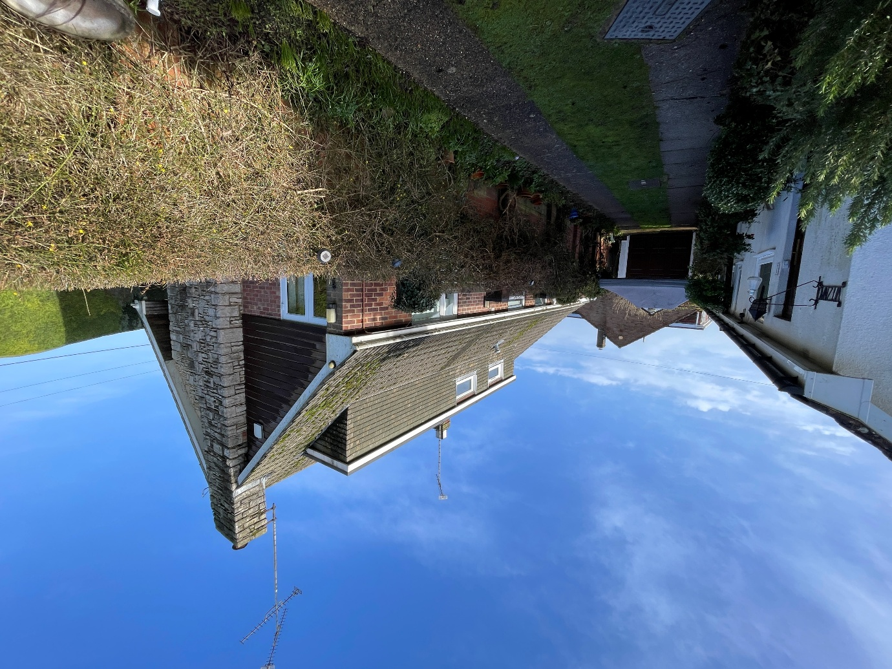

Existing plans of 36 Kitchener Road (rightmove)
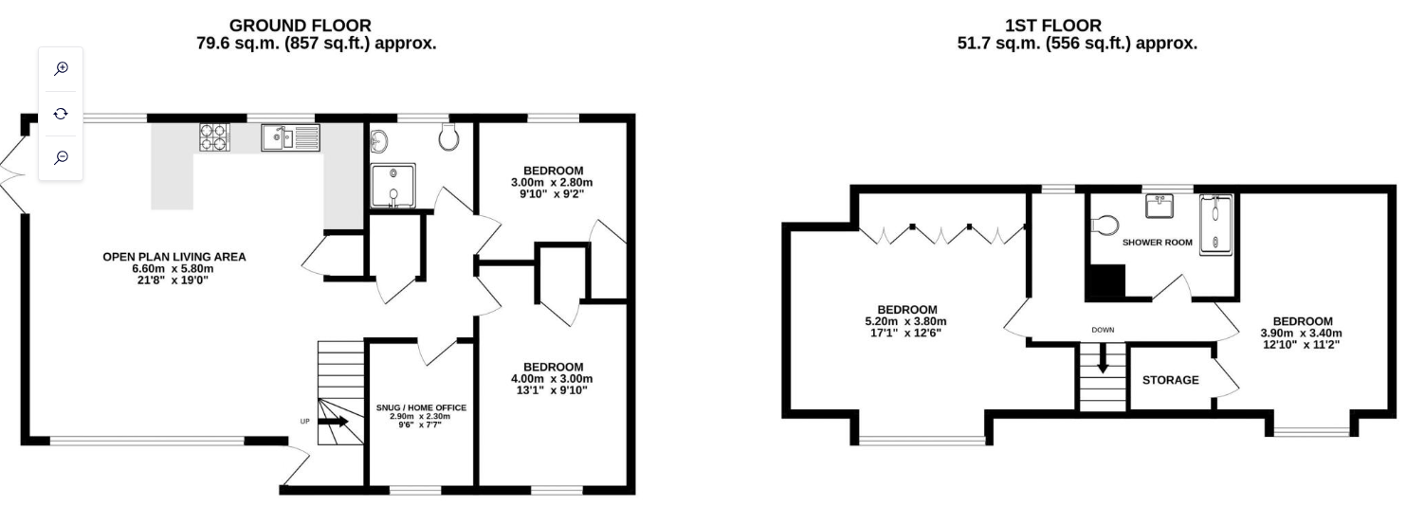

The proposals extend up to the shared boundary, there is the potential for overbearing effects and loss of light. The extensions are single storey, with a small parapet (3m above finished floor level, approx. 750mm higher than the eaves of the dwelling) and the two areas of extension along the northeast boundary have a traditional flat roof eaves detail, reducing the height as far as possible. The layout of the proposal, broken up with a courtyard, avoids a bulky extension close the boundary.

The proposed north-west extension, which will contain the living room, is positioned on the footprint of the existing garage. As such, its relationship with 36 Kitchener Road is broadly comparable to the existing arrangement in terms of outlook, potential loss of light and general sense of enclosure.

The existing plans for 36 Kitchener Road show that the windows on the affected elevation serve a WC and part of an open-plan living area. This living space also benefits from additional windows and doors on two other elevations. Taking into account the modest height of the proposed extension and its position along the shared boundary, the extent of any additional impact on these rooms is limited and is not considered to result in a materially greater effect than the shadowing already created by the existing boundary treatment and dwelling to the south.

As the extension is single storey, modest in scale in relation to the host property and its plot, and located on the north-west side of the dwelling, any potential impact in terms of overshadowing or dominance is unlikely to be significant when compared with the existing situation, and is therefore acceptable.

The development is single storey only, so the first-floor windows of 36 Kitchener Road will remain unaffected.

No new windows are proposed facing the shared boundary. Although some glazing is positioned toward it, these openings are in line with those on the existing bungalow, and as such, no harmful loss of privacy for neighbouring occupiers is anticipated.

No objections were received from this neighbour, and the revised plans address initial concerns raised by the Case Officer. Given the small-scale, single-storey nature of the scheme, the proposals are not considered to result in any material harm to the amenity of neighbouring properties to the south or west.

On balance, the proposals therefore accord with Core Policy 57 point vii in respect of safeguarding residential amenity and Appendix D of the Wiltshire Design Guide.

Highways Impact
Core Policy 57 (xiv) of the Wiltshire Core Strategy seeks to ensure that development must meet the requirements of Core Policy 61. This policy requires proposals to be capable of being served by safe access to the highway network. Core Policy 64 seeks to ensure compliance with parking standards set out in the Local Transport Plan.

The National Planning Policy Framework (NPPF), particularly Paragraph 115 and 116, requires that development proposals do not have an unacceptable impact on highway safety and that safe and suitable access to the site can be achieved for all users.

The demolition of the garage and proposed development on part of the driveway will result in the loss of parking space. The property will have three bedrooms, the Wiltshire Local Transport Plan 2011 – 2016: Car Parking Strategy (March 2011) Parking Standards require dwellings of three bedrooms to have a minimum of two parking spaces. The site would still be capable of accommodating two parking spaces within the driveway. The development is therefore acceptable in terms of parking provision and complies with Core Policy 64 of the Wiltshire Core Strategy.

Biodiversity Net Gain

Householder planning applications are exempt from the requirement to deliver Biodiversity Net Gain under Schedule 7A, Section 4(2)(a) of the Town and Country Planning Act 1990, as inserted by the Environment Act 2021.

CONCLUSION

The proposed development is considered to be acceptable in terms of its design, scale, and relationship with the surrounding area. It would not result in any unacceptable harm to the character of the locality, significantly impact the amenities of neighbouring occupiers, or the interests of highway safety or ecology.

The proposal is therefore considered to comply with the relevant policies of the Wiltshire Core Strategy, the Wiltshire Local Plan, and the National Planning Policy Framework. As such, the application is recommended for approval, subject to the conditions set out below.

RECOMMENDATION: That Planning Permission be GRANTED subject to conditions.

- The development hereby permitted shall be begun before the expiration of three years from the date of this permission.

REASON: To comply with the provisions of Section 91 of the Town and Country Planning Act 1990 as amended by the Planning and Compulsory Purchase Act 2004.

- The development hereby permitted shall be carried out in accordance with the following approved plans and documents:
25.14-400P Site Location Map, received 15.01.2026
25.14-401P Proposed Floor Layout Rev 1, received 10.03.2026
25.14-402P Proposed Site Layout Rev 1, received 10.03.2026
24.14-403P Proposed Section & Elevation Sheet 1 Rev 1, received 10.03.2026
24.14-404P Proposed Section & Elevation Sheet 2 Rev 1, received 10.03.2026
24.14-405P Proposed Elevations Rev 1, received 10.03.2026

REASON: For the avoidance of doubt and in the interests of proper planning.
- The materials to be used in the construction of the external surfaces of the development hereby permitted shall match in material, colour and texture those used in the existing building and detailed on the application form and approved plans.
REASON: In the interests of visual amenity and the character and appearance of the area.

