Planning Application:
Tudor House,
Horton, Devizes, Wiltshire SN10 3NB

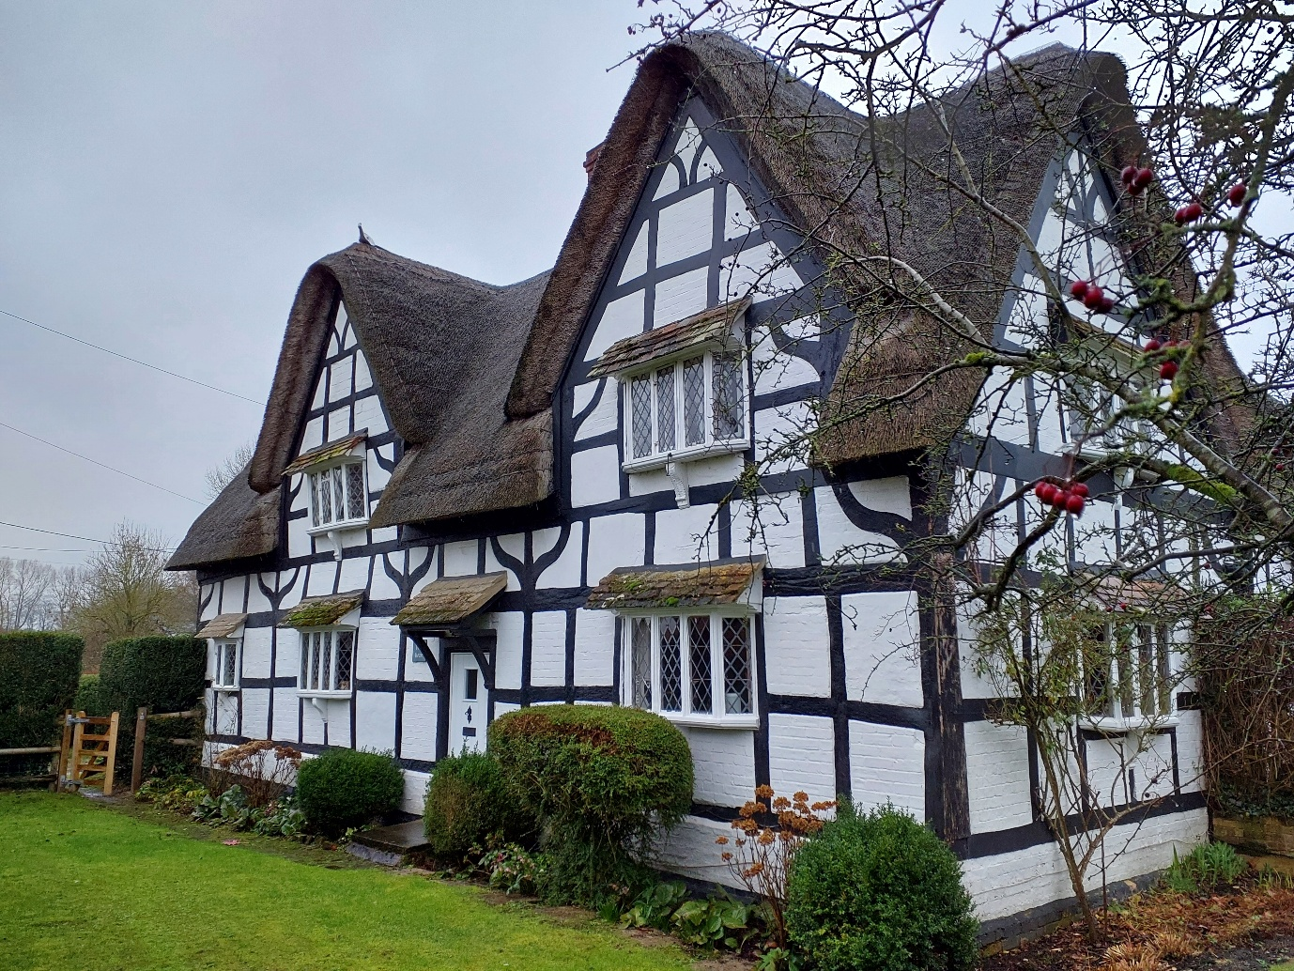
Project:
To install a thru floor disabled lift into the property from ground floor to first floor.
Address:
Horton, Devizes, Wiltshire SN10 3NB
Owner(s):
Mr & Mrs G Dodd

Contents:
1) Heritage Statement
The Heritage asset
2) Making the strategic case
a) The building.
b) Options for maintaining accessibility and mobility for the owners/occupiers.
3) Considering a suitable location and alternative options.
c) Enabling access between the two floors
d) Achieving full mobility in the two main floors.
e) Assessment of the two options.
4) Proposed works including methodology.
f) Description of Property and Proposed Works.
g) Assessing the impact of the proposal:
h) The Objective of the Installation of the Lift
5) Design & Access Statement
i) Considering a suitable location and alternative options:
j) Proposed works.
k) Access.

- The building and Heritage asset.
General photos of building.
Corner view looking down The Street
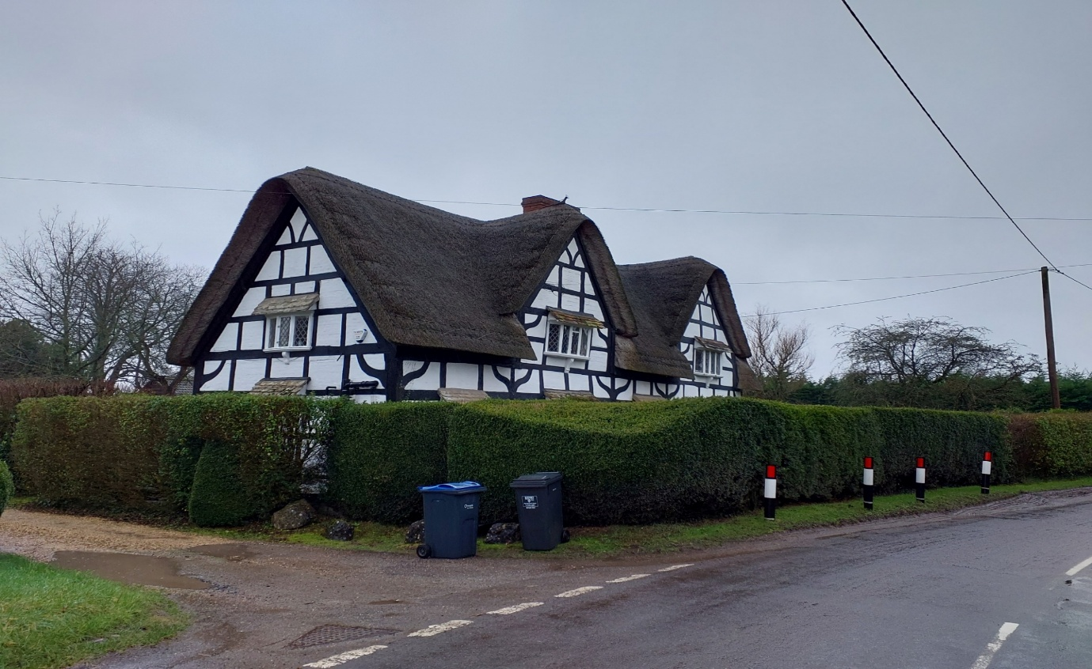
Rear view from Road.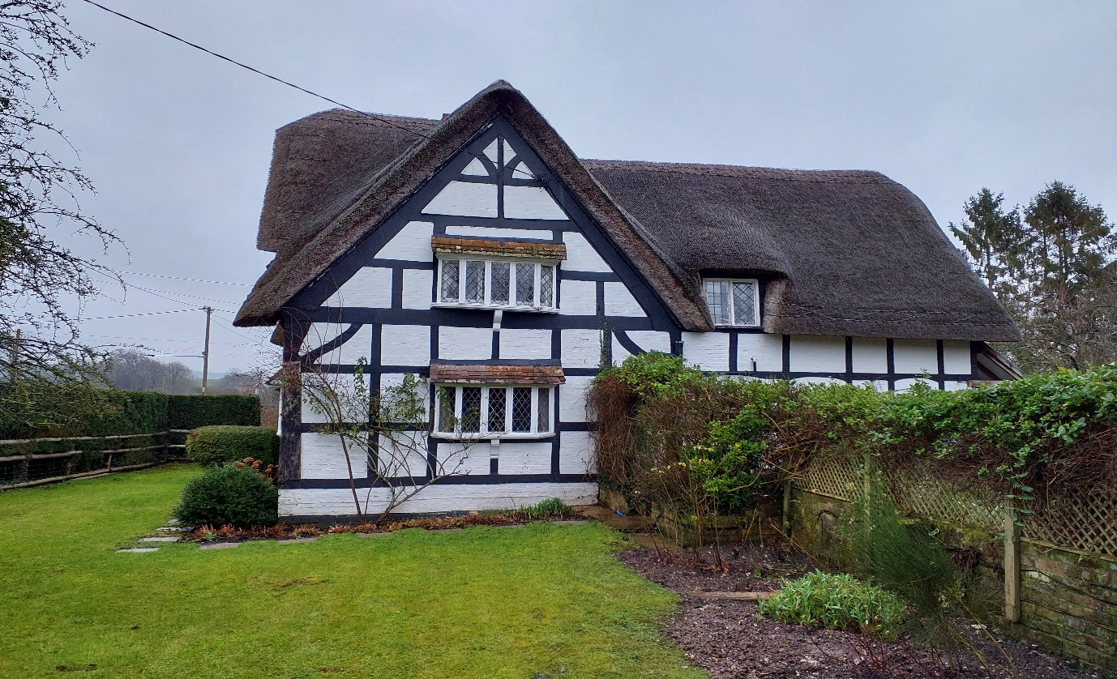

Official list entry
Heritage Category:
Listed Building
Grade:
II
List Entry Number:
1193416
Date first listed:
29-Apr-1987
List Entry Name:
Tudor Cottage
Statutory Address 1:
TUDOR COTTAGE

Location
Statutory Address:
TUDOR COTTAGE
The building or site itself may lie within the boundary of more than one authority.

District: Wiltshire (Unitary Authority)
Parish: Bishops Cannings
National Grid Reference: SU 04928 63362
Details
BISHOPS CANNINGS HORTON SU 06 SW (south side) 6/135 Tudor Cottage

II

House. Late C16-early C17. Timber framed with whitewashed wattle and daub and brick infilling. Brick sill and thatched roof. Single storey and attics, 3½ bays. Lobby entry plan with entrance to half bay between bays 2 and 3, the latter with a later C17 two- bay rear wing. Framing 3 panels high with ogee corner braces. Door boarded with pent stone-tiled porch. Moulded 5-light canted oriel windows on single carved brackets, and tiled roofs. Small diamond glazing. Windows 3-light to end bay and gable. Upper windows in bays 2 and 3 within raised gables. Two flush dormers to rear. Thatch peaked at gables and central brick stack. Lean-to clasping rear wing, boarded, with Bridgewater tiled roof. Interior has later stair in lobby. Bay 3, original parlour, has moulded cross ceiling beams and chalkstone fireplace with timber fire beam, and smoking chamber centrally at rear. Original hall in bay 2 has similar fireplace with side oven, and third bread oven in same stack opens off entrance lobby. Smaller fireplace to chamber over parlour, now divided as access to rear wing. Central half-bay windbraced. Rear wing has chamfered cross beams with pyramid bar stops, and carved circular motif at intersection. (WILBR B 1717)

Listing NGR: SU0492863362

Legacy
The contents of this record have been generated from a legacy data system.

Legacy System number:
311557
Legacy System:
LBS

Legal
This building is listed under the Planning (Listed Buildings and Conservation Areas) Act 1990 as amended for its special architectural or historic interest.

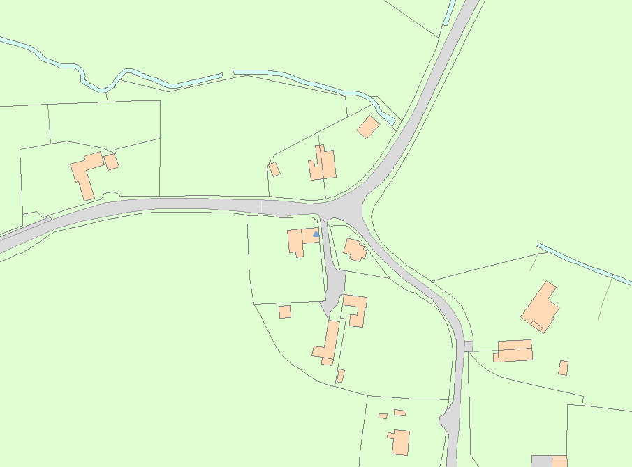
There is limited information available online that give an insight into the history and significance of the heritage asset. Therefore, we have followed planning guidance available from the Planning Document (SPD) (2014; the Historic England Conservation Principles; and the National Planning Policy Framework (NPPF, to assess the significance of the heritage asset.
The Historic England Conservation Principles suggest that the proposed works can normally be considered acceptable if there is “compelling evidence of the evolution of the place, and is executed in accordance with that evidence.

- Making the strategic case:
- The building.
House. Late C16-early C17. Timber framed with whitewashed wattle and daub and brick infilling. Brick sill and thatched roof. Single storey and attics, 3½ bays. Lobby entry plan with entrance to half bay between bays 2 and 3, the latter with a later C17 two- bay rear wing. Framing 3 panels high with ogee corner braces. Door boarded with pent stone-tiled porch. Moulded 5-light canted oriel windows on single carved brackets, and tiled roofs. Small diamond glazing. Windows 3-light to end bay and gable. Upper windows in bays 2 and 3 within raised gables. Two flush dormers to rear. Thatch peaked at gables and central brick stack. Lean-to clasping rear wing, boarded, with Bridgewater tiled roof. Interior has later stair in lobby. Bay 3, original parlour, has moulded cross ceiling beams and chalkstone fireplace with timber fire beam, and smoking chamber centrally at rear. Original hall in bay 2 has similar fireplace with side oven, and third bread oven in same stack opens off entrance lobby. Smaller fireplace to chamber over parlour, now divided as access to rear wing. Central half-bay windbraced. Rear wing has chamfered cross beams with pyramid bar stops, and carved circular motif at intersection. (WILBR B 1717)
- Planning History.
K/45188/L The re-thatching of cottage with long straw, in traditional Wiltshire style
K/34397 - Reinstatement of vehicular access, new hardstanding and turning area, re-siting of gate and erection of detached double garage
K/34019/L - Insert window to rear wall of Reception 3.
K/34018/L – Paint timber clan lean too
K/33997/L - To insert patio doors to rear wall of kitchen.
K/34444/L - To remove modern bannisters and level irregular and dangerous floor area above modern staircase.
K/34043/L - To demolish former lean-to conservatory, make good and replace paving next to house with gravel bed.
K/33977/L - Reinstate rear staircase

- Living on one floor.
While the courtyard approach from the rear parking area provides level access from the street into the house, there are insufficient facilities on the ground floor to support living only on this level, and no potential to create a bedroom and bathroom without substantial detriment to the building’s unique character and heritage. Therefore, the owners have considered two possible options for enabling full mobility access between ground and first floors (i.e. without climbing the staircase), allowing them to remain in their home.
- Considering a suitable location and alternative options
- Enabling access between the two floors
Stair lift:
Investigations have been made into a modern stairlift , due to the design and historical value of the staircase a stair lift alternative has been evaluated and discarded as not a viable option to achieve the required mechanism for travelling between the floors, Limited space to sit without the users hitting their knees, limited space on the stairs restricting any non-users access to the stairs. Its operation on the staircase does compromise the everyday use of the staircase, as well as making the carrying of trays, luggage, and items of furniture etc very awkward or impossible. It also compromises essential space in the hall. Ingenious as it is, the stairlift is designed to carry only a person; it does not provide for moving heavy objects such as packed suitcases between floors – already something of an issue for the owners. In the small but much-used space of the hall, stairs and landing, the stair li is prominent and adversely affects the visual and practical amenity of these areas.
Through-floor lift: Duo Hybrid lift
Investigations have also been made into two modern lift systems, and design work and structural evaluation on has been carried out for the installation on of the preferred system (Stiltz DUO hybrid with Fire seal Lid LIFT). It is an elegant design: the structure supporting the lift is limited to two vertical supports, each 17cms wide and 10cms deep, which is all that is visible when the li car is in the other room. With the li car present the dimensions of the space occupied are 106cms wide and 79cms front-to-back. The location of the lift has been chosen to minimise the visual and physical impact to the two rooms concerned and to provide maximum convenience to the user, as heavy items (suitcases, for example) can be moved as well as a person. The structural works to accommodate the lift are described later in the application. The details of the design and its interaction on with the building are also set out elsewhere in this application.
- Assessment of the two options
Assessment requires trading off the benefits of each solution against the ‘harm’ caused due to the installation – in the context of this building and its character and presentation. We believe that the advantage of the lift – its ease of use, safety, non-interference with users of the staircase and elsewhere in the house, ability to take loads other than people, and fundamentally to permit the current owners to go on living in and taking care of this listed building – outweighs the harm caused by the installation (as detailed in the later part of the application); and noting also that most of the modest structural changes are reversible. The nature of the stair lift installation, if possible, would give rise to minimal harm, due to its method of installation. But the benefits of the mobility it offers between ground and first floors is offset by the presence of the stairlift.
This not only causes awkwardness and inconvenience to other users of the staircase, including those handling bulky items, luggage, trays etc; but it would have an adverse visual impact on the character of this part of the house. It is also offset by the inability of the stairlift to carry bulky and heavy items – indeed anything other than a person. The owners believe that the clear advantage of the through-floor lift greatly offsets the harm done to the building, especially as the work is reversible. The stairlift does not deliver nearly as much benefit, due to its being limited to the movement of a person and other heavy items, and in any case the benefit is offset by the many limitations and inconveniences imposed by the staircase. Its installation however would involve little impact on the fabric of the building, and it is reversible.
- Proposed works including methodology
- Description of Property and proposed works
The proposed works involve creating a new opening within the first floor to allow a Disabled Access Lift to be installed in the Ground Floor Dining room, rising to the First-Floor Master bedroom. Lift supplier Stiltz were approached by the Clients, who have produced proposals for forming the new opening. Their proposals would involve cutting and re-supporting the existing joists to the bedroom floor with new timbers, which would be positioned between the 2 structural elements which will have load bearing capabilities.
The proposed lift would not apply any additional load to first floor, and the opening is small, at around 0.8m x 1.0m. The orientation of the opening would mean that only 2 joists would need to be cut to create it. Stiltz’s structural engineer will assess the capacity of the existing floor and will propose a sympathetic method for forming the opening.
Two of the existing joists would be cut and re-supported by new timber trimmers running between the two new main timbers which will be supported at both ends.
The bedroom floor is a timber joist construction topped with original timber floorboards measuring 270mm in width. They run north to south as you look at the lift from the stairs.
The bedroom floor area will also need to be levelled over the footprint of the lift so that the Steel insert can sit flush with the carpet.

H) The Objective of the Installation of the Lift
The main objective of the lift installation is to provide easier access to the first floor from the lounge on the ground floor. The owner has disabilities and is finding it difficult to walk up the stairs to the first-floor rooms. Life within the owner’s home will be much improved after the lift installation. The nature and layout of this property would make the installation of a ground floor bedroom with washing facilities harmfully to its character and the fabric of the building, the upheaval and destruction to the historical fabric would outweigh the work required to fit the lift in the floor void.

5) Design and Access Statement:
I) Considering a suitable location and alternative options:
Firstly, a stair lift is deemed to be impractical and potentially hazardous to other visitors due to its existing layout and character. The width and curved nature of the staircase would make it difficult for visitors not requiring a stair lift to manoeuvre around its apparatus safely. A stair lift would also negatively impact the aesthetics of the staircase and character of the building. The current staircase is also too steep and narrow to accommodate a stair lift. As evidenced by the alterations to both internal and external features of the building the subsequent changes show that the original house has evolved over the centuries to accommodate the requirements of the occupants. The remodelling works completed have produced minimal disturbance and/or alterations to the heritage assets of the original building fabric. The current owners have replaced non historical items with new structures in keeping with the historical fabric to return it to its former glory.
Having the lift located in the Dining room (not viewable from the front of the property) does not detract from the character of the building. Consideration has been given to the type and size of lift appropriate for the building to achieve the above.
The Trio+ lift is large enough to accommodate a wheelchair and could be considered as delivering greater accessibility and public benefit. However, the amount of the existing building fabric that would need to be removed (such as the joists and plasterboard ceiling) to create a big enough opening for this lift to pass through would be significantly increased. The size of the lift would also mean that the likelihood of it been visible through the windows from the outside of the property is increased. possibly impacting the external appearance of the building.
Therefore, the Duo + Hybrid passenger lift is the most suitable as it takes up the smallest footprint and ensures that the removal and alteration to the existing building fabric is minimal. It is also possible to retro fit grab rails and a fold down seat inside the Duo Plus Hybrid lift which helps to make the lift and the property more accessible to a wider range of user and visitors.
In order to fit the framework, the new timber joist need to be supported by a structural wall as per the structural engineer’s requirements, this is to ensure that the integrity of the building is kept intact and the loading across the joists is sufficient to carry the alterations to the floor void. In most cases this involves the doubling up of the timbers to the side of the lift, wall to wall or structural element with the front trimmer doubled to allow safe access from the lift and the correct loading for the cut joist to the front.

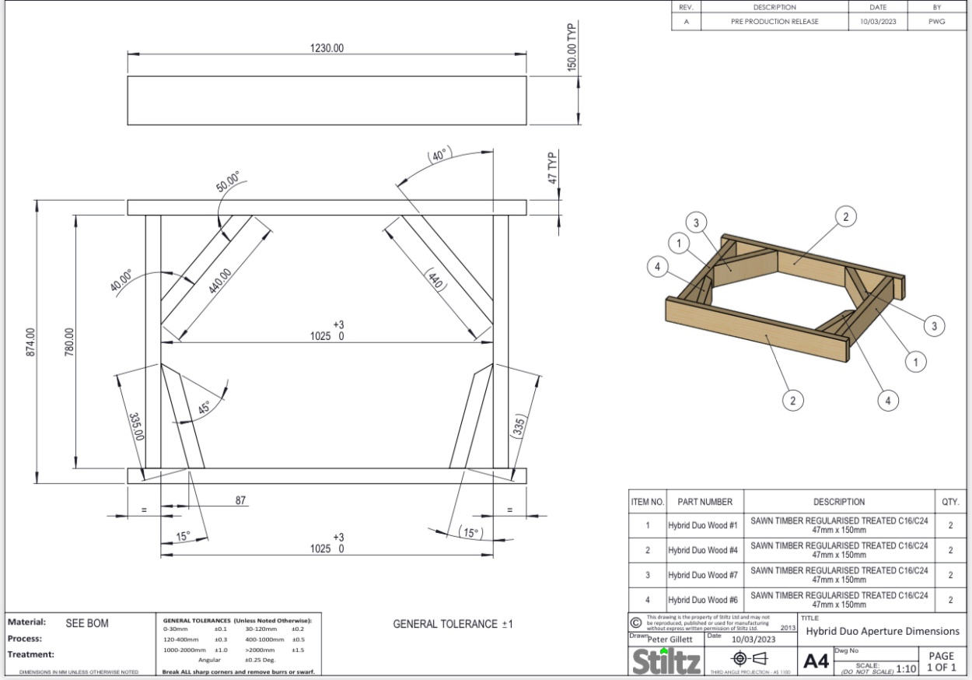
example of the Lift in down position, lid forming the floor and rails visible. Lid can be infilled with the desired covering, normally the existing carpet or laminate flooring.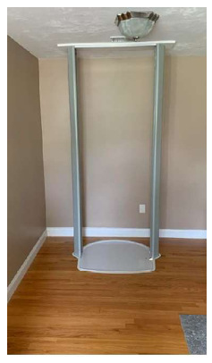

An example of the metal insert in the floor void without the lift installed

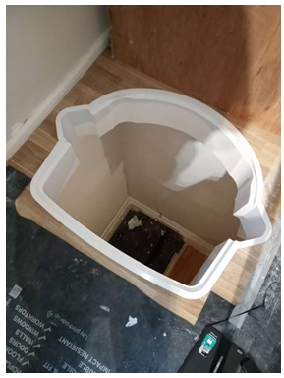
Lift installation seen from the first-floor position. i.e. the up position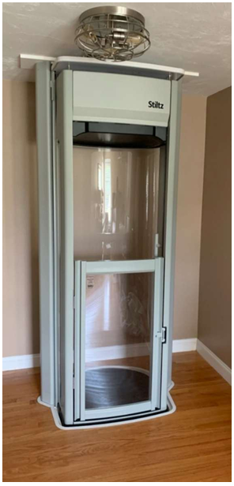

J) Proposed Works:
Please refer to the Duo Plus Lift Schematic Drawings for design and technical information for the lift. To install a thru floor lift rising from the ground floor Dining room up to and the first-floor bedroom:
The proposed works are all subject to the planning and listed consent been granted. All trimming out will follow the recommendations and calculations of the structural engineer. Copies of which will be submitted once the existing joists have been surveyed.
The construction of the floor is uneven as over the years the existing timber have shrunk or moved, to enable the lift to stop on a level floor the existing boards will need to be re addressed with packers placed on top of the existing joist thus levelling the floor. The ceilings have been tested for asbestos and have come back negative.
An approximate area of 1050mm by 825mm of the ground floor Day room ceiling will be removed.
The aperture for the lift is to be created by trimming out and strengthening the original first floor joists as per the structural engineer’s drawings and recommendations. This means that 2 sections of the original joists, approximately 1m in length, will be removed, and additional joists added for structural support.
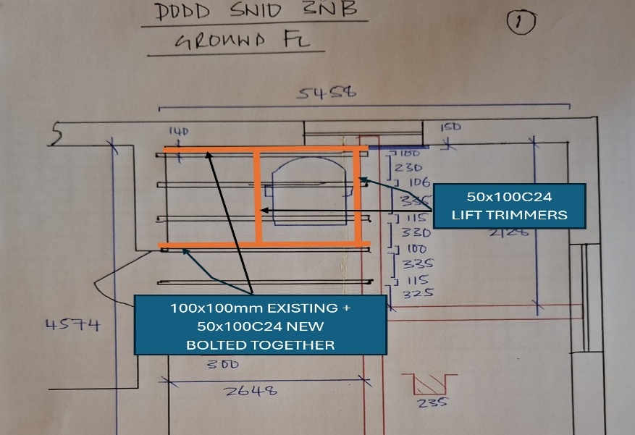
The plasterboard ceiling will also be cut through, equating to approximately 0.8 by 1.2m, over the area of the lift. The joist work around the aperture will be carried out from above, through the bedroom floor. This floor consists of new sawn timbers, any original timbers will be kept and stored for future use. The proposed method of fixing the new timber joists to the existing joists would be to double up and bolt together the new to the existing joist then create an opening 1050mm across by 825mm, all new timbers will be structurally sound and be carried by a supporting wall at each end. A double trimmer will then be positioned in front of the lift at 825mm to pick up and carry the cut joists and thus support the floor in front of the lift.
A steel frame, called the “insert”, will be fitted within the floor void to support the lift, and house the lift lid. It will also finish off the edges of the ceiling via means of a flange to match the lip on the first floor. Please see the Lift Schematic drawings. The insert will fit within the trimmed-out joists. The feet of the guide rails will sit onto the ground floor and will be fixed using non penetrative fixings to prevent the tiled ground floor from been damage.
An new Oak beam will be introduced to support the legs of the lift, this will span between the existing oak beams within the bedroom ceiling.

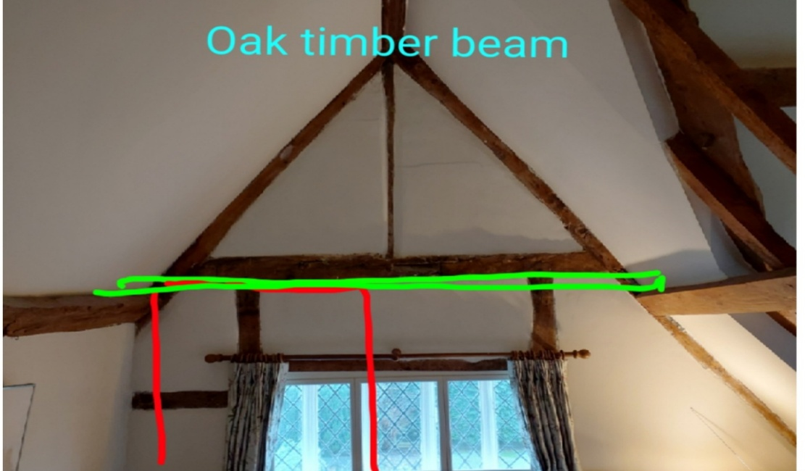
All works will only be to the area of the lift and will have very little impact to the building fabric. The Historic England Conservation Principles (2008) suggests that consideration is given to the reversibility of changes as “our ability to judge the long-term impact of changes on the significance of a place is limited. Interventions may not perform as expected. As perceptions of significance evolve, future generations may not consider their effect in heritage values positive. It is therefore desirable that changes…are capable of being reversed” (para 100: p.46). There is minimal work required to remove a Stiltz lift once installed as the opening can be infilled with joists, floorboards and plasterboard relatively easily without any damage to the surrounding area.

Dining room:
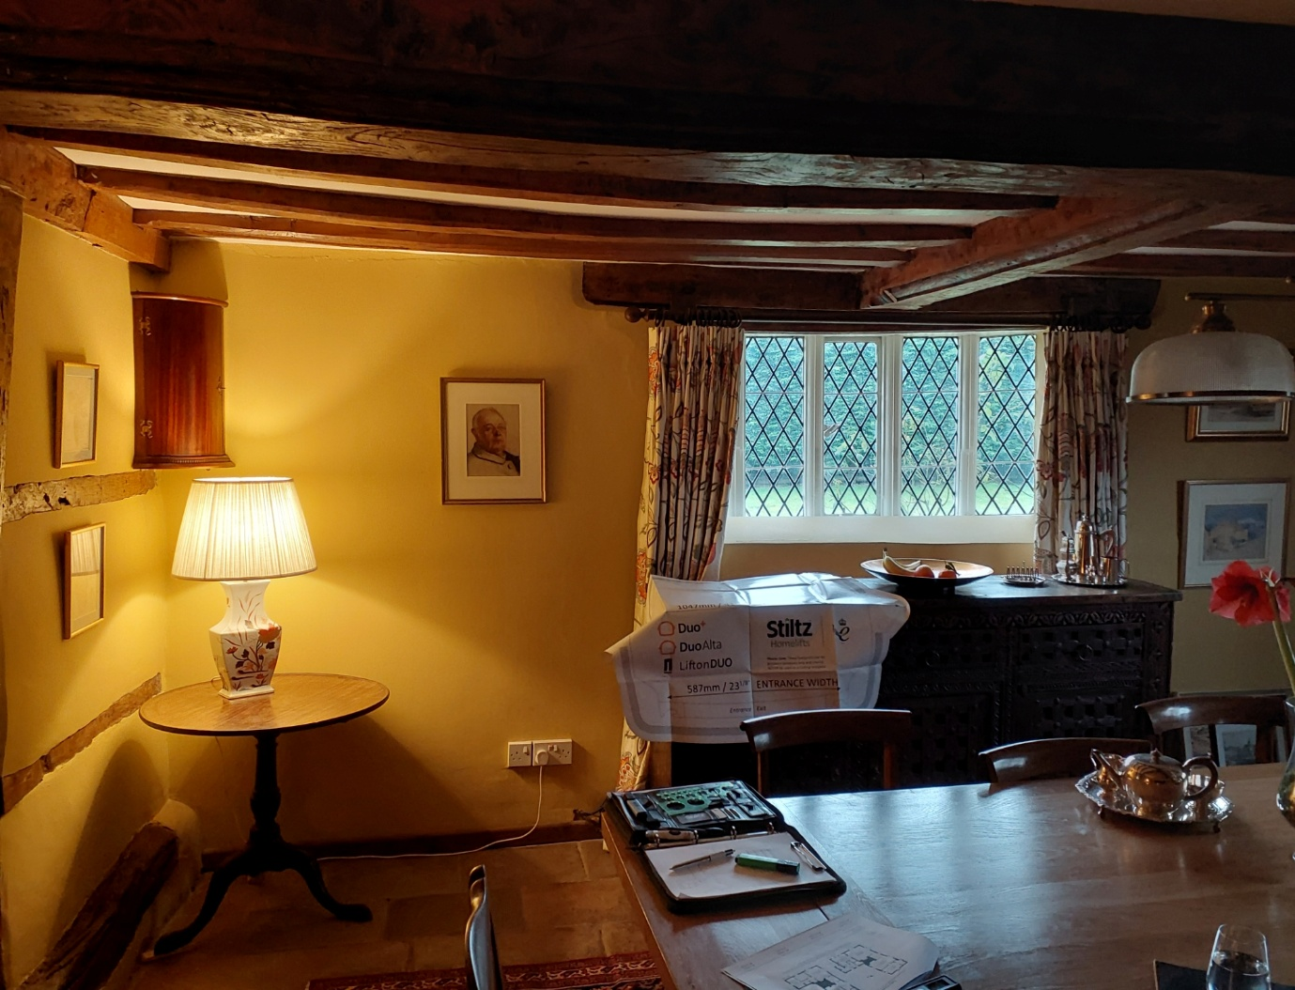
Bedroom: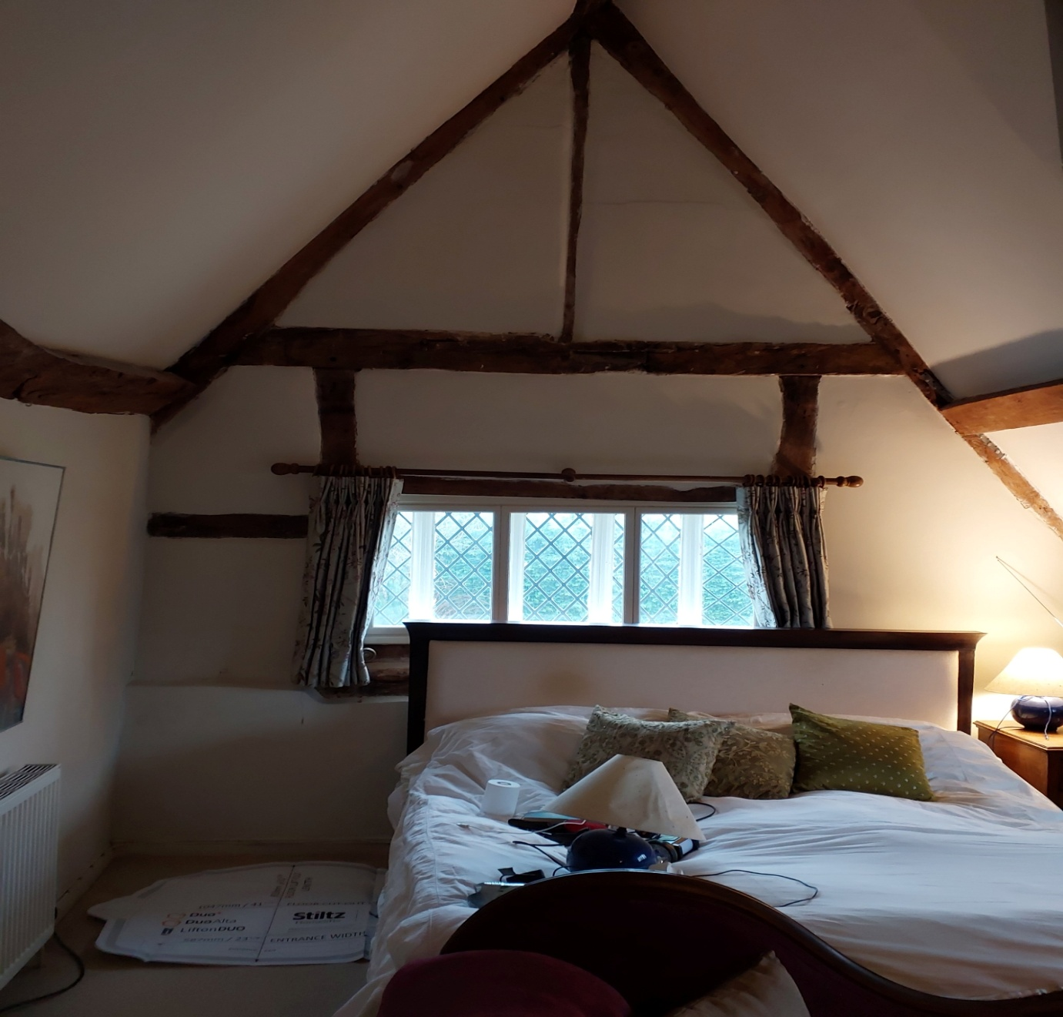

K) Access:
Access into the property is via a private driveway, through the side door of the property and into the kitchen area. Straight ahead is the dining room where the lift will be sited. The doorways are wide enough for the Duo+ hybrid to be carried through as the lift itself is flat packed and built in situ, without requiring any alterations for accessibility.

Looking through the dining room towards the kitchen:
