To: | Samantha Stockley | From: | Drainage

Planning App Ref: | PL/2026/00594
Service Ref: | Drainage
Date: | 5/03/2026

PROPOSAL

Full planning permission for erection of a dwelling with associated car and cycle parking, refuse and recycling provision and private garden.

SITE LOCATION

Lane to the rear of 18 Honey Garston, Calne, SN11 8BL

SUMMARY OF THE CONSULTEE POSITION

Object
Holding Objection: Further information required | X
Support
No comment
No objection
No objection subject to conditions
Consultation not required

APPLICATION DOCUMENTS REVIEWED

• Application Form Redacted
• Block Plan Site Analysis
• Existing Tree Plan
• Design and access statement
• Location Plan
• Location Plan-2
• Proposed Block Plan
• Proposed Drainage and Landscape Plan
• Proposed Elevations
• Proposed Floor and roof plans
• Proposed Site Plan

ASSESSMENT OF THE PROPOSAL

Context
In planning terms, flood risk refers to the potential for development to increase the likelihood or severity of flooding on-site or elsewhere, while drainage considerations relate to the capacity of the site and surrounding infrastructure to manage surface water runoff in a sustainable and effective manner.

The local planning authority must be satisfied that the proposed development will not increase flood risk, either on-site or elsewhere, and that surface water will be managed in a sustainable and coordinated manner.

Where necessary, planning conditions or legal agreements may be used to secure the implementation, maintenance, and monitoring of SuDS and other drainage infrastructure.

Assessment
The application has not been supported with a Site Specific Flood Risk Assessment (FRA). It should be noted that our comments below are reliant on the accuracy and completeness of the other documents and we do not take any responsibility for incorrect data or interpretation made by the authors. The developer, or agent working on their behalf, retains the responsibility for the checking of the design, calculations and details contained in the additional submitted information.

The Wiltshire Council Strategic Flood Risk Assessment, SFRA Data Explorer, has indicated that the site is located within Flood Zone 1 and has a low level of risk from fluvial flooding.

The site has a low level of risk from surface water flooding.

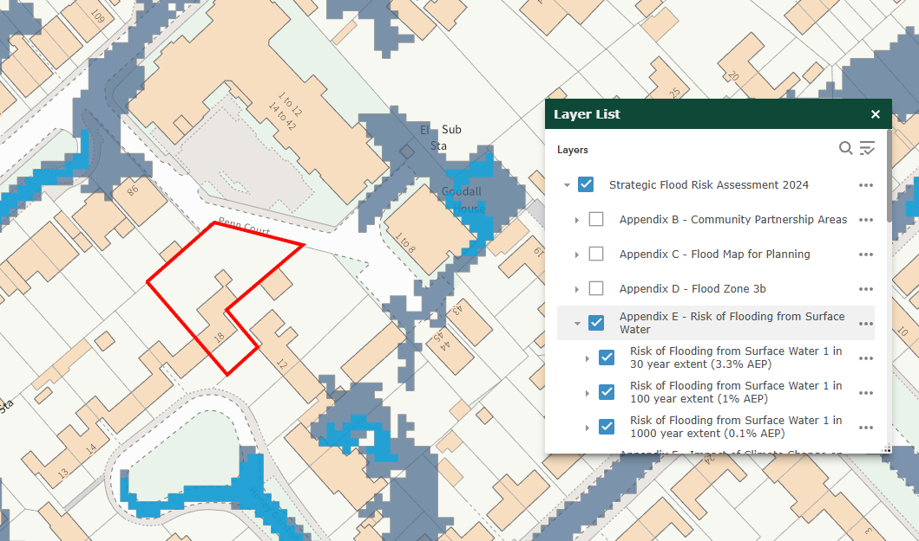

The site has medium risk of flooding from ground water flooding; the groundwater levels are between 0.025m and 0.5m below the ground surface.

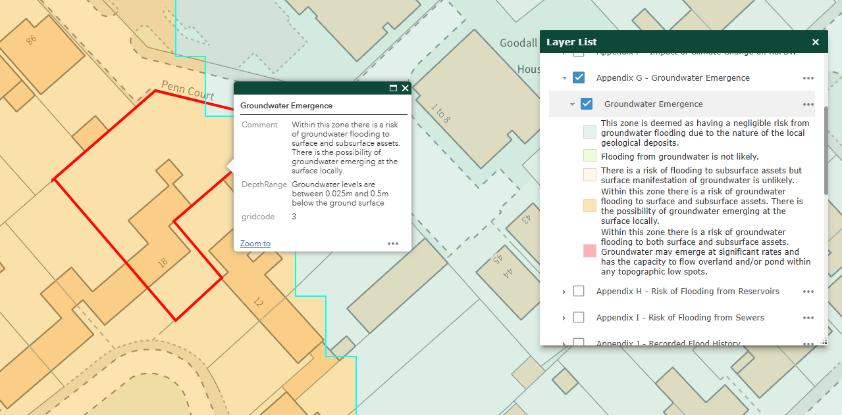

The proposal is the creation of a two-storey detached building to provide a three-bedroom, six persons dwelling with associated car and cycle parking, refuse and recycling provision and private garden.

The applicant proposes to manage surface water using buried attenuation crates. However, they have not confirmed whether the final method of discharge will be via infiltration or through a connection to an existing surface water network. The applicant must demonstrate that the chosen discharge method complies with the surface water discharge hierarchy.

To establish whether infiltration is feasible, BRE 365–compliant soakaway testing should be undertaken on site. Groundwater monitoring will also be required to confirm that 1m clearance can be achieved between the base of any soakaway feature and the maximum groundwater level. If infiltration is found not to be viable, the applicant must instead provide a plan identifying the existing surface water network within the vicinity and confirming the point of connection they intend to use.

RECOMMENDATION

Holding objection as further information required

At this stage, a full assessment cannot be completed due to insufficient information. The following documents/information are required to enable a proper review of the drainage and flood risk aspects of the proposal:

- Evidence that Soil percolation tests/soakage tests have been undertaken in accordance with Building Regulations / BRE 365, and confirmation of infiltration rates – to indicate whether infiltration will be a feasible means of discharge.
- A plan identifying the existing surface water network within the vicinity and confirming the point of connection they intend to use – to confirm that an alternative means of discharge is available should infiltration testing fail.

INFORMATIVES
- The EA’s standing advice for minor extensions will apply.
- All new drainage will need to comply fully with Building Regulations Part H (and they should engage with the building control department in order to ensure this).
- In line with the NPPF and National Standards for SuDS, the applicant should seek to use SuDS wherever practicable as part of the surface water drainage strategy.
- Any new connections to sewers will be subject to S106 agreement under the Water Industry Act with the Sewerage Undertaker.

RELEVANT PLANNING POLICY & GUIDANCE

National Planning Policy Framework (NPPF) NPPF December 2024 Link
Planning and Flood Risk (Paras 170–182)

Wiltshire Core Strategy – Adopted January 2015 Wiltshire Core Strategy Link
Core Policy 67 requires that all new development must address flood risk from all sources and not increase flood risk elsewhere. It supports the use of Sustainable Drainage Systems (SuDS) and requires that developments demonstrate how surface water will be managed sustainably.

Wiltshire Local Plan (emerging) Local Plan Review Link
Development must avoid high flood risk areas using the sequential approach. Proposals require a Flood Risk Assessment, Surface Water Drainage Strategy, and Groundwater Assessment where relevant. All schemes must include Sustainable Drainage Systems (SuDS), with major developments achieving a 30% reduction in runoff compared to greenfield rates, following the surface water discharge hierarchy.

Culverting and building over watercourses is discouraged, and natural drainage features should be retained or restored. Drainage strategies must ensure safety during extreme flood events (1-in-100-year + climate change) and provide safe access/egress. SuDS should also deliver biodiversity, amenity, and water quality benefits.

Supplementary Planning Documents

Wiltshire Council Drainage Betterment Strategy (2024) SPD Link
This technical guidance outlines expectations for surface water discharge hierarchy, attenuation, exceedance routes, water quality, and post-development monitoring.

Wiltshire Design Guide (March 2024) SPD Link
Includes principles of good design, including integration of SuDS and flood resilience.

RELEVANT PLANNING POLICY & GUIDANCE

National Planning Policy Framework (NPPF) NPPF December 2024 Link
Planning and Flood Risk (Paras 170–182)

Wiltshire Core Strategy – Adopted January 2015 Wiltshire Core Strategy Link
Core Policy 67 requires that all new development must address flood risk from all sources and not increase flood risk elsewhere. It supports the use of Sustainable Drainage Systems (SuDS) and requires that developments demonstrate how surface water will be managed sustainably.

Wiltshire Local Plan (emerging) Local Plan Review Link
Development must avoid high flood risk areas using the sequential approach. Proposals require a Flood Risk Assessment, Surface Water Drainage Strategy, and Groundwater Assessment where relevant. All schemes must include Sustainable Drainage Systems (SuDS), with major developments achieving a 30% reduction in runoff compared to greenfield rates, following the surface water discharge hierarchy.

Culverting and building over watercourses is discouraged, and natural drainage features should be retained or restored. Drainage strategies must ensure safety during extreme flood events (1-in-100-year + climate change) and provide safe access/egress. SuDS should also deliver biodiversity, amenity, and water quality benefits.

Supplementary Planning Documents

Wiltshire Council Drainage Betterment Strategy (2024) SPD Link
This technical guidance outlines expectations for surface water discharge hierarchy, attenuation, exceedance routes, water quality, and post-development monitoring.

Wiltshire Design Guide (March 2024) SPD Link
Includes principles of good design, including integration of SuDS and flood resilience.

Other Relevant Policies and Guidance

Planning Practice Guidance (PPG) – Flood Risk and Drainage Guidance Link
Covers detailed expectations for flood risk assessments, SuDS design, discharge hierarchy, sequential testing and climate change allowances.

Wiltshire SFRA (2024) SFRA Link
This document underpins the Sequential and Exception Test application and provides site screening evidence.

Section 19 Flood Investigation Reports Section 19 Reports Link
These documents summarise investigations into significant local flood incidents and establish what caused the flooding, how authorities responded, and actions needed to prevent future floods.

National Standards for Sustainable Drainage Systems (SuDS) June 2025 Guidance Link
Establishes mandatory criteria for runoff destination hierarchy, interception, flood resilience, water quality, amenity, biodiversity, and long-term maintenance for all new developments in England.

SuDS Manual (CIRIA C753)
This document set outs design principles, especially where attenuation, exceedance routing, and water quality are discussed.

Infiltration drainage design must be supported by ground investigations, including infiltration testing in accordance with British Research Establishment (BRE) Digest 365 – Soakaway Design, and groundwater level monitoring that accounts for seasonal variation.

