To: | Lucy Rutter-Dowd | From: | Drainage

Planning App Ref: | PL/2026/00595
Service Ref: | Drainage
Date: | 3/03/2026

PROPOSAL

Full planning permission for conversion of curtilage-listed redundant agricultural buildings to form four residential dwellings, including the demolition of modern farm buildings, the formation of a new vehicular access, and associated landscaping, drainage and ancillary works.

SITE LOCATION

Old Manor Farm, High Street, Wedhampton, Devizes, SN10 3QE

SUMMARY OF THE CONSULTEE POSITION

Object
Holding Objection: Further information required
Support
No comment
No objection
No objection subject to conditions | X
Consultation not required

APPLICATION DOCUMENTS REVIEWED

• Application Form
• Access and Visibility Plan
• Design and access statement
• Existing Site Plan
• Existing Elevations and Floor Plans - Barns 1 and 2
• Existing Elevations and Floor Plans - Barn 3
• Existing Elevations and Floor Plans - Barns 4 and 5
• Existing Elevations and Floor Plans - Barn 7
• Existing Elevations and Floor Plans - Barns 6 and 8
• Proposed Elevations and Floor Plan - Barns 1 and 2
• Proposed Elevations and Floor Plan - Barns 4 and 5
• Proposed Elevations and Floor Plan - Barns 6 and 8
• Proposed Site Block Plan
• Location and Proposed Block Plan
• Flood Risk Assessment

ASSESSMENT OF THE PROPOSAL

Context
In planning terms, flood risk refers to the potential for development to increase the likelihood or severity of flooding on-site or elsewhere, while drainage considerations relate to the capacity of the site and surrounding infrastructure to manage surface water runoff in a sustainable and effective manner.

The local planning authority must be satisfied that the proposed development will not increase flood risk, either on-site or elsewhere, and that surface water will be managed in a sustainable and coordinated manner.

Where necessary, planning conditions or legal agreements may be used to secure the implementation, maintenance, and monitoring of SuDS and other drainage infrastructure.

Assessment
The application has been supported with a Site Specific Flood Risk Assessment (FRA). It should be noted that our comments below are reliant on the accuracy and completeness of the FRA and we do not take any responsibility for incorrect data or interpretation made by the authors. The developer, or agent working on their behalf, retains the responsibility for the checking of the design, calculations and details contained in the FRA and additional submitted information.

The Wiltshire Council Strategic Flood Risk Assessment, SFRA Data Explorer, has indicated that the site is located within Flood Zone 1 and has a low level of risk from fluvial flooding.

The site has a low level of risk from surface water flooding and a small portion along east direction of the road located in front of the site falling within the 1 in 1000-year flood extent.

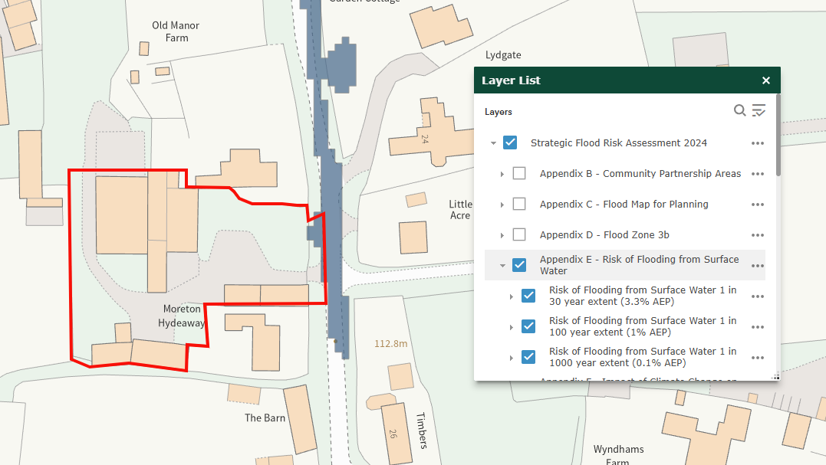

The groundwater levels are between 0.025m and 0.5m below the ground surface. But as per Flood Risk Assessment (Section 3.4.6 & 3.4.7) confirms that as per local topography groundwater emerged at the surface, it would flow to the north without ponding at the site. As a result of the above, the site has low risk of flooding from ground water flooding,

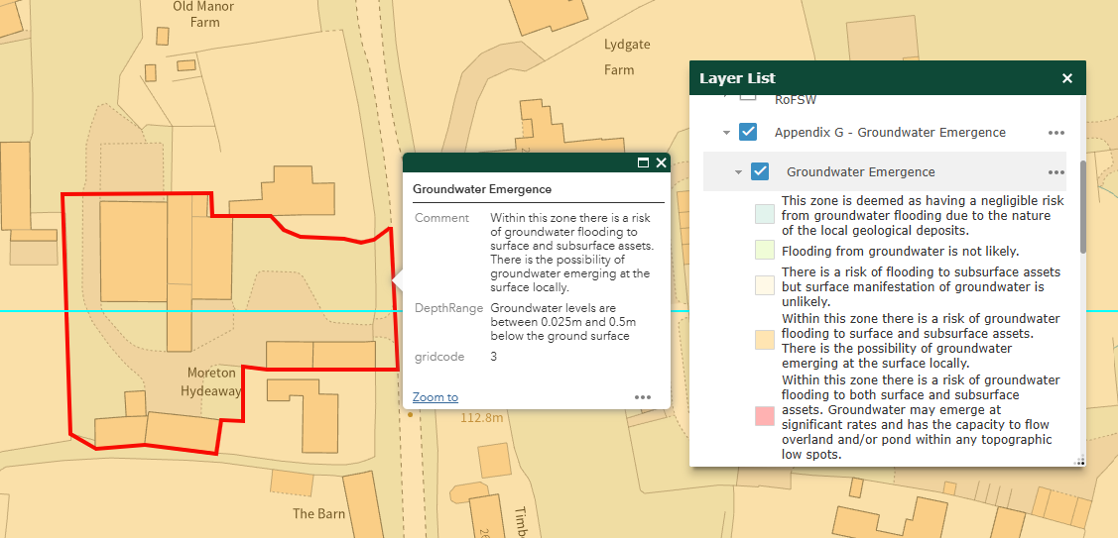

The proposal involves the conversion of curtilage-listed redundant agricultural buildings to form four residential dwellings. This includes the demolition of modern farm buildings, the formation of a new vehicular access, and associated landscaping, drainage and ancillary works. As per Design and Access Statement (Section 3.8 & 3.9) confirms that vehicular access to the site will be taken from the High Street via a newly formed access located north of the existing entrance. The existing access will be closed and incorporated into the garden areas.

The Flood Risk Assessment (Section 4.1.2 & 4.1.3) confirms that there is negligible alteration to the impermeable footprint of the site. It is therefore proposed to retain the same general drainage arrangements for the site. The proposed access and parking would be permeable surfaced and therefore no additional mitigation is required.

The application includes only a basic indicative safe-access and egress route and indicates an intention to prepare an Emergency Plan. It is also stated that the finished floor levels will be raised by 100mm. However, finished floor levels must be raised at minimum 150mm above surrounding ground levels to protect people and property from flood risk.

RECOMMENDATION

No objection subject to the following conditions

- No development shall take place until a surface water drainage strategy, complying with Wiltshire Council requirements, NPPF, PPG and the National Standards for SuDS has been submitted to and approved in writing by the Local Planning Authority.

In order to discharge the above drainage, condition the following additional information must be provided:

- The access to the site is predicted to flood, therefore in line with the National Planning Policy Framework, an emergency plan needs to be agreed with Wiltshire Council. Guidance on the preparation of an emergency plan can be found here.

- Evidence that the finished floor levels are at minimum of 150mm above surrounding ground levels.

INFORMATIVES
- The EA’s standing advice for minor extensions will apply.
- All new drainage will need to comply fully with Building Regulations Part H (and they should engage with the building control department in order to ensure this).
- In line with the NPPF and National Standards for SuDS, the applicant should seek to use SuDS wherever practicable as part of the surface water drainage strategy.

RELEVANT PLANNING POLICY & GUIDANCE

National Planning Policy Framework (NPPF) NPPF December 2024 Link
Planning and Flood Risk (Paras 170–182)

Wiltshire Core Strategy – Adopted January 2015 Wiltshire Core Strategy Link
Core Policy 67 requires that all new development must address flood risk from all sources and not increase flood risk elsewhere. It supports the use of Sustainable Drainage Systems (SuDS) and requires that developments demonstrate how surface water will be managed sustainably.

Wiltshire Local Plan (emerging) Local Plan Review Link
Development must avoid high flood risk areas using the sequential approach. Proposals require a Flood Risk Assessment, Surface Water Drainage Strategy, and Groundwater Assessment where relevant. All schemes must include Sustainable Drainage Systems (SuDS), with major developments achieving a 30% reduction in runoff compared to greenfield rates, following the surface water discharge hierarchy.

Culverting and building over watercourses is discouraged, and natural drainage features should be retained or restored. Drainage strategies must ensure safety during extreme flood events (1-in-100-year + climate change) and provide safe access/egress. SuDS should also deliver biodiversity, amenity, and water quality benefits.

Supplementary Planning Documents

Wiltshire Council Drainage Betterment Strategy (2024) SPD Link
This technical guidance outlines expectations for surface water discharge hierarchy, attenuation, exceedance routes, water quality, and post-development monitoring.

Wiltshire Design Guide (March 2024) SPD Link
Includes principles of good design, including integration of SuDS and flood resilience.

Other Relevant Policies and Guidance

Planning Practice Guidance (PPG) – Flood Risk and Drainage Guidance Link
Covers detailed expectations for flood risk assessments, SuDS design, discharge hierarchy, sequential testing and climate change allowances.

Wiltshire SFRA (2024) SFRA Link
This document underpins the Sequential and Exception Test application and provides site screening evidence.

Section 19 Flood Investigation Reports Section 19 Reports Link
These documents summarise investigations into significant local flood incidents and establish what caused the flooding, how authorities responded, and actions needed to prevent future floods.

National Standards for Sustainable Drainage Systems (SuDS) June 2025 Guidance Link
Establishes mandatory criteria for runoff destination hierarchy, interception, flood resilience, water quality, amenity, biodiversity, and long-term maintenance for all new developments in England.

SuDS Manual (CIRIA C753)
This document set outs design principles, especially where attenuation, exceedance routing, and water quality are discussed.

Infiltration drainage design must be supported by ground investigations, including infiltration testing in accordance with British Research Establishment (BRE) Digest 365 – Soakaway Design, and groundwater level monitoring that accounts for seasonal variation.

