APPLICATION FOR HOUSEHOLDER PLANNING PERMISSION
DELEGATED REPORT

APPLICATION REFERENCE: | PL/2025/08890
APPLICATION TYPE: | Householder planning permission
SITE ADDRESS: | Saxon, Castle Grounds, Devizes, SN10 1HL
DEVELOPMENT DESCRIPTION: | 3no Dormers to Side Elevations and Removal of Outbuilding
RECOMMENDATION: | That Planning Permission be REFUSED

PROPOSAL

The original proposal sought planning permission for the construction of two dormer windows. A box roof dormer in the southern, side roofslope and a hipped roof dormer in the northern, elevation. These dormers replaced existing rooflights.

Further proposed is the demolition of the outbuilding in the garden.

The application has been the subject of revisions which include the construction of three, pitched roof dormer windows. One in the southern, side roofslope and two in the northern, roofslope, fronting Castle Road.

SITE DESCRIPTION/CONTEXT

The application site relates to a detached brick built, 1.5 storey, dwelling, under predominantly tiled pitched roofs. There are bay windows, with small gablets, either side of the main entrance on the west elevation. There are some single storey extensions adjacent to the southern elevations of the dwelling, a single storey porch extension to the northern elevation, together with a single garage, attached to the eastern side elevation of the dwelling. There is a garage door fronting a short gravel driveway onto Castle Road, wide enough to accommodate two cars. The rear elevation of this garage also comprises a door, accessing onto a further gravel driveway, with the private amenity space beyond.

There is a detached, 1.5 storey, brick and tile built, double garage in the south-western corner of site, with a vehicular access via a metal, agricultural gate in the northern boundary with Castle Road. There is a further brick,timber and tiled, linear outbuilding in the south-eastern corner of the garden, extending along part of the southern, walled boundary.

The application site is within the Devizes Conservation Area Boundary; within the setting of listed buildings; a non-designated heritage asset; the Castle grounds to the west are in an Area of Minimum Change; and Devizes Castle is a scheduled monument. The site lies along the access to the Castle.

A photograph of the vista from the entrance of Castle Road is shown in figure 1 below.

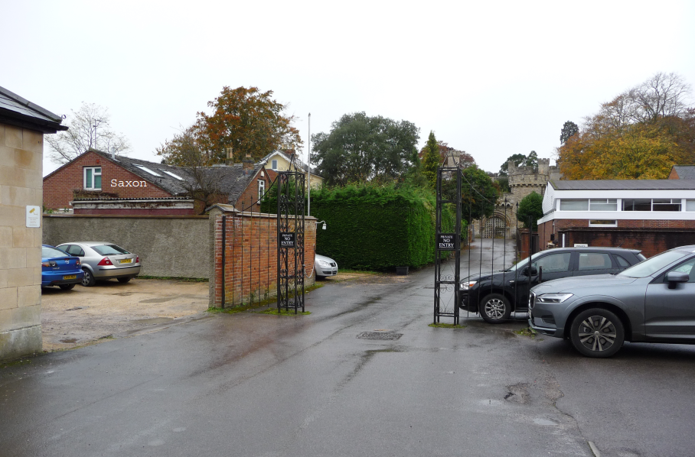

Figure 1: View looking west along Castle Road, with the gatehouse and the application site both visible.

PLANNING HISTORY

Proposal / Summary
E/10/0529/FUL - Full planning permission Decision - Approve with Conditions Date: 4/6/2010 – Erection of sunroom.
K/77/0119 - Full planning permission Decision - Approved Date: 28/3/1977 – Extension to bungalow
K/14065 - Full planning permission Decision - Approve with Conditions Date: 31/5/1989 – DETACHED GARAGE
K/10373 - Full planning permission Decision - Approve with Conditions Date: 6/5/1987 – First floor storeroom
K/81/0629 - Full planning permission Decision - Approve with Conditions Date: 18/8/1981 – First floor storeroom
PL/2023/04791 - Full planning permission Decision - Withdrawn by Applicant Date: 3/8/2023 – Proposed new two storey detached dwelling within part of garden of existing property

RELEVANT POLICIES AND GUIDANCE

Wiltshire Core Strategy:

- Core Policy 50: Biodiversity and Geodiversity
- Core Policy 51: Landscape
- Core Policy 57: Ensuring High Quality Design and Place Shaping
- Core Policy 58: Ensuring the Conservation of the Historic Environment

Devizes Area Neighbourhood Plan July 2015 Referendum Version

Wiltshire Design Guide: Appendix D – Design Guidance for Householder extensions

The National Planning Policy Framework (NPPF)

The Planning Practice Guidance

National Design Guide

Wiltshire Local Transport Plan 2011 – 2026 – Car Parking Strategy

The Devizes Conservation Area Statement (2005)

CONSULTATION RESPONSES

Devizes Town Council – Consultation 1: No objection.

Consultation 2:
Devizes Town Council has no objection to this application

Conservation Officer – Consultation 1:
Object.

Consultation 2:
Object.

Trust for Devizes – Consultation 1:
The proposed box dormer on the N side (fronting Castle Road) will be prominent in this street scene and will be an alien and jarring feature in this part of the Conservation Area, in conflict with the statutory objective to conserve & enhance the character & appearance of the Conservation Area.

Consultation 2:
Objection: The proposed box dormer on the N side (fronting Castle Road) will be prominent in this street scene and will be an alien and jarring feature in this part of the Cons Area, in conflict with the statutory objective to conserve & enhance the character & appearance of the Conservation Area. Revisions since we commented in November do not affect this intrusive feature.

REPRESENTATIONS

No comments were received.

ASSESSMENT

Section 38(6) of the Planning and Compulsory Purchase Act 2004 states:

"If regard is to be had to the development plan for the purposes of any determination to be made under the planning Acts, the determination must be made in accordance with the plan unless material considerations indicate otherwise."

In accordance with this statutory requirement, this application has been assessed against the relevant policies of the Development Plan, including the adopted Wiltshire Core Strategy (2015) and, where applicable, any made Neighbourhood Plans.

Design and Impact upon the upon the character and context of the area:

Core Policy 57 - Ensuring High Quality Design and Place Shaping of the Wiltshire Core Strategy seeks to ensure that all new development is of high design quality, reflecting local context, character, and distinctiveness. A high standard of design is required in all new developments, including extensions, alterations, and changes of use of existing buildings. Development is expected to create a strong sense of place through drawing on the local context and being complementary to the locality.

Under CP 57 applications for new development must demonstrate how the proposal will make a positive contribution to the character of Wiltshire through:

iii. responding positively to the existing townscape and landscape features in terms of building layouts, built form, height, mass, scale, building line, plot size, elevational design, materials, streetscape and rooflines to effectively integrate the building into its setting.

iv. being sympathetic to and conserving historic buildings and historic landscapes.

The original proposals were for two large box roof dormers, one with a hipped roof and one with a flat roof. These proposals, together with the existing elevations, are shown in Figure 2 below:

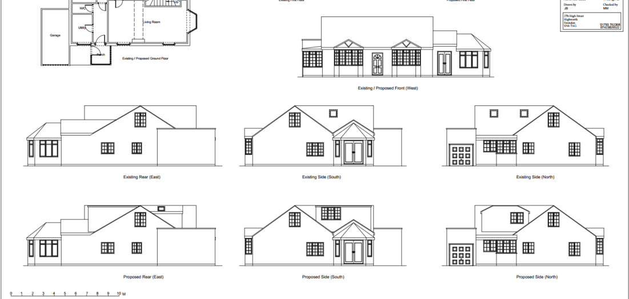

Figure 2: Existing and originally proposed elevation drawings

Any additions to the dwellinghouse need to relate to the design of the original dwelling, following basic planning principles. The originally proposed dormers shown above, were purely functional in design, providing an extension of room space from the ground floor to ceiling level in the loft rooms they would be installed in, giving no consideration to the original design of the dwellinghouse, which is characterised by low pitched, gable roof construction.

Strong concerns were raised regarding the original design of the dormers with the agent, and it was recommended that the application was withdrawn or was refused. However, the agent was keen to revise the dormers to reflect advice given to include much smaller, matching, pitched roof, more subservient dormers, which would be more sympathetic, in keeping with the design of the existing dwelling. However, it was highlighted to the agent that these would not serve the function intended to increase the floorspace of the room, they would only provide additional light but would have significantly less visual impact upon the dwelling from a design perspective.

The revised proposals include three, hipped roof dormers. They are shown in figure 3 below:

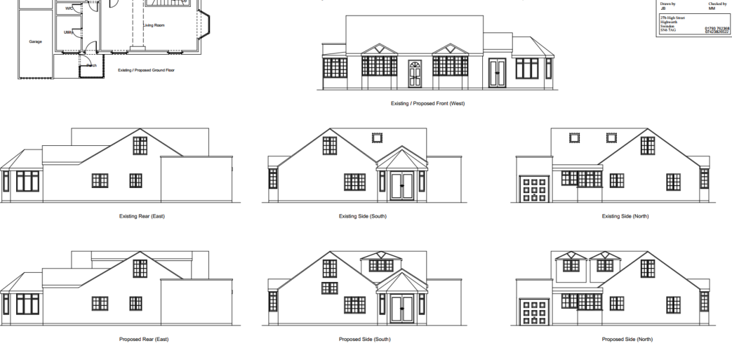
Figure 3: Revised proposed elevations

Similar to the original submission, the revised proposals will still present very large dormers, which dominate the existing roofslopes, in addition to dormers which have disproportionately shallow hipped roofs, an alien roof form on this dwelling and are still positioned at the top of the roofslopes in line with the main ridge over the dwelling. These present a contrived and conflicting roof design to the main dwelling and lack any form of subservience, due to their size, height and positioning in the roofslope. They introduce an overtly dominant design, competing with the existing, shallow pitched roofs.
Undesirable design to neighbouring properties, such as the Telephone Exchange Building opposite, a 1960/70s, flat roof building, is not a justification for poor design here. The current proposals do not draw on the existing architectural form and design of the existing dwelling and as such would result in an incongruous design on two visually prominent roofslopes at the entrance to Devizes Castle. The prominence of the dormer in the southern roofslope is due to the position of the property, which is on lower ground level, compared to the neighbouring property at The Beeches, as the garden of Saxon rises up towards this and to the Castle beyond. As such the proposed dormers are considered to fail to demonstrate high quality design and would not conserve the character of the existing dwelling or that of the area and would therefore be considered contrary to the National Planning Policy Framework and Core Policy 57 of the Wiltshire Core Strategy. Having regard for the Trust for Devizes comments, they support the above.

Conclusion

On balance it is considered that the development due to its inappropriate form, size, position in the roofscape and design would result in a scheme which would appear overly dominant and disproportionate to the existing dwelling and would have an incongruous and detrimental impact upon the existing appearance, character and setting of the existing dwelling, which in turn would have a detrimental impact upon the character and appearance of the area. As such the development would be contrary to Section 7 “Requiring good design” (paragraphs 17 and 58) of the NPPF and Core Policy 57 of the Wiltshire Core Strategy.

The proposal does not represent high-quality design resulting in harm to the character and appearance of the locality. Therefore, it is contrary to Core Policy 57 of the Wiltshire Core Strategy, Appendix D of the Wiltshire Design Guide, and the relevant provisions of the National Planning Policy Framework. The application must therefore be refused on design grounds.

Further proposed is the demolition of the outbuilding. This is acceptable in principle and has been supported by the conservation officer, however, as only a Block Plan has been submitted and no existing elevation plans, the Council are unable to accurately work out the cubic volume of the outbuilding to see if it falls under one of the exceptions, under Section 74 of the Planning (Listed Buildings and Conservation Areas Act 1990, in particular whether it exceeds 115 cubic metres. If it does, then ‘relevant demolition’ in a conservation area will need to be applied for. If it does not exceed this threshold, then planning permission is not required for the demolition of the outbuilding in a conservation area.

Based on the submitted, scaled block plan and the site photographs, the volume of outbuilding is very unlikely to exceed 115 cubic metres. The volume of the building to the eaves is approximately 13.41 x 2.75 x 2m (max eaves height) = 73.76 m3. The roof volume is approximately 13.41 x 2.75 x 1m/2 = 18.42 cubic metres. The sum of these is 92.18 cubic metres.

Heritage Impact

From the point of view of the historic environment the main statutory tests are set out within the Planning (Listed Building and Conservation Areas) Act 1990.

Section 66 requires that special regard be given to the desirability of preserving listed buildings, their settings or any features of special architectural or historic interest which they possess.

Section 72(1) of the Act requires the Council to pay special attention to the desirability of preserving or enhancing the character or appearance of designated Conservation Area.

The NPPF outlines government policy, including its policy in respect of the historic environment. Section 16 of the NPPF 'Conserving and enhancing the historic environment' sets out the Government's high-level policies concerning heritage and sustainable development. Paragraphs 214-216 of the NPPF require a balanced approach with any harm which would be caused being weighed against the potential public benefits which might be achieved. Paragraph 210 requires local planning authorities should take account of the desirability of sustaining and enhancing the significance of heritage assets and of new development making a positive contribution to local character and distinctiveness.

National Planning Practice Guidance provides guidance on interpreting the NPPF.

The Council’s Core Strategy Policy CP58 ‘Ensuring the conservation of the historic environment’ requires that designated and non-designated heritage assets and their settings will be conserved, and where appropriate enhanced, in a manner appropriate to their significance and encourages proposals which improve the condition of heritage assets at risk.

The Council’s Core Strategy CP 57: Ensuring high quality design requires a high quality of design in all new developments. The policy requires applicants to “demonstrate how the proposal will make a positive contribution to the character of Wiltshire through (amongst other things) responding to the value of the natural and historic environment and being sympathetic to and conserving historic buildings and landscapes. Development is required to respond positively to the existing in terms of building layouts, built form, height, mass, scale, building line, plot size, elevational design, materials, streetscape and rooflines to effectively integrate the building into its setting”.

Historic England Advice Note 2 – Making changes to Heritage Assets illustrates the application of policies set out in the NPPF in determining applications for planning permission and listed building consent.

Site and assets considered: The bungalow is a modern unlisted building located in the Castle Close within Devizes Conservation Area.

Proposal: The proposal seeks two large dormers and the demolition of an outbuilding.

Relevant planning history: K/81/0629 - First floor storeroom (approve); K/10373 – First Floor Storeroom (approve);

Issues: impact on the setting of neighbouring listed buildings, impact on the character and appearance of the conservation area.

Information considered/provided: Paragraph 207 of the NPPF requires that applicants describe the significance of any heritage assets affected, including any contribution made by their setting. This should include sufficient information to provide a clear understanding of the significance of the heritage asset and its setting and the potential impact of any proposals on that significance. In this case, whilst the application is accompanied by a “Statement of Significance and Impact” the document provides limited information about the building, it fails to provide any objective assessment of the impact of the proposals on the setting of the listed buildings and the character and appearance of the conservation area, as a result, it fails to meet the requirements of the NPPF.

However, paragraph 208 of the NPPF also provides for the local planning authority to make its own assessment of impact and the following heritage recommendations are offered on this basis.

Significance of assets and contribution of setting: The NPPF defines significance as the “value of a heritage asset to this and future generations because of its heritage interest. The interest may be archaeological, architectural, artistic or historic. Significance derives not only from a heritage asset’s physical presence, but also from its setting.” Historic England assesses significance in a similar manner, referring to evidential, historic, aesthetic and communal values of a place.

The application site is located within Devizes town centre and is within the Devizes Conservation Area Boundary. Barford House and 33-34 St John’s Street to the east are grade II* listed buildings. Indeed, every building on either side of St John’s Street to the east of the site are at least grade II listed. Immediately to the west is the residential property of The Beeches, which is a non-designated heritage asset. The castle grounds beyond this are designated an Area of Minimum Change and a Scheduled Monument, with the castle itself being grade I listed. The historic gatehouse, which can be viewed in the vistas looking westwards along Castle Road, is grade II listed.

The Council’s Conservation Officer has made the following comments:

“The location of the property is important as it is located at the gateway to the castle close and the schedule monument. Individual buildings of architectural and historic interest line the full length along both sides of St John’s Street”. To the west is the access to the Castle., where glimpse views of it are visible, although the Castle itself is largely hidden from this view. “The significance of the individual buildings lies largely with their historic fabric and architecture - form, layout and architectural expression/detailing and use of high-quality design materials which have significant aesthetic and architectural interest, and which contribute to the character of the conservation area”.

“Assessment: This is my second consultation response and follows on from the submission of amended plans, which include the installation of 3no. dormers”.

“The property is an unimposing bungalow of little architectural presence and makes no positive contribution to the character and appearance of the conservation area. The property is located directly behind rear gardens of listed buildings along St John’s Street and forms part of the gateway to Devizes Castle”.

“The proposal seeks the removal of an outbuilding along the southern boundary of the site and the erection of three dormers on the roof slope of the existing bungalow”.

“There is no objection to the loss of the outbuilding since this is largely modern apart from a small section of red brick outbuilding which has been heavily altered”.

“However, I have significant concerns at the impact of the proposed dormers since these are large dormers which would dominate the existing low pitched roof form of the existing bungalow”.

“The design of the dormers would be highly intrusive to the significance of the heritage assets and would have a harmful impact on the setting of neighbouring listed buildings and the character and appearance of the conservation area”.

“The design of the dormers is so bulky and dominant on the roof form that they would not even be acceptable outside of a conservation area”.

“The dormers would have an unbalancing effect on the existing property and would be a negative element within the setting of the nearby listed buildings and the character and appearance of the conservation area”.

“I point out, that there is a legislative requirement for proposals to preserve or enhance the setting of listed buildings, and to preserve or enhance the character and appearance of a conservation area. This proposal would have a harmful effect on the significance of all designated heritage affected by this proposal”.

“Summary & conclusion: The NPPF confirms that when considering the impact of a proposed development on the significance of a designated heritage asset, great weight should be given to the asset’s conservation (and the more important the asset, the greater the weight should be). It makes clear that any harm to a designated heritage asset requires clear and convincing justification”.

“The proposals will result in harm to the setting of neighbouring listed buildings and the character and appearance of the conservation area through three large box dormers on the existing host building which would constitute poor design which would have a harmful impact on the designated heritage assets. The proposals involve only part of the setting of the listed buildings and the boundary of the conservation area and could therefore be considered as causing ‘less than substantial harm’ for the purposes of interpreting the NPPF. Indeed, the wording of the NPPF and the ‘special regard’ by Section 66 and ‘special attention by Section 72 of the Act requires that any level harm caused should be taken seriously”.

“Whilst paragraph 208 allows that a level of harm may be offset by public benefits, which could include conservation benefits, in this case no objective justification has been provided for the works and the proposals are articulated as being primarily for the convenience of the occupants i.e. a private benefit. As a result, the proposals fail to meet with the requirements of current conservation legislation, policy or guidance and I therefore recommend refusal”.

As such, the proposed development would fail to preserve or enhance the character and appearance of the Devizes Conservation Area and the setting of the listed buildings. Therefore, the proposal is contrary to the statutory duty under Sections 66 and 72(1) of the Planning (Listed Buildings and Conservation Areas) Act 1990 and Section 16 of Core Policy 58 of the Wiltshire Core Strategy, and the relevant provisions of the National Planning Policy Framework. The application must therefore be refused on heritage grounds.

Amenity

Point vii of Core Policy 57 - Ensuring High Quality Design and Place Shaping of the Wiltshire Core Strategy seeks to ensure that developments do not adversely affect neighbouring properties.

The National Planning Policy Framework (NPPF), particularly Paragraph 135(f), stresses that planning decisions should ensure developments provide a high standard of amenity for existing and future users.

The proposed development has been assessed in terms of its potential impact on the residential amenity of neighbouring properties, with particular regard to loss of light, overshadowing, loss of privacy, and overbearing effects.

The revised, proposed dormers will face north and south. The property is well contained within the plot, with gardens to the north, bounded by Castle Road; with the carpark, associated with the Telephone Exchange building on the opposite side of this road; the main private amenity space to the dwelling is to the west; adjoining the front garden of The Beeches; and south, sited approximately 20m to the nearest residential dwelling at 29B St Johns Street. The eastern, side elevation of the garage, with gravel hardstanding, adjoins this side boundary with Nos. 33 and the carpark of No. 35 (Barford House), St John’s Street. Therefore, the proposed dormers are not considered to cause any loss of privacy, through causing any overlooking; are sufficiently separate from neighbouring dwellings; to have any overbearing impact or cause any overshadowing or loss of light.

The proposal therefore accords with Core Policy 57 point vii in respect of safeguarding residential amenity and Appendix D of the Wiltshire Design Guide.

Highways Impact

Core Policy 57 (xiv) of the Wiltshire Core Strategy seeks to ensure that development must meet the requirements of Core Policy 61. This policy requires proposals to be capable of being served by safe access to the highway network. Core Policy 64 seeks to ensure compliance with parking standards set out in the Local Transport Plan.

The National Planning Policy Framework (NPPF), particularly Paragraph 115 and 116, requires that development proposals do not have an unacceptable impact on highway safety and that safe and suitable access to the site can be achieved for all users.

The existing property has five bedrooms and the proposed dormer extensions will not alter this position, as such the status quo will be maintained, therefore, it is not necessary to change the existing parking arrangements, which include two parking spaces in front of the northern elevation with Castle Road, with a single garage, with a car parking space behind and a double garage in the garden. The Wiltshire Parking standards require 4+ bedroom dwellings to have a minimum of 3 car parking spaces, which the existing arrangement complies with.

Therefore, the proposed development would not result in any adverse impact on highway safety. Adequate parking and turning provision is provided in accordance with Wiltshire’s adopted parking standards, and access arrangements are acceptable.

The proposal is therefore considered to comply with Core Policies 57 (xiv), 61 and 64 of the Wiltshire Core Strategy, the NPPF, and the Wiltshire Local Transport Plan.

Ecology Impact

Core Policy 50 of the Wiltshire Core Strategy seeks to protect and enhance biodiversity and geodiversity, including through ensuring that development avoids harm to protected species and habitats.

The National Planning Policy Framework (NPPF), in Paragraphs 193, requires that development minimises impacts on and provides net gains for biodiversity, including ensuring mitigation is secured where harm cannot be avoided.

The applicant should be aware that under the terms of the Wildlife and Countryside Act (1981) and the Habitats Regulations (2010) it is an offence to disturb or harm any protected species or to damage or disturb their habitat or resting place. It should be noted that consent does not override the statutory protection afforded to any such species. Upon demolition of the outbuilding, if bats or birds (protected species) are found during this phase, the applicant is advised to stop works and seek the advice of a suitably qualified and experienced ecologist and consider the need for a licence from Natural England prior to commencing works.

Providing the above is adhered to, the development complies with Core Policy 50 of the Wiltshire Core Strategy and the relevant provisions of the NPPF.

Plan Accuracy and Drawing Discrepancies

During assessment, it was noted that the revised plans introduce several inconsistencies which affect clarity over the exact nature and extent of the development. The revised ground floor plan shows a store with double doors on the side elevation which does not appear on the corresponding elevation drawings, nor was it present on the originally submitted plans, and does not appear on the existing building as observed during the officer’s site visit. In addition, the revised elevations include an additional window that is not shown on the floor plans, was not included on the original drawings, and also does not appear on the existing building as observed during the officer’s site visit. These discrepancies create uncertainty regarding the proposed built form and the external appearance of the development. Given that the application is being refused on substantive design and heritage grounds and that the determination deadline has been reached, it was not reasonable or proportionate to seek further amended plans. A separate refusal reason has therefore been included to address the lack of clarity and internal inconsistency within the submitted drawings.

Biodiversity Net Gain

Householder planning applications are exempt from the requirement to deliver Biodiversity Net Gain under Schedule 7A, Section 4(2)(a) of the Town and Country Planning Act 1990, as inserted by the Environment Act 2021.

CONCLUSION

Having carefully assessed the proposed dormer additions, it is clear that the development would result in a form of built intervention that fails to integrate successfully with the character, appearance and roofscape of the host dwelling. The scale, massing and design of the dormers would appear visually dominant and incongruous, resulting in a harmful alteration to the appearance of the building when viewed from public vantage points. This, in turn, would fail to preserve or enhance the character and appearance of the conservation area and would adversely affect the setting and significance of nearby listed buildings, contrary to the statutory duties set out under Sections 66(1) and 72(1) of the Planning (Listed Buildings and Conservation Areas) Act 1990.

The development therefore gives rise to less-than-substantial harm to designated heritage assets. In line with paragraph 215 of the National Planning Policy Framework, this harm has been weighed against the public benefits of the proposal. No clear or convincing justification, nor any public benefits of sufficient weight, have been demonstrated that would outweigh the great weight that should be given to the identified heritage harm.

As a result, the proposed development conflicts with Core Policies 57 and 58 of the Wiltshire Core Strategy (2015), the design expectations within the Wiltshire Design Guide SPD, and the requirements of Chapter 16 of the National Planning Policy Framework, all of which seek to ensure high-quality design that conserves and enhances heritage assets and respects local character.

In addition to these substantive concerns, inconsistencies within the submitted drawings create uncertainty over the precise nature and extent of the development, further limiting the ability to support the proposal.

For these reasons, the proposal is considered contrary to the development plan when read as a whole, and no material considerations have been identified that would indicate a decision other than refusal.

RECOMMENDATION: That Planning Permission be REFUSED.

