Supporting notes RE: Tilshead Village Hall, High Street, Tilshead, Salisbury, SP3 4RX : PL/2026/012
Existing situation: At present the area outside our hall contains several items installed throughout the years. These items combined with the uneven ground; unsafe paths and a ditch make it a challenging area to make use of.
Overall intention: The aim is to create a space outside our Village Hall that is inclusive, safe, and flexible.
- We would like to make the access to the hall suitable for the infirm, wheelchairs and pushchairs.
- We would like to make the are safer for families with young children.
- We would like to use the area to increase the usage of our hall. This may be by having bistro tables set up for coffees, small gazebos set up for craft fairs or home cooked goods or by putting up a large marquee for receptions or wakes. (the Church is next door to the Hall)
The Plan to achieve the above intention:
1. To direct the * winterbourne spring through a French drain underground along its present route.
2. To clear the area of obstacles or to move them so that they are not in the way.
3. To level and grade the ground.
4. To add an area of hard landscaping so that bistro tables can be set up even when the ground is soft. This will also be a lovely wide space for everyone to access the hall.
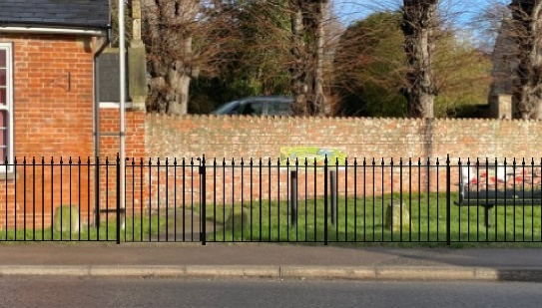
5. To add a traditional style **fence around the area so that there is a barrier between the door of the hall and the A360!

Notes:
*The winterbourne spring: this is an occasional spring that has appeared 7 times over the last 15 years. (yes, we have a villager who records this!). Once it has appeared it tends to last for 4-6 weeks until the water levels drop. The remainder of the time we just have a dry ditch for people to fall into!
**The fence: The style we have chosen is very similar to that of two properties neighbouring the hall. We are led to believe by our railings supplier that the height of the fence can be 1m to the top railing. It would be helpful if you could confirm this.

The plan as presented has been developed in consultation with the residents of Tilshead and was voted through at the Village Hall AGM May 2025. We have raised the funds for the project in full and we have identified our preferred contractors.

