APPLICATION FOR HOUSEHOLDER PLANNING PERMISSION
DELEGATED REPORT

APPLICATION REFERENCE: | PL/2026/00440
APPLICATION TYPE: | Householder planning permission
SITE ADDRESS: | 8 Westfield Close, Durrington, Salisbury, SP4 8BY
DEVELOPMENT DESCRIPTION: | Remove existing pvcu conservatory and construct single storey rear extension
RECOMMENDATION: | That Planning Permission be GRANTED

PROPOSAL

The proposal seeks planning permission for the demolition of an existing single conservatory on the rear (northwest elevation) and construction of a larger, single storey rear extension. No changes to the number of bedrooms or parking arrangements are proposed.

Existing and proposed plans

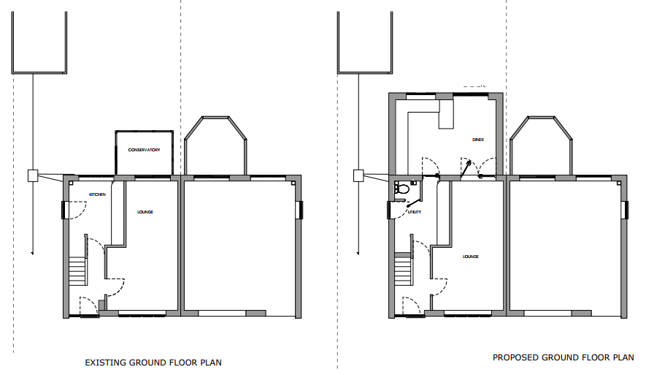

Proposed elevations

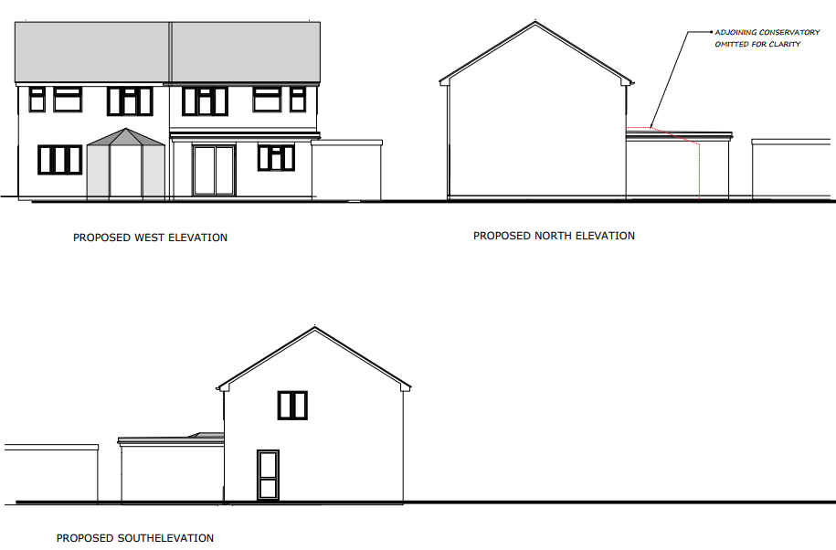

SITE DESCRIPTION/CONTEXT

This application relates to 8 Westfield Close, a semi-detached two storey house, in a residential area on the western side of the Market Town of Durrington, as defined by Wiltshire Core Strategy (WCS) core policies 1 (Settlement Strategy), 2 (Delivery Strategy) and 4 (Spatial Strategy for the Amesbury Community Area).
The property sits back from the road with a driveway and front garden within a residential area. It has facing brick and a tiled roof. There is a very open boundary between the rear gardens of 8 and 6 Westfield Close.

The application site is within the Hampshire River Avon SAC Catchment and is within the 6.4km recreational buffer of the Salisbury Plain SPA, but given the nature of the development, ecological impact is not an issue for this application. The site is within Flood Zone 1.

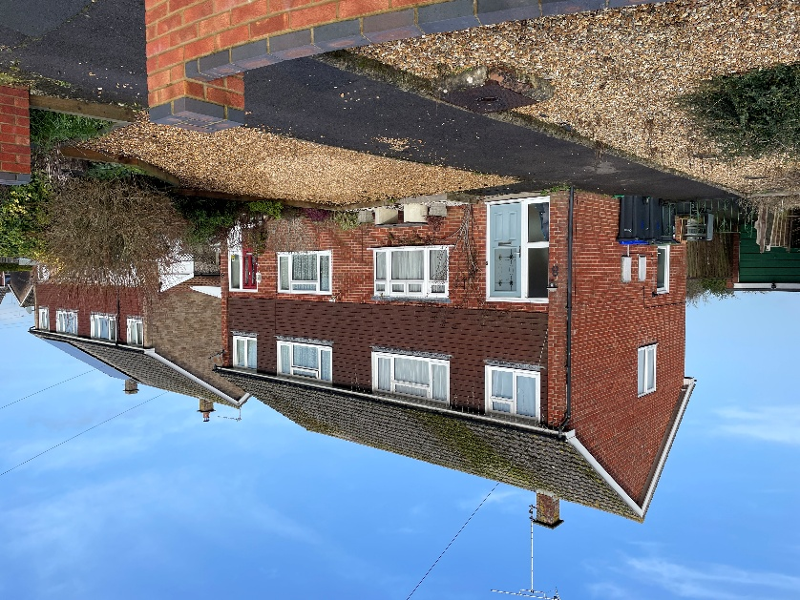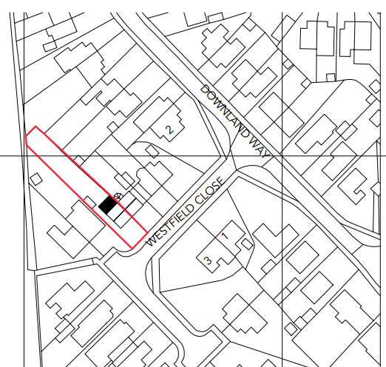
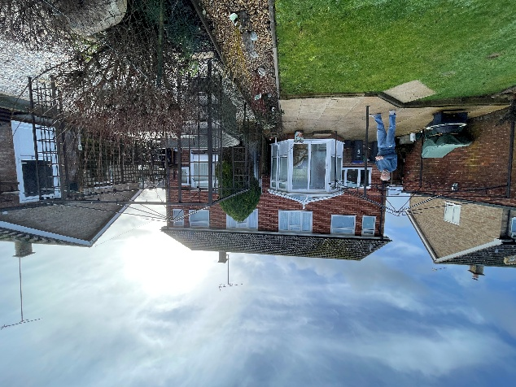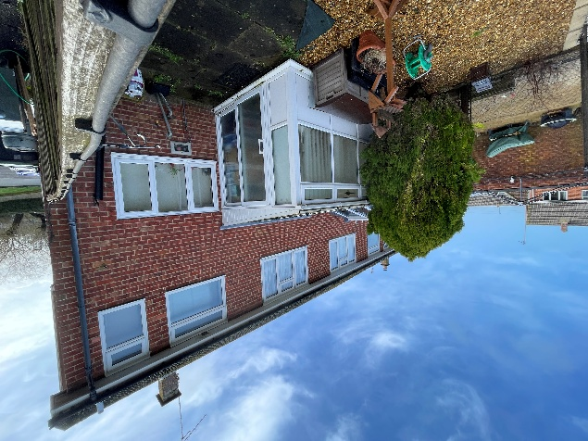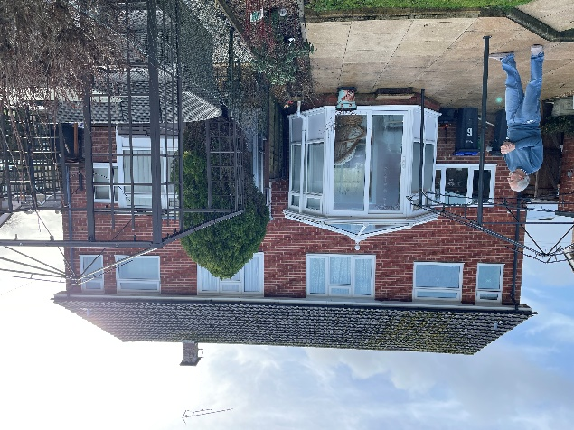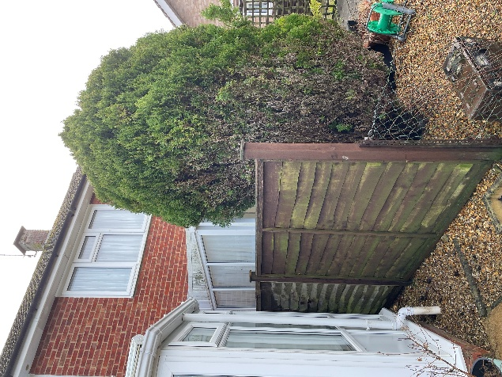

PLANNING HISTORY

None relevant

RELEVANT POLICIES AND GUIDANCE

Wiltshire Core Strategy:
- Core Policy 1: Settlement Strategy
- Core Policy 2: Delivery Strategy
- Core Policy 4: Spatial Strategy for the Amesbury Community Area
- Core Policy 57 Ensuring High Quality Design and Place Shaping
- Core Policy 50: Biodiversity and Geodiversity

Wiltshire Design Guide: Appendix D – Design Guidance for Householder extensions

The National Planning Policy Framework (NPPF)

The Planning Practice Guidance

National Design Guide

CONSULTATION RESPONSES

Durrington Town Council: No comment received

REPRESENTATIONS

A representation was received from the attached neighbour (6 Westfield Close) as follows:
Mr & Mrs Bush of 8 Westfield Close have informed and discussed with us their proposed single storey rear extension. We verbally covered details of The Party Wall Act and agreed on several matters to mitigate any damage to our property when building work starts, for example leaving the Party Wall fence in place until the footings have been completed. Other minor concerns were raised answered and agreed, therefore we have no objection to the single storey rear extension as detailed in the above planning application.

ASSESSMENT

Section 38(6) of the Planning and Compulsory Purchase Act 2004 states:

"If regard is to be had to the development plan for the purposes of any determination to be made under the planning Acts, the determination must be made in accordance with the plan unless material considerations indicate otherwise."

In accordance with this statutory requirement, this application has been assessed against the relevant policies of the Development Plan, including the adopted Wiltshire Core Strategy (2015) and, where applicable, any made Neighbourhood Plans.

Design and Impact upon the character and context of the area

Core Policy 57 - Ensuring High Quality Design and Place Shaping of the Wiltshire Core Strategy seeks to ensure that all new development is of high design quality, reflecting local context, character, and distinctiveness.

The proposal is for a single storey rear extension (5.85m x 4.25m) to create a kitchen/dining room. The extension is proposed to have a single ply, flat roof with ‘multi-stock red brick’ walls, to match the existing. No windows are proposed on the northeast or southwest elevations. The northwest elevation is proposed to have a set of French doors and a window.

The proposed single-storey extension reflects the existing dwelling’s character in terms of materials and detailing. It would remain subservient and is located at the rear of the property and would not be visible from public vantage points. Its design, form and materials are traditional and preserve the character and appearance of the area.

Having regard to the above, the proposal complies with the design principles set out in Core Policy 57 of the Wiltshire Core Strategy and Appendix D of the Wiltshire Design Guide.

Amenity

Point vii of Core Policy 57 - Ensuring High Quality Design and Place Shaping of the Wiltshire Core Strategy seeks to ensure that developments do not adversely affect neighbouring properties.

The National Planning Policy Framework (NPPF), particularly Paragraph 135(f), stresses that planning decisions should ensure developments provide a high standard of amenity for existing and future users.

The proposed development has been assessed in terms of its potential impact on the residential amenity of neighbouring properties, with particular regard to loss of light, overshadowing, loss of privacy, and overbearing effects.

The extension has the potential to impact upon the occupiers of 6 Westfield Close by reason of its location as an attached neighbour. These two properties currently have a very minimal/open garden boundary between them, and both properties have conservatories on the rear elevation, close to the shared boundary. Comments have been received from this neighbour, with no objections and stating that discussions relating to party wall matters have taken place.

The proposed extension would introduce a solid wall closer to the shared boundary; to the south west of the neighbour’s conservatory; and it would extend out further along this shared boundary than the existing conservatory and past the end elevation of the neighbour’s conservatory. While the new extension would affect the amount of light reaching the neighbour’s conservatory, there is already a timber fence and an evergreen tree between the two conservatories that provides privacy and already limits the amount of light enjoyed by the existing neighbours. Any new impact that may be caused by this proposed extension for this attached neighbour is therefore unlikely to be significantly greater than the existing shadow that would be cast by the existing intervening boundary features. Given that the extension is to be single-storey, modest in scale relative to the host property and plot, and located on the north-west elevation, it is considered that any potential impact in terms of loss of light or dominance is unlikely to be significant comparative to the existing arrangement and is thus acceptable in this regard.

It is also worth noting that the property has permitted development rights and the applicant could construct a single storey rear extension of up to three meters in length, which therefore represents a fallback position for the assessment of this current scheme.

On balance, the proposal therefore accords with Core Policy 57 point vii in respect of safeguarding residential amenity and Appendix D of the Wiltshire Design Guide.

Biodiversity Net Gain

Householder planning applications are exempt from the requirement to deliver Biodiversity Net Gain under Schedule 7A, Section 4(2)(a) of the Town and Country Planning Act 1990, as inserted by the Environment Act 2021.

CONCLUSION

The proposed development is considered to be acceptable in terms of its design, scale, and relationship with the surrounding area. It would not result in any unacceptable harm to the character of the locality, or significantly different impact for the amenities of neighbouring occupiers compared with the existing arrangement.

The proposal is therefore considered to comply with the relevant policies of the Wiltshire Core Strategy, the Wiltshire Local Plan, and the National Planning Policy Framework. As such, the application is recommended for approval, subject to the conditions set out below.

RECOMMENDATION: That Planning Permission be GRANTED subject to conditions.

- The development hereby permitted shall be begun before the expiration of three years from the date of this permission.
REASON: To comply with the provisions of Section 91 of the Town and Country Planning Act 1990 as amended by the Planning and Compulsory Purchase Act 2004.

- The development hereby permitted shall be carried out in accordance with the following approved plans and documents:
MB/05/25 Location and Block Plan, received 22.01.2026
MB/03/25 Ground Floor Plans, received 22.01.2026
MB/04/25 Roof Plans, received 22.01.2026
MB/02/25 Proposed Elevations, received 22.01.2026

REASON: For the avoidance of doubt and in the interests of proper planning.
- The materials to be used in the construction of the external surfaces of the development hereby permitted shall match in material, colour and texture those used in the existing building and detailed on the application form.
REASON: In the interests of visual amenity and the character and appearance of the area.

- Notwithstanding the provisions of the Town and Country Planning (General Permitted Development) (England) Order 2015 (as amended by the Town and Country Planning (General Permitted Development) (Amendment) (No.3) (England) Order 2020 (or any Order revoking or re-enacting or amending that Order with or without modification), no windows, doors or other form of openings other than those shown on the approved plans, shall be inserted in the north east elevation (shared boundary wall) of the development hereby permitted.

﻿REASON: In the interests of residential amenity and privacy

