APPLICATION FOR HOUSEHOLDER PLANNING PERMISSION
DELEGATED REPORT

APPLICATION REFERENCE: | PL/2026/00315
APPLICATION TYPE: | Householder planning permission
SITE ADDRESS: | 9 Easton Square, Sherston, Malmesbury, SN16 0LX
DEVELOPMENT DESCRIPTION: | Construction of single-storey front porch and two-storey side and rear extension with associated external alterations, demolition, access and landscaping works.
RECOMMENDATION: | That Planning Permission be GRANTED

SITE CONTEXT

9 Easton Square (the ‘site’) is a residential plot situated on a low-density modern suburban square on the eastern periphery of Sherston (designated a Large Village in the Wiltshire Core Strategy).

The site is occupied by a modern semi-detached two storey dwelling and its associated amenity space. The dwelling comprises the original pitched roof main range with a mono-pitch roof porch, pitched roof single storey side and rear element and a more recent single storey hipped roof permitted development extension. Though an ostensibly modern building, its narrower gables, steeper pitched roof and taller chimney stacks are more characteristic of historic Cotswolds rural vernacular. The external materials of the property comprises patterned render walling, concrete tile roofing and uPVC fenestration.

The site is surrounded by the following properties/land uses:

- North: 8 Easton Square (a modern semi-detached two storey dwelling).
- East: Woodland buffer with a field beyond.
- South: 10 Easton Square (a modern semi-detached two storey dwelling with which the application site is paired).
- West: Easton Square public highway and green.

The application site is subject to the following planning policy designations/constraints:

- Within Cotswolds National Landscape
- Sherston Conservation Area located circa 70m to the west.
- Several grade II listed buildings located circa 130-140m to the northeast:
  - Home Farmhouse
  - Outbuildings to the north of Home Farmhouse
  - Prater’s Farmhouse
  - Barn to the southwest of Prater’s Farmhouse
- N.B. Site within close proximity of Tree Preservation Order N/TPO187, however the TPO tree was removed in accordance with permission 16/01553/DDD.

PROPOSAL

The proposal involves replacing the front porch and side and rear extension, plus external alterations to expand and improve the living environment of the host dwelling. The proposal would add an extra bedroom, resulting in a 4-bedroom property with increased parking requirements. Revised plans have been submitted providing additional parking.

The front porch is a single storey pitched roof element measuring circa 2m long by 2.6m wide with 2.4m high eaves and a 3.5m high ridge.

The side and rear extension is a two storey pitched roof addition (though reads as 1½ storey in scale) with front central cross-gable and a rear projection. It measures 7.9m long by 5.5m wide with 4.2m high eaves and a 7.3m high ridge.

The alterations involve replacing the existing render with a smooth textured light grey arctique render and replacing the fenestration with anthracite grey composite/aluminium and uPVC framed units. These materials will also be used for the extensions. The roofing of the porch and extension shall match the existing roof tiles. The proposed elevations are shown below.

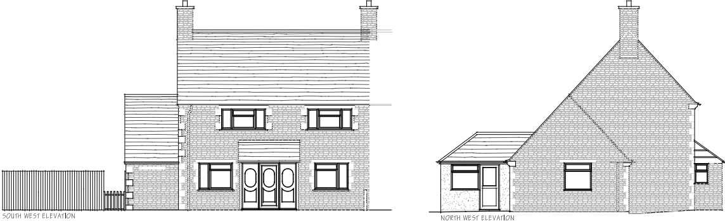

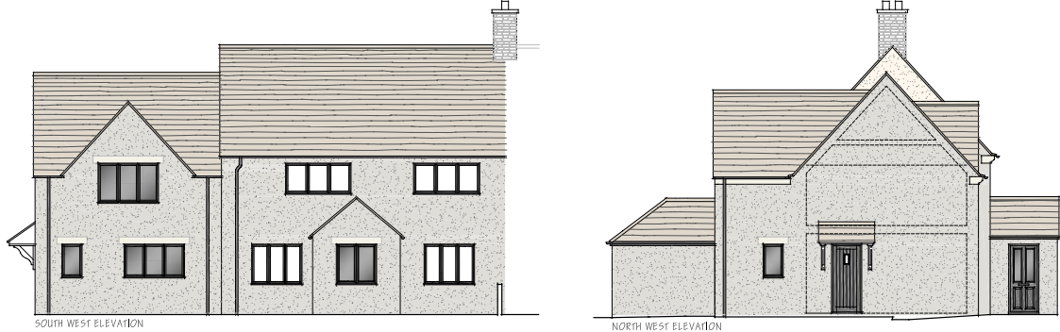

In terms of access works, it is proposed that the front drive is widened to accommodate three parking spaces in accordance with the Highway Engineer’s advice.

PLANNING HISTORY

No relevant records.

RELEVANT LEGISLATION, POLICIES AND GUIDANCE

Planning Legislation:

- Town and Country Planning Act 1990
- Planning and Compulsory Purchase Act 2004

Development Plan:

- Wiltshire Core Strategy (adopted January 2015):
  - Core Policy 41: Sustainable construction and low-carbon energy
  - Core Policy 57: Ensuring high quality design and place shaping
  - Core Policy 64: Demand management

Material Considerations (Policy):

- National Planning Policy Framework (NPPF) December 2024
  - Section 2. Achieving sustainable development
  - Section 9. Promoting sustainable transport
  - Section 12. Achieving well-designed places

- Wiltshire Local Plan Submission Draft 2020-2038 (Regulation 24):
  - Policy 4: Addressing climate change
  - Policy 73: Transport: demand management
  - Policy 85: Sustainable construction and low carbon energy
  - Policy 98: Ensuring high quality design and place shaping

Material Considerations (Guidance):

- National Planning Practice Guidance
- National Design Guide (January 2021)
- Wiltshire Design Guide (March 2024)
- Wiltshire Local Transport Plan 2011-2026: Car Parking Strategy

CONSULTATION RESPONSES

Sherston Parish Council: No objection.

Wiltshire Council Highways Department: On the basis the proposal increased the number of bedrooms, the Highways Engineer requested an amended site plan showing a sufficient level of parking. Following receipt of the amended plan showing three parking spaces, the Engineer confirmed that they had no objection and noted that they would still support the proposal if only a total of two spaces were provided.

REPRESENTATIONS

No comments were received.

ASSESSMENT

Section 38(6) of the Planning and Compulsory Purchase Act 2004 states that planning decisions must be made in accordance with the development plan unless material considerations indicate otherwise. In accordance with this requirement, this application has been assessed against the relevant policies of the development plan and the material considerations listed above.

Having regard to the planning context and nature of the proposal, the following key matters are considered pertinent to the assessment of the proposal and are addressed in turn:

- Design (including heritage)
- Neighbouring amenity
- Transport

Design (including Heritage)

Core Policy 57 of the Wiltshire Core Strategy requires that all development be of high design quality, create a strong sense of place and complement its context, including through enhancing local distinctiveness and responding positively to local characteristics. This requirement is carried forward in draft Policy 98 of the emerging Wiltshire Local Plan.

Appendix D of the Wiltshire Design Guide states that extensions should be subservient to and respect the scale, form, appearance and character of the host dwelling and should harmonise with its context.

The proposal would replace the existing poor-quality lean-to style porch with a compact and proportionate porch that features a more characteristic steeper pitched roof and this is considered to be a positive change.

The proposed side and rear extension represents a reasonable increase in scale. However, it remains tangibly secondary and subservient to the host dwelling in terms of length, width and height. Indeed, it is circa 2.8m narrower than the façade, set back 0.4m and is set down 0.6m and 0.9m from the eaves and ridge of the primary range respectively. Moreover, its cross-gable form successfully breaks up the massing of the extension while providing the necessary internal headroom in a sensitive manner. The extension also reflects the characteristic steeper roof pitch and narrower gables of the main range which is positive.

The proposed light grey render and anthracite grey framed fenestration proposed is considered to upgrade the aesthetic of the whole property. The associated expansion of the front drive to facilitate additional parking is also acceptable.

Having regard to the above, the proposal is considered to successfully increase the living space of the host dwelling with a high-quality design solution that represents a comprehensive and very welcome upgrade to the character and appearance of the dwelling. The proposal is subservient to and harmonises with the host dwelling and street scene and promotes local distinctiveness. It therefore complies with the design principles set out in Core Policy 57, draft Policy 98, and the Design Guide.

Heritage: While the site is within reasonable proximity of some heritage assets and can sometimes form the peripheral setting of these assets in winter, it is for the most part well-screened (particularly as a result of the woodland buffer along the east boundary). Moreover, given the modest scale and high-quality nature of the design solution, it is considered that the proposal would have a negligible impact on the setting of the proximate assets.

Neighbouring Amenity

Core Policy 57(vii) requires that development be compatible with the adjoining uses and protect the residential amenity of existing and future users of the site and its surroundings, including in respect of natural lighting, privacy, outlook and pollution sources. This requirement is carried forward in draft Policy 98.

The Design Guide states that minimum garden areas for all houses should be equivalent to the footprint of the house and that a back-to-back separation distance of minimum 20m should be respected. The guide also refers to the BRE Site layout planning for daylight and sunlight as an appropriate source for assessing proposals. Appendix D of the guide states that extensions should not be unduly overbearing or obtrusive to neighbouring properties.

The site has a side-to-front relationship with 8 Easton Square to the north, and the proposal would reduce the separation to approximately 12 metres. The Wiltshire Council Design Guide does not prescribe standards for this type of relationship—particularly where a blank side elevation is proposed—and applying the 20-metre back-to-back standard would be disproportionate given the lower sensitivity of a side-to-front arrangement. Nonetheless, several comparable best-practice guides recommend a minimum separation of 10–12 metres, or a distance equivalent to the height of the building. The proposal meets these thresholds. It also complies with the vertical 25-degree test, which is typically reserved for more sensitive back-to-back scenarios. As such, the development would safeguard the natural light and outlook of No. 8. Owing to its modest scale and greater distance from No. 10 to the south, the proposal would also preserve the natural light and outlook to that property.

The proposed fenestration would not facilitate any adverse level of mutual overlooking and thereby safeguards the privacy of the surrounding properties. Moreover, the proposal would retain sufficient amenity space for the host dwelling.

Having regard to the above, the proposal maintains an acceptable standard of residential amenity for users of the site and neighbouring properties in accordance with Core Policy 57(vii) and the Design Guide.

Transport

Core Policy 64 requires that development proposals comply with parking standards set out in the Local Transport Plan (which requires that 4-bedroom dwellings are provided with 3 parking spaces at minimum). This requirement is carried forward in draft Policy 73.

The revised plans show that the existing drive would be widened to provide three parking spaces in accordance with the Council’s parking standards. This has been confirmed as acceptable by the Highways Engineer who also noted that the Council would support the provision of two spaces given the available street parking. The proposal therefore complies with Core Policy 64 and draft Policy 73.

CONCLUSION

The proposed extensions are considered to be secondary and subservient in terms of layout, scale and form. The extensions and external alterations are considered to harmonise with and upgrade the appearance and character of the host dwelling and the wider street scene. Furthermore, the proposal would maintain an acceptable standard of residential amenity for the host and surrounding properties and provide sufficient parking. The proposal therefore complies with the aforementioned sections and policies of the Wiltshire Core Strategy, emerging Wiltshire Local Plan, NPPF and the Wiltshire Design Guide. As such, the application is recommended for approval, subject to the conditions set out below.

RECOMMENDATION: That Planning Permission be GRANTED subject to the following conditions:

- The development hereby permitted shall be begun before the expiration of three years from the date of this permission.

REASON: To comply with the provisions of Section 91 of the Town and Country Planning Act 1990 as amended by the Planning and Compulsory Purchase Act 2004.

- The development hereby permitted shall be carried out in accordance with the following approved plans and documents:

- Site Location Plan, ref: 5866/03
- Proposed Block Plan, ref: 5866/52
- Proposed Ground and First Floor Plan, ref: 5866/50 rev C
- Proposed Elevations, ref: 5866/51 rev B
- Design and Access Statement, ref: 5866/IMM

REASON: For the avoidance of doubt and in the interests of proper planning.

- The materials to be used in the construction of the external surfaces of the development hereby permitted shall match in material, colour and texture those used in the existing building unless otherwise stated on the approved documents.

REASON: In the interests of visual amenity and the character and appearance of the area.

