Replacement Windows and Doors Details

at
Bennells, Oxenwood

March 2026

Windows and Doors

The majority of the existing windows and doors at Bennells are beyond repair, many have had repair works carried out previously and we would now wish to replace them with new windows and doors. The existing are single glazed and condensate internally.

Bennells is in a conservation area and we propose to replace the existing with windows and doors to closely match existing.
Planning Approval was granted on application ref PL/2034/05543

The existing Windows and Door frames are in Sapele hardwood and softwood. The proposal is to replace them using French Oak, deliberately cosmetically aged with dye and natural finish. Handpicked Grade A Oak from specific Oak Supplier Hewins .
We propose to use 9 mm single acoustic glass toughened to Building Control requirements where necessary, 21 mm structural glazing bars cut in fine lambs tongue beaded in oak to glass.
Glass to have only a small furniture stamp of Pilkingtons’.
Doors 58 mm thick Oak with glazing bars same as windows, toughened glass to accord with building regs. All frames thresholds weather boards drip strips all in cosmetically aged Oak .

East Elevation
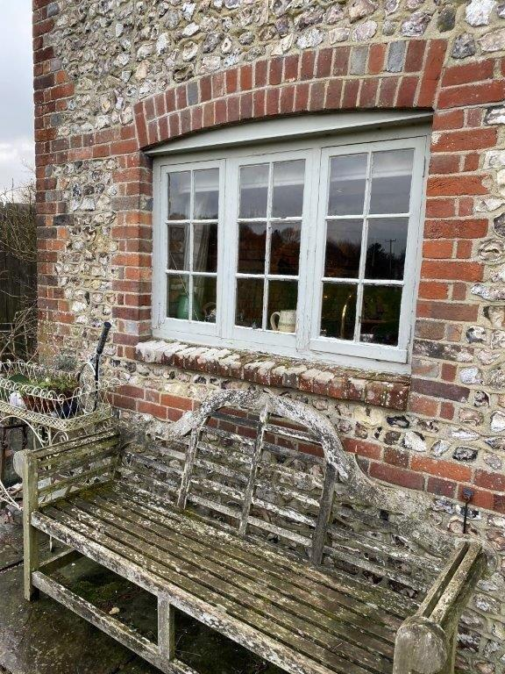
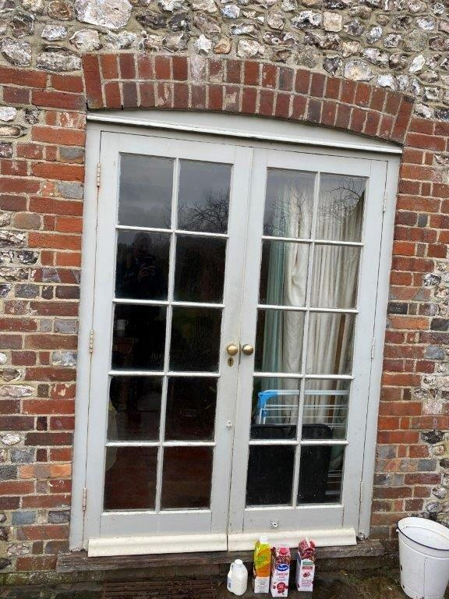
Kitchen Ground Floor – Window W1 and Door D1
Master Bedroom First Floor – 2 windows - W2 and W3 are habitable rooms
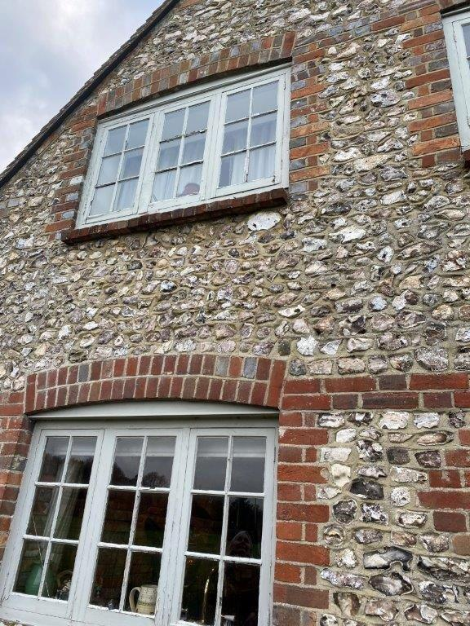
and they must have an unobstructed opening of 0.33m², with a minimum clear opening width of at least 450mm
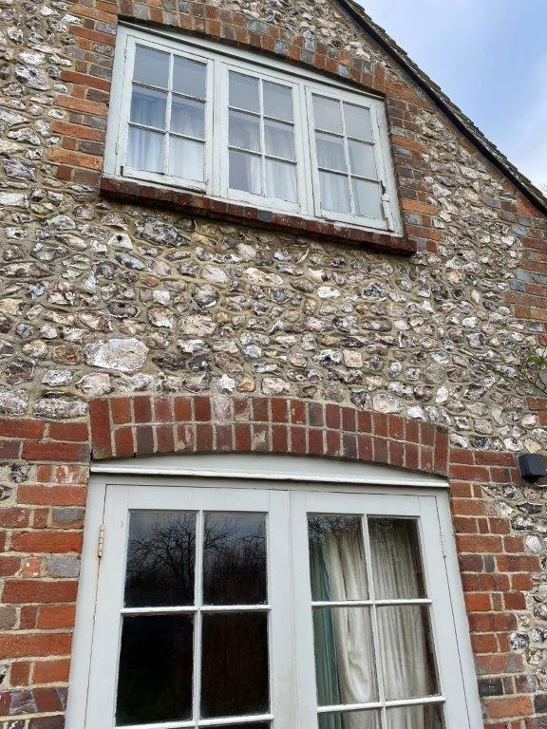
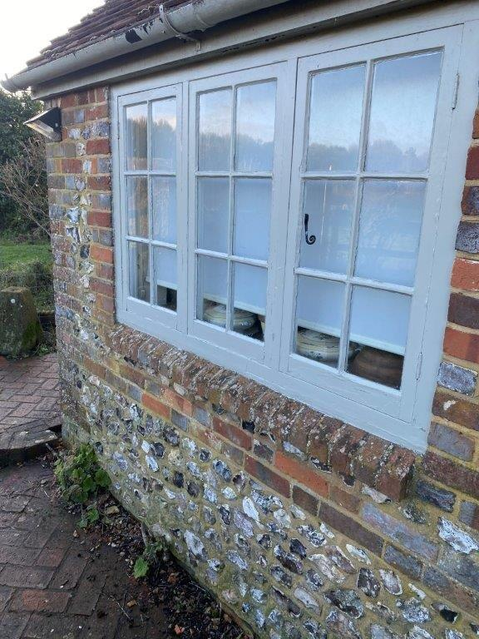
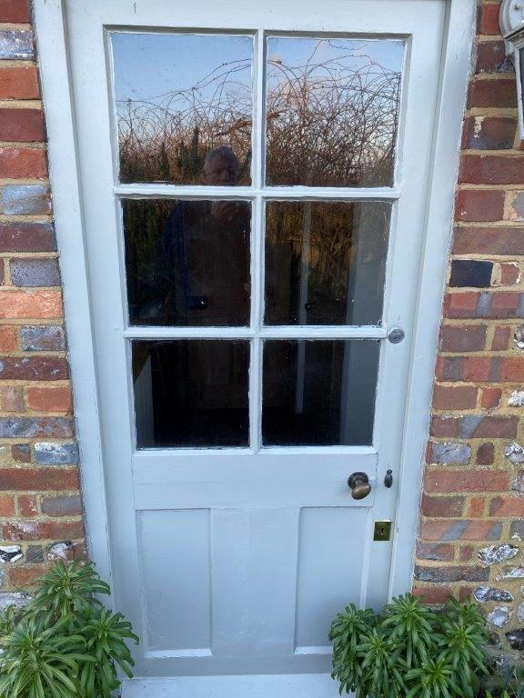
Kitchen No 2 Ground Floor Kitchen No 2 Ground Floor
Window W4 Door D2

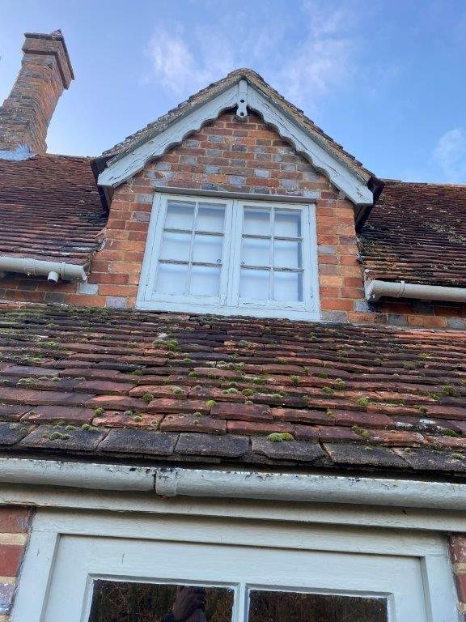
Bathroom No 2 Ground Floor Landing First Floor -
Window W5 Window W6
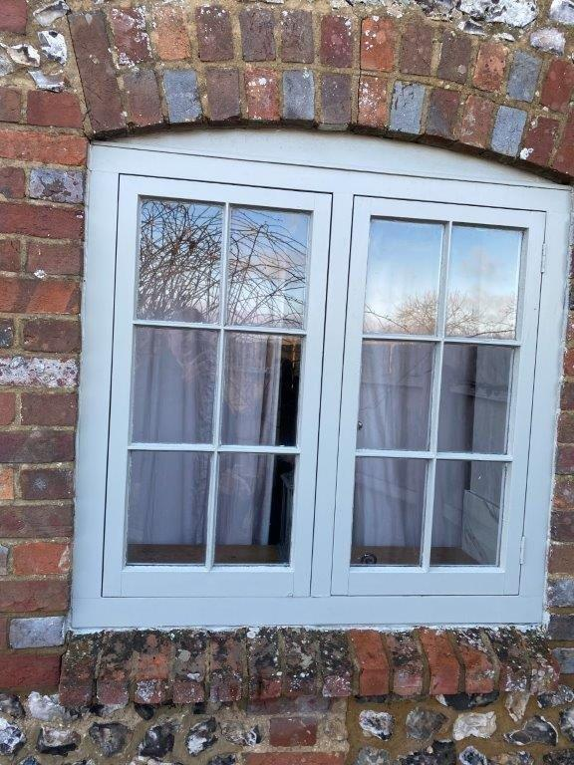
North Elevation
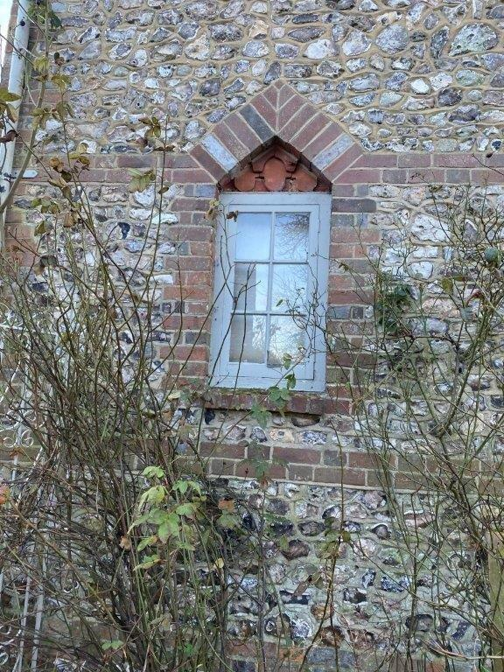
Kitchen Ground Floor Hall Ground Floor
Window W7 Window W8
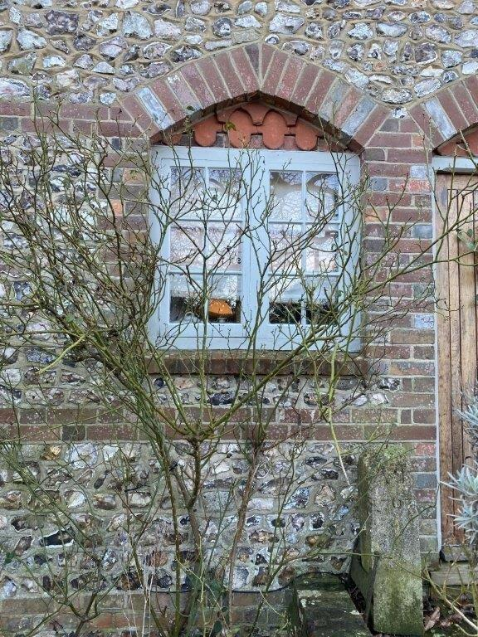
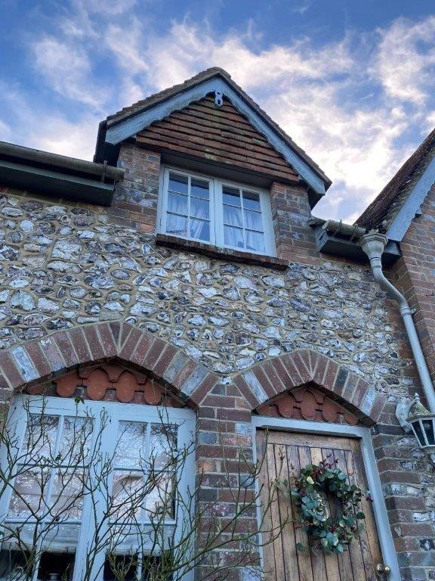
Hall Ground Floor Landing First Floor –
Door D3 Window W9
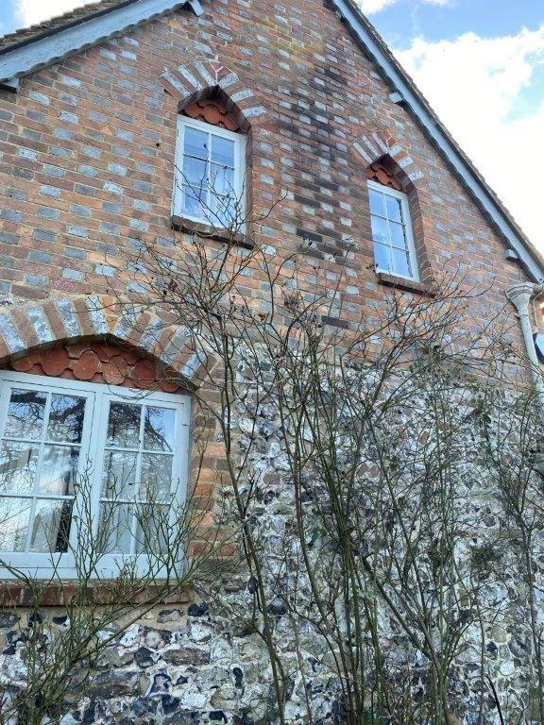
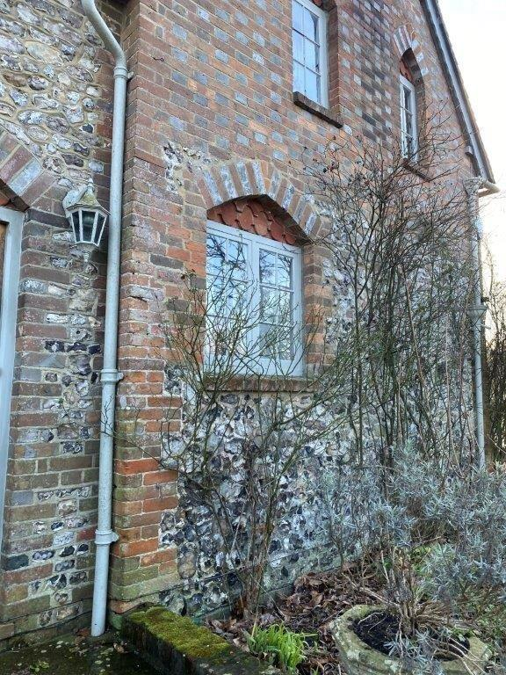
Drawing Room Ground Floor Bath & Bed First Floor
Window W10 Windows W11 & W12
W11 and W12 is to the same habitable room and one window must have an unobstructed opening of 0.33m², with a minimum clear opening width of at least 450mm

West Elevation
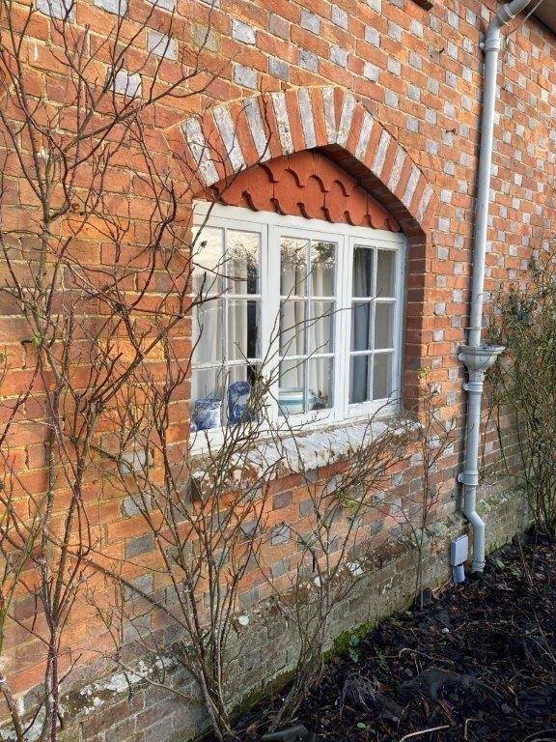
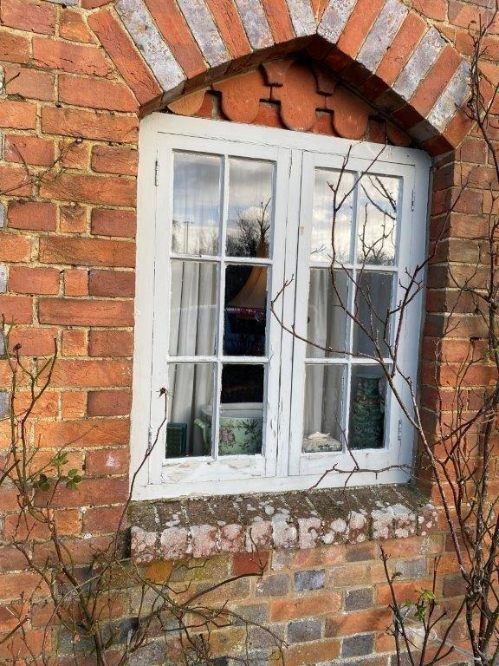
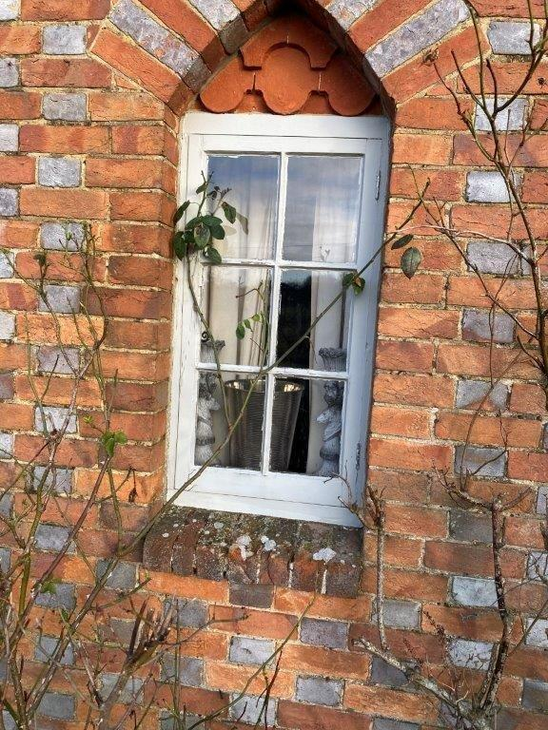
Drawing Room Ground Floor - 3 no Windows W13, W14 & W15

Lounge 2 Ground Floor – 2no Windows W16 & W17
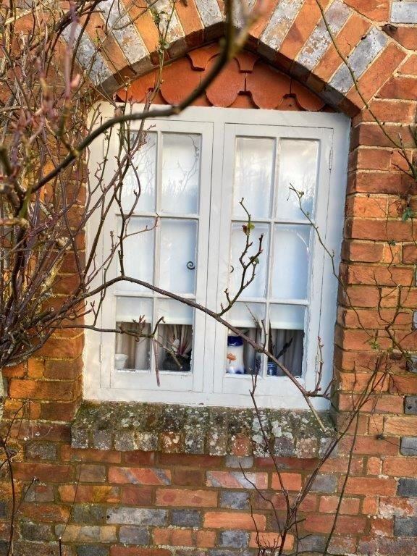
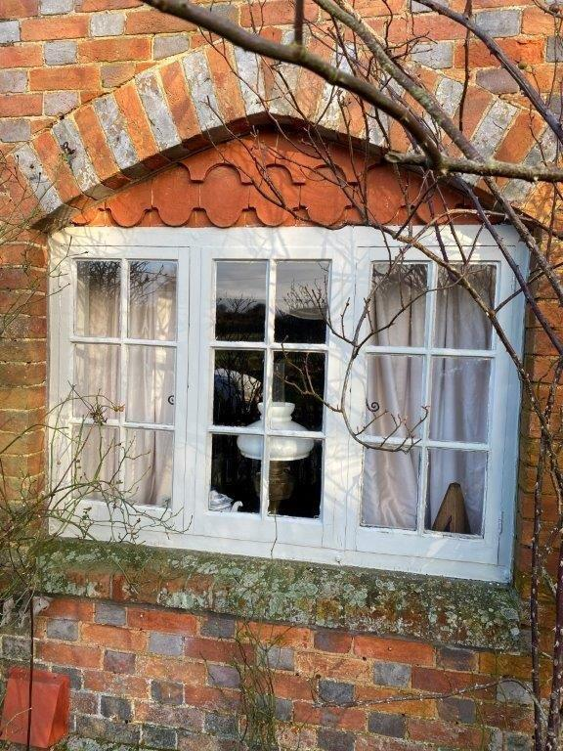

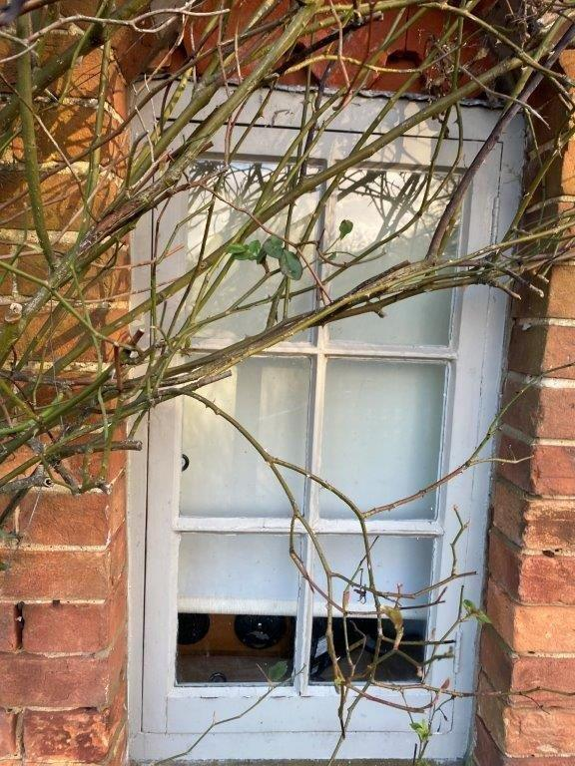
Kitchen No 2 Ground Floor – Window W18

Guest Bedrooms First Floor – 2no Windows W19 & W20
W19 and W20 are habitable rooms and they must have an unobstructed opening of 0.33m², with a minimum clear opening width of at least 450mm
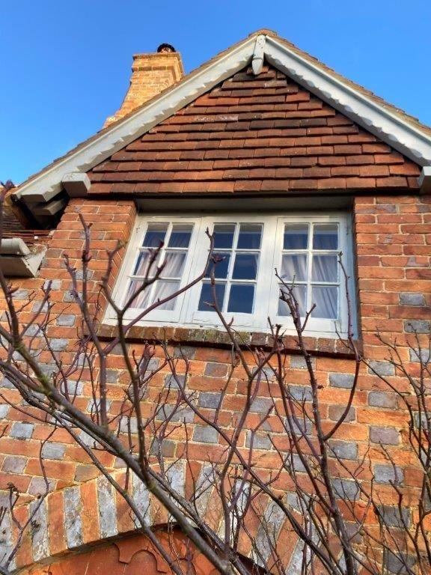
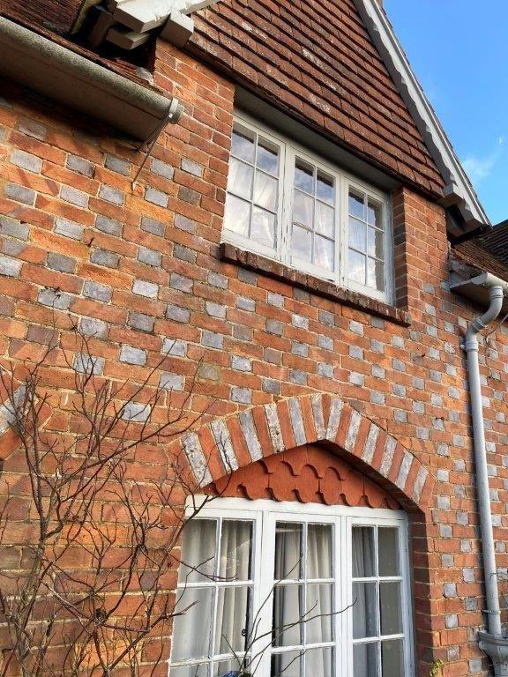
South Elevation
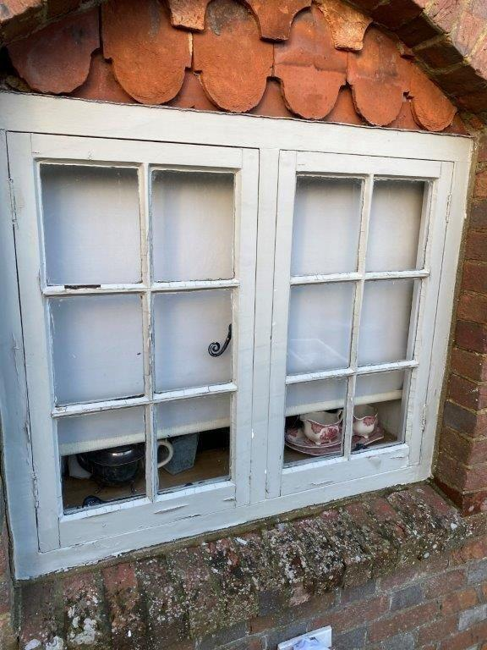
Kitchen No 2 Ground Floor Kitchen Alley Ground Floor
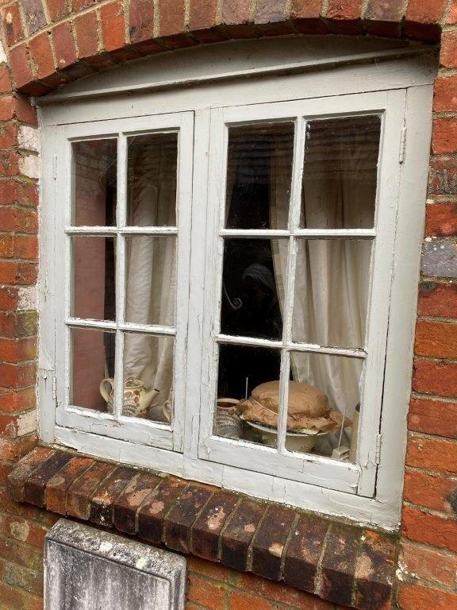
Window W21 Window W22

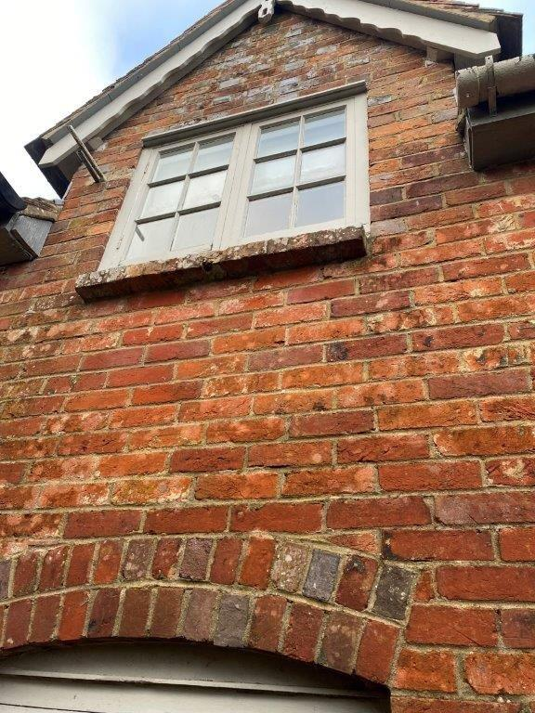
En Suite Alley – First Floor Window W23

Spare Bedrooms First Floor – 2no Windows W24 & W25

W24 and W25 are habitable rooms and they must have an unobstructed opening of 0.33m², with a minimum clear opening width of at least 450mm
