APPLICATION FOR HOUSEHOLDER PLANNING PERMISSION
DELEGATED REPORT

APPLICATION REFERENCE: | PL/2025/09510
APPLICATION TYPE: | Householder planning permission
SITE ADDRESS: | 8 Middle Lane, Trowbridge, BA14 7LG
DEVELOPMENT DESCRIPTION: | Demolition of garages and partial porch and construction of a two-storey extension, front and rear single storey extensions and pitched roof to porch. (Re-submission of PL/2021/08919 amended)
RECOMMENDATION: | That Planning Permission be GRANTED

SITE DESCRIPTION/CONTEXT
The subject property is a detached, two-storey dwelling in an area characterised by detached C20 dwellings as part of the modern expansion of northeast Trowbridge. The property benefits from two attached garages and off-road parking to the front elevation.

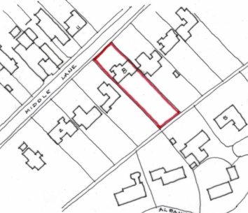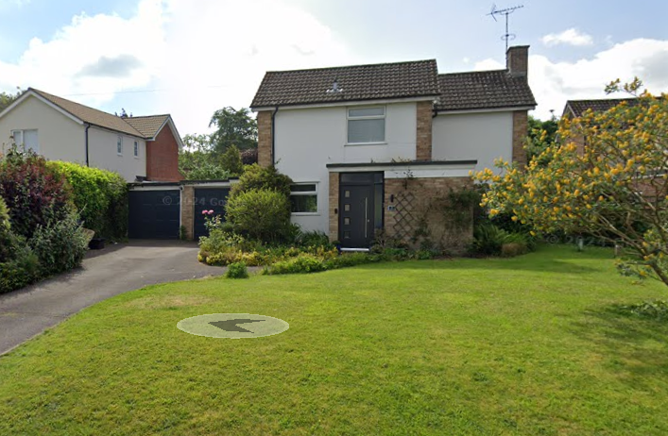

Location Plan and Google Earth Site Photo

The Trowbridge Conservation Area which includes listed buildings and boundary walls on Middle Lane, wraps around the property but given the spatial gaps and prevailing character of the street outside of the Conservation Area, this raises no concerns.

Public Right of Way TROW47 lies to the rear of the garden affording views but its use would not be impacted by proposals.

PROPOSAL

The proposal is a resubmission of PL/2021/08919, amended, and seeks planning permission for
- Demolition of Garages and partial porch demolition
- Two storey front extension – projecting forward of exiting front building line with ridge line to match the host dwelling (previous application was for additional ½ storey)
- Single storey rear extension
- Flat roof to porch inline with proposed garage flat roof
- Increased width of drive
- Replacement windows

The two-storey extension would include a relocated utility, study and a snug at GF, and at first floor a dressing room and ensuite. The residential conversion of the 2 garage spaces would create an open plan kitchen/dining space under a lantern light, and utility at ground floor, and at first floor level a master bed. Internal reconfiguration includes the creation of a corridor through to the proposed extension, insertion of an additional first floor window and sacrificing a small bedroom for a bathroom so retaining 4 bedrooms.

The proposal includes the reduction of the porch to enable space for a single storey garage to be built besides, both under a flat roof. The application has seen revisions to the porch to better integrate with the flat roof of the garage, which is welcomed.

Proposed materials include brick, render, concrete roof tiles and uPVC windows/doors – all to match existing.

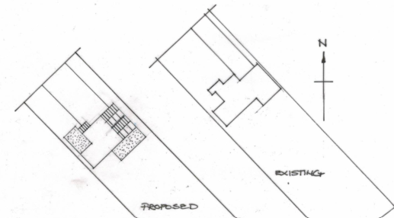

Existing and Proposed Site Plans

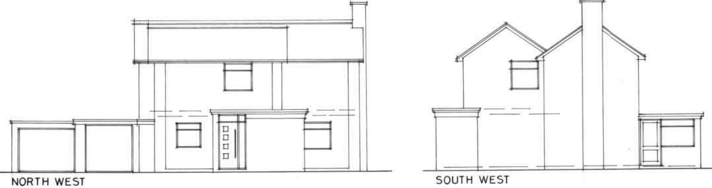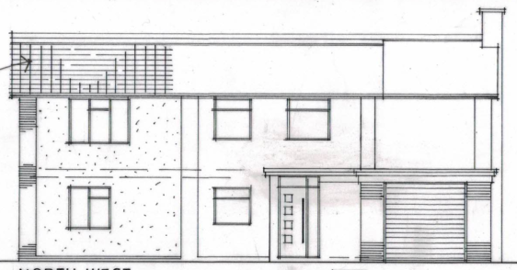

Existing and Proposed Front (NW) Elevations

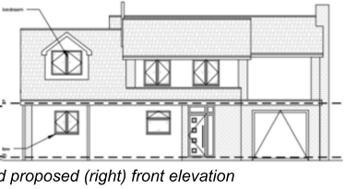

Previously approved PL/2021/08919

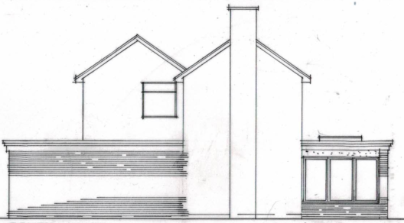

Existing and Proposed Side (SW) Elevations

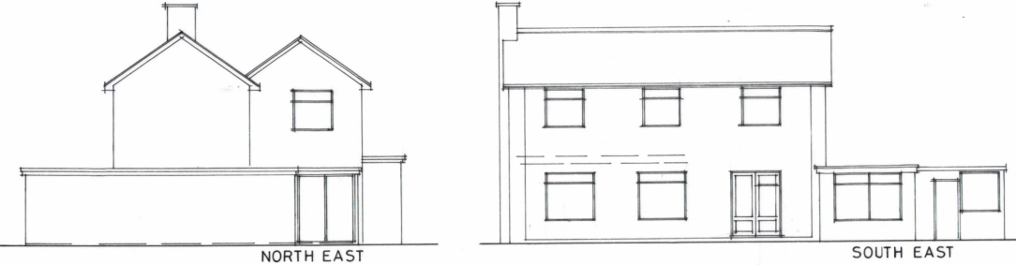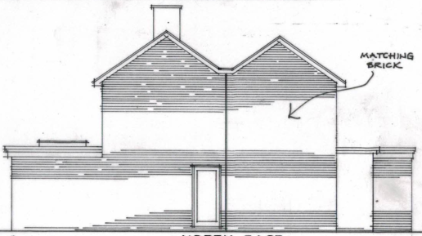

Existing and Proposed Side (NE) Elevations

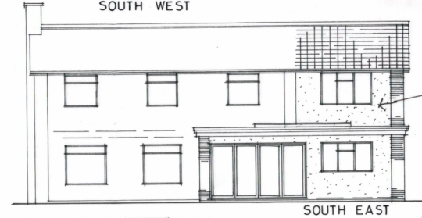

Existing and Proposed Rear (SE) Elevations

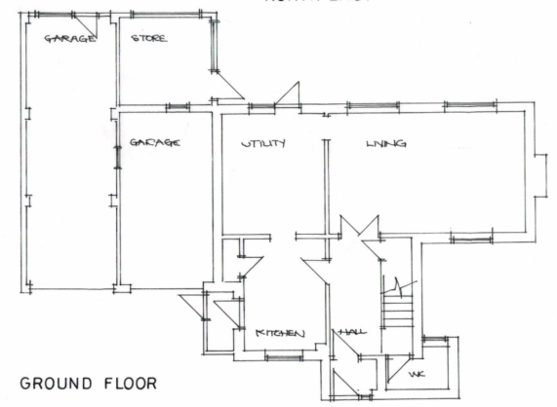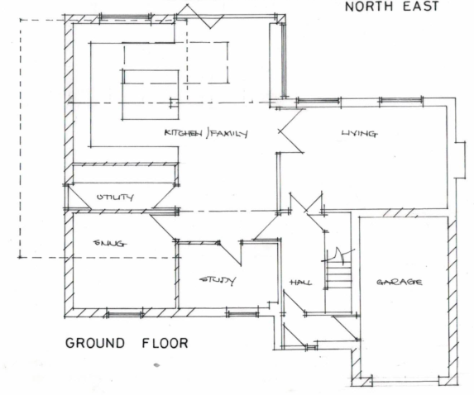

Existing and Proposed Ground Floor Plan

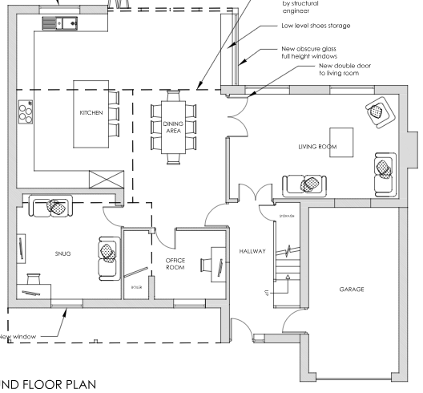

Previously approved Ground Floor Plan

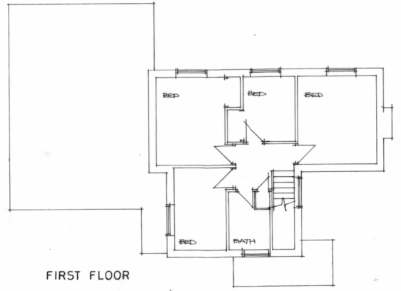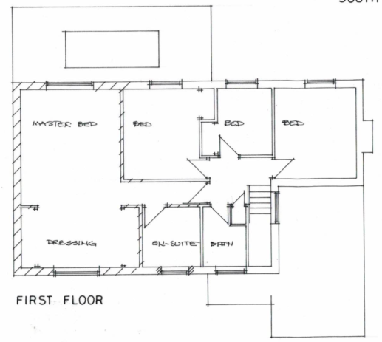

Existing and Proposed First Floor Plan

PLANNING HISTORY
PL/2021/08919 - Householder planning permission Decision - Approve with Conditions Date: 12/1/2022 – Erection of a new flat roof garage and a double-storey side and rear extension to accommodate a growing family.
W/06/02306/FUL - Full planning permission Decision - Approve with Conditions Date: 15/9/2006 – Extension
PL/2022/06332 - Householder planning permission Decision - Approve with Conditions Date: 10/10/2022 – Proposed first floor extension to north west & south west elevations together with external and internal alterations – no.10.
W/76/00777/HIS - Historic apps 1974 to 1983 Decision - Approve with Conditions Date: 20/9/1976 – Erection of lounge extension – no.10.

RELEVANT POLICIES AND GUIDANCE
The National Planning Policy Framework (NPPF)
The Planning Practice Guidance
National Design Guide
Wiltshire Design Guide: Appendix D – Design Guidance for Householder extensions

Wiltshire Core Strategy:
- Core Policy 57 Ensuring High Quality Design and Place Shaping
- Core Policy 61: Transport and New Development
- Core Policy 64: Demand Management

Trowbridge has a designated Neighbourhood Plan Area but no made plans as yet.

CONSULTATION RESPONSES

Trowbridge Town Council: No objection, subject to no significant adverse impact on neighbouring amenity.

Highways Department: No objection.

REPRESENTATIONS
No comments were received.

ASSESSMENT
Principle of Development:
Section 70(2) of the Town and Country Planning Act 1990 and section 38(6) of the Planning and Compulsory Purchase Act 2004, require that the determination of planning applications must be made in accordance with the Development Plan, unless material considerations indicate otherwise.

The proposal comprises development to an existing residential property set in an established residential area within the settlement boundary of Westwood. The proposal is wholly within the residential curtilage, and as such, the principle of development is acceptable subject to the following considerations.

In accordance with this statutory requirement, this application has been assessed against the relevant policies of the Development Plan, including the adopted Wiltshire Core Strategy (2015) and, where applicable, any made Neighbourhood Plans.

Design and Impact upon the character and context of the area
Core Policy 57 - Ensuring High Quality Design and Place Shaping of the Wiltshire Core Strategy seeks to ensure that all new development is of high design quality, reflecting local context, character, and distinctiveness.

The approved 2021 application included a garage projecting forwards 2.4m, as does this proposal, with the garage projecting 1.3m forwards of the existing porch.

The side extension would extend over the existing garages which would be converted to habitable spaces and project further forwards, as per previously approved.

The proposed extensions would be considered additions, but with the increase of ridge height the only significant deviation from the previously approved 2021 application of which this is a resubmission.

The roof ridge would match that of the host dwelling, so whilst not subservient as is the standard lexicon for extensions, would not appear out of keeping with the other dwellings on the street that have wider frontages and continuous roof ridges.

The use of matching materials would ensure the proposal integrates successfully with the host dwelling and existing street scene.

Having regard to the above, the proposal complies with the design principles set out in Core Policy 57 of the Wiltshire Core Strategy and Appendix D of the Wiltshire Design Guide.

Amenity
Point vii of Core Policy 57 - Ensuring High Quality Design and Place Shaping of the Wiltshire Core Strategy seeks to ensure that developments do not adversely affect neighbouring properties.

The National Planning Policy Framework (NPPF), particularly Paragraph 135(f), stresses that planning decisions should ensure developments provide a high standard of amenity for existing and future users.

The proposed development has been assessed in terms of its potential impact on the residential amenity of neighbouring properties, with particular regard to loss of light, overshadowing, loss of privacy, and overbearing effects.

All windows proposed would look out over curtilage gardens including bifold doors on the SW elevation of the proposed kitchen meaning no concerns with overlooking. A side access door is to be relocated and reduced and a window on the SW elevation at first floor level would be removed, improving amenity.

The two-storey extension poses an increase of massing besides immediate neighbour no. 10. The detached property however benefits from a large plot and does not align with the building line across the rest of this side of the road, but sits further forward. It does however abut the shared boundary with no.10 such that the two are only 3m apart.

At first floor level, no.10 has windows for an ensuite and bathroom (considering previous planning applications) facing the proposed extension. As non-habitable spaces this does not raise concerns.

At ground floor level of no.10 is a study. However, given the current position of the study, beside the subject property’s garages, the study is already impacted by neighbouring massing which would not be further impacted by first storey extensions.

It should also be noted that a first-floor extension has previously been approved, such that only the materially different amendments are to be reviewed, notably an increased ridge height, which is considered to not further impact light levels.

The proposal therefore accords with Core Policy 57 point vii in respect of safeguarding residential amenity and Appendix D of the Wiltshire Design Guide.

Highways Impact
Core Policy 57 (xiv) of the Wiltshire Core Strategy seeks to ensure that development must meet the requirements of Core Policy 61. This policy requires proposals to be capable of being served by safe access to the highway network. Core Policy 64 seeks to ensure compliance with parking standards set out in the Local Transport Plan.

The National Planning Policy Framework (NPPF), particularly Paragraph 115 and 116, requires that development proposals do not have an unacceptable impact on highway safety and that safe and suitable access to the site can be achieved for all users.

The proposal does not seek to increase the number of bedrooms nor associated parking demands.

The proposal would see the removal of two garages, but they are both of a size to not accommodate modern cars easily, such that there would be no associated loss of parking spaces. A wider driveway is proposed which would terminate before the proposed garage, meaning it does not provide alternative garaged parking. An informative is required to note that a highways licence will be required to drop a kerb.

The proposed development would not result in any adverse impact on highway safety. Adequate parking and turning provision is provided in accordance with Wiltshire’s adopted parking standards, and access arrangements are acceptable.

The proposal is therefore considered to comply with Core Policies 57 (xiv), 61 and 64 of the Wiltshire Core Strategy, the NPPF, and the Wiltshire Local Transport Plan.

Biodiversity Net Gain
Householder planning applications are exempt from the requirement to deliver Biodiversity Net Gain under Schedule 7A, Section 4(2)(a) of the Town and Country Planning Act 1990, as inserted by the Environment Act 2021.

CONCLUSION
The proposed development is considered to be acceptable in terms of its design, scale, and relationship with the surrounding area. It would not result in any unacceptable harm to the character of the locality, the amenities of neighbouring occupiers, nor the interests of highway safety.

The proposal is therefore considered to comply with the relevant policies of the Wiltshire Core Strategy, the Wiltshire Local Plan, and the National Planning Policy Framework. As such, the application is recommended for approval, subject to the conditions set out below.

RECOMMENDATION: That Planning Permission be GRANTED subject to conditions.

