APPLICATION FOR HOUSEHOLDER PLANNING PERMISSION
DELEGATED REPORT

APPLICATION REFERENCE: | PL/2025/08551
APPLICATION TYPE: | Householder planning permission
SITE ADDRESS: | 40A Church Street, Warminster, BA12 8PQ
DEVELOPMENT DESCRIPTION: | Proposed removal of a section of the front boundary wall
RECOMMENDATION: | That Planning Permission be GRANTED

PROPOSAL

The proposal seeks planning permission for removal of part of the existing front boundary wall, to widen the existing highway access to the application site.

SITE DESCRIPTION/CONTEXT
This application relates to a detached chalet bungalow, 40A Church Street, located within the town centre of Warminster, set back from the public highway. The host dwelling benefits from an off-road parking area to the front elevation.

The host dwelling sits within the Conservation Area which covers the historic core of the town, the general area comprises of a mixture of housing types and styles of different periods, a number of listed buildings lie within the vicinity of the application site. This proposal falls within the recreational impact zone of the Salisbury Plain Special Protection Area for birds and located within the Hampshire catchment area of the River Avon SAC.

PLANNING HISTORY
Proposal / Summary
W/89/01570/FUL - Full planning permission Decision - Approved Date: 17/10/1989 – Vehicular access and standing
20/01335/FUL - Full planning permission Decision - Approved Date: 6/4/2020 – Conversion of dormer bungalow into an 'Eco House' and associated works

RELEVANT POLICIES AND GUIDANCE
Wiltshire Core Strategy:
Core Policy 2 – Delivery Strategy
Core Policy 31 – Spatial Strategy for the Warminster Community Area
Core Policy 50 – Biodiversity and Geodiversity
Core Policy 57 - Ensuring High Quality Design and Place Shaping
Core Policy 58 - Ensuring the Conservation of the Historic Environment
Core Policy 60 – Sustainable Transport
Core Policy 61 – Transport and Development
Core Policy 64 – Demand Management
Core Policy 69 – Protection of the River Avon SAC
Warminster Neighbourhood Plan 2015- 2026 Made November 2016
Wiltshire Design Guide: Appendix D – Design Guidance for Householder extensions
The National Planning Policy Framework (NPPF)
The Planning Practice Guidance
National Design Guide
Planning (Listed Buildings and Conservation Areas) Act 1990

CONSULTATION RESPONSES

Warminster Town Council: No objection

Wiltshire Council Highways: No objection, subject to conditions

Wiltshire Council Conservation: No objection

REPRESENTATIONS
No comments were received.

ASSESSMENT
Section 38(6) of the Planning and Compulsory Purchase Act 2004 states:

"If regard is to be had to the development plan for the purposes of any determination to be made under the planning Acts, the determination must be made in accordance with the plan unless material considerations indicate otherwise."

In accordance with this statutory requirement, this application has been assessed against the relevant policies of the Development Plan, including the adopted Wiltshire Core Strategy (2015) and, where applicable, any made Neighbourhood Plans.

Design and Impact upon the character and context of the area
Core Policy 57 - Ensuring High Quality Design and Place Shaping of the Wiltshire Core Strategy seeks to ensure that all new development is of high design quality, reflecting local context, character, and distinctiveness.

The proposal seeks to remove a length of existing rubble and brick boundary wall that fronts the public highway. A section of 2.5m of wall would be removed to widen the existing highway access to the application site. The host dwelling benefits from off road parking provision to the front elevation with the existing access limited to 3m in width, restricting the access and egress to the parking area to the width of one vehicle. The proposal seeks to widen the existing accessway to a width of 5.5m, with the removal of a 2.5m wide section of the existing wall that sits at a height of 1.8m.

The wall consists of brick elevations to the rear with stone rubble fronting the public highway. The wall would be made good with materials to match the existing boundary wall with stone piers replicating the existing arrangement. The existing sliding gate would be removed from the proposal.

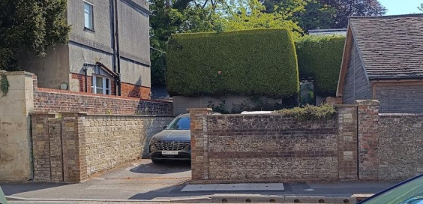
Image of the existing boundary wall arrangement fronting the public highway.

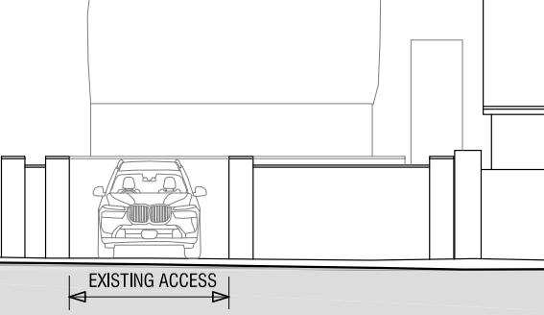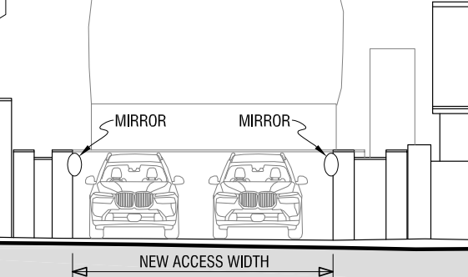

Existing (left) and proposed (right) front elevation

The Planning Statement submitted within the application documents states that the wall is not original and was erected within the mid-20th century and upon examination of The Council’s historic maps, officers broadly agree with this statement.

The existing built form along this section of Church Street consists of the brick elevations of properties directly fronting the highway but also properties set back from the highway with driveway openings leading from the street.

Whilst it is observed that the proposal would remove existing built form that would open up views across the application site, those views already exist with the existing opening. The section of wall is not original and would not result in the loss of any historic fabric, and the loss of a length of 2.5m of a stone rubble and brick wall, would not be so great as to harm the street scene or visual amenity or adversely impact on the character and appearance of the area.

Having regard to the above, the proposal complies with the design principles set out in Core Policy 57 of the Wiltshire Core Strategy and Appendix D of the Wiltshire Design Guide.

Amenity
Point vii of Core Policy 57 - Ensuring High Quality Design and Place Shaping of the Wiltshire Core Strategy seeks to ensure that developments do not adversely affect neighbouring properties.

The National Planning Policy Framework (NPPF), particularly Paragraph 135(f), stresses that planning decisions should ensure developments provide a high standard of amenity for existing and future users.

The proposed development has been assessed in terms of its potential impact on the residential amenity of neighbouring properties, with particular regard to loss of light, overshadowing, loss of privacy, and overbearing effects.

Given the nature of the proposal, the removal of a 2.5m length of existing boundary wall fronting the public highway, with extended separation distances to any neighbouring occupiers, officer raise no concerns in regard to any adverse neighbouring amenity impacts.

The proposal therefore accords with Core Policy 57 point vii in respect of safeguarding residential amenity and Appendix D of the Wiltshire Design Guide.

Highways Impact
Core Policy 57 (xiv) of the Wiltshire Core Strategy seeks to ensure that development must meet the requirements of Core Policy 61. This policy requires proposals to be capable of being served by safe access to the highway network. Core Policy 64 seeks to ensure compliance with parking standards set out in the Local Transport Plan.

The National Planning Policy Framework (NPPF), particularly Paragraph 115 and 116, requires that development proposals do not have an unacceptable impact on highway safety and that safe and suitable access to the site can be achieved for all users.

The proposal seeks planning permission for removal of part of the existing front boundary wall, to widen the existing highway access to the application site and improve the visibility of vehicles exiting the site.

The council’s highway team have no objection to the scheme subject to conditions. However, it is not considered necessary to impose a condition requiring the consolidation of the access, as the access is already consolidated. In addiction it is not clear whether the proposed visibility splays are necessary and can be achieved on site. There would also seem to be no need to impose a condition regarding surface water due to the nature of the application (removal of a wall).

The area of hardstanding behind the wall to be removed, used to park up to 2 cars, is existing as approved under application W/89/01570/FUL. Due to the removal of the section of wall fronting the highway, is it considered the development would improve visibility on exiting the site for vehicles. As such the development would provide a betterment and the scheme complies with policy CP61 of the WCS and the site can be served by a safe access.

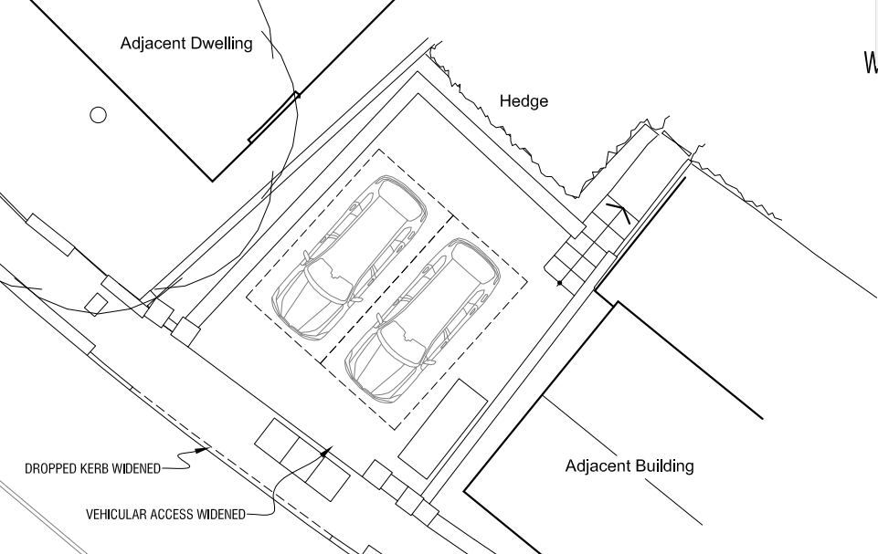

The highways team also recommended that ‘the applicant apply for the Vehicle Access application at their earliest convenience to enable discussions to commence with regards to the works involved with the alterations to the drainage system in the highway that will be required to be amended. I also stress that works must not commence on site until the Vehicle Access application has been approved’

Therefore, officers are of the opinion that the proposed development would not result in any adverse impact on highway safety. The proposal is therefore considered to comply with Core Policy 57 of the Wiltshire Core Strategy and the NPPF.

Heritage Impact
From the point of view of the historic environment the main statutory tests are set out within the Planning (Listed Building and Conservation Areas) Act 1990.

Section 66 requires that special regard be given to the desirability of preserving listed buildings, their settings or any features of special architectural or historic interest which they possess.

Section 72(1) of the Act requires the Council to pay special attention to the desirability of preserving or enhancing the character or appearance of designated Conservation Areas.

The Council’s Core Strategy Policy CP58 ‘Ensuring the conservation of the historic environment’ requires that designated and non-designated heritage assets and their settings will be conserved, and where appropriate enhanced, in a manner appropriate to their significance and encourages proposals which improve the condition of heritage assets at risk.

The Council’s Core Strategy CP 57: Ensuring high quality design requires a high quality of design in all new developments. The policy requires applicants to “demonstrate how the proposal will make a positive contribution to the character of Wiltshire through (amongst other things) responding to the value of the natural and historic environment and being sympathetic to and conserving historic buildings and landscapes. Development is required to respond positively to the existing in terms of building layouts, built form, height, mass, scale, building line, plot size, elevational design, materials, streetscape and rooflines to effectively integrate the building into its setting.

The NPPF outlines government policy for planning. Chapter 16 of the NPPF 'Conserving and enhancing the historic environment' sets out the Government's high-level policies concerning heritage and sustainable development.

The application site sits adjacent to a grade II* listed property, Byne House and opposite the grade II listed Warminster School, and to the south of the entranceway a grade II listed milestone is positioned, as illustrated by the map insert below (black hatching). The application site also sits within the Warminster Conservation area.

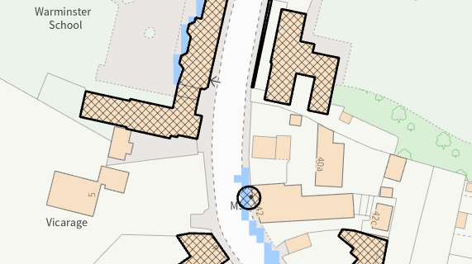

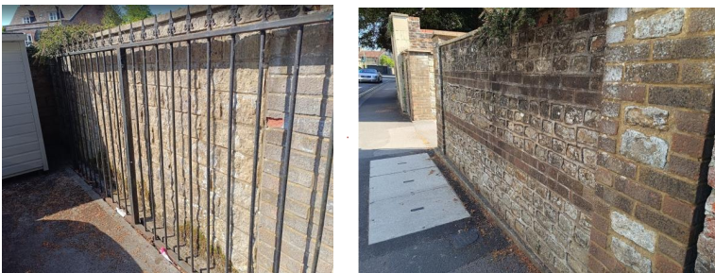
Rear elevation(left) and front elevation (right) of the existing wall

The Local Authority Conservation officer offered the following response to the proposal;

‘The section of wall does look to be a later insertion and the bricks 20th century. That said, it is a reasonably attractive feature within this part of the CA.
I have checked the 2007 Warminster CA appraisal (not sure if it was ever adopted) and this bit of wall has not been flagged up as a 'significant wall' and therefore worthy of careful consideration.
On balance, I think there would be some slight harm but in respect of Section 72 of the Planning LBCA Act 1990, I think the proposals would preserve the character of the CA, and in respect of section 66, would not have an adverse impact on the setting of LBs in the vicinity’
The wall would be made good with materials typical to the development type, matching the existing built form of the boundary wall, that would help the development blend into the existing environment. The scale of the development is considered to be commensurate to the size of the application site and would therefore not adversely impact the setting of the listed buildings nearby.

Given the limited works proposed, that would be set within the built envelope of the application site, the proposal, by virtue of its scale, design, and use of materials, is considered to preserve the character and appearance of the conservation area and the setting of the listed buildings nearby.

The development is therefore considered to comply with Core Policy 58 of the Wiltshire Core Strategy, as well as the relevant provisions of the NPPF.

Ecology Impact
Core Policy 50 of the Wiltshire Core Strategy seeks to protect and enhance biodiversity and geodiversity, including through ensuring that development avoids harm to protected species and habitats.

The National Planning Policy Framework (NPPF), in Paragraphs 193, requires that development minimises impacts on and provides net gains for biodiversity, including ensuring mitigation is secured where harm cannot be avoided.

This proposal falls within the recreational impact zone of the Salisbury Plain Special Protection Area for birds. Therefore, potential disturbance to nesting birds through the creation of additional visitor numbers to the Salisbury Plain has to be assessed. However, given that this proposal relates to removal of a section of an existing boundary wall only, without the creation of separate independent living accommodation, it is considered that there would not be any adverse impacts on the Special Protection Area.

The site is located within the Hampshire catchment area of the River Avon SAC where phosphates and nutrients are carefully controlled and monitored. However, given that this proposal relates to removal of a section of an existing boundary wall only, without the creation of separate independent living accommodation, it is considered that there would not be any adverse impacts on the phosphates/nutrient discharge.

As such, the development complies with Core Policy 50 of the Wiltshire Core Strategy and the relevant provisions of the NPPF.

Biodiversity Net Gain
Householder planning applications are exempt from the requirement to deliver Biodiversity Net Gain under Schedule 7A, Section 4(2)(a) of the Town and Country Planning Act 1990, as inserted by the Environment Act 2021.

CONCLUSION
The proposed development is considered to be acceptable in terms of its design, scale, and relationship with the surrounding area. It would not result in any unacceptable harm to the character of the locality, the amenities of neighbouring occupiers, or the interests of highway safety, heritage, or ecology.

The proposal is therefore considered to comply with the relevant policies of the Wiltshire Core Strategy, the Wiltshire Local Plan, and the National Planning Policy Framework. As such, the application is recommended for approval, subject to the conditions set out below.

RECOMMENDATION: That Planning Permission be GRANTED subject to conditions.

