APPLICATION FOR HOUSEHOLDER PLANNING PERMISSION
DELEGATED REPORT

APPLICATION REFERENCE: | PL/2025/10024
APPLICATION TYPE: | Householder planning permission
SITE ADDRESS: | 12 The Pastures, Lower Westwood, Bradford On Avon, BA15 2BH
DEVELOPMENT DESCRIPTION: | Roof dormer bedroom extension & Porch canopy
RECOMMENDATION: | That Planning Permission be GRANTED

SITE DESCRIPTION/CONTEXT
The subject property is a chalet-style semi-detached bungalow within Lower Westwood, in an area of the village with shared character, design and modern road layout. The majority of properties along this section of the street are 1 1/2 storeys, with steep pitches and the gable ends facing onto street.

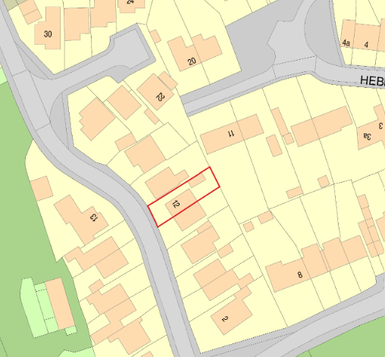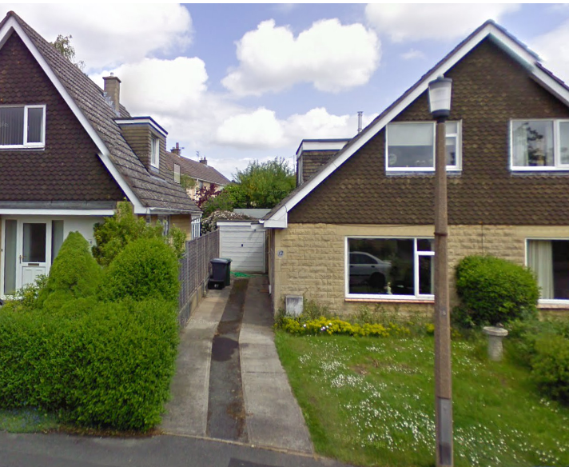

Location Plan and Google Earth Site Photo

The application site is subject to the following planning policy constraints:
- Bath and Bradford on Avon Special Area of Conservation for Bats
- Flood zone 1 of lowest risk, but of increased ground water flooding risk

PROPOSAL

The proposal seeks planning permission for:
- Roof dormer bedroom extension
- Porch canopy

Proposed materials include plain concrete tiles and uPVC casements both to match existing and an EPDM rubber flat roof covering.

All as per plans and elevations below:

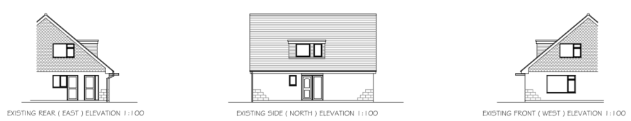

Existing Elevations

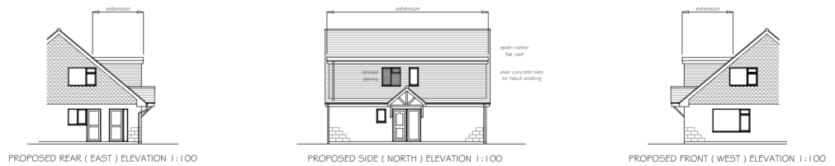

Proposed Elevations

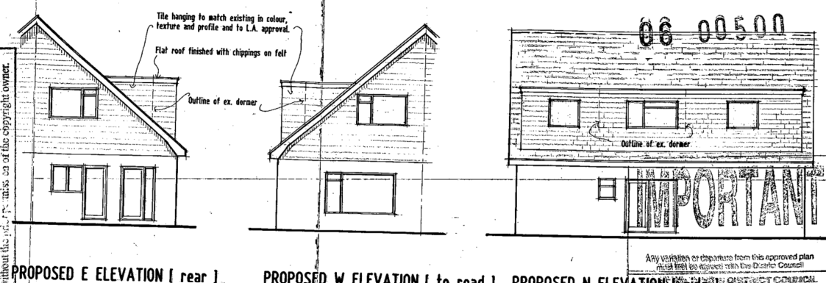

Previously Approved Elevations

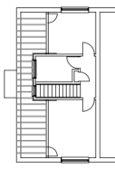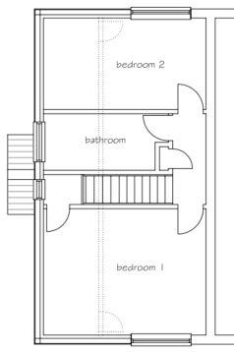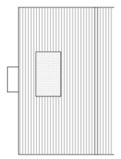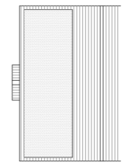

Existing and Proposed First Floor and Existing and Proposed Roof Plan

PLANNING HISTORY
W/06/00500/FUL - Full planning permission Decision - Approve with Conditions Date: 7/4/2006 – Enlargement of ex dormer
W/91/00620/FUL - Full planning permission Decision - Approve with Conditions Date: 18/6/1991 – Extension and new dormer window – no. 14 The Pastures
W/80/01451/HIS – rear extension to ground floor and extension to first floor dormer – approve with conditions - no.11.
PL/2023/01166 – single storey wrap around extension with covered patio area, front extension, garage and dormer – approve with conditions – no.3.

RELEVANT POLICIES AND GUIDANCE
The National Planning Policy Framework (NPPF)
The Planning Practice Guidance
National Design Guide
Wiltshire Design Guide: Appendix D – Design Guidance for Householder extensions

Wiltshire Core Strategy:
- Core Policy 7 - Spatial Strategy for Bradford on Avon
- Core Policy 57 - Ensuring High Quality Design and Place Shaping
- Core Policy 50: Biodiversity and Geodiversity
- Core Policy 67: Flood Risk

Westwood has a designated Neighbourhood Plan Area but no made plans as yet

CONSULTATION RESPONSES
Westwood Parish Council: no objection.
Highways: no objection.

REPRESENTATIONS
No comments were received.

ASSESSMENT
Principle of Development:
Section 70(2) of the Town and Country Planning Act 1990 and section 38(6) of the Planning and Compulsory Purchase Act 2004, require that the determination of planning applications must be made in accordance with the Development Plan, unless material considerations indicate otherwise.

The proposal comprises development to an existing residential property set in an established residential area within the settlement boundary of Westwood. The proposal is wholly within the residential curtilage, and as such, the principle of development is acceptable subject to the following considerations.

In accordance with this statutory requirement, this application has been assessed against the relevant policies of the Development Plan, including the adopted Wiltshire Core Strategy (2015) and, where applicable, any made Neighbourhood Plans.

Design and Impact upon the character and context of the area
Core Policy 57 - Ensuring High Quality Design and Place Shaping of the Wiltshire Core Strategy seeks to ensure that all new development is of high design quality, reflecting local context, character, and distinctiveness.

The previous 2006 application was assessed under the previous incarnation of the Wiltshire Core Strategy; policies former West Wilts district council Local Plan. As such, this entire application must be assessed against the 2015 WCS, not just the amendments.

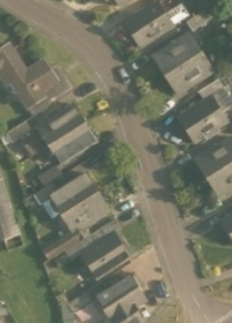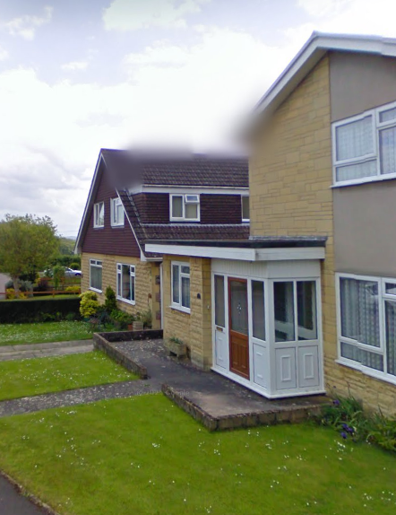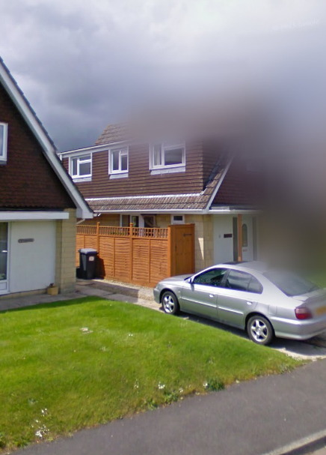

Given the existing dormer on no.10, the proposed dormer of increased projection, to almost full width, would still retain the symmetry and balance of the paired dormers at the proposed scale.

There are notable similar precedents on The Pastures such that the proposals would integrate successfully with the surrounding streetscene and retain the locally distinctive character.

The porch would be located at the entrance to the side, echoing the pitch of the chalet bungalow, and not altering its characteristic street-facing gable end.

It is considered that the extensions would by virtue of their height, scale and design constitute complementary additions to the host dwelling that would appear commensurate to the size of the property and plot. The development would therefore comply with Policy CP57 of the WCS.

Amenity
Point vii of Core Policy 57 - Ensuring High Quality Design and Place Shaping of the Wiltshire Core Strategy seeks to ensure that developments do not adversely affect neighbouring properties.

The National Planning Policy Framework (NPPF), particularly Paragraph 135(f), stresses that planning decisions should ensure developments provide a high standard of amenity for existing and future users.

The proposed development has been assessed in terms of its potential impact on the residential amenity of neighbouring properties, with particular regard to loss of light, overshadowing, loss of privacy, and overbearing effects.

The proposed extended dormer would contain two windows at a scale to match the existing windows. These two windows are to a stairwell and bathroom; both uninhabitable rooms. The proposal includes obscure glazing to the bathroom window given the slight increase of scale of dormer and therefore proximity to no.14.

It is considered necessary to remove permitted development rights for any additional windows or openings within the proposed extended dormer, at first floor level on the northwest elevation. This measure ensures that any future changes which could affect neighbouring amenity are subject to formal planning consideration.

Such rights should only be withdrawn where there is clear justification and where the six tests for planning conditions are met. In this case, the restriction is necessary and proportionate to safeguard neighbouring privacy.

The increased scale of the dormer would entail a small increase of massing and therefore impact late evening light levels, but at such a level to not cause concern.

The proposal therefore accords with Core Policy 57 point vii in respect of safeguarding residential amenity and Appendix D of the Wiltshire Design Guide.

Ecology Impact
As per CP50, ‘development proposals must demonstrate how they protect features of nature conservation … as part of the design rationale.There is an expectation that such features shall be retained, buffered and managed favourably in order to maintain their ecological value, connectivitiy and functionality in the long-term.’

The proposals pose no loss of biodiversity, and the application does not meet the threshold set out in legislation to demonstrate BNG.

All UK bat species are protected by European and UK legislation; the Conservation of Habitats and Species Regulations and the Wildlife and Countryside Act. Considering the scale and form of proposed development, as a first floor extension to an existing inhabitated structure, within a suburban area, no substanitave ecology impact is raised and as such does not meet the threshold for a habitat regulations assessment.

An informative is included as a precautionary measure, raising the profile of the Bat SAC, including that if any evidence of bat activity is detected, that the applicant should follow the advice of a professional ecologist or contact Natural England.

Drainage:
CP67 of the WCS, Flood risk, highlights that “development proposed in flood risk zones 2 and 3, will require measures to reduce rainwater runoff and improve sustainable urban drainage.”

The area is in flood zone 1, with an increased risk of ground water flooding.

The NPPF, paragraph 167, states that where appropriate, an application should be supported by a site-specific flood risk assessment.

Minor Development, under the Flood Risk planning guidance, barring a few exceptions not relevant here, is “unlikely to raise significant flood risk issues.”

As such, the proposal is deemed to be safe for its users for the intended lifetime of the development with respect to the level and nature of the flood risk.

Biodiversity Net Gain
Householder planning applications are exempt from the requirement to deliver Biodiversity Net Gain under Schedule 7A, Section 4(2)(a) of the Town and Country Planning Act 1990, as inserted by the Environment Act 2021.

CONCLUSION
The proposed development is considered to be acceptable in terms of its design, scale, and relationship with the surrounding area. It would not result in any unacceptable harm to the character of the locality, the amenities of neighbouring occupiers, or the interests of highway safety, heritage, or ecology.

The proposal is therefore considered to comply with the relevant policies of the Wiltshire Core Strategy, the Wiltshire Local Plan, and the National Planning Policy Framework. As such, the application is recommended for approval, subject to the conditions set out below.

RECOMMENDATION: That Planning Permission be GRANTED subject to conditions.

