APPLICATION FOR FULL-PLANNING PERMISSION
CASE OFFICER REPORT

APPLICATION REFERENCE: | PL/2025/09974
APPLICATION TYPE: | Full planning permission
SITE ADDRESS: | Barters Farm Nurseries LTD, High Street, Chapmanslade, Westbury, BA13 4AL
DEVELOPMENT DESCRIPTION: | Erection of 2 No. prefabricated office and staff welfare units, prefabricated staff WC block and 2 No. polytunnels ancillary to established horticultural use (part retrospective).
RECOMMENDATION: | Approve with Conditions

SITE DESCRIPTION/CONTEXT
This application relates to an established horticultural nursery, Barters Farm Nurseries, located on the northeastern side of the village of Chapmanslade. The site also benefits from a retail plant centre.

This proposal falls within the recreational impact zone of the Salisbury Plain Special Protection Area for birds and located within the Bath and Bradford on Avon Special Area of Conservation for bats. The application site is also located within a Special Landscape Area.

PROPOSAL

The applicant is seeking part retrospective permission for the erection of two polytunnels, a staff welfare unit, an administration block and a block of staff toilets. The administration building and staff welfare building are already in position but were not in use at the time the site was visited by the case officer. The polytunnels were in the process of being erected at the time of the visit. The plan insert below illustrates the proposal.

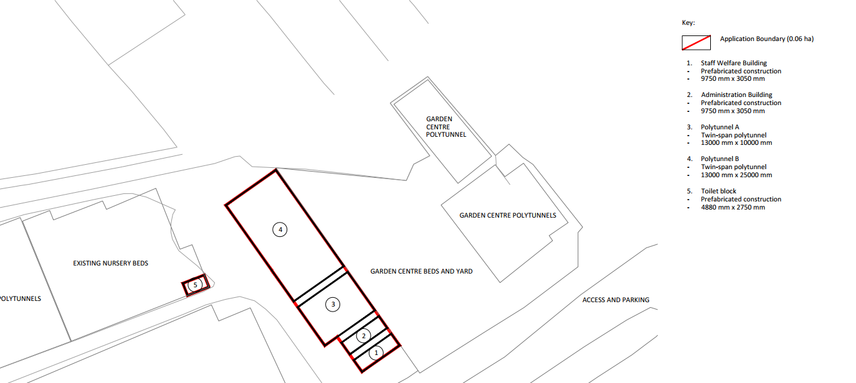

PLANNING HISTORY
Proposal / Summary
W/00/01026/FUL - Full planning permission Decision - Approve with Conditions Date: 22/2/2001 – Change of use from nursery plant centre to garden centre
W/74/00636/HIS - Historic apps 1974 to 1983 Decision - Approved Date: 24/7/1974 – Office, staff room and store
W/97/09029/AGD - Agricultural & Forestry - Detailed matters Decision - Approved Date: 1/12/1997 – Polythene tunnel
W/96/09018/AGD - Agricultural & Forestry - Detailed matters Decision - Approved Date: 24/6/1996 – Glasshouses
W/96/09034/AGD - Agricultural & Forestry - Detailed matters Decision - Approved Date: 13/11/1996 – Buildings for propagation of young plants and office use
W/99/09002/AGD - Agricultural & Forestry - Detailed matters Decision - Approved Date: 20/1/1999 – Polythene tunnels
W/99/01557/OUT - Outline Planning Decision - Approve with Conditions Date: 16/12/1999 – Construction of student accommodation (renewal)
W/94/00015/OUT - Outline Planning Decision - Approve with Conditions Date: 14/2/1994 – Construction of student accommodation
19/08797/APD - Agricultural & Forestry - Detailed matters Decision - Prior Approval Not Required Date: 9/10/2019 – New Barn and Poly Tunnel
PL/2023/05349 - Full planning permission Decision - Refuse Date: 25/4/2024 – Erection of 9 Dwellings, demolition, and associated works (additional information)
PL/2024/08591 - Full planning permission Decision - Withdrawn by Applicant Date: 5/8/2025 – Erection of 9 Dwellings, demolition and associated works (resubmission of PL/2023/05349)

RELEVANT LEGISLATION, POLICIES AND GUIDANCE

National Planning Policy:
- National Planning Policy Framework (NPPF)
- Planning Practice Guidance (PPG)
- National Design Guide
Development Plan:
The development plan for Wiltshire comprises the Wiltshire Core Strategy (WCS) (adopted January 2015) and any made neighbourhood plans, which remains the principal statutory planning document guiding development across the county. In line with Section 38(6) of the Planning and Compulsory Purchase Act 2004, planning decisions must be made in accordance with the development plan unless material considerations indicate otherwise.

Though the development plan is considered as a whole, those parts deemed to be particularly relevant to this application are listed below:

The adopted Wiltshire Core Strategy (WCS), with particular regard to:

- Core Policy 2 Delivery Strategy
- Core Policy 32 – Spatial Strategy for the Westbury Community Area
- Core Policy 35 Existing Employment Land
- Core Policy 50 Biodiversity and Geodiversity
- Core Policy 51 Landscape
- Core Policy 57 Ensuring High Quality Design and Place Shaping
- Core Policy 67 Flood Risk

Supplementary Planning Documents and other Guidance:
Wiltshire Design Guide (adopted April 2024)

Wiltshire Council’s Emerging Local Plan (WLP) 2020-2038 - The Council’s emerging Local Plan has reached Regulation 24 stage, although at the time of writing this report, the examination has been paused by the examining inspectors.

ISSUES

The main planning issues for this case are

- Whether the development is acceptable in principle (CP 1 and 2)
- Whether the scheme constitutes high quality design (CP 57)
- Whether the scheme would have an acceptable impact upon the reasonable living conditions of the adjoining occupants (CP 57)
- Whether the scheme would have an acceptable landscape impact (CP 51)
- Whether the site can be adequately drained without increasing flood risk elsewhere (CP 67)
- Whether there would be any harmful impacts upon protected species or priority habitats (CP 50)

CONSULTATION RESPONSES
Chapmanslade Parish Council: No objection

WC Highways: No objection

REPRESENTATIONS
In accordance with the requirements of the Town and Country Planning (Development Management Procedure) (England) Order 2015 (as amended), the application was publicised by way of neighbour notification letters sent to adjoining and nearby properties. This method was used to inform interested parties and provide a period of 21 days for comments to be submitted.

One third party / local resident raised concerns that the development would lead to an increase in flooding to neighbouring properties.

The local resident has also raised concerns that the development would lead to an increase of an existing rat problem, with rats accessing gardens within the vicinity.

ASSESSMENT
Section 38(6) of the Planning and Compulsory Purchase Act 2004 states:
"If regard is to be had to the development plan for the purposes of any determination to be made under the planning Acts, the determination must be made in accordance with the plan unless material considerations indicate otherwise."

In accordance with this statutory requirement, this application has been assessed against the relevant policies of the Development Plan, including the Wiltshire Core Strategy (2015) and, where applicable, any made Neighbourhood Plans. Consideration has also been given to the policies of the National Planning Policy Framework (NPPF) as a material consideration in the assessment.

Principle of Development
The proposed development comprises additions to an existing established horticultural business set within the confines of the existing application site, within the settlement boundary of Westbury. The development would be wholly within the application site and as such the principle of development is acceptable subject to the following considerations

Design and Impact on the Character and Appearance of the Area
Adopted WCS Core Policy 57 requires a high standard of design in all new developments, of particular relevance to householder extensions is paragraph (iii) which requires development to respond positively to the existing townscape and landscape features in terms of building layouts, built form, height, mass, scale, building line, plot size, elevational design, materials, streetscape and rooflines to effectively integrate the building into its setting.

The proposal seeks retrospective permission for the siting of a prefabricated office and a staff welfare unit as well as a prefabricated toilet block and two polytunnels on the site. The horticultural business at Barters Farm is well established. The welfare unit and office accommodation buildings are to be located adjacent to each other and are of a matching form, prefabricated white steel buildings 2.7m high with a flat roof form with the structure extending to 29.7m2.

The toilet building is steel construction with dark green elevations, with a flat roof form and would occupy 13m2. At the time of the site visit, works had commenced with the building being sited, but it has not yet been connected to mains foul drainage. In the supporting Planning Statement, the applicant submits that Newland Homes are contractually obligated to provide a mains foul drainage connection from their Phase 2 development (the new build housing development to the west of the application site) to which the proposed WC block would connect with (via separate agreements/consent).

The polytunnels consist of a galvanised steel double-hoop frame with UV-stabilised polyethylene sheeting. Polytunnel A would extend over a footprint of 130m2 and polytunnel B an area of 325m2. The tunnels are located to the northwest of the staff welfare and admin building, and adjacent to the existing plant sales area of the nursery.

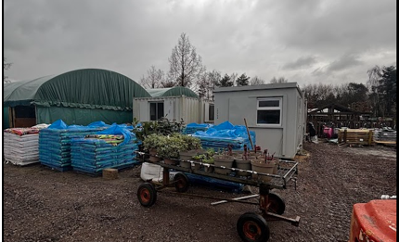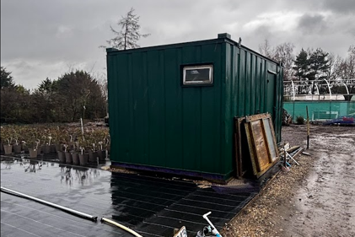

The character of the area is heavily influenced by the present horticultural business and operations with existing polytunnels and outbuildings located around the extended site. The proposed buildings and materials to be utilised for this retrospective application are considered sympathetic to the existing site character.

Officers consider the development would therefore have no adverse impact on the character of the area and the scheme complies with Core Policy 57 of the WCS.

Amenity
Core Policy 57 (Point vii) of the Wiltshire Core Strategy requires development to respect the amenity of existing occupants and ensure appropriate amenity levels for future residents.

The National Planning Policy Framework (NPPF), particularly Paragraph 135, reinforces the need for development to provide a high standard of amenity for both existing and future users.

The proposal seeks to regularise the erection of three existing buildings along with the proposed erection of two polytunnels.

Given the scale and nature of the development proposal, there would be no substantive harm to neighbouring amenities given the extended separation distances to the neighbouring occupiers.

For these reasons, the development proposals would therefore accord with Core Policy 57-point vii, Appendix D of the Wiltshire Design Guide SPD and the NPPF in respect of safeguarding residential amenity.

If there is an existing vermin issue with the site, that would be dealt with through the environmental health team of the Council and under separate legislation.

Ecology and Biodiversity
CP50 of the adopted WCS and the NPPF requires the local planning authority (LPA) to ensure the protection of important habitats and species in relation to development and seeks enhancement for the benefit of biodiversity through the planning system.

The National Planning Policy Framework (NPPF), in Paragraphs 193, requires that development minimises impacts on and provides net gains for biodiversity, including ensuring mitigation is secured where harm cannot be avoided.

This proposal falls within the recreational impact zone of the Salisbury Plain Special Protection Area for birds. Therefore, potential disturbance to nesting birds through the creation of additional visitor numbers to the Salisbury Plain must be assessed. However, given that this proposal relates to the erection of buildings associated with the existing horticultural business only, with no independent living accommodation being provided, there would be no adverse impacts on the Special Protection Area.

The application site sits within the Bath and Bradford on Avon Special Area of Conservation for bats therefore due consideration needs to be given to the potential disturbance of any bats because of the proposed development. As a precautionary measure a planning informative shall be added to any approval that in event any evidence of bat activity is detected that the applicant should follow the advice of a professional ecologist or contact Natural England.

Landscape and Visual Impact
Core Policy 51 of the adopted Wiltshire Core Strategy states “great weight will be afforded to conserving and enhancing landscapes and scenic beauty”.

Saved Policy C3 requires the landscape character of this area to be “conserved and enhanced and development will not be permitted which is considered to be detrimental to the high quality of these landscapes”.

The application site lies within a Special Landscape Area and due consideration has been given to the proposed development impacts.

Following a site visit, officers are satisfied that the proposal would be well contained within the site and the various structures would be read alongside the existing horticultural business operations and pre-existing buildings and would not appear harmful or out of keeping.

The size of the structures and the use of materials would be sympathetic to the existing local character.

As such the proposed development is considered to meet the requirements of CP51 and CP57 of the WCS and paragraph 182 of the NPPF.

Flood Risk and Drainage
Paragraph 170 of the National Planning Policy Framework states that inappropriate development in areas at risk of flooding should be avoided by directing development away from areas at highest risk (whether existing or future). Where development is necessary in such areas, the development should be made safe for its lifetime without increasing flood risk elsewhere.

Paragraph 181 of the Framework goes on to state that when determining any planning applications, local planning authorities should ensure that flood risk is not increased elsewhere. Where appropriate, applications should be supported by a site-specific flood risk assessment. The footnote to this paragraph states that a site-specific flood risk assessment should be provided for all development in Flood Zones 2 and 3.

Paragraph 051 of the Planning Practice Guidance (Reference ID: ID: 7-051-20220825) states that minor developments “are unlikely to raise significant flood risk issues unless; they would have an adverse effect on a watercourse, floodplain or its flood defences; they would impede access to flood defence and management facilities, or; where the cumulative impact of such developments would have a significant effect on local flood storage capacity or flood flows”.

The application site is not designated as land at risk of fluvial flooding and does not trigger a consultation with the Environment Agency, and the most updated Council mapping for surface water flood risk does not identify the site at substantive risk.

A neighbouring occupier has raised concerns that the proposal would increase existing flooding to their property and has objected to the proposal on this basis. The pre-existing land drainage is not a matter that can be addressed through this application. The Council can only reasonably consider what is proposed under this application and review its likely impacts.
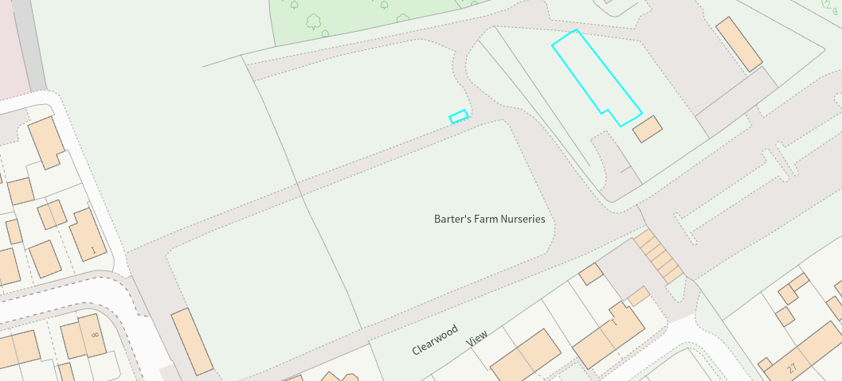

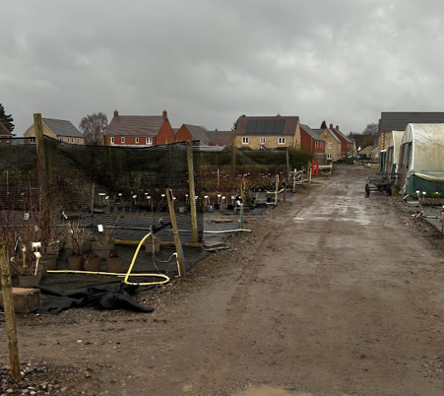
View from the welfare building looking west

The Design and Access Statement confirms that the buildings would be portable and by their very nature would involve minimal ground disturbance. Therefore, officers are of the opinion that the development would not give rise to concern over ground water and surface water flooding.

Based on site inspection and a review of the application submission and flood risk mapping, officers are satisfied that the proposals would not exacerbate flood risk, and the development would not be at risk from flooding or result in flood risk elsewhere when tested against WCS CP67 and Paragraphs 170 and 181 of the NPPF.

Biodiversity Net Gain (BNG)
As of April 2024, unless exempted, applications need to demonstrate no net loss and a minimum of 10% net gain in biodiversity (BNG) on the site, in line with the requirements of the NPPF, PPG, WCS policy CP50 (Biodiversity and Geodiversity) and the Environment Act. In this case, the application was submitted with a de minimis exemption.

CONCLUSION
The proposed development is considered acceptable in terms of its design, scale, and relationship with the surrounding area. It would not result in any unacceptable harm to the character of the locality, the amenities of neighbouring occupiers, or the interests of the Special Landscape Area, ecology or flood risk. The proposal is therefore considered to comply with the relevant policies of the Wiltshire Core Strategy, the Wiltshire Local Plan, and the National Planning Policy Framework. As such, the application is recommended for approval, subject to the conditions set out below.

RECOMMENDATION:
That Planning Permission be APPROVED

Conditions

1.The development hereby permitted shall be carried out in accordance with the following approved plans and documents:

Site Location Plan DWG No 373_GLA_00_XX_DR_L_1001_P3
Existing Block Plan DWG No 373_GLA_00_XX_DR_L_1002 _P3
Proposed Block Plan DWG No 373_GLA_00_XX_DR_L_1003 _P3
Structure Details - Staff Welfare DWG No 373_GLA_00_XX_DR_L_5401 _P2
Structure Details - Administration Block DWG No 373_GLA_00_XX_DR_L_5402 _P2
Structure Details - Polytunnel A DWG No 373_GLA_00_XX_DR_L_5403 _P2
Structure Details - Polytunnel B DWG No 373_GLA_00_XX_DR_L_5404 _P2
Structure Details - Toilet Block DWG No 373_GLA_00_XX_DR_L_5405 _P2
All Plans Received 23.02.2025

REASON: For the avoidance of doubt and in the interests of proper planning.

2. The development hereby approved shall only be used for ancillary purposes associated to the barters farm nurseries business and operations.

REASON: To define to terms of this permission and to ensure the use of the structures are only used for the purposes ancillary to the existing horticultural business.

Informative
If bats or evidence of bats are found during the works, the applicant is advised to stop work and follow advice from an independent ecologist or to contact Natural England’s Bat Line through the internet.

