DELEGATED REPORT

APPLICATION REFERENCE: | PL/2026/00223
APPLICATION TYPE: | Prior approval Part 14 Class J: Installation or alteration etc of solar equipment on non-domestic premises
SITE ADDRESS: | Lower Bridmore Farm, Berwick St John, Shaftesbury, SP7 0HG
DEVELOPMENT DESCRIPTION: | Proposed 105 x Solar Photovoltaic panels to be installed to roof of existing agricultural barn
RECOMMENDATION: | That prior approval is NOT REQUIRED

PROPOSAL

This application seeks the view of the Local Planning Authority as to whether prior approval is required for the installation of solar panels to the roof of an existing agricultural barn permitted under planning permission S/2001/1371 under the provisions of The Town and Country Planning (General Permitted Development) (England) Order 2015 (as amended), Schedule 2, Part 14, Class J.

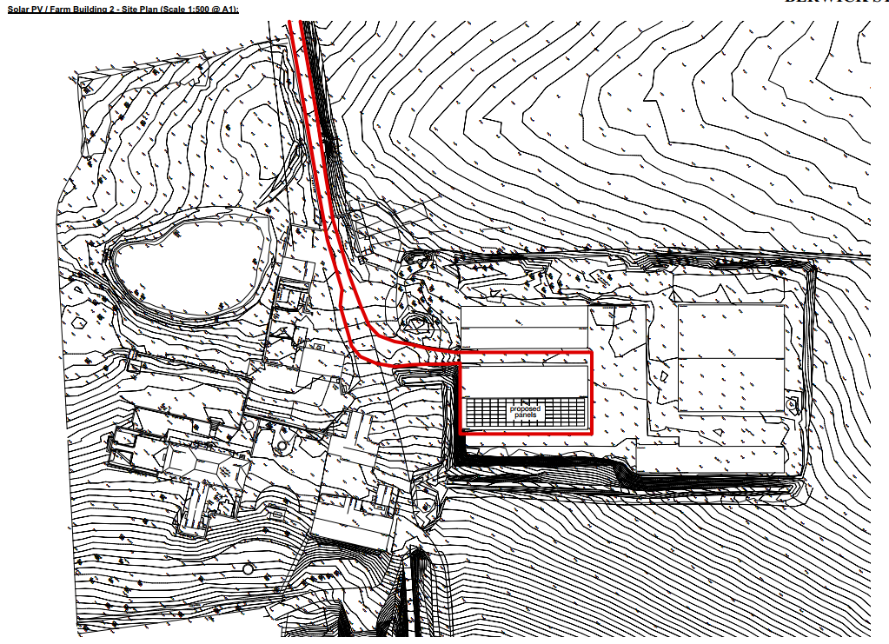
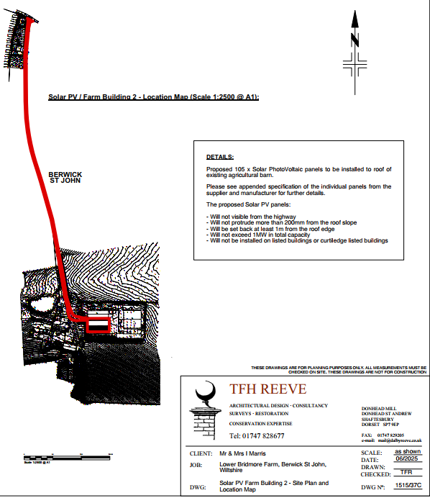

SITE DESCRIPTION

The site forms part of Lower Bridmore Farm, located 1.2km south east small village of Berwick St John, as defined by as defined by Wiltshire Core Strategy (WCS) core policies 1 (Settlement Strategy), 2 (Delivery Strategy) and CP27 (Spatial Strategy for the Tisbury Community Area).

The site lies within the Cranbourne Chase and West Wiltshire Downs National Landscape. Public Rights of Way BSJ014 crosses to the west of the application site.

The site is within the River Avon catchment however given the nature of the proposals, there is no specific impact to consider on this designation.

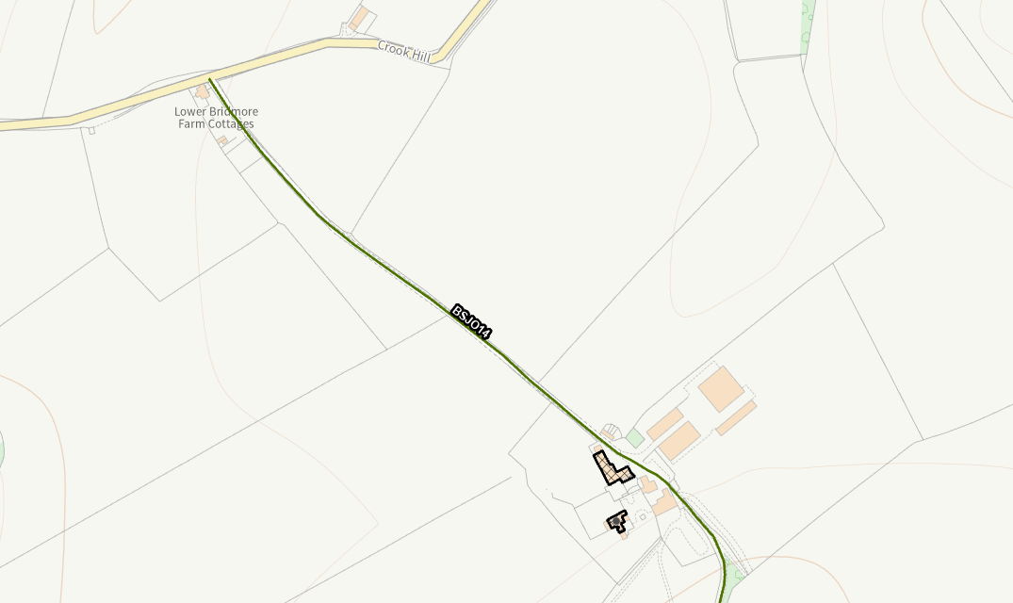

Access is south from Crook Hill, via a private road. The farmyard comprises four agricultural barns around a hardstanding on the east side of the access track. To the west of the track lies Grade II listed ‘Lower Bridmore Farmhouse’ and ‘Barn and Cowshed at Lower Bridmore Farm’. There are open fields to the north, east and south, the land rises to the south.
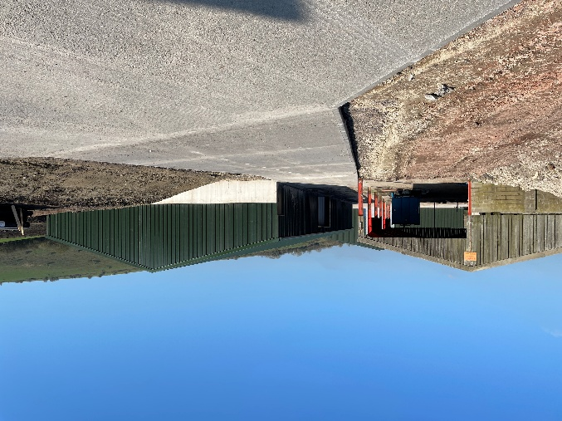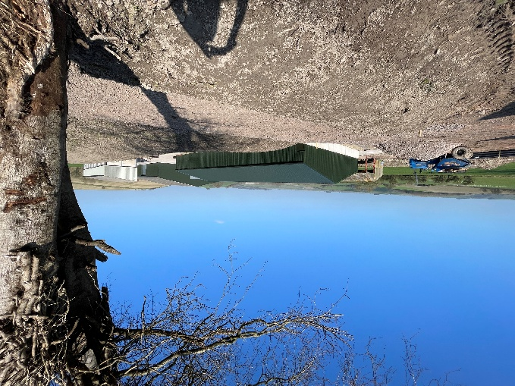

RELEVANT SITE HISTORY
The site has the following relevant planning history:

Proposal / Summary
S/2001/1371 - Full planning permission Decision - Approve with Conditions Date: 7/9/2001 – ADDITIONAL CATTLE HOUSING
PL/2025/03669 - Householder planning permission Decision - Approve with Conditions Date: 14/7/2025 – Repairs to barn and change of roof material
PL/2025/03809 - Listed building consent (Alt/Ext) Decision - Approve with Conditions Date: 14/7/2025 – Repairs to barn and change of roof material
PL/2025/04749 - Hedgerow removal notice Decision - No Objection Date: 7/7/2025 – Removal of 365m of hedgerow
PL/2025/07743 - Listed building consent (Alt/Ext) Decision - Approve with Conditions Date: 18/12/2025 – Change of use of existing farm barn from Agricultural Store to Farm Office, Farm Store and Farm Welfare Facilities. To include repairs to barn; change of roof material; and new air source heat pump

LEGISLATION

Town and Country Planning (General Permitted Development) (England) Order 2015 (as amended) - Schedule 2, Part 14 Class J (GPDO)

CONSULTATION RESPONSES

Berwick St John Parish Council: No response received.

REPRESENTATIONS

No comments were received.

ASSESSMENT

This submission is not a planning application but is instead a prior notification application submitted pursuant to the Permitted Development rights enshrined within Schedule 2, Part 14 Class J of the Town and Country Planning (General Permitted Development) (England) Order 2015 (as amended) for the installation of, alteration or replacement of solar photovoltaic equipment on the roofs on non-domestic buildings. There is no requirement for planning permission for such development providing the conditions and caveats set out with Class J are satisfied. The legislation is shown below in italics with comments related to the proposals added by the case officer (not in Italics).

Permitted development
Schedule 2, Part 14, Class J of the GPDO sets out permitted development rights for:

J. The installation, alteration or replacement of-

(a) microgeneration solar thermal equipment on a building;
(b) microgeneration solar PV equipment on a building; or
(c) other solar PV equipment on the roof of a building,

other than a dwellinghouse or a block of flats.

The application would accord with (c).

Development not permitted
J.1 Development is not permitted by Class J if-

(a) the solar PV equipment or solar thermal equipment would be installed on a pitched roof and would protrude more than 0.2 metres beyond the plane of the roof slope when measured from the perpendicular with the external surface of the roof slope;

The proposed installation would be located on a pitched roof and would not protrude more than 0.2 metres beyond the plane of the roof slope.

(b) the solar PV equipment or solar thermal equipment would be installed on a flat roof, where the highest part of the solar PV equipment would be higher than 1 metre above the highest part of the roof (excluding any chimney);

The proposed installation would not be installed on a flat roof.

(c) the solar PV equipment or solar thermal equipment would be installed on a roof and within 1 metre of the external edge of that roof;

The proposed installation would be installed on a roof but would not be within 1 metre of the external edge of that roof.

(d) …

Omitted (21.12.2023).

(e) the solar PV equipment or solar thermal equipment would be installed on a site designated as a scheduled monument; or

The application site is not designated as a scheduled monument.

(f) the solar PV equipment or solar thermal equipment would be installed on a listed building or on a building within the curtilage of a listed building.

The application building is not listed and is not within the curtilage of a listed building. This has been checked with the Conservation Officer and it is concluded that the barn is of modern construction, sited away from the listed buildings and for an agricultural use.

J.2 Development is not permitted by Class J(a) or (b) if-

(a) the solar PV equipment or solar thermal equipment would be installed on a wall and would protrude more than 0.2 metres beyond the plane of the wall when measured from the perpendicular with the external surface of the wall;

The proposed installation would not be installed on a wall.

(b) the solar PV equipment or solar thermal equipment would be installed on a wall and within 1 metre of a junction of that wall with another wall or with the roof of the building; or

The proposed installation would not be installed on a wall.

(c) in the case of a building on article 2(3) land, the solar PV equipment or solar thermal equipment would be installed on a wall which fronts a highway.

Although the application building is within article 2(3) land, the proposed installation would not be installed on a wall.

Conditions
As outlined in the assessment above, the proposed development meets the relevant criteria to be considered permitted development under Class J(c). However, it is important to note that Class J development is only permitted subject to full compliance with the conditions set out in paragraphs J.4(1) to J.4(12) of the Town and Country Planning (General Permitted Development) (England) Order 2015.

These provisions include requirements relating to prior approval, design and external appearance, potential glare impacts, and other site-specific considerations. Therefore, while the proposal appears to fall within the scope of permitted development, it must also satisfy all applicable conditions under J.4 to benefit from this status.

J.4 (1) Class J development is permitted subject to the following conditions-

(a) the solar PV equipment or solar thermal equipment must, so far as practicable, be sited so as to minimise its effect on the external appearance of the building and the amenity of the area; and

This condition is met. Assessment as part of (2) Class J(c) below.

(b) the solar PV equipment or solar thermal equipment is removed as soon as reasonably practicable when no longer needed.

This is a compliance based condition for the applicant should permission be granted.

(2) Class J(c) development is permitted subject to the condition that before beginning the development the developer must apply to the local planning authority for a determination as to whether the prior approval of the authority will be required as to the design or external appearance of the development, in particular the impact of glare on occupiers of neighbouring land, and the following sub-paragraphs apply in relation to that application.

In this case, the proposed solar panels are to be installed on the roof of an existing agricultural barn. The barn is of modern construction with a shallow roof the solar panels will be aligned in neat, uniform rows, ensuring they are visually integrated into the roofscape. This alignment helps to minimise any impact on the external appearance of the buildings and maintains the overall character of the site.

From a design perspective, the proposal is sympathetic to the existing built form and does not introduce incongruous or visually intrusive elements. The external appearance remains consistent with the agricultural setting, and the panels do not detract from the visual amenity of the area.

In terms of glare, the nearest residential properties are located approx. 65m away, and are situated to the south-west of the site, not directly in line with the orientation of the solar panels. Given the height of the barns and the shallow angle of the roofs, the potential for glare affecting neighbouring occupiers is considered negligible.

The proposed development satisfies the conditions of Class J(c). The design and external appearance are appropriate for the setting, and the risk of glare is minimal. Prior approval is therefore not required in this instance.

(3) to (12)

The remaining conditions set out in J.4(3) to J.4(12) do not require detailed assessment by the local planning authority. Instead, they impose procedural and compliance-based requirements on the applicant, such as when development may commence and how it must be carried out.

The applicant has fulfilled their duties by submitting a prior approval application that includes sufficient detail to enable the local planning authority to make an informed decision. The authority, in turn, has met its obligations by advertising the application appropriately and issuing a determination within the required timeframe.

The remaining provisions under J.4 are therefore compliance-based and relate to the implementation of the development, rather than matters requiring further assessment or judgment by the authority.

CONCLUSION:

On the basis of the above, it is considered that the development is permitted development as defined by Schedule 2, Part 14, Class J of the Town and Country Planning (General Permitted Development) Order 2015 (as amended) and prior approval is not required.

RECOMMENDATION:

That prior approval is NOT REQUIRED

