In terms of lighting, having just discussed with our client, I can confirm that the only external lighting proposed would be a single 'dark sky friendly' wall light per unit.

It will be this one - https://www.darkskylighting.co.uk/products/ugo-outdoor-wall-light-round-eyelid-anthracite-ip65-led

"Ugo Outdoor Wall Light Round Eyelid Anthracite IP65 LED"

We are happy for a condition to be added to confirm this - only one external light per unit and must be 'dark sky friendly'.

Whilst we do obviously appreciate the sensitivity around external lighting in the WHS, it should also be pointed out that this area does not benefit from dark skies - primarily due to the proximity to the settlement and A road which is lighted. Below is an extract from the CPRE Night Blight map to demonstrate this point:

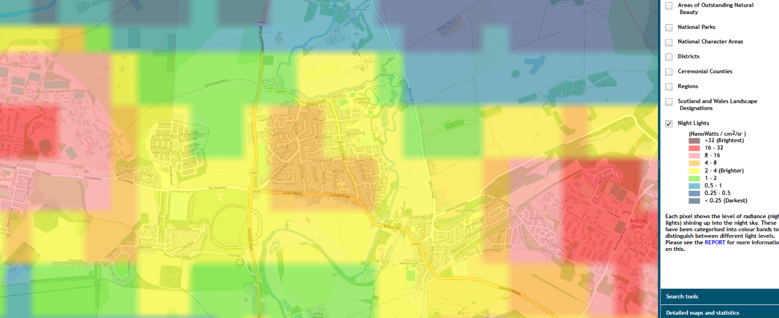

Best regards

Dan

