The Farm Consultancy Group
Whitelands Cottage,
Days Lane,
Kington Langley,
Chippenham,
Wiltshire,
SN15 5PD.
Telephone: (01249) 750151
Email: whiteavonconsultancy@fcgagric.com

ASSESSMENT OF ESSENTIAL NEED FOR AN AGRICULTURAL STORAGE BUILDING
at

Carpenters Farm, Avon, Chippenham, Wiltshire, SN15 4LS

Prepared for:

IC CA JC & BC Carter

January 2026

Table of Contents
Introduction 3
Background 3
Proposed Building 3
Dimensions 4
Materials 4
Building Use 4
The Proposed Site 5
Other development 5
Landscape 5
Permitted Development Planning Policy 6
Conclusion 7
Supporting Evidence 8

Introduction
This report has been prepared by George Drewett of The Farm Consultancy Group on behalf of IC CA JC & BC Carter to confirm agricultural justification for a machinery and straw storage building at Carpenters Farm, Avon, Chippenham, Wiltshire, SN15 4LS.

Background
The partnership of IC CA JC & BC Carter operates a 300-head dairy enterprise which has expanded significantly over the past five years. Substantial investment has been made in buildings and infrastructure at the main farmstead to support this growth.
The holding comprises approximately 110 hectares of owned land, together with additional locally rented land used primarily for maize production under a mix of short and long term tenancies.
The business is a progressive dairy unit, with Joe Carter involved since leaving school. He is recognised locally for implementing forward-thinking and ambitious farming practices, with a strong focus on high standards of animal welfare and the production of high-quality milk from forage. The farm supplies milk to Cadbury via the Selkley Vale Milk Group.
As the enterprise continues to expand under the guidance of Joe Carter and his father, further investment in infrastructure is required to support increasing cow numbers and ensure the efficient operation of the business.

Proposed Building
A new agricultural storage building is required at Carpenters Farm to provide covered storage for straw and farm machinery. The building is necessarily large in scale to accommodate the substantial quantity of straw required for both bedding and feeding purposes, as well as keeping the farm machinery protected from the elements it currently faces parked in the open farmyard (see supporting evidence below).

Dimensions
The proposal is to construct a building of the below dimensions.
Width: 32.28 m
Length: 36.58 m
Height to eaves: 4.80 m
Height to ridge: 9.32 m
Total floor area: 1180.8 m²

Materials
The building will be of a steel portal frame construction, with an open front and a grey corrugated fibre cement roof. 10% of the roof area to have translucent GRP rooflights. East and west elevations to have pre-cast concrete panels with tanalised space boarding above. South and north elevations to be open fronted with tanalised space boarding above eaves level.

Building Use
The proposed development comprises the erection of an agricultural building that is reasonably necessary for the purposes of agriculture. It will function solely as a storage facility and will not be used for the accommodation of livestock or for engineering operations.
The farm uses approximately 2,000 large square straw bales per annum, comprising around 1000 bales for bedding and 1000 bales for feeding. Each six-string bale measures approximately 0.9 metres high, 1.2 metres wide and 1.83 metres (6 feet) long. When stacked six bales high in the tallest part of the shed and 4 bales in the lower eaves, this volume of straw requires approximately 918 m² of floor space.
The remaining 263 m² of floor area within the proposed building will be used for the storage of farm machinery, which is currently stored in less suitable locations around the holding. The provision of a dedicated storage building will improve operational efficiency, protect machinery and straw from the elements, and support the continued growth of the dairy enterprise.

The Proposed Site
The proposed site is located within the main farmyard at Carpenters Farm. The building would be positioned between an existing cattle shed and a proposed rural workers’ dwelling, which is currently subject to a planning application under consideration by the local planning authority.
The site is not located within 3 kilometres of an aerodrome, nor is it within 25 metres of a classified or trunk road.

Other development
Carpenters Farm has previously secured planning permission for a static caravan adjacent to the existing cattle shed, in the position of this proposal. A subsequent planning application has been submitted to reposition this caravan further north in order to accommodate the proposed machinery and straw storage building.
The planning reference for the static caravan to accommodate agricultural workers is PL/2026/00625.

Landscape
The proposed development would be sited between the existing cattle shed and the newly proposed static caravan. This would result in the loss of approximately 45 metres of native hedgerow.
However, mitigation for this loss was accounted for as part of the static caravan application, which included the planting of approximately 95 metres of new native hedgerow to the north of the proposal. In order to meet the Biodiversity Net Gain (BNG) requirements for that application, a minimum 10% net gain in hedgerow units was required. Taking into account the submission of this application, the overall hedgerow unit net gain has been increased to 76.21%.
The new hedgerow planting will also include six native hedgerow trees. This substantial net gain will more than compensate for the hedgerow loss associated with the proposed machinery and straw storage building.

Permitted Development Planning Policy
The proposal is considered to conform with the requirements under the General Permitted Development Order 2015; Class A - agricultural development on units of 5 hectares or more. The beneath examines this in further detail.
Permitted Development Requirement | Comment
A. The carrying out on agricultural land comprised in an agricultural unit of 5 hectares or more in area of—  (a)works for the erection, extension or alteration of a building; or  (b)any excavation or engineering operations,  which are reasonably necessary for the purposes of agriculture within that unit. | The farmed unit extends to 110 hectares of owned land, with additional land rented in for maize production.  The proposal is for the erection of an agricultural building and is reasonably necessary for the purposes of agriculture and will serve as an essential storage shed for machinery and straw.
A.1 Development is not permitted by Class A if—  (a)the development would be carried out on a separate parcel of land forming part of the unit which is less than 1 hectare in area;  (b)it would consist of the erection or extension of any agricultural building on an established agricultural unit (as defined in paragraph X of Part 3 of this Schedule) where development under Class Q or S of Part 3 (changes of use) of this Schedule has been carried out within a period of 10 years ending with the date on which development under Class A(a) begins; | The proposed erection lies within the farmyard which extends to 2.78 hectares. It also very partially lies on the boundary of a 1.36 hectare parcel of land to the north of the farmyard.  There have been no Class Q or S developments on the unit within the previous 10 years, or ever.
(c)it would consist of, or include, the erection, extension or alteration of a dwelling; | The proposal does not concern a dwelling
(d)it would involve the provision of a building, structure or works not designed for agricultural purposes; | The building is designed for the purposes of agriculture, being a steel portal frame design and open fronted to allow for ease of access by machinery, and for access to store and transport straw bales.
(e)the ground area which would be covered by—  (i)any works or structure (other than a fence) for accommodating livestock or any plant or machinery arising from engineering operations [F1would exceed 1,000 square metres]; or  (ii)any building erected or extended or altered by virtue of Class A [F2would exceed 1,500 square metres],  F3... calculated as described in paragraph D.1(2)(a) of this Part; | The building will not be used for accommodating livestock or engineering operations.  The building measures 1180.8 m² of floorspace.
(f)the height of any part of any building, structure or works within 3 kilometres of the perimeter of an aerodrome would exceed 3 metres; | The proposal does not lie within 3 kilometres of an aerodrome.
(g)the height of any part of any building, structure or works not within 3 kilometres of the perimeter of an aerodrome would exceed 12 metres; | The proposal does not exceed 12 metres in height; it measures 9.32 metres in height in total to the ridge.
(h)any part of the development would be within 25 metres of a metalled part of a trunk road or classified road;  (i)it would consist of, or include, the erection or construction of, or the carrying out of any works to, a building, structure or an excavation used or to be used for the accommodation of livestock or for the storage of slurry or sewage sludge where the building, structure or excavation is, or would be, within 400 metres of the curtilage of a protected building; | The development is not within 25 metres of a classified road.  The proposal will not be used for livestock accommodation, or for the storage of slurry or sewage sludge.  The proposal does not involve excavations or engineering operations.
(j)it would involve excavations or engineering operations on or over article 2(4) land which are connected with fish farming; | The land is not connected with fish farming.
(k)any building for storing fuel for or waste from a biomass boiler or an anaerobic digestion system—  (i)would be used for storing waste not produced by that boiler or system or for storing fuel not produced on land within the unit; or  (ii)is or would be within 400 metres of the curtilage of a protected building [F5; or | The proposal will not be used for the storage of fuel or waste.

Conclusion
In conclusion, the Carter family operate a well-established, progressive and successful dairy farming business that has evolved and expanded over several generations. Continued growth of the enterprise, together with the need to improve efficiency and properly manage machinery and straw storage, creates a clear and essential requirement for the proposed agricultural storage building.
The development is reasonably necessary for the purposes of agriculture, complies with permitted development criteria, and represents an appropriate and proportionate investment in the continued sustainable operation of Carpenters Farm.

Supporting Evidence
Photos show large amount of machinery stored at unsecure locations at Carpenters Farm.
Further to these items there is another 2 tractors, tanker and bale trailer parked in the yard.
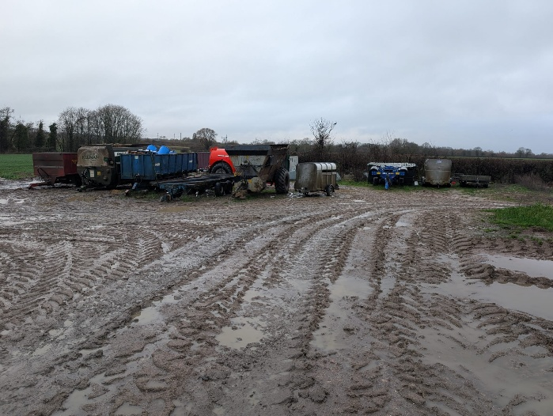
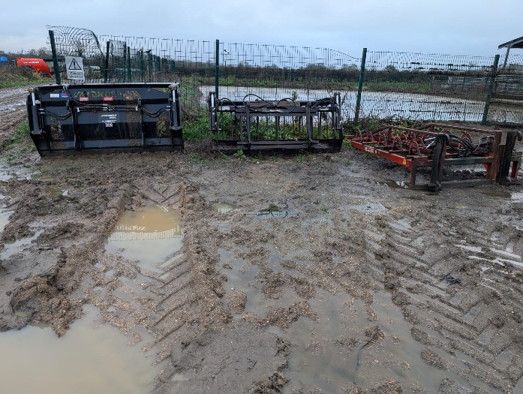
Photo 1
Photo 2

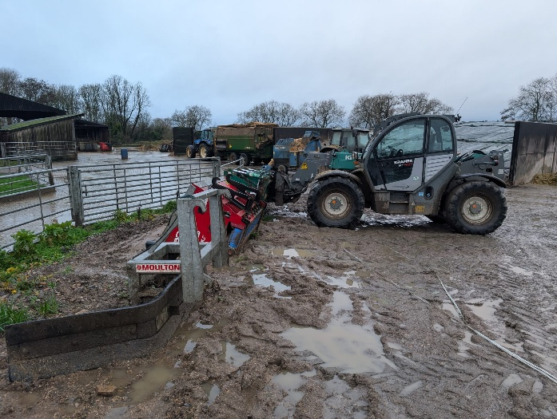
Photo 3

