APPLICATION FOR HOUSEHOLDER PLANNING PERMISSION
DELEGATED REPORT

APPLICATION REFERENCE: | PL/2025/09963 & PL/2026/00158
APPLICATION TYPE: | Householder planning permission
SITE ADDRESS: | 96 Milford Hill, Salisbury, SP1 2QL
DEVELOPMENT DESCRIPTION: | Alteration of existing extension, associated internal alterations & erection of a new studio/garden room
RECOMMENDATION: | That Planning Permission be GRANTED

PROPOSAL

The proposal seeks planning permission for the erection of a new studio/garden room, alteration of existing extension and associated internal alterations.

SITE DESCRIPTION/CONTEXT

The site comprises a mid-terrace two storey dwelling located on the southern side of Milford Hill. It is located within the built-up area of Salisbury and the Milford Hill Conservation Area. It is situated within the defined settlement boundary of the principal settlement of Salisbury, as defined by Wiltshire Core Strategy (WCS) policies CP1, CP2 and CP20. Whilst the site is in Flood Zone 1 and is not in the immediate vicinity of any rivers, it is situated within the Hampshire River Avon Catchment; and is within the 13.8-kilometre recreational buffer of the New Forest Special Protection Area (SPA) and RAMSAR site. However, due to the nature of the application, these designations do not have any bearing on the assessment of this application.

The application site is bordered by the highway on the north and residential dwellings on all other sides.

MILFORD HILL 1. 1594 (South Side) SU 1429 NE 4/515 Nos 94 & 96 II GV 2. Late C18 altered. 2 storeys rendered. Steep pitch hipped old tile roof. 4 C19 gabled dormers. No 94 has 2 windows 1st floor, No 96 has 3 the centre one narrow, recessed C19 sashes. Both houses on ground floor have central doors and flanking, late C19 or later, canted bay windows with hipped tiled roofs. Doors are recessed, C19, panelled. But No 94 retains C18 or early C19, broken pediment hood.

Nos 94 & 96 form a group with Nos 50 to 65 (odd) Rampart Road.

Listing NGR: SU1486129894.

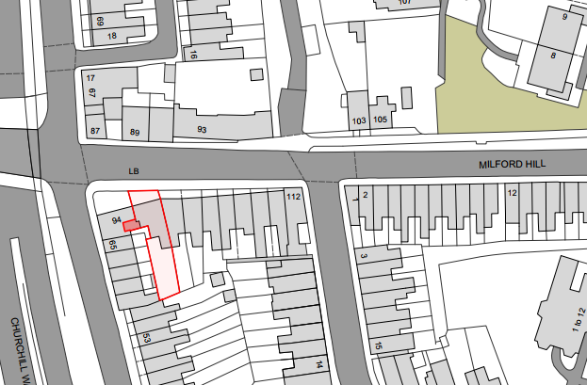

PLANNING HISTORY

Reference | Proposal / Summary | Decision
S/2004/0876 | NEW ROOF LIGHT AND LOFT STORE ON FIRST FLOOR | Approve with Conditions
S/2003/1505 & S/2003/1506 | DEMOLITION OF REAR SIDE EXTENSION AND REPLACEMENT WITH LARGER EXTENSION | Approve with Conditions

RELEVANT POLICIES AND GUIDANCE

Wiltshire Core Strategy:
Core Policy 1: Settlement Strategy
Core Policy 2: Delivery Strategy
Core Policy 20: Spatial Strategy: Salisbury Community Area
Core Policy 57: Ensuring High Quality Design and Place Shaping

Wiltshire Design Guide: Appendix D – Design Guidance for Householder extensions

The National Planning Policy Framework (NPPF)

The Planning Practice Guidance

National Design Guide

Salisbury Neighbourhood Development Plan 2020 to 2038

Wiltshire Local Transport Plan 2015-2026: Car Parking Strategy

The Planning (Listed Building and Conservation Area) Act 1990
Section 66
Section 72

CONSULTATION RESPONSES
Salisbury City Council: Support.
Archaeology: No Objection.

No. 96 Milford Hill, along with No. 94, is a Grade II listed, late 18th-century dwelling on the fringes of the regionally important medieval City of Salisbury. The property lies outside of the medieval defences of the City, which at this point lay under the inner ring road (Churchill Way East). Salvage excavations by the Salisbury Museum Archaeological Research Group during the construction of the inner ring road in 1972 found evidence of 13th-century occupation and buildings beneath the city rampart at several points close to Milford Hill.

There is therefore an archaeological interest in No. 94 Milford Hill. However, this proposal would have very modest below ground impacts, and, on balance, it would not be proportionate to recommend an archaeological response, should this application be permitted. I therefore have no archaeological concerns, and no further action is required in relation to this application as regards the buried archaeological heritage.

Conservation: None received.

REPRESENTATIONS

No comments were received.

ASSESSMENT

Section 38(6) of the Planning and Compulsory Purchase Act 2004 states:

"If regard is to be had to the development plan for the purposes of any determination to be made under the planning Acts, the determination must be made in accordance with the plan unless material considerations indicate otherwise."

In accordance with this statutory requirement, this application has been assessed against the relevant policies of the Development Plan, including the adopted Wiltshire Core Strategy (2015) and, where applicable, any made Neighbourhood Plans.

From the point of view of the historic environment the main statutory tests are set out within the Planning (Listed Building and Conservation Areas) Act 1990. Section 16 requires that special regard be given to the desirability of preserving listed buildings, their settings or any features of special architectural or historic interest which they possess.

Section 72(1) of the Planning (Listed Building and Conservation Areas) Act 1990 also requires the Council to pay special attention to the desirability of preserving or enhancing the character or appearance of designated Conservation Areas.

Section 16 of the NPPF ('Conserving and enhancing the historic environment') sets out the Government's high-level policies concerning heritage and sustainable development.

Paragraphs 213-215 of the NPPF require a balanced approach with any harm which would be caused being weighed against the potential public benefits which might be achieved. Paragraph 210 requires local planning authorities to take account of the desirability of sustaining and enhancing the significance of heritage assets and of new development making a positive contribution to local character and distinctiveness.

The Council’s Core Strategy Policy CP58 ‘Ensuring the conservation of the historic environment’ requires that designated and non-designated heritage assets and their settings will be conserved, and where appropriate enhanced, in a manner appropriate to their significance and encourages proposals which improve the condition of heritage assets at risk.

The Council’s Core Strategy CP 57: Ensuring high quality design requires a high quality of design in all new developments. The policy requires applicants to “demonstrate how the proposal will make a positive contribution to the character of Wiltshire through (amongst other things) responding to the value of the natural and historic environment and being sympathetic to and conserving historic buildings and landscapes. Development is required to respond positively to the existing in terms of building layouts, built form, height, mass, scale, building line, plot size, elevational design, materials, streetscape and rooflines to effectively integrate the building into its setting.

Design and impact of proposals on the significance and setting of the listed building

Understanding the impact of proposed works on a listed building requires a careful and proportionate assessment of how those changes affect the asset’s heritage significance and its setting. This includes both the physical alterations to the building itself and any changes to its spatial or visual relationship with surrounding structures or spaces.

The significance of a heritage asset is not static; it is shaped by its architectural, historic, and communal values, and by how these are experienced in context. Therefore, any intervention must be considered in light of the asset’s identified significance, with attention given to both potential harm and benefits. Benefits may include repairs that support the long-term conservation of the building, improved energy performance, or enhanced public access and understanding.

This assessment is grounded in the statutory duty under Section 16 of the Planning (Listed Buildings and Conservation Areas) Act 1990, which requires special regard to be given to the desirability of preserving the building and its features of special interest. It is also informed by national policy, particularly paragraphs 199–208 of the National Planning Policy Framework (NPPF), and relevant local heritage policies and guidance.

This dual listed building consent and householder planning application assesses the proposed alteration of the existing single storey rear extension erected after planning permission S/2003/1505 & S/2003/1506, the erection of a garden room at the bottom of the garden, external alterations to the rear garden of the host dwelling, and reinstating an existing circular window to the listed building.
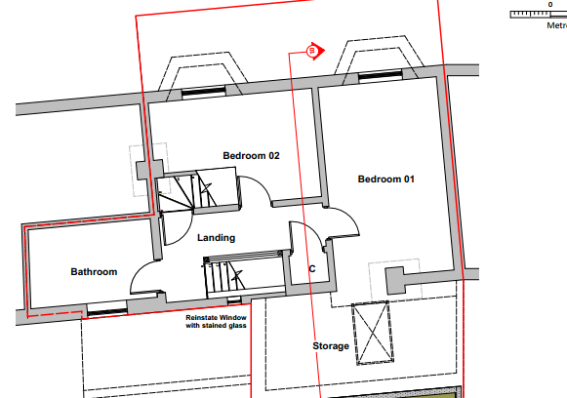
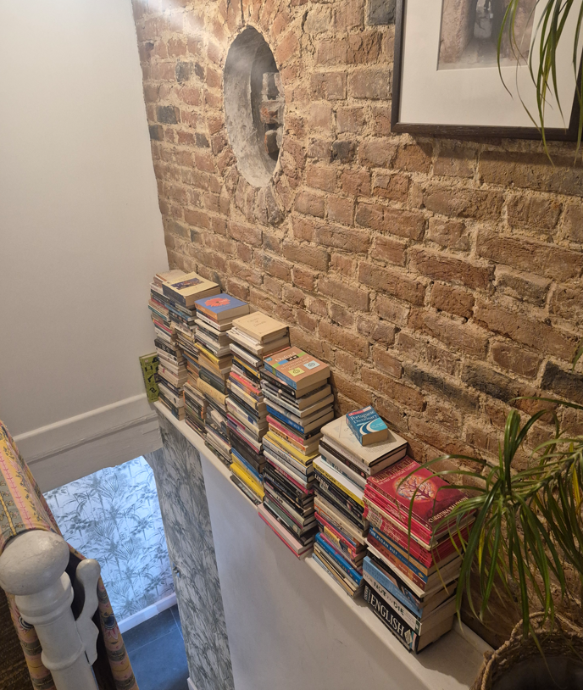
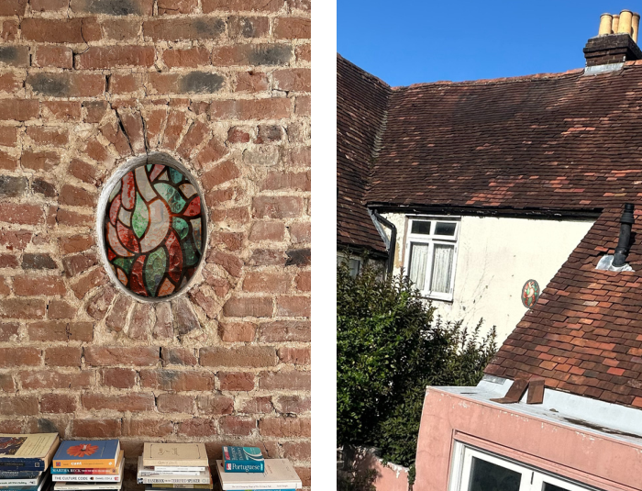

Regarding the impact of reinstating the circular window to the listed building, it is not considered that this would harm the significance of the listed building as this circular window appears to already be in place internally.

The application also includes the demolition of the existing single storey addition to the listed building and replacing this with a larger and bigger single storey rear extension. The proposed use is the same as existing, to create a larger kitchen dining and bathroom area incidental to the host dwelling. The materials are proposed to be rendered to match the existing dwelling, red bricks, areas of cladding and sedum flat roof. With regards to the impact on the listed building fabric, the proposed extensions are considered to have a neutral effect on this. The extensions are proposed to be in a location already occupied by a recent single storey extension built after planning permission in 2004.

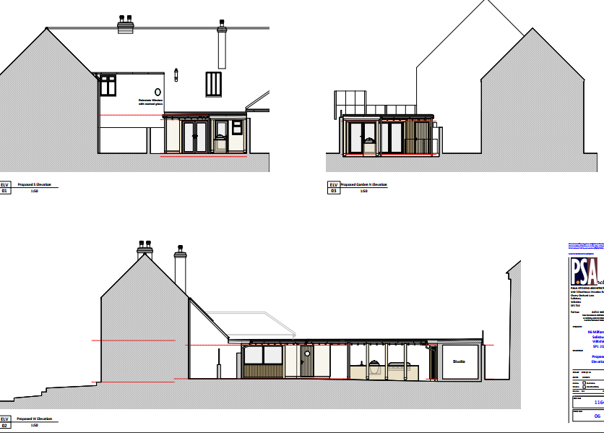
With regards to the impact of the development on the setting of the adjacent listed dwellings, it is noted that the proposed rear extension, outdoor kitchen area, and garden room appear to encompass a large area within the existing rear garden of the host dwelling. The proposed extensions and developments are single storey in nature and have been proposed for incidental use associated with the host dwelling. The use of the garden room has been conditioned to remain incidental to the host dwelling. It is therefore considered that these extensions have a neutral impact on the setting of the adjacent listed buildings.
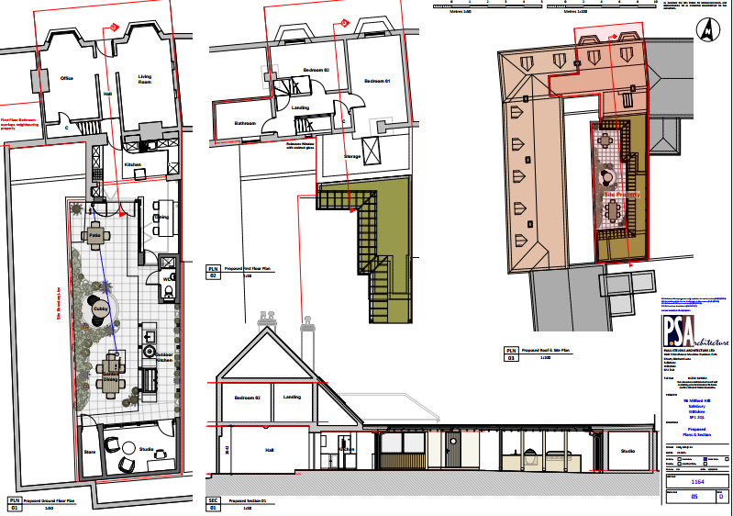
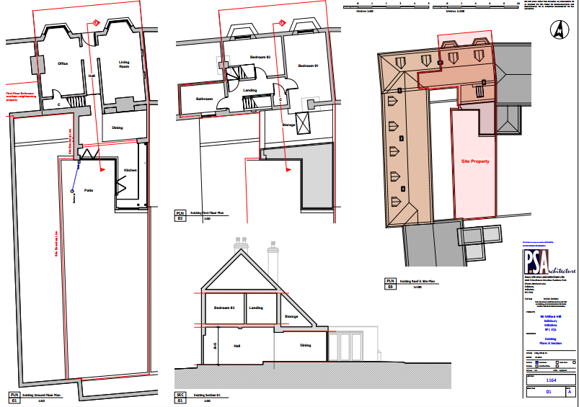

Amenity

Point vii of Core Policy 57 - Ensuring High Quality Design and Place Shaping of the Wiltshire Core Strategy seeks to ensure that developments do not adversely affect neighbouring properties.

The proposed development has been assessed in terms of its potential impact on the residential amenity of neighbouring properties, with particular regard to loss of light, overshadowing, loss of privacy, and overbearing effects. The proposed works associated with this dual full and listed building application does not propose any external changes that would have adverse impacts on the amenity of the neighbouring properties. The existing oil tank does not produce noise. The proposed 0.4 metre height dwarf wall and 0.6 metre willow screen are located to the front of the host dwelling and the front driveway of the associated host dwelling. The proposal therefore accords with Core Policy 57 point vii in respect of safeguarding residential amenity and Appendix D of the Wiltshire Design Guide.

The proposed development has been assessed in terms of its potential impact on the residential amenity of neighbouring properties, with particular regard to loss of light, overshadowing, loss of privacy, and overbearing effects.

The rear garden of the application site and location of the proposed extensions are enclosed and surrounded by residential dwellings on all sides. The proposed development creates an extension to the existing rear extension which has a kitchen and dining area. A proposed bathroom outdoor kitchen and studio room area proposed. These proposed uses are incidental to the use of the existing host dwelling located in an established residential area which is close knit to each other. The proposed extensions are single storey; this allows the development to be subservient in height and scale to minimise any impact this has on neighbouring amenity. The proposal therefore accords with Core Policy 57 point vii in respect of safeguarding residential amenity and Appendix D of the Wiltshire Design Guide.
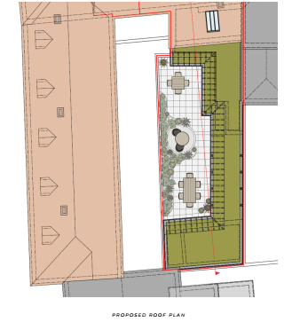
Biodiversity Net Gain

Householder planning applications are exempt from the requirement to deliver Biodiversity Net Gain under Schedule 7A, Section 4(2)(a) of the Town and Country Planning Act 1990, as inserted by the Environment Act 2021.

CONCLUSION

The proposed development is considered to be acceptable in terms of its design, scale, and relationship with the surrounding area. It would not result in any unacceptable harm to the character of the locality, the amenities of neighbouring occupiers, or the interests of highway safety, heritage, or ecology.

The proposal is therefore considered to comply with the relevant policies of the Wiltshire Core Strategy, the Wiltshire Local Plan, and the National Planning Policy Framework. As such, the application is recommended for approval, subject to the conditions set out below.

RECOMMENDATION: That Planning Permission be GRANTED subject to conditions.

That Planning Permission be GRANTED subject to the following conditions:
1.The development hereby permitted shall be begun before the expiration of three years from the date of this permission.
REASON: To comply with the provisions of Section 91 of the Town and Country Planning Act 1990 as amended by the Planning and Compulsory Purchase Act 2004.
2.The development hereby permitted shall be carried out in accordance with the following approved plans:
Location Plan Drawing Ref: 1164 - 09 A Received: 09 January 2026
Proposed Ground, First Floor, Roof Plan and Section Drawing Ref: 1164 - 05 D Received: 09 January 2026
Proposed Elevations Drawing Ref: 1164 - 06C Received: 22 December 2025
Milford Hill Heritage Statement Drawing Ref: 1164 - 96 Rev B Received: 20 January 2026
REASON: For the avoidance of doubt and in the interests of proper planning.
3.Materials to be used in the construction of the works hereby permitted shall be as stated on
the application form and shall match the existing brickwork and roof tiles as the host dwelling.

REASON: In the interests of visual amenity and the character and appearance of the area.

4. The proposed garage hereby approved shall only be used for purposes incidental to the residential use of the dwelling known as 96 Milford Hill, Salisbury, SP1 2QL and shall not at any time be occupied for overnight accommodation and it shall remain within the same planning unit as the main dwelling of 96 Milford Hill, Salisbury, SP1 2QL.

REASON: The nature of the proposed works having regard to the reasonable standards of residential amenity, access, parking provision and planning policies pertaining to the area would not permit overnight accommodation.

That Listed Building Consent be GRANTED subject to the following conditions:

1.The works for which Listed Building Consent is hereby granted shall be begin before the expiration of three years from the date of this consent.
REASON: To comply with the provisions of Section 18 of the Planning (Listed Buildings and Conservation Areas) Act 1990 as amended by the Planning and Compulsory Purchase Act 2004.
2.The development hereby permitted shall be carried out in accordance with the following approved plans:
Location Plan Drawing Ref: 1164 - 09 A Received: 09 January 2026
Proposed Ground, First Floor, Roof Plan and Section Drawing Ref: 1164 - 05 D Received: 09 January 2026
Proposed Elevations Drawing Ref: 1164 - 06C Received: 22 December 2025
Milford Hill Heritage Statement Drawing Ref: 1164 - 96 Rev B Received: 20 January 2026
REASON: For the avoidance of doubt and in the interests of proper planning.
3.Materials to be used in the construction of the works hereby permitted shall be as stated on
the application form and shall match the existing brickwork and roof tiles as the host dwelling.

REASON: In the interests of visual amenity and the character and appearance of the area.

