APPLICATION FOR A NON-MATERIAL AMENDMENT
CASE OFFICER REPORT

APPLICATION REFERENCE: | PL/2026/01326
APPLICATION TYPE: | NON-MATERIAL AMENDMENT
SITE ADDRESS: | 1 Mill Road, Manningford Bruce, Pewsey, SN9 6JN
DEVELOPMENT DESCRIPTION: | Non Material Amendment to PL/2022/08365 - Relocation and alterations of windows and doors on extension and reduction of flat roof overhang to north facing elevation
RECOMMENDATION: | That the non-material amendment be GRANTED

PROPOSAL

This is a non-material amendment application to change the fenestration design of a rear extension granted permission in application PL/2022/08365. Application PL/2025/08365 remains extant until 14 March 2026. There were no pre-commencement of development conditions.

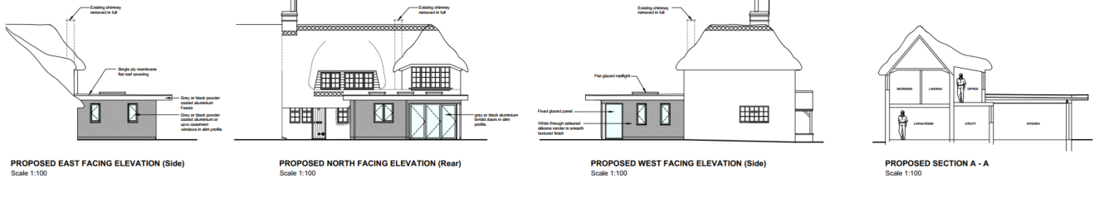

Approved Elevations in PL/2022/08365

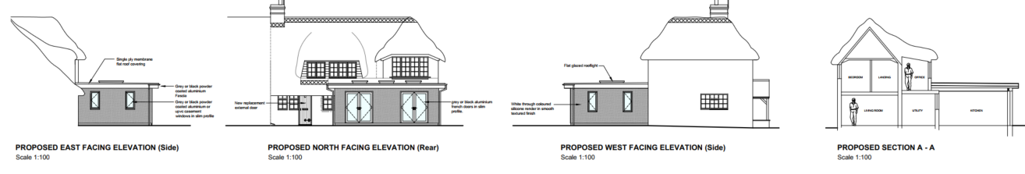

Proposed Non-Material Amendment Elevations in PL/2026/01326

There are no proposed changes to the footprint or proposed materials. There would be a slight change in the depth of the overhang roof which would be reduced from c700mm to c300mm. The overall depth of the roof therefore would be reduced from 6m to 5.6m.

RELEVANT LEGISLATION AND GUIDANCE

Town and Country Planning Act 1990 (as amended):
- Section 96A: This section provides the legal basis for non-material amendments to an existing planning permission. It allows Local Planning Authorities (LPAs) to make changes to a planning permission without the need for a new application, provided that the changes are considered to be "non-material."
- The Act does not define "non-material," and it is at the discretion of the LPA to determine whether a proposed amendment qualifies as such, considering the specific context of the development and its impacts.

CONSULTATION

As an application for a non-material amendment is not a full planning application, the provisions under the Town and Country Planning (Development Management Procedure) (England) Order 2015 relating to statutory consultation and publicity do not apply. Consequently, local planning authorities have discretion regarding whether and how to inform interested parties or seek their views.

Given that the changes proposed are by definition non-material, consultation or publicity are typically not required. Additionally, as the proposed amendments are minor in nature, there are generally no significant effects that would necessitate consideration under the Environmental Impact Assessment Regulations 2011. In this instance, it has not been considered necessary to consult.

ASSESSMENT

Non-material amendments are changes that do not significantly alter the scheme's overall impact. They can involve minor adjustments to the design or other aspects of the development but should not fundamentally change its character, scale, or overall effect on the surrounding area.

The footprint of the extension remains as originally proposed with the size of the roof overhang reduced. This will be of some limited benefit to its neighbouring semi – No 2 in terms of reduced overshadowing and increased daylight.

The east elevation window design facing No 2 would be unchanged, thereby having no impact on the neighbouring amenity.

The proposal would increase the amount of glazing on the north elevation facing into the garden but this should also not cause any adverse harm to No 2 as the windows would predominately look into its own garden. Given that garden boundaries can have 2m high enclosures without needing planning permission, with the proposed glazed doors being circa 2.1m high, no adverse overlooking of No 2 would occur.

Therefore, the proposed changes would not alter the appearance or understanding of the extension, would be in keeping with the original permission and would not cause any adverse harm to neighbouring amenity. Therefore, it is considered that the proposed changes would be a non-material amendment.

CONCLUSION

In conclusion, based on the assessment, it is recommended that the non-material amendment application be granted.

SUMMARY OF REASONS FOR RECOMMENDATION:
The proposed changes are considered to be minor and non-material in nature for the following reasons:

The proposed changes would not alter the appearance or understanding of the extension, would be in keeping with the original permission and would not cause any adverse harm to neighbouring amenity.

