APPLICATION FOR HOUSEHOLDER PLANNING PERMISSION
DELEGATED REPORT

APPLICATION REFERENCE: | PL/2026/00162
APPLICATION TYPE: | Householder planning permission
SITE ADDRESS: | Lawn Cottage, Zeals, Warminster, BA12 6NH
DEVELOPMENT DESCRIPTION: | Conversion of the original garage into a single-storey residential annexe for occupation by the parents of the applicants, including internal facilities and changes to external fenestration.
RECOMMENDATION: | That Planning Permission be GRANTED

PROPOSAL

The proposal seeks planning permission for the conversion of the original garage into a single-storey residential annexe for occupation of dependents including internal facilities and changes to external fenestration.

SITE DESCRIPTION/CONTEXT

The site is located outside of the settlement boundary as defined by Wiltshire Core Strategy (WCS) policies CP1, CP2 and CP17. The site lies within the Special Landscape Area, as defined by saved Salisbury District Local Plan (SDLP) policy C6. It is located along a residential area accessed from an unclassified country lane. The application site consists of an existing detached dwelling with an L shaped garage located to the front of the host dwelling.

The site is bordered by the highway to the north and residential dwellings on all other sides.

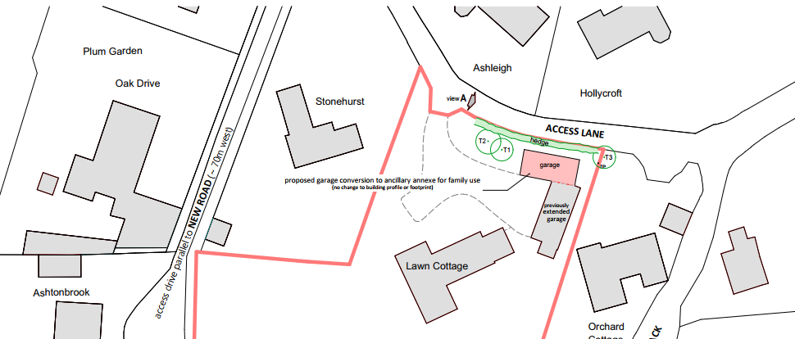

PLANNING HISTORY

Reference | Proposal / Summary | Decision
14/06945/FUL | Extension to existing garage | Approve with Conditions
S/2011/0087 | Two storey and first floor extensions, addition of dormer windows, balcony, porch and associated works | Approve with Conditions
S/1984/1688 | O/A Application - Erection of two dwellings and alteration of vehicular access | Refused

RELEVANT POLICIES AND GUIDANCE

National Planning Policy Framework (NPPF)
2. Achieving sustainable development
4. Decision-making
12. Achieving Well-designed places

Wiltshire Core Strategy (WCS)
Core Policy 1: Settlement Strategy
Core Policy 2: Delivery Strategy
Core Policy 17: Spatial Strategy: Mere Community Area
Core Policy 39: Tourist Development
Core Policy 57: Ensuring High Quality Design and Place Shaping
Core Policy 60: Sustainable transport
Core Policy 61: Transport and new development

Saved Salisbury District Local Plan Policies
H33 Accommodation for Dependents
C24 Extensions to Buildings
C6 Special Landscape Area

The National Planning Policy Framework (NPPF)

The Planning Practice Guidance

National Design Guide

CONSULTATION RESPONSES

Zeals Parish Council: None received.
Highways Officer: No Objection.
Ecology: None received.

REPRESENTATIONS

1 comment of no objection was received from the neighbouring dwelling.

ASSESSMENT

Section 38(6) of the Planning and Compulsory Purchase Act 2004 states:

"If regard is to be had to the development plan for the purposes of any determination to be made under the planning Acts, the determination must be made in accordance with the plan unless material considerations indicate otherwise."

In accordance with this statutory requirement, this application has been assessed against the relevant policies of the Development Plan, including the adopted Wiltshire Core Strategy (2015) and, where applicable, any made Neighbourhood Plans.
Design and Impact upon the character and context of the area

Core Policy 57 - Ensuring High Quality Design and Place Shaping of the Wiltshire Core Strategy seeks to ensure that all new development is of high design quality, reflecting local context, character, and distinctiveness.

Annexe as ancillary accommodation
This application is described as a proposal for an annexe, and as there are often concerns surrounding annexes and their potential to be used as a separate unit of accommodation it is worth addressing this.

The judge in Uttlesford DC v SSE & White [1992] considered that, even if the accommodation provided facilities for independent day-to-day living, it would not necessarily become a separate planning unit from the main dwelling – instead it would be a matter of fact and degree. In the case referenced above, the accommodation gave the occupant the facilities of a self-contained unit although it was intended to function as an annex with the occupant sharing her living activity in company with the family in the main dwelling. There was no reason in law why such accommodation should consequently become a separate planning unit from the main dwelling.

The design and access statement included in this householder application has noted that the proposed annex is for the use of the elderly parents of applicant. The parking and outdoor amenity facilities are shared with the main house. There is no proposed additional footprint created by the proposed development. The application site consists of an existing L shaped carport and garage. The garage area has been used as a store/workshop area there are currently no vehicle sized openings to the garage. The existing 4 car carport remains as existing. Internally, the garage would accommodate one bedroom with an en-suite wet room and a kitchen and living area.

Externally, there are no proposed changes to the scale or massing of the garage. Two windows are a rooflight are proposed to be inserted on the northern elevation (which faces the highway but sits behind an existing tall hedge). On the southern elevation (faces the internal area of the application site and the associated host dwelling) one window and one rooflight is proposed. On the western elevation (faces a small green area associated with the host dwelling) bi folding doors are proposed. There are no changes to the materials, or height of the existing garage.

While the proposed annex has a separate entrance and facilities, the front door is not visible from the street scene, allowing the dwelling to appear like a single dwelling from the visibility of the public. Additionally, as the application site is located down an unclassified no through road, minimal public traffic and visibility is expected from this location. The garage sits behind a tall established hedge with the pitched tiled roof of the garage visible about this.

H33 Proposals to create separate units of accommodation for dependent persons will be permitted provided that either:

(i) the accommodation is created wholly or partly within the existing dwelling or takes the form of an extension to that dwelling;

(ii) the design and internal arrangement of the proposed unit of accommodation would allow it to be re-absorbed into the main dwelling when it is no longer required to house a dependent person; and
(iii) where an extension is proposed, its siting and design is acceptable and the remaining external space around the building is adequate or,
(iv) the accommodation is created as a result of a conversion of an existing building within the curtilage of the main dwelling; and

In accordance with SDP saved policy H33 indicated above, the accommodation is created as a result of a conversion of an existing building within the curtilage of the main dwelling proposed to be used for accommodation for an elderly relative. The internal accommodation is modest in scale and utilises the existing footprint of the garage. A condition has been added to the recommendation noting that the use of the annex is to be ancillary to the main dwelling and shall remain under one planning unit. Therefore, it is considered that having regard to the above, the proposal complies with the design principles set out in Core Policy 57 of the Wiltshire Core Strategy and Appendix D of the Wiltshire Design Guide and H33 of the SDP.

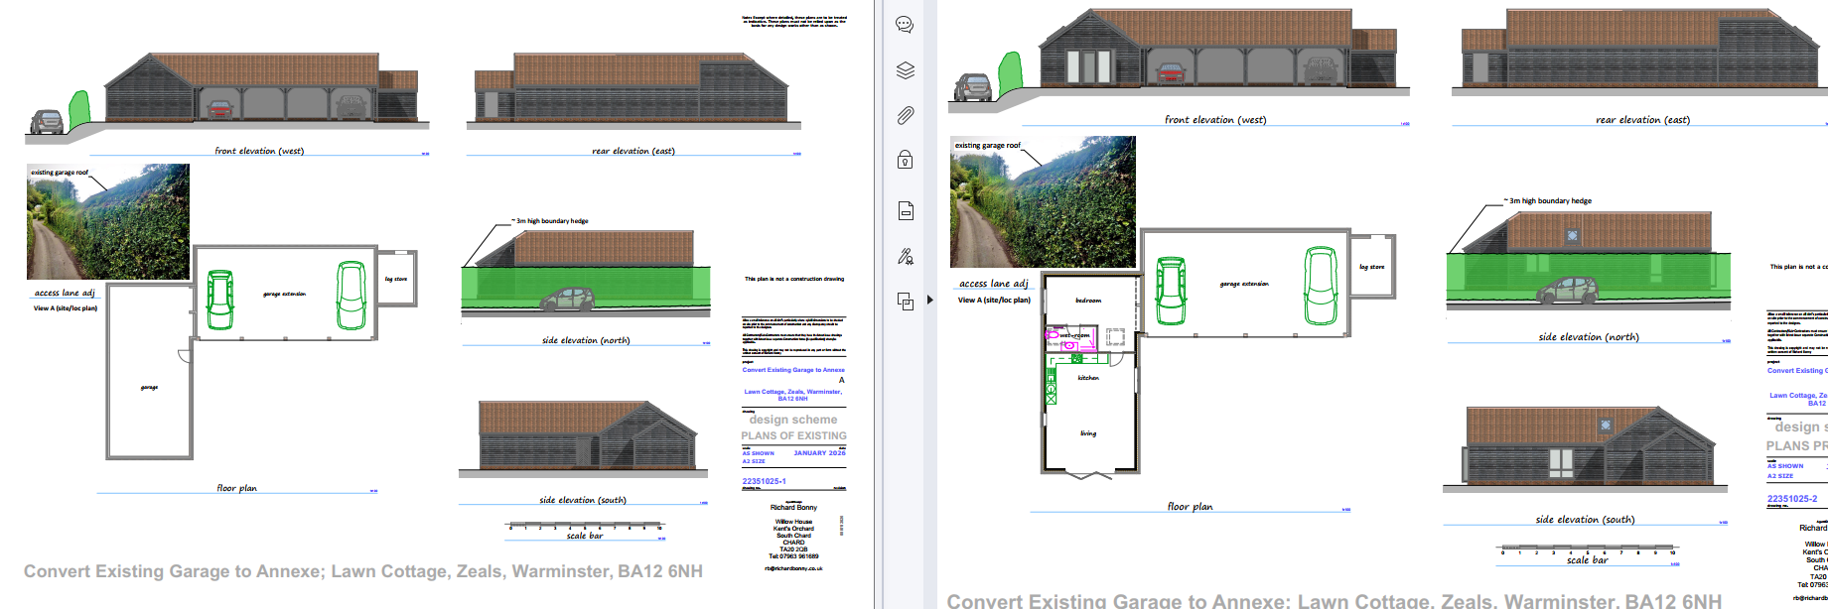

Amenity
Point vii of Core Policy 57 - Ensuring High Quality Design and Place Shaping of the Wiltshire Core Strategy seeks to ensure that developments do not adversely affect neighbouring properties.

The National Planning Policy Framework (NPPF), particularly Paragraph 135(f), stresses that planning decisions should ensure developments provide a high standard of amenity for existing and future users.

The proposed development has been assessed in terms of its potential impact on the residential amenity of neighbouring properties, with particular regard to loss of light, overshadowing, loss of privacy, and overbearing effects.

The application site is bordered by residential dwellings on the South, East and West with the highway on the northern boundary. The existing L shaped garage is located along the northeastern boundary of the application site. This application proposes for the conversion of the garage into ancillary accommodation. To facilitate this conversion, windows and doors are proposed to be inserted into the existing structure. These are all on the ground floor with 2 proposed rooflights on the north and south elevations. The north elevation proposes 1 roof light and 2 windows. This is adjacent to an existing hedge with the highway beyond this. On the south elevation, 1 window is proposed to be inserted. This faces the host dwelling’s driveway with the host dwelling beyond. On the western elevation, bi-folding doors are proposed. This faces a lawn area section of the application site. It is not considered that the insertion of doors and windows to the single storey garage will have adverse effects to the neighbouring amenity of the adjacent dwellings on the north, east and west of the existing garage. There are ample boundary treatments separating the location of the annex to the surrounding dwellings. The proposal therefore accords with Core Policy 57 point vii in respect of safeguarding residential amenity and Appendix D of the Wiltshire Design Guide.

Highways Impact
Core Policy 57 (xiv) of the Wiltshire Core Strategy seeks to ensure that development must meet the requirements of Core Policy 61. This policy requires proposals to be capable of being served by safe access to the highway network. Core Policy 64 seeks to ensure compliance with parking standards set out in the Local Transport Plan.

The National Planning Policy Framework (NPPF), particularly Paragraph 115 and 116, requires that development proposals do not have an unacceptable impact on highway safety and that safe and suitable access to the site can be achieved for all users.

The application site is accessible from a no through unclassified road serving less than 20 dwellings. The application site has an L shaped building with existing four car carport and a garage. The garage area does not have an opening for vehicular access, this is the section proposed to be converted into annex accommodation. The LPA’s highways officer has no objection to this conversion. The application site retains adequate parking provision for both the main house and the proposed annexe and the existing vehicle access is not proposed to be altered.

The proposal is therefore considered to comply with Core Policies 57 (xiv), 61 and 64 of the Wiltshire Core Strategy, the NPPF, and the Wiltshire Local Transport Plan.
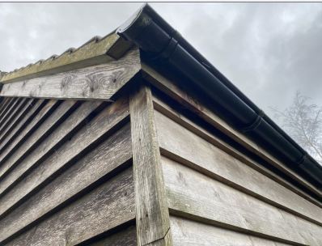
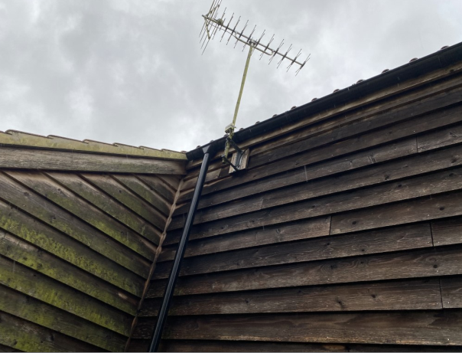
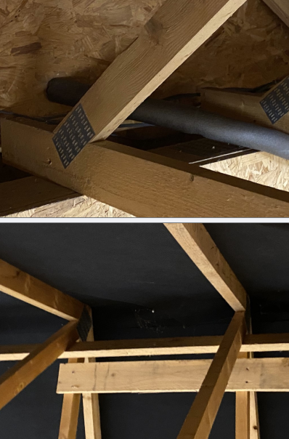
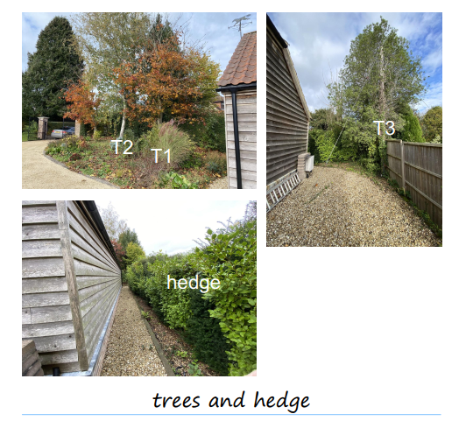
Ecology Impact
Core Policy 50 of the Wiltshire Core Strategy seeks to protect and enhance biodiversity and geodiversity, including through ensuring that development avoids harm to protected species and habitats.

The National Planning Policy Framework (NPPF), in Paragraphs 193, requires that development minimises impacts on and provides net gains for biodiversity, including ensuring mitigation is secured where harm cannot be avoided.

The application site is not subject to any statutory or non-statutory ecological designations, and the scale and nature of development is such that significant harm to biodiversity is unlikely. The garage/workshop element proposed to be converted for ancillary accommodation was constructed in 2014, there are no visible gaps within the existing building that raises ecology concerns. No consultation was received from the LPA’s ecologist during the duration of this application. However, this consent does not override the statutory protection afforded to any protected species. An informative ensuring that the applicant is aware of this has been included in the recommendation.

Alongside this, the submitted documents note that there are 3 trees and a mature hedge adjacent to the existing garage proposed for conversion. This application does not include any additional footprint to the existing garage building. This application does not include any proposed changes to these identified trees and hedge. These do not benefit from a tree protection order (TPO), nor are they located in a conservation area and therefore in planning terms, it is not a constraint. While construction methods to allow for these features to be retained should be considered by the applicant, this is not required for the purposes of planning and cannot therefore be secured as part of this application.

Biodiversity Net Gain

Householder planning applications are exempt from the requirement to deliver Biodiversity Net Gain under Schedule 7A, Section 4(2)(a) of the Town and Country Planning Act 1990, as inserted by the Environment Act 2021.

CONCLUSION

The proposed development is considered to be acceptable in terms of its design, scale, and relationship with the surrounding area. It would not result in any unacceptable harm to the character of the locality, the amenities of neighbouring occupiers, or the interests of highway safety, heritage, or ecology.

The proposal is therefore considered to comply with the relevant policies of the Wiltshire Core Strategy, the Wiltshire Local Plan, and the National Planning Policy Framework. As such, the application is recommended for approval, subject to the conditions set out below.

RECOMMENDATION: That Planning Permission be GRANTED subject to conditions.

1.The development hereby permitted shall be begun before the expiration of three years from the date of this permission.

REASON: To comply with the provisions of Section 91 of the Town and Country Planning Act 1990 as amended by the Planning and Compulsory Purchase Act 2004.

2.The development hereby permitted shall be carried out in accordance with the following approved plans and documents:

Location Plan Drawing No: 22351025-3 Received: 09 Jan 2026
Proposed Elevations and Floor Plans Drawing No: 22351025-2 Received: 09 Jan 2026
Planning Statement Received: 09 Jan 2026

REASON: For the avoidance of doubt and in the interests of proper planning.

3.Materials to be used in the construction of the works hereby permitted shall be as stated on
the application form and in the submitted documents.

REASON: In the interests of visual amenity and the character and appearance of the area.

4. The proposed annex hereby approved shall only be used for purposes ancillary to the residential use of the dwelling known as Lawn Cottage, Zeals, Warminster, BA12 6NH and it shall remain within the same planning unit as the main dwelling of Lawn Cottage, Zeals, Warminster, BA12 6NH.

REASON: The nature of the proposed works having regard to the reasonable standards of residential amenity, access, parking provision and planning policies pertaining to the area would not permit a separate dwelling.

Informative:

Wildlife and countryside act

The applicant should note that under the terms of the Wildlife and Countryside Act (1981)
and the Habitats Regulations (2010) it is an offence to disturb or harm any protected
species, or to damage or disturb their habitat or resting place. Please note that this
consent does not override the statutory protection afforded to any such species. In the event
that your proposals could potentially affect a protected species you should seek the advice of
a suitably qualified and experienced ecologist and consider the need for a licence from Natural
England prior to commencing works. Please see Natural England’s website for further
information on protected species.

