APPLICATION FOR HOUSEHOLDER PLANNING PERMISSION
DELEGATED REPORT

APPLICATION REFERENCE: | PL/2026/00364
APPLICATION TYPE: | Householder planning permission
SITE ADDRESS: | 26 Lordsmead Road, Mere, Warminster, BA12 6BZ
DEVELOPMENT DESCRIPTION: | Single-storey side extension to form a porch and installation of a solar panel array.
RECOMMENDATION: | That Planning Permission be GRANTED

PROPOSAL

The proposal seeks planning permission for a single storey side extension to form a porch and the installation of a solar panel array on the existing roof.

SITE DESCRIPTION/CONTEXT

The application site is a semi-detached bungalow located within the settlement of Mere as defined by Wiltshire Core Strategy (WCS) policies CP1, CP2 and CP17. The site is located on Flood Zone 1, with no risk to groundwater or surface area flooding as per the data on the SFRA.

The site is bordered by detached residential dwellings on the north and west and is located on the corner of Woodlands Road on the east and Lordsmead Road on the south.

PLANNING HISTORY
There are no records of historic planning applications submitted for works at the application site.
RELEVANT POLICIES AND GUIDANCE

Wiltshire Core Strategy:

- CP1: Settlement Strategy
- CP2: Delivery Strategy
- CP17: Spatial Strategy: Mere Community Area
- CP41: Sustainable construction and low-carbon energy
- CP50: Biodiversity and Geodiversity
- CP51: Landscape
- CP57: Ensuring High Quality Design and Place Shaping
- CP60: Sustainable Transport
- CP61: Development Impact on the Transport Network
The Designation of Mere Neighbourhood Area has been approved in accordance with section 61G of the Town and Country Planning Act 1990 as amended for the purposes of Neighbourhood Planning and Part 2 of the Neighbourhood Planning (General) Regulations 2012 as amended 2016. However, at the time of writing there has not been a made neighbourhood plan for this area.

Wiltshire Design Guide: Appendix D – Design Guidance for Householder extensions

The National Planning Policy Framework (NPPF)

The Planning Practice Guidance

National Design Guide

CONSULTATION RESPONSES

Mere Town Council: Support.

REPRESENTATIONS

No comments were received.

ASSESSMENT

Section 38(6) of the Planning and Compulsory Purchase Act 2004 states:

"If regard is to be had to the development plan for the purposes of any determination to be made under the planning Acts, the determination must be made in accordance with the plan unless material considerations indicate otherwise."

In accordance with this statutory requirement, this application has been assessed against the relevant policies of the Development Plan, including the adopted Wiltshire Core Strategy (2015) and, where applicable, any made Neighbourhood Plans.
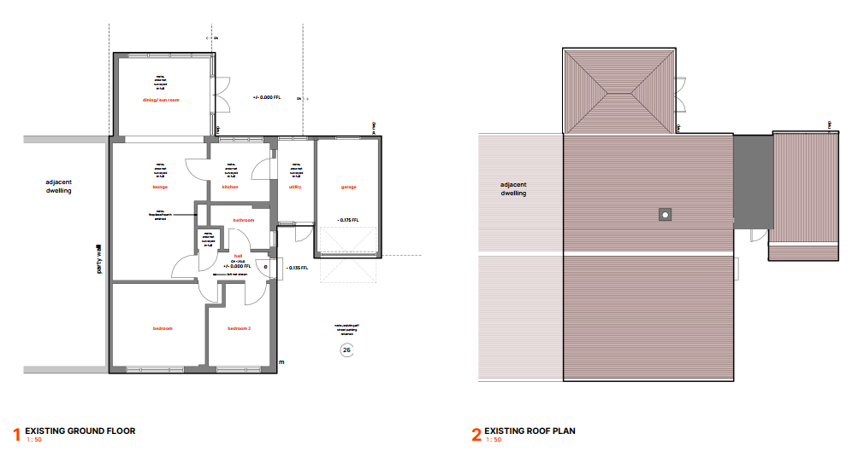
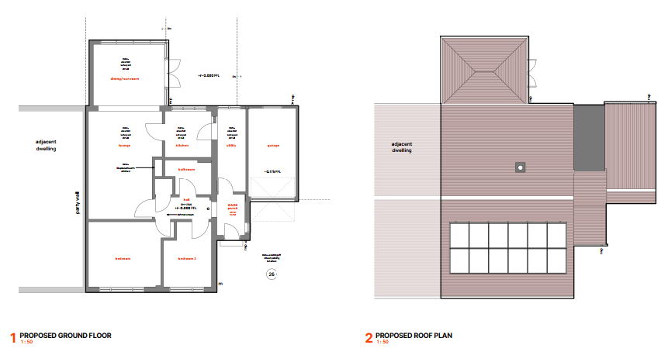

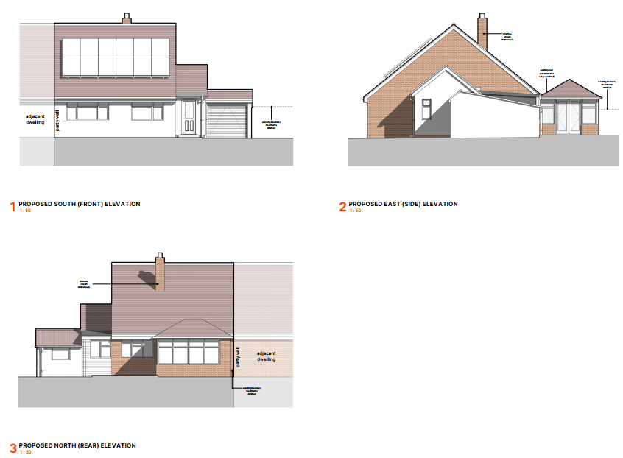

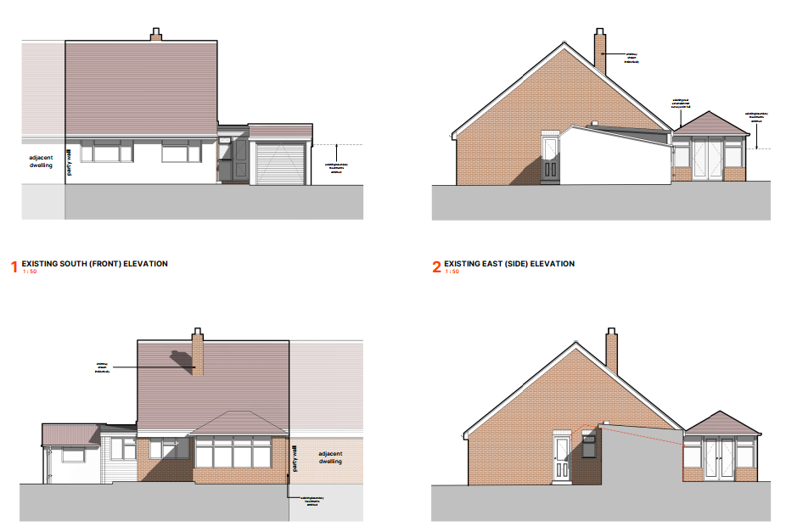

Design and Impact upon the character and context of the area

Core Policy 57 - Ensuring High Quality Design and Place Shaping of the Wiltshire Core Strategy seeks to ensure that all new development is of high design quality, reflecting local context, character, and distinctiveness.

The application site is an existing semi-detached bungalow in a residential area. This householder planning application proposes to erect a front porch measuring approximately 1.8 metres in width and 2 metres in length and 4 metres in height. This porch is proposed to be lower in height than the host dwelling and remains subservient to the principal roof of the host dwelling. The proposed materials match the existing host dwelling. The proposed works are considered to be subservient in scale, utilises suitable materials, has been designed to complement the existing style of the dwelling, and would not be of harm to the visual amenity of the streetscape. The proposed alterations would not cause any significant impact on the wider area and are acceptable accordingly. Having regard to the above, the proposal complies with the design principles set out in Core Policy 57 of the Wiltshire Core Strategy and Appendix D of the Wiltshire Design Guide.

In addition to the proposed front porch, this application also proposes to install 12 solar panels on the front elevation of the host dwelling. Paragraph 164 states that ‘In determining planning applications, local planning authorities should give significant weight to the need to support energy efficiency and low carbon heating improvements to existing buildings, both domestic and non-domestic (including through installation of heat pumps and solar panels where these do not already benefit from permitted development rights).

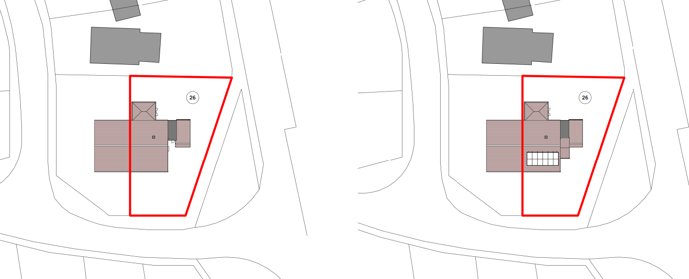
The principle of the addition of solar panels to an existing building is considered a positive contribution to Wilshire as part of a high standard of design. Encouraging energy reduction measures to improve energy performance is good design in the context of the Wiltshire Core Strategy. The solar array is proposed to be used for the residential dwelling. CP42 of the adopted WCS states that proposals for “standalone renewable energy schemes will be supported subject to satisfactory resolution of all site specific constraints.” This application site is not located within a conservation area nor are there any listed buildings in the nearby vicinity. It is located within an established residential area, as such it is not considered that the solar panels would have an impact on the street scene of the local area.
Amenity
Point vii of Core Policy 57 - Ensuring High Quality Design and Place Shaping of the Wiltshire Core Strategy seeks to ensure that developments do not adversely affect neighbouring properties.

The National Planning Policy Framework (NPPF), particularly Paragraph 135(f), stresses that planning decisions should ensure developments provide a high standard of amenity for existing and future users.

The proposed development has been assessed in terms of its potential impact on the residential amenity of neighbouring properties, with particular regard to loss of light, overshadowing, loss of privacy, and overbearing effects.

The application site is a semi-detached dwelling located in a residential area. The proposed porch is single storey in nature. Due to the minimal scale and proposed use of the extension as a porch, it is not considered that this proposed porch would detrimentally impact the existing residential amenity of the neighbouring dwellings with regard to loss of light/overshadowing, loss of privacy or would it have an overbearing impact. Alongside this, the proposed solar panels are not considered to cause any undue impacts to the neighbouring dwellings. The proposal therefore accords with Core Policy 57 point vii in respect of safeguarding residential amenity and Appendix D of the Wiltshire Design Guide.

Biodiversity Net Gain
Householder planning applications are exempt from the requirement to deliver Biodiversity Net Gain under Schedule 7A, Section 4(2)(a) of the Town and Country Planning Act 1990, as inserted by the Environment Act 2021.

CONCLUSION

The proposed development is considered to be acceptable in terms of its design, scale, and relationship with the surrounding area. It would not result in any unacceptable harm to the character of the locality and the amenities of neighbouring occupiers.

The proposal is therefore considered to comply with the relevant policies of the Wiltshire Core Strategy, the Wiltshire Local Plan, and the National Planning Policy Framework. As such, the application is recommended for approval, subject to the conditions set out below.

RECOMMENDATION: That Planning Permission be GRANTED subject to conditions.

1.The development hereby permitted shall be begun before the expiration of three years from the date of this permission.

REASON: To comply with the provisions of Section 91 of the Town and Country Planning Act
1990 as amended by the Planning and Compulsory Purchase Act 2004.

2.The development hereby permitted shall be carried out in accordance with the following
approved plans:

Location Plan Received: 20 Jan 2026

Design and Access Statement Received: 20 Jan 2026

Existing and Proposed Site Block Plan Drawing No. P2525-LXW-ZZ-XX-DR-A-105_P05 Received: 20 Jan 2026

Proposed Ground Floor Plan and Roof Plan Drawing No. P2525-LXW-ZZ-XX-DR-A-103_P05 Received: 20 Jan 2026

Proposed Elevations Drawing No. P2525-LXW-ZZ-XX-DR-A-104_P05 Received: 20 Jan 2026

REASON: For the avoidance of doubt and in the interests of proper planning.

3.Materials to be used in the construction of the works hereby permitted shall be as stated on
the application form and shall match the existing brickwork and roof tiles as the host dwelling.

REASON: In the interests of visual amenity and the character and appearance of the area.

