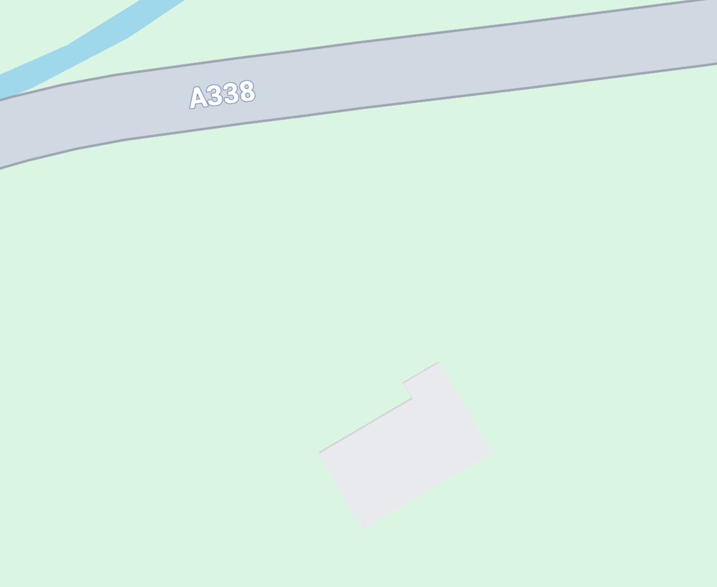
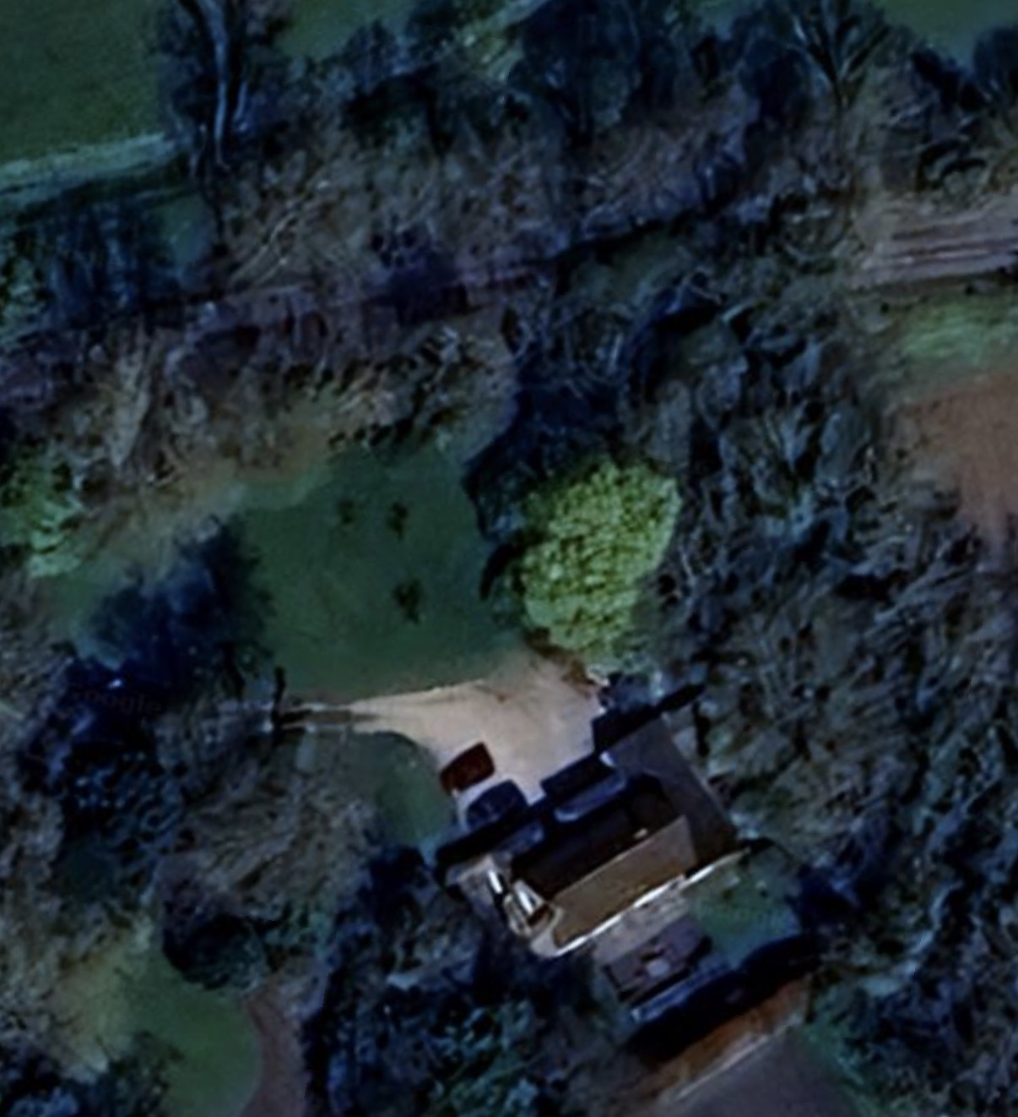
- Ash Trees to be removed
Property Boundary
North
North
The Brake
The Brake
Property Boundary

