APPLICATION FOR PRIOR APPROVAL FOR PART 3 CLASS Q AGRICULTURAL BUILDING TO A DWELLINGHOUSE.

DELEGATED REPORT

APPLICATION REFERENCE: | PL/2025/08812
APPLICATION TYPE:
  Prior approval Part 3 Class Q: Agricultural buildings to dwellinghouses
SITE ADDRESS: | Barn on land southwest to Huntenhall Farmhouse, Huntenhall Lane, Chapmanslade, Westbury, BA13 3AS
DEVELOPMENT DESCRIPTION: | Prior Approval Part 3 Class Q - Change of use of existing tractor shed to a holiday cottage
RECOMMENDATION: | Prior Approval granted with Conditions

ISSUES & POLICIES

The only consideration in the determination of this application is whether the proposed development conforms to the requirements and limitations of Schedule 2, Part 3, Class Q of the Town and Country Planning (General Permitted Development) Order 2015 (as amended – by the Town and Country Planning (General Permitted Development) (England) (Amendment) Order 2024).

Subject to several conditions and restrictions, buildings that are part of an established agricultural unit and land within the building’s curtilage may convert to a use falling within Class C3 (dwelling houses) of the Schedule to the Use Classes Order 1987 (as amended):

Permitted development:

Q. Development consisting of—
(a) a change of use of—
(i) a building that is part of an established agricultural unit and any land within that building’s curtilage, or
(ii) a former agricultural building that was (but is no longer) part of an established agricultural unit and any land within that building’s curtilage, to a use falling within Class C3 (dwellinghouses) of Schedule 1 to the Use Classes Order, (b) development referred to in sub-paragraph (a) together with the extension of the building referred to in sub-paragraph (a), or
(c) development referred to in sub-paragraph (a) together with building operations reasonably necessary to convert the building referred to in sub-paragraph (a) to a use falling within Class C3 (dwellinghouses) of that Schedule or to extend that building.

THE SITE
The existing wooden barn is on land to the southwest of Huntenhall Farmhouse, Huntenhall Lane, Chapmanslade, it is located in the open countryside and surrounded by open farmland. It is located within the Salisbury Plain SPA 6400m buffer and just outside of the Bath & Bradford on Avon Bat SAC. The site is not located within flood zones 2 and 3 and is not subject to high levels of surface water flooding. However, as detailed on the council strategic flood risk map (snipper copied below), the site is subject to high levels of groundwater flooding–
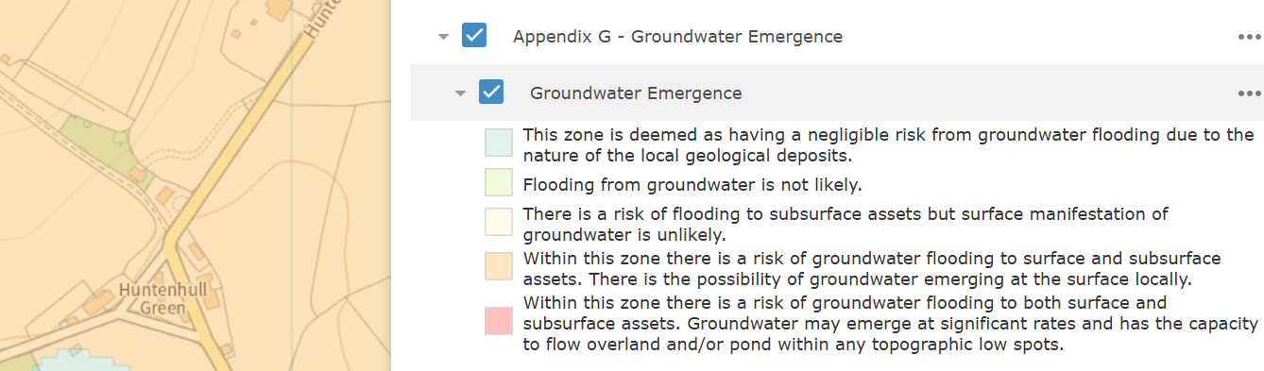
The following plan snippet shows the location of the existing barn:

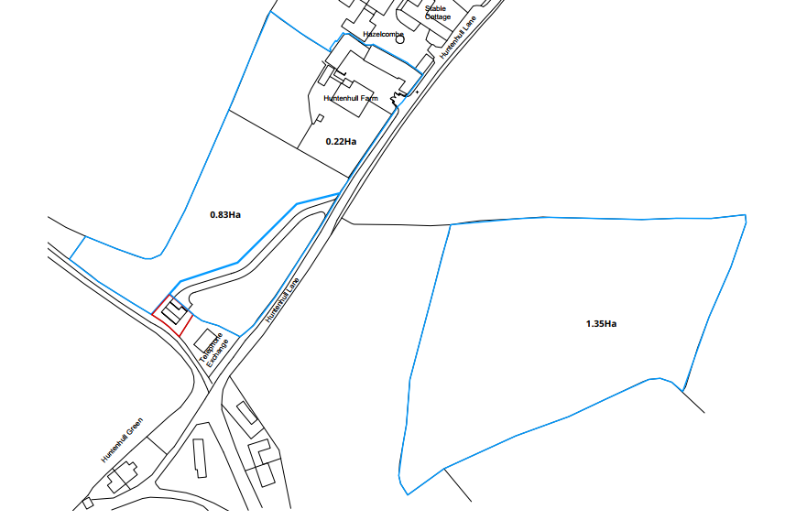
Site Location Plan

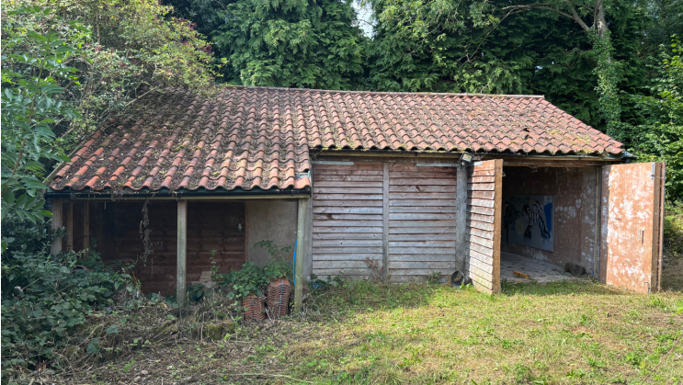
Existing photograph of the barn taken from the applicant’s structural survey.

Consultation Responses.
Chapmanslade Parish Council: Commented as follows:

“Chapmanslade Parish Councillors discussed this item at length taking note of the previous planning approval application PL/19/11906 granted in 2020 for this development and found no pertinent grounds to object.

All councillors agreed that they did not actively support this further application being mindful of previous concerns raised over such class Q conversions of agricultural buildings to dwellings.”

Public Protection: No objections.

Highways: No objections subject to conditions and comment:

As you will be aware, the access was approved under application 19/11906.
I raise no highway objection to the proposed development, subject to the following conditions being attached to any planning permission granted:
No part of the development shall be first brought into use, until the visibility splays shown on the approved plans have been provided with no obstruction to visibility at or above a height of 600mm above the nearside carriageway level. The visibility splays shall always be maintained free of obstruction thereafter.
Reason: In the interests of highway safety
The development hereby permitted shall not be first brought into use until the first 5m of the access, measured from the edge of the carriageway, has been consolidated and surfaced (not loose stone or gravel). The access shall be maintained as such thereafter.
REASON: In the interests of highway safety
Notwithstanding the submitted details, the proposed development shall not be occupied until means/works have been implemented to avoid private water from entering the highway.
Reason: To ensure that the highway is not inundated with private water.
The proposal includes proposed closures to the public highway, consent hereby granted shall not be construed as authority to carry out closures to the highway. The applicant is advised that an application must be cleared with Wiltshire Council Traffic Orders (www.wiltshire.gov.uk/highways-road-closures) prior to a temporary closure order. Please contact the traffic orders team on telephone 01225 713104 or email mailto:TrafficOrders@wiltshire.gov.uk for further details. Temporary Traffic Orders team require a 12-week lead in so enough time should be factored in for the necessary orders.
For further information please contact mailto:Streetworks@wiltshire.gov.uk for any additional information.

Ecology: No objections subject to the inclusion of the following informative:

There is a low risk that bats may occur at the development site. Many species of bat depend on buildings for roosting, with each having its own preferred type of roost. Most species roost in crevices such as under ridge tiles, behind roofing felt or in cavity walls and are therefore not often seen in the roof space. Bat roosts are protected all times by the Conservation of Habitats and Species 2017 (as amended) even when bats are temporarily absent because, being creatures of habit, they usually return to the same roost site every year. Planning permission for development does not provide a defence against prosecution under this legislation or substitute for the need to obtain a bat licence if an offence is likely. If bats or evidence of bats is found during the works, the applicant is advised to stop work and follow advice from an independent ecologist or the applicant is advised to follow the advice of a professional ecologist or to contact Natural England’s Batline through the internet.

REPRESENTATIONS
No comments were received.

Relevant Planning History.
12/02210/FUL Retrospective application for erection of a tractor shed. Approved.

19/11906/Ful Change of use of tractor shed to holiday cottage and new access. Approved.

Assessment.
This application proposes the change of use and conversion of a vacant building to a 2-bed dwelling, which is intended to be utilised as a holiday let.

Planning permission was recently granted in 2019 for a change of use of the building to that of a holiday let, this permission was not implemented.

The proposals can be viewed within the following plan snippets taken from the submitted plans:

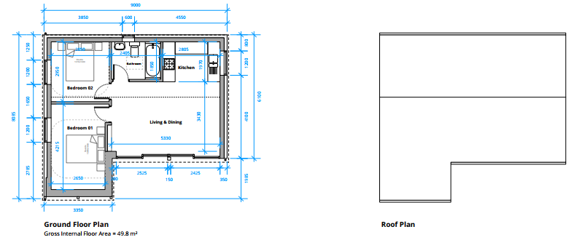
Proposed ground floor plan & roof plan.

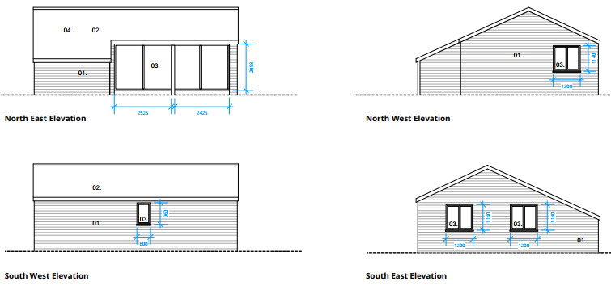
Proposed elevations

The Structural Survey.
The building is a substantial timber framed structure and is of solid construction:
‘The barn comprises what appears to be an oak primary frame with infill timber walls sheathed in plywood which provides lateral stability to the frame and building overall. The timber walls appear to be supported on the edge of the concrete slab, but the principal posts to the oak frame appear to extend through the concrete slab and most likely extend through to the foundations beneath’.

The building has been sited on a solid stone base referred to within the structural survey as a ‘Boyne Hollow Chert Sandstone member comprising interbedded sedimentary rock.’ This ground material forms a good founding medium for the barn.

The timber frame is in a good condition and also has a good line and level. The roof structure is formed from pre-fabricated softwood timber trusses with insulation at truss cord / ceiling level and are also in good condition. Internally, there is a good concrete slab on the floor to carry and support farm machinery, this floor is considered to be wholly adequate to support domestic use. These two aspects are shown in the following photos:

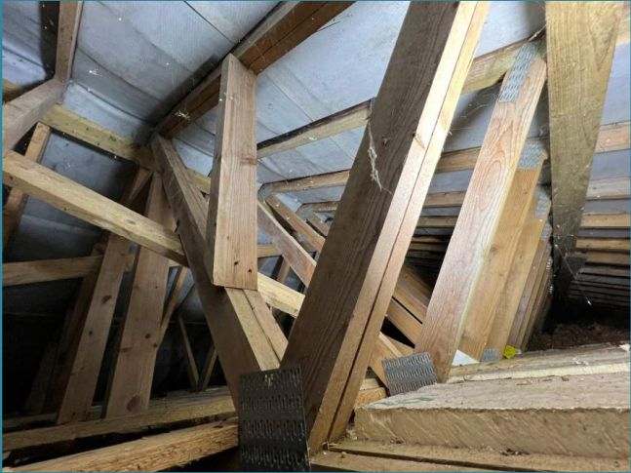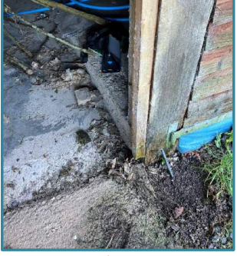

The survey report concludes that the barn frame and roof are well configured and the walls and frame have a good line with no structural issues noted. It is recommended that the conifer immediately behind the barn be considered for removal as its bow is quite close to the rear of the barn and the branches overhang the building.
The Use of the Building
In considering Part 3, Class Q of the GPDO the Local Planning Authority (LPA) must first establish whether the application building is part of an established agricultural unit or a former agricultural building that was (but is no longer) part of an established agricultural unit (class (a) (i) and (ii)) as part of an established agricultural unit on 24 July 2023 (restriction Q1(a)(i)). Or in the case of a site that was (but is no longer) part of an established agricultural unit –
(i)the site was part of an established agricultural unit on 24th July 2023,
(ii)where the site ceased to be part of an established agricultural unit after 24th July 2023, the site has not been part of the established agricultural unit for a period of at least 10 years before the date development under Class Q begins, or
(iii)since ceasing to be part of an established agricultural unit, the site has been used for any non-agricultural purpose, Included within the procedure notes for prior approvals under Part 3 (Part X ‘Interpretation of Part 3”) is the definition of an agricultural building. Such a definition sets out that an agricultural building ‘means a building (excluding a dwellinghouse) used for agriculture and which is so used for the purposes of a trade or business; and
“agricultural use” refers to such uses.’ In addition, the notes define an established agricultural unit as ‘…..agricultural land occupied as a unit for the purposes of agriculture – (a) for the purposes of Class R, on or before 3rd July 2012 or for 10 years before the date the development begins; or (b) for the purposes of Class Q or S, on or before 20th March 2013 or for 10 years before the date the development begins’.

The applicants have produced a statement on the building’s former use, confirming such agricultural use. The council has no evidence to the contrary and it is appraised that the building is a former agricultural building that complies with paragraph Q1 (b) (iii).

The Proposed Conversion of the Building
The next key consideration is whether the proposal involves the conversion of the building only.
Class Q.1(j) states development under Class Q(c) would consist of building operations other than—
(i) the installation or replacement of—
(aa)windows, doors, roofs, or exterior walls, or (bb)water, drainage, electricity, gas or other services,
to the extent reasonably necessary for the building to function as a dwellinghouse, and (ii)partial demolition to the extent reasonably necessary to carry out building operations allowed by paragraph Q.1(j)(i),
Case Law has established that a proposal must comprise a ‘conversion’ and not a ‘rebuild’ to qualify as permitted development under Class Q as set by Hibbitt and Another v. Secretary of State for Communities and Local Government and Rushcliffe Borough Council) [2016] EWHC 2853 (Admin)).

In this instance the proposed changes involve the addition of windows and changes to the internal layout of the building, as such this is a conversion and not a re-build.

The change of use of a building and any land within its curtilage
Paragraph (Q) (a) of Class Q allows the change of use of a building that is part of an established agricultural unit and any land within that building’s curtilage to a use falling within Class C3 (dwellinghouses).

For the purposes of Class Q, “curtilage” means the lesser of—
(a)the piece of land, whether enclosed or unenclosed, immediately beside or around the building on an established agricultural unit or former agricultural building (as the case may be), closely associated with and serving the purposes of that building, and (b)an area of land immediately beside or around the building on an established agricultural unit or former agricultural building (as the case may be) no larger than the land area occupied by that building.

The submitted proposed site plan (see below) shows the red line extent of the proposed building curtilage which is considered to comply with the above criteria.

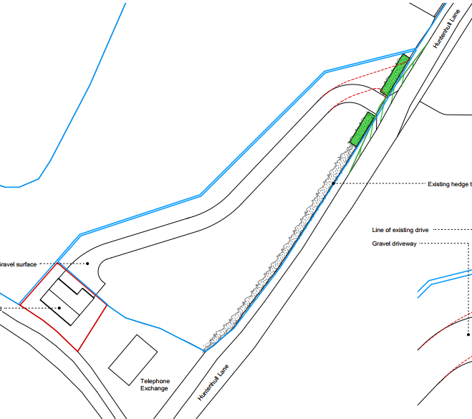

Other Paragraph Q.1 Restrictions.
In terms of other restrictions Q1.(a) and (b) such points have been addressed above. The remaining restrictions within the GPDO area as follows:

Q1(c)the floor space of any dwellinghouse developed under Class Q having a use falling within Class C3 (dwellinghouses) of Schedule 1 to the Use Classes Order exceeds 150 square metres,

Q1(d)the development under Class Q, together with any previous development under Class Q, within the original limits of an established agricultural unit (see paragraph Q.3(2) of this Part) would result in—
(i)the cumulative number of separate dwellinghouses having a use falling within Class C3 (dwellinghouses) of Schedule 1 to the Use Classes Order exceeding 10, or
(ii)the cumulative floor space of dwellinghouses having a use falling within Class C3 (dwellinghouses) of Schedule 1 to the Use Classes Order exceeding 1,000 square metres,

Q1(e)the site is occupied under an agricultural tenancy, unless the express consent of both the landlord and the tenant has been obtained,

Q1(f)less than 1 year before the date development begins—
(i)an agricultural tenancy over the site has been terminated, and
(ii)the termination was for the purpose of carrying out development under Class Q,
unless both the landlord and the tenant have agreed in writing that the site is no longer required for agricultural use,

Q1(g)development under Class A(a) or Class B(a) of Part 6 of this Schedule (agricultural buildings and operations) has been carried out on the established agricultural unit during the period which is 10 years before the date development under Class Q begins.

Q1(h)the development would result in the external dimensions of the building extending beyond the external dimensions of the existing building at any given point, other than—
(i)extension of the building allowed by paragraph Q.1(i);
(ii)protrusions of up to 0.2 metres to accommodate building operations allowed by paragraph Q.1(j)(i),

Q1(i)the development under Class Q(b) would result in an extension that—
(i)has more than one storey,
(ii)is sited anywhere other than to the rear of the existing building,
(iii)extends beyond the rear wall of the existing building by more than 4 metres,
(iv)has eaves the height of which exceed the height of the eaves of the existing building,
(v)is higher than whichever is the lower of—
(aa)the highest part of the roof of the existing building, or
(bb)a height of 4 metres above the ground,
(vi)extends beyond a wall that forms a side or principal elevation of the existing building.
(vii)would be sited on land that, before the development under Class Q(b), is not covered by a hard surface that was provided on the land by virtue of any development, and—
(aa)the hard surface was not provided on the land on or before 24th July 2023, or
(bb)where the hard surface was provided on the land after 24th July 2023, the hard surface has not been situated on the land for a period of at least 10 years before the date development under Class Q(b) begins,

Q1(j)the development under Class Q(c) would consist of building operations other than—
(i)the installation or replacement of—
(aa)windows, doors, roofs, or exterior walls, or
(bb)water, drainage, electricity, gas or other services,
to the extent reasonably necessary for the building to function as a dwellinghouse, and
(ii)partial demolition to the extent reasonably necessary to carry out building operations allowed by paragraph Q.1(j)(i),

Q1(k)the site is on article 2(3) land,

Q1(l)the site is, or forms part of—
(i)a site of special scientific interest;
(ii)a safety hazard area;
(iii)a military explosives storage area,

Q1(m)the site is, or contains, a scheduled monument,

Q1(n)the building is a listed building,

Q1(o)the existing building, excluding any proposed extension under Class Q(b) but including any proposed building operations under Class Q(c), would not be capable of complying with the nationally described space standard issued by the Department for Communities and Local Government on 27th March 2015 as read with the notes dated 19th May 2016 which apply to it, or

Q1(p)the building does not have suitable existing access to a public highway.

From the case officer’s site visit and examination of the submitted information, the proposals for the dwelling do not breach the above restrictions.

Paragraph Q.2 Conditions
Paragraph Q.2 of Class Q states that the conversion of an agricultural building to residential, is considered permitted development subject to the condition that before beginning the development, the developer shall apply to the local planning authority for a determination as to whether the prior approval of the authority will be required as to –

(a) transport and highway impacts of the development (b) noise impacts of the development (c) contamination risks on the site
(d) flooding risks on the site
(e) whether the location or siting of the building makes it otherwise impractical or undesirable for the building to change from agricultural use to a use falling within Class C3 (dwellinghouses) of the Schedule to the Use Classes Order
(f) design and appearance of the building
(g) the provision of adequate natural light in all habitable rooms of the dwellinghouse

a) The transport and highway impacts of the proposed development have been appraised and as discussed above in this report, the council highways team have not raised any objections to the scheme. They have asked that their suggested three conditions relating to visibility splays, surfacing of the access track and surface water disposal be attached to the final decision notice, which is acceptable.

b) Officers are not aware of any noise impacts or contamination risks of the site.

c) Environmental Public Protection have not raised any objections or concerns in regard to possible land contamination.

d) The site is not located within flood zones 2 and 3 and is not subject to high levels of surface water flooding. However, as detailed on the council strategic flood risk map, the site is subject to high levels of groundwater flooding. As such a condition requiring the submission of a site-specific drainage strategy and proportionate groundwater flood risk assessment will be imposed on the scheme in order to ensure the development is safe for its lifetime without increasing flood risk elsewhere.

e) Whether the location or siting of the building makes it otherwise impractical or undesirable for the building to change from agricultural use to a use falling within Class C3 (dwellinghouses) of the Schedule to the Use Classes Order. The location and siting of the development are considered acceptable.

f) Design and appearance: The design and appearance of the building is considered acceptable.

g) The provision of natural daylight is adequately provided within the front of the building, as there would be four large areas of glass fenestration to provide natural daylight. The conifer tree to the side of the building would be removed as it is overgrown and has the potential to cause damage to the building. Its removal will allow more natural daylight into the building.

CONCLUSION
For the reasons outlined in the above report, the proposed development satisfies the requirements of Class Q. Prior approval is required, and the submitted details have satisfied the prior approval requirements and therefore can be granted.

RECOMMENDATION: Prior approval granted with conditions

