APPLICATION FOR PRIOR NOTIFICATION – PART 14 CLASS J
CASE OFFICER REPORT

APPLICATION REFERENCE: | PL/2026/00636
APPLICATION TYPE: | Prior Approval Part 14 Class J: Installation or alteration etc of solar equipment on non-domestic premises
SITE ADDRESS: | Tesco Extra, County Way, Trowbridge, BA14 7AQ
DEVELOPMENT DESCRIPTION: | Installation of a roof-mounted solar photovoltaic (PV) system comprising up to 308 panels (500Wp each), providing a total installed capacity of approximately 154 kWp.
RECOMMENDATION: | That Prior Approval is Not Required

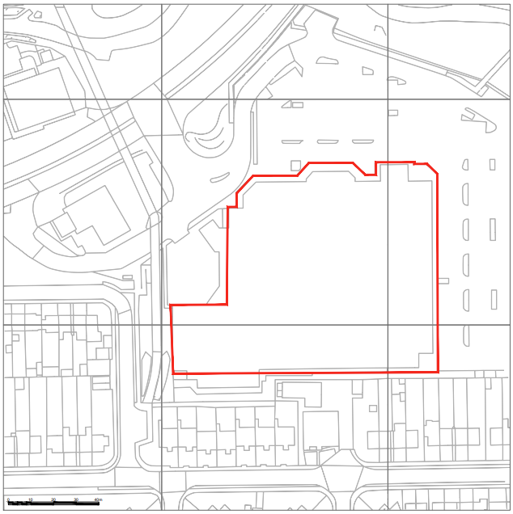

PROPOSAL

The proposal seeks prior approval under Part 14, Class J of the General Permitted Development Order for the installation of a roof‑mounted solar photovoltaic (PV) system on the existing Tesco Extra building. The development would comprise the installation of up to 308 PV panels, each with a capacity of approximately 500Wp, generating a total installed capacity of around 154 kWp. The panels would be fixed to the roof of the existing structure without increasing the building’s overall height or footprint. The works are confined to the roof area and do not involve ground‑level alterations or external plant beyond the PV array itself.

SITE DESCRIPTION / CONTEXT

The application site comprises the Tesco Extra superstore located off County Way within the Trowbridge Principal Settlement. The site occupies a central urban position with residential properties situated to the south and south-west, and the River Biss corridor and adjoining highway infrastructure immediately to the north. Biss Meadows Country Park lies adjacent to the site, forming part of the broader green infrastructure network. The site falls within the Trowbridge and Westbury Bat Mitigation Strategy (TWBMS) Grey Zone, is located within Flood Zone 1, and is identified by the Strategic Flood Risk Assessment as being at negligible risk from groundwater flooding but some areas ranging between 0.1-3.3% AEP for surface water flooding. The existing building is a large-scale commercial structure with extensive roof space and associated car parking areas typical of major retail developments.

PLANNING HISTORY

Reference No. | Proposal / Summary | Decision
W/89/00828/FUL | New tesco store petrol filling station and associated works | Approved
W/92/00464/FUL | New tesco store petrol filling station car park | Approved
W/98/00345/FUL | Single storey extensions, alterations to car park and County Way | Approved
W/99/01176/FUL | Jetwash and vacuum facility at petrol station | Approved
W/99/01220/FUL | Replacement car park lighting | Approved
W/99/01822/FUL | Variation of condition 05 (W98/0345) to allow 20% of the total retail sales floor area to be used for the sale and display of comparison goods | Approved
W/00/00223/FUL | Goods storage canopy | Approved
W/01/00118/FUL | Alterations to access road | Approved
W/03/00287/FUL | Extension to bulk storage area | Approved
W/03/01354/FUL | Provision of trolley bays, ATM, warehouse extension and alteration to service yard | Approved
W/03/02006/FUL | Extensions to bulk store area of store and conversion of loading dock canopy | Approved
W/04/01015/FUL | Amendments to bulk store extension scheme (03/02006) to alter layout of service yard, incorporating home shop loading area and sprinkler tank, and minor alterations to car park layout | Approved
W/05/03013/FUL | Variation to condition 1 of permission 99/01822 and alteration to car parking | Approved
W/06/01813/FUL | Additional roof plant installations and proposed elevation changes | Approved
W/06/01822/FUL | Alterations to existing car park layout | Approved
W/06/02820/FUL | Changes to shop front | Approved
W/06/03764/FUL | Elevation changes - New window in southern elevation | Approved
W/08/01574/FUL | New glazed lobby | Approved
W/08/02857/FUL | Clear glazed lobby to store entrance | Approved
W/06/03041/FUL | Installation of an external sprinkler tank and pump house in the car park | Approved
14/07470/FUL | Installation of "hello" feature fence and replacement upgrade of 9 trolley bays | Approved
14/07471/FUL | Installation of a Woodtex welcome wall adjacent to the lobby | Approved

RELEVANT LEGISLATION, POLICY AND GUIDANCE

This application is assessed under Article 3 of the Town and Country Planning (General Permitted Development) (England) Order 2015 (as amended), which grants planning permission for certain types of development described in Schedule 2 of the Order. The grant of permission is subject to the limitations, conditions, and provisions set out within the relevant Classes of permitted development.

Under Schedule 2, Part 14, Class J of the Town and Country Planning (General Permitted Development) (England) Order 2015 (as amended), certain changes of use and associated operations may be permitted subject to prior approval from the Local Planning Authority.

CONSULTATION RESPONSES

Trowbridge Town Council – No Objection

REPRESENTATIONS

No comments received.

PLANNING ISSUES

This submission is not a planning application, rather it is a prior notification application submitted pursuant to the Permitted Development rights enshrined within Schedule 2, Part 14 Class J of the Town and Country Planning (General Permitted Development) (England) Order 2015 (as amended) for the installation of, alteration or replacement of solar photovoltaic equipment on the roofs on non-domestic buildings producing up to a capacity of 1 megawatt. There is no requirement for planning permission for such development providing the conditions and caveats set out with Class J are satisfied. The legislation is shown below with comments related to the proposals added by the case officer in response to each section.

ASSESSMENT

Schedule 2, Part 14, Class J of the General Permitted Development Order (England) 2015 (hereafter referred to as the GPDO), provides permitted development rights concerning the “installation or alteration etc of solar equipment on non-domestic premises”. This is stated to include the installation, alteration or replacement of (a) microgeneration solar thermal equipment on a building; (b) microgeneration solar PV equipment on a building; or (c) other solar PV equipment on the roof of a building, other than a dwellinghouse or block of flats. The GPDO states that development would not be permitted in the following circumstances.

J.1 (a) the solar PV equipment or solar thermal equipment would be installed on a pitched roof and would protrude more than 0.2 metres beyond the plane of the roof slope when measured from the perpendicular with the external surface of the roof slope.

The proposed panels are to be installed on a flat roof which is recessed below the surround pitched structure as indicated by the below proposed elevations image. As such, it is neither installed on a pitched roof, nor would it protrude more than 0.2m beyond the plane of a roof slope.
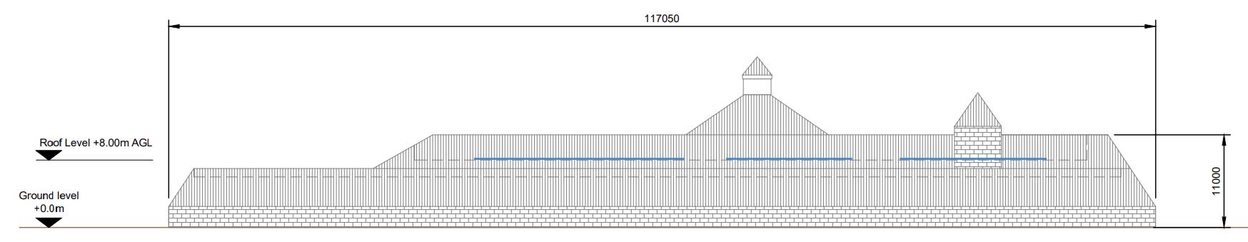
Proposed South Elevation

J.1 (b) the solar PV equipment or solar thermal equipment would be installed on a flat roof, where the highest part of the solar PV equipment would be higher than 1 metre above the highest part of the roof (excluding any chimney).

As per the previous proposed elevations, the panels would be installed in a recessed section of the roof structure and would not exceed 1m in height above the highest part of the roof.

J.1 (c) the solar PV equipment or solar thermal equipment would be installed on a roof and within 1 metre of the external edge of that roof.

The shortest distance of any proposed equipment is 6m to the edge on the western side of the building.

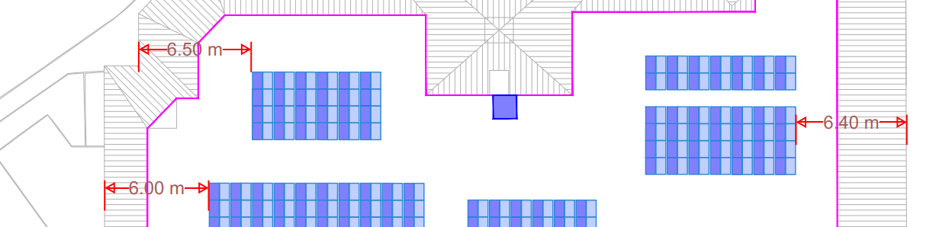
Proposed Site Plan

J.1 (d) was omitted in December 2023.

J.1 (e) the solar PV equipment or solar thermal equipment would be installed on a site designated as a scheduled monument; or J.1 (f) the solar PV equipment or solar thermal equipment would be installed on a listed building or on a building within the curtilage of a listed building.

The site is not a scheduled monument, listed building, or located within the curtilage of a listed building.

Section J.2 concerns development specified under J (a) and (b) and subsequently all sections relate to development affixed to the wall of a building which does not apply to this application.

Section J.4 concerns conditions which apply to these permitted development rights.

J.4 (1) States that development is permitted subject to the conditions (a) the solar PV equipment or solar thermal equipment must, so far as practicable, be sited so as to minimise its effect on the external appearance of the building and the amenity of the area; and (b) the solar PV equipment or solar thermal equipment is removed as soon as reasonably practicable when no longer needed.

Given that the solar equipment is mounted on the recessed flat roof, it is considered that they will be completely hidden from external views of the building. The second point concerning removal is not a matter which needs to be considered at this stage.

J.4 (2) Class J(c) development is permitted subject to the condition that before beginning the development the developer must apply to the local planning authority for a determination as to whether the prior approval of the authority will be required as to the design or external appearance of the development, in particular the impact of glare on occupiers of neighbouring land, and the following sub-paragraphs apply in relation to that application.

This application forms compliance with this condition. The proposed solar array would be installed within a recessed section of the existing roof structure, ensuring that the panels sit below the roofline and remain entirely concealed from public viewpoints and the wider public realm. As a result of this recessed positioning, the development would not give rise to any appreciable visual change to the building’s appearance, nor would it introduce glare or reflective impacts capable of affecting nearby residential properties or adjacent land uses. The proposal is therefore considered to result in no harm in respect of design, appearance, or amenity.

J.4 (3) The application must be accompanied by (a) a written description of the proposed development; (b)
a plan indicating the site and showing the proposed development; (c) the developer's contact address; and (d) the developer's email address if the developer is content to receive communications electronically; together with any fee required to be paid.

This condition is considered to have been complied with by virtue of this application.

J.4 (4) The local planning authority may refuse an application where, in the opinion of the authority (a) the proposed development does not comply with, or (b) the developer has provided insufficient information to enable the authority to establish whether the proposed development complies with, any conditions, limitations or restrictions specified in Class J applicable to the development in question.

Sufficient and proportionate information has been submitted to allow the local planning authority to assess the proposal against all relevant limitations and conditions of Class J. The details provided clearly demonstrate that the development falls within the scope of permitted development, and no elements have been identified that would conflict with the criteria set out in Part 14. The application contains adequate plans, specifications, and descriptions to confirm full compliance, and there are no grounds to conclude that the proposal fails to meet the requirements of Class J or that insufficient information has been supplied.

J.4 (5) Sub-paragraphs (6) and (8) do not apply where a local planning authority refuses an application under sub-paragraph (4) and for the purposes of section 78 (appeals) of the Act such a refusal is to be treated as a refusal of an application for approval.

J.4 (6) The local planning authority must give notice of the proposed development (a) by site display in at least one place on or near the land to which the application relates for not less than 21 days of a notice which (i) describes the proposed development; (ii) provides the address of the proposed development; (iii) specifies the date by which representations are to be received by the local planning authority; or (b) by serving a notice in that form on any adjoining owner or occupier.

The local planning authority has fulfilled its statutory duty to publicise the proposed development by displaying the required site notice for a minimum period of 21 days. The notice set out the nature of the proposed works, identified the site address, and specified the deadline for receipt of any representations. This ensured that all interested parties were afforded a reasonable opportunity to comment. The authority has therefore complied with the publicity requirements of the GPDO, and the consultation process was undertaken in accordance with the provisions of Class J.

J.4 (7) The local planning authority may require the developer to submit such information as the authority may reasonably require in order to determine the application.

No further information has been considered necessary to support this assessment.

J.4 (8) The local planning authority must, when determining an application (a) take into account any representations made to them as a result of any notice given under sub-paragraph (6); and (b) have regard to the National Planning Policy Framework issued by the Ministry of Housing, Communities and Local Government in July 2021, so far as relevant to the subject matter of the prior approval, as if the application were a planning application.

No public representations were received, and Trowbridge Town Council responded to state no objection to the proposed development.

J.4 (9) The development must not begin before the occurrence of one of the following (a) the receipt by the applicant from the local planning authority of a written notice of their determination that such prior approval is not required; (b) the receipt by the applicant from the local planning authority of a written notice giving their prior approval; or (c) the expiry of 56 days following the date on which the application under sub-paragraph (3) was received by the local planning authority without the authority notifying the applicant as to whether prior approval is given or refused.

J.4 (10) The development must be carried out (a) where prior approval is required, in accordance with the details approved by the local planning authority; (b) where prior approval is not required, or where sub-paragraph (9)(c) applies, in accordance with the details provided in the application referred to in sub-paragraph (3), unless the local planning authority and the developer agree otherwise in writing.

J.4 (11) The local planning authority may grant prior approval unconditionally or subject to conditions reasonably related to the subject matter of the prior approval.

J.4 (12) When computing the number of days in paragraph (6)(a), any day which is a public holiday must be disregarded.

CONCLUSION

The proposed development is permitted development and prior approval is not required.

RECOMMENDATION: That prior approval is not required.

