APPLICATION FOR VARIATION OF CONDITION
CASE OFFICER REPORT

APPLICATION REFERENCE: | PL/2026/00080
APPLICATION TYPE: | Removal/variation of conditions
SITE ADDRESS: | Midway Manor, Bradford Road, Wingfield, Bradford On Avon, BA15 2AJ
DEVELOPMENT DESCRIPTION: | Variation of condition 2 (Approved Plans) revised fenestration details relating to application PL/2023/03375.
RECOMMENDATION: | Approve with Conditions

SITE DESCRIPTION/CONTEXT
This application relates to an existing building at Midway Manor, Bradford Road, Wingfield, which has been converted to use as a Café/Restaurant, with ancillary conference space. The change of use was permitted under Class R of the Schedule 2, Part 3 of the Town and Country Planning (General Permitted Development) Order 2015 (PL/2021/08635).

The application site sits within the Bath and Bradford on Avon Special Area of Conservation for bats and sits within the West Wiltshire Green Belt.

PROPOSAL

This report considers a Section 73 application for the variation of condition imposed on planning permission PL/2023/03375 (external adaptations and alterations to building pursuant to Prior Approval PL/2021/08435). The application relates to the site at Midway Manor, Bradford Road, Wingfield, Bradford on Avon, and seeks to vary condition 2 in relation to revisions to the previously consented fenestration.

RELEVANT PLANNING HISTORY

Proposal / Summary
PL/2021/08435 - Prior approval Part 3 Class R: Agricultural buildings to a flexible commercial use Decision - Prior Approval Granted Date: 21/10/2021 – Notification for Prior Approval under Class R for a Change of Use of Existing Agricultural Storage Barn for Use as a Café/ Restaurant with Ancillary Conference Space
PL/2023/03375 - Full planning permission Decision - Approve with Conditions Date: 27/6/2023 – External adaptations and alterations to building pursuant to Prior Approval PL/2021/08435

RELEVANT LEGISLATION, POLICIES AND GUIDANCE

Town and Country Planning Act. 1990 (as amended)
Section 73 of the Town and Country Planning Act. 1990 (as amended) relates to the determination of applications to develop land without compliance with conditions previously attached. It states that:

(2) On such an application the local planning authority shall consider only the question of the conditions subject to which planning permission should be granted, and—

- if they decide that planning permission should be granted subject to conditions differing from those subject to which the previous permission was granted, or that it should be granted unconditionally, they shall grant planning permission accordingly, and

- if they decide that planning permission should be granted subject to the same conditions as those subject to which the previous permission was granted, they shall refuse the application.

The National Planning Practice Guidance (PPG) states the following:

- Nature of the Application: A Section 73 application is treated as a new planning permission, although it does not alter the original permission itself. The original permission remains intact and can still be implemented unless it has expired or been superseded.
- Limitations:
  - Section 73 cannot be used to change the description of development or the operative part of the permission (e.g. the nature or extent of the approved use).
  - It cannot be used to extend the time limit for implementing the original permission.
  - If the proposed changes go beyond what can reasonably be considered under Section 73, a new planning application under Section 70 would be required.
- Decision-making: The local planning authority must consider the application only in relation to the conditions subject to which the original permission was granted. However, it may impose new or revised conditions if granting a new permission.
- Legal Agreements: Because a Section 73 application results in a new permission, any existing Section 106 agreement may need to be varied or replaced via a deed of variation to ensure obligations continue to apply to the new permission.

National Planning Policy:
- National Planning Policy Framework (NPPF)
- Planning Practice Guidance (PPG)
- National Design Guide
Development Plan:
The development plan for Wiltshire comprises the Wiltshire Core Strategy (WCS) (adopted January 2015) and any made neighbourhood plans, which remains the principal statutory planning document guiding development across the county. In line with Section 38(6) of the Planning and Compulsory Purchase Act 2004, planning decisions must be made in accordance with the development plan unless material considerations indicate otherwise.

Though the development plan is considered as a whole, those parts deemed to be particularly relevant to this application are listed below:

The adopted Wiltshire Core Strategy (WCS), with particular regard to:
CP2 - Delivery Strategy
CP7 – Spatial Strategy for the Bradford on Avon Community Area
CP50 – Biodiversity and Geodiversity
CP51 - Landscape
CP57 - Ensuring High Quality Design and Place Shaping

Neighbourhood Plan:
Bradford on Avon Neighbourhood Plan 2013 – 2026 Made October 2017

Supplementary Planning Documents:
Wiltshire Design Guide
National Design Guide

ISSUES

The key considerations in the assessment of this application are as follows:

- Determining whether the proposed amendments fall within the scope of Section 73 of the Town and Country Planning Act 1990 which allows for the variation or removal of conditions attached to an existing planning permission.
- Assessing whether the development, as amended, remains in accordance with the relevant policies and provisions of the development plan, and whether the changes materially alter the nature or impacts of the approved scheme.

CONSULTATION RESPONSES
Wingfield Parish Council: No comments received

REPRESENTATIONS
No comments received

ASSESSMENT
Section 38(6) of the Planning and Compulsory Purchase Act 2004 states:

"If regard is to be had to the development plan for the purposes of any determination to be made under the planning Acts, the determination must be made in accordance with the plan unless material considerations indicate otherwise."

In accordance with this statutory requirement, this application has been assessed against the relevant policies of the Development Plan, including the Wiltshire Core Strategy (2015) and, where applicable, any made Neighbourhood Plans. Consideration has also been given to the policies of the National Planning Policy Framework (NPPF) as a material consideration in the assessment.

Principle of the Development – Do the proposed amendments fall within the scope of s73?

The proposed amendments have been reviewed and are considered to fall within the scope of Section 73 of the Town and Country Planning Act 1990. The changes do not result in a fundamentally different development from that originally approved, nor do they seek to alter the description of development or extend the time limit for implementation. As such, the application is valid under Section 73 and can be determined as a variation of condition 2 attached to the original planning permission.

Material Considerations/Issues
The previously consented application appraised the scheme in terms of Principle of Development and Impact on the Host Building and Character of the Wider Area.
The variation of plans within this subsequent application would only affect the Design and Visual Impact, therefore this will be the only material consideration to be appraised within this report.

Design and Visual Impact
Core Policy 57 requires a high standard of design in all new developments, of particular relevance to householder extensions is paragraph (iii) which requires development to respond positively to the existing townscape and landscape features in terms of building layouts, built form, height, mass, scale, building line, plot size, elevational design, materials, streetscape and rooflines to effectively integrate the building into its setting.

The proposal seeks minor variations to the previously approved fenestration on the north, east and south elevations, with the insertion of four rooflights within the east and west roofscapes. The north elevation will have additional windows inserted on the first floor with a full height glazed panel positioned centrally. The east elevation will have some of the previously approved glazing reduced with the full height panels to the left-hand side and right-hand side of the elevation reduced to four windows. The glazing on the south elevation would also be reduced with the right-hand side full length glazed panel replaced with a large window and the left-hand side full height glazed panel removed entirely. The west elevation would still maintain the absence of any windows however the pedestrian door would be repositioned further to the right-hand side.

The materials would remain as previously approved (metal joinery) and the rooflights would be dark framed to match. The consented timber clad elevations and sheet roofing would remain unchanged. The change to the proposed fenestration detail is illustrated within the plan inserts below.
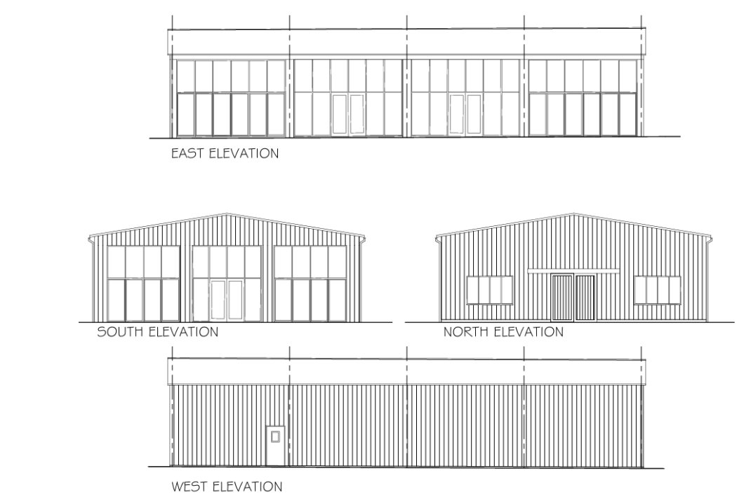
Previously consented elevations (PL/2023/03375)

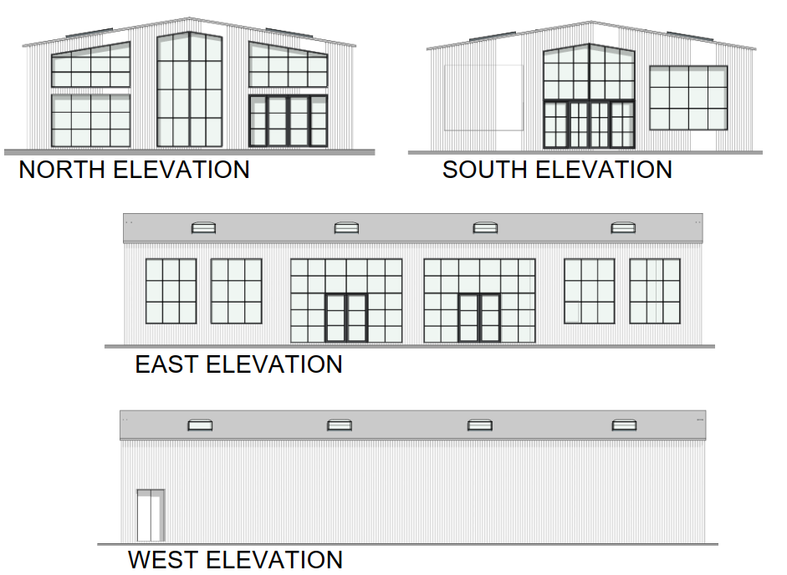
Proposed elevations

The proposal would maintain the contemporary aesthetic that was proposed within the extant permission and maintain the use of natural sustainable materials, which would not appear at odds within the backdrop of the countryside setting. It is considered that the works would by virtue of their height, scale and design constitute complementary additions to the host building that would appear commensurate to the size of the building and plot. The development would therefore comply with Policy CP57 of the WCS.

Assessment of Conditions
The variation of condition 2 of the original permission (PL/2023/08435) in respect of the revised plans is considered acceptable as previously appraised above. The rest will remain as existing.

PLANNING BALANCE AND CONCLUSION
In determining this application under Section 73 of the Town and Country Planning Act 1990, the Local Planning Authority has considered whether the proposed amendments fall within the scope of Section 73. The proposed amendments have been assessed against the relevant policies of the Wiltshire Core Strategy, any applicable Neighbourhood Plan, and the National Planning Policy Framework. The assessment has also considered whether the development, as amended, materially alters the nature or impacts of the approved scheme.

The proposed variation of condition is considered acceptable. The benefits of the proposal, revised fenestration detail, with glazing lessened on some elevations, that would be of benefit to the café/restaurant business, are judged to outweigh any identified harms, which can be appropriately mitigated through planning conditions or other controls. The proposal remains in accordance with the development plan and relevant national guidance, and there are no material considerations that indicate otherwise.

RECOMMENDATION:
That Planning Permission be GRANTED subject to the following conditions

1. The development hereby permitted shall be carried out in accordance with the following approved plans and documents:
Site Location Plan - Received 27.04.2023
Proposed Site Plan DWG No LPC 2892 PR 101 - Received 04.05.2023
Existing Site Plan (LPC 2892 EX 01) - Received 27.04.2023
Existing Elevations (LPC 2892 EX 02) - Received 04.05.2023
Existing Floorplan (LPC 2892 EX 03) - Received 27.04.2023
North & South Elevations DWG No 020_MMB_4_A_00_.1 - Received 06.01.2026
East & West Elevations DWG No 020_MMB_4_A_00_.2 - Received 06.01.2026
Ground Floor Plan DWG No 020_MMB_4_A_00_.3 - Received 06.01.2026

REASON: For the avoidance of doubt and in the interests of proper planning.

