Sash windows at 19 High street – All 6 windows subject to the proposal are of the same construction, age and dimensions.
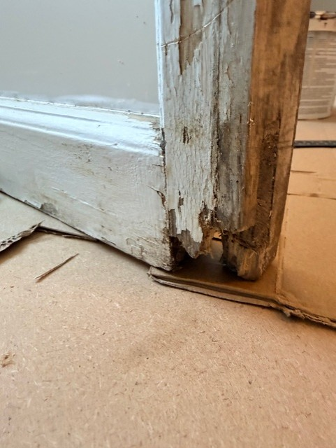
Wet rot decay evident in lower sash of upper floor of former carriage house
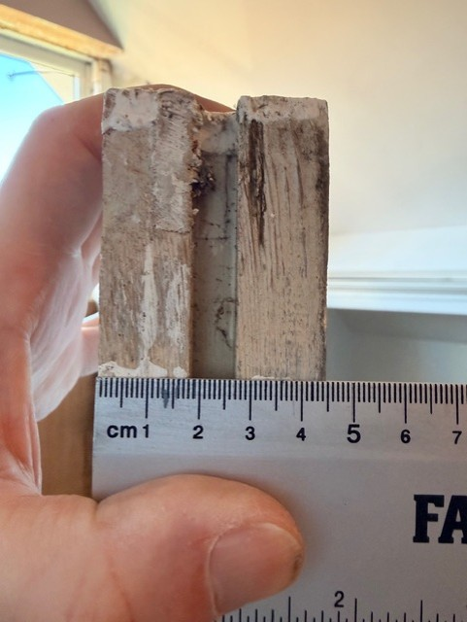
Depth dimension of (all) replacement sash windows
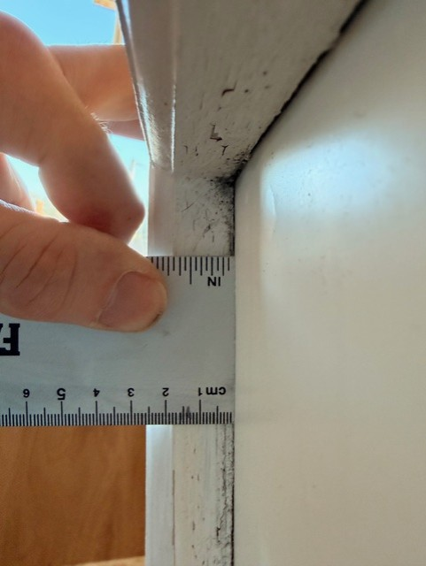
Internal dimension of (all) replacement sash windows. 8mm to be routed out to accommodate new double glazed unis (leaving 16mm intact).

Glazing will be provided by CN Glass https://www.cnglass.co.uk/double-glazing/cn-slim-heritage-double-glazed-units/
CN Slim Heritage double glazed units have the appearance of single glazing, therefore, retaining the character, charm and heritage of the building. Only a very close inspection will reveal the glass to be a double-glazed unit especially if Crown reproduction glass is used.
When glazed traditionally into sash/casement window frames the units are virtually undetectable because slim units do not have the double reflection or the distorted reflection that is seen when you sometimes look at standard double glazing, making them perfectly suitable for conservation or listed buildings. (subject to local planning permissions).
By also using the technical glasses available today and by filling the space between the two panes of glass with an inert gas, a homeowner may gain all the soundproofing benefits of normal double glazing without compromising the appearance or the value of their property. As a FENSA-registered company, our slimline heritage double glazing combines the best in performance and durability to allow for extensive thermal efficiency whilst still maintaining the authentic period aesthetic.
Slimline Double Glazing Key Features
- The thinnest unit is available from 11mm depth
- Slim Sightlines
- Use Planitherm Low E Glass for a warmer house in winter and cooler in summer
- Use restoration Glass
- Use Toughened Glass
- Fill the cavity with an inert Gas for improved acoustic performance
- Low U-Values (Read our FENSA standards document here)
Eco Slim Heritage Double Glazed Units
Our slimline double glazing utilises Super Spacer technology to allow for a minimum depth of 4mm. This means we can produce very thin Double Glazed Units suitable for glazing in conservation areas and listed buildings (subject to planning permission).
It is important to note that sometimes you do have to use Krypton when limited width is available. i.e.: in old buildings for example.
Currently, our CN Slim Heritage Double Glazed Units do not have an associated accreditation to conform to BS EN1279.
We manufacture our Slim Heritage Double Glazed Units to the same standards and processes as our accreditation.
How thick will the glass be?
For a heritage double glazing unit that will fit into a minimum 17mm rebate the outside glass will be 3mm thick and the inside glass 4mm thick this will produce an overall unit of 11mm depth. The glass can be simply clear or patterned annealed/float glass, for security it can be toughened, for improved thermal performance, it can be Low E Energy Saving glass.
For new replica timber windows, the rebate will be slightly deeper allowing for both internal and external glass to be 4mm therefore the overall depth of the unit will be 12mm.
We bed the heritage units on silicone centralising the unit within the frame, fill the void between frame and glass with a low module silicone this allows both movement and a waterproof seal, allowing the silicone to cure and then face putty or use a timber glazing bead to finish.
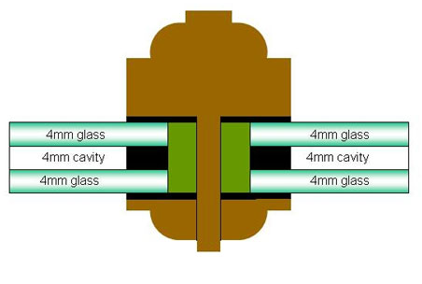
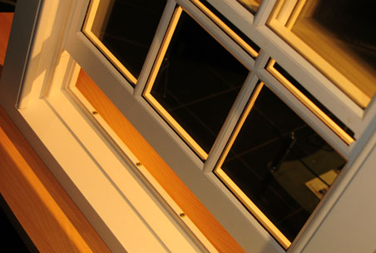
Edgetec Super Spacer®
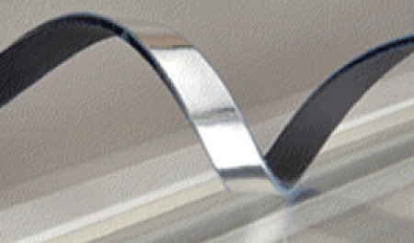
To produce our CN Slim Heritage Double Glazed Units we use Edgetec Super Spacer bar. Edgetec Super Spacer bar introduces no-metal, pre-desiccated, structural foam spacer system that is a warm edge technology to suit all sealed glass unit applications helping to deliver windows of the highest standards.
Super Spacer® bar is produced down to a minimum of 4mm, therefore, our CN Slim Heritage units may be produced with a minimum overall depth of 11mm this means it will fit a 17mm rebate.
Traditional timber windows are glazed with low sightlines. This creates problems for standard aluminium spacer bars which protrude into the sightline of the Heritage window. Edgetec Super Spacer is just 3mm in depth, designed for slim sightlines.
By utilising the award-winning patented Thermal Set Spacer (TSS) technology, our heritage double glazing offers the best in high-performance spacer systems. Super Spacer has 100% memory and allows for expansion and contraction, a major cause of fractures in conventional sealed units.
With Super Spacer® thermal bridging is all but eliminated, resulting in a massive 70% reduction in condensation.
Most of the heat loss through a window occurs at the edge of the unit, Super Spacer® blocks this escape route.
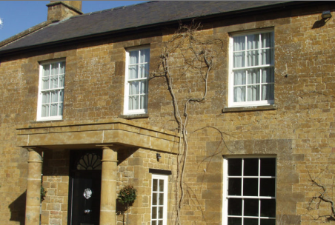
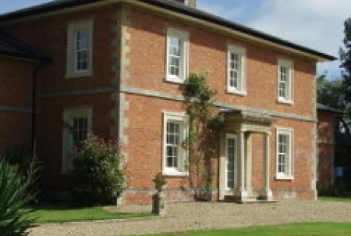
Gas-filled Units - Argon & Krypton
The introduction of gas into the cavity of a slimline double glazed unit reduces the heat conductance between the panes, helping to keep more heat in during the winter and out in the summer. As a result, living and working conditions become more comfortable the whole year-round. The combination of Argon Gas and Low E energy saving glass can achieve an improvement in thermal performance in the region of 50% over and above that of a standard sealed unit.
Argon, which has 34% lower thermal conductivity than air, is the most commonly used. Apart from its heat insulation properties, Argon is non-toxic, sunlight stable, non-corrosive, colourless and odourless.
Although argon-filled units cost around 5% more than air-filled units, they can improve a heritage double glazing window’s U value or energy rating by over 30%. Argon fillings should last the lifetime of a double glazing window and over a period of 25 years should not lose more than 5%.
Krypton is even more energy-efficient than Argon but are seldom used in double glazing windows as they are more expensive.
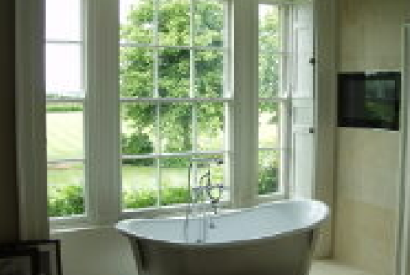
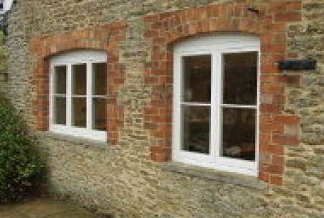
U-Values (the term used to measure thermal efficiency)
A U value is a measure of heat loss in a building element, therefore, it is the measurement of the whole window and not just the glass. It can also be referred to as an ‘overall heat transfer coefficient’ and measures how well parts of a building transfer heat. This means that the higher the U value the less efficient the thermal performance of the building element. A low U value usually indicates higher levels of insulation.
The thermal efficiency benefits of C N Slim Heritage Double Glazed Units over single glass can be seen below:
Single Glass – U-Value ….is approx. 5.6 W/m2K
The benefits of CN Slim Heritage Double Glazing
Single Glass – U-Value ….is approx. 5.6 W/m2K
Glass 1 (External) | Cavity | Glass 2 (Internal) | Centre Pane U-Value
4mm Float/Toughened | 4mm Krypton Filled | 4mm Planitherm Total Plus Low E | 1.9W/m2K

