Project:

To obtain listed building consent to reglaze six existing (non original) sash windows with slimline double glazing.

Application:

Over the years, a number of planning and listed building applications have been submitted for the nearby properties, as well as some for this site.

The most notable is the approved application for a detached garage (Application W/84/00723/FUL) on the 17.07.1984. There has also been a number of window replacement and repair applications, such as approved application W/89/00734/LBC dated 27.06.1989 and approved application W/04/00340/LBC dated 30.03.2004. Other works include repair work to the roof under approved application W/11/02034/LBC dated 13.09.2011.

It is also worth noting that more recently applications for kitchen relocation under application PL/2024/05056 and replacement ground floor structure under application PL/2024/05059 have both been withdrawn and are to be resubmitted again with new information. The kitchen replacement is covered under this application.

The Building in its Environment

The site is located on the high street in Steeple Ashton near Trowbridge on the road linked to Common Hill and Edington Road, which then links to the A350 between Melksham and Westbury.

The village is fortunate to have a range of transport facilities provided by public transport, which can then be used to provide access to the nearest train station in Westbury.

19 High Street is a Grade II listed building, with other listed buildings around it. The listing for 19 High Street can be found in Appendix A, but a brief description of the listing is as follows:

‘Detached house. Circa 1830. Limestone ashlar, double Roman tiled roof, cropped gable end stone stacks and coped verges. Two-storey, 2-window. Central 6-panelled door in Ionic portico with balustraded parapet, 4-pane sash either side. Plat band to first, floor; two 4-pane sashes. Right return has 4 -pane sash to right, 16 pane sash to first floor. Rear former carriage house, now kitchen with casement inserted into former large opening, 4-pane first floor sash. The Baptist Chapel until mid C20.’

In the current Local Plan (North Wiltshire Local Plan), 19 High Street is located in a ‘Conservation Area’ as shown in Image 2, but is not in an Area of Outstanding Natural Beauty. However, there is a scheduled monument to the front or property as shown in Image 3.

Image 2 shows that 19 High Street is within the Conservation Area (blue hatching)
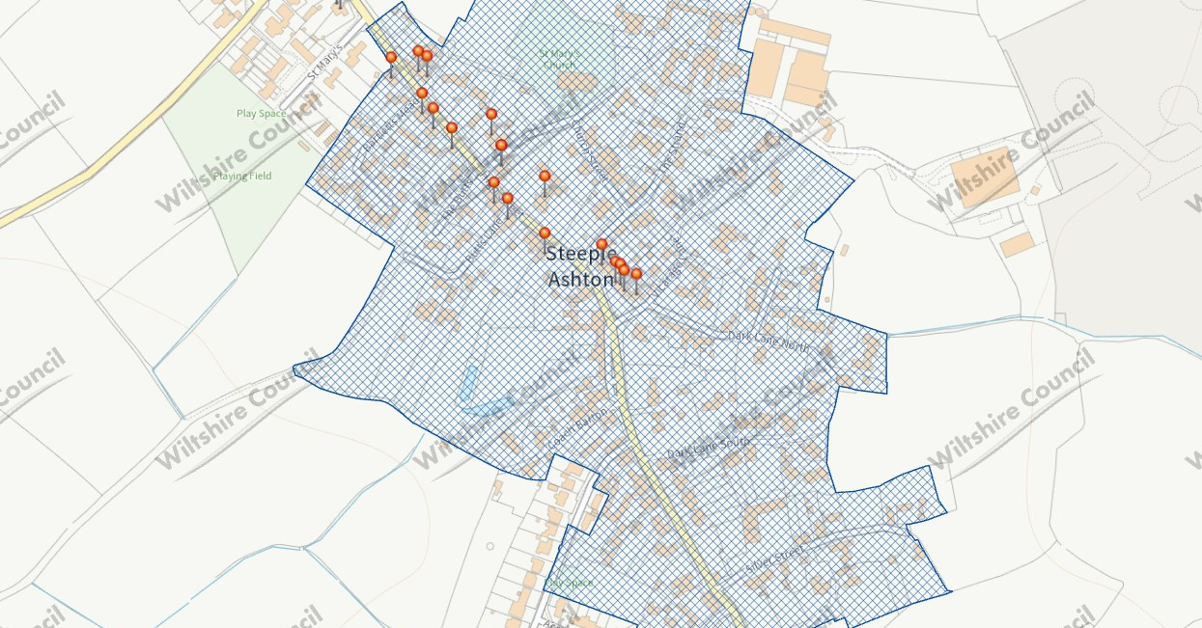

Image 3 shows that there is a scheduled monument to the front of the building - Purple hatch. The Market Cross is a Grade II listed monument and its listing can be found in Appendix B

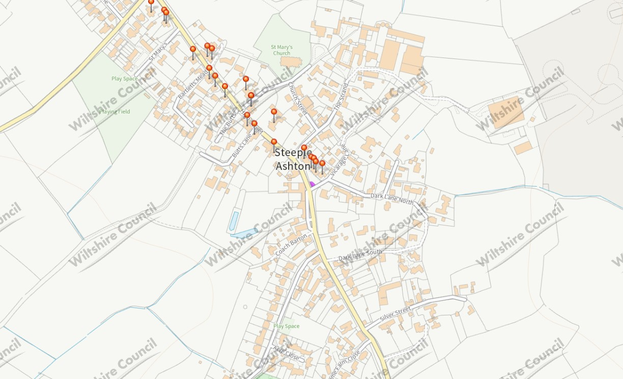

It is also noted that there are no Tree Preservation Orders (TPO) on the site as per Image 4, but there is to the rear of the site.

Image 4 shows that 19 High Street has no Tree Preservation Orders on site (Green hatching)
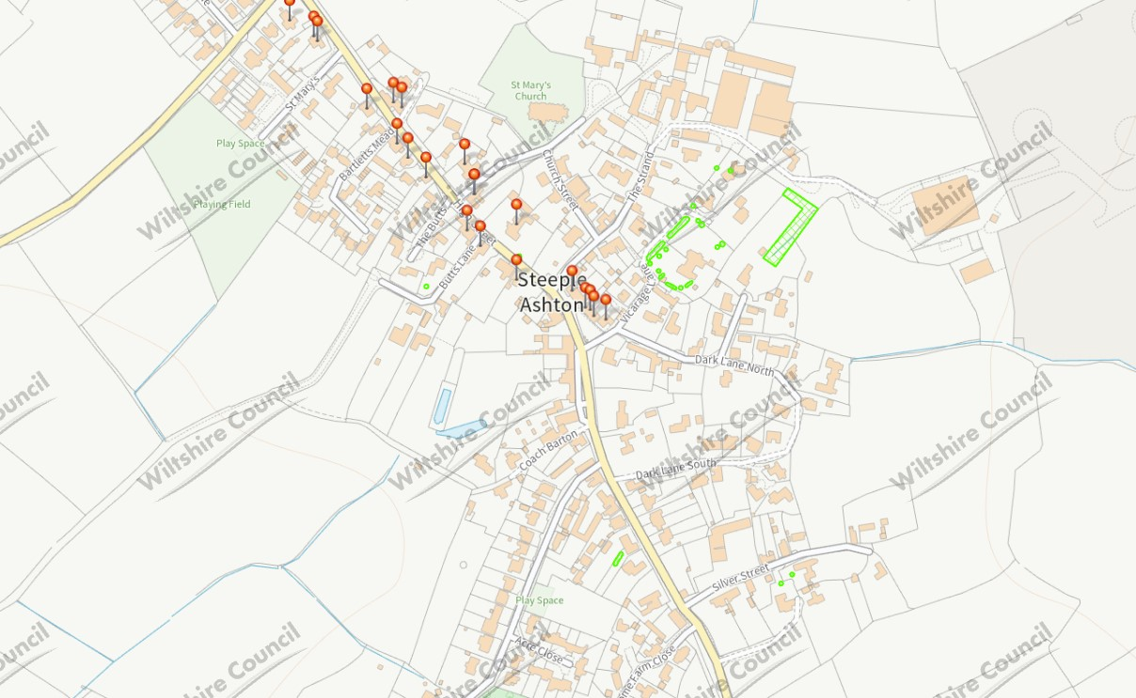

Having reviewed the planning website it appears that none of the nearby buildings that are listed will have their settings affected by the proposed scheme, including 19 High Street itself.

Image 2 shows the location of the listed buildings near the proposed site. (Black stripe hatching)
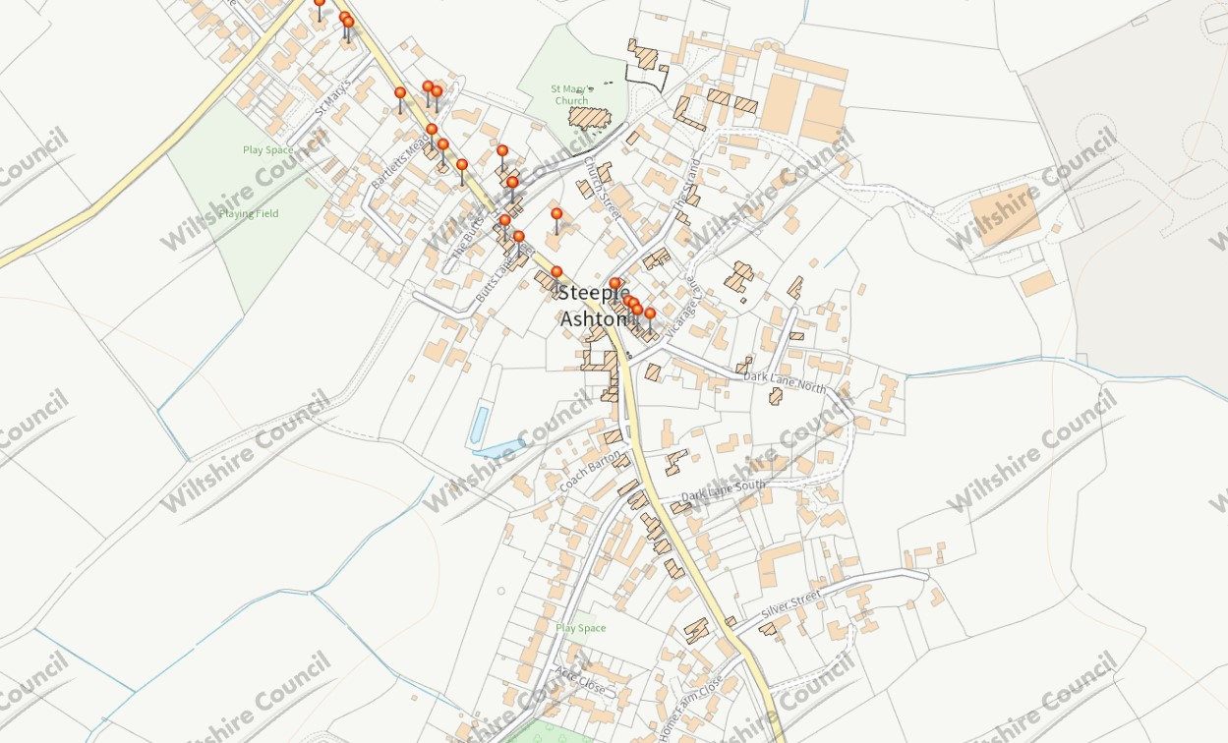

As per the Environment Agency maps 19 High Street is located in a flood risk zone 1 area. Refer to below image.

Image 4 shows the flood risk zone for 19 High Street
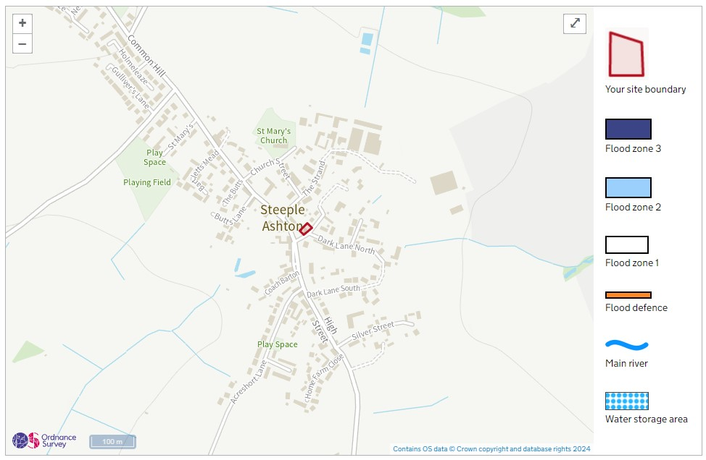

The Area Affected by the Proposal

The building is a detached-linked two storey period building with later additions that include a single storey extension to rear of the property referred to as the carriage house that has been converted into habitable space and current kitchen and utility area with reception room. The material of the building consists of ashlar stone facing to the front and side elevation and boundary walls, (which also has iron railings) with painted masonry to the rear carriage house. The roof is double Roman tiles with stone coping stones to the front building only.

The property is in a very poor state of repair and requires modernising that can become a more sustainable family home which meets current and future family requirements.

The existing single storey carriage house to the rear of the property is of an older age, but not original to the building, but does still have historic merit although not as much as the main house itself. Refer to photograph 2 and 3

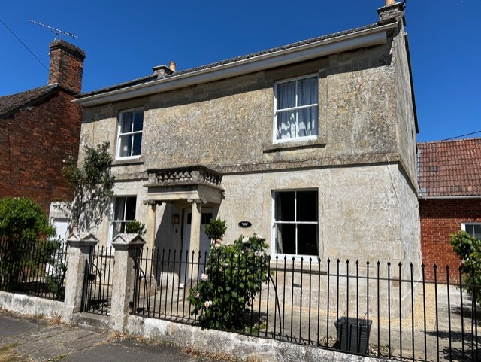

Photograph 1 – Front elevation of 19 High Street with the Carriage House to the rear with brick and masonry finish.

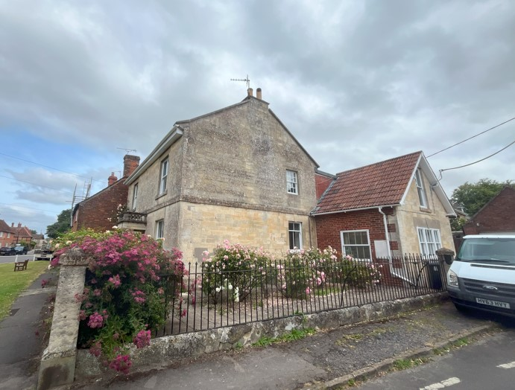

Photograph 2 – Side elevation of 19 High Street with the Carriage House to the rear with brick and masonry finish.

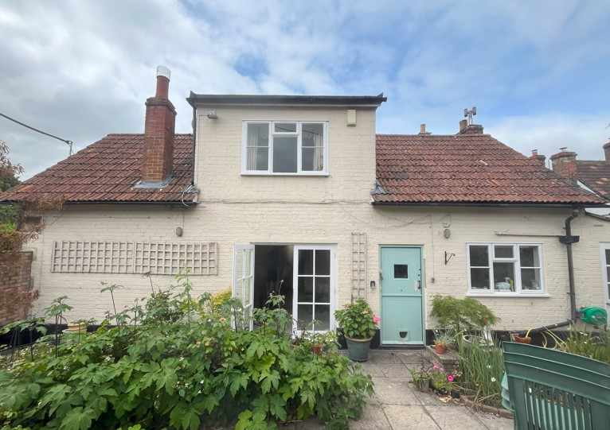

Photograph 3 – Rear elevation of 19 High Street

As noted in the planning application history section, approved applications have requested the replacement and repair of some of the existing windows. All the windows are timber, but most are modern and not original to the building. This includes the 4 sash window to the front elevation of the main house as shown in photograph 1, and the two sash windows to the side of the carriage house as shown in photograph 4

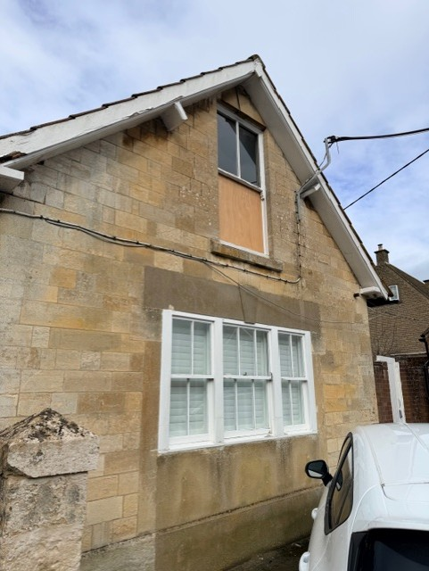

Photograph 4 – Side elevation of the rear former carriage house at 19 High Street

Reglazing of windows is proposed only to the four sash windows on the front elevation shown in photograph 1 and the two sash windows to the side of the former carriage house shown in photograph 4.

Other listed buildings and their settings will not be affected by the proposed works.

It is also worth noting that stated in the Wiltshire and Swindon Historic Environment Records that the village is stated to have Saxon origins (refer to Appendix 3) and there is a scheduled monument in front of the building that is Grade II listed and referred to as the Market Cross. Again, neither of these scheduled monuments are affected by the proposed works.

Statement of Need

The existing windows are in various states or disrepair. While some appear to be virtually intact, others are showing sign of wood decay and rot. All require urgent maintenance.

This proposal affects 8 windows: the 4 sash windows shown in photograph 1, and the 4 sash windows shown in photograph 5.

Feature | Description | Significance | Proposed Works | Possible Impact | Justification
All windows specified in the Statement of Need above. | Non-original (replacement date unknown) single glazed timber sash windows. | Low | New double-glazed units to replace existing single glass panes. Repairs required to some of the woodwork. None of the window frames or sashes will be replaced.  All windows prepared, primed and painted with cream-white (RAL 9001) premium oil-based exterior paint for woodwork. | Loss of existing non-original fabric. | Poor thermal insulation, security and sound insulation properties. Existing inherent condensation problems is causing damage/rot to both upper and lower sashes

The Proposals

The proposal is modest and takes consideration of the style, integrity and age of the existing main house. There is no material impact on the existing building. Furthermore, the proposed works will not have an impact on the neighbours or their properties.

NPPF does state as a core principle that any design should ensure a good standard of amenity for all existing and future users of the building. Ensuring the windows are sound and retain as much of the oil-based generated heating as possible is imperative.

Overall, the proposed work will provide a high standard of design that is maintained in keeping the appearance, character and environmentally quality of the existing building. It is important to note that the street scene and other various views will not be affected by the proposed work.

The proposed work is as per the following categories:

The Proposed Development

- Replace the existing glass (single) panes with 'slimline' 12mm (4+4+4) dbl glazed units.
- To accommodate the new dbl glazed units, 8mm will need to be routed from existing sash apertures.
- At the same time, all rotten material will be removed. Affected areas will be repaired and the entire woodwork will be primed and painted.

Appendix 1

Appendix 1 – Listing of 19 High Street

Appendix 2

Appendix 2 – Listing of The Market Cross

Appendix 3

Appendix 3 – Wiltshire and Swindon Historic Environment Records Saxon Village

Appendix 4

Appendix 4 – Wiltshire and Swindon Historic Environment Records The Market Cross

