APPLICATION FOR FULL-PLANNING PERMISSION (SOLAR FARM)
DELEGATED REPORT

APPLICATION REFERENCE: | PL/2025/09795
APPLICATION TYPE: | Full planning permission
SITE ADDRESS: | Berhills Farm, Berhills Lane, Seend, Melksham, SN12 6RR
DEVELOPMENT DESCRIPTION: | New PV array and associated hedging and stock fencing to form enclosure
RECOMMENDATION: | That Planning Permission be GRANTED

PROPOSAL

This is a full planning application for “New PV array and associated hedging and stock fencing to form enclosure” at Berhills Farm, Berhills Lane, Seend, Melksham, SN12 6RR.

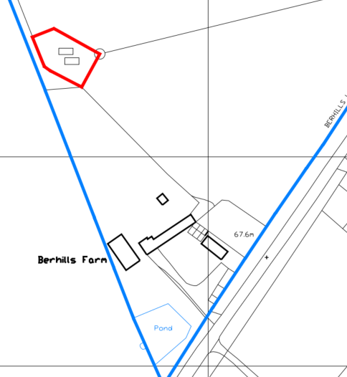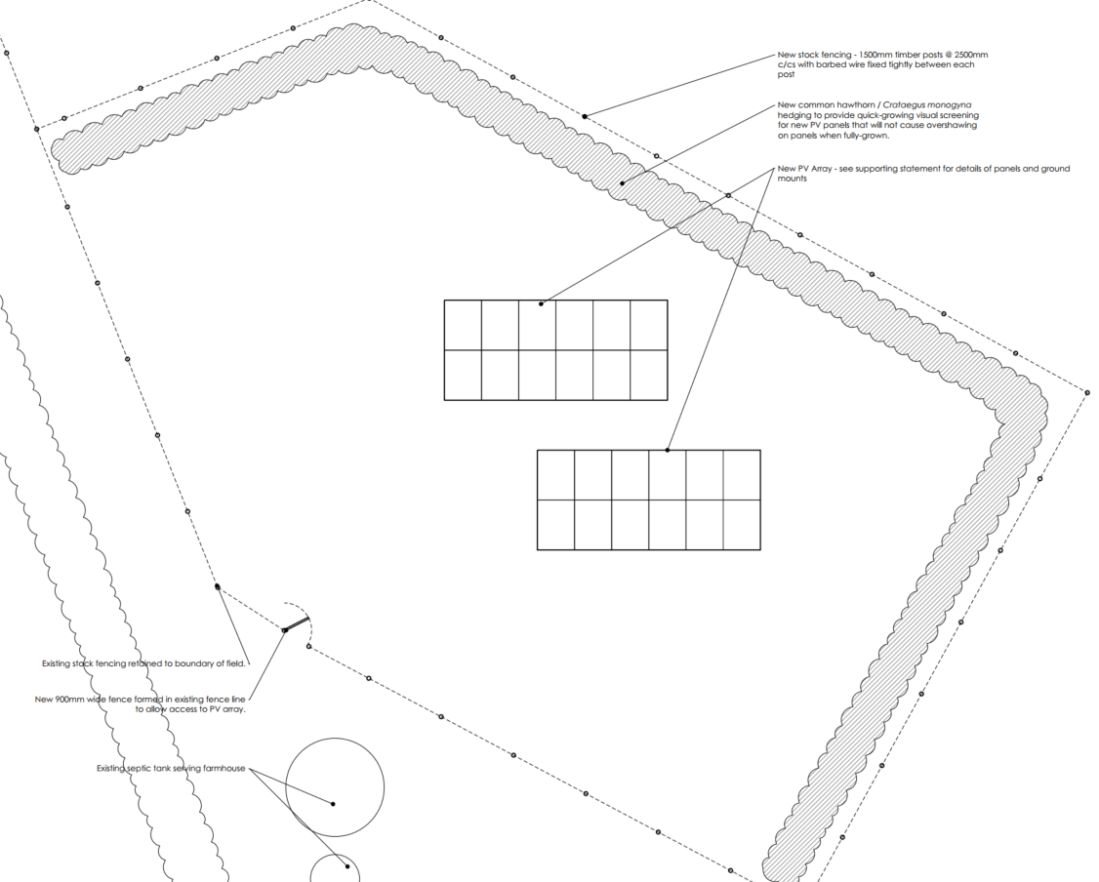

Site Location Plan and Block Plan

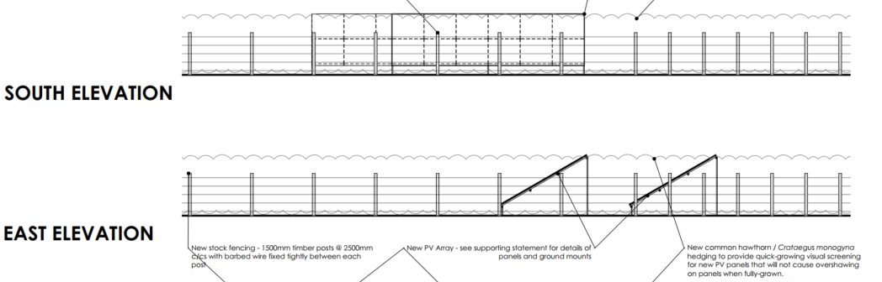

South and East Elevations

There would be two arrays each comprising 12 panels (24 panels in total). The arrays would be fixed to the ground using ground anchors (and not a concrete base). The panels would be at a 30-degree angle and have a maximum height of circa 2.15m.

The panels would be enclosed by a new 1.5m high stock fence, with a common hawthorn/Crataegus Monogyna hedge behind.

SITE DESCRIPTION/CONTEXT

Berhills Farmhouse is a Grade II listed building where its listed description states;

“Farmhouse, C1800, red brick with plain tile half-hipped roof and ridge stack. Rubble stone end and rear walls. Two storeys and garret. Front has ashlar plinth and two string courses, raised brick eaves and 2-window range of 4-pane sashes with gauged brick heads and stone sills. C19 door to right in flush ashlar surround with hood on brackets. Rubble stone rear lean-to, raised in C20. Interior is not of special interest, Stair rebuilt. Roof re-raftered in 1930's but retains original principal rafters and staggered purlins.”

The red outline (which only comprises of 0.03 hectares) is not within the residential curtilage of the farmhouse and is within a larger agricultural field which is approximately 3.1 hectares. The applicants have also sought to utilise a small wooded area as a boundary to locate the proposal and use the existing trees and hedge as a visual screen.

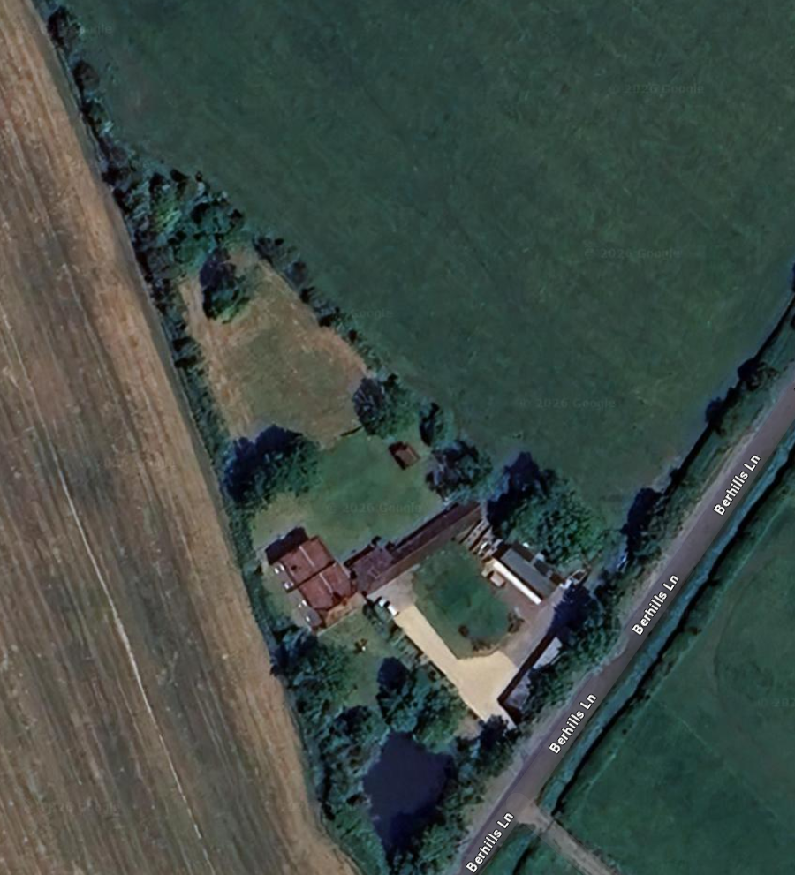

Aerial Image of the site and the Farmhouse below

The land is understood to be Grade 3 agricultural Land although it is not known whether this is grade 3a or 3b.

The closest Public Right of Way is SEEN55, which is approximately 255m to the north. The site is within Flood Zone 1 and is not subject to surface or ground water flood risk. There are no other ecology or landscape designations.

PLANNING HISTORY

There have been a number of planning and listed building applications at Berhills Farm but none relate or are relevant to a solar array in its adjacent agricultural fields.

RELEVANT LEGISLATION, POLICIES AND GUIDANCE

Statutory Legislation:

National Planning Policy:

- National Planning Policy Framework (NPPF)
- Planning Practice Guidance (PPG)
- National Design Guide
Development Plan:

The development plan for Wiltshire comprises the Wiltshire Core Strategy (WCS) (adopted January 2015) and any made neighbourhood plans, which remains the principal statutory planning document guiding development across the county. In line with Section 38(6) of the Planning and Compulsory Purchase Act 2004, planning decisions must be made in accordance with the development plan unless material considerations indicate otherwise.

Though the development plan is considered as a whole, those parts deemed to be particularly relevant to this application are listed below:

The adopted Wiltshire Core Strategy (WCS), with particular regard to:

- Core Policy 1 Settlement Strategy;
- Core Policy 2 Delivery Strategy;
- Core Policy 15 Spatial Strategy Melksham Community Area
- Core Policy 42 Standalone Renewable Energy Installations;
- Core Policy 50 Biodiversity and Geodiversity;
- Core Policy 51 Landscape
- Core Policy 57 Ensuring High Quality Design and Place Shaping;
- Core Policy 58 Ensuring the Conservation of the Historic Environment;

Neighbourhood Plan: Seend Neighbourhood Plan 2021 – SP4 Landscape and Local Key Views

Other Relevant Documents:

- Wiltshire Biodiversity Action Plan (2008) (BAP)
- Wiltshire Design Guide (adopted April 2024)
- Wiltshire Infrastructure Delivery Plan 3 (2011-2026)
- Wiltshire Climate Strategy (2022-2027)

KEY ISSUES

- Principle of the Development
Assessment against national and local policy support for renewable energy, including CP42 of the Wiltshire Core Strategy and the NPPF.
- Impact on Heritage Assets
Consideration of direct or indirect effects on listed buildings, conservation areas, and their settings, in line with Sections 66 and 72 of the Planning (Listed Buildings and Conservation Areas) Act 1990.
- Archaeology
Assessment of the potential for archaeological interest on the site and the need for mitigation or further investigation, in consultation with the Council’s archaeology team.
- Landscape and Visual Impact
Assessment of effects on landscape character and views, including cumulative impacts with other nearby solar developments.
- Loss of Best and Most Versatile (BMV) Agricultural Land
Consideration of the site’s Agricultural Land Classification and the implications of using Grades 1, 2, or 3a land, in accordance with the NPPF and Written Ministerial Statements.
- Neighbour Amenity
Consideration of potential impacts on residential amenity, including outlook, noise, glint and glare.
- Highway Safety and Access
Review of the Construction Traffic Management Plan, access arrangements, and anticipated vehicle movements during construction and decommissioning.
- Ecology and Biodiversity
Assessment of submitted ecological surveys, biodiversity net gain, and mitigation/enhancement measures in accordance with Policy CP50 and the Environment Act 2021.

CONSULTATION RESPONSES

Seend Parish Council: No comments received

Wiltshire Council Public Protection – No comments received

REPRESENTATIONS

In accordance with the requirements of the Town and Country Planning (Development Management Procedure) (England) Order 2015 (as amended), the application was publicised by way of:

- Neighbour notification letters sent to adjoining and nearby properties;
- A site notice displayed at the entrance to the site

These methods were used to inform interested parties and provide a period of 21 days for comments to be submitted.

No comments were received.

ASSESSMENT

Solar farms form part of the UK’s strategy to reduce carbon emissions and transition towards cleaner, more sustainable sources of energy. As the impacts of climate change become more pressing, renewable energy developments like solar farms play an increasingly important role in helping to meet national and local carbon reduction targets. Wiltshire Council has committed to becoming carbon neutral by 2030, and national planning policy encourages local authorities to support renewable energy projects where the impacts are, or can be made, acceptable. However, the need for clean energy must be balanced with other important considerations such as protecting landscape character, heritage assets, local amenity, agricultural land, and biodiversity. This section of the report provides a detailed assessment of the relevant planning issues, including how the proposed solar farm aligns with local and national policy objectives, and whether its impacts are acceptable when weighed against the wider environmental benefits of the scheme.

Section 38(6) of the Planning and Compulsory Purchase Act 2004 states:

"If regard is to be had to the development plan for the purposes of any determination to be made under the planning Acts, the determination must be made in accordance with the plan unless material considerations indicate otherwise."

In accordance with this statutory requirement, this application has been assessed against the relevant policies of the Development Plan, including the Wiltshire Core Strategy (2015) and, where applicable, any made Neighbourhood Plans. Consideration has also been given to the policies of the National Planning Policy Framework (NPPF) as a material consideration in the assessment.

Principle of Development

Paragraph 165 of the National Planning Policy Framework (NPPF) encourages local plans to support the increase in the use and supply of renewable and low-carbon energy, while ensuring that any adverse impacts are appropriately addressed.

Paragraph 168 of the NPPF confirms that applicants are not required to demonstrate the overall need for renewable or low-carbon energy. Instead, local planning authorities are expected to approve such schemes if their impacts are (or can be made) acceptable, in accordance with national policy.

In line with this national direction, Wiltshire Council has committed to becoming carbon neutral by 2030. This ambition is embedded within the Wiltshire Climate Strategy, which identifies renewable energy generation as a key priority for the efficient and environmentally responsible use of land, in support of a growing population and biodiversity.

At the local level, Core Policies CP1 and CP2 of the Wiltshire Core Strategy (WCS) set out the spatial strategy for sustainable development in the county. While the proposal does not directly deliver housing or employment development, it represents a form of sustainable development, supporting Wiltshire's transition to a low-carbon economy. The development may also deliver short-term employment opportunities during the construction phase.

Core Policy 42 of the WCS provides specific policy support for standalone renewable energy schemes, stating that such proposals will be supported where it is demonstrated that individual and cumulative impacts have been satisfactorily addressed. The policy identifies the following considerations as particularly relevant (in the context of this proposal):

- The landscape, particularly in and around AONBs
- Biodiversity
- The historic environment including the Stonehenge and Avebury World Heritage Site and its setting
- Residential amenity, including noise, odour, visual amenity and safety
- Best and most versatile agricultural land.

As a matter of principle, the development of a solar farm is supported where it can be demonstrated that the proposal will not result in unacceptable impacts, or that any identified impacts can be suitably mitigated. A detailed assessment of the proposal against the relevant criteria of CP42—including landscape, heritage, biodiversity, residential amenity, and agricultural land quality—is provided in the following sections of this report.

Best and most versatile agricultural Land

The National Policy Statement (NPS) for Energy, published in January 2024, is a material consideration in the determination of planning applications under the Town and Country Planning Act 1990. The NPS is relevant to both nationally significant infrastructure projects (NSIPs) and smaller-scale renewable energy proposals considered at the local level.

In May 2024, a Written Ministerial Statement (WMS) by the Secretary of State for Energy Security and Net Zero provided further guidance on balancing national priorities for energy security and food production. The WMS states:

“Due weight needs to be given to the proposed use of Best and Most Versatile land when considering whether planning consent should be granted for solar developments. For all applicants the highest quality agricultural land is least appropriate for solar development and as the land grade increases, there is a greater onus on developers to show that the use of higher quality land is necessary.”

Both the NPPF and the NPS define Best and Most Versatile (BMV) agricultural land as land falling within Grades 1, 2, and 3a of the Agricultural Land Classification.

Footnote 65 of the NPPF reinforces this approach, stating:

“Where significant development of agricultural land is demonstrated to be necessary, areas of poorer quality land should be preferred to those of a higher quality.”

Further guidance is provided in the Planning Practice Guidance (PPG), Paragraph 013 (ID: 5-013-20150327), which advises that:

- Local planning authorities should encourage the use of previously developed and non-agricultural land for large-scale solar farms.
- Solar farms are typically temporary structures, and planning conditions can be used to secure the removal of infrastructure once it is no longer in use and restoration of the land to its previous condition.

At the local level, Core Policy 42 (criterion viii) of the Wiltshire Core Strategy requires that proposals for standalone renewable energy schemes demonstrate that the impact on Best and Most Versatile agricultural land has been satisfactorily considered.

In addition, the Wiltshire Climate Strategy (2022–2027) identifies as a key objective:

“The efficient and environmentally sensitive use of land, providing for the needs of an increasing population and nature; food production, renewable energy generation, housing and transport, alongside woodland creation and nature recovery.”

Agricultural Land Classification strategic maps show the likelihood of BMV land and identify the site as likely to have an ALC of Grade 3 (but unknown whether a or b) however, Natural England’s explanatory note on ALC strategic scale maps is clear that the gradings are predictions and that the map is “intended for strategic planning purposes only, is not suitable for use below scale 1:250,000 or for the definitive classification of any local area of site.”

In line with national planning guidance, the use of previously developed land and non-agricultural land should be prioritised for the development of ground-mounted solar farms. However, it is recognised that across Wiltshire, there is a limited supply of previously developed or non-agricultural land of sufficient scale that is not already in active alternative use and capable of accommodating large-scale solar installations.

The proposal would only have a site area of 0.03 hectares representing less than 1% of the agricultural field the site is part of. The site could return to agriculture once the solar panels are no longer needed meaning that the agricultural land will not be lost in the long term. In this context, it is not considered that there would be any harm by loss of the best and most versatile agricultural land, even it were found to be grade 3a.

Cumulative Impact

In addition to providing updated guidance on the use of best and most versatile agricultural land, the Written Ministerial Statement (WMS) issued in May 2024 also provides direction on the need to assess cumulative impacts of solar energy developments. It states:

“[…] we are increasingly seeing geographical clustering of proposed solar developments in some rural areas. […] When considering whether planning consent should be granted for solar development it is important to consider not just the impacts of individual proposals, but also whether there are cumulative impacts where several proposals come forward in the same locality.”

This reflects a growing national and local concern about the spatial concentration of solar farms and associated infrastructure in certain rural areas.

At its Full Council meeting on 21 May 2024 Wiltshire Council supported a motion (Motion No. 2024-03 – Solar Farms) calling for greater clarity on national policy regarding the distribution and cumulative assessment of solar development. The motion stated:

“[…] this Council is increasingly concerned at the concentration of solar farms, battery storage and associated infrastructure in Wiltshire. Some villages are now completely surrounded by solar farms and their continued concentration represents a significant cumulative impact and industrialisation of the countryside.
Wiltshire Council therefore calls on the Secretary of State for the Department of Levelling Up, Housing and Communities to define more closely what is meant by ‘cumulative impact’ regarding solar farms and to take clear steps to ensure that solar developments are more evenly spread across the UK […]”

While no further central government guidance has yet been issued in response to this motion, and although the WMS stops short of defining cumulative impact in detail, national planning policy continues to emphasise the importance of balancing the need for clean energy investment with appropriate environmental and spatial safeguards. The Autumn Budget (30 October 2024) also reiterated the Government’s commitment to supporting clean energy technologies, which remains an important material consideration.

Within this context, officers have considered the potential cumulative landscape and visual effects of this proposal, including its relationship with other solar and battery storage developments in the surrounding area.

Policy CP42 of the Wiltshire Core Strategy explicitly requires consideration of cumulative effects when determining proposals for standalone renewable energy installations.

The Planning Practice Guidance (PPG) provides additional context, stating:

- Cumulative landscape impacts refer to the effects on the character, fabric, and quality of the landscape, and whether the proposed development would become a dominant or defining feature.
- Cumulative visual impacts relate to the degree to which the development would be seen from the same viewpoints or along the same journey as other installations, and the resulting effect on visual amenity for those experiencing the landscape.

Although the term “locality” as used in the Written Ministerial Statement (WMS) is not formally defined, Wiltshire Council’s motion of 21 May 2024 highlights that multiple solar farm proposals within or surrounding the same village can collectively alter the local character and setting. This interpretation supports a more nuanced and locally responsive assessment of cumulative impact.

While technical assessments submitted with this application may cover a broader geographical area, officers consider that a radius of 2.5km from the edge of the application site represents a reasonable and proportionate study area for evaluating cumulative landscape and visual impacts in the wider countryside.

For the purposes of this report, officers therefore interpret “locality” as follows:
- For **village setting and “Sites in close proximity to the proposal, or within the same settlement or neighbourhood.”
- For countryside setting and broader landscape impact: “Sites located within a 2.5km radius of the application site boundary.”

This interpretation ensures a consistent and robust approach to the assessment of cumulative impacts in line with Policy CP42 of the Wiltshire Core Strategy and national guidance.

Officers duly acknowledge that there are three nearby solar scheme of various scales within 1.7km of the application site but given the very small size of this application it is not considered that this proposal would have any cumulative impact on the landscape. The site is set a fair distance back from the main road and would be enclosed by existing and proposed hedgerows.

Archaeology and Heritage

Section 66(1) of the Planning (Listed Buildings and Conservation Areas) Act 1990 places a statutory duty on decision-makers to have special regard to the desirability of preserving a listed building or its setting, or any features of special architectural or historic interest which it possesses. Similarly, Section 72(1) of the same Act requires local planning authorities to pay special attention to the desirability of preserving or enhancing the character or appearance of conservation areas when exercising their planning functions. This duty is further supported by Part 1 of the Historic Buildings and Ancient Monuments Act 1953.

Relevant national policy is set out in Chapter 16 of the National Planning Policy Framework (NPPF), which provides guidance on conserving and enhancing the historic environment. Paragraphs 212 to 221 specifically address how local planning authorities should assess and balance the potential impacts of development on heritage assets, including their settings.

At the local level, Policy CP42 (v) of the Wiltshire Core Strategy (WCS) requires standalone renewable energy proposals to demonstrate that impacts on the historic environment, including the setting of heritage assets, have been appropriately considered. In addition:

- Policy CP57 promotes high-quality design and place-shaping for all new development, with criterion (iv) requiring proposals to be sympathetic to and to conserve historic buildings and historic landscapes.
- Policy CP58 provides further protection, requiring development to protect, conserve, and where possible enhance the historic environment of Wiltshire.
These combined national and local requirements form a robust framework for ensuring that solar farm developments are appropriately assessed in terms of their potential impact on the historic environment.

Historic England’s Advice note 15 relates to Commercial Renewable Energy Development and the Historic Environment, paragraph 53 advises the following:
“When informed by relevant assessments, the design of a scheme can help to mitigate the visual impact of a proposal, for example through the use of landscape bunds or tree planting. This is likely to be particularly important in areas known and valued for their historic character, such as conservation areas, registered parks and gardens or registered battlefields. However, such measures need very careful consideration as they are not appropriate in all situations. Bunds, for instance, can themselves be intrusive features in the setting of a heritage asset. Any proposed landscape mitigation needs to be appropriately visualised and presented in the visual impact assessment. […]”
Historic England’s Advice note 17 relates to Planning and Archaeology, paragraph 43 advises the following summarised point:
“In dealing with applications for planning permission, there are a range of activities relating to archaeology which are usually carried out by planning officers:
- Agree and implement a consultation procedure with their archaeological advisers.
- Validate the application ensuring that it meets local requirements.
- Consult Historic England (when required).
- Ensure sufficient information is available to make an informed planning decision […]
- Take advice from archaeological advisers before discharging conditions.
- Take action if conditions are no being complied with.

The proposal would be approximately 80m from the grade II listed building. The panels would only be 2.3m high (thereby only 30cm higher than an enclosure that could be erected under permitted development rights) and would utilise existing landscaping as a mitigation screen (in addition to proposed landscaping).

Settings of listed farmhouses often extend into their surrounding countryside as does the setting of Berhills Farmhouse, meaning that the proposal would cause ‘less than substantial’ harm to the setting of the listed building. However, it is considered that due to the small scale of the proposal and its distance from the listed building this would be at the very lowest end on the scale of harm. Therefore under NPPF paragraph 215 this limited harm is weighed against the public benefits of the proposal.

Whilst the benefits would be of a private nature to the applicants, there would be a public benefit from renewable energy provision, helping to reduce carbon emissions. Furthermore, it would help make a small, albeit limited contribution to Wiltshire Councils target for renewable energy provision within the County, and with having very limited impact on the surrounding landscape.

Therefore, it is considered that the less than substantial harm would be outweighed by the public benefit afforded by the proposal.

In regard to archaeology, there are no archaeological designations in the application site and the limited number of ground mounted poles should help prevent risks to a reasonable level.

Landscape and visual impact, design and appearance

The application site is not within a National Landscape, is not a valued landscape or any locally designated landscape protection. Neighbourhood Plan Policy SP4 relates to “development which are of a scale that could impact on the Parish Landscape” to which this scheme would not.

The site is relatively flat and views that could look down into the site are distant. Additionally, public rights of way are also a fair distance away and the site would be screened by a landscaping scheme.

It is considered that the proposal is complaint with CP42 i), CP51 and CP57.

Residential Amenity

Criteria (vii) of Policy CP42 of the WCS requires development to address and take into account residential amenity including noise, odour etc.

Criteria (vi) of Policy CP57 of the WCS requires development to have regard to the compatibility of adjoining buildings and uses.

Paragraph 135(f) of the NPPF requires development proposals to create a high standard of amenity for amongst others, existing users.

It is considered that the small scale of the proposal, along with the existing and proposed screening and the lack of any neighbouring residential dwelling, would result in no harm to the amenity of the area through and glint and glare or through construction noise.

Highways safety, access and rights of way

Criteria (vi) of Core Policy 42 requires proposals to consider their effects on the local transport network, while Criteria (ix) of Core Policy 57 seeks development that creates a safe, legible and accessible public realm, including roads and rights of way. Core Policy 60 supports sustainable, safe and efficient movement, including the assessment and, where necessary, mitigation of development impacts on transport users, communities and the environment. Core Policy 61 requires proposals to be served by safe access to the highway network and, where appropriate, to contribute towards sustainable transport improvements, while Core Policy 62 requires suitable mitigation to address any adverse transport impacts during construction and operation. Core Policy 64 relates to demand management, including measures to manage traffic associated with new development.

Access would be via the existing access onto the site and would remain unchanged. The proposal relates to the installation of a small‑scale domestic solar array. Construction activity would be limited to a short installation period involving only a small number of contractor vehicles, comparable to ordinary domestic maintenance. No alterations to access, parking arrangements, public rights of way, or the public realm are proposed. Once installed, the development would generate no ongoing traffic and would not affect the safety, capacity or operation of the local highway network. As such, the scheme would not result in any material transport impacts and no mitigation is required. The development is therefore considered to comply with Core Policies 42, 57, 60, 61, 62 and 64 of the Wiltshire Core Strategy.

Drainage

Policy CP67 of the WCS relates to flood risks and outlines the expectation that all new development will include measures to reduce the rate of rainwater run-off and improve rainwater infiltration to soil and ground (sustainable urban drainage) unless site or environmental conditions make those measures unsuitable.

The site is not within any flood risk areas or concerns and therefore the proposal should not affect the existing drainage from the site.

Ecology

Policy

Paragraph 192 of the National Planning Policy Framework (NPPF) sets out the expectation that planning should protect and enhance biodiversity and geodiversity. In exercising its statutory functions, the local planning authority must ensure that it has sufficient information to assess whether the proposal is likely to result in harm to protected habitats or species.

Schedule 14 of the Environment Act 2021 introduces a requirement that all planning permissions granted in England are subject to a condition preventing development from commencing until a Biodiversity Gain Plan (BGP) demonstrating at least a 10% net gain in biodiversity has been submitted to and approved by the local planning authority.

At a local level, Core Policy 50 (CP50) of the Wiltshire Core Strategy requires development to protect Wiltshire’s natural environment, including features that perform ecological functions for wildlife. Proposals must demonstrate how they have considered features of nature conservation and geological value in their design. CP50 also expects all development to seek opportunities to enhance biodiversity, with enhancement measures contributing to the aims of the Wiltshire Biodiversity Action Plan (BAP).

Context

Whilst no ecological documentation has been submitted it is considered that as there would only be a few ground mounted poles, leaving the ground undisturbed, the risk to any protected species would be extremely low.

The enclosing fence would only be stock fencing (designed to keep deer out) rather than protected species and there would also be new hawthorn and Crataegus planting which will provide wildlife with shelter and food opportunities.

It is also considered that the proposal would be exempt from the 10% Biodiversity Net Gain due to the ground mounted poles occupying far less than 25m².

Other matters

Grid Connection

The presence of a confirmed grid connection is not a requirement for the grant of planning permission. While it is helpful for applicants to provide details of how the proposed solar farm will connect to the electricity grid, this is ultimately a technical and commercial matter between the developer and the relevant electricity network operator. The planning system is primarily concerned with assessing the land use impacts of the development itself, rather than the commercial arrangements behind its implementation.

In this instance the scheme is a domestic scale installation associated with the energy generation for Berhills Farm. This is therefore considered not an issue.

CONCLUSION (The Planning Balance)

Benefits of the Proposal

The proposed development is for the installation of a renewable led energy scheme comprising ground mounted photovoltaic solar arrays together with landscaping. The proposed development is sustainable development that will make a small contribution to the supply of renewable energy helping to reduce carbon emissions required to meet the Climate Change Act 2050 net zero target.

Identified Harms

There would be some very limited ‘less than substantial’ harm to the setting listed building and the landscape character of the open countryside but officers submit that the public benefit of the renewable energy will outweigh these harms.

RECOMMENDATION: That Planning Permission be GRANTED subject conditions.

