Design and Access Statement
Sundial House, 19 High Street, Steeple Ashton. BA14 6EL

Proposal:
The proposal is to replace existing single pane glass in some of the newer sash windows with slimline double-glazed units.
There are no proposed demolition or extensions. The building’s footprint remains unchanged.
Design principles:
Necessity –
The existing single pane glass has minimal thermal insulation, offers little security and minimal sound insulation.
The single panes are also highly prone to form condensation which over the years has begun to rot the interior sash timber.
Rationale:
- Preservation of Historic Character: This is the primary advantage. Slimline units have thin sightlines that closely resemble single glazing, allowing them to pass conservation and planning regulations in listed buildings. They can be fitted into existing sash or casement windows.
- Improved Thermal Efficiency: Despite their thinness, they provide a significant upgrade over single glazing, reducing heat loss by up to 77%. They can achieve U-values as low as 1.2 on an 8mm gas-filled cavity.
- Reduced Condensation and Damp: By replacing cold single panes, these units significantly reduce condensation buildup, which in turn helps prevent mould and rot on timber frames.
- Enhanced Sound Insulation: The dual-pane, gas-filled design (often Argon or Krypton) provides better soundproofing than single glazing, creating a quieter home environment.
- No Unnatural "Double Reflection": Standard double glazing can produce a "distorted reflection" that looks modern. Slimline units, often used with putty-line beads, avoid this effect, maintaining the traditional, slightly irregular reflection of period glass.
- Cost-Effective Compared to Replacement: Retaining and re-glazing existing, sound, old timber frames is more affordable than fabricating and installing entirely new, bespoke, period-styled hardwood windows.

Honesty – The existing timber sashes and frame will remain aesthetically unchanged from both inside the property and from outside.
Reversibility – Replacing the glass with double glazed units is a permanent solution to the existing problems.
- Champion good design – This is not especially relevant here as there are no proposed changes to the design or aesthetic. However, because there is no unnatural ‘Double Reflection’, the traditional, slightly irregular reflection of period glass will be maintained.

What features are on the existing site?
The property is a Grade II listed detached house. Circa 1830. Limestone ashlar, double Roman tiled roof, cropped gable end stone stacks and coped verges. Two-storey, 2-window. Central 6-panelled door in Ionic portico with balustraded parapet, 4-pane sash either side. Plat band to first. floor; two 4-pane sashes. Right return has 4-pane sash to right, 16-pane sash to first floor. Rear former carriage house, now kitchen with casement inserted into former large opening, 4-pane first floor sash. The Baptist Chapel until mid C20.
The property sits on the village high street consisting numerous other disparate listed buildings. Sundial House itself occupies a prominent position on the village green behind the listed lockup and sundial. The property is surrounded by iron railings on two sides containing a paved area with various shrubs. Because of the minimal ‘double reflection’ properties of slimline double glazing, there is no effect on the building setting or the wider area.
Note: The Historic England official list entry, (Entry Number: 1262215) states that the former carriage house has already been converted to a kitchen. Our proposal is to move that kitchen to the other section of that space (already divided by solid wall). It also states that the former large opening of the carriage house has been replaced with a large casement window whereas it’s actually been replaced with three 4-pane sashes.
How access issues will be addressed.
The existing thresholds are unchanged as a result of these proposals.
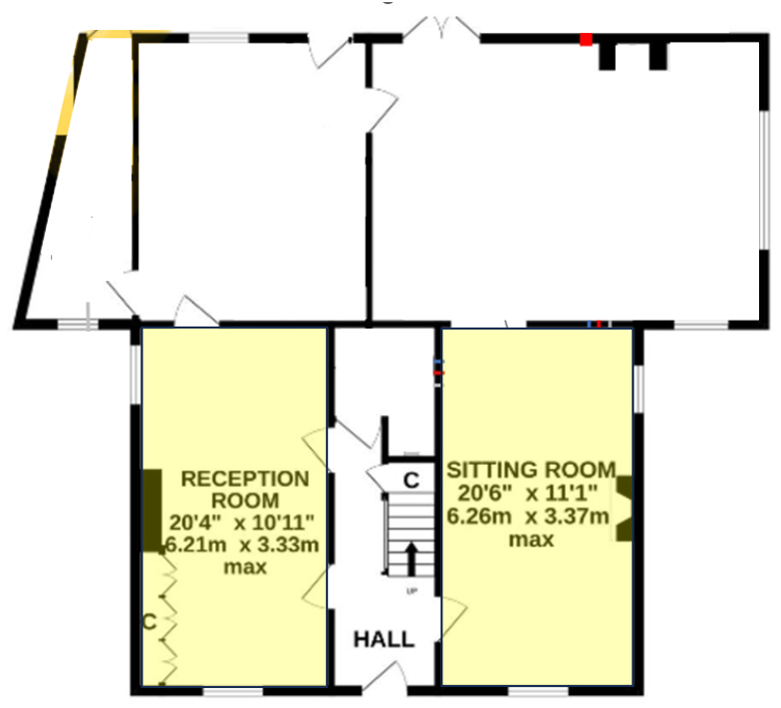
Details of the scale/appearance of the proposed development.
N/A. There is no proposal to affect the scale or appearance of the property except for the glazing units.
Details of the landscaping in the proposed development.
N/A
Details of how Heritage Assets issues have been Addressed.
There is no effect on or change to heritage assets except for the minor routing of the timber to enable it to accommodate 12mm (4+4+4) double glazed units. This requires the aperture of each sash to be routed out by 8mm.

