APPLICATION FOR HOUSEHOLDER PLANNING PERMISSION DELEGATED REPORT

APPLICATION REFERENCE: | PL/2026/00504
APPLICATION TYPE: | Householder planning permission
SITE ADDRESS: | The White House, High Street, Berwick St James, Salisbury, SP3 4TL
DEVELOPMENT DESCRIPTION: | Single storey rear and side extension with new chimney and associated works
RECOMMENDATION: | That Planning Permission be GRANTED

PROPOSAL

The proposal seeks planning permission for a single storey rear and side extension, new chimney with associated works. Existing and proposed plans and elevations included below for comparison.

Existing west and north elevations

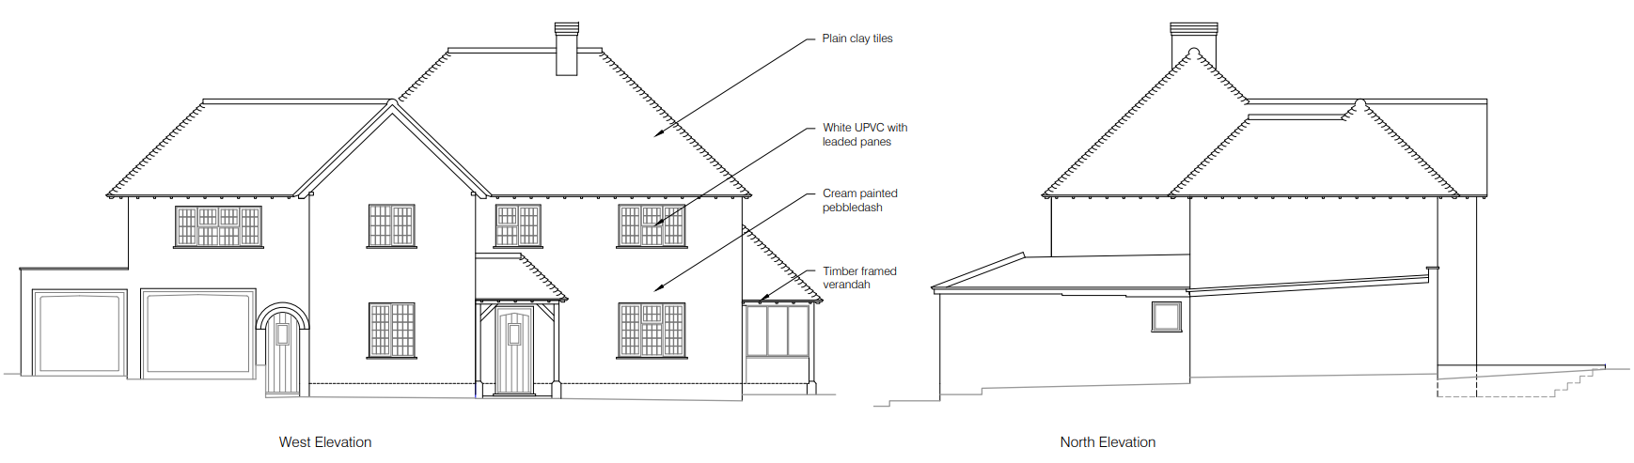

Proposed west and north elevations

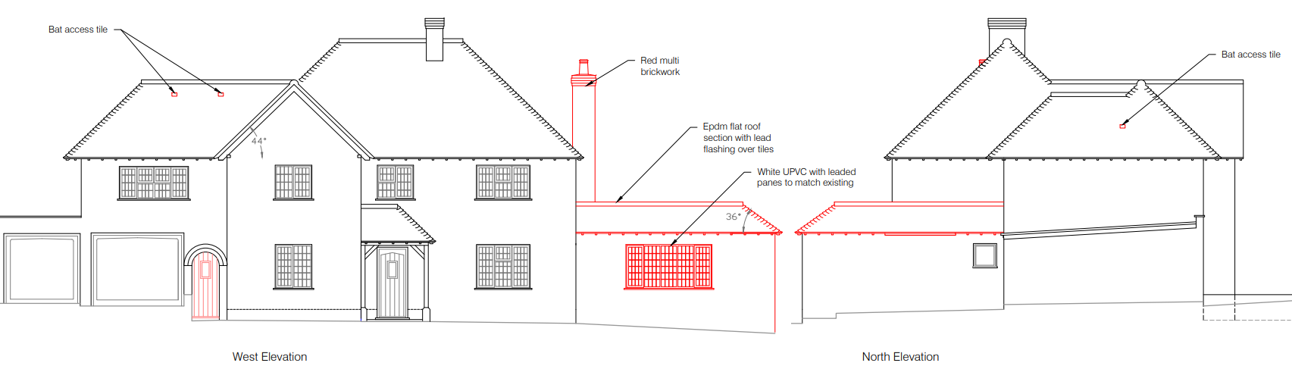

Existing east and south elevations

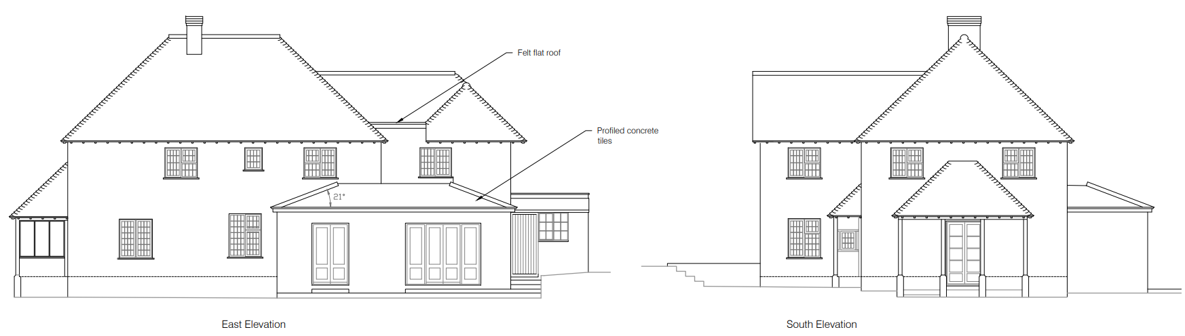

Proposed east and south elevations

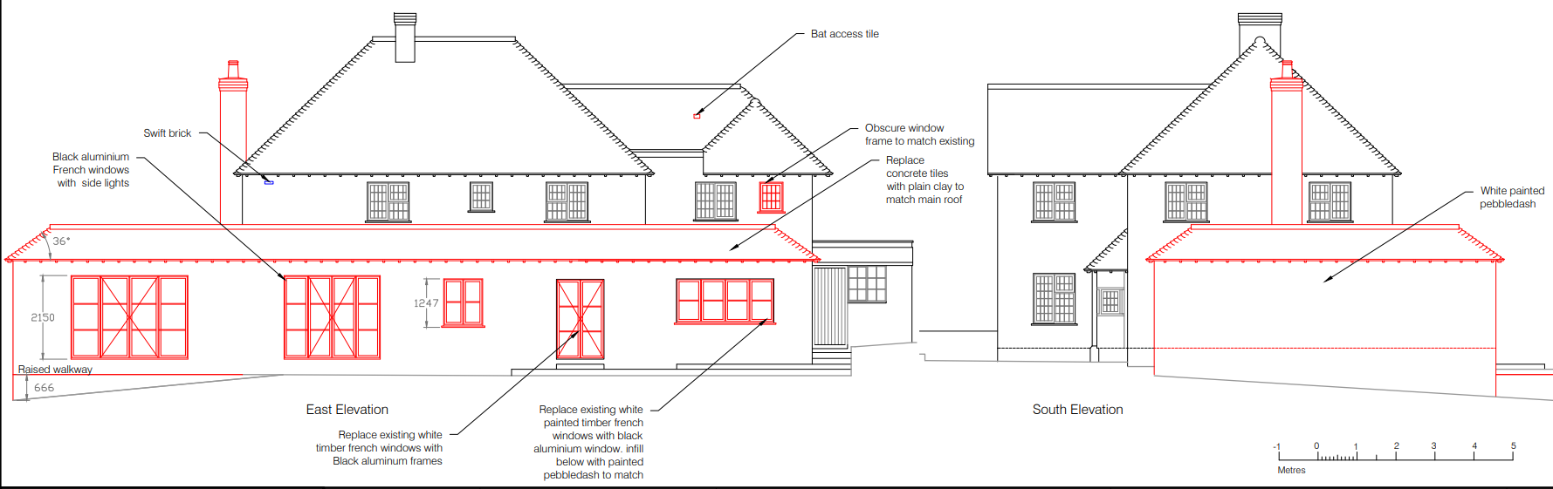

Existing and proposed ground floor plan

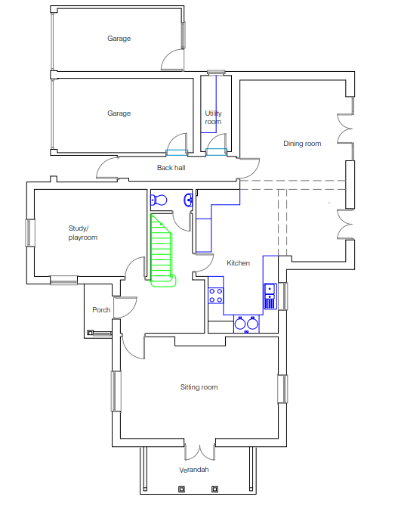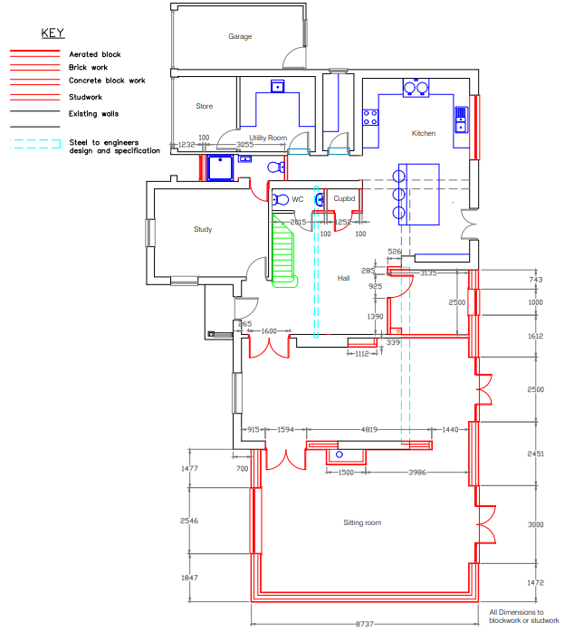

Existing and proposed first floor plan

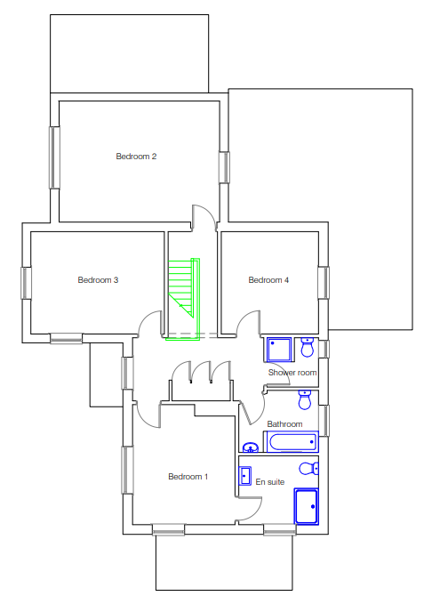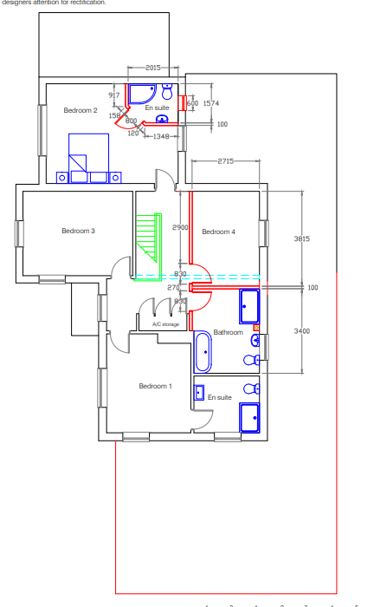

This application is a redesign and reduction to two previously approved planning applications to extend the host dwelling. Both applications PL/2025/03468 and PL/2024/03811 are extant and either could still be built out, these earlier permissions are therefore material considerations to this new revised scheme. Case Officers reports for PL/2025/03468 and PL/2024/03811 included at Appendix A for reference.

SITE DESCRIPTION/CONTEXT

The application is site relates to a large detached residential dwelling located on the northern edge of the small village of Berwick St James as defined by Wiltshire Core Strategy (WCS) core policies 1 (Settlement Strategy), 2 (Delivery Strategy), 4 (Spatial Strategy for the Amesbury Community Area. The application is the last dwelling when leaving the village to the north towards the A303. The property is set back from the road and surrounded by amenity space with the majority of the gardens to the east (rear) which slopes downwards towards the River Till. The property is surrounded by fields to the north, east and west; and is bordered by residential dwellings to the south, sharing a boundary with The Leat House. The site lies outside of the conservation area, approx. 140m north of the conservation area boundary; the property is not listed and is not in close proximity to any listed buildings. The image below taken from the Council's mapping shows the conservation area boundary in shaded green and listed buildings hatched black. Access to the site is via an existing vehicular access from the B3083 Berwick Road which runs past the western boundary of the site. The application site lies within the 6400m buffer of the Salisbury Plain SPA; is within the Hampshire Riven Avon Catchment area, the development is within 20m buffer of the River Avon SAC.

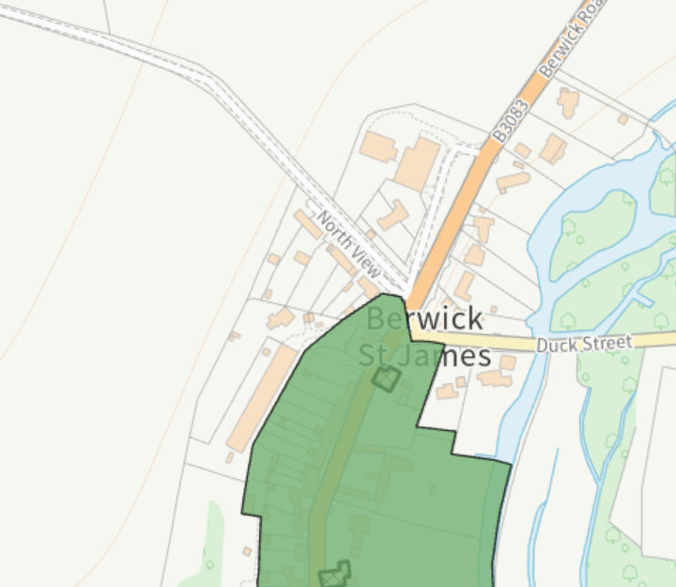

The rear boundary of the site is clipped by flood zones 2 and 3 but the dwelling itself and proposed development are outside of the flood zones.

Flood zone 3 Flood zone 2

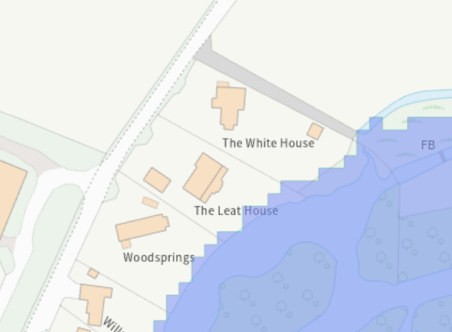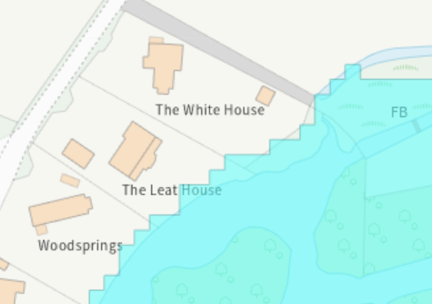

PLANNING HISTORY

PL/2025/03468 Variation of condition 2 (approved plans) of planning permission PL/2024/03811 for the replacement of the proposed central gable with a smaller version. Reposition of central front section and reduction of the proposed porch, hall and landing size with roof alterations. Lengthening of ground floor windows on either side of front door. Reposition of swift brick. Approved
PL/2024/03811 Two storey front extension and single storey rear and side extension with new chimney and associated works. Approved
S/2012/0363 Erection of single storey rear extension. Approved
S/2009/0507 To construct an extension to the side (south) of the existing house to form a separate sitting room. Approved.
S/2001/1106 Construction of pitched roof over first floor flat roof. Approved
S/1994/1366 Improvements/alterations to low level roof. Approved

RELEVANT POLICIES AND GUIDANCE

National Planning Policy Framework (NPPF)
National Planning Practice Guidance (NPPG)
National Design Guidance (Planning practice guidance for beautiful, enduring and successful places)

Salisbury District Local Plan policies (Saved by Wiltshire Core Strategy):

C6 (Special Landscape Character Area)
H31 (Extensions in the Countryside)
C24 (Extensions in the Countryside)

Wiltshire Core Strategy:
CP1 (Settlement Strategy)
CP2 (Delivery Strategy)
CP4 (Spatial Strategy for the Amesbury Community Area)
CP50 (Biodiversity)
CP51 (Landscape)
CP57 (Ensuring High Quality Design & Space Shaping)
CP69 (River Avon SAC)

Supplementary Planning Documents:
Creating Places Design Guide SPG (April 2006)
Wiltshire Design Guide

CONSULTATION RESPONSES

Parish Council: None received

REPRESENTATIONS

On third party comment was received, this is included in full below.

- The revised plans which show a reduction in size of the modified house is welcome. We are also grateful that the window in the ground floor extension looking south and towards our property has been removed in the new proposal.
2. However, we remain concerned about the isolated chimneystack located above the flat roof over the sitting room and attached to the outside wall of the second floor. It is a less than attractive addition to the house, giving it an almost industrial presence. We have been assured by the present owners of the house that they have no intention to build a second floor over the new sitting room in the future. Therefore, to minimise the odd visual effect that the chimney gives in the present proposal, could the chimney be built inside the original outside wall rather than stuck on the outside. It would certainly blend in much better.

ASSESSMENT

Section 38(6) of the Planning and Compulsory Purchase Act 2004 states:

"If regard is to be had to the development plan for the purposes of any determination to be made under the planning Acts, the determination must be made in accordance with the plan unless material considerations indicate otherwise."

In accordance with this statutory requirement, this application has been assessed against the relevant policies of the Development Plan, including the adopted Wiltshire Core Strategy (2015) and, where applicable, any made Neighbourhood Plans.

Design and Impact upon the character and context of the area

Core Policy 57 - Ensuring High Quality Design and Place Shaping of the Wiltshire Core Strategy seeks to ensure that all new development is of high design quality, reflecting local context, character, and distinctiveness.

The proposed extension relates to a single storey extension which wraps around the rear and side of the host dwelling. The extension has a flat roof and will be constructed using materials to match the host dwelling; a tall chimney is also proposed. Both the single storey rear/side extension and chimney are similar to those approved as part of applications PL/2025/03468 and PL/2024/03811 albeit part of larger schemes for enlarging the existing dwelling. However, no objections were previously raised regarding the single storey extension of chimney and the scale, design and siting were considered acceptable. Regarding the proposed rear extension, fenestration changes are proposed with this current application. The proposed side extension has been reduced in foot print and the window in the south elevation has been removed.

Given that there have been no changes to National and Local planning policy in the period between the recent approvals for extensions at White House and this current application and the elements now seeking permission are essentially a scaled down version of the previous approvals, there are no concerns raised.

Officers note the third party comments regarding the chimney, however, given that the chimney has been approved previously and could still be built under the previous consents, officers do not feel it would be reasonably to now raise objections regarding the chimney.

Having regard to the above, the proposal complies with the design principles set out in Core Policy 57 of the Wiltshire Core Strategy and Appendix D of the Wiltshire Design Guide.

Amenity

Point vii of Core Policy 57 - Ensuring High Quality Design and Place Shaping of the Wiltshire Core Strategy seeks to ensure that developments do not adversely affect neighbouring properties.

The National Planning Policy Framework (NPPF), particularly Paragraph 135(f), stresses that planning decisions should ensure developments provide a high standard of amenity for existing and future users.

The proposed development has been assessed in terms of its potential impact on the residential amenity of neighbouring properties, with particular regard to loss of light, overshadowing, loss of privacy, and overbearing effects.

The application site has one adjacent neighbour that has the potential to be affected by the proposed development, this neighbour is known as The Leat House and is to the south of The White House. The proposed development will include a single storey side extension on the south side brining the build form of The White House closer to the shared boundary with The Leat House. Included below is an extract from the submitted plans which shows the location of the application site in the location plan and also a site plan with the proposed extensions marked in red.
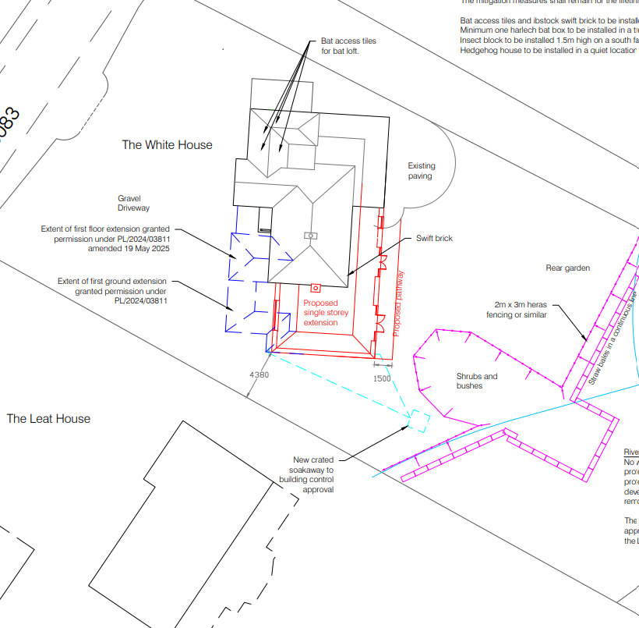
The proposed side extension will be constructed with a gap of approx. 4.40m from the boundary with The Leat House. The proposed south elevation of the extension facing The Leat House will comprise of a blank wall and the glazing in the east elevation will face away from The Leat House. The proposed extension is single storey with a flat roof design which helps to minimise impacts on the adjacent dwelling. Given the design, scale and siting of the proposed extension it is not considered that the proposed extension will conflict with neighbour amenity. A condition can be added to any permission to remove permitted development rights to prevent additional windows or opening being added to the south elevation which could have adverse amenity impacts.

The proposed chimney is located adjacent to the existing south elevation of the existing dwelling and therefore is unlikely to impact on the amenity of The Leat House, again this chimney has been previously approved as part of the two schemes previously mentioned, therefore, Officers can see no reasonable grounds to now object to this part of the proposed works on amenity grounds.

The proposal therefore accords with Core Policy 57 point vii in respect of safeguarding residential amenity and Appendix D of the Wiltshire Design Guide.

Highways Impact

Core Policy 57 (xiv) of the Wiltshire Core Strategy seeks to ensure that development must meet the requirements of Core Policy 61. This policy requires proposals to be capable of being served by safe access to the highway network. Core Policy 64 seeks to ensure compliance with parking standards set out in the Local Transport Plan.

The National Planning Policy Framework (NPPF), particularly Paragraph 115 and 116, requires that development proposals do not have an unacceptable impact on highway safety and that safe and suitable access to the site can be achieved for all users.

The proposals do not increase the number of bedrooms within the host dwelling and do not involve alterations to the existing access and current parking provision within the property.

The proposed development would not result in any adverse impact on highway safety. Adequate parking and turning provision are provided in accordance with Wiltshire’s adopted parking standards, and access arrangements are acceptable.

The proposal is therefore considered to comply with Core Policies 57 (xiv), 61 and 64 of the Wiltshire Core Strategy, the NPPF, and the Wiltshire Local Transport Plan.

Ecology Impact

Core Policy 50 of the Wiltshire Core Strategy seeks to protect and enhance biodiversity and geodiversity, including through ensuring that development avoids harm to protected species and habitats.

The National Planning Policy Framework (NPPF), in Paragraphs 193, requires that development minimises impacts on and provides net gains for biodiversity, including ensuring mitigation is secured where harm cannot be avoided.

The application submission includes a Bat Survey Report by Daniel Ahern Ecology), this confirmed the building is/was a bat roost for summer/day roost and that it will be necessary to apply for and obtain a European Protected Species Licence (EPSL) from Natural England under the conservation (Natural Habitats, &c) (Amendments) 2017 Regulations, to legally allow the proposed works to take place. No building works must take place until an EPSL has been issued. Under section 4.2 of the Bat Survey Report, a list of mitigation/enhancement measures are included. Any approval will include a condition which states the development shall be carried out in strict accordance with these details.

Officers note that whilst the proposed development has changed since the Bat Survey Report was undertaken, the proposals have been reduced with less impact on the roof; the mitigation measures however still remain relevant and can still be carried in accordance with the details contained within the Bat Survey Report.

The site, and location for the proposed development is within the River Avon 20m buffer, a construction method statement is therefore required to set out how the development will incorporate measures to avoid pollution to the river and natural environment. The applicant provided a construction method statement and associated plan to show where barriers will be erected to prevent pollution into the river. Any approval will condition the works carried out in accordance with the agreed details in the construction method statement and associated plan.

Biodiversity Net Gain - Householder planning applications are exempt from the requirement to deliver Biodiversity Net Gain under Schedule 7A, Section 4(2)(a) of the Town and Country Planning Act 1990, as inserted by the Environment Act 2021.

As such, the development complies with Core Policy 50 of the Wiltshire Core Strategy and the relevant provisions of the NPPF.

CONCLUSION

The proposed development is considered to be acceptable in terms of its design, scale, and relationship with the surrounding area. It would not result in any unacceptable harm to the character of the locality, the amenities of neighbouring occupiers, or the interests of highway safety, or ecology.

The proposal is therefore considered to comply with the relevant policies of the Wiltshire Core Strategy, and the National Planning Policy Framework. As such, the application is recommended for approval, subject to the conditions set out below.

RECOMMENDATION: That Planning Permission be GRANTED subject to conditions.

1.The development hereby permitted shall be begun before the expiration of three years from the date of this permission.

REASON: To comply with the provisions of Section 91 of the Town and Country Planning Act 1990 as amended by the Planning and Compulsory Purchase Act 2004.

2.The development hereby permitted shall be carried out in accordance with the following approved plans:

Application form received 26/01/2026
Location plan received 26/01/2026
Construction method statement received 26/01/2026
Proposed elevations Drg no TWH2 08EP received 30/01/2026
Proposed block plan Drg no TWH204BP received 30/01/2026
Proposed floor plans TWH206FPP Rev A received 30/01/2026

REASON: For the avoidance of doubt and in the interests of proper planning.

3.The materials to be used in the construction of the external surfaces of the development hereby permitted shall match in material, colour and texture those detailed within the approved application form and plans.

REASON: In the interests of visual amenity and the character and appearance of the area.

4. The flat roof area of the development hereby permitted shall not be used as a balcony, roof garden or similar amenity area.

REASON: In the interests of residential amenity and privacy

5. The development will be carried out in strict accordance with the following documents:

• Bat Survey Report by Daniel Ahern Ecology dated 28th March 2025

The development hereby approved shall not be occupied or used until the mitigation measures specified under section 4.2 of the above report have been carried out. The mitigation measures shall remain for the lifetime of the development.

REASON: For the avoidance of doubt and for the protection, mitigation and enhancement of biodiversity.

6. No works including demolition or site clearance shall commence until the protective barriers as detailed with the approved construction method statement and shown on the associated site plan Drg no Drg no TWH204BP have been erected in accordance with the agreed details. The protective barriers shall remain in the agreed location until the proposed development has been completed and all materials and equipment have been removed from site.

The development shall not be carried out otherwise than in accordance with the approved construction method statement without the prior written permission of the Local Planning Authority.

REASON: To minimise detrimental effects to the natural environment which includes the River Avon SAC through the risks of pollution during the construction phase.

7. Notwithstanding the provisions of the Town and Country Planning (General Permitted Development) (England) Order 2015 (or any Order revoking or reenacting or amending that Order with or without modification), there shall be no additions/extensions or external alterations to any building forming part of the development hereby permitted.

REASON: In the interests of the amenity, character and appearance of the area and to enable the Local Planning Authority to consider individually whether planning permission should be granted for additions/extensions or external alterations.

8. Notwithstanding the provisions of the Town and Country Planning (General Permitted Development) (England) Order 2015 (or any Order revoking or reenacting or amending that Order with or without modification), no windows, doors or other form of openings other than those shown on the approved plans, shall be inserted in the south elevation of the development hereby permitted.

REASON: In the interests of residential amenity and privacy

9. The extension hereby permitted shall not be occupied at any time other than for purposes ancillary to the residential use of the main dwelling, known as The White House and it shall remain within the same planning unit as the main dwelling.

REASON: The additional accommodation is sited in a position where the Local Planning Authority, having regard to the reasonable standards of residential amenity, access, and planning policies pertaining to the area, would not permit a wholly separate dwelling.

INFORMATIVES

INFORMATIVE TO APPLICANT - Party Wall

The applicant is requested to note that this permission does not affect any private property rights and therefore, does not authorise the carrying out of any work on land outside their control. If such works are required, it will be necessary for the applicant to obtain the landowners consent before such works commence. If you intend carrying out works in the vicinity of the site boundary, you are also advised that it may be expedient to seek your own advice with regard to the requirements of the Party Wall Act 1996.

INFORMATIVE TO APPLICANT – Building control

Any alterations to the approved plans, brought about by compliance with Building Regulations or any other reason must first be agreed in writing with the Local Planning Authority before commencement of work.

INFORMATIVE TO APPLICANT - protected species

The applicant should note that under the terms of the Wildlife and Countryside Act (1981) and the Habitats Regulations (2010) it is an offence to disturb or harm any protected species, or to damage or disturb their habitat or resting place. Please note that this consent does not override the statutory protection afforded to any such species. In the event that your proposals could potentially affect a protected species you should seek the advice of a suitably qualified and experienced ecologist and consider the need for a license from Natural England prior to commencing works. Please see Natural England’s website for further information on protected species.

INFORMATIVE TO APPLICANT - Breeding Birds

The adults, young, eggs and nests of all species of birds are protected by the Wildlife and Countryside Act 1981 (as amended) while they are breeding. Please be advised that works should not take place that will harm nesting birds from March to August inclusive. All British birds, their nests and eggs are protected under Section 1 of the Wildlife and Countryside Act 1981 (as amended) and the Countryside and Rights of Way Act 2000 while birds are nesting, building nests and sitting on eggs. The applicant is advised to check any structure or vegetation capable of supporting breeding birds and delay removing or altering such features until after young birds have fledged. Damage to extensive areas that could contain nests/breeding birds should be undertaken outside the breeding season. This season is usually taken to be the period between 1st March and 31st August, but some species are known to breed outside these limits.

INFORMATIVE TO APPLICANT – BNG not required

BNG not required -The effect of paragraph 13 of Schedule 7A to the Town and Country Planning Act 1990 is that planning permission granted for development of land in England is deemed to have been granted subject to the condition (biodiversity gain condition) that development may not begin unless:

(a) a Biodiversity Gain Plan has been submitted to the planning authority, and
(b) the planning authority has approved the plan.

The planning authority, for the purposes of determining whether to approve a Biodiversity Gain Plan, if one is required in respect of this permission would be Wiltshire Council.

There are statutory exemptions and transitional arrangements which mean that the biodiversity gain condition does not always apply. For further information on exempt developments please refer to:
https://www.gov.uk/guidance/biodiversity-net-gain-exempt-developments
Based on the information available this permission is considered to be one which will not require the approval of a biodiversity gain plan before development is begun because one or more of the statutory exemptions or transitional arrangements is considered to apply.

APPENDIX A

DELEGATED REPORT

Application Reference: PL/2025/03468
Application Type: Variation of condition

Site Address: The White House, High Street, Berwick St James, Salisbury, SP3 4TL
Proposal: Variation of condition 2 (approved plans) of planning permission PL/2024/03811 for the replacement of the proposed central gable with a smaller version. Reposition of central front section and reduction of the proposed porch, hall and landing size with roof alterations. Lengthening of ground floor windows on either side of front door. Reposition of swift brick.
Recommendation: Planning Permission be GRANTED

PROPOSAL

Variation of condition 2 (approved plans) of planning permission PL/2024/03811 for the replacement of the proposed central gable with a smaller version. Reposition of central front section and reduction of the proposed porch, hall and landing size with roof alterations. Lengthening of ground floor windows on either side of front door. Reposition of swift brick.

SITE DESCRIPTION/CONTEXT

The application is site relates to a large detached residential dwelling located on the northern edge of the small village of Berwick St James as defined by Wiltshire Core Strategy (WCS) core policies 1 (Settlement Strategy), 2 (Delivery Strategy), 4 (Spatial Strategy for the Amesbury Community Area. The application is the last dwelling when leaving the village to the north towards the A303. The property is set back from the road and surrounded by amenity space with the majority of the gardens to the east (rear) which slopes downwards towards the River Till. The property is surrounded by fields to the north, east and west; and is bordered by residential dwellings to the south, sharing a boundary with The Leat House. The site lies outside of the conservation area, approx. 140m north of the conservation area boundary; the property is not listed and is not in close proximity to any listed buildings. The image below taken from the Council's mapping shows the conservation area boundary in shaded green and listed buildings hatched black. Access to the site is via an existing vehicular access from the B3083 Berwick Road which runs past the western boundary of the site. The application site lies within the 6400m buffer of the Salisbury Plain SPA; is within the Hampshire Riven Avon Catchment area, the development is within 20m buffer of the River Avon SAC.

The rear boundary of the site is clipped by flood zones 2 and 3 but the dwelling itself and proposed development are outside of the flood zones.

PLANNING HISTORY

PL/2024/03811 Erection of a two storey front extension and single storey rear and side extension with new chimney and associated works. Approved
S/2012/0363 Erection of single storey rear extension. Approved
S/2009/0507 To construct an extension to the side (south) of the existing house to form a separate sitting room. Approved.
S/2001/1106 Construction of pitched roof over first floor flat roof. Approved
S/1994/1366 Improvements/alterations to low level roof. Approved

POLICIES

National Planning Policy Framework (NPPF)
National Planning Practice Guidance (NPPG)
National Design Guidance (Planning practice guidance for beautiful, enduring and successful places)

Salisbury District Local Plan policies (Saved by Wiltshire Core Strategy):

C6 (Special Landscape Character Area)
H31 (Extensions in the Countryside)
C24 (Extensions in the Countryside)

Wiltshire Core Strategy:

CP1 (Settlement Strategy)
CP2 (Delivery Strategy)
CP4 (Spatial Strategy for the Amesbury Community Area)
CP50 (Biodiversity)
CP51 (Landscape)
CP57 (Ensuring High Quality Design & Space Shaping)
CP69 (River Avon SAC)

Supplementary Planning Documents:
Creating Places Design Guide SPG (April 2006)
Wiltshire Design Guide
Achieving Sustainable Development SPG (April 2005)
Wiltshire Local Transport Plan – Car Parking Strategy

ISSUES

Principle
Character & Design
Parking/highway safety
Ecology
Neighbouring Amenities

CONSULTATION

Parish Council – none received
Highways – no objections
Ecology – none received

REPRESENTATIONS

None received

ASSESSMENT

Principle

The application site is located within the small village of Berwick St James, part of the Amesbury Community Area, which is defined as a small village by WCS core strategies 1 and 2. The housing policy boundaries have been removed from small villages effectively categorizing them as the countryside. Saved policy H31 from the previous Salisbury District Local Plan has been retained following the adoption of the WCS.

The WCS states that within small villages some modest development may be appropriate to contribute to the vitality of rural communities by ensuring better facilities and homes.

Saved policy H31 from the Salisbury District Local Plan 2003 states that in the countryside extensions to existing dwellings will be permitted provided that

a) The extension is subservient in size to the existing dwelling and house plot and does not substantially alter the character of the dwelling;
b) The design of the extension is in keeping with that of the existing dwelling and uses complementary materials;
c) The extension would not create, or be capable of creating, a separate dwelling.

Saved policy C24 From the Salisbury District Local Plan 2003 states that: Extensions and additions to buildings in the countryside will only be permitted if they are sympathetic in scale and character with the existing building and surroundings and fall within the existing curtilage.

Saved Policy C6 seeks to ensure that development proposals have regard to the high quality of the landscape: Within the Special Landscape Area, proposals for development in the countryside will be considered having particular regard to the high quality of the landscape. Where proposals which would not have an adverse effect on the quality of the landscape are acceptable, they will be subject to the following criteria;

i) the siting and scale of development to be sympathetic to the landscape; and
ii) high standards of landscaping and design, using materials which are appropriate to the locality and reflect the character of the area.

Furthermore, the site is already in use for residential purposes and the principle of extensions or additions to be used in association with the residential use is accepted. The principal acceptability is, however, subject to the detail, such as their implications for the character of the area and neighbouring amenities, noting that this is an amendment to a recently approved development for householder extensions and alterations on the site which were found to be acceptable in principle. These will, therefore, be addressed in more detail below.

Character and design
Core Policy 57 states that new development is expected to create a strong sense of place through drawing on the local context and being complementary to the locality. Residential extensions such as this are acceptable in principle subject to there being no adverse impacts.

This application is seeking consent to amend the recent approved scheme PL/2024/03811, the following text taken from the submitted supporting planning statement explains the changes made and now seeking consent.

Planning was granted on 18 September 2024 under Planning application no. PL/2024/03811 for a two storey front extension and single storey rear and side extension with new chimney and associated works. On further investigation my client has found that the internal structure for the proposed roof layout was complex and too costly, so they are proposing an alteration to the roof to facilitate the construction.

The proposed large central gable has been replaced with an additional smaller front gable to mirror the existing one on the left hand side of the building. The central front section has been pushed back to break the front elevation this is now to be roofed with a lead flat roof with a soffit detail to match the porch.

The porch has been reduced in scale to remove the pillars and provide a cantilevered rain cover. The floor plan is not greatly altered although the front section has been pushed back reducing the space in the hall and on the landing. The windows on either side of the front door have been lengthened to ground level to increase the light in the smaller hall.

The ecologists were reconsulted about the new scheme and their report with added statement is included and the site of the swift brick has been moved to a more suitable location given the alteration to the rooflines.

These alterations do not impact the amenity of the neighbours, and it is considered that these changes do not impact the very special character of the surrounding neighbourhood.

Included below are as approved and as proposed/amended elevations for comparison

Approved front elevation Proposed/amended front elevation
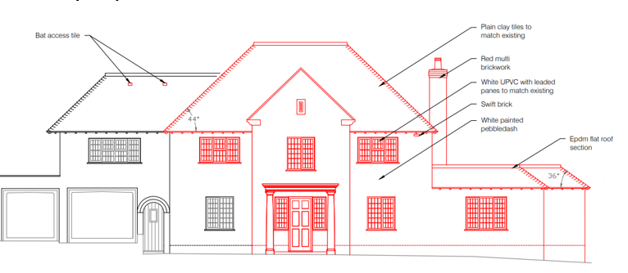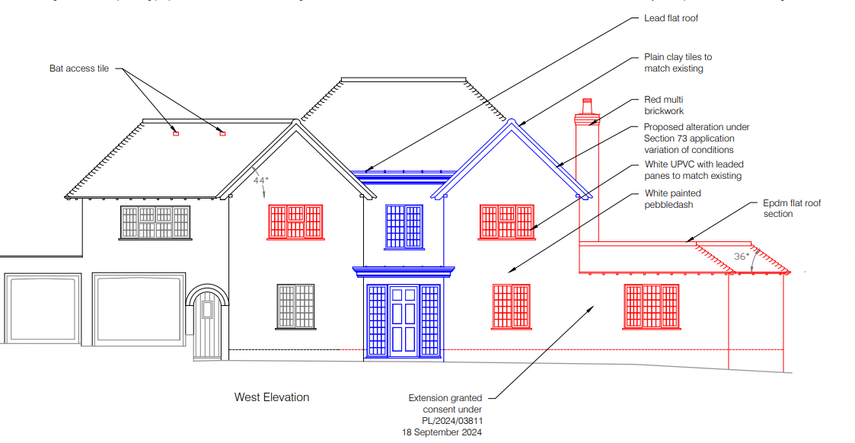
Approved side elevation Proposed/amended side elevation
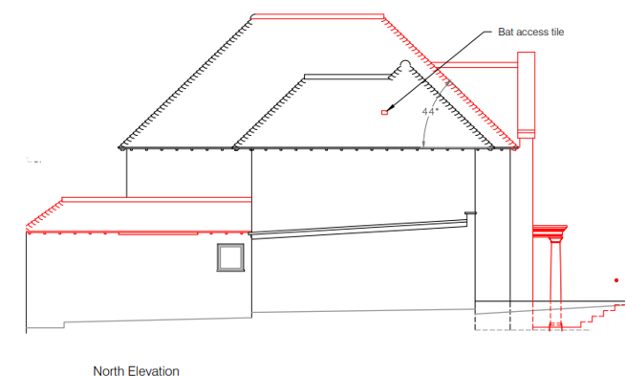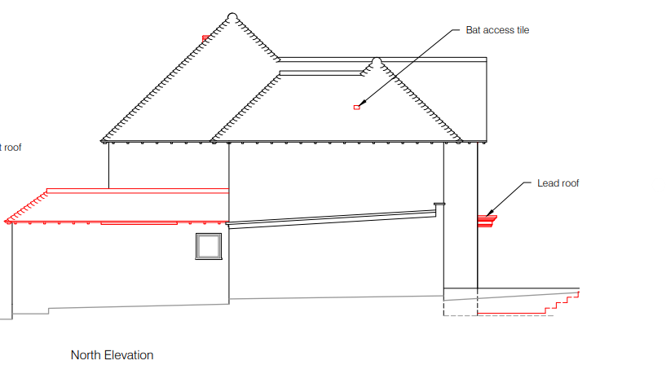
Approved rear elevation Proposed/amended elevation
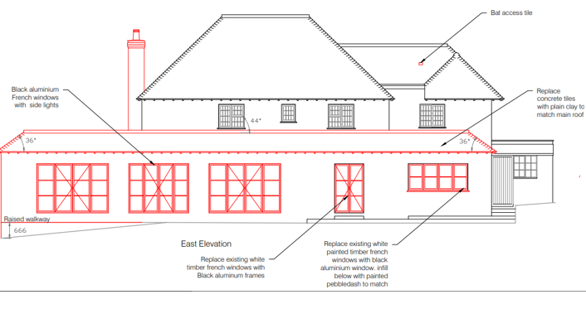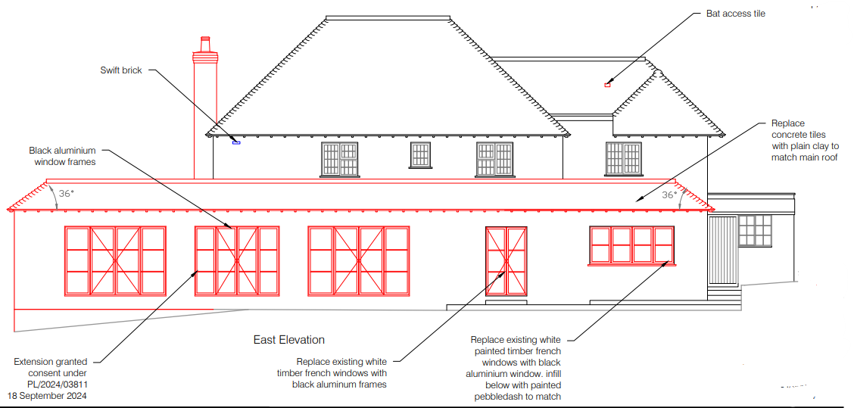
Approved side elevation Proposed/amended side elevation
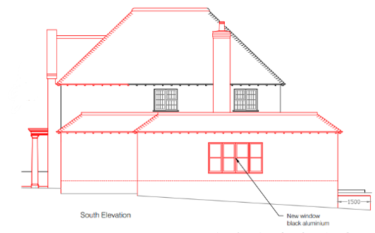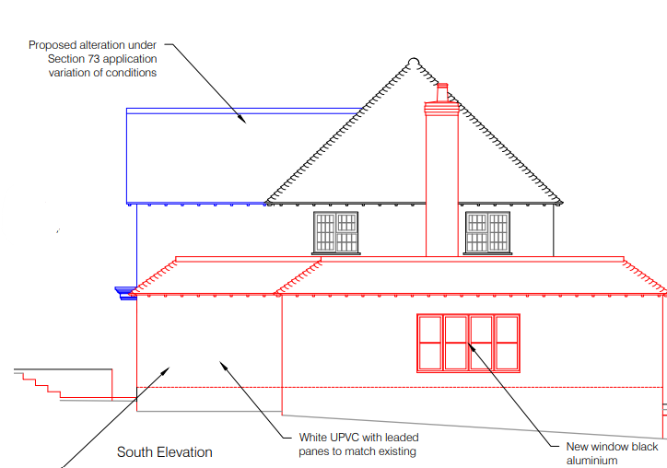
As can be seen from above and as detailed within the submitted planning statement, the changes predominantly relate to roof changes and changes to the front elevation of the property. The proposed changes to the approved plans are modest and are not considered to be unacceptable in terms of scale or design. The changes to the front elevation and roof form reduce the height and bulk of the previously approved front addition with the overall appearance of the property raising no particular concerns. The main part of the dwelling i.e the two storey part in the centre will result in a symmetrical design, to be built using appropriate materials. Officers have no objections to the proposed design changes to the consented scheme in relation to the character and appearance of the host dwelling or impact on the streetscene/local area.

Parking/highway safety

The application site has an existing vehicle access to the front with an area to the front for off road parking, there is also space for vehicles to turn to exit in a forward gear. The Highway Authority was consulted as part of the application process and has raised no objections.

Ecology

Core Policy 50 of the Wiltshire Core Strategy and the National Planning Policy Framework requires that the planning authority ensures protection of important habitats and species in relation to development and seeks enhancement for the benefit of biodiversity through the planning system.

The application has been supported by a Bat Survey Report by Daniel Ahern Ecology, this is the same report that was approved for the recent approval - PL/2024/03811 but has been updated to relate to the amended plans. The proposals still include appropriate mitigation and enhancement measures as detailed within this report which will be conditioned on any approval. The application is still supported by the previously approved construction method statement which is still relevant and still applies to this amended scheme.

Amenity

WCS policy CP57 (Ensuring High Quality Design & Space Shaping) requires that development should ensure the impact on the amenities of existing occupants/neighbours is acceptable and ensuring that appropriate levels of amenity are achievable within the development itself. The NPPF includes that planning should ‘always seek to secure high quality design and a good standard of amenity for all existing and future occupants of land and buildings.’ Residential amenity is affected by significant changes to the environment including privacy, outlook, daylight and sunlight, and living areas within private gardens and this therefore needs to be carefully considered accordingly.

Whilst the previously approved application PL/2024/03811 received a large number of objections from third parties, this revised scheme has received no third party representations.

The proposed amendments mainly relate to changes to the roof form and front elevation of the existing dwelling and do not encroach further onto the south boundary with The Leat. There are no additional windows or other openings on the south or east elevations. It is therefore it is not considered that this proposed amended scheme will create additional amenity impacts over and above the approved and still extant permission. Therefore, there are no further concerns raised regarding impact on neighbour amenity.

CONCLUSION

The proposed development is considered to be acceptable by reason of its scale, design and siting, with no significant impact to neighbouring amenities, the character of the area/Special Landscape Area, no significant highway impacts or ecological impacts. The proposed development is therefore considered to be in accordance with Core Policies 1, 2, 4, 50, 51, 57 and 69 of the adopted Wiltshire Core Strategy, saved policies C6, C24 and H31 of the Salisbury District Local Plan and the aims of the NPPF.

RECOMMENDATION: Approve subject to the following conditions.

1. The development hereby permitted shall be begun before the expiration of three years from the date of the original permission (18/09/2027)

REASON: To comply with the provisions of Section 91 of the Town and Country Planning Act 1990 as amended by the Planning and Compulsory Purchase Act 2004.

2.The development hereby permitted shall be carried out in accordance with the following approved
plans:

Application form received 23/04/2024
Location plan received 04/04/2025
Construction method statement 16/09/2024
Site Plan Drg no Drg no TWH04BP Rev C river protection details received 17/09/2024
Proposed floor plans 7 Drg no TWH06FPP dated 20 March 2025 received 14/04/2025
Proposed elevations 8 Drg no TWH08EP dated 21 March 2025 received 04/04/2025
Planning statement received 11/04/2025
Site sections Drg no TWH10SCS received 09/08/2024

REASON: For the avoidance of doubt and in the interests of proper planning.

3.The materials to be used in the construction of the external surfaces of the development hereby
permitted shall match in material, colour and texture those detailed within the approved application form
and plans.

REASON: In the interests of visual amenity and the character and appearance of the area.

4. The flat roof area of the development hereby permitted shall not be used as a balcony, roof garden
or similar amenity area.

REASON: In the interests of residential amenity and privacy

5. The development will be carried out in strict accordance with the following documents:

• Bat Survey Report by Daniel Ahern Ecology dated 28 March 2025

The development hereby approved shall not be occupied or used until the mitigation measures specified under section 4.2 of the above report have been carried out. The mitigation measures shall remain for the lifetime of the development.

REASON: For the avoidance of doubt and for the protection, mitigation and enhancement of biodiversity.

6. No works including demolition or site clearance shall commence until the protective barriers as detailed with the approved construction method statement and shown on the associated site plan Drg no TWH04BP Rev C river protection details have been erected in accordance with the agreed details.

The protective barriers shall remain in the agreed location until the proposed development has been completed and all materials and equipment have been removed from site.

The development shall not be carried out otherwise than in accordance with the approved construction method statement without the prior written permission of the Local Planning Authority.

REASON: To minimise detrimental effects to the natural environment which includes the River Avon SAC through the risks of pollution during the construction phase.

7. Notwithstanding the provisions of the Town and Country Planning (General Permitted Development) (England) Order 2015 (or any Order revoking or reenacting or amending that Order with or without modification), there shall be no additions/extensions or external alterations to any building forming part of the development hereby permitted.

REASON: In the interests of the amenity, character and appearance of the area and to enable the Local
Planning Authority to consider individually whether planning permission should be granted for
additions/extensions or external alterations.

8. Notwithstanding the provisions of the Town and Country Planning (General Permitted Development) (England) Order 2015 (or any Order revoking or reenacting or amending that Order with or without modification), no windows, doors or other form of openings other than those shown on the approved plans, shall be inserted in the south elevation of the development hereby permitted.

REASON: In the interests of residential amenity and privacy

9. Notwithstanding the provisions of the Town and Country Planning (General Permitted Development) (England) Order 2015 (or any Order revoking or reenacting or amending that Order with or without modification), no window, dormer window or rooflight, other than those shown on the approved plans, shall be inserted in the south or east roof slopes of the development hereby permitted.

REASON: In the interests of residential amenity and privacy

10. The extension hereby permitted shall not be occupied at any time other than for purposes ancillary to the residential use of the main dwelling, known as The White House and it shall remain within the same planning unit as the main dwelling.

REASON: The additional accommodation is sited in a position where the Local Planning Authority, having regard to the reasonable standards of residential amenity, access, and planning policies pertaining to the area, would not permit a wholly separate dwelling.

11. Notwithstanding the approved plans, before the development hereby permitted is first brought into use/occupied, the new ground floor window in the west elevation serving the ensuite for bedroom No 5 shall be entirely glazed with obscure glass only (to level 5 obscurity). The window shall be retained as such for the lifetime of the development.

REASON: In the interests of residential amenity and privacy

12. Notwithstanding the approved plans, before the development hereby permitted is first brought into Use/occupied, the new ground floor window in the south elevation serving the sitting room, facing The Leat House shall be entirely glazed with obscure glass only (to level 5 obscurity). The window shall be retained as such for the lifetime of the development.

REASON: In the interests of residential amenity and privacy

INFORMATIVE TO APPLICANT -Party Wall

The applicant is requested to note that this permission does not affect any private property rights and therefore, does not authorise the carrying out of any work on land outside their control. If such works are required, it will be necessary for the applicant to obtain the landowners consent before such works commence. If you intend carrying out works in the vicinity of the site boundary, you are also advised that it may be expedient to seek your own advice with regard to the requirements of the Party Wall Act 1996.

INFORMATIVE TO APPLICANT – Building control

Any alterations to the approved plans, brought about by compliance with Building Regulations or any other reason must first be agreed in writing with the Local Planning Authority before commencement of work.

INFORMATIVE TO APPLICANT protected species

The applicant should note that under the terms of the Wildlife and Countryside Act (1981) and the Habitats Regulations (2010) it is an offence to disturb or harm any protected species, or to damage or disturb their habitat or resting place. Please note that this consent does not override the statutory protection afforded to any such species. In the event that your proposals could potentially affect a protected species you should seek the advice of a suitably qualified and experienced ecologist and consider the need for a license from Natural England prior to commencing works. Please see Natural England’s website for further information on protected species.

INFORMATIVE TO APPLICANT – nesting birds

The adults, young, eggs and nests of all species of birds are protected by the Wildlife and Countryside Act 1981 (as amended) while they are breeding. Please be advised that works should not take place that will harm nesting birds from March to August inclusive. All British birds, their nests and eggs are protected under Section 1 of the Wildlife and Countryside Act 1981 (as amended) and the Countryside and Rights of Way Act 2000 while birds are nesting, building nests and sitting on eggs. The applicant is advised to check any structure or vegetation capable of supporting breeding birds and delay removing or altering such features until after young birds have fledged. Damage to extensive areas that could contain nests/breeding birds should be undertaken outside the breeding season. This season is usually taken to be the period between 1st March and 31st August, but some species are known to breed outside these limits.

INFORMATIVE TO APPLICANT - BNG

The effect of paragraph 13 of Schedule 7A to the Town and Country Planning Act 1990 is that planning permission granted for development of land in England is deemed to have been granted subject to the condition (biodiversity gain condition) that development may not begin unless:

(a) a Biodiversity Gain Plan has been submitted to the planning authority, and
(b) the planning authority has approved the plan.

The planning authority, for the purposes of determining whether to approve a Biodiversity Gain Plan, if one is required in respect of this permission would be Wiltshire Council.

There are statutory exemptions and transitional arrangements which mean that the biodiversity gain condition does not always apply.

Based on the information available this permission is considered to be one which will not require the approval of a biodiversity gain plan before development is begun because one or more of the statutory exemptions or transitional arrangements is considered to apply.

The following exemption is considered to apply -

Development which is subject of a householder application within the meaning of article 2(1) of the Town and Country Planning (Development Management Procedure) (England) Order 2015. A “householder application” means an application for planning permission for development for an existing dwellinghouse, or development within the curtilage of such a dwellinghouse for any purpose incidental to the enjoyment of the dwellinghouse which is not an application for change of use or an application to change the number of dwellings in a building.

CASE OFFICER'S REPORT
Application Reference:  Site: | PL/2024/03811  The White House, High Street, Berwick St James Salisbury, SP3 4TL.

POLICIES:
National Planning Policy Framework (NPPF)
National Planning Practice Guidance (NPPG)
National Design Guidance (Planning practice guidance for beautiful, enduring and successful places)

Salisbury District Local Plan policies (Saved by Wiltshire Core Strategy):

C6 (Special Landscape Character Area)
H31 (Extensions in the Countryside)
C24 (Extensions in the Countryside)

Wiltshire Core Strategy:
CP1 (Settlement Strategy)
CP2 (Delivery Strategy)
CP4 (Spatial Strategy for the Amesbury Community Area)
CP50 (Biodiversity)
CP51 (Landscape)
CP57 (Ensuring High Quality Design & Space Shaping)
CP69 (River Avon SAC)

Supplementary Planning Documents:
Creating Places Design Guide SPG (April 2006)
Wiltshire Design Guide

REPRESENTATIONS:

Berwick St James Parish Council – Object to both the original and revised plans.

Highways - The planning application is seeking approval for a front and side extension to the existing dwelling known as The White House. The proposed extension will not impact on the space available to park and turn vehicles within the site curtilage and the overall parking provision remains at 3 parking spaces, in line with the Wiltshire Parking Strategy. There is, and will remain, ample space to park to the front of the dwelling. No highway objection is raised.

Ecology - I note that the submitted preliminary ecological assessment found evidence of bats roosting in the building proposed for works; recommendations in line with best practice guidance are made, for additional survey work to fully inform the planning application and Natural England licence application. I cannot see that this survey work has yet been completed.

A final assessment of the impact of the works on protected species should be conducted and submitted, and recommendations for mitigation measures incorporated into amended drawings and plans.

Further survey data and report was submitted and ecology reconsulted, however no comments were received from the Councils ecologist.

Letters – One letter of support and 17 letters of objection were received on the original plans and 10 letters of objection on revised plans. Points raised are summarised below (these include the Parish Council comments)

• Enormous redevelopment
• Out of keeping for the village or houses in the area
• Prominent location
• Too big for the plot
• First house entering the village therefore any alterations would impact the character
• Small village needs to maintain character the plans are a massive change
• Double the frontage and whole appearance
• Scope for extending that doesn’t change the frontage
• Design like modern symmetrical houses in Oxshott or Cobham in sure, not historically important and architecturally interesting.
• Building could be used for purposes of worship and more traffic and footfall
• Intrusive to neighbours
• Too close to neighbours
• Design not appropriate
• Not appropriate to a SSSI
• Single storey extension making way for future vertical addition
• Scale and form doubling size of property
• Close to boundary with adj dwelling and will impact amenity
• inappropriate development in terms of the scale, mass and form
• 8ft deciduous hedge gives no visual protection during winter months
• proposals do not identify any levels, sectional details, or indeed refer to any topographical information for the site. Properties have varying levels, plans need to reflect the changes
• current style of the building is “vernacular” to the village and more “arts and crafts” in style as opposed to Georgian
• isolated chimney stack causes concerns for future development of the site
• new windows facing Leat house will affect privacy
• discrepancies on plans, window/door details don’t match
• varying colours of windows and types on plans which are proposed on the proposal. We feel that the drawings are misleading in terms of the interpretation and the proposals for the mix of materials and architectural styles.
• Understand there is a well below the extension this should be addressed
• Breach of Wiltshire plan for small villages
1. Development preserves the character and setting of the village. [Ref: 4.216]
2. Development at small villages will be limited to respond to local needs and to contribute to their vitality. [Ref: 3.14]
• Extensions to be used for non-residential purposes
• Chimney to high and visible
• Could consider works to north side of property rather than south side
• At village meeting 30people objected and no one supported
• Existing house sensibly proportioned, and structurally balanced village house proposals unbalance the house and spoils proportions
• If extended back towards the river would have less impact

Revised plans

• Amendments only made minor changes, proposals too big and unsuitable for this plot
• If applicant wanted big house why buy this one
• Revisions not taken into account village objections
• Overdevelopment covers nearly entire width
• Loss of greenery
• Design out of balance with vernacular
• Design bulk, massing still almost 40% increase
• Ground floor extension reduced by smallest margins on south side
• Plan has removed downstairs bathroom, no change to size of sitting room.
• Leat House bult 5m from boundary, White House should be the same.
• Height of Hedge on Leat House side is 2.4m high, being deciduous is not permanent feature and should not be used as reference for visual protection.
• The height and positioning of the chimney continues to be visually unsightly and unnecessarily intrusive.
• The additional windows originally planned to overlook our property and thereby affecting our privacy and amenity have been addressed satisfactorily.
• Eye sore to village
• The amount of building will cause safety problems with building traffic on the A303 where the speed limit goes from 50mph to 30mph in front of r the White House drive
• Changes minimal and don’t address village concerns
• design still shows absolutely no consideration for the style and period of the current property

Support

• This design is a great improvement for the owner without taking away from the original style and character of the house. The way the architect has kept it at an equal distance from the boundary as the neighbours property and mostly at the rear of the house is considerate and thoughtful for them all. It will add to the value of the white house plus the surrounding properties and is good to see a development being made in-keeping with this area.

ISSUES:
The main considerations which are material to the determination of this application are listed below:
- Principle
- Character & Design
- Parking/highway safety
- Ecology
- Neighbouring Amenities

SITE DESCRIPTION

The application is site relates to a large detached residential dwelling located on the northern edge of the small village of Berwick St James as defined by Wiltshire Core Strategy (WCS) core policies 1 (Settlement Strategy), 2 (Delivery Strategy), 4 (Spatial Strategy for the Amesbury Community Area. The application is the last dwelling when leaving the village to the north towards the A303. The property is set back from the road and surrounded by amenity space with the majority of the gardens to the east (rear) which slopes downwards towards the River Till. The property is surrounded by fields to the north, east and west; and is bordered by residential dwellings to the south, sharing a boundary with The Leat House. The site lies outside of the conservation area, approx. 140m north of the conservation area boundary; the property is not listed and is not in close proximity to any listed buildings. The image below taken from the Council's mapping shows the conservation area boundary in shaded green and listed buildings hatched black. Access to the site is via an existing vehicular access from the B3083 Berwick Road which runs past the western boundary of the site. The application site lies within the 6400m buffer of the Salisbury Plain SPA; is within the Hampshire Riven Avon Catchment area, the development is within 20m buffer of the River Avon SAC.

The rear boundary of the site is clipped by flood zones 2 and 3 but the dwelling itself and proposed development are outside of the flood zones.

Flood zone 3 Flood zone 2

PROPOSAL:

This is a householder application proposing the erection of a two storey front extension and single storey rear and side extension with new chimney and associated works.

NB, Revised plans were received during the course of the application to reduce the size of the side/rear extension and move the extensions further away from the boundary with The Leat House; the new first floor side window was also removed.

Included below for comparison are extracts from the existing and proposed elevations.

Existing front (west) elevation proposed front elevation
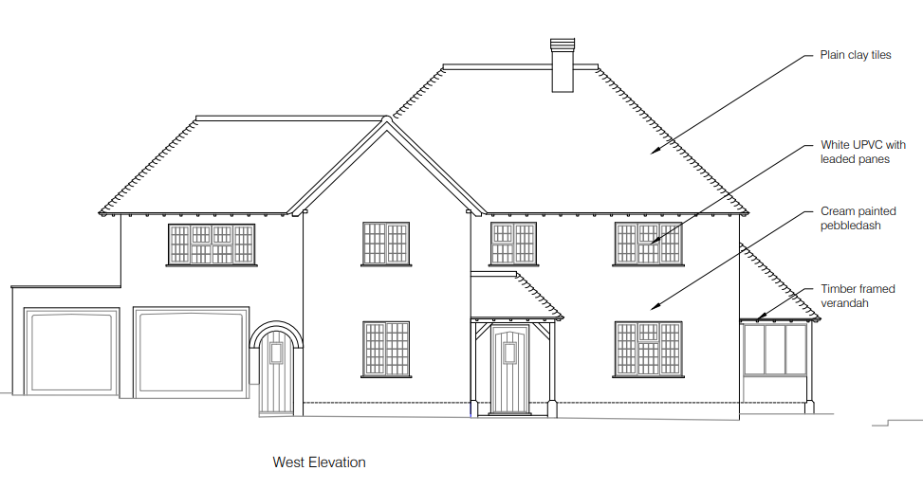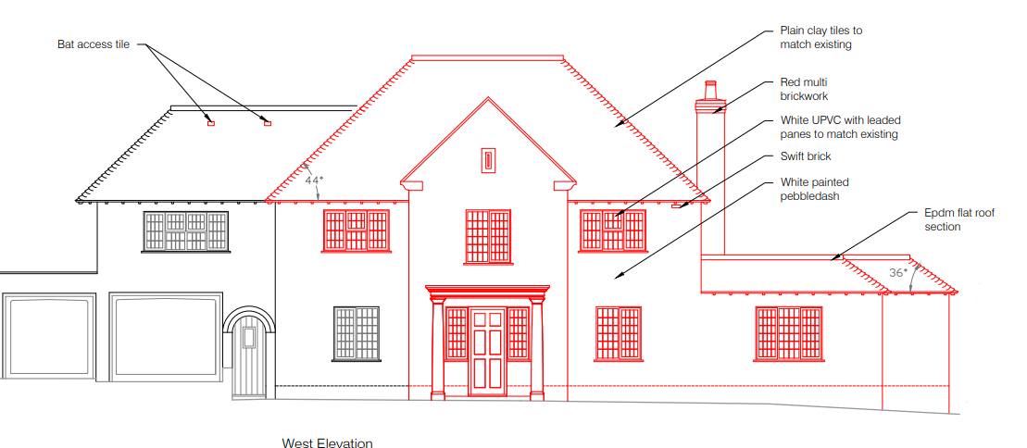

Existing side (north) elevation proposed proposed side elevation
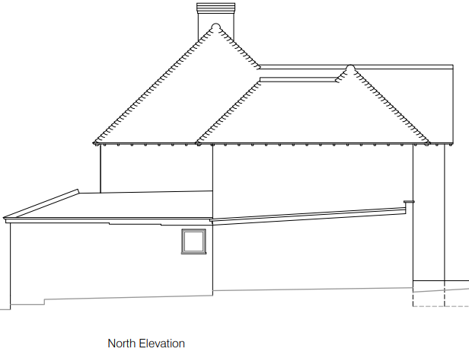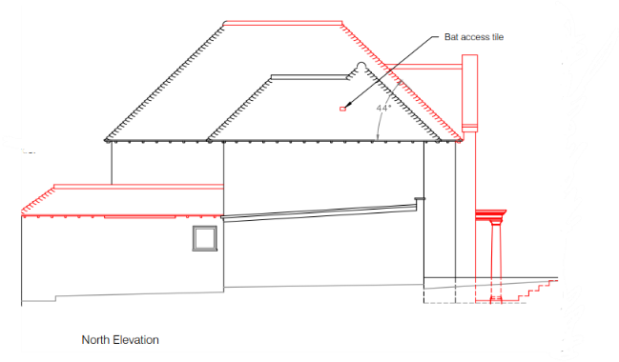
Existing rear (east) elevation proposed rear elevation
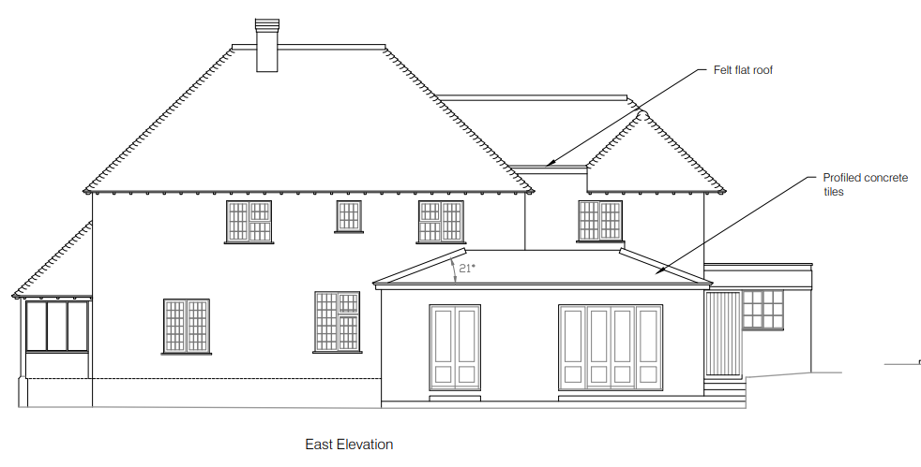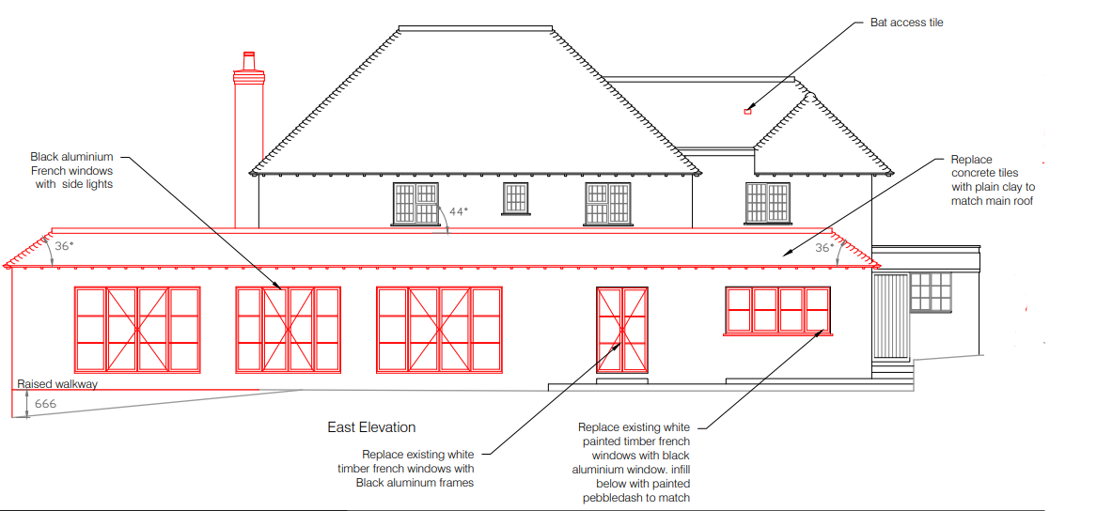

Existing side (south) elevation proposed side elevation
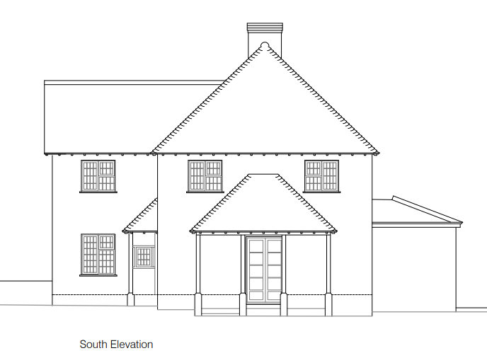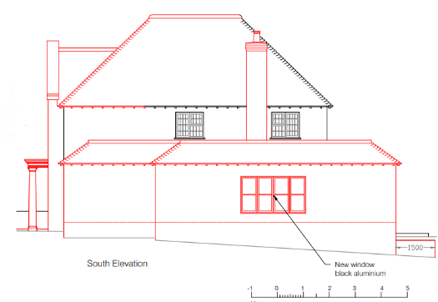

RELEVANT PLANNING HISTORY:

S/2012/0363 Erection of single storey rear extension. Approved
S/2009/0507 To construct an extension to the side (south) of the existing house to form a separate sitting room. Approved.
S/2001/1106 Construction of pitched roof over first floor flat roof. Approved
S/1994/1366 Improvements/alterations to low level roof. Approved

PLANNING ASSESSMENT:

Principle:

The application site is located within the small village of Berwick St James, part of the Amesbury Community Area, which is defined as a small village by WCS core strategies 1 and 2. The housing policy boundaries have been removed from small villages effectively categorizing them as the countryside. Saved policy H31 from the previous Salisbury District Local Plan has been retained following the adoption of the WCS.

The WCS states that within small villages some modest development may be appropriate to contribute to the vitality of rural communities by ensuring better facilities and homes.

Saved policy H31 from the Salisbury District Local Plan 2003 states that in the countryside extensions to existing dwellings will be permitted provided that

a) The extension is subservient in size to the existing dwelling and house plot and does not substantially alter the character of the dwelling;
b) The design of the extension is in keeping with that of the existing dwelling and uses complementary materials;
c) The extension would not create, or be capable of creating, a separate dwelling.

Saved policy C24 From the Salisbury District Local Plan 2003 states that: Extensions and additions to buildings in the countryside will only be permitted if they are sympathetic in scale and character with the existing building and surroundings, and fall within the existing curtilage.

Saved Policy C6 seeks to ensure that development proposals have regard to the high quality of the landscape: Within the Special Landscape Area, proposals for development in the countryside will be considered having particular regard to the high quality of the landscape. Where proposals which would not have an adverse effect on the quality of the landscape are acceptable, they will be subject to the following criteria;

- the siting and scale of development to be sympathetic to the landscape; and
- high standards of landscaping and design, using materials which are appropriate to the locality and reflect the character of the area.

Furthermore, the site is already in use for residential purposes and the principle of extensions or additions to be used in association with the residential use is accepted. These principle acceptabilities are, however, subject to the detail, such as their implications for the character of the area and neighbouring amenities. These will, therefore, be addressed in more detail below.

Character & Design:

Core Policy 57 states that new development is expected to create a strong sense of place through drawing on the local context and being complementary to the locality. Residential extensions such as this are acceptable in principle subject to there being no adverse impacts.

Good design helps to provide a sense of place, creates or reinforces local distinctiveness, and promotes community cohesiveness and social wellbeing; The layout and design of new developments must also be based on a thorough understanding of the site itself and its wider context, and seek to maximise the benefits of the site's characteristics. This will require careful consideration of the site layout. No two sites share the same landscapes, contours, relationship with surrounding buildings, street pattern and features. The proximity of poor quality or indistinct development is not a justification for standard or poor design solutions. New development should integrate into its surroundings whilst seeking to enhance the overall character of the locality; A high standard of design is required in all new developments, including extensions, alterations, and changes of use of existing buildings.

The proposed development seeks to extend the existing dwelling by way of a two storey front extension which essentially relocates the existing two storey front extension further to the south, so it sits more centrally within the larger, main part of the dwelling. The two storey front extension is similar in scale and design to the existing which will be removed although the first floor window is larger. The proposed front extension also includes a front porch.

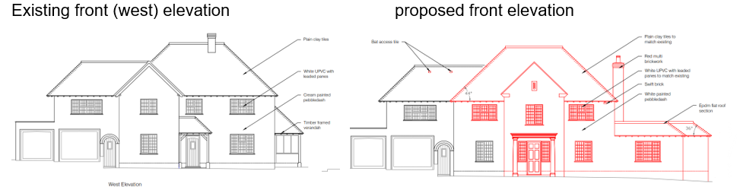
The proposed two storey extension is considered to be of an appropriate design and scale and is considered to enhance the appearance of the host dwelling. The use of materials to match the existing dwelling allowing the extension to integrate with the existing built form.

It is also proposed to erect a flat roof single storey side and rear extension which is an L shape wrapping from the south and east elevations of the property. The single storey extension will also be constructed using materials to match the existing dwelling.

The single storey extension is a large addition to the existing dwelling, in particular the rear extension in terms of footprint/floor area. When viewed from the front and public realm, as the property has been constructed at an angle to the road, the single storey side extension will be the furthest part of the front elevation from the road. The montage of images below taken from Google maps dated June 2024 show how the dwelling as existing sits within the streetscene. The images start looking south as entering the village past the 30mph sign, and end looking north back at the property through The Leat House front garden.

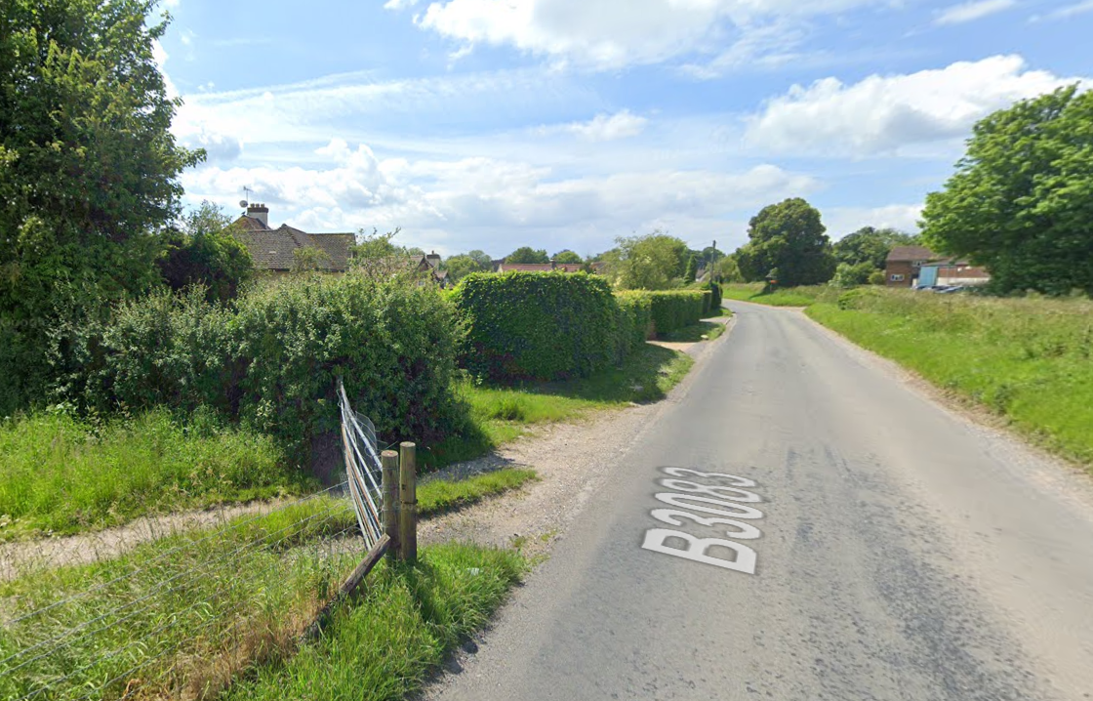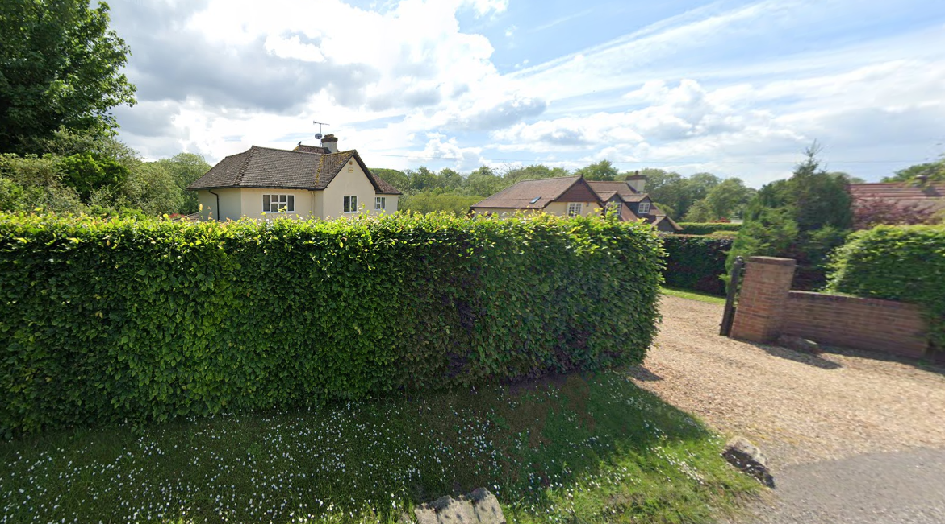
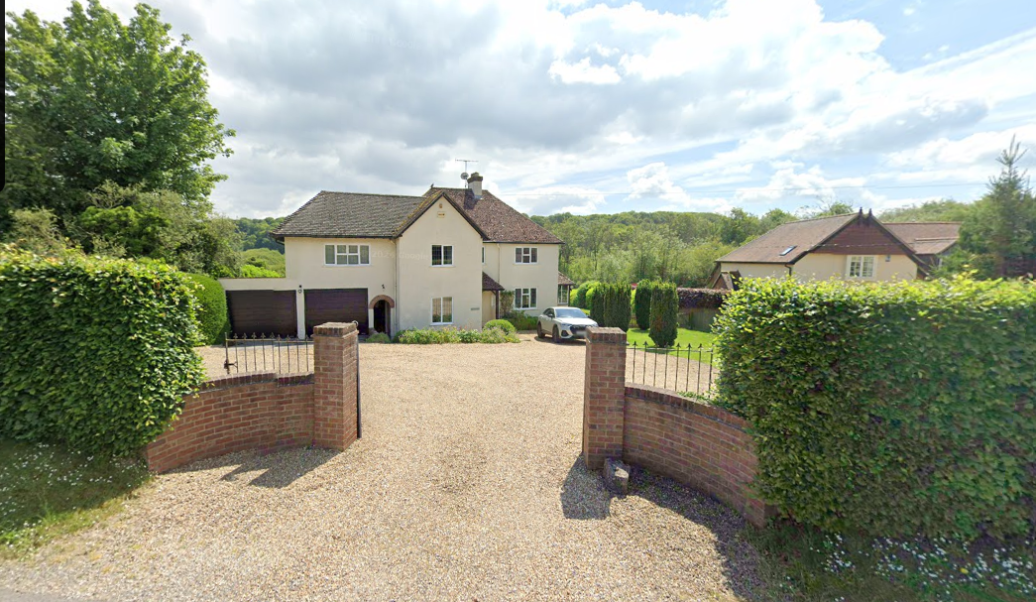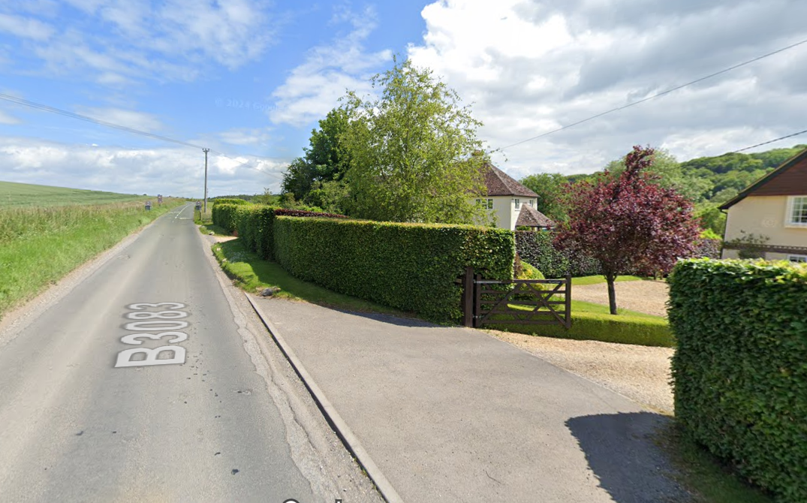

In this regard, the proposed single storey extension is not considered to have a harmful impact on the character of the dwelling or wider area. It is noted that there is a new chimney proposed which does project above the roof of the single storey addition, this however when viewed in context of the overall proposed built form is not considered to add a visually unacceptable element to the host dwelling.

Regarding the single storey rear extension, whilst this is a large addition to the existing dwelling, its location at the rear minimises the impact of the extension. The application site is a large site and as such can accommodate a large extension without appearing as overdevelopment of the site.

The overall proposed development is not considered to have an adverse impact on the character of the area, taking into account the varying designs and scale of properties within the village. Officers are not of the view that the proposals are out of keeping with the overall character of the area, Officers also note the that the property is outside of the conservation area therefore having no adverse impacts on the conservation area and does not affect the setting of any listed buildings. The property is also fairly well screened to the north and west through the existing mature hedges and trees; and whilst the property is the first dwelling when entering the village from the north, the proposals in terms of scale, design, materials and siting are not unacceptable for this locality and do not warrant a refusal in this instance.

Officers note the third party objections which relate to the development being too big for the site, overdevelopment, out of keeping with the village, inappropriate design, scale, form, mass; doubling size of dwelling and a 40 % increase in size. Officers also note the large number of objections received as well and that all 30 people who attended the village meeting objected to the proposals. However, as above, Officers do not consider when taking into account the context, size of plot, existing and proposed design/scale/siting/form/mass that the proposed extensions and alterations are contrary to policy and consider that to refuse on these grounds would not be defendable at appeal.

Parking/highway safety

The application site has an existing vehicle access to the front with an area to the front for off road parking, there is also space for vehicles to turn to exit in a forward gear. The Highway Authority was consulted as part of the application process and has raised no objections.

The third party comment raising concerns that the building will cause safety concerns with building traffic on the A303 and where the site is, is where the speed limits goes from 50 mph to 30mph is noted. However, the application is for householder extensions and not major development, the building traffic therefore will not be on a scale to significantly impact on highway safety with the duration of the works being limited due to their scale.

Ecology

Core Policy 50 of the Wiltshire Core Strategy and the National Planning Policy Framework requires that the planning authority ensures protection of important habitats and species in relation to development and seeks enhancement for the benefit of biodiversity through the planning system.

An initial preliminary ecological assessment was submitted with the application which identified the site as having potential as a bat roost and stated that further surveys were due to be carried out on site during the summer.

A further ecology report (Bat Survey Report by Daniel Ahern Ecology) was submitted after additional on-site surveys were carried out in June and July 2024. This confirmed the building was a bat roost for summer/day roost and that it will be necessary to apply for and obtain a European Protected Species Licence (EPSL) from Natural England under the conservation (Natural Habitats, &c) (Amendments) 2017 Regulations, to legally allow the proposed works to take place. No building works must take place until an EPSL has been issued. Under section 4.2 of the Bat Survey Report, a list of mitigation/enhancement measures are included. Any approval will include a condition which states the development shall be carried out in strict accordance with these details.

The site and location for the proposed development is within the River Avon 20m buffer, a construction method statement is therefore required to set out how the development will incorporate measures to avoid pollution to the river and natural environment. The applicant provided a construction method statement and associated plan to show where barriers will be erected to prevent pollution into the river. Any approval will condition the works carried out in accordance with the agreed details in the construction method statement and associated plan.

Neighbouring Amenities:
WCS policy CP57 (Ensuring High Quality Design & Space Shaping) requires that development should ensure the impact on the amenities of existing occupants/neighbours is acceptable and ensuring that appropriate levels of amenity are achievable within the development itself. The NPPF includes that planning should “always seek to secure high quality design and a good standard of amenity for all existing and future occupants of land and buildings”. Residential amenity is affected by significant changes to the environment including privacy, outlook, daylight and sunlight, and living areas within private gardens and this, therefore, needs to be carefully considered accordingly.

The application site has one adjacent neighbour that has the potential to be affected by the proposed development, this neighbour is known as The Leat House and is to the south of The White House. The proposed development will include a single storey side extension on the south side brining the build form of The White House closer to the shared boundary with The Leat House. Included below is an extract from the submitted plans which shows the location of the application site in the location plan and also a site plan with the proposed extensions marked in red.

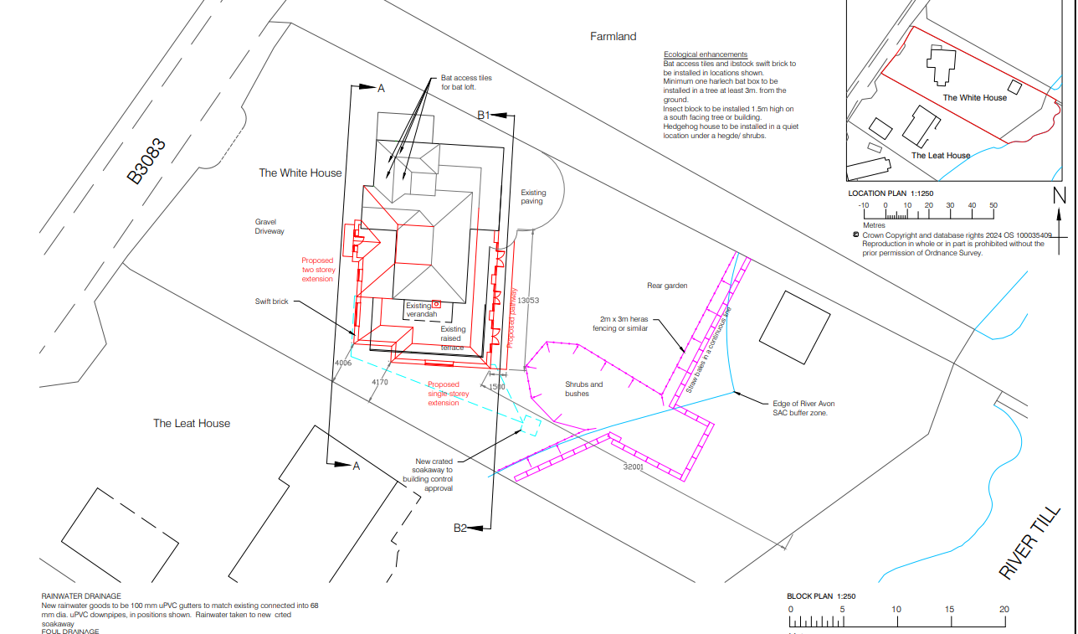

The White House has been constructed at an angle to The Leat House, the rear of The White House therefore orientated towards the east rather than south east. This orientation removes overlooking from the rear directly towards The Leat House with. The proposed single storey rear extension includes a large amount of windows/glazing, however, due to the orientation and single storey height it is not considered that the rear extension will conflict with neighbour amenity.

The proposed single storey side extension will bring the property to within approx. 4m of the boundary with The Leat House, the extension includes one new window for the sitting room as shown below. In order to construct the extension, the ground level to the south of the property is to be raised so it is level with the existing. This is shown on the site section as below which also provides details of the differing ground levels and possible views towards The Leat House.
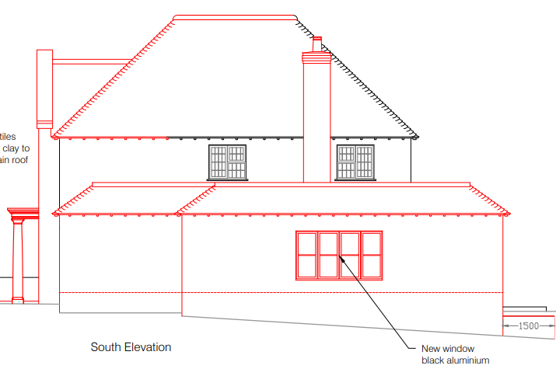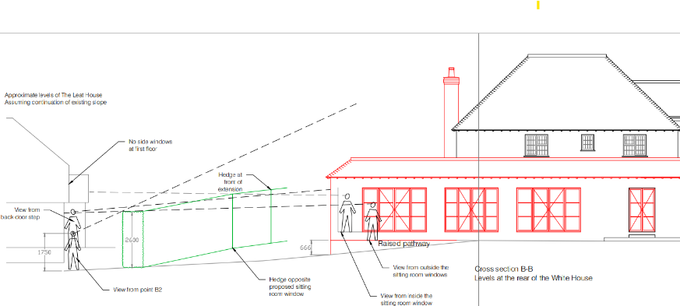

The photos below taken by the case officer show the current southern boundary of the application site with the upper part of the north elevation of The Leat House visible. This hedging provides good screening which helps to minimise impacts on The Leat House. The occupiers of The Leat House have raised objections that the hedge is deciduous and therefore does not provide the same level of visual protection during the winter months; this is noted.

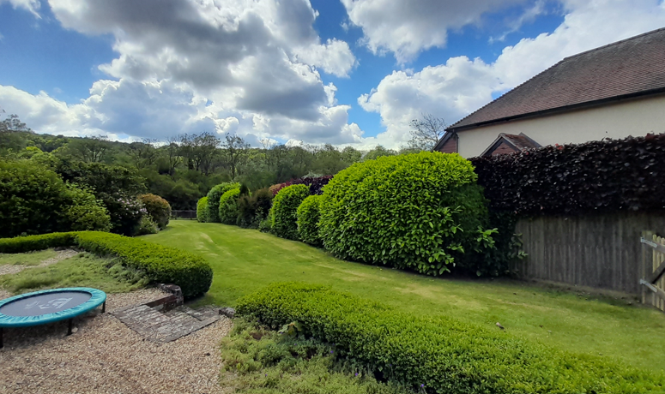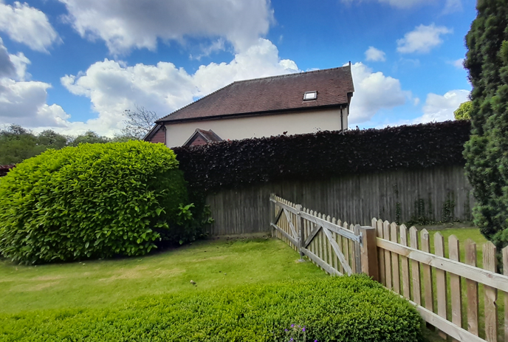

The comments received have also stated that as The Leat House was built 5 metres from the boundary, The White House should do the same. There is no policy which stipulates the proximity of a development from the boundary, each case is assessed on its own merits. In this instance the proposals are approx. 4m from the boundary with The Leat House and is considered to be acceptable.

It is however considered prudent to add a condition to an approval that the window in the south elevation at ground floor level serving the new sitting room facing The Leat House is obscure glazed to level 5 obscurity to protect the amenity of The Leat House due to the finished levels of the build being uncertain until the works are carried out. To obscure glaze a sitting room window is generally not something the Council would wish to do but, in this instance, the rear elevation has a large amount of clear glazing providing views across the garden of the application site thus the obscure glazing would have limited impacts on the occupiers of the property when using the sitting room. There will be some impact on The Leat House in relation to this south facing sitting room window, it is not considered that this will be significant however to be on the safe side this condition will be added. This will give the occupiers of The Leat House some reassurance and once built it may become evident that there is no overlooking or that there is some which has been mitigated against through the obscure glazing on the sitting room south facing window.

The proposed two storey front extension and front porch due to their siting are not considered to have adverse impacts on neighbour amenity.

Officers note the objections from third party and in particular from the occupiers of The Leat House. Officers do understand their concerns however, in this instance, whilst the proposed extension may have some impacts on The Leat House, it is not considered that these impacts will be significant and, in this regard, it is not considered that the impacts are sufficient to warrant a refusal in this instance.

Other

There are a few points raised by third party objections which haven’t been covered in the sections above, for completeness these will be addressed below.

Starting with the issue relating to the single storey extension and isolated chimney having a design which is making way for future development to create a second storey. Officers cannot object to a development which may or may not happen in the future, to add a second storey would require planning consent and should the applicants decided to do this in the future they would need to submit a planning application. Should an application submitted, Officers would assess the acceptability of this at the time and third parties/consultees would be consulted and have the opportunity to comment at the time.

A comment has been received which states that there is a well below the extension that should be addressed. If a well is uncovered, then building regulations would need to assess the situation to ensure the development can be built appropriately. If changes need to be made to the development as a result, then a new application would need to be submitted.

Comments have been received about the proposed extensions not being used for residential purposes but for use as a place of worship, this is a householder application for residential extensions to a residential property, if the applicant wishes to conduct a business or other use from the property then a change of use application would be required- subject to the details.

Comments have suggested the house should extend to the north or to the rear and would then be more appropriate. Firstly, the development is extending to the rear. Secondly Officers are obliged to consider the development before them and the acceptability of what has been put forward. If the proposals as submitted were to be considered unacceptable to a degree which would warrant a refusal, then alternatives could potentially be discussed.

A comment has been received stating that if applicant wanted big house why buy this one, this is not a material planning consideration.

A comment has been received which relates to the property being big and unaffordable for village families to buy, this is noted but is not a material consideration for an application for householder extensions such as this.

CONCLUSION:

The proposed development is considered to be acceptable by reason of its scale, design and siting, with no significant impact to neighbouring amenities, the character of the area/Special Landscape Area, no significant highway impacts or ecological impacts. The proposed development is therefore considered to be in accordance with Core Policies 1, 2, 4, 50, 51, 57 and 69 of the adopted Wiltshire Core Strategy, saved policies C6, C24 and H31 of the Salisbury District Local Plan and the aims of the NPPF.

RECOMMENDATION: Approve subject to the following conditions.

1.The development hereby permitted shall be begun before the expiration of three years
from the date of this permission.

REASON: To comply with the provisions of Section 91 of the Town and Country Planning Act
1990 as amended by the Planning and Compulsory Purchase Act 2004.

2.The development hereby permitted shall be carried out in accordance with the following
approved plans:

Application form received 23/04/2024
Location plan received 23/04/2024
Construction method statement 16/09/2024
Site Plan Drg no Drg no TWH04BP Rev C river protection details received 17/09/2024
Proposed floor plans TWH06FPP Rev B received 09/08/2024
Proposed elevations Drg no TWH08EP Rev C ecology mitigation received 09/08/2024
Site sections Drg no TWH10SCS received 09/08/2024

REASON: For the avoidance of doubt and in the interests of proper planning.

3.The materials to be used in the construction of the external surfaces of the development
hereby permitted shall match in material, colour and texture those detailed within the approved
application form and plans.

REASON: In the interests of visual amenity and the character and appearance of the area.

4. The flat roof area of the development hereby permitted shall not be used as a balcony, roof
garden or similar amenity area.

REASON: In the interests of residential amenity and privacy

5. The development will be carried out in strict accordance with the following documents:

- Bat Survey Report by Daniel Ahern Ecology dated 23 July 2024

The development hereby approved shall not be occupied or used until the mitigation measures
specified under section 4.2 of the above report have been carried out. The mitigation
measures shall remain for the lifetime of the development.

REASON: For the avoidance of doubt and for the protection, mitigation and enhancement of
biodiversity.

6. No works including demolition or site clearance shall commence until the protective barriers
as detailed with the approved construction method statement and shown on the associated
site plan Drg no TWH04BP Rev C river protection details have been erected in accordance
with the agreed details.

The protective barriers shall remain in the agreed location until the proposed development has
been completed and all materials and equipment have been removed from site.

The development shall not be carried out otherwise than in accordance with the approved
construction method statement without the prior written permission of the Local Planning
Authority.

REASON: To minimise detrimental effects to the natural environment which includes the River
Avon SAC through the risks of pollution during the construction phase.

7. Notwithstanding the provisions of the Town and Country Planning (General Permitted
Development) (England) Order 2015 (or any Order revoking or reenacting or amending that
Order with or without modification), there shall be no additions/extensions or external
alterations to any building forming part of the development hereby permitted.

REASON: In the interests of the amenity, character and appearance of the area and to enable
the Local Planning Authority to consider individually whether planning permission should be
granted for additions/extensions or external alterations.

8. Notwithstanding the provisions of the Town and Country Planning (General Permitted
Development) (England) Order 2015 (or any Order revoking or reenacting or amending that
Order with or without modification), no windows, doors or other form of openings other than
those shown on the approved plans, shall be inserted in the south elevation of the
development hereby permitted.

REASON: In the interests of residential amenity and privacy

9. Notwithstanding the provisions of the Town and Country Planning (General Permitted
Development) (England) Order 2015 (or any Order revoking or reenacting or amending that
Order with or without modification), no window, dormer window or rooflight, other than those
shown on the approved plans, shall be inserted in the south or east roofslopes of the
development hereby permitted.

REASON: In the interests of residential amenity and privacy

10. The extension hereby permitted shall not be occupied at any time other than for purposes
ancillary to the residential use of the main dwelling, known as The White House and it shall
remain within the same planning unit as the main dwelling.

REASON: The additional accommodation is sited in a position where the Local Planning
Authority, having regard to the reasonable standards of residential amenity, access, and
planning policies pertaining to the area, would not permit a wholly separate dwelling.

11. Notwithstanding the approved plans, before the development hereby permitted is first
brought into use/occupied, the new ground floor window in the west elevation serving the
ensuite for bedroom No 5 shall be entirely glazed with obscure glass only (to level 5 obscurity).
The window shall be retained as such for the lifetime of the development.

REASON: In the interests of residential amenity and privacy

12. Notwithstanding the approved plans, before the development hereby permitted is first
brought into Use/occupied, the new ground floor window in the south elevation serving the
sitting room, facing The Leat House shall be entirely glazed with obscure glass only (to level
5 obscurity). The window shall be retained as such for the lifetime of the development.

REASON: In the interests of residential amenity and privacy

Informative Party Wall

The applicant is requested to note that this permission does not affect any private property
rights and therefore, does not authorise the carrying out of any work on land outside their
control. If such works are required, it will be necessary for the applicant to obtain the
landowners consent before such works commence. If you intend carrying out works in the
vicinity of the site boundary, you are also advised that it may be expedient to seek your own
advice with regard to the requirements of the Party Wall Act 1996.

INFORMATIVE TO APPLICANT – Building control

Any alterations to the approved plans, brought about by compliance with Building Regulations or any other reason must first be agreed in writing with the Local Planning Authority before commencement of work.

INFORMATIVE- protected species

The applicant should note that under the terms of the Wildlife and Countryside Act (1981) and the Habitats Regulations (2010) it is an offence to disturb or harm any protected species, or to damage or disturb their habitat or resting place. Please note that this consent does not override the statutory protection afforded to any such species. In the event that your proposals could potentially affect a protected species you should seek the advice of a suitably qualified and experienced ecologist and consider the need for a license from Natural England prior to commencing works. Please see Natural England’s website for further information on protected species.

Informative Breeding Birds

The adults, young, eggs and nests of all species of birds are protected by the Wildlife and
Countryside Act 1981 (as amended) while they are breeding. Please be advised that works
should not take place that will harm nesting birds from March to August inclusive. All British
birds, their nests and eggs are protected under Section 1 of the Wildlife and Countryside Act
1981 (as amended) and the Countryside and Rights of Way Act 2000 while birds are nesting,
building nests and sitting on eggs. The applicant is advised to check any structure or
vegetation capable of supporting breeding birds and delay removing or altering such features
until after young birds have fledged. Damage to extensive areas that could contain
nests/breeding birds should be undertaken outside the breeding season. This season is
usually taken to be the period between 1st March and 31st August but some species are
known to breed outside these limits.

