APPLICATION FOR FULL PLANNING PERMISSION DELEGATED REPORT

APPLICATION REFERENCE: | PL/2025/08637
APPLICATION TYPE: | Full planning permission
SITE ADDRESS: | PILE OAK COTTAGE, SCOTTS HILL, DONHEAD ST ANDREW, SHAFTESBURY, SP7 9EH
DEVELOPMENT DESCRIPTION: | Change of use of Agricultural Land to residential curtilage, retention of shed and associated landscape works (retrospective)
RECOMMENDATION: | That Planning Permission be GRANTED

PROPOSAL

The application is seeking retrospective consent for the change of use of agricultural land to residential curtilage, landscaping works and retention of an existing shed.

Below left shows the area for change of use, below right is the full site plan.

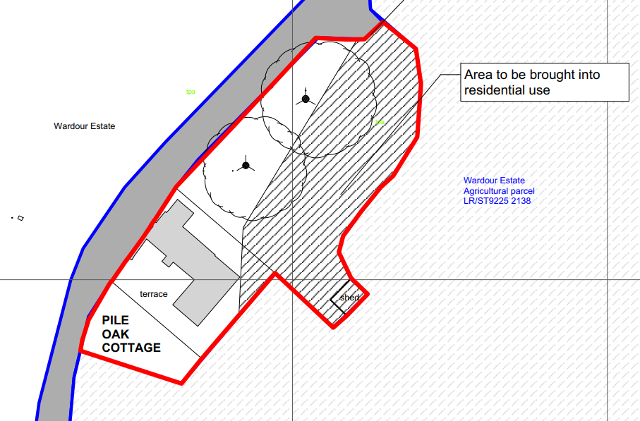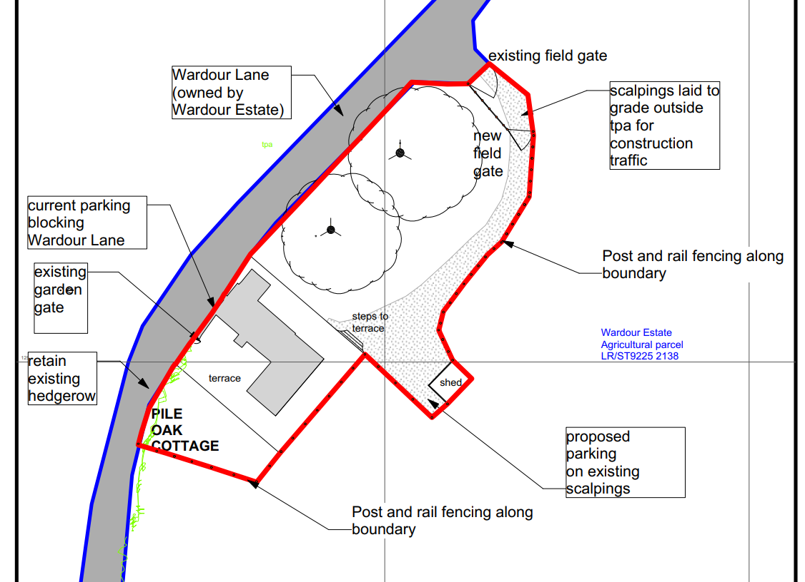

During the course of the application, amendments were made to the extent of the red line and area for change of use following concerns relating to the encroachment of residential land into the rural landscape. Officers also raised that the south section of the originally shown red line which was allegedly residential garden had not benefitted from a formal change of use and did not have the character of residential garden, nor was it separated from the adjacent field by a fence or other form of boundary. Having discussed with the applicant, it also became clear that it would be unlikely that there was evidence that come support the use of the southern section of originally red lined land as residential for a continuous period of at least 10 years and therefore a certificate of lawfulness would be unlikely to succeed, this was subsequently removed from the red line. A reduced red line was therefore submitted relating to the above.

SITE DESCRIPTION/CONTEXT

The application site relates to an existing extended detached dwelling located off of a public right of way DSTA7 which branches off to the east of Scots Hill on the outskirts Donhead St Andrew. Donhead St Andrew is a small village as defined by Wiltshire Core Strategy (WCS) core policies 1 (Settlement Strategy), 2 (Delivery Strategy) and 27 (Spatial Strategy for the Tisbury Community Area). The site is located within the Cranborne Chase & West Wiltshire Downs National Landscape (formerly known as AONB) and is within the River Avon SAC. Trees subject to a tree preservation order are located along the north west boundary of the site.

PLANNING HISTORY

Proposal / Summary
PL/2021/11765 - Full planning permission Decision - Withdrawn by Applicant Date: 12/10/2022 – Demolition of existing cottage and replacement with new dwelling
PL/2021/05901 - Householder planning permission Decision - Approve with Conditions Date: 18/10/2021 – Extension and refurbishment of cottage to include a two storey side extension, replacement porch, off-road parking / turning and associated works
TPO/2021/00012/IND – Two Oak Trees

RELEVANT POLICIES AND GUIDANCE

The National Planning Policy Framework (NPPF)
The Planning Practice Guidance
National Design Guide

Wiltshire Core Strategy

Core Policy 1 Settlement Strategy
Core Policy 2 Delivery Strategy
Core Policy 27 Tisbury Community Area
Core Policy 50 Biodiversity and Geodiversity
Core Policy 51 Landscaping
Core Policy 57 Ensuring high quality design and place shaping
Core Policy 69 Hampshire River Avon SAC

Wiltshire Design Guide
Creating Places Design
National Landscape Management Plan

CONSULTATION RESPONSES

Parish Council: Objection to the initial submission but no objections to the amended submission.

WC Rights of Way: No comments received

REPRESENTATIONS

For the original submission one letter of support was received

Being one of the closest neighbours, I do not have a problem with the erection of a shed, or the parking and access plan. In fact, the access to the house is much better as it gets their cars off the track.

and one letter of objection was received, points made are summarised below

- For application PL/2021/05091, a parking area was arranged on the domestic curtilage beside the front door with no intrusion into the field. A temporary access track was construction for PL/2021/11765 but the application was withdrawn. This track is the drive subject to this current application. The shed was built 2025.
- Pile Oak and adjoining field are outside of settlement boundary, the increase curtilage is pushing development into the countryside, affecting footpath DSTA7
- Concerns regarding incorporating and fencing off existing field gate into domestic curtilage and no longer suitable for tractors or livestock. No new dedicated field gate is shown. The field would appear as garden and not field
- If field not fenced could become large car park with a risk to animals and children.
- Domestic curtilage will increase approx. 50% due to the shed, this takes away large chunk of field and will reduce grazing
- Many houses park outside their front/back door which is convenient and desirable.
- Approval of retrospective works should not be underestimated.

A further letter of objection has been received in relation to the amended plans, points raised are summarised below-

- Amount of land converted to residential has been reduced and a fence proposed around it but there are still question marks about the fundamental desirability of this request.
- Drawings show incomplete picture of existing residential curtilage; this runs up to Vale House. Why is this now outside the residential curtilage
- Laurel has been planted in the hedge which is poisonous to horses.
- Applicants assured village that tractors would still access the field by the existing access, but it is shown within the red line with a post and rail fence. Unacceptable to designate a field gate as a domestic one unless there are to be other uses for the field than agricultural
- Drive was for a temporary track to facilitate building works; they were told they couldn’t have one when they applied to extend the cottage
- The drive, car park and particularly the shed are out of keeping with the character and beauty of this rural setting .
- important to preserve the rural outlook from the village’s main footpath DSTA7 to Wardour Wood and Wardour Castle.
- The shed in particular, thrust into the middle of the field, introduces what has been described elsewhere as an “urbanising and visually intrusive feature” into a landscape which forms part of the Cranborne Chase National landscape.
- Track is never blocked so no need to remove cars from parking on the track
- If fence isn’t erected between house and field the field could be sued as a car park
- approval of the drive, parking area and shed by designating the area residential curtilage is not in the interests of the village, could lead to a substantial degradation of a protected site and would set an unfortunate precedent.

ASSESSMENT

Section 38(6) of the Planning and Compulsory Purchase Act 2004 states:

"If regard is to be had to the development plan for the purposes of any determination to be made under the planning Acts, the determination must be made in accordance with the plan unless material considerations indicate otherwise."

In accordance with this statutory requirement, this application has been assessed against the relevant policies of the Development Plan, including the adopted Wiltshire Core Strategy (2015) and, where applicable, any made Neighbourhood Plans.

Design and Impact upon the character and context of the area including the National Landscape

Core Policy 57 - Ensuring High Quality Design and Place Shaping of the Wiltshire Core Strategy seeks to ensure that all new development is of high design quality, reflecting local context, character, and distinctiveness.

Core Policy 51 of the Wiltshire Core Strategy requires all development to protect, conserve, and where possible enhance the character and quality of Wiltshire’s landscapes, giving particular weight to designated areas such as National Landscapes.

The National Planning Policy Framework (NPPF), in Paragraph 176, states that “great weight” should be given to conserving and enhancing landscape and scenic beauty in National Landscapes (formerly Areas of Outstanding Natural Beauty). Development within or affecting the setting of a National Landscape must demonstrate that it will not result in unacceptable harm to the special qualities of that area.

The proposal seeks consent for the retention for change of use of an area of agricultural land to residential. The works include the retention of the use of a former agricultural field gate and track leading from the gate to the rear of Pile Oak Cottage for use as the main access and off road parking for the application site. The gateway would be used for both access to the field and also for the dwelling (Pile Oak Cottage). It is not unusual for an access to serve both agricultural fields and residential curtilage. It is understood that the drive was constructed as part of previous development at the site for use during building works.

The land is owned by Wardour Estate, and it is understood that an informal arrangement between the occupiers of Pile Oak Cottage and Wardour Estate has allowed the use of an additional section of the adjacent agricultural field to the north of the dwelling as garden. There is no formal physical subdivision through any boundary treatment and therefore the area for change of use has been arbitrary. Through this current planning application, the formal change of use and subdivision can be assessed. The applicant has also agreed to erect a post and rail fence as a formal boundary between the residential land and agricultural land to avoid any question in the future regarding the extent of the residential curtilage for Pile Oak Cottage.

The site is located off a private road which also serves as a public right of way. The site is slightly elevated above the right of way, to the south of Pile Oak Cottage, a boundary hedge provides screening and limits views into the property from this section of the right of way. To the north of the dwelling, there are views into the application site from the gate as shown below.

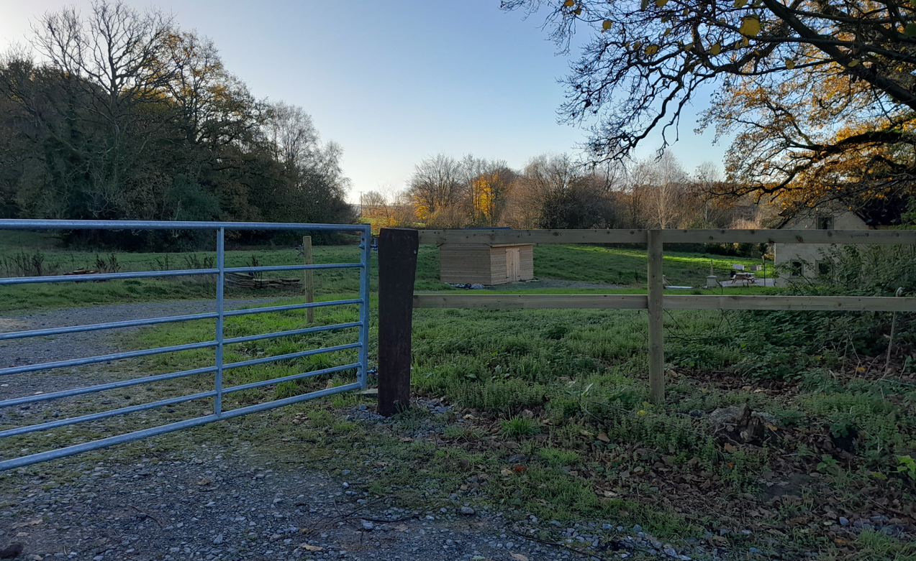

The application is also seeking consent to retain a timber shed that has been erected on the site and on what is agricultural land, should change of use be granted this would become part of the official residential curtilage for Pile Oak Cottage.

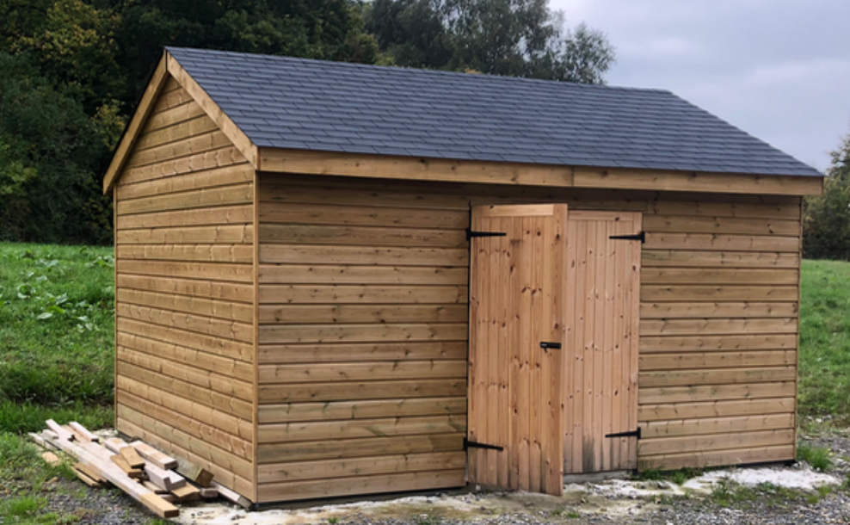

The area of land seeking change of use to residential is not considered to be a significant area, in this instance it considered that the change of use would not give rise to harm to the character or appearance of the area.

The proposed change of use and erection of the new shed given its location, and the design, scale and materials used , would adversely impact on the landscape in the opinion of officers. The site is not prominent within the wider landscape and is screened to a degree by existing boundary features; although the site can be glimpsed from the adjacent public right of way, these views are limited and have only localised modest visual impacts. The proposed post and rail fence is considered appropriate for this rural setting and raises no concerns.

There are no concerns regarding the drive that has been constructed to provide parking to the rear of the existing dwelling.

The proposal therefore accords with Core Policies 57 and 51 of the Wiltshire Core Strategy and does not create significant harm to the character of the National Landscape

Amenity

Point vii of Core Policy 57 - Ensuring High Quality Design and Place Shaping of the Wiltshire Core Strategy seeks to ensure that developments do not adversely affect neighbouring properties.

The National Planning Policy Framework (NPPF), particularly Paragraph 135(f), stresses that planning decisions should ensure developments provide a high standard of amenity for existing and future users.

The proposed development has been assessed in terms of its potential impact on the residential amenity of neighbouring properties, with particular regard to loss of light, overshadowing, loss of privacy, and overbearing effects.

The application site has no immediately adjacent residential dwellings that will be affected by the development. The nearest residential property is located to the south and known as Vale House, the change of use does not encroach on the boundary with Vale House, and the shed is in excess of 90m from the dwelling at Vale House. Therefore, it is considered that the development poses no adverse impacts to neighbour amenity.

The proposal therefore accords with Core Policy 57 point vii in respect of safeguarding residential amenity and the relevant provisions of the NPPF.

Highways Impact/Right of Way

Core Policy 57 (xiv) of the Wiltshire Core Strategy seeks to ensure that development must meet the requirements of Core Policy 61. This policy requires proposals to be capable of being served by safe access to the highway network. Core Policy 64 seeks to ensure compliance with parking standards set out in the Local Transport Plan.

The National Planning Policy Framework (NPPF), particularly Paragraph 115 and 116, requires that development proposals do not have an unacceptable impact on highway safety and that safe and suitable access to the site can be achieved for all users.

The application site does not currently benefit from on-site parking with the occupier parking on the adjacent track which is a public right of way. As part of a previous planning permission, on-site parking was permitted to the south of the dwelling with access directly off the right of way. This permitted on site parking has however not been implemented as it conflicts with the occupiers of Pile Oak Cottage and the use of their patio area. The drive that has been constructed to the north of Pile Oak Cottage which leads to off road parking to the rear of the property is considered to provide a more practical access and does not impact on the applicants outside amenity space/patio area.

The removal of vehicles parking on the right of way is a benefit and is therefore supported by Officers.

There are no other highway safety impacts of the development.

The proposal is therefore considered to comply with Core Policies 57 (xiv), 61 and 64 of the Wiltshire Core Strategy, the NPPF, and the Wiltshire Local Transport Plan.

Ecology Impact

Core Policy 50 of the Wiltshire Core Strategy seeks to protect and enhance biodiversity and geodiversity, including through ensuring that development avoids harm to protected species and habitats.

The National Planning Policy Framework (NPPF), in Paragraphs 193, requires that development minimises impacts on and provides net gains for biodiversity, including ensuring mitigation is secured where harm cannot be avoided.

From 12 February 2024 Biodiversity Net Gain (BNG) became mandatory under Schedule 7A of the Town and Country Planning Act 1990 (as inserted by Schedule 14 of the Environment Act 2021).

Biodiversity Net Gain (BNG) does not apply to retrospective planning applications. National guidance confirms that the statutory BNG framework introduced under Schedule 7A of the Town and Country Planning Act 1990 is subject to specific exemptions and transitional arrangements, and these include retrospective applications.

As such, the development complies with Core Policy 50 of the Wiltshire Core Strategy and the relevant provisions of the NPPF.

CONCLUSION

The proposed development is considered to be acceptable in terms of its design, scale, and relationship with the surrounding area. It would not result in any unacceptable harm to the character of the locality including the National Landscape the amenities of neighbouring occupiers, or the interests of highway safety/use of the right of way or ecology.

The proposal is therefore considered to comply with the relevant policies of the Wiltshire Core Strategy, the Wiltshire Local Plan, and the National Planning Policy Framework. As such, the application is recommended for approval, subject to the conditions set out below.

RECOMMENDATION: That Planning Permission be GRANTED subject to conditions.

1.The development hereby permitted shall be carried out in accordance with the following approved plans:

Proposed Parking and access Drg no WEPO3LR received 27/01/2026
Proposed Boundary & Shed Drg no WEPO2LR received 27/01/2026
Location plan Drg no WEPO1LR received 27/01/2026

REASON: For the avoidance of doubt and in the interests of proper planning.

2. Within 6 months of the date of this permission, the post and rail fence shall be erected along the east, south and north boundaries of the application site as shown on approved plan Drg no WEPO2LR and shall be retained for the lifetime of the development.

REASON: For the avoidance of doubt and in the interests of the character of the area.

3. Notwithstanding the approved plans and provisions of the Town and Country Planning (General Permitted Development) (England) Order 2015 (or any Order revoking or re-enacting or amending that Order with or without modification), no garages, sheds, greenhouses and other ancillary domestic outbuildings shall be erected anywhere within the site.

REASON: To safeguard the character and appearance of the area.

INFORMATIVES

BNG not required -The effect of paragraph 13 of Schedule 7A to the Town and Country Planning Act 1990 is that planning permission granted for development of land in England is deemed to have been granted subject to the condition (biodiversity gain condition) that development may not begin unless:

(a) a Biodiversity Gain Plan has been submitted to the planning authority, and
(b) the planning authority has approved the plan.

The planning authority, for the purposes of determining whether to approve a Biodiversity Gain Plan, if one is required in respect of this permission would be Wiltshire Council.

There are statutory exemptions and transitional arrangements which mean that the biodiversity gain condition does not always apply. For further information on exempt developments please refer to:
https://www.gov.uk/guidance/biodiversity-net-gain-exempt-developments
Based on the information available this permission is considered to be one which will not require the approval of a biodiversity gain plan before development is begun because one or more of the statutory exemptions or transitional arrangements is considered to apply.

