APPLICATION FOR PLANNING PERMISSION & LISTED BUILDING CONSENT. DELEGATED REPORT

APPLICATION REFERENCE: | PL/2025/09959 (FUL) & PL/2026/00098 (LBC)
APPLICATION TYPE: | Full planning permission & LBC
SITE ADDRESS: | South Wraxall House, South Wraxall, Bradford on Avon, BA15 2RY.
DEVELOPMENT DESCRIPTION: | Retrospective Construction of outdoor swimming pool with kitchen/storage, associated landscaping works. Partial demolition of existing external walls, construction of new external walls/gate.
RECOMMENDATION: | That Planning Permission & LBC be GRANTED

PROPOSAL& SITE DESCRIPTION

The site is located within the village of South Wraxall and is sited within the open countryside, it is not defined as a large or small village within the council’s adopted Core Strategy. The site is within the South Wraxall Conservation Area and Green Belt land, with the house being of Grade II listed status and dating predominantly from the 19th century.

The application is retrospective with the works being complete for the construction of an outdoor open air swimming pool, the construction of an associated small sized timber outbuilding, which is utilised as an outside kitchen and storage area. Landscaping works have taken place. The scheme has also part demolished a section of external wall to accommodate the construction of a new gate and external walling.

Although these are two separate applications, one for planning permission and the other for listed building consent, for the purposes of reviewing the application one joint report has been compiled covering all the issues.

RELEVANT PLANNING HISTORY
W/95/01262/FUL Addition of 3 dormers to north side of front range and 1 dormer to east side of north range. Approved.
W/08/00160/LBC & W/08/00159/FUL. Erection of timber framed glass house in existing vegetable garden within domestic curtilage. Approved.
W/08/03328/LBC & W/08/03323/FUL. Demolition of garden outbuilding and taking down retaining walls, reshaping wall with swan's neck detailing and construction of curved retaining wall in the front garden. Approved.
W/16/03783/FUL & W/16/04225/LBC Internal and extend alterations to existing to existing building, and construction of iron verandah. Approved.
W/19/01548/FUL & W/19/1704/LBC Alterations and widening of the existing vehicular entrance. Move and relocate a single stone pier and associated adjacent radiused walling. Form new pedestrian opening within adjacent rubble stone wall. Supply and fit new metal estate gates with matching metal pedestrian gate. New stone setts to bell mouth of new opening. Approved.

RELEVANT POLICIES AND GUIDANCE
National Context:
National Planning Policy Framework (NPPF) Planning Practice Guidance (PPG)
Planning (Listed Buildings and Conservation Areas) Act 1990

Wiltshire Core Strategy (WCS) adopted 2015:
• CP07 – Bradford on Avon Community Area Strategy
• CP50 – Biodiversity and Geodiversity
• CP51 – Landscape
• CP55 – Air Quality
• CP57 – Ensuring High Quality Design and Place Shaping
• CP58 – Ensuring the Conservation of the Historic Environment

Emerging Wiltshire Local Plan:
The emerging Wiltshire Local Plan has reached Regulation 24 stage. The examination is programmed to have more hearing sessions through 2026 and as such, the weight to be attributed to the emerging local plan is very limited at this stage.

CONSULTATION RESPONSES
South Wraxall Parish Council: Comment that they had concerns about the impact of the development on the listed building and the curtilage.

Conservation Officer: No objections and comment:

“The works are concealed within an existing walled garden context and therefore screened from view
by existing garden features.
The need for listed building consent is required in this case due to the amendment of the existing walling around the pool area.”

Historic England: No objections and refer the case officer to the comments of the Conservation Officer.

REPRESENTATIONS
One email of support has been received commenting that:

“The swimming pool and surrounds are very sympathetic with the main house and garden, beautifully designed and safety is provided by stone walls and a gate. The residents of the village have been welcomed by the owner to use this facility which is a wonderful opportunity to encourage wellbeing and health. I support this retrospective application fully”.

Principle of Development:
The principle of the completed works is acceptable as discussed below.

ASSESSMENT
The official listing of this grade II building describes the building as follows:
‘Detached house. Late C18. Limestone ashlar, mansard Welsh slate roof with coped verges and gable end stone stacks. L-plan. Two- storey, 3-window. Central double doors with 6 fielded panels and fanlight in portico with Composite columns, tripartite 16-pane sash with fluted pilasters either side, within segmental-headed recessed panel. First floor has 12-pane sash over doorway, flanking tripartite 16-pane sashes, dentil cornice to plain blocking course. Attic has two pairs of 12-pane sashes to lower pitch of mansard. Conservatory to right of front with three tall margin-pane casements, plain pilasters to entablature, glazed door, garden room attached to left has two 2-light margin-pane casements, plain pilasters to entablature. Rear wing has sashes. Interior not accessible at time of survey June 1987’.

Section 38(6) of the Planning and Compulsory Purchase Act 2004 states:

"If regard is to be had to the development plan for the purposes of any determination to be made under the planning Acts, the determination must be made in accordance with the plan unless material considerations indicate otherwise."

In accordance with this statutory requirement, this application has been assessed against the relevant policies of the Development Plan, including the adopted Wiltshire Core Strategy (2015).

The proposals can be viewed within the plan snippets taken from the submitted plans:

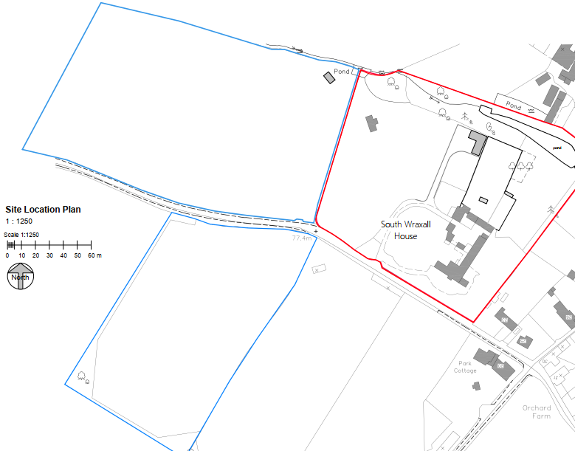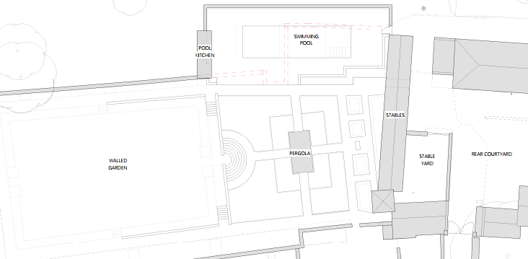
Location Plan Block plan of the swimming pool area.

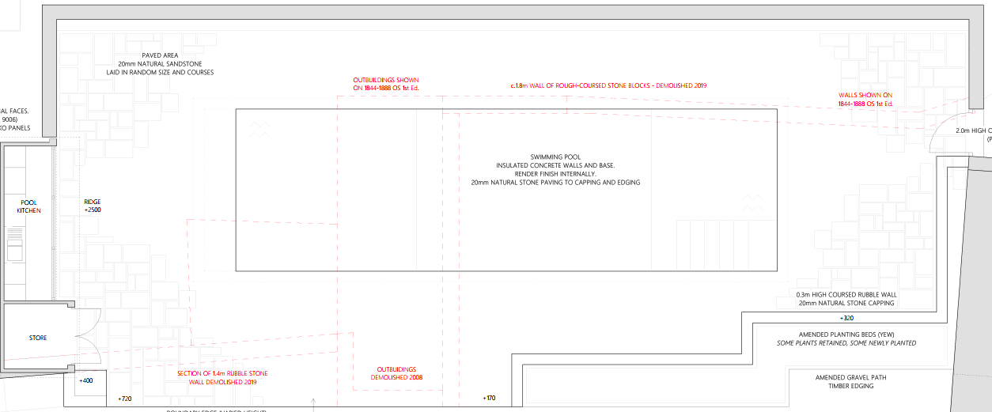
Swimming pool block plan.

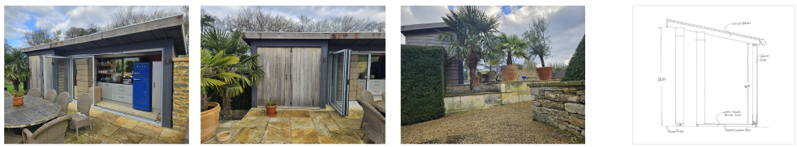
Photographs of outside kitchen / storage area

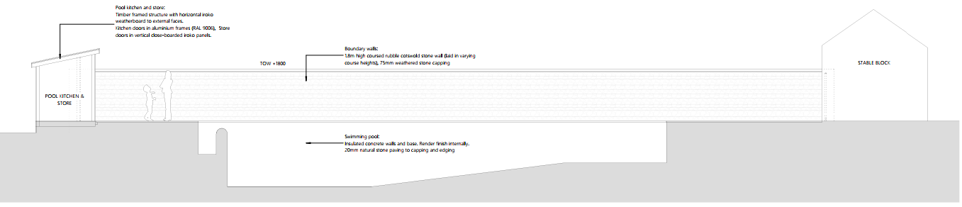
Cross section of pool area.

As initially discussed, this is a combined report for the listed building consent and planning application/s.

Above the various tiers of planning policy and guidance is the over-arching statutory requirement under the Planning (Listed Buildings and Conservation Areas) Act 1990 to give special regard to the “desirability of preserving the building or its setting or any features of special architectural or historic interest which it possesses” (s16 and s66).

Paragraph 212 of the NPPF states that “when considering the impact of a proposed development on the significance of a designated heritage asset, great weight should be given to the asset’s conservation. … This is irrespective of whether any potential harm amounts to substantial harm, total loss or less than substantial harm to its significance.”
Paragraph 213 of the NPPF states that “Any harm to, or loss of, the significance of a designated heritage asset (from its alteration or destruction, or from development within its setting), should require clear and convincing justification.

Paragraph 214 of the NPPF states that “Where a development proposal will lead to less than substantial harm to the significance of a designated heritage asset, this harm should be weighed against the public benefits of the proposal...”

Design and Impact upon the upon the character and context of the main listed building and area.
Core Policy 57 of the Wiltshire Core Strategy states: “A high standard of design is required in all new developments, including extensions… Development is expected to create a strong sense of place through drawing on the local context and being complementary to the locality. Applications for new development must be accompanied by appropriate information to demonstrate how the proposal will make a positive contribution to the character of Wiltshire through… being sympathetic to and conserving historic buildings”

Core Policy 58 of the Wiltshire Core Strategy echoes the above national policy in seeking the protection, conservation and, where possible, enhancement of heritage assets.

The swimming pool works were completed during the 2020-2021 period, with the application site forming part of the domestic curtilage of South Wraxall House and being located to the rear of the principal building, adjoining the south-east corner of the historic walled garden.
The pool area occupies a projecting portion of land that extends from the main body of the walled garden, forming a contiguous edge along its south-east boundary. Historically this area functioned as a side garden, spatially separate from the principal garden enclosure.

The swimming pool has been constructed as a fully submerged structure, with surrounding ground levels retained at their pre-existing heights. The pool and associated works are entirely screened from the principal elevations of the house and are largely imperceptible from within the curtilage, including from the walled garden, due to the combination of boundary walls, planting and level changes.

The works have relied on the partial demolition of small areas of existing boundary wall/s, with new boundary walls being constructed to define the pool area and retain the existing ground levels; these have been formed in course Cotswold rubble stone with weathered stone copings, with sections faced in reclaimed ashlar stone. Existing raised planting beds have been extended between the pool area and the walled garden, with additional recessed planting beds formed along the new wall edges. The use of quality matching materials and thoughtful design has ensured that the scheme fits in well with the overall built form at South Wraxall house. The following site photographs serve to show this:

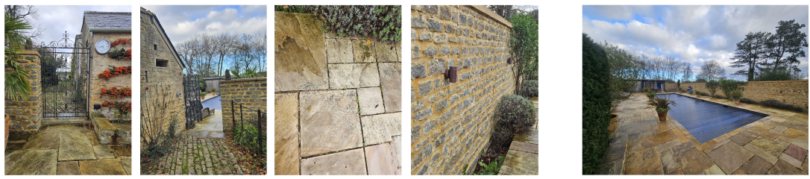

The significance of the listed building is considered to be its architectural and historic past, which can be traced back to the 1840’s as shown in the following plan:

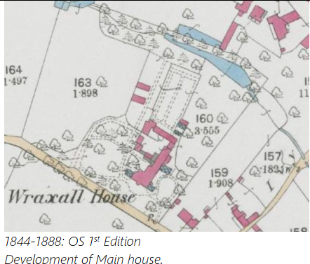

In terms of the impact of the new development on the significance of the principal listed building, the swimming pool and associated outbuilding are physically separate from the main house and do not involve alteration to, or loss of, any fabric of the listed building itself. The works are located to the rear of the property and site and are fully screened from the principal elevations by intervening outbuildings, boundary walls, planting and changes in level. There are no views of the pool area from the principal rooms or garden-facing elevations of the house. As a result, the architectural and historic interest of the listed building, from which its primary significance derives, is preserved.

In terms of impact on curtilage listed structures, the site’s planning history shows that various works were undertaken within this part of the site by consents granted in 2008. Current works involved the demolition of various sections of garden walling, which consisted of deteriorated rubble wall forming part of the walled garden enclosure and a further length of ancillary side garden wall of mixed origins. These walls comprised a combination of previously altered fabric, remnants of former outbuildings and an area that had already been extensively remodelled as part of previous landscaping work and which were not of consistent date, quality or architectural interest and did not form part of the formal setting of the main house.

By contrast, new boundary walls have been constructed using traditional materials and detailing appropriate to the site, and remaining sections of the walled garden enclosure have been retained and repaired. A new gate has been introduced between the stables and the pool area, with only a single fixing into the stables wall and no material impact on significant historic fabric
The development results in no harm to the significance, setting and character of South Wraxall House. The impact of the works on the wider curtilage is limited and relates primarily to the loss of fabric of low heritage significance within an area long characterised by change and adaptation.

The council’s Conservation Officer is in support of the works and has not raised any objections.

Amenity
Part vii of Core Policy 57 - Ensuring High Quality Design and Place Shaping of the Wiltshire Core Strategy, seeks to ensure that developments do not adversely affect neighbouring properties. The National Planning Policy Framework (NPPF), particularly Paragraph 135(f), stresses that planning decisions should ensure developments provide a high standard of amenity for existing and future users.

The construction of the swimming pool and its ancillary small kitchen area are all totally enclosed within the walled garden area of the site, with no neighbours being affected or impacted on. Consequently, the works therefore accord with Core Policy 57 point vii in respect of safeguarding residential amenity and Appendix D of the Wiltshire Design Guide.

Ecology Impact
CP50 requires no net loss of biodiversity on site. The site is located within the Bath and Bradford on Avon Bat SAC, the proposed development because of its nature is considered unlikely to result in harm to bats or their habitat. There is no mechanism for significant effects from recreational pressure since it does not result in the creation of a new dwelling. Accordingly, the proposal is acceptable in this regard. As such, the development complies with Core Policy 50 of the Wiltshire Core Strategy and the relevant provisions of the NPPF.

Biodiversity Net Gain. This application is exempt from the requirement to deliver Biodiversity Net Gain under Schedule 7A, Section 4(2)(a) of the Town and Country Planning Act 1990, as inserted by the Environment Act 2021, because the proposal is a householder ancillary extension of works.

Green Belt. The site lies within Green Belt land and there are no relevant WCS development plan policies relating to the Green Belt, therefore the NPPF provides the policy direction. The NPPF sets out within paragraph 142 that “The Government attaches great importance to Green Belts. The fundamental aim of Green Belt policy is to prevent urban sprawl by keeping land permanently open; the essential characteristics of Green Belts are their openness and their permanence”. Openness is the absence of development and Paragraph 143 of the NPPF sets out five key purposes of the Green Belt with one being to safeguard the open countryside from encroachment. The NPPF explains how to treat proposals within the Green Belt.

Paragraph 153 of the NPPF states inappropriate development is, by definition, harmful to the Green Belt and should not be approved except in very special circumstances. The two key characteristics of the Green Belt are its openness and its permanence.

Paragraph 154 sets out the categories of development which may be regarded as being ‘appropriate’ or exceptions in the Green Belt, such that in this instance sub-paragraph B allows for development in connection with outdoor recreation, as long as the facilities preserve the openness of the Green Belt.

In this instance it is the swimming pool and accompanying shed that is under consideration here. The pool area is not visible from public viewpoints, nor from the approach to the house, or from principal internal or external viewpoints within the site. The accompanying timber kitchen outbuilding is at a low level and is a small sized form of development, that is utilised in connection with the recreational use of the pool. The shed has been constructed in line with the stone boundary wall and so in effect acts as a form of boundary treatment, set within the context of an established residential enclosed garden area. All of these factors serve to mitigate visual impact and maintain the openness of the Green Belt.
As such, it is not considered that this application would result in inappropriate development in the Green Belt.

Conservation Area. The site is located within this area and the NPPF, Section 72 of the Planning (Listed Building and Conservation Area) Act 1990 and Core Policy 58 of the Council’s adopted Core Strategy set out the critical importance on attributing special attention to the preservation and enhancement of the character and appearance of the Conservation Area, when appraising applications that affect such protected areas.

The site is located within the South Wraxall Conservation Area and careful consideration has been given to CP58 of the Core Strategy and to the statutory requirement as mentioned above, whereby it has been concluded that for the reasons as discussed throughout this report, the proposed works have not resulted in any harm to the character and special appearance and setting of the Conservation Area.

Conclusion
The development results in no harm to the significance, setting and character of South Wraxall House. The impact on the wider curtilage is limited and relates primarily to the small loss of wall fabric of low heritage significance, with this area long characterised by change and adaptation. The overall effect of the works on the significance of the designated heritage asset is therefore neutral.

In terms of conditions, the application is retrospective with all works completed, there is no requirement for the standard 3 year commencement condition.

The proposal is considered to comply with the relevant policies of the Wiltshire Core Strategy, the Wiltshire Local Plan, and the National Planning Policy Framework and the application is recommended for approval, subject to conditions.

RECOMMENDATION:

PL/2025/09959 (FUL) Planning permission be granted.

PL/2025/07000 (LBC Listed building consent be granted.

