APPLICATION FOR FULL PLANNING PERMISSION DELEGATED REPORT

APPLICATION REFERENCE: | PL/2026/00366
APPLICATION TYPE: | Full planning permission
SITE ADDRESS: | Salisbury ATE Complex, Scots Lane, Salisbury, SP1 3TR
DEVELOPMENT DESCRIPTION: | The removal of 3 no. antenna, and the installation of 6 no. antenna and ancillary radio equipment onto new and existing support poles at existing rooftop site along with ancillary development thereto.
RECOMMENDATION: | That Planning Permission be GRANTED

PROPOSAL

The proposal seeks planning permission for the removal of 3 no. antenna, and the installation of 6 no. antenna and ancillary radio equipment onto new and existing support poles at existing rooftop site along with ancillary development.

Existing NW elevation

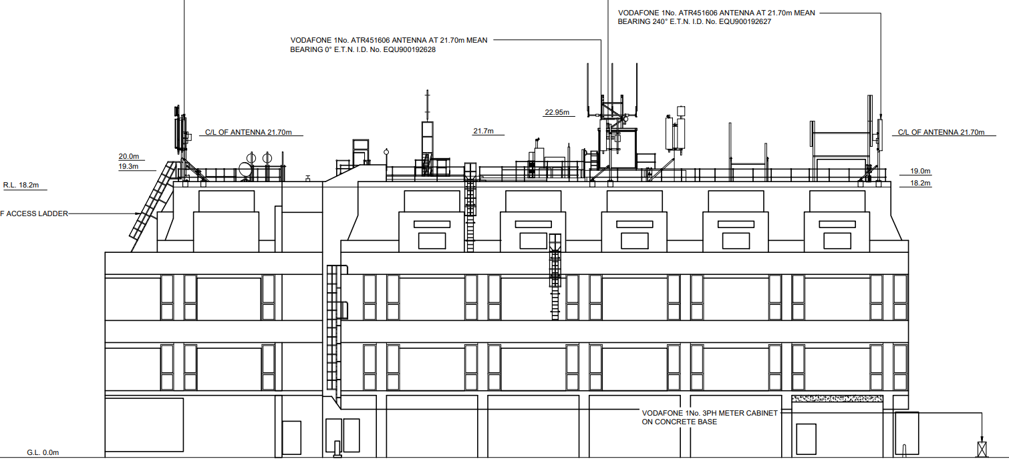

Proposed NW elevation

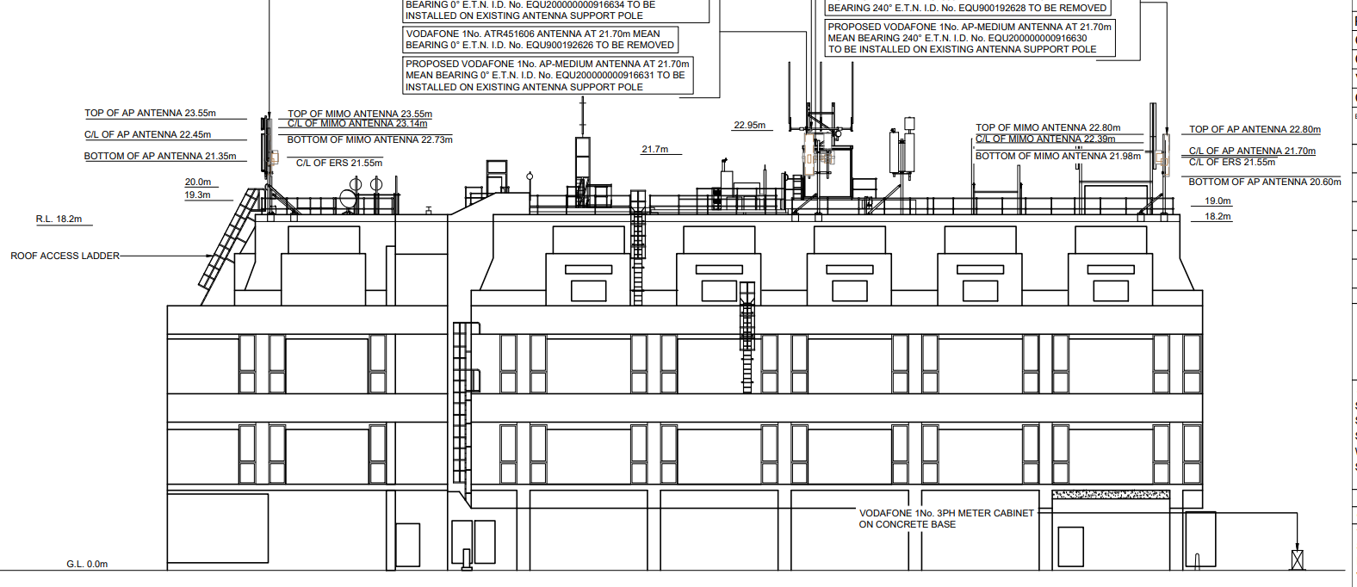

Amended plans were sought from the applicant during the application process due to the conservation officer noticing an additional structure/equipment cabinet was shown on the proposed drawings which were not fully detailed within the submission and it was unclear if this was part of the proposed development for consideration. The applicant confirmed that this was an error on the master plan and removed the erroneous cabinet.

SITE DESCRIPTION/CONTEXT

The application site relates to the existing base station installation on the roof of the existing telecommunications building located in Scots Lane within Salisbury City Centre. The site is located within Salisbury Conservation Area and close to many listed buildings which are as shown as black hatching on the map extract below.

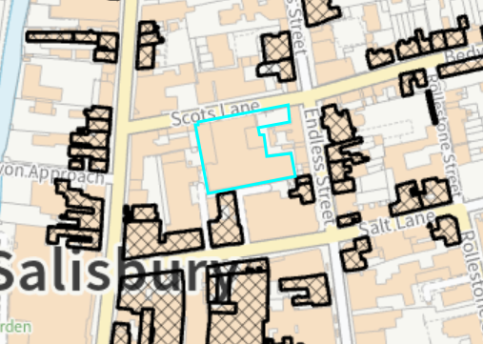

PLANNING HISTORY

21/00884/FUL Installation of 3 no. antennas, relocation of 3 no. antennas, installation of supporting steelwork and associated apparatus and ancillary works. Approved

17/11090/FUL The installation of a single PSU cabinet with dimensions 0.74m x 0.7m x 1.64m high on the rooftop of the telephone exchange building, and minor ancillary works. Approved

15/02359/FUL Replace 6 no. existing antennas with 6 no. replacement modern equivalent antenna units, install 3x new antennas and 2x 60cm transmission dishes & 6x remote radio units with associated support bracketry, feeder cables and ancillary development thereto. Approved

S/2011/1717 To replace two existing equipment cabinets with one equipment cabin and associated access steps for Airwave Solutions Limited.

S/2006/0666 Upgrade existing telecoms equipment by means of like-for-like swap of 3 antennas & 1x equipment cabinet. Approved

RELEVANT POLICIES AND GUIDANCE

National Planning Policy Framework (NPPF) Planning
National Practice Guidance (PPG)
National Design Guide

Planning (Listed Buildings and Conservation Areas) Act 1990 – S72 and S66

Wiltshire Core Strategy (WCS) adopted 2015
Core Policy 1 (Settlement Strategy)
Core Policy 2 (Delivery Strategy)
Core Policy 3 (Infrastructure Requirements)
Core Policy 20 (Spatial Strategy for the Salisbury Community Area)
Core Policy 57 (Ensuring High Quality Design and Place Shaping)
Core Policy 58 (Ensuring the Conservation of the Historic Environment)

Saved Policy PS7 Telecommunications

Wiltshire Design Guide
Creating Places Design Guide
Salisbury Neighbourhood Plan
Salisbury Conservation Area Appraisal

CONSULTATION RESPONSES

City Council: SCC has no comment to make on this application.

Conservation: Now that the drawings have been clarified, the revisions to equipment will have no perceptible impact on the character of the CA or the setting of listed buildings.

REPRESENTATIONS

On third party representation was received commenting on the application, the representation is included in full below.

The applicant states that the proposed development would conform with INTERNATIONAL COMMISSION ON NON-IONIZING RADIATION PROTECTION (ICNRP) guidelines, as amended 2020, a statutory requirement by OFCOM. The RF Safety Compliance Certificate submitted with the application pre-dates (29/7/25) the scheme plans (19/11/25) and therefore Development Services should entirely satisfied that the certificate submitted relates to the actual scheme submitted and furthermore that appropriate account has been taken of the cumulative Electromagnetic Fields (EMF) exposure levels of the entire site, in accordance with OFCOM guidelines.

ASSESSMENT

Section 38(6) of the Planning and Compulsory Purchase Act 2004 states:

"If regard is to be had to the development plan for the purposes of any determination to be made under the planning Acts, the determination must be made in accordance with the plan unless material considerations indicate otherwise."

In accordance with this statutory requirement, this application has been assessed against the relevant policies of the Development Plan, including the adopted Wiltshire Core Strategy (2015) and, where applicable, any made Neighbourhood Plans.

Principle of Development

The application site relates to an existing base station installation on the roof of the existing telecommunications building with the removal and replacement of existing antennae with associated works. The use of the existing building and associated antennae on the roof of the building has been established over many years. The principle of development to improve telecoms infrastructure is supported in this location subject to the criteria of Saved Policy PS7 and consideration of the scale and visual impact of development with particular regard to the historic environment with regard to Core Policies 57 and 58.

Saved policy PS7 of the Salisbury Local Plan states that proposals for new telecommunication development will be subject to the following considerations:

(i) where the proposal involves the New Forest, the Stonehenge World Heritage site, the Cranborne Chase and West Wiltshire Downs Area of Outstanding Natural Beauty, Sites of Special Scientific Interest, Conservation Areas or areas and buildings of architectural and historic importance, such development will only be permitted where technical considerations mean that there are no satisfactory alternative locations available. In such instances, the environmental impact of the development should be minimised by the judicious use of siting, design and landscaping.
(ii) elsewhere in the District proposals will be allowed provided that their siting and design minimise the environmental impact of the apparatus; and
(iii) applications for large masts should show evidence that the possibility of erecting antennae
on an existing building, mast or other structure has been explored.

Where such development is no longer required its removal will be sought.

As the use of the building is established and the scale and siting of the development is incorporated with the existing apparatus on the building, there is no conflict with the requirements of saved policy PS7.

The proposed development is considered to be acceptable in principle subject to compliance with other relevant polices, guidance and material considerations.

Design and Impact upon the character and context of the area and heritage impacts

From the point of view of the historic environment the main statutory tests are set out within the Planning (Listed Building and Conservation Areas) Act 1990.

Section 66 requires that special regard be given to the desirability of preserving listed buildings, their settings or any features of special architectural or historic interest which they possess.

Section 72(1) of the Act requires the Council to pay special attention to the desirability of preserving or enhancing the character or appearance of designated Conservation Areas.

The Council’s Core Strategy Policy CP58 ‘Ensuring the conservation of the historic environment’ requires that designated and non-designated heritage assets and their settings will be conserved, and where appropriate enhanced, in a manner appropriate to their significance and encourages proposals which improve the condition of heritage assets at risk.

The Council’s Core Strategy CP 57: Ensuring high quality design requires a high quality of design in all new developments. The policy requires applicants to “demonstrate how the proposal will make a positive contribution to the character of Wiltshire through (amongst other things) responding to the value of the natural and historic environment and being sympathetic to and conserving historic buildings and landscapes. Development is required to respond positively to the existing in terms of building layouts, built form, height, mass, scale, building line, plot size, elevational design, materials, streetscape and rooflines to effectively integrate the building into its setting.

The NPPF outlines government policy for planning. Chapter 16 of the NPPF 'Conserving and enhancing the historic environment' sets out the Government's high-level policies concerning heritage and sustainable development.

The application site is the roof of the New Telephone Exchange building located on Scots Lane. The subject building is a large four storey modern structure with a flat roof. The rooftop currently has a substantial amount of telecommunications equipment erected on it, together with other steel paraphernalia such as roof ladders, walkways and generators, including antenna of the nature proposed by this application.

Whilst the building is a tall, prominent structure than can be viewed from longer distance vantage points such as the central car park and top of Culver Street car park, it is largely screened from shorter distance views by the buildings that surround it and due to the height of the building its roof is not readily visible from street level, noting also that Scots Lane is a narrow road with limited views of the roof.

Taking into consideration the existing site context and limited scale of development, none of which would exceed the height or size of existing features on the roof, it is considered that the proposal would not have any notable impact on the appearance and character of the Conservation Area or the setting of nearby listed buildings. The requirements of the Planning and Listed Buildings Act and development plan policy are considered to be met, the Council's Conservation Officer has confirmed there are no objections in this regard.

Having regard to the above, the proposal complies with the design principles set out in Core Policy 57 of the Wiltshire Core Strategy and complies with Core Policy 58 of the Wiltshire Core Strategy and Sections 66 and 72 of the Planning (Listed Buildings and Conservation Areas) Act 1990, as well as the relevant provisions of the NPPF.

Amenity

Point vii of Core Policy 57 - Ensuring High Quality Design and Place Shaping of the Wiltshire Core Strategy seeks to ensure that developments do not adversely affect neighbouring properties.

The National Planning Policy Framework (NPPF), particularly Paragraph 135(f), stresses that planning decisions should ensure developments provide a high standard of amenity for existing and future users.

The proposed development has been assessed in terms of its potential impact on the residential amenity of neighbouring properties, with particular regard to loss of light, overshadowing, loss of privacy, and overbearing effects.

Paragraph 122 of the NPPF states that applications for electronic communications development (including applications for prior approval under the General Permitted Development Order) should be supported by the necessary evidence to justify the proposed development. This should include

b) for an addition to an existing mast or base station, a statement that self-certifies that the cumulative exposure, when operational, will not exceed International Commission guidelines on non-ionising radiation protection.

The application submission includes a Declaration of Conformity which deals with the health and safety aspects of the proposal which provides satisfactory evidence for the LPA having regard to. A third party questioned whether the submitted document was correct, up to date and related to the current proposals. The applicant confirmed that the submitted document was correct for the proposed development; their full response is included below-

I refer to the Declaration of Conformity with ICNIRP Public Exposure Guidelines (“ICNIRP Declaration”), sent with this submission in relation to the proposed telecommunications installation as detailed above.

The “ICNIRP Declaration” certifies that the proposed site shall be operated to be in full compliance with the requirements of the radio frequency (RF) guideline limits of the International Commission on Non-Ionizing Radiation Protection (ICNIRP) for public exposure and UK legislation. This ICNIRP declaration takes into account the cumulative effect of the emissions from the proposed installation and all radio base stations present at, or near, the proposed location.

All operators of radio transmitters are under a legal obligation to operate those transmitters in accordance with the conditions of their licence. Operation of the transmitter in accordance with the conditions of the licence fulfils the legal obligations in respect of interference to other radio systems, other electrical equipment, instrumentation, or air traffic systems. The conditions of the licence are mandated by Ofcom, an agency of national government, who are responsible for the regulation of the civilian radio spectrum. The remit of Ofcom also includes investigation and remedy of any reported significant interference.

The telecommunications infrastructure the subject of this application accords with all relevant legislation and as such will not cause significant and irremediable interference with other electrical equipment, air traffic services or instrumentation operated in the national interest.

Paragraph 123 of the NPPF states that "Local planning authorities must determine applications on planning grounds only. They should not seek to prevent competition between different operators, question the need for an electronic communications system, or set health safeguards different from the International Commission guidelines for public exposure."

It is therefore considered that the proposal would not introduce any other demonstrable impacts on nearby residents having regard to the location of the equipment and existing function of the building

The proposal therefore accords with Core Policy 57 point vii in respect of safeguarding residential amenity.

Ecology Impact

Core Policy 50 of the Wiltshire Core Strategy seeks to protect and enhance biodiversity and geodiversity, including through ensuring that development avoids harm to protected species and habitats.

The National Planning Policy Framework (NPPF), in Paragraphs 193, requires that development minimises impacts on and provides net gains for biodiversity, including ensuring mitigation is secured where harm cannot be avoided.

Biodiversity Net Gain - From 12 February 2024 Biodiversity Net Gain (BNG) became mandatory under Schedule 7A of the Town and Country Planning Act 1990 (as inserted by Schedule 14 of the Environment Act 2021). Based on the information available the biodiversity gain planning condition is not considered to apply to this application as the proposal is for telecommunications works on the roof of an existing building and would fall within one of the exemptions - development that does not impact a priority habitat and impacts less than 25 square metres (5m by 5m) of on-site habitat.

As such, the development complies with Core Policy 50 and Core Policy 69 of the Wiltshire Core Strategy and the relevant provisions of the NPPF.

CONCLUSION

The proposed development is considered to be acceptable in terms of its design, scale, and relationship with the surrounding area. It would not result in any unacceptable harm to the character of the locality, the amenities of neighbouring occupiers, heritage, or ecology.

The proposal is therefore considered to conform with the objectives of saved policy PS7 and complies with the relevant policies of the Wiltshire Core Strategy and the National Planning Policy Framework. As such, the application is recommended for approval, subject to the conditions set out below.

RECOMMENDATION: That Planning Permission be GRANTED subject to conditions.

1. The development hereby permitted shall be begun before the expiration of three years from the date of this permission.

REASON: To comply with the provisions of Section 91 of the Town and Country Planning Act 1990 as amended by the Planning and Compulsory Purchase Act 2004

2. The development hereby permitted shall be carried out in accordance with the following approved plans:

Application form received 20/01/2026
Location plan Drg no UK-WI-001346- 00-004 - ML005 Rev 5 received 20/01/2026
Proposed site plan Drg no UK-WI-001346 – 04-110- MD047 Rev A received 09/02/2026
Proposed elevations Drg no UK-WI-001346 – 04-160- MD047 Rev A received 09/02/2026

REASON: For the avoidance of doubt and in the interests of proper planning.

3. The telecommunications equipment hereby approved shall be dismantled and removed from the site, and the site reinstated to its former condition when no longer required for use.

REASON: In the interests of visual amenity and the character and appearance of the area

Informative

BNG not required - The effect of paragraph 13 of Schedule 7A to the Town and Country Planning Act 1990 is that planning permission granted for development of land in England is deemed to have been granted subject to the condition (biodiversity gain condition) that development may not begin unless:

(a) a Biodiversity Gain Plan has been submitted to the planning authority, and
(b) the planning authority has approved the plan.

The planning authority, for the purposes of determining whether to approve a Biodiversity Gain Plan, if one is required in respect of this permission would be Wiltshire Council.

There are statutory exemptions and transitional arrangements which mean that the biodiversity gain condition does not always apply. For further information on exempt developments please refer to:
https://www.gov.uk/guidance/biodiversity-net-gain-exempt-developments
Based on the information available this permission is considered to be one which will not require the approval of a biodiversity gain plan before development is begun because one or more of the statutory exemptions or transitional arrangements is considered to apply.

