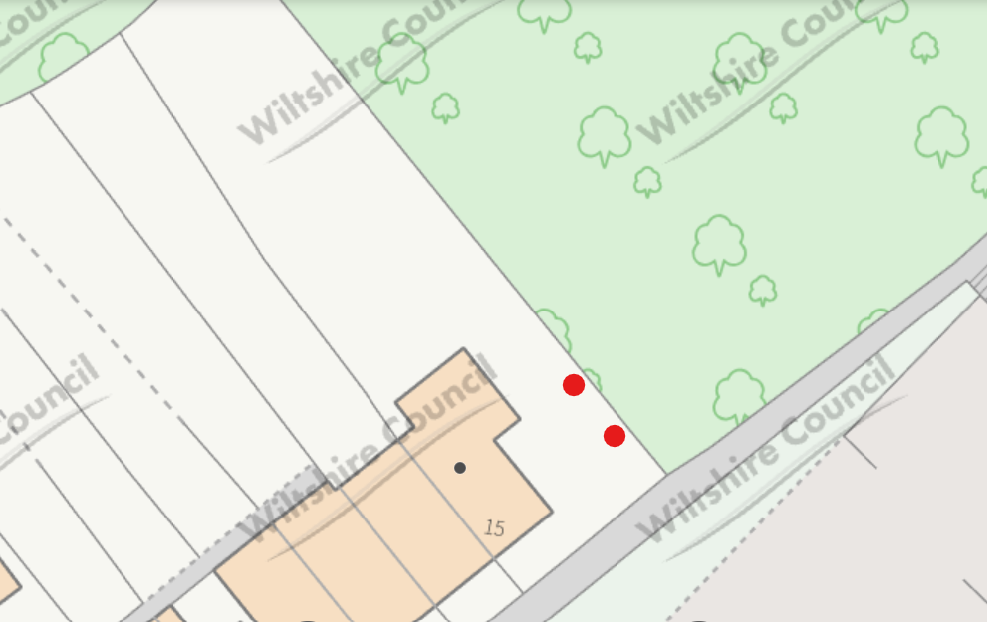
T2- Beech Tree
T1- Laurel

