APPLICATION FOR FULL-PLANNING PERMISSION
CASE OFFICER REPORT

APPLICATION REFERENCE: | PL/2025/09819
APPLICATION TYPE: | Full planning permission
SITE ADDRESS: | 7 Weavers Mead, Great Cheverell, Devizes, SN10 5TP
DEVELOPMENT DESCRIPTION: | Change of Use from agricultural land to residential garden
RECOMMENDATION: | Approve with Conditions

SITE DESCRIPTION/CONTEXT

The application site comprises a semi‑detached, two‑storey dwelling located at the south‑western end of a cul‑de‑sac within Great Cheverell. The property is bordered by residential development to the north and west, with open countryside lying to the east and south. A Public Right of Way (PRoW CHEM7) runs east–west along the southern boundary. The dwelling benefits from off‑street parking and front, side, and rear garden areas, and the applicants have recently acquired an additional parcel of land adjoining the southern boundary. The site falls within the 6.4km buffer zone of the Salisbury Plain SPA and is situated on Grade 4 agricultural land.

PROPOSAL

The application seeks full planning permission for the change of use of the recently acquired parcel of land from agricultural use to residential garden land associated with the host dwelling. The land is already enclosed along its southern and eastern boundaries by mature mixed hedging and established trees. The submitted block plan indicates that the existing 1.8‑metre close‑boarded fence along the western boundary will be extended to form a continuous boundary treatment, while a 1‑metre post‑and‑wire stock fence is proposed along the southern and eastern boundaries, positioned in front of the existing hedge line. The intention of the proposal is to incorporate this additional land into the residential curtilage of the property to serve as an extended garden area.

PLANNING HISTORY

Proposal / Summary
13/05866/OUT - Outline Planning Decision - Refused Date: 11/2/2014 – Residential development (up to 25 dwellings), access, parking, open space and associated infrastructure

RELEVANT LEGISLATION, POLICIES AND GUIDANCE

Statutory Legislation:

Town and Country Planning Act 1990

National Planning Policy:
- National Planning Policy Framework (NPPF)
- Planning Practice Guidance (PPG)
- National Design Guide
Development Plan:
The development plan for Wiltshire comprises the Wiltshire Core Strategy (WCS) (adopted January 2015) and any made neighbourhood plans, which remains the principal statutory planning document guiding development across the county. In line with Section 38(6) of the Planning and Compulsory Purchase Act 2004, planning decisions must be made in accordance with the development plan unless material considerations indicate otherwise.

Though the development plan is considered as a whole, those parts deemed to be particularly relevant to this application are listed below:

The adopted Wiltshire Core Strategy (WCS), with particular regard to:

- Core Policy 1 Settlement Strategy;
- Core Policy 2 Delivery Strategy;
- Core Policy 50 Biodiversity and Geodiversity;
- Core Policy 51 Landscape
- Core Policy 57 Ensuring High Quality Design and Place Shaping;
- Core Policy 67 Flood Risk.

Draft Wiltshire Local Plan Policies [delete/insert above as appropriate]

- Policy 1: Settlement Strategy
- Policy 2: Delivery Strategy
- Policies 64 – 75: Economic, tourism, retail and transport
- Policies 76 – 84: Social, housing, community, public open space and wellbeing
- Policies 85 – 101: Sustainability, ecology, water and landscape, heritage, air quality

Supplementary Planning Documents and other Guidance:

- Wiltshire Design Guide (adopted April 2024)

ISSUES

The main issues that need to be addressed in this case include:

- Whether the development is acceptable in principle (CP 1 and 2)
- Whether the scheme constitutes high quality design (CP 57)
- Whether the scheme would have an acceptable impact upon the reasonable living conditions of the adjoining occupants (CP 57)
- Whether the scheme would have an acceptable landscape impact (CP 51)
- Whether there would be any harmful impacts upon protected species or priority habitats (CP 50)
- Whether the site can be adequately drained without increasing flood risk elsewhere (CP 67)

CONSULTATION RESPONSES

WC Rights of Way: No objection subject to the nearby right of way remaining clear at all times.

Cheverell Magna Parish Council: Following comments received:

“The Parish Council is concerned that the current garden has a ditch within it, next to the boundary, which had been blocked for some time and required clearing. The blocked ditch causes flooding onto the footpath and surrounding field.

Members have no objection to the application subject to the condition that the owners reinstate a drainage system such as concrete pipes so that flooding onto the footpath and field is prevented.”

REPRESENTATIONS
In accordance with the requirements of the Town and Country Planning (Development Management Procedure) (England) Order 2015 (as amended), the application was publicised by way of:

- Neighbour notification letters sent to adjoining and nearby properties;
- A site notice displayed near the site;
- An advertisement placed in the local press.

These methods were used to inform interested parties and provide a period of 21 days for comments to be submitted. No letters of representations were received.

ASSESSMENT
Section 38(6) of the Planning and Compulsory Purchase Act 2004 states:

"If regard is to be had to the development plan for the purposes of any determination to be made under the planning Acts, the determination must be made in accordance with the plan unless material considerations indicate otherwise."

In accordance with this statutory requirement, this application has been assessed against the relevant policies of the Development Plan, including the Wiltshire Core Strategy (2015) and, where applicable, any made Neighbourhood Plans. Consideration has also been given to the policies of the National Planning Policy Framework (NPPF) as a material consideration in the assessment.

Principle of Development
Policy Context
Core Policy 1: Settlement Strategy of the WCS establishes a hierarchy of settlements to guide where development should be focused. The policy prioritises growth in:
- Principal Settlements (e.g., Salisbury, Chippenham, Trowbridge) – main focus for strategic growth.
- Market Towns – support local services and employment; suitable for sustainable development.
- Local Service Centres – smaller towns and villages with a range of services; limited development supported.
- Large and Small Villages – development should be limited and respond to local needs.
- Outside the defined settlements – development is strictly controlled and generally not supported unless exceptional circumstances apply.
.
Core Policy 2: Delivery Strategy of the WCS sets out how development will be distributed and delivered across Wiltshire. The policy emphasises:
- Sustainable patterns of growth, reducing the need to travel and supporting local services.
- Development should be plan-led, aligning with the settlement strategy and supported by infrastructure.
- Windfall development (not allocated in plans) must still comply with the principles of sustainable development.
- Development outside settlement boundaries is generally not permitted, unless it meets specific policy exceptions (as set out in paragraph 4.25 of the WCS).

Together, CP1 and CP2 ensure that new development is strategically located, sustainable, and supports the character and function of Wiltshire’s communities.

Assessment

Core Policies 1 and 2 of the Wiltshire Core Strategy set out the settlement strategy for the county and direct new development to the most sustainable locations, with open countryside generally afforded strong protection from inappropriate or unjustified forms of development. The proposal seeks the change of use of a small parcel of land from agricultural to residential garden land. Although the site lies outside the identified Limits of Development for Great Cheverell and therefore within the open countryside for planning policy purposes, the land is immediately contiguous with the existing domestic curtilage and forms a logical and modest extension to the established garden of the host dwelling.

The parcel is visually and functionally well related to the existing residential plot, and its incorporation into the domestic curtilage would not result in an encroachment of built form or an isolated, detached pattern of development. No operational development of significance is proposed beyond low‑level boundary treatments, and the change of use would not materially alter the character or pattern of settlement in this location. Given the small scale of the land and its strong relationship with the existing dwelling, the proposal is not considered to conflict with the strategic aims of CP1 and CP2, which seek to prevent sporadic development in the countryside and ensure that uses remain appropriately located.

Conclusion

Accordingly, the principle of the development is considered acceptable, subject to the proposal satisfying all other relevant policies of the local development plan.

Design and Impact on the Landscape and Character and Appearance of the Area
Policy Context
Core Policy 57 of the WCS requires high-quality design that:
- Enhances local character.
- Responds to the natural, historic, and built environment.
- Retains important features (e.g., trees, hedges).
- Supports sustainable construction and compatibility with surrounding uses.
- Creates safe, legible, and accessible spaces.

Core Policy 51 of the Wiltshire Core Strategy requires development to:
- Protect, conserve, and enhance landscape character and quality.
- Respect local distinctiveness, key views, and visual receptors.
- Give particular weight to impacts on National Landscapes (formerly AONBs) and locally valued landscapes.

Section 12 of the NPPF emphasises design that is:
- Visually attractive.
- Functionally effective.
- Contributes to the quality of the built environment.

The Wiltshire Design Guide encourages sensitivity to local character, materials, and architectural styles and supports modern living standards while maintaining aesthetic and functional quality.

Assessment

The parcel of land proposed for incorporation is physically and visually well related to the host dwelling. The existing garden already sits at a higher ground level to the south and east, which aligns naturally with the adjoining land, meaning only minimal ground regrading would be required. The former boundary treatment along the southern edge of the garden has been removed, and the parcel now forms a coherent and easily integrated extension to the domestic curtilage.

The mature hedging along the southern and eastern boundaries of the parcel will be retained and continues to provide a strong and established landscape edge. This ensures that the land does not appear as an encroachment into the wider agricultural field system to the south and instead reads as part of the well‑contained garden environment of the host dwelling. The proposal to extend the existing 1.8‑metre close‑boarded fence along the western boundary is very minor, involving only a short continuation of approximately 2.5 metres. The remaining boundaries would be enclosed with low‑level post‑and‑wire stock fencing, which is an appropriate and rural form of boundary treatment for edges adjoining open countryside. Any small gaps within the hedgerow can be reinforced through additional planting if required, further supporting the established landscape structure.

In design terms, the proposal is modest and sympathetic to its rural setting. With only limited new boundary treatments and the retention of key landscape features, the overall character of the area would remain largely unchanged. Any domestication arising from the garden extension would be well screened from public and wider landscape views, ensuring that the proposal sits comfortably within its surroundings.

Conclusion

The proposal accords with the requirements of CP 51 and 57 of the WCS and relevant sections of the NPPF.

Amenity
Policy Context
Core Policy 57 (Point vii) of the Wiltshire Core Strategy requires development to respect the amenity of existing occupants and ensure appropriate amenity levels for future residents.

The National Planning Policy Framework (NPPF), particularly Paragraph 135, reinforces the need for development to provide a high standard of amenity for both existing and future users.

These policies guide the assessment of amenity impacts.

Due to the nature of the proposals, and the positioning to the blind side of any nearby neighbours, the proposal is not considered to give rise to any impacts which would cause a negative effect on amenity.

Ecology and Biodiversity
Policy Context
The ecological impact of development is a key planning consideration, especially for larger schemes. Proposals must assess and address potential effects on:

- Protected species
- Priority habitats
- Ecological networks
- Green and blue infrastructure

Core Policy 50 of the Wiltshire Core Strategy requires development to:

- Avoid harm to ecological assets.
- Deliver measurable Biodiversity Net Gain (BNG), in line with the Environment Act 2021.
- Support habitat restoration and connectivity.
- Integrate biodiversity into site design.

The Green & Blue Infrastructure Strategy (2022–2030) promotes nature recovery, ecosystem services, and habitat connectivity through development.

Unless exempt, National policy requires a minimum of 10% Biodiversity Net Gain (BNG) for major developments, demonstrated via:

- Biodiversity Metric calculations
- Ecological assessments (e.g. PEAs, Phase 1 surveys, protected species surveys)

Assessment

The proposal is not expected to result in any significant harm to ecology or biodiversity. There are no records of protected species within the immediate vicinity of the site, nor does the land form part of a priority habitat. While the site lies within the 6.4km buffer zone of the Salisbury Plain SPA, the development does not involve any new residential units or intensification of occupation and would therefore not increase recreational pressure on the designated site. On this basis, the proposal can be screened out of requiring appropriate assessment under the Habitats Regulations.

No ecological features would be adversely affected, as the existing mature hedgerow along the southern and eastern boundaries would be retained, continuing to provide valuable habitat and a buffer between the garden area and the surrounding countryside. The proposal represents only a modest extension to an established residential curtilage, and it is not considered necessary to impose restrictions on external lighting in this instance, given that the development would not materially change the existing baseline or introduce lighting impacts beyond those already associated with the residential setting.

In relation to Biodiversity Net Gain (BNG), it is noted that the applicant has referred to the de minimis exemption; however, the area of land proposed for change of use exceeds the 25sqm threshold and therefore does not technically qualify for exemption. Nevertheless, as no physical alteration of the existing habitat is proposed and the land will remain as it currently exists, the pre‑development habitat value would be unchanged. In this context, it is not considered necessary to request a BNG metric calculation, as the proposal would not give rise to a loss of habitat or measurable ecological impact.

Conclusion

Accordingly, the proposal is considered to comply with Core Policy 50 of the Wiltshire Core Strategy, as it would not result in harm to ecological interests and retains the site’s existing habitat value.

Flood Risk and Drainage
Policy Context
Core Policy 67 of the Wiltshire Core Strategy and NPPF paragraphs 170–182 require:
- Avoidance of increased flood risk.
- Use of appropriate mitigation measures.
- Application of the sequential and exception tests for developments in Flood Zones 2 or 3.

Assessment

Concerns have been raised by the Parish Council regarding occasional flooding along the nearby Public Right of Way (PRoW) and the suggestion that this may be linked to inadequate clearance of a ditch within or adjacent to the application site. The maintenance of private ditches is a civil matter between the landowner and affected parties and falls outside the remit of the planning process.

In assessing flood risk in accordance with Core Policy 67, it is noted that the application site and neighbouring properties lie within an area with some susceptibility to groundwater flooding. However, the proposal involves no operational development and no alterations to land levels, surfacing, drainage arrangements, or built form. As such, the development would not increase surface water run‑off, impede natural drainage patterns, or exacerbate existing localised flooding issues.

During the case officer’s site visit, it was observed that water was flowing onto the footpath from a nearby watercourse (see image below), indicating that the issue is likely to be a naturally occurring hydrological process unrelated to the proposed change of use. As the proposal would not alter existing ground conditions or hydrology, it would not contribute to or worsen this situation.

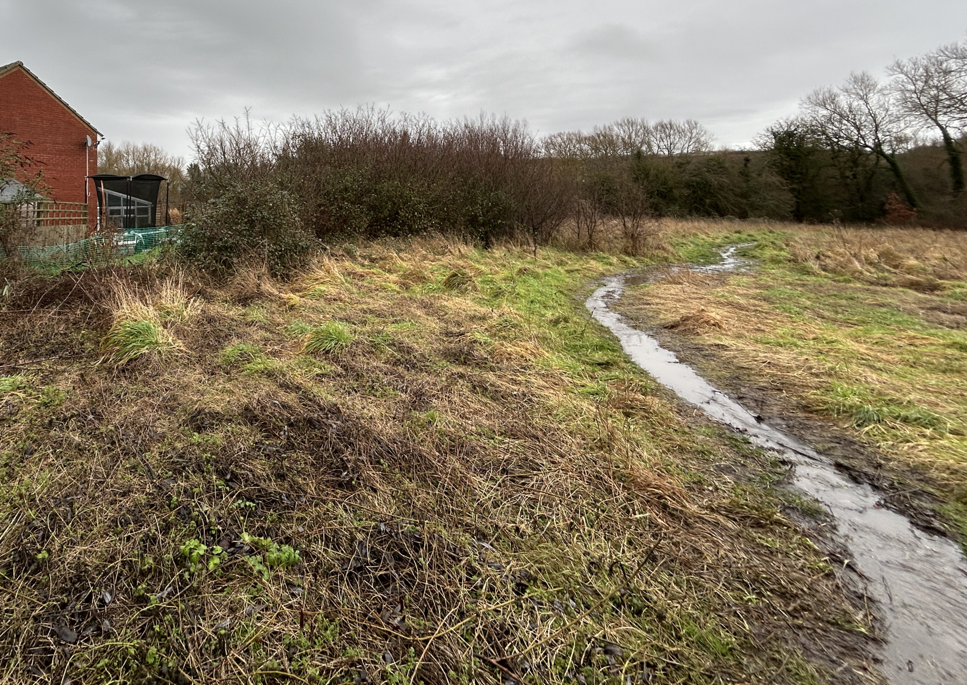

Conclusion

Accordingly, the proposal raises no concerns in respect of flood risk and is considered to comply with Core Policy 67 of the Wiltshire Core Strategy.

PLANNING BALANCE AND CONCLUSION
At the heart of the NPPF there is a presumption in favour of sustainable development requiring local planning authorities to approve development proposals that accord with an up-to-date development plan without delay; and where there are no relevant development plan policies, or the policies which are most important for determining the application are out-of-date, permission should be granted unless (taken from paragraph 11d of the NPPF):

- The application of policies in the NPPF that protect areas or assets of particular importance provides a clear reason for refusing development proposed; or
- any adverse impacts of doing so would significantly and demonstrably outweigh the benefits, when assessed against the policies in the NPPF taken as a whole;

The principle of development is considered acceptable when assessed against the settlement strategy of the Wiltshire Core Strategy and the emerging Local Plan.

The proposal is broadly compliant with relevant local and national planning policies in respect of design, scale, residential amenity, landscape, flood risk and drainage, and ecology and biodiversity.

Accordingly, the proposal is considered acceptable in planning terms and in accordance with the Wiltshire Core Strategy, the National Planning Policy Framework, and all other relevant material considerations.

RECOMMENDATION:
That Planning Permission be GRANTED, subject to conditions.

