APPLICATION FOR HOUSEHOLDER PLANNING PERMISSION
DELEGATED REPORT

APPLICATION REFERENCE: | PL/2025/09619
APPLICATION TYPE: | Householder planning permission
SITE ADDRESS: | 1 St Johns Close, Milford, Salisbury, SP1 1NW
DEVELOPMENT DESCRIPTION: | Demolition of garage and shed, construction of single storey extension to east elevation and alteration to porch. Enlargement of parking area with extended dropped kerb.
RECOMMENDATION: | That Planning Permission be GRANTED

PROPOSAL

The proposal seeks planning permission to demolish a detached garage and construct a single storey side and front extension on the east side of the dwelling to create a store, kitchen and family room. Landscaping and dropped kerb to front garden to create additional parking.

Revised plans were received 24.02.2026, removing a projecting wall on the north elevation, position of No 2 St Johns Close and noting the proposed materials for the garage door.

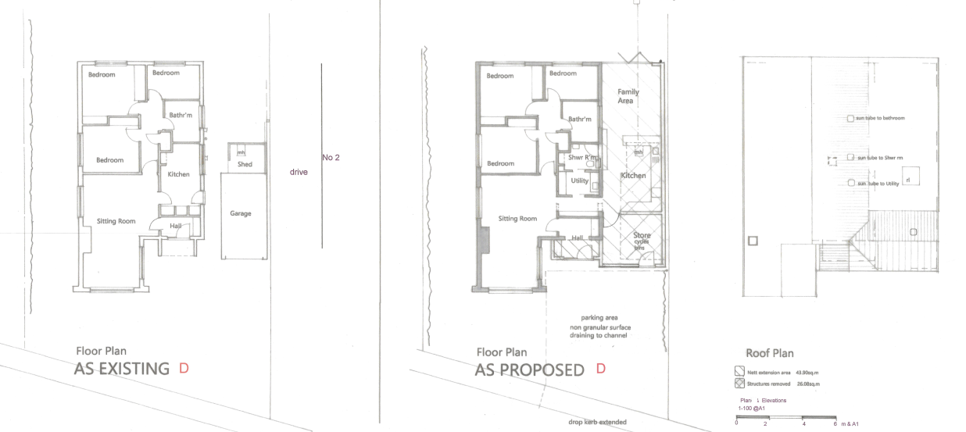

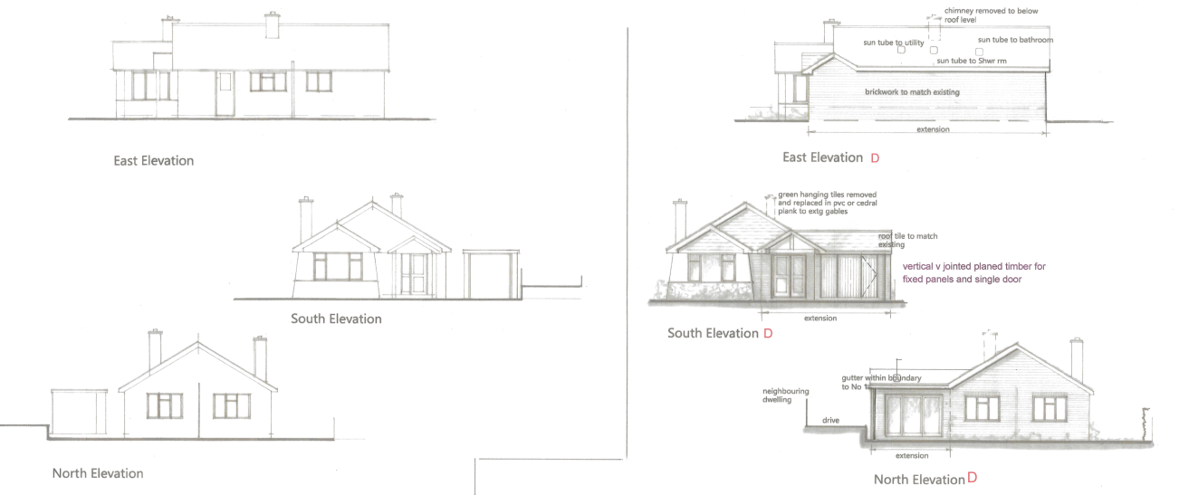

SITE DESCRIPTION/CONTEXT

The application relates to 1 St Johns Close, a detached, single storey dwelling, located on the southern edge of the small village of Laverstock, as defined by Wiltshire Core Strategy (WCS) core policies 1 (Settlement Strategy), 2 (Delivery Strategy) and 20 (Spatial Strategy for the Salisbury Community Area).

The site is located within a residential neighbourhood, at the end of a cul-de-sac, set higher than Queen Manor Road to the south. There are residential neighbours to the west, north and east. The site has off road parking, detached garage, front and rear gardens.

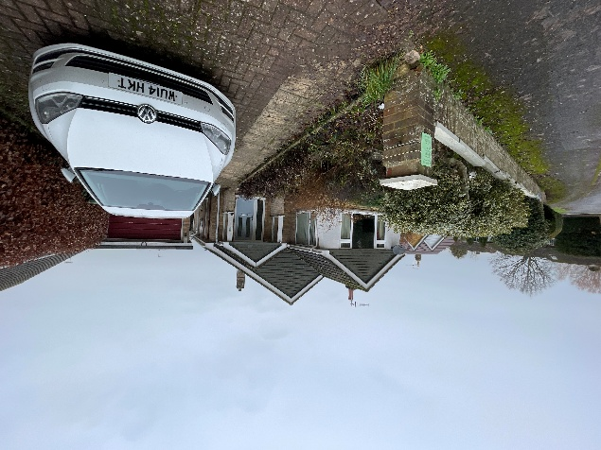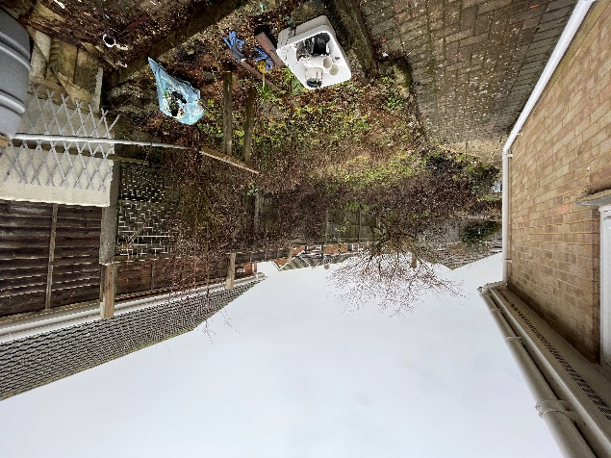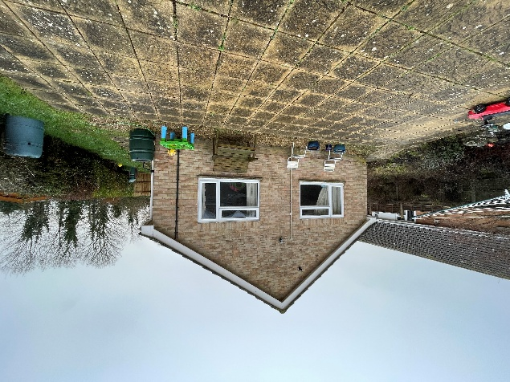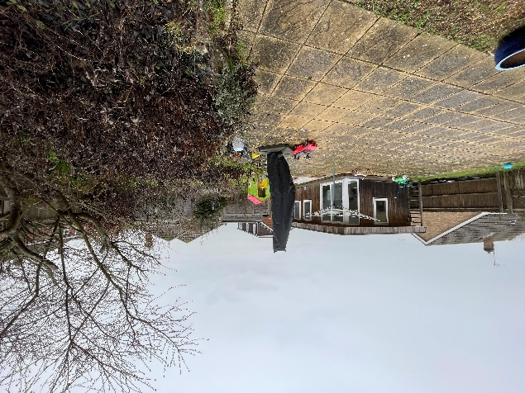

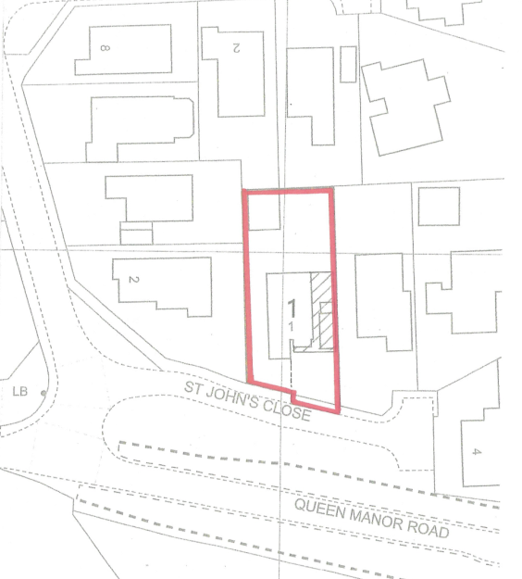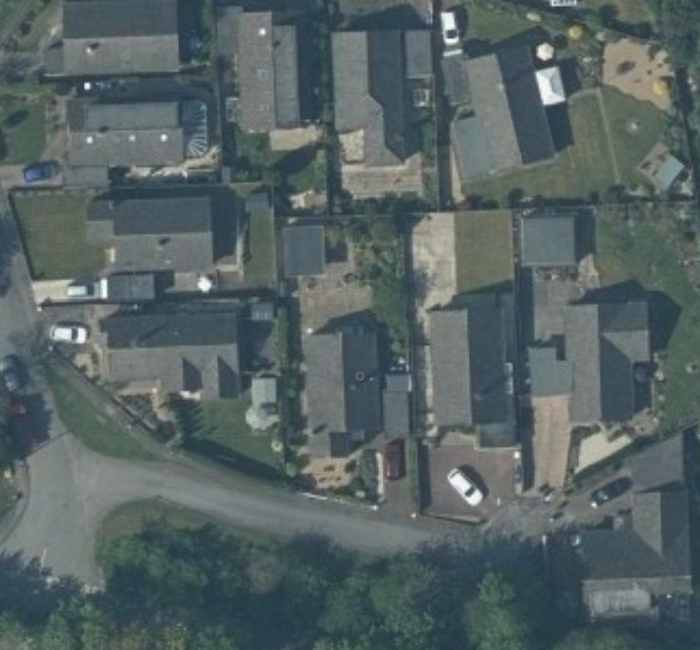

PLANNING HISTORY

None

RELEVANT POLICIES AND GUIDANCE

Wiltshire Core Strategy:
- Core Policy 1: Settlement Strategy
- Core Policy 2: Delivery Strategy
- Core Policy 20: Spatial Strategy for the Salisbury Community Area
- Core Policy 57 Ensuring High Quality Design and Place Shaping
- Core Policy 50: Biodiversity and Geodiversity
- Core Policy 61: Transport and New Development

Laverstock and Ford Communities Neighbourhood Plan 2021 to 2036. Made October 2022

Wiltshire Design Guide: Appendix D – Design Guidance for Householder extensions

The National Planning Policy Framework (NPPF)

The Planning Practice Guidance

National Design Guide

CONSULTATION RESPONSES

Laverstock and Ford Parish Council: No comment

Highways Officer: No objection subject to conditions
I refer to the above planning application for the demolition of the garage and shed, construction of a single storey extension to the east elevation and alteration to porch. Enlargement of parking area with extended dropped kerb.
The proposal will retain 3 bedroom in the dwelling and therefore 2 off street parking spaces must be provided to meet Wiltshire’s current parking standards. No parking plan has been provided, however the site frontage is able to accommodate 2 vehicles.
I raise no highway objection providing he following conditions are imposed:

- Visibility at nearside carriageway edge
- Consolidated surface to driveway
- Works to avoid surface water entering highway
- Vehicle access remains unaged
- Two parking spaces maintained

REPRESENTATIONS

One representation was received as follows:
This comment is one of support and raise some minor objections (considerations), the home owners have discussed their plans with me, where I raised some concerns and questions, which are not identified in the planning documentation. Firstly the plans do not show any dimensions, the width of the proposed building, it is assumed that this is not extending further ( same line as the original garage) towards No 2 St John’s, it should be noted that there is a minor shed extending out by approx 30cm, this is on the existing fence line, the extension should not extend beyond our boundary. Looking at the drawings the height of the single story extension and rear wall s acceptable.
The main concerns are that the main kitchen in the proposal is opposite our French doors which are generally open, the doors (to my bungalow) are 3.2m from my boundary. It is requested that any extractions (gas or food) are located away from location iaw Wiltshire Council relevant issues instructions. It should also be noted that there is a proposal to have a skylight above the kitchen, if this is an opening window, conversations from both parties may be heard creating privacy and relevant noise issues, without dimensions I assume this will place the window well within 4m of each dwelling.
The planned up lighters in the existing property or the removal of the chimney are considered as not affecting my property.

ASSESSMENT

Section 38(6) of the Planning and Compulsory Purchase Act 2004 states:

"If regard is to be had to the development plan for the purposes of any determination to be made under the planning Acts, the determination must be made in accordance with the plan unless material considerations indicate otherwise."

In accordance with this statutory requirement, this application has been assessed against the relevant policies of the Development Plan, including the adopted Wiltshire Core Strategy (2015) and, where applicable, any made Neighbourhood Plans.

Design and Impact upon the character and context of the area

Core Policy 57 - Ensuring High Quality Design and Place Shaping of the Wiltshire Core Strategy seeks to ensure that all new development is of high design quality, reflecting local context, character, and distinctiveness.

This application is seeking permission to construct a single storey extension on the east elevation of the dwelling. The extension would contain a kitchen/family area and storage space to the front. The dwelling would retain three bedrooms.

An existing, detached, single storey garage would be demolished and the proposed extension would infill the area between the east side of the dwelling and the shared boundary with no 2 St Johns Close. The extension would align with the rear (north) elevation of the existing property and extend forward of the front elevation by approximately 1.74m. The forward extension would include for an extension to the front hall and a storage area. The roof to the front elevation is proposed to have a gable end above the front door, a small gable on the east elevation and then the rest of the roof would be a flat roof.

Materials are proposed to be brickwork walls and tiles to the pitched areas of roof, to match the existing dwelling. The south elevation of the extension will have vertical timber cladding, similar to a garage door with a single opening door.

The proposed extension would be positioned along the shared east boundary. Access to the rear garden would be available on the west side of the dwelling. It would be preferable to maintain a distance from the boundary on both sides, but it is noted that there is an existing, detached garage along this boundary that the proposed extension would replace and would not harm the proportions and character of the dwelling.

The proposed extension is subservient to the existing dwelling and reflects the existing dwelling’s character in terms of materials.

Alterations to the existing dwelling include removal of a chimney stack and changing the hanging clay tiles on the front elevation with horizontal boarding. The removal of the chimney stack and proposed change from hanging tiles to horizontal cladding is considered acceptable.

Three sun tubes are proposed within the existing pitched roof and a flat roof window within the side extension. These are considered acceptable.

Having regard to the above, the proposal complies with the design principles set out in Core Policy 57 of the Wiltshire Core Strategy and Appendix D of the Wiltshire Design Guide.

Amenity

Point vii of Core Policy 57 - Ensuring High Quality Design and Place Shaping of the Wiltshire Core Strategy seeks to ensure that developments do not adversely affect neighbouring properties.

The National Planning Policy Framework (NPPF), particularly Paragraph 135(f), stresses that planning decisions should ensure developments provide a high standard of amenity for existing and future users.

The proposed development has been assessed in terms of its potential impact on the residential amenity of neighbouring properties, with particular regard to loss of light, overshadowing, loss of privacy, and overbearing effects.

The proposed extension has the potential to impact upon the occupiers of 2 St Johns Close due to its location on the shared east boundary. The proposed extension is single storey, with a flat roof for the majority of the extension with no windows proposed in the east elevation. It is noted that there is an existing single garage along this boundary, a tall fence and no 2 St Johns Close sits at a slightly elevated level. It is therefore considered that the extension would not have such an overbearing effect on the neighbour or result in the loss of light to warrant a refusal in this instance.

The comments received from the neighbour are duly noted. They raised concerns regarding the impact of the kitchen, and extractions coming from this, on the rear elevation of their neighbouring dwelling. Although it is noted that the proposed works will extend the kitchen and ‘family area’ along the boundary with no.2 St Johns Road, the site is set within a residential area, where an interrelationship exists. There will not be any commercial level of extraction required, which would be of impact on residential amenity. The residential occupation of the dwelling ensures that any output from the kitchen would be of a level considered acceptable, and building regulations will dictate the need and location of flues and/or extraction units. It is therefore not considered necessary to include a condition relating to this.

Concerns were also raised regarding the proposed skylight above the kitchen, and the impact of this on privacy should it be open. As previously mentioned, the site is set within a residential area, where an interrelationship exists. The dwellings are bordered by other residential dwellings, in close proximity, and such it would not be appropriate to condition this window to be fixed closed. The rooflight is to be sited centrally within the eastern roof, and therefore set forward of the rear of no.2s rear garden area and patio doors. Neighbour amenity is a key consideration when assessing planning applications, however the proposal is not considered of further impact on privacy, overshadowing or overlooking than the existing on neighbouring dwellings.

It is considered that the proposal accords with Core Policy 57 point vii in respect of safeguarding residential amenity and Appendix D of the Wiltshire Design Guide.

Highways Impact
Core Policy 57 (xiv) of the Wiltshire Core Strategy seeks to ensure that development must meet the requirements of Core Policy 61. This policy requires proposals to be capable of being served by safe access to the highway network. Core Policy 64 seeks to ensure compliance with parking standards set out in the Local Transport Plan.

The National Planning Policy Framework (NPPF), particularly Paragraph 115 and 116, requires that development proposals do not have an unacceptable impact on highway safety and that safe and suitable access to the site can be achieved for all users.

The proposals include for the demolition of the existing single garage, an extension to the existing dropped kerb and additional hard standing to provide for off road parking for two vehicles. The proposals create sufficient off-street parking to comply with the Council’s adopted standards. No objection has been received from the Highways Officers subject to conditions relating to:
- Visibility at nearside carriageway edge
- Consolidated surface to driveway
- Works to avoid surface water entering highway
- Vehicle access remains unchanged
- Two parking spaces maintained

The proposed development would not result in any adverse impact on highway safety. Adequate parking and turning provision is provided in accordance with Wiltshire’s adopted parking standards, and access arrangements are acceptable.

The proposal is therefore considered to comply with Core Policies 57 (xiv), 61 and 64 of the Wiltshire Core Strategy, the NPPF, and the Wiltshire Local Transport Plan.

Ecology Impact
Core Policy 50 of the Wiltshire Core Strategy seeks to protect and enhance biodiversity and geodiversity, including through ensuring that development avoids harm to protected species and habitats.

The National Planning Policy Framework (NPPF), in Paragraphs 193, requires that development minimises impacts on and provides net gains for biodiversity, including ensuring mitigation is secured where harm cannot be avoided.

The proposal relates to a single-storey extension to a dwelling with no trees or roof voids affected. The application site is within the New Forest Protection Sites 13.8km Recreation zone of influence and Hampshire River Avon Catchment but due to the nature of the development, ecological impact is not an issue for this application. There is no reasonable likelihood of protected species being present or affected. The development complies with Core Policy 50 and the relevant provisions of the NPPF.

Biodiversity Net Gain
Householder planning applications are exempt from the requirement to deliver Biodiversity Net Gain under Schedule 7A, Section 4(2)(a) of the Town and Country Planning Act 1990, as inserted by the Environment Act 2021.

Drainage and Flood Risk
Core Policy 67 of the Wiltshire Core Strategy and paragraph 181 of the NPPF requires that all new development avoids increasing flood risk on-site or elsewhere and, where appropriate, incorporates sustainable drainage measures. Development must also comply with national policy on flood risk management and drainage design. Paragraph 176 (via footnote 62) of the NPPF states that householder development should not be subject to the sequential test, nor the exception test.

The site lies within Flood Zone 1 and is not in an area identified as being at risk of surface water flooding. The proposal would not increase the risk of flooding to the site or surrounding land.
The proposal therefore complies with Core Policy 67 of the Wiltshire Core Strategy and the policy in the NPPF, ensuring that flood risk is not increased and that surface water drainage is appropriately managed.

Other issues
Comments were received from the neighbour regarding the shared boundary; land ownership and boundary lines are not planning considerations. An informative relating to the Party Wall Act will be included on the consent.

CONCLUSION

The proposed development is considered to be acceptable in terms of its design, scale, and relationship with the surrounding area. It would not result in any unacceptable harm to the character of the locality, the amenities of neighbouring occupiers, or the interests of highway safety or ecology.

The proposal is therefore considered to comply with the relevant policies of the Wiltshire Core Strategy, the Wiltshire Local Plan, and the National Planning Policy Framework. As such, the application is recommended for approval, subject to the conditions set out below.

RECOMMENDATION: That Planning Permission be GRANTED subject to conditions.

- The development hereby permitted shall be begun before the expiration of three years from the date of this permission.
REASON: To comply with the provisions of Section 91 of the Town and Country Planning Act 1990 as amended by the Planning and Compulsory Purchase Act 2004.

- The development hereby permitted shall be carried out in accordance with the following approved plans and documents:

  - Rev D Proposed Extensions and Alterations, received 24.02.2026

REASON: For the avoidance of doubt and in the interests of proper planning.

- The materials used in the construction of the external surfaces of the development hereby permitted shall match those detailed on the application form and approved plans.

REASON: In the interests of visual amenity and the character and appearance of the area.

- The development hereby permitted shall not be first brought into use until the area between the nearside carriageway edge and a line drawn 2.4m parallel thereto over the entire site frontage has been cleared of any obstruction to visibility at and above a height of 600mm above the nearside carriageway level and maintained as such thereafter.

REASON: In the interests of highway safety.

- The development hereby permitted shall not be first brought into use until the first 5m of the access, measured from the edge of the carriageway and/or whole of the parking area, has been consolidated and surfaced (not loose stone or gravel). The access shall be maintained as such thereafter.

REASON: In the interests of highway safety.

- The proposed development shall not be first brought into use until means/works have been implemented to avoid surface water from entering the highway.

REASON: To ensure that the highway is not inundated with surface water.

- The vehicle access and parking spaces shall remain ungated.
REASON: In the interests of highway safety.

- The proposed development shall not be first brought into use until enough space for the parking of 2 vehicles together with a vehicular access thereto has been provided in accordance with details submitted to and approved in writing by the Local Planning Authority. The said space shall not be used other than for the parking of vehicles or for the purpose of access.
REASON: To ensure that adequate provision is made for parking within the site in the interests of highway safety.
Informative
The application involves an extension to the existing vehicle access/dropped kerb. The consent hereby granted shall not be construed as authority to carry out works on the highway. The applicant is advised that a licence will be required from Wiltshire’s Highway Authority before any works are carried out on any footway, footpath, carriageway, verge or other land forming part of the highway. Please contact our Vehicle Crossing Team on vehicleaccess@wiltshire.gov.uk and/or 01225 713352 or visit their website at http://wiltshire.gov.uk/highways-streets to make an application.

